Lethal Dose (LD₅₀ )And Acute Toxicity , Histopathological Effects Of Glycosides Extract Of Lawsonia Inermis (Henna) Leaves In Mice
Sadiyha Yasir AL-Jubory.
College of Veterinary medicine /AL Qadisyia Uni.
Abstract
This study was curried out on the extraction glycosides constituents of Lawsonia inermis leaves ,determination LD₅₀ and study histopathological effects of intestine, lungs ,liver and kidney in mice. The results exhibited high acute toxicity with LD₅₀ of 2116.6 mg/kg upon intraperitoneal administration in mice. The histopathological examination indicated that the tested extract induced several histopathological changes in the mice such as necrosis associated with inflammatory cell infiltration in intestinal , hemorrhage in the lungs , necrosis and desquamation in intestine , necrosis of some hepatocytes, hydropic degeneration, edema , there are scattered bile canaliculi and damage in septa between lobes of liver . Necrosis of some of renal tubules with atrophy in some other , as well as necrosis of glomerulus with dilatation of bowman’s capsule, sloughing of epithelium lining of collecting tubules , as well as presence of completely fibrosis glomerulus .
الخلاصة
هذه الدراسة شملت على استخلاص المركبات الكلايكوسيدية من اوراق نبات الحناء
وتحديد الجرعة المميتة الوسطية في الفئران كما تم دراسة التأثيرات النسجية المرضية في كل من الأمعاء والرئتين والكبد والكلية وأظهرت النتائج بأن هناك سمية عالية عند الجرعة المميتة الوسطية التي كانت 2116.6 ملغم \ كغم عند إعطائها تحت البريتون في الفئران كما اظهر الفحص النسجي بأن المستخلص المستخدم قد احدث بعض التغيرات النسجية تمثلت بنزف في الرئتين ,تنخر و ارتشاح كثيف للخلايا الألتهابية في ظهارة الأمعاء , تنخر و تميء وتناثر قنيات الصفراء في الكبد,.تنخر في النبيبات الكلوية وضمور في البعض الاخروتنخر الكبيبة و اتساع في محفظة بومان وانسلاخ في بطانة النبيبات الجامعة وتليف تام للكبيبة.
Introduction
glycosides Compounds that yield one or more sugars upon hydrolysis are known as glycosides. A Glycosides are non-reducing organic compounds (unless the aglycone portion contains a reducing group (e.g. K-strophanthoside) that on hydrolysis with acids, alkalis or enzymes yield:two moieties: sugar portion (glycone formed of one or more sugar units) and non-sugar portion (aglycone or genin). Glycosides of many different aglycones are extensively found in the plant kingdom. Many of these glycosides are formed from phenols, polyphenols, steroidal and terpenoidal alcohols through glycosidic attachment to sugars. Glycosides are extremely important pharmaceutically and medicinally for example, digitoxin is a cardiac glycoside found in the foxglove plant (Digitalis purpurea)
( Sarker and Nahar,2007). Pharmacological activity is mainly associated with and due to the aglycone part.Important biological and pharmacological activities of glycosides have been reported, for example: Cancer-related activity, antiviral,immunomodulating,antihepatotoxic,,antipyretic,hypoglycemic,diuretic, inary antiseptic (Arbutin) ,anti-rheumatic and analgesic (Salicin),anti-inflammatory
( Rhein),Laxative ( Sennosides, Barbaloin) and Cardiotonic
( Lanatosides ,digitoxin).( Joy et al.,1998). L.inermis ( family Lythreaceae ) is a monotypic genus represented by L.inermis Linn. The leaves of L.inermis contain tannins, alkaloids glycosides, saponins, traces of reducing sugars and steroids (ALJubory,2010;So et al.,2010). L. inermis is important medicinal properties , especially leaves are used in scabies, leprosy syphilis and gonorrhea. Antifungal drugs ,as a cooling agent it is used for burning of skin. Allergic reaction is rare (Chopra et al.,1982;Kirtikar and Basu,1984). L.inermis leaves have alpha –glucosidase inhibitory activity (Prashanth et al .,2001) and cytotoxic activity (Ali and Grever,1998). Free radical scavenging assay depicted that seven compounds isolated from leaves of L.inermis exhibited antioxidant activity comparable to that of ascorbic acid. (Mikhaeil et al.,2004). The toxic profile of lawsone (2-hydroxy-[1,4]naphthoquinone) and a series of [1,4]naphthoquinone derivatives was evaluated against the brine shrimp Artemia salina and against the mollusk Biomphalaria glabrata, the main transmitting vector of schistosomiasis in Brazil. As a general rule derivatives with non-polar substituents presented the highest molluscicidal activities. These substances showed significant toxicity in A. salina lethality bioassay. (Camara et al .,2008 ). Many glycosiedes compounds isolated from L.inermis such as luteolin, and cosmosiin (Mikhaeil et al.,2004); Lacoumarin (Chakrabortty et al.,1977) Apigenin-7-O-glycoside; Acacetin(Chakrabortty et al.,1982) Fraxetin ; Scopoletin ; Esculetin ( Afzal et al.,1984); Lawsoniaside , Lalioside (Gupta etal.,1992). According to the above mention and because of no data exists for safety of glycosides extract of L.inermis leaves. the aim of this study was determination the LD₅₀ and histopathological effects of glycoside constituents of L.inermis in mice.
Materials and Methods
Albino mice (20-25g), of either sex roughly the same age (8-10 weeks) they were kept in large airy cages in groups of 6 animals per cage with free access to food and water.
Extraction of Glycosides
Henna were collected from house gardens of Hilla city in June. The plants were identified and authenticated immediately after collection in botany laboratory, department of Biology College of science, Kufa University. leaves of L. inermis washed and then dried under shade (at room temperature). The dried plants were ground well into a fine powder in a mixer grinder and extracted with n-butanol according to Okonta and Aguwa (2007 ).
Assessment of acute toxicity of GE (LD₅₀)
The glycoside extraction was administered to albino mice once intraperitoneally at various dose levels to ten ( 100,250,500,750,1000,1250,1500,1750,2000 and 2500 mg/kg) groups (six mice of both sexes per group) .The extract was dissolved in distil water D.W. All doses were upon intraperitoneal injection in mice. Injection in a maximum volume of 12 ml/kg. Similarly , one group of mice was given same size of D.W. intraperitoneally (controls).The injected mice were placed separately for close observation and observed continuously for 6 hours then kept and observed occasionally for 4 hours. The behavioral changes, symptoms of toxicity and mortality were recorded. Signs were recorded during acute toxicity studies, respiration, convulsions, hypothermia, twitching. hyperthermia, aggression heart rate, excitation , iloerection, itching, salivation, waltzing movements, micturation, locomotor activity, defecation Pupil size, writhing, sedation, staggering and calmness straub tail morta. (Al-Ali et al.,2008).Then LD₅₀ was determined by the method of Karber (Karber,1931) as following:-
LD50 = Least lethal dose of all animals -∑ Product / N
Product = Mean X Differences between doses
Mean = (number of mortality animals in dose + number of mortality animals in previously dose) ÷ 2,
N= Number of animals in a group.

Histopathology study
After death of animals and anatomy the organs ( kidney, lung, liver and intestine ) fixed by neutralized formalin solution 10% and embedded in paraffin .Multiple section were cut by microtome from each specimen ,stain with haematoxylin and eosin and examined by light microscope .
Results and discussion
LD₅₀ ) ِAcute toxicity of GE (
Although,the L.inermis leaves are used in traditional medicine of countries in Africa and Asia for the treatment of various diseases, little research had been done to investigate the safety of L.inermis leaves . Acute intraperitoneal ( I.P) toxicity study of glycoside extract (GE) in mice revealed the LD₅₀ were 2116.6 mg / kg . The animals receiving GE injection suffering from twitching , increase rate of respiration, sedation , calmness, and abdominal muscle contractions were observed, which persisted for few hours. At the 6th hour they were drowsy, less responsive and dyspnoeic before death or they recovered after 48 hours. However, at 48th hour most of the survivors had recovered from these symptoms. The sedation and abdominal muscle contractions symptoms agreement with other study (So et al.,2010).This high LD₅₀ indicated to the safety of the use of this compound in the experimental animals.
In comparison our results with other extracts of L. inermis has been reported in literature, the LD₅₀ was near from that 2200mg/kg for petroleum ether and ethanolic extract, higher than chloroform extract (1995 mg/kg) (Sakarkar et al.,2004) and much higher than 894 mg/kg of aqueous leaves extract (So et al.,2010,4) but lesser than aqueous extract (2600 mg/kg) in mice were injection intraperitoneal
(Sakarkar et al.,2004).
Histopathological results
Mice administered GE intraperitoneal at leathal dose developed necrosis and desquamation in intestine (Figure 2). Visible hemorrhage in the lungs (Figure 4), most likely related to increased capillary permeability.Necrosis of some hepatocytes, hydropic degeneration, edema , there are scattered bile canaliculi and damage in septa between lobes of liver(Figure 6). Necrosis of some of renal tubules with atrophy in some other , as well as necrosis of glomerulus with dilatation of bowman’s capsule(Figure 8). , sloughing of epithelium lining of collecting tubules , as well as presence of completely fibrosis glomerulus (Figure 9).This changes in intestine ,liver and kidney ( degeneration ,necrosis ,lymphocyte infelteraion , vaculation )is similarity to that obtain of aqueous extract of seeds of L.inermis (Abdelgader.,2010).

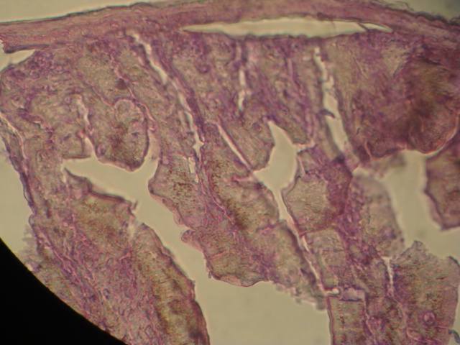
Figure (1 ):Intestine (Control). 400X ,H&E stain.

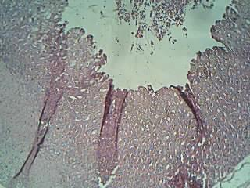
D
N
Figure (2):Histopathological section of intestine treated with GE show desquamation ( D )and necrosis (N). 400X ,H&E stain.

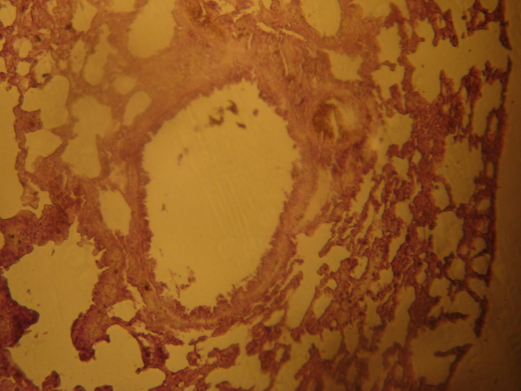
Figure (3):Lung (Control). 400X,H&E stain .

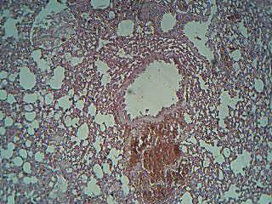
H

N
Figure (4):Histopathological section of lung treated with GE show hemorrhage (H) and necrosis (N). 400X,H&E stain .

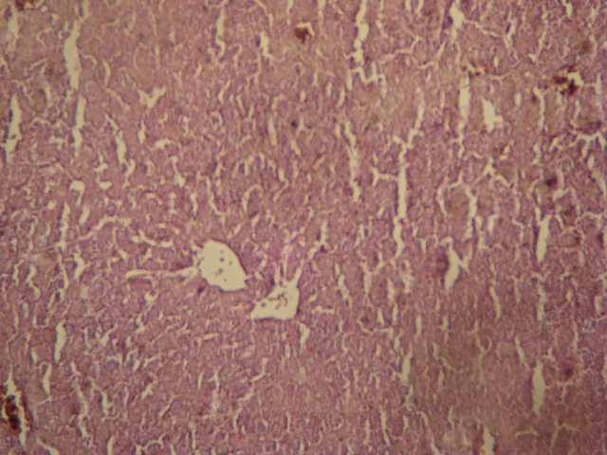
Figure(5):Liver(Control).100X, H&E stain.

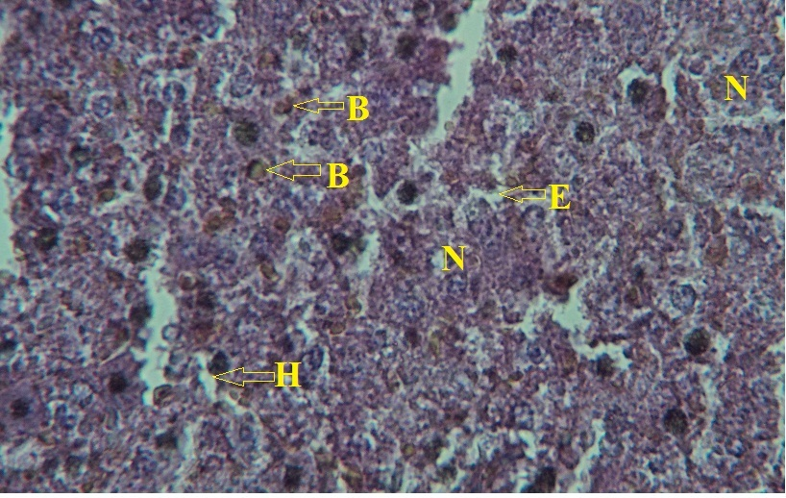
Figure(6):Liver- necrosis of some hepatocytes(N), hydropic degeneration(H), edema(E) and there are scattered bile canaliculi.100X, H&E stain.

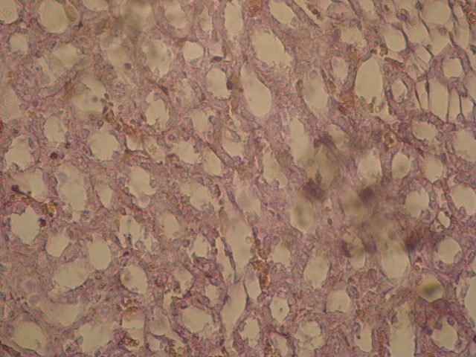
Figure(7): Kidney(Control).100X, H&E stain.

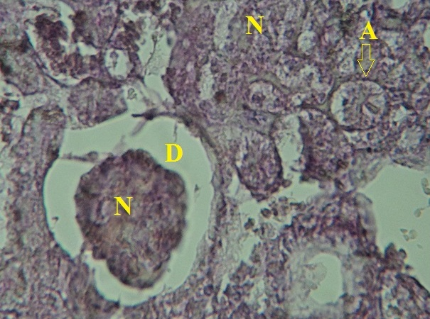
Figure(8): Kidney- necrosis of some of renal tubules(N) with atrophy in some other (A), as well as necrosis of glomerulus with dilatation of bowman’s capsule.400X, H&E stain.

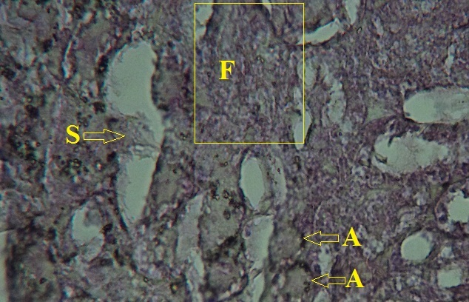
Figure(9): Kidney- there are atrophy of some renal tubules(A) with sloughing of epithelium lining of collecting tubules(S), as well as presence of completely fibrosed glomerulus.400X, H&E stain.

Acknowledgements The author are grateful to Dr.Hassan Kalaf Hamady and Dr. Kalil Kzar in the Pathology department /AL-Qadiysia Uni. for reading histopathological section .

References
Abdelgader ,E.;Ahmed,SR.; Adam,S. and Husein,A.(2010).Evaluation of toxicological activity (Acute and sub-chronic toxities)of the aqueous extract of Lawsonia inermis seeds on wistar rats.J.Pharmaacology and Toxicology,5(7):324-333.
Afzal, M.; Al-Oriquat, G.; Al-Hassan, JM.and Muhammand, N. (1984).Isolation of 1,2-dihydroxy-4-glucosyloxynaphthalene from Lawsonia inermis. Heterocycles ,22(4):813-816.
Al-Ali , A .; Alkhawajah A .; Akram R .; and Ahmed, N. ( 2008 ). Oral and intraperitoneal LD₅₀ of thymoquinone ,an active principle of Nigella sativa, in mice and rats . J. Ayub Med. Coll. Abbottabad. 20 ( 2):25-27.
Ali, M. and Grever, M. R.(1998). A cytotoxic naphthoquinone from Lawsonia inermis. Fitoterapia LXIX (2): 1810-1813.
AL-Jubory,S.Y.(2010). Extraction and Identification of some active compounds from Alhagi maurorum , Lawsonia inermis and Rhus coriari Plants and Evaluating some of their Biological effects .Ph.D.Thesis , college of science / Kufa Uni.
Camara, C.; Silva, T.; Da-Silva, T.; Martins, R.; Barbosa, T.; Pinto, A. and Vargas, M.(2008). Molluscicidal activity of 2-hydroxy-[1,4] naphthoquinone and derivatives. Anais da Academia Brasileira de Ciencias, 80(2): 329-334.
Chakrabortty, T.; Podder, G.and Deshmukh, SK. ( 1977).Triterpenoids and other constituents of Lawsonia alba. Indian J. Chem. Ser. B. 15: 96.
Chakrabortty, T.; Poddar, G. and ST Pyrek J. (1982). Isolation of dihydroxylupene and dihydroxylupane from the bark of Lawsonia inermis. Phytochemistry, 21(7):1814-1816.
Chopra, R.; Chopra, I.; Hard, K. and Kapur, L. (1982). Indigenous drugs of India. Academic Publishers, New Delhi, p.667.
Gupta S.; Ali, M.; Alam, S.; Niwa, M. and Sakai T. (1992).24-Ethycholest-4-en-3-ol from the roots of Lawsonia inermis. Phytochemistry, 31(7): 2558-2560.
Joy,P.;Thomas,J.; Mathew,S.and Sharia,B.(1998). Medicinal plants. Kerala Agricultural Uni. Aromatic and Medicinal Plants Research Station .India .pp :210.
Karber, G. (1931).Arch. Exptl. Pathol. Pharmakol. 162: 480-483.Cited by Turner, R. (1965).Screening methods in pharmacology.Academic Press.New York and London.63-64.
Kirtikar, K. and Basu, B.(1984).Indian medicinal plants.II.Biahen Sing Mahendra Pal Singh,Delhi,p.1076.
Mikhaeil, B.; Badria, F.; Maatooq, G. and Amer, M. (2004). Antioxidant and Immunomodulatory Constituents of Henna Leaves. Z. Naturforsch. 59: 468-476.
Okonta, J. and Aguwa, C. (2007).Evaluation of hypoglycemic activity of glycosides and alkaloids extracts of Picralima nitida Stapf (Apocynaceae) seed.International J. Pharmacol.3 (6) : 505-509.
Prashanth, D.; Amit, A.; Samiulla, D.; Asha. M. and Padmaja, R. (2001). Alpha-Glucosidase inhibitory activity of Mangifera Indica bark. Fitoterapia .72 ( 6) : 686-688.
Sakarkar,D.;Sakarkar,U.;Shrikhande,U.;Vyas,V.;Mandavgade,S.;Jaiswal,S.and Purohit,R.(2004).Wound healing properties of henna leaves.Natural Product Radiance ,3(6):406-411.
Sarker, S. and Nahar L. ( 2007 ). Chemistry for pharmacy students general , organic and natural product chemistry. John Wiley & Sons, Ltd. (Wiley). England p:283-359.

So,B.; Bashar, I.; Muhammad , B. and Onyeyili ,P.(2010). Acute toxicity and uterotonic activity of aqueous extract of Lawsonia inermis (Lythraceae). RJPBCS :1 (3):790-798.

