Structural and microhardness studies of
Al-Ni-Cr alloy ingots
Khalid H. Abass , Foaad SH. Hashim
Dep. of Physics, College of Education for pure science, Babylon University, Hilla, Iraq

Abstract:
Ingots of Al and Al-Ni-Cr (contains 0.25,0.5,0.99,1.98 at.% Ni-Cr) alloys were prepared by melting together wire aluminium, powder nickel and very small pieces of chromium in an electric furnace at 800 ºC under an argon atmosphere. XRD analysis after exposed the alloys to annealing at 560 ºC for 1300 hr showed the emergence and growth of three binary phases: Al₃Ni(Orthorhombic, a=6.598Ǻ, b=7.352 Ǻ, c=4.802 Ǻ), Cr₉Al₁₇(Rhombohedral, a=12.910, c=15.677 Ǻ), and Ni₂Cr₃(Tetragonal, a=8.82 Ǻ, c=4.58 Ǻ) in addition to unknown phases. The crystallite size decrease with increasing Ni-Cr contents exception the ratio 1.98 at.%. The results refer to rising of microhardness three times when raised the alloy density 0.1 g/cm³.
Keywords: Al-Ni-Cr alloy, crystallite size, microhardness.
الخلاصة
مسبوكة Al و Al-Ni-Cr (المحتوية على نسب مختلفة من Ni-Cr بالمقدار 0.25، 0.5، 0.99، 1.98) المحضرة باذابة اسلاك من الالمنيوم مع مسحوق النيكل وقطع صغيرة جداً من الكروم في فرن كهربائي بدرجة حرارة مقدارها 800 ºC تحت فراغ من الاركون. بعد المعاملة الحرارية للنماذج المحضرة بدرجة 560 ºC لفترة 1300 hr، يبين حيود الاشعة السينية ظهور ونمو ثلاثة اطوار ثنائية: Al₃Ni(معيني، a=6.598، b=7.352، c=4.802)، Cr₉Al₁₇(موشوري سداسي،( c=15.677 ,a=12.910 و Ni₂Cr₃( رباعي الزوايا،(c=4.58 ,a=8.82 اضافةً الى اطوار غير معروفة. الحجم الحبيبي يقل بزيادة محتوى Ni-Cr في السبيكة باستثناء النسبة 1.98at%. النتائج تشير الى زيادة الصلادة الدقيقة ثلاثة اضعاف بزيادة الكثافة بمقدار 0.1 g/cm³.
1. Introduction
The materials normally used in airplane industry, cars and ships, must have special properties as light weight and high strength, as well as economically significant [Merati, 2005].
Alloys of the Al-Ni-Cr attract great attention in the modern metallography, because of its higher mechanical properties at high temperature especially yielding, stiffness and combine high hardness with high resistance for corrosion [Sevtsova and Shepelavech, 2006]. Coating used aluminum alloys has a wider applications connection with the formation on surface oxide film of aluminum and chromium. This film provides a protective coating properties able to regenerate after mechanical damages[Compton et al., 2001]. Although the contains low-Al of the Al-Ni-Cr alloy system has been studied since the 1950s, only a few recent publications have been devoted to its high-Al [Grushko et al., 2008].
The Al-Ni-Cr layers used as an interconnect within a semiconductor device is disclosed, usually, the nickel or chromium concentrations are no greater than 0.5 weight percent. The layer is resistant to electromigration and corrosion. The low nickel and chromium concentrations allow the layer to be deposited and patterned similar to most aluminum-based layers[Olowolafe et al., 1997].
This work interest in studying the effect of additive of Ni-Cr in different percentages on the structure and microhardness of the Al-Ni-Cr alloys. Our investigation has been made by using X-ray diffraction(Cu Kα radiation), optical microscopy(400X), scanning electron microscopy(SEM), Vickers microhardness.
2. Experimental procedure
For the investigation, we used an Al-1.8at.%Ni-0.18at.%Cr, Al-0.9at.%Ni-0.09at.%Cr, Al-0.45at.%Ni-0.05at.%Cr, and Al-23at.%Ni-0.02at.%Cr alloys prepared by melting together elements of wire aluminium, powder nickel and very small pieces of chromium curried out in an electric furnace (Via P.da Cannobia, 10, 20122 MILANO, Italy) at 800 ºC under an argon atmosphere, using graphite crucible. The weight of casting alloy approximately 33g.
The composition of aluminum alloys adopted in the search in terms of atomic percentage and weight percentage shown in Table(1).
The heat treatment is an important operation in the final fabrication process of any engineering component. The objective of heat treatment however, is to make the metal better suited, structurally and physically for some specific application, so the product expose to annealing at 560 ºC for 1300 hr. After annealing, the ingots were water quenched.
The ingots of Al and Al-Ni-Cr were studied by X-ray diffraction (XRD, Cu Kα radiation was used), scanning electron microscopy (SEM), optical microscopy, and Vickers microhardness.
3. Results and Discussion
3.1 Surface morphology studies
Preparing samples for optical microscopy require prefacing the samples, polishing, and surface treatment by HF solution (95% distilled water with 5% HF). The microscopic photos of the prepared samples are shown in Fig. 1. The homogeneity that appears on the surfaces is a result of isothermal annealing at 560 ºC for 1300 hr. Regular distribution of the deposited phase during the foundation phase, causes a high hardness made ​​by ingot. Fig. 2 shows the SEM surface micrograph of samples, S₃(13000X) and S₅(10000X).
There are a numerous irregular shapes microcrystals. The steps, which show in figures, means a different scattering cases, the biggest scattering of the elements that have the greater atomic number, and seems bright, where elements of scattering look least dark gradually, then can be concluded that the phases consisting of composition nickel or chromium appear bright area, either aluminum matrix will seems as a dark areas.
The increase in the amount of nickel and chromium elements in aluminum alloys lead to increase the size of the conglomerates of atoms of the material that makes the alloy more systematic in terms of the distribution of grains as well as the growing collected of molecules with each other.
3.3 X-ray diffraction analysis
Fig. 3 shows the XRD pattern of Al as defined in sample S₁ and its alloys with Ni-Cr defined in samples S₂, S₃, S₄, and S₅.
Fig.3 shows the obtained three peaks corresponding to (111), (200), and (220) directions of the face centered cubic Al crystal structure which is corresponding to the positions 2θ = 38.49º, 44.74º, and 65.1º respectively. Also the XRD measurements revealed that the intensity of peak (111) orientation is predominant.
According to thermal equilibrium diagrams of Al-Ni-Cr alloys, the small amounts of Ni and Cr contained in the sample S₂ (Al-0.23at.%Ni-0.02at.%Cr), does not expect the emergence of a new phase, although our expectation is the propagation of Ni and Cr within the structure of Al matrix.
In spite of, there is no reflection peaks in the spectrum of XRD indicate the presence of conglomerates of chromium or nickel, it can be seen the diffraction peaks of alloys Al-Ni-Cr are slightly shifted towards higher angles compared with peak of Al as shown in Fig. 3, resulting from the distortion (in the form of swelling) that has plagued the basic lattice attributed to the high ionic radius of nickel (0.078 nm) and chromium (0.064 nm) compared with that values of aluminum (0.057 nm) [Flinn and Trojan, 1975]. Other alloys: S₃, S₄, and S₅ show the emergence and growth of binary phases include: Al₃Ni (Orthorhombic, a=6.598 Ǻ, b=7.352 Ǻ, c=4.802Ǻ), Cr₉Al₁₇ (Rhombohedral, a=12.910 Ǻ, c=15.677 Ǻ), and Ni₂Cr₃ (Tetragonal, a=8.82 Ǻ, c=4.58 Ǻ), in addition to unknown phases expected be affiliated to the ternary phases particular as Ni-Cr content increases in alloy.
The average crystallite size D_{g} of aluminum and its alloys with Ni and Cr was calculated from diffraction line broadening using the Scherrer’s formula[Moses et al., 2007]:
D_{g}=Kλ/β cosθ ……………..(1)
Where K is the shape factor which takes value about 0.94, λ is the wavelength of incident X-ray radiation equal 1.5404 Å for Cu Kα, θ is the Bragg’s diffraction angle of the respective XRD peak, β is the instrumental effect corrected full width at half maximum of the peak. The values of crystallite size of aluminum and its alloys were tabulated in Table(2). The crystallite size decreases with increasing of Ni-Cr content exception of the ratio 1.98at.% in sample S₅. The decrease of crystallite size in the samples S₂, S₃, S₄ attributed to the presence of Cr (few percentage lees than 0.3wt%) where a smooth of grains[Budinsk, 1996]. Large crystallite size as can be seen in sample S₅ due to increased proportion of Cr[Budinsk, 1996].
From the crystallite size calculations was calculated the dislocation density (δ) by using the relation [Gopal et al., 2005]:
Δ=1/D_{g}² (line/cm²) ……………..(2)
The values of the dislocation density(δ) of Al and its alloys was written in Table(2).
The micro strain(ε) calculated by using tangent formula[Mahalingam 1 et al., 2012], [Mahalingam 2 et al., 2012]:
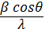 = +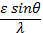 ……………..(3)
And its values written in Table(2).
The number of crystallites per unit area (N) of the films was determined with the using formula[Mahalingam 1 et al., 2012]:
N= ……………..(4)
where t is thickness. The values of (N) are written in Table(2).

3.4 Density
Fig. 4 shows the effect of Ni-Cr content in samples S₂, S₃, S₄, and S₅ on the density of Al. The linearly increases with Ni-Cr content indicates that the addition of Ni-Cr leads to improve the properties of aluminum as evidenced by the results of microhardness test later.
3.5 Microhardness
The results obtained from microhardness test conducted by Vickers microhardness test method is presented in Fig. 5. The aging behavior of the microhardness is shown to depend on the Ni-Cr ratio [Sivtsova, 2007]. Slightly increased in the microhardness up to the ratio defined in the sample S₂ is due to the diffusion of Ni and Cr as a dopant. Significant increase in the values of microhardness appears in the highest ratio of Ni-Cr in alloy. The results attributed to the microcrystalline structure
[Sevtsova et al, 2006],[Abubakre et al, 2009], supersaturated solid solution, and the appearance of fine disperse inclusion of three binary phases: Al₃Ni, Cr₉Al₁₇, and Ni₂Cr₃.
The emergence of phase Al₃Ni is in agreement with (Mondolf, 1979) and (Sevtsova et al, 2006). We believe that the emergence of phases Cr₉Al₁₇ and Ni₂Cr₃ was due to exposing all samples to isothermal annealing at 560 ºC for 1300 hr. This modernity in our work.
From the comparison of density and microhardness values of aluminum and its alloys after annealing, it can be conclude that the increase in density by 0.1 g/cm³ in sample S₅ than for aluminum in sample S₁ lead to increase the amount of microhardness approximately three times. This conclusion is presented in Table (3).
The comparison of density values for aluminum and its alloy with microhardness values after annealing, we conclude that the increase in density by 0.1 g/cm³ in sample S₅ than its of aluminum in sample S₁ lead to increase the amount of microhardness approximately three times. This conclusion can be noted in Table(3).
4. Conclusions
Synthesis Al-Ni-Cr alloy ingots from initial components at 800 ºC under an argon atmosphere. X-ray diffraction analysis after exposed the alloys to annealing at 560 ºC for 1300 hr followed by rapid quenching in water showed the emergence and growth of binary phases include Al₃Ni, Cr₉Al₁₇, and Ni₂Cr₃ in addition to unknown phases expected to be affiliated to the ternary phases. The crystallite size decreases with increasing of Ni-Cr content exception of the ratio 1.98at.% in alloys. From mechanical properties, the emergence of phases raising the microhardness three times when raised the aluminum ingot density 0.1 g/cm³.

Table (1): The chemical composition of Al-base alloys.
Alloy symbol | Al |  | Ni |  | Cr
 | at.% | wt.% | at.% | wt.% | at.% | wt.%
S₁ | 100 | 100 | 0 | 0 | 0 | 0
S₂ | 99.75 | 99.463 | 0.23 | 0.499 | 0.02 | 0.038
S₃ | 99.5 | 98.968 | 0.45 | 0.957 | 0.05 | 0.075
S₄ | 99.01 | 97.896 | 0.9 | 1.935 | 0.09 | 0.169
S₅ | 98.02 | 95.836 | 1.8 | 3.827 | 0.18 | 0.337

Table(2):Values of crystallite size, dislocation density, micro strain, and the no. of crystallite per unit area in Al and Al-Ni-Cr alloys
Alloy sample | Concentration of Ni-Cr (at.%) | Crystallite size (nm) | Dislocation density(δ)  x10⁶(line/cm²) | Micro strain (ε) x10⁻³ lines⁻²·cm⁻⁴ | No. of crystallites per unit area(N)  x10¹⁵ m⁻²
S₁ | 0.00 | 5522 | 3.279496 | 0.0069910 | 5.93897
S₂ | 0.25 | 4963 | 4.059863 | 0.0077220 | 8.18026
S₃ | 0.50 | 4324 | 5.348458 | 0.0041740 | 12.36920
S₄ | 0.98 | 3833 | 6.806476 | 0.0100058 | 17.75760
S₅ | 1.98 | 4081 | 6.004361 | 0.0073861 | 14.71300

Table (3): The values of microhardness and density of Al and Al-Ni-Cr alloy.
Alloy symbol | Vickers microhardness  ( kg/mm²) | density
S₁ | 26.76 | 2.683
S₂ | 30.55 | 2.698
S₃ | 43.57 | 2.720
S₄ | 54.48 | 2.752
S₅ | 72.67 | 2.793

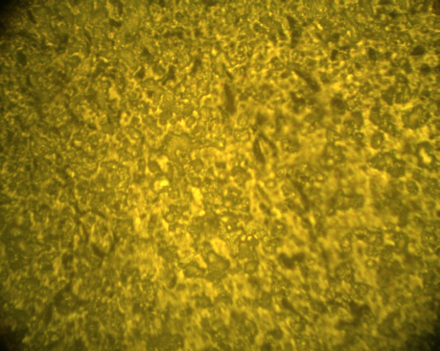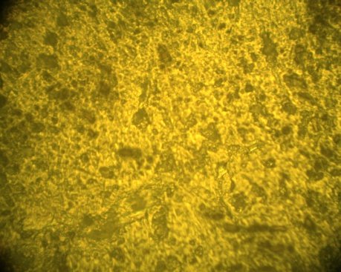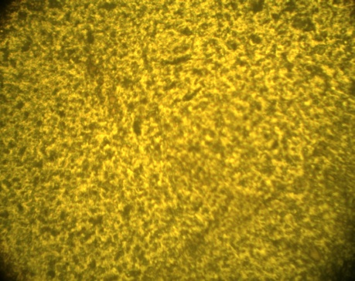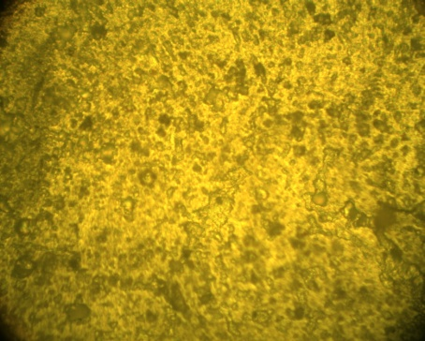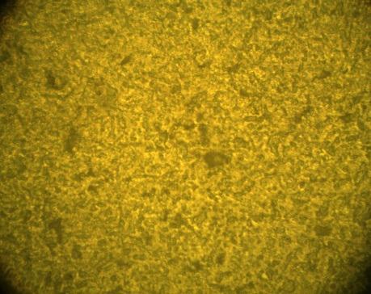
S₂
S₂
S₂
S₂
S₁

Fig. 1: Optical microscopic pictures (400X).
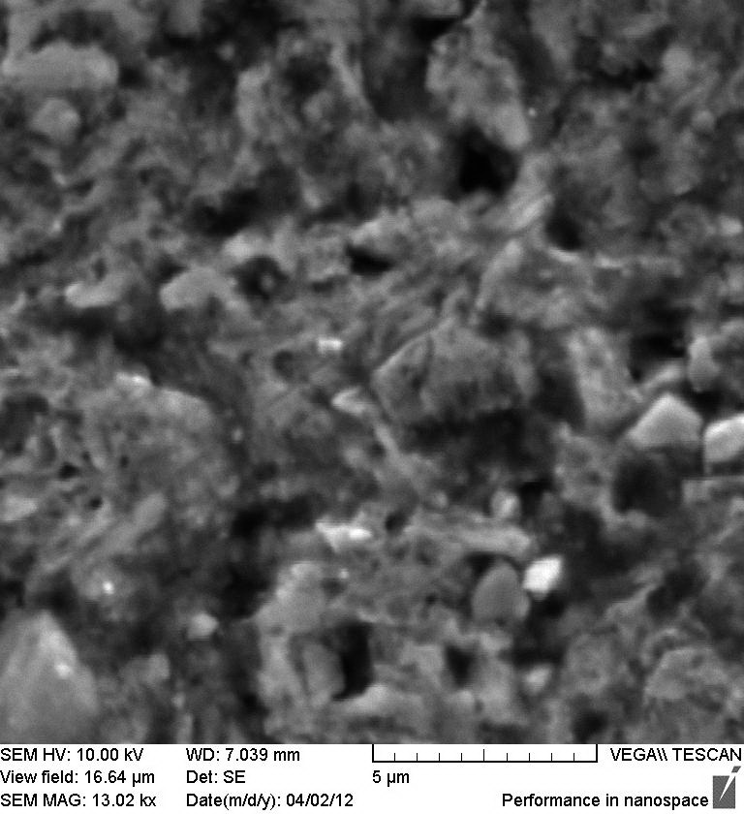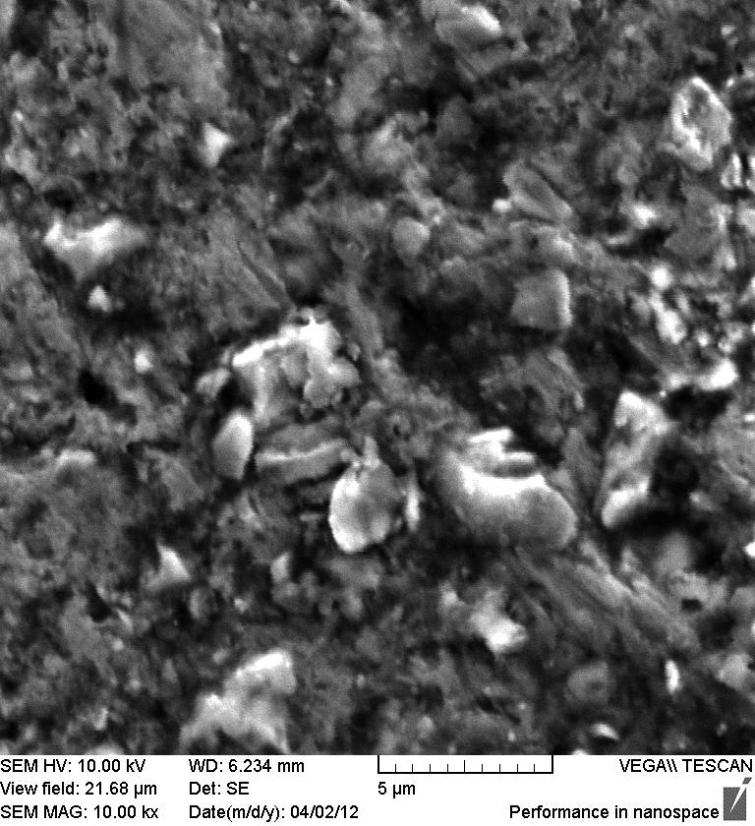

(a) (b)
Fig. 2: SEM micrograph of a- S₃ (13000X), and b- S₅ (10000X).

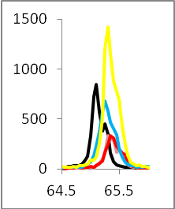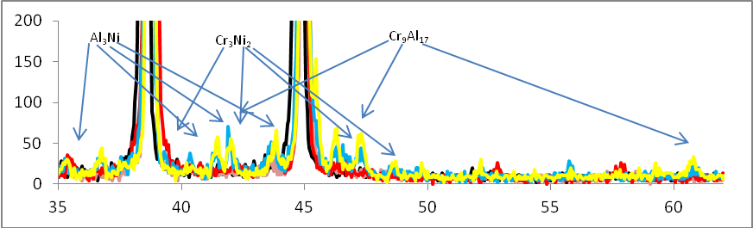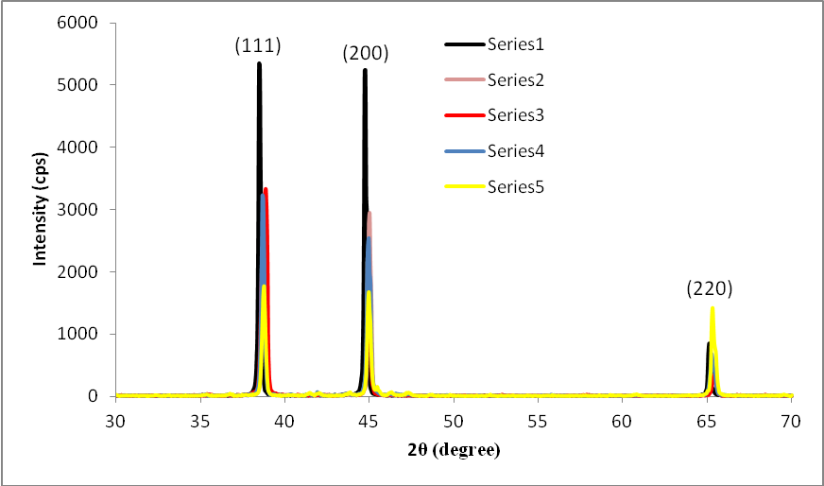

Fig. 3 :XRD pattern of Al and Al-Ni-Cr alloys.
2θ degree
2θ degree

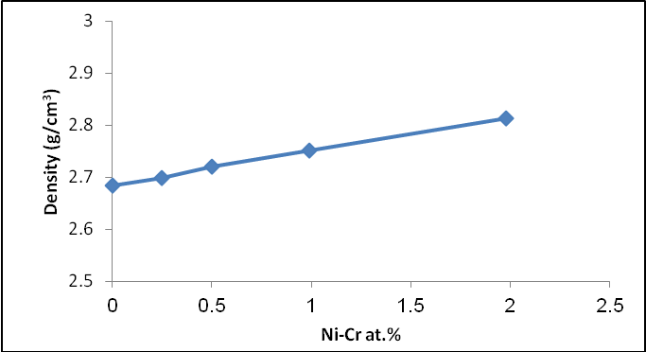

Fig. 4: Effect of content Ni-Cr at.% on density of aluminum alloy.

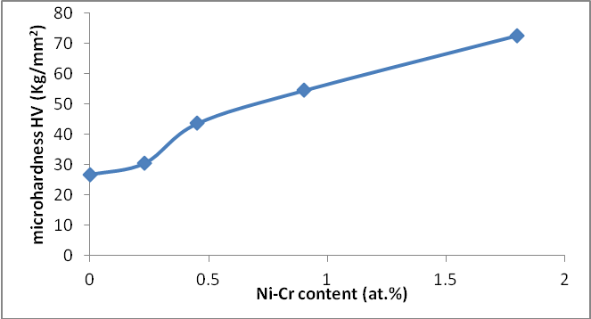
Fig. 5: Effect of content Ni-Cr at.% on Vickers microhardness of aluminum.

Refrences
Abubakre O. K., Mamaki U. P. and Muriana R. A, 2009, "Investigation of the Quenching Properties of Selected Media on 6061 Aluminum Alloy", Journal of Minerals & Materials Characterization & Engineering, Vol. 8, No.4, pp. 303-315.
Budinsk K. G. , 1996, "Engineering materials properties and selection", 5th edition, prentice-Hall.
Compton D. N., Coornish L. A., Witcomb M. J., 2001, "The effect of microstructure on hardness measurements in the aluminum-rich corner of the Al-Ni-Cr system", journal of alloys and compounds, Vol.317-318, pp. 371-378.
Flinn R. A. and Trojan P. K., 1975, "Engineering Materials and Their Applications", Houghton Mifflin Company, Boston.
Gopal S., Karunagaran B., Narayandass Sa. K., Mangalaraj D. , and Yi. Junsin, 2005, "Cryst. Res. Technol.", No. 6, p 557.
Grushko B., Kowalski W., Pavlyuchkov D., Przepi´orzy´nski B., Surowiec M. , 2008, "A contribution to the Al–Ni–Cr phase diagram", J. of Alloys and Compounds Vol. 460, pp. 299-304.
JCPDS, 1979, Joint Committee for Powder Diffraction Standards, Power Diffraction File for Inorganic Materials, 79–2205.
Mahalingam T. 1, Dhanasekaran V., Chandramohan R., and Rhee Jin-Koo", 2012, Microstructural properties of electrochemically synthesized ZnSe thin films", Journal of Material Science, 47, pp 1950–1957.
Mahalingam T. 2, Dhanasekaran V., Sundaram K., Kathalingam A., and Rhee Jin-Koo, 2012, " Characterization of electroplated ZnTe coatings", Ionics, 18, pp 299–306.
Merati A., 2005, "A Study of Nucleation and Fatigue Behavior of an Aerospace Aluminum Alloy 2924-T3", International J. of FatigueVol.27, pp. 33-44.
Mondolof L. F., 1979, "Structural and propertiesof aluminum alloys", Moscow, metallurgy, p640.
Moses A., Raj E., Nehru L. C., Jajachandran M., and Sanjeeviraja C., 2007, "Crys.Rev.Technol.", 42(9), 867.
Olowolafe H. O., Kawasaki H., Lee C. , 1997, "Al-Ni-Cr Conductive Layer for Semiconductor Devices", United States Patent no. 5623166.
Sevtsova N. A. and Shepelavech V. G., 2006, "Rapidly solidified for the foels of Al-Ni-Cr alloys system", Minsk, pp. 8-13.

