Antibacterial Activity of Titanium Dioxide (Tio₂) Doped with H₂O₂ against staphylococcus aureus Human pathogen in aqueos solution.
Hawraa Whab Azize
College of Science for women, Babylon University.
hwazize@gmail.com
Abstract
The effects of parameters such as amount of TiO₂, presence of H₂O₂, irradiation time, dark and light condition were studied and investigated their acted against S.aureus human pathogen in aqueous solution. The results show that the number of S.aureus was greatly reduced after treatment with a visible light and Tio₂ doping H₂o₂ better than after treatment with visible light only and visible light with Tio₂ only. In the treatment with Tio₂ and light the number of bacteria was decreased with survival ratio at 40% . The best result has been obtained at 0.33mg/ml Tio₂ concentration which is equal to survival ratio 30%. Two dark/H₂O₂ treatments have been done in presence and absence of Tio_{2,} in adding 10ppm H₂o₂ the bacterial number decreases (survival ratio 45%) and in adding 0.33mg/ml of Tio₂ with 10 ppm H₂O₂ in dark the survival ratio 40%. Two light/H₂O₂ treatments have been done in presence and absence of Tio₂. Survival ratio in presence of light /H₂O₂ was 23%, the survival ratio of S. aureus in presence of light/H₂O₂/Tio₂ was 11%. This study suggests that H₂o₂ doped Tio₂ can be used as disinfectant in water phase.
Keywords: photocatalytic killing of S. aureus, TiO2 photocatalyst, H₂O₂, sterilization, water phase, light, dark.
الخلاصة:
تم دراسة تاثير عدد من العوامل مثل كمية Tio₂ ,وجود H₂O₂ .وقت التشعيع ,وجود او عدم وجود الضوء على بكتريا S.aureus الممرضة للانسان في الطور المائي .بينت النتائج ان اعداد البكتريا اختزلت بشكل كبير بعد المعاملة مع Tio₂/H₂O₂ بوجود الضوء افضل من المعاملة بالضوء فقط او المعاملة بالضوء و Tio₂فقط . عند المعاملة Tio₂ والضوء انخفضت اعداد البكتريا بنسبة بقاء 40% . كانت افضل النتائج المستحصلة عند تركيز 0.33 mg/ml من Tio₂ اذ كانت نسبة البقاء 30% . تم اجراء تجربتين بظروف الظلام و H₂O₂بوجود او عدم وجود Tio₂ , عند اضافة 10 ppm من H₂O₂ والظلام انخفضت اعداد البكتريا (نسبة البقاء 45%) وعند اضافة Tio₂ كانت نسبة البقاء للبكتريا 40%. تم اجراء تجربتين بظروف الضوء و H₂O₂ بوجود او عدم وجود Tio₂ , عند عدم وجود Tio₂ كانت نسبة بقاء البكتريا 23% في حين عند وجود Tio₂ بهذه الظروف كانت نسبة بقاء البكتريا 11%. توصي هذه الدراسة باستخدام H₂o₂ و Tio₂كمعقم في الطور المائي .
الكلمات المفتاحية : القتل الضوئي ، بكتريا aureus, TiO H₂O₂, ، التعقيم , الضوء المائي , الضلام
Introduction:
Staphylococcus aureus are capable of prolonged survival on a variety of environmental surfaces, it can be alive in distilled water and in all parts of hospital and it is resistant to chemical disinfectants and many of conventional antibiotics (Carson etal, 1988).
It is the most virulent of the many staphylococcus species and it is responsible for infections ranging from superficial skin to soft tissue infections (Kasper etal, 2005), and its exotoxin producing pathogen, can cause food-borne disease in human (Salyers and Whitt, 1994) it has the highest pathogenic effect in human and it is the first pathogen agent in hospitals (Gacesa and Russell, 1990).
The Bacteria can be destroyed by a number of different techniques including heat, radiation and chemical oxidizing agents such us H₂O₂,Which are used to treat microbial pollution of waters ,but they are not completely efficient on some of resisting microorganism such us S.aureus (Mills and Lettunte ,1997).
The wide spread use of antibiotics led to the emergence of more resistant and virulent strains of bacteria and this caused an urgent need to develop alternative sterilization technologies to disinfect water and waste water from hospital such us using photocatalytic effect of Tio₂,this method is feasible and inexpensive to act as disinfectants (Russell, 2004 and Manes etal 1999 and Aiello and Larson ,2003 and Block, etal 1997 ) and powerful biocide process due to production of redox reaction species from Tio_{2,} when irradiation Tio₂ particles are indirect contact with or close to microbes to initial oxidative attack (Daneshvar etal, 2007 and Lee etal, 2005) and photokilling action was associated with the reduction in the level of intracellular coA through photo oxidation (Mills & Lettunte 1997).
The oxidation processes such us Tio₂/Uv and H₂o₂/Uv are useful in water purification and surgical suites (Coates etal, 2007 , Julian etal, 2007 and Cho etal,2002).
Since 1981 many papers have been published about semiconductor, the most studies in this field have been done on bacteria especially E.coli and S. aureus and other bacteria. Mastsunaga and coworkers published first report about photocatalytic disinfection in 1985 (Mills & Lettunte 1997; Aiello & Larson 2003; Julain etal 2007; Hemraj etal,2014).
The action of this technology in aqueous phase is in presence of Tio₂ alone or with H₂o₂ upon Uv light excitations ,the photo energy excites valenee band electron and generate pairs of electrons and holes that diffuse and trapped on or near the Tio₂ surface (Wong etal 2006; Cheng etal, 2009; John etal, 2014) and these pairs have strong reducing and oxidizing oxygen to yield reactive species such us –OH &⁻O₂ (Fujishima and Honda 1972) which are extremely reactive upon contact with organic compounds and bacterial cell (Saleh, 2011) and complete oxidation to carbon dioxide (Jacoby etal, 1998). These radicals operate in consent to attack poly unsaturated phospholipids in bacteria (Wong etal, 2006) Another related study was carried out by Hirakawa and coworkers (2004) which has shown that photo irradiation Tio₂ catalyzed site-specific DNA damage via H₂o₂ .These findings suggested that Tio₂ might exert antimicrobial effects similar to these of peroxygen disinfectant H₂o₂ (McDonnell and Russell, 1999).
The aim of this study is to investigate the effect of Uv visible light on the antibacterial activity in presence of H₂o₂/Tio₂ and using photo catalytic reaction for disinfecting water and waste water instead of chemical material.
Materials and Methods
Bacterial Strains and Culture
Basic bacterial cultured methods have been done (Johnson and Case, 1995). Clinical isolated S. aureus was collected from Babylon Hospital of pediatric and maternity.
In this study, bacterial concentrations were determined by standard plating count method (SPC).Afresh bacterial culture was diluted by factors 10⁻¹ to 10⁻⁶ and bacterial concentrations of these dilutions were determined using SPC. After this step the right dilution has been selected to be used in these experiments and before every experimental the number of bacteria reading and this number is used as astandard number.
Chemicals
A:-Nutient agar was supplied from HIMDIA.
B:-H₂O₂was supplied from DDH at 30%.
C:-Titanium dioxide (Tio₂) was supplied from Degussa P25(Cheng etal, 2009; Julain etal, 2007).
2-3 Instruments: photo catalysis cell.
A:-Source of irradiation: use low pressure mercury lamp type OSRAM (160W) (306-750nm)
B: Reaction vessel: content photo cell (35 cm³ ) with quartz window (2cm² ).
C: Regulator circulating thermostat (Desagafrigosta): using to control the temperature.
D: Oxygen gas container was connected with flowmeter (Rato) to control the rate of gas passing on the surface of aqueous solution.
E: Amagnetic stirrer (Abovolt) was used to homogenous suspension.
F: Centrifuge (Hettich) was used to remove Tio₂ practical and the supernal liquid, the instruments used in this work were previously described in detail (Gassim etal, 2004).
2-4 Photo Catalysis Experiments:-
In all photo catalytic experiments 30 ml of aqueous solution of S. aureus cell suspensions were added to a known weight of Tio₂ particles in photo cell quartiz window and suspended by using magnetic stirrer the oxygen was passed on the surface of aqueous suspension at the rate 10 ml/min. The temperature was controlled at 25c⁰ by using circulating thermostat. The suspension was irradiated for 40 min.
Other experiments have been done by adding 10 ppm of H₂o₂ S. aureus aqueous solution in absence and in presence of Tio₂ catalyst, dark and light condition. After each 10(min) samples of irradiated mixture were drawn by using syringe with along pliable needle and then centrifuged at 1000 rpm /5min in all experiments, 0.5 ml of the suspension was immediately added to 20ml nutrient agar media in petri dish with triplicates per each treatment. The culture was kept in the dark at 37c⁰ for 24h .Colony forming units (cfu) of S. aureus were counted by SPC (Saleh,2011).
The incident light intensity was measured by using parcker and Haut chard method (Maness etal, 1999) this method consists of irradiated potassium ferrioxalate actinometry k3fe (c₂o₄) 2.3 H₂o₂ for 3min after passing nitrogen gas for 15 min at 25c⁰. The average light intensity is 6.2×10⁻⁸ Einstein L⁻¹S⁻¹(Gassin etal, 2009).
Results & Discussion:-
In this study the effects of parameters such as amount of TiO₂, presence of H₂O₂, irradiation time, dark and light condition were studied and investigated their acted against S.aureus human pathogen. All experiments occurred in presence of oxygen.
1-Determination of optimum conditions for photocatalytic reactions.
To determine the optimum condition, which led to high killing efficiency, four primary experiments have been done .Figure(1) shows that ,in the first treatment with dark only the number of bacterial cell was increased with time because the bacteria have acclimatized to their new environment and synthesis the enzymes needed to initialize the available materials (Johnson &case ,1995) and division by binary fission this leads to increase the number of cells with time in aqueous solution(Kwaadsteniet etal,2011).
In the treatment with Tio₂ in dark (Figure-2), there's no effect on bacterial number because Tio₂ are biologically and chemically invert and its antibacterial activity can be switched on and off or modulated by controlling the light intensity, and this agrees well with other studies (wong etal,2006; cheng, etal,2009; Kwaadsteniet etal,2011; Hemraj etal,2014).
In the treatment with light only, the number of bacteria is decreased, because the light used in this work has wave length ranges from 306 to 750 nm which can cause damage to DNA resulting in the cell death by forming oxygen radicals within cell (Johnson &case,1995, Ireland etal 1993, Kruft, and Green 2011).
In the treatment with Tio₂ and light the number of bacteria was decreased with survival ratio at 40%. This means that the presence of light and Tio₂ catalyst was very essential for photocatalytic reaction due to the bacterial activity of Tio₂ act in presence of light. The study of pal &coworkers (2006) and cheng and coworkers (2009) found that light can activate the antibacterial activity of Tio₂ by exciting it (Saleh, 2011).

Fig(1) Primary experiments for determination of optimum conditions for photocatalytic reactions
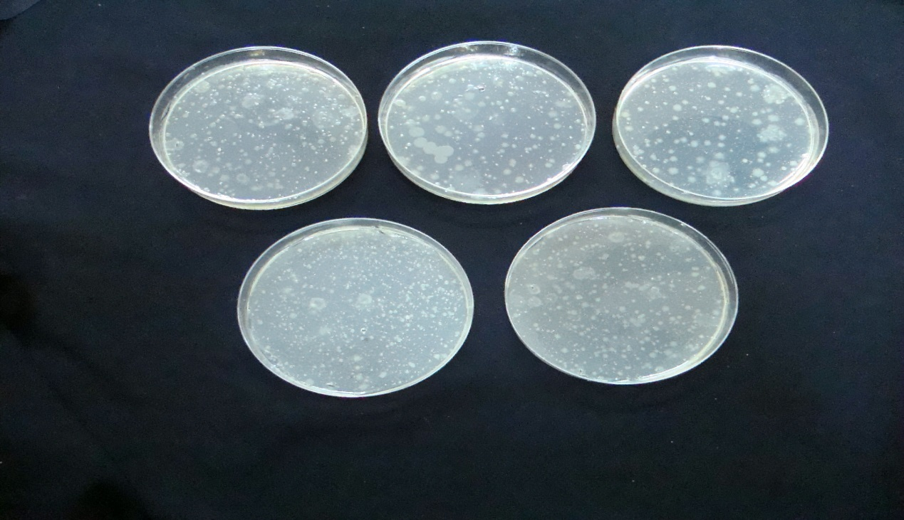
0
20
10
Fig(2): Treatment with dark and Tio₂ (time 0,10,20,40 min.).
40
30
2- Effect of Tio₂ amount on removal of S.aureus.
Tio₂ is the most widely used as semiconduction photocatalyst due to its high photostability non-toxic high oxidizing potential and insolubility in water under different conditions (Saleh,2011).
Different amounts of Tio₂ (0.23, 0.26, 0.33, 0.5 and 0.66 mg/ml) were added to the samples with known initial number of bacterial cells and the results in figure (3) show that the increasing in Tio₂ concentration led to increase the removal of S. aureus and this result agrees with Kweedsteniet and coworkers (2011) and Saleh (2011) and Daneshvar and coworkers (2007) who found that the presence of Tio₂ in water has higher photocatalytic effects on S.aureus in the aqueous solution.
At high Tio₂ concentration (more than 0.33mg/ml) the removal efficiency of S. aureus was decreased. The turbidity of the solution prevents the effect of light, theTio₂ particles from inner filter which absorbs high portion of the incident light. The light scattering due to the turbidity of the solution which led to reduce the rate of photocatalytic reactions. (Gassim, 2009).
The best result has been obtained at 0.33mg/ml Tio₂ concentration which is equal to survival ratio 30% so that this concentration will be chosen to study the effect of H₂O₂/Tio₂ semiconductors on the killing efficiency of S. aureus in aqueous solution.

Fig(3) Effect of Tio₂ amount on removal of S.aureus
3- S. aureus photodegradation with H₂O₂ in different condition.
A number of experiments has been carried out including the adding 10 ppm of H₂O₂ to study its bactericidal effect on S.aureus. Two dark/H₂O₂ treatments have been done in presence and absence of Tio₂ as shown in figure (4).
In the adding 10ppm H₂o₂ the bacterial number decreases (survival ratio 45%) and in adding 0.33mg/ml of Tio₂ with 10 ppm H₂O₂ in dark the survival ratio 40%. The hydrogen peroxide decreases the respiratory activities that led to cell death (Johnson &case1995).There was no actual effect on survival ratio when Tio₂ was added to the treatment because it was inert in dark.
Two light/H₂O₂ treatments have been done in presence and absence of Tio₂ (figure 5) the number of bacterial cells decreases (survival ratio in presence light /H₂O₂ was 23% but the killing efficiency of S. aureus in presence of light/H₂O₂/Tio₂ was highest than when compared with light /H₂o₂ condition alone (survival ratio 11%).
This effect was explained by many studies (Matsunaga, etal 1985; Saleh, 2011; Djurisic, etal 2012 and Jaisai etal 2012) which found that both H₂O₂ and hydroxyl Radicals from Tio₂ are necessary for bactericidal effect, and H₂o₂ alone could not induce the same anti-bacterial effect when doping with Tio₂.

Fig (4): photodegradation effect of H₂O₂ on S. aureus in different condition

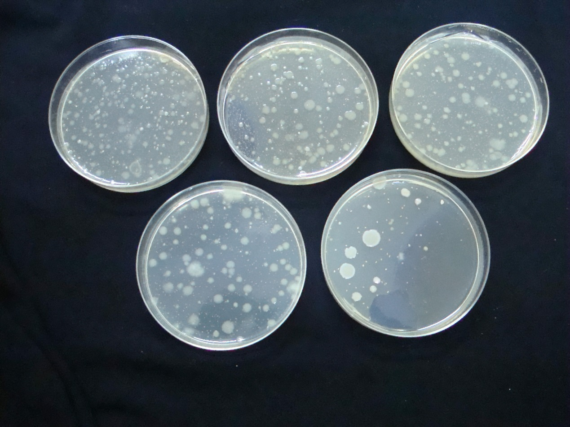
4
30
0
1
20
Fig(5):Treatment with H₂O₂ and Tio₂ and light.(time 0,10,20,30,40 min.)
4- The effect of presence and absence of H₂O₂ on S.aureus survival ratio
Figure (6) shows the comparison of survival ratio of S.aureus in aqueous solution treated with light/Tio₂ 0.33mg/ml between the presence and absence of H₂O₂.
The killing efficiency of S.aureus was increased in both treatments but the higher killing rate was obtained when adding 10 ppm H₂o₂ (survival ratio 11%) the presence of H₂o₂ /Tio₂/light operates in concerted attack poly unsaturated phospholipids in bacteria cell surface and photocatalytic this surface first makes contact with whole cells, and cells suffering from cell-wall damage and increased cell permeability and then OH , O₂ and Tio₂ particles have easier access and photo oxidation of intracellular elements which cause cell death (Saleh,2011; Fujishima and Honda, 1972 and Wong etal 2006).

Fig (6): comparison of survival ratio of S.aureus in the presence and absence of H₂O₂.
These results show that the number of S.aureus was greatly reduced after treatment with a visible light and Tio₂ doping H₂o₂ better than treatment with visible light only and visible light with Tio₂ only.
This study suggests that we can use H₂o₂ doped Tio₂ as disinfectants in water phase.
References
Aiello, A. and Larson , E. 2003. Antibacterial cleaning and hygiene products as an emerging risk factor for antibiotic resistance in the community.Lancet infect. Dis. 3:501-506.
Block, S.; Seng, V. and Goswami , D. 1997. Chemically enhanced sun light for killing bacteria . ASME J.SOL Energy Eng.119:85-91.
Carson, L.; Tablon,O.; Cusick, L.; Jarvis, W.; Faver , M. and Bland, L. 1988. Comparative evaluation of selective media for isolation of Psedomonas cepacia from cystic fibrosis patients and environmental sources . J. Clin. Microbiol. 26: 2096-2100.(ivsl)
Cheng,D.; Sun,D.;Chu,W.Tseng, Y.; Ho. H.;Wong,J.;Chung,P.;Chen,J.;Tsai,P.; Lin,N.;yu, M.and Chang,H.2009. the effects of the bacterial interaction with visible light responsive titanium photocatalytic on the bactericidal performance .J.Biomed sci.16(1):7
Cho,I. ; Mon, L.; Chung,M.;Lee, H. and Zoh,K. 2002.Disinfection effects on E. coli using Tio₂/UV and solar light system water supply .2: 181-190.
Coates, C.; Caldwell, W.; Alberte, R.; Barreto, P. and Barreto, J. 2007. Bata-carotene protects Sudan Iv from photocatalytic degradation in amiceller model system: Insights into the antioxidant properties of the golden Staphylococcus aureus .Word J.M. Biotechnology. 23:1305-1310.
Daneshvar, N; Niaei, A.; Akbari, S. ;Alber,S. and Kazemian ,N. 2007. Photocatalytic disinfection of water polluted by Pseudomonas aeruginosa. Global Nest J. 9(2):132-136.
Djurisic, A.;Chan, W. and Leunge, F. 2012.Antimicrobial nano structured coatings deposited by low temperature inexpensive , solution methods RFCID/HHSRF/HSRF/HCPF. 3-18.
Fuji shima,A. and Honda,K.1972. Electrochemical photolysis of water at a semiconductor electrode.Nature.238:37-38.

Gacesa, P. and Russell, N.1990. Psedomonas infection and Alginates: Biochemistry , Genetic and Pathology , Chapman and Hall, Landon, England.
Gassim, F. and AL-Anbaeki, R.2009.Application of the photo catalytic reaction of Tio₂ to disinfection and the killing of Escherichia coli bacteria . National J of chem. 35:480-488.
Gassim,F.; Alkhateeb,A .and Hussein,F. 2004. Photo catalytic oxidation of benzyl alcohol using pure and sensitized analyses .the 8th Arab international word renewable energy. Conference and exhibition 8-10 March. King .Bahrain.461-471.
Hemraj M. , Sachin V. , Raghvendra A. , Sawanta S. , Shivaji H. and Sagar D. 2014. Synthesis and visible light photocatalytic antibacterial activity of nickel-doped TiO₂ nanoparticles against Gram-positive and Gram-negative bacteria. Journal of Photochemistry and Photobiology A: Chemistry.
294(15):130-136.
Hirakawa, K.; Mori, M.; Yoshida, M.; Oikawa, S. and Kawanishi, S. 2004.Photo- irradiated Titanium dioxide catalyzes site specific DNA damage via generation of hydrogen peroxide. Free Radic. Res. 38: 439-447.
Ireland ,J.; Klostermann, P.;Rice, E. and Clark ,R. 1993. Inactivation of E. coli by titanium dioxide photocatalytic oxidation . App.Environ. microbial. 59(5):1668-1670.(ivsl)
Jacoby,W.; Maness,P.; Wolfrum, E.; Blake, D.and Fennel,J.1998.Mineralization of bacterial cell mass on aphotocatalytic surface in air. Environ.Sci.Technol.32:2650- 2653.
Jaisai,M.; Bauah,S. and Dutta, J. 2012. Paper modified with zno nanorods antimicrobial studies .Beilstein J.of nanotechnology .3:684-691.(ivsl)
John, K.; Sami, R.; Rosendo, S.; and Cesar Pulgarin.2014. TiO2 and TiO2-Doped Films Able to Kill Bacteria by Contact: New Evidence for the Dynamics of Bacterial Inactivation in the Dark and under Light Irradiation. International Journal of Photoenergy.2014(2014):17
Johnson, T. and Case, C.1995. Laboratory Experiments in microbiology 4th Ed. Benjamin/ Cumming s publishing company INC. New York.
Julian, B.; Pilar, F. and Sixto, M. 2007. Solar photo catalytic detoxification and disinfection of water ; Recent overview – solar energy. Engineering J. 129: 4-15.
Kasper, D. ; Braunwald, E.; Fauci,A.(eds).2005. Harrisons, principles of internal medicine, 16th ed.chap.120.
Kruft, B. and Green, A. 2011. Photosensitization Reactions in vitro and in vivo. Photochemistry and photobiology .87: 1204-1213.
Kwaadsteniet, M.; Boles, M. and Cloete, T. 2011. Application of Nanotechnology in antimicrobial coatings in the water industry .NanoBrief Reports and Reviews . 6(5): 395-407.
Lee, S.;Pumprueg , S.; Moudgil, B. and Sigmund, W. 2005. Inactivation of bacterial endospores by photocatalytic nanocomposites, colloids and surface. B: Bio interfaces .40 :93-98.(ivsl).
Maness,P.;Molinski,S.;Blak,D.;Huang,Z.;Wolfrum,E.1999. Bactericidal activity of photocatalytic Tio₂ reaction :Toward an understanding of its killing mechanism. Appl. Environ. Microbiol. 65(9):4094-4098.
Matsunaga,T. ; Tomato, R.; Nakajima,T. and Wake, H. 1985. photoelectron chemical sterilization of microbiology cell by semiconductor powders ,FEMS Microbiology letters 29:211-214.(ivsl).
McDonnel, G. and Russell, A. 1999.Antisepties and disinfectants: activity , action and resistance . Clin. Microbiol. Rev.12: 147-179.(ivsl)
Mills, A. and Lettunte, S. 1997. An overview of semiconductor photocatalysis. J. photochemistry and photobiology, A; chemistry 108: 1-35.(ivsl)
Pal, A.; Pehkouen, S.; Yu, L. and Ray, M.2006. Tio₂ mediated photo catalytic in activation of Gram- positive and Gram-negative Bacteria using fluorescent light . 1st international conference on natural Resources Engineering Technology :65-76.
Russell, A. 2004. Bacterial adaptation and resistance to antiseptics, disinfectants and preservatives is not a new phenomenon. J. Hosp.Infict. 57:97-104.
Saito, T.; Iwase, T.;Horie, J .and Morioka, T. 1992 . Mode of photocatalytic bactericidal action of powdered semiconducter Tio₂ on mutans Streptococcus .J. photochem. Photobiol .B:Biology . 14:369-377.(ivsl)
Saleh, F. 2011. Sensitization of semiconducting nan powder catalysts in photo degradation of medical drugs and microorganisms in water . An-Najah National University Faculty of Graduate studies . thesis.
Salyers, A. and Whitt, D.1994. Bacterial pathogenesis :molecular approach .Washington D. C.:Asm press pp 122-129.
Wong, M.; Chu,W.; Sun, D.; Huang,H.; Chen, J.; Tsai, P.; Lin, N.;Yu, M.; Hsu,Sh.;Wang,S. and Chang,H. 2006.Visible –light induced bactericidal activity of anitrogen –doped titanium photo catalysis against human pathogens .Appl.Environ. Microbiol.72(9):6111-6116.

