Biostratigraphy Of Mauddud Formation In
Badra well – 1; Eastern Iraq
Noor A. Noori
University of Karbala - College of Agriculture
noora.alyassery@yahoo.com
Sa'ad S. J. Al-Sheikhly, and
University of Baghdad - College of Science
Saadalsheikhly@yahoo.com
Salam I. M. Al-Dulaim
University of Baghdad - College of Science
Salamrudist@yahoo.com
Abstract
The Muaddud Formation is the most important and widespread Lower Cretaceous formation in Iraq. This formation has been studied at Badra well No-1 within Badra oil field, at Eastern Iraq. Seventy thin sections were prepared and studied in this study. Nineteen species of foraminifera were determined, in addition to that high abundant of rudist, bivalvia and gastropoda shells fragment were identified in this study. Three biozones were distinguished.
The age of the Formation is determined according to the fossil content as Late Albian – Cenomanian,
Keywords:- Mauddud Formation, Biostratigraphy, Foraminifera, Orbitolina, and Badra – 1.
الخلاصة
يعتبر تكوين المودود احد التكاوين المهمة التي ترسبت و بشكل واسع ضمن الطباشيري الأسفل في العراق. تم دراسة التكوين في بئر بدرة – 1 و الواقع ضمن حقل بدرة النفطي شرق العراق. تم تحضير 70 شريحة رقيقة , ومن خلال دراسة تلك الشرائح تم تحديد تسعة عشر نوعا من الفورامنفيرا , هذا إضافة إلى تمييز وفرة من قطع الرودست و بعض الأصداف و قطع من بطنية القدم ورأسية القدم. تم تحديد ثلاثة أنطقه حياتية و التي من خلالها تم تحديد عمر التكوين بالالبيان الأعلى – سينومانيان.
الكلمات المفتاحية :- تكوين المودود ، الطاباقية الحياتية، الفورامنفيرا، الاوربيتولينا، و بدرة -1.
Introduction
The Mauddud Formation was first defined by Henson, from the subsurface section of Qatar Petroleum Company, well Dukhan No.1, where it takes its name from Ain Mauddud. (Mohammed,1981).
Mauddud Formation is a subsurface, largely neomorphosed and dolomitized limestone. (Shubber,1986).
The lower contact of the Mauddud Formation is conformable and gradational with the Nahr Umr, Lower Balambo or Sarmord Formations. The upper contact is marked by a break and is either nonsequential or unconformable; it is an unconformity in N Central, N and NE part of Iraq (Jassim and Goff 2006).
In the type locality where the formation had been described for the first time, it is of 55m thickness consisting of limestone rich in Orbitolina and Trocholina tests. In the Northern Arabian Gulf especially in the Saudi Arabia– Kuwait border, the Mauddud Formation was found to consist of a limestone ranging in thickness between averages from 30.5 to 97.6 m. (Al – Dabbas, et al, 2012).
The Zubair well no.3 was used as supplementary type section for the Mauddud Formation in Iraq by Owen and Nasr(1958) they described the formation as a detrital organic limestone, locally pseudo oolitic creamy in color, contains blue to green shale in layers (Sayyab and Mohammed,1985).
The Mauddud Formation pinches out on the eastern flank of the Hail – Rutbah Arch, also it vanishes between Wara and Nahr Umr in Western Kuwait.
( Ibrahim, 1981).
The age of Mauddud Formation is still in flux (Fig1), where the Albian age was cited by some, and Cenomanian age by others. Abundant fossils cited by Bellen et al. (1959) support an Albian age. The formation was originally believed to extend into the Cenomanian because of the frequent occurrence of some species of the Orbitolina concave group (Bellen et al., 1959).
The Mauddud Formation is the most widespread Lower Cretaceous Formation Middle and Southern Iraq. (Fig 2)

Cenomanian |  |  | Albian |  |  | Age  Author(s)
Late | Middle | Early | Late | Middle | Early
 |  |  |  |  |  | Sadooni (2003)
 |  |  |  |  |  | Mohammed (1996)
 |  |  |  |  |  | Ibrahim (1981)
 |  |  |  |  |  | Riché & Prestat (1980)
 |  |  |  |  |  | Al-Siddiki (1978)
 |  |  |  |  |  | Al-Khersan & Hassan (1978)
 |  |  |  |  |  | Sugden & Standring (1975)
 |  |  |  |  |  | Al-Shamlan (1975)
 |  |  |  |  |  | Ditmar (1972)
 |  |  |  |  |  | Naqib (1967)
 |  |  |  |  |  | Sayyab (1966)
 |  |  |  |  |  | James & Wynd (1965)
 |  |  |  |  |  | Dunnington in Bellen et al (1959)
 |  |  |  |  |  | Owen & Nasr (1958)
 |  |  |  |  |  | Smout (1956)

Fig 1:- Previously published Dating of Mauddud Formation

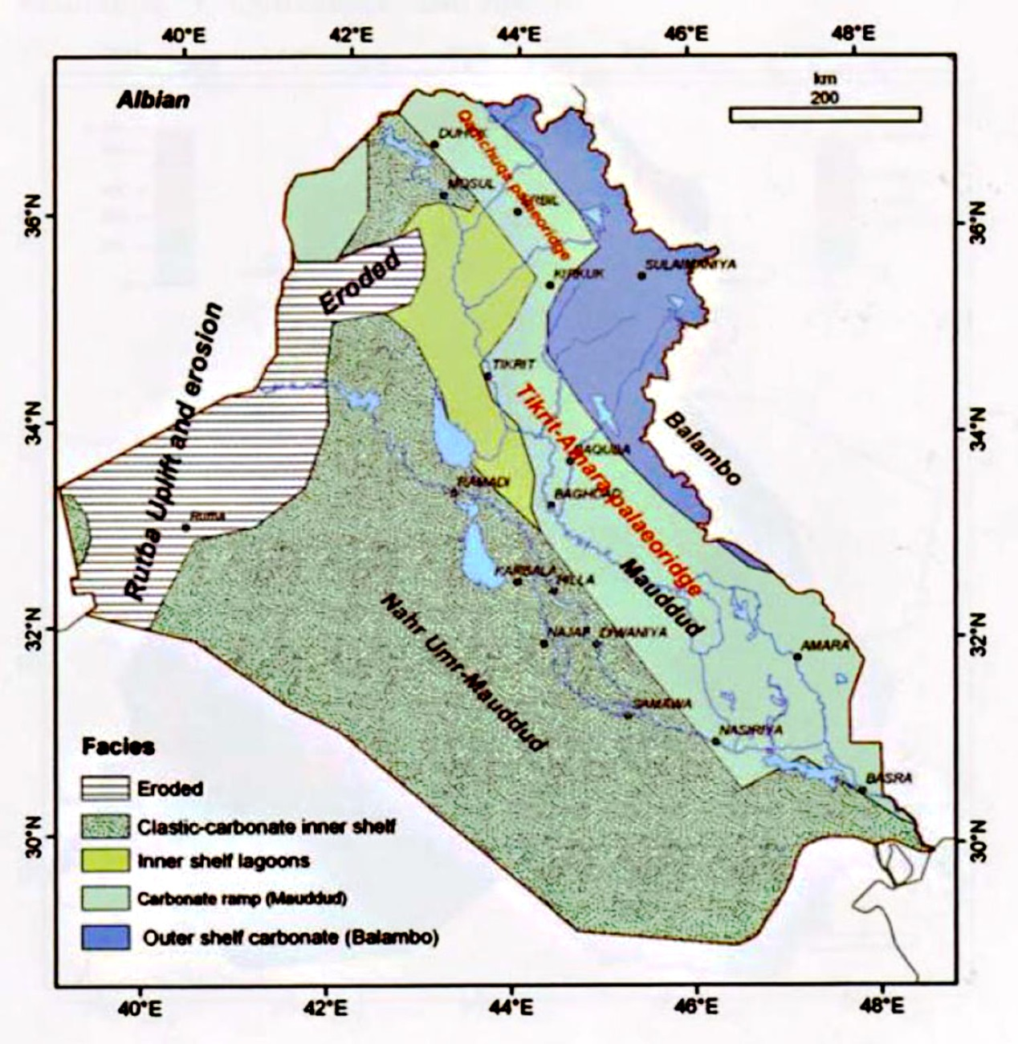
Fig 2:- Albian paleogeography map shows the depositional basin of Mauddud Formation (after Jassim and Goff 2006).

Location and Tectonic setting of study area:-
The study area (Badra oil felid) is situated in Wasit governorate,160 km south – east Baghdad, and extends across the border with Iran. Badra oil field is asymmetrical anticlinal structure located in the foreland basin of the Zagros fold and thrust belt, mainly developed during the Oligo-Miocene as an asymmetric anticline. The Badra anticline is trending NW-SE with a steeply dipping SW flank and a more gently dipping NE flank, (Al-Asadi, 2012). The area under study according to Buday and Jassim (1987) lies in two zones, Mesopotamian Zone, and Foothill Zone(Low Folded Zone). (Fig.3&4)

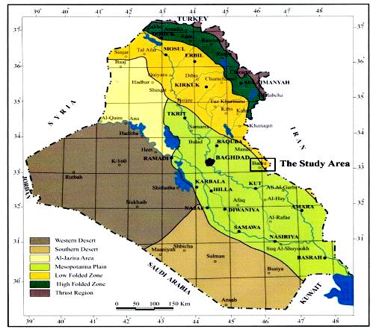
Fig 3:- Mesopotamian zone and Low Folded Zone of Iraq (after Yacoub,2011)
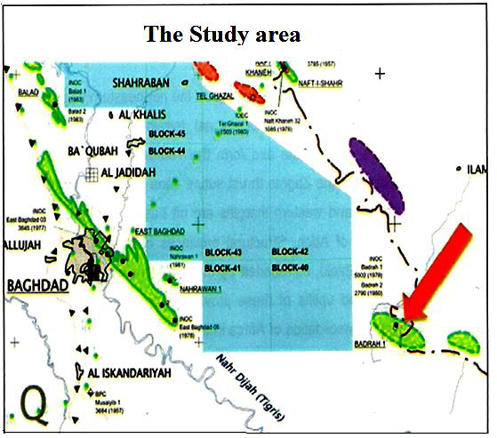
Fig 4:- Location map of Badrah Oil Field (after Al- Asadi, 2012).

Methodology
In this study the Mauddud reference section was reported from the Badra well – No.1.Studying Biostratigraphy of these wells by thin sections examination which prepared by Petroleum R &D center, these thin sections have been studied by the aid of binocular microscope in order to determine the fossils content and then estimate the age of formation
Previous studies:-
The Mauddud Formation is an important formation, therefore, there are many studies done concerning this formation.
Owen and Naser (1958), defined two wells marked fossil zones occur in the Mauddud, at Zubair well No.3 (2537.1 – 2673 meters) :
- A zone of Iraqia simplex, Beggia sp., and Praealveolina in the upper part (about 26561.1m).
- A zone of Trocholina sp. and Archaeolithothamnium sp. in the lower part (about 2640 m).
Bellen, et al (1959) mentioned that Mauddud Formation does not outcrop in Iraq until in its pinching out area near Mileh Al – Tharthar north of Awasil.
Al – Shamlan(1975), studied Microfacies analysis of the Mauddud Formation in Kuwait.
Buday (1980) mentioned that the Upper Qamchuqa which crops out in Northeastern of Iraq may be equivalent to the Mauddud Formation.
Mohammed (1981) studied the microfacies of Mauddud Formation. He studied (320) samples, collected from the subsurface sections from South and Southeastern Iraq. He concluded that the Mauddud Formation deposited under various ecological conditions.
Ibrahim (1981) stated that the age of Mauddud Formation is Albian.
Sayyab and Mohammed (1983) mentioned that The Mauddud Formation represents one of the widely distributed oil – bearing formation in the Middle East specially the Arabian Gulf area.
Sayyab and Mohammed (1985) studied the biostratigraphy of Mauddud Formation in the South of Iraq and mentioned that the identified fossils besides the lithological characters reflect basically four discriminated microfacies units. They are:
- Biomicrite rather marly rich in Favusella sp. and Hedbergella sp., which reflect deep water environment.
- Biomicrite to biosparite affected by different degrees of dolomitization and recrystallization rich in Orbitolina spp. and Trocholina spp. These parameters reflect shoal facies.
- Biomicrite to biosparite with miliolids; and this is lagoonal facies.
- Biomicrite to biomicrite with shell debris and rudist fragments and these reflect effects of open sea facies.
Shubber (1986) studied the sedimentology of Mauddud Formation in Middle and Southern Iraq. He mentioned that the petrography of Mauddud Formation affected by Digenesis processes like cementation, dolmatization, neomorphism and compaction.
Mohammed (1996) studied Orbitolinds of the Lower Cretaceous of Iraq and discriminate three biozone in Mauddud Formation, they are: Orbitolina concava, Orbitolina sefeni, and Orbitolina qataricia.
Sadooni and Alsharhan (2003) studied the stratigraphy, microfacies, and petroleum potential of Mauddud Formation. They mentioned that The Orbitolina indicate in tropical to subtropical water along shallow coast lines where the temperature would have been between 15 and 25C◦
Al-Dabbas, et al (2012) studied the depositional environment of Mauddud Formation. They said that the sedimentary microfacies of the Mauddud Formation include lime mudstone, wakestone, wakestone – packstone, packstone, packstone – grainstone, in addition to dolostone lithofacies and green shale lithofacies.
Al- Shakeri (2013) mentioned that Mauddud Member is equivalent to Lower Sarvak Formation and designated to represent the Orbitolina bearing limestone of the southern Arabian Gulf.

Biostratigraphy of Mauddud Formation in Badra well – 1
From 55 samples collected, 70 thin sections were prepared and studied by binocular microscop. The following benthic foraminifera are identified in the Mauddud Formation at Badra well – 1 (Fig 4):-
Orbitolina qatarica Henson (pl.1,Fig.1), Nezzazata simplex Omara (pl.1,Fig.2), Nezzazata conica(Smout) (pl.1,Fig.3) Quinqueloculina sp. (pl.1,Fig.4),Orbitolina sefini Henson(pl., Fig.5), Iraqia simplex(pl.1,Fig.6), Paracoskinolina sp. ,Orbitolina sp.(pl.2,Fig.1), Spiroloculina sp.(pl.2,Fig.2), Orbitolina concava Lamarck (pl.2,Fig.3) ,Mesorbitolina aperta, Triloculina sp. (pl.2,Fig.4), Volvulina sp.(pl.2,Fig.5), Conicorbitolina conica(D'Archiac) (pl.2,Fig.6), Corinoconus castarasi , Spirolectammina sp.(pl.3,Fig.1), Textularia sp., Miliolids sp.(pl.3,Fig.2),and Dictyconella sp.
In addition to the following fossils:- Rudist fragments (pl.3,Fig.3), Gastropoda (pl.3,Fig.4) and Bivalvia(pl.3,Fig.5).

The Biozone of Mauddud Formation:-
Through the detailed biostratigraphic study of Mauddud Formation, depending on the presence of benthonic foraminifera, three Biozones are distinguished. The descriptions of the biozones are manifested below:-
- Orbitolina qatarica Range Zone:-
This zone was determined with accordance of the first appearance of this species as a lower limit and the disappearance of it as the upper limit. The thickness of this zone is 150 m at Badra well – 1.

The age of Orbitolina qatarica Zone:-
This zone is of late albian age(Schoeder,1975 and Mohammed, 1996). In this study the age of this zone was determined as Albian age, some of these occurrences were recorded by number of researchers such as:
Henson (1948) limited the occurrence of Orbitolina qatarica from Early Cenomanian of Qatar, Schroeder (1962) described it from Early Cenomanian of Germany, Sampo (1969) limited O. qatarica to the Albian of Iran, Loutfi and Jaber (1970) described it from Albian of the offshore area of the Saudia – Kuwait. Also Sugden and Standring (1975) describe O. qatarica from Albian rocks of Qatar. Berthou (1984) limited it from Late Albian – Early Cenomanian of Portugal, and Late Albian of Iraq (Mohammed, 1996).

- Orbitolina sefini Range Zone:-
The lower limit of this zone is set with accordance of the first appearance of this species and its upper limit coincides with disappearance of the species. The thickness of this zone is 90m at Badra well – 1.
The age of Orbitolina sefini Zone:-
In this study the age of this zone was determined to be Late Albian depending on Schroeder,1975) who stated that this zone is located at Late Albian – Early Cenomanian boundary. Also the species Orbitolina sefini was recorded from strata belonging to Albian – Cenomanian age in each of the following countries:-
Cenomanian in Sefin Dagh from the so – called Upper Qamchuqa Formation north Iraq(Henson 1948). Albian of Mauddud Formation at south Iraq(Chatton and Hart, 1960) , Late Albian in Spian (Peybernes,1976), Early Cenomanian in Portugal (Berthou and Schroeder,1978)Late Albian – Early Cenomanian of Mauddud Formation at South Iraq ( Sayyab and Mohammed,1984),and Late Albian – Early Cenomanian of Mauddud Formation (Mohammed, 1996).

- Orbitolina concave Range Zone:-
This zone was determined with accordance of the first appearance of this species as a lower limit and the disappearance of it as the upper limit. The thickness of this zone is 120 m at Badra well– 1.
The age of Orbitolina concave Zone:-
This zone is Early Cenomanian age (Schroede, 1975), Mohammed, 1996 also determined this zone as Early Cenomanian age. In this study the age of this zone was determined Cenomanian age, some of these occurrences were recorded by number of researchers as:
(Lamarck, 1918 in Douglass 1960) define the species Orbitolina cf. concava (Lamark) for the first time in its type locality as of Cenomanian age. The species Orbitolina concava was recorded from strata belonging to Cenomanian age in each of the following countries:-
Iraq and Qatar (Henson, 1948) , Southern France (Dufaure,1959), Germany (Schroeder,1962), Switzerland, Spain and Italian (Ellis and Messina,1966), Iran (Sampo, 1969), Zagros (Sartorio and Venturini,1988), Iraq (Mohammed, 1996).
Bozorgania (1964) described Orbitolina cf. concava (Lamark) from Albian – Early Cenomanian Rocks. Loeblich and Tappan (1988) mentioned that Orbitolina cf. concava (Lamark) found in Albian – Cenomanian Rocks in France Spain and Qatar. Al-Siddiqi (1978) limited it from Late Albian – Early Cenomanian at south of Iraq.

Plate 1

- Wackestone with Orbitolina qatarica (Henson), axial section, at depth 4831m.
- Grainstone with Nezzazata simplex (Omara), Transversal section,at depth 4664m.
- Rudistone with Nezzazata conica (Smout), Transversal section, at depth 4574m.
- Grainstone with Quinqueloculina sp., Subequatorial section, at depth 4767m.
- Packstone – Grainstone with Orbitolina sefini (Henson), Oblique section, at depth 4670m.
- Packstone – Grainstone with Iraqia simplex (Henson), Transversal section, at depth 4711m.

Plate 2

- Wackestone with Orbitolia sp. (d 'Orbigy) , axial section, at depth 4672m.
- Grainstone with Spiroloculina sp., axial section, at depth 4652m.
- Wackestone with Orbitolina concava (Lamarck), axial section, at depth 4622m.
- Grianstone with Triloculina sp., Transversal section, at depth 4570m.
- Grainstone with Volvulina sp., axial section, at depth 4587 m.
- Wackestone with Conicorbitolina conica (D'Archiac), axial section, at depth 4600m.

Plate 3

- Rudistone with Spirolectammina sp., longitudinal section, at depth 4593m.
- Grainstone with Miliolids sp., axial section, at depth 4538m.
- Grianstone with Rudist fragments, at depth 4593.70m.
- Wackestone – Packestone with Gastropada, at depth 4742m.
- Packstone – Grainstone with large pelecypoda shell, at depth 4719.30m.

Plate 1

Plate 2

Plate 3

Conclusion
The Mauddud Formation in Badra well – 1 is composed of recrystallized, dolomitized in some place and foraminifera bearing limestone, occasionally sandy limestone. Fifteen genera and three biozones were distinguished (Orbitolina qatarica zone, Orbitolina sefini zone, and Orbitolina concave zone). The age of the Formation determined as (Late Albian – Cenomanian) according to these biozones of Foraminifera. Rudist fragments, Gastropoda and Bivalvia are recorded in this study but less than Foraminifera. The recommended that can be taken into consideration in future studies on the Mauddud Formation is extending this study by covering other localities.
Refrence
Al- Asadi,R.H., 2012. Badra Oil Field 3 D Seismic Interpretation Study, final report from Iraq/Ministry of Oil, Oil Exploration Company, Interpretation Department.
Al-Dabbas, M.A., Jassim, J.A., and Qaradaghi, A.I., 2012: Sedimentological and depositional environment studied of Mauddud Formation, centeral and southern Iraq. Arabian Journal of Geosciences, Volume: 5, Issue: 2, p 297 – 312.
Al-Khersan, A. Z. and Hassan, K. H., 1978. Microfacies of Cenomanian rocks in south Iraq: 10 th Arbian Petroleum Cong., Tripoli Paper139, Sec. B3, 30p.
Al- Shakeri, A.R., 2013. Microfacies, Depositional Environment and Diagenetic Processes of the Mauddud Member, in a Field in the Arabian Gulf. J Geol Geosci. V.2 Issu.2. p 1-10.
Al-Shamlan, A.A., 1975. Microfacies analysis of the Mauddud Formation in Kuwait. Al-Qabas Printing Press, Shuwaikh – Kuwait, 217p.
Al-Siddiki, A.A., 1978. Subsurface geology of southreastern Iraq: 10 th Arbian Petroleum Cong., Tripoli, Paper 141, Sec. B3, 47p.
Bellen,R.C. van, H. V. Dunnington, R. Wetzel and D. M. Morton, 1959, Lexique Stratigraphique international. v.3, Asia, fasc. 10a, Iraq, 333p.
Berthou, P. Y., 1984. Repartition stratigraphique actualisee des principaux foraminiferas benthiques du Cretace moyen et superior du basin occidental Portugais. In Oertli, H. J. (ed); Benthos 83 (2 nd International Symposium On Benthonic Foraminifera, Elf Aquitaine, Pau (France, 1983), p. 45 – 54.
Berthou, P. Y. and Schroeder, R., 1978. Les Orbitolinidae et Alveolinidae de 1 Albien superieur Cenomanien inferieur et le problem de la limite Albien/Cenomanien dans le sud – oust de la region de lisbonne (Portugal).
Bozorgania, F., 1964. Microfacies and micro – organism of Paleozoic through Tertiary sediments of some parts of Iran. Nati. Iran. Oil. Comp.,Tahran, 22p.
Buday, T., 1980. Regional geology of Iraq (Vol.1 Stratigraphy and Paleogeography) Dar Al-Kutib publishing House, Mosul, 445p.
Buday,T., and Jassim, S.Z.,1987. The regional geology of Iraq, Tectonism, Magmatism, and Metamorphism, V.2,GEOSURV, Baghdad.
Chatton, M. and Hart, E., 1960. Revision of the Tithonian to Albian stratigraphy of Iraq. INOC inter.rep. No. 1/141, 62(2374), Baghdad.
Ditmar, V., Kurenkov, N. T., Mohonkov, O. M., Hassan, K., Kaddouri, N., and Al-Haba, Y. K., 1972. Geological condition and hydrocarbon prospects of the Republic of Iraq Vol. 11 South Iraq. Technical report, INOC library, Baghdad.
Douglass, R. C., 1960. Revision of the family Orbitolinidae. Micropal., V. 6, no. 3, pp. 249 – 270.
Dufaure , P., 1959. Proplémas stratigraphiques Dans Le Crétace Supérieur Des Pays De Bigare Et De Comminges. Rev. Micropal., V.2, no. 2, pp. 99 – 112.
Ellis, B. F. and Messina, A. R., 1966. Catalogue of Index Foraminifera. New York, Amer. Mus. Nat. Hist., Spec. Publi., V.2.
Henson, F.R.S., 1948. Larger Imperforate Foraminifera of Southwest Asia, Families Lituolidae, Orbitolinidae, and Meandropsinidae. Brit. Muse. (Nat. Hist.), London, V-XI, 127 p.
Ibrahim, M.W., 1981. Lithostratigraphy and subsurface geology of the Albian rocks of south Iraq, Journal of petroleum geology, 4, 2, p 147 – 162.
James, C. A., and Wynd, 1965. Stratigraphic nomenclature of Iranian oil consortium agreement area: AAPG. Bull, V.49, p.835 – 870.
Jassim, S.Z., and Goff, J.C., 2006. Geology of Iraq, Dolin, Prague and Moravian Museum, Brno, 337p.
Leoblich, A. R. and Tappan, H., 1988. Foraminiferal genera and their classification. Van Nostrand Reinhold Comp., New York, 970p.
Loutfi, G. and Jaber, A. S., 1970. Geology of Upper Albian – Campanian succession in the Kuwait – Saudia Arabia neutral zone, offshore area. 7 th Arab Petrol. Congr., p. 1 – 14.
Mohammed, M. U., 1981. The microfacies of Mauddud Formation. Unpubl.M.Sc. Thesis, University of Baghdad, 61p.
Mohammed, M. U., 1996. Orbitolinids (Foraminifera) of the Lower Cretaceous (Barremian – Turonian) of Iraq, Unpubl.Ph.D. Thesis, University of Baghdad, 144p.
Naqib, K. M., 1967. Geology of the Arabian Peninsula, southwestern Iraq: U.S. Geol. Survey Prof. Paper, 560 – G, 54p.
Owen, R.M.S., and Nasr,S.N.,(1958).The stratigraphy of Kuwait – Basrah area. In Habitat of Oil-A Symposium, Spec. Publ. AAPG, p1252 – 1278.
Peybernes, B., 1976. Le Jurassique et le Cretace inferieur des Pyrenees franco – espagnoies entre la Garonne et al Mditerranee. These Doct. Toulouse, 459p.
Riché, P. and Prestat, B., 1980. Paleogeographie du CretaceMoyen du petroche et Moyen – Orient et sa signification petroliere: 10 th World Petroleum Cong., Prpc., V.2, p. 57 – 75.
Sadooni,F.N. and Alsharhan,A.S.,2003. Stratigraphy, microfacies , and petroleum potential of the Mauddud Formation (Albian – Cenomanian) in the Arabian Gulf basin. The American Association of petroleum geologists bulletin, V.87, No.10, p1633 – 1680.
Sampo, M., 1969. Microfacies and microfossils of the Zagros area, southwest Iran (from pre – Permian to Miocene). Inter. sed. petrograph. Ser.(E.J.Brill edit.), Leiden, 12,102p.
Satorio, D. and Venturini, S., 1988. Southern Tethys biofacies. Agip S.p.A., S. Donato Milanese, Italy, 236p.
Sayyab, A., 1966. Prospects of stratigraphic oil accumulation of the Upper Jurassic to Middle Cretaceous rocks of Southern Iraq. Bull. Coll. Sci., Baghdad, V.9, pp. 137 – 145.
Sayyab, A. and Mohammed, M. U., 1984. The age of the Mauddud Formation in south Iraq. Iraqi J. Sci. V.25, nos. 1 – 2, pp. 47 – 55.
Sayyab, A.S., and Mohammed, M.U., 1985. Biostratigraphic study of some subsurface sections of Mauddud Formation (south of Iraq). Iraqi. Sci., V.26, p 45 - 67.
Schroeder, R., 1962. Orbitolines des Cenomans sudwesteuropas. Pal. Zeitscher., Stuttgart, Germany, V.36, no. 3 – 4, pp. 171 – 202.
Schroeder, R., 1975. General evolutionary trendsin orbitolinas. Riv. Esp. Micropal., Madrid,num. spec., p 117 – 128.
Shubber, B.A., 1986. Sedimentology of Muddud Formation in middle and southern Iraq. Unpubl M.Sc. Thesis, University of Baghdad, 104 p.
Smout, A. H., 1956. Three new Cretaceous genera of Foraminifera related to the Certaobuliminidea: Micropaleontology, V.2, p.S 335 – 348.
Sugden, W., and Strandring, A. J., 1975. Qatar: Lexique Stratigraphique Internat., V.II, Asie, Fasc. 10b3, 120 p.
Yacoub, S.Y., 2011. Geomorphology of the Mesopotamia plain. Iraqi Bull. Geol. Min. special Issue, No.4: Geology of the Mesopotamia Plain,p(7 – 32).

