Buckling Columns Resistenes Using Liquid Nitride Case Hardening Method.

jamal mohammed hamed
Materials Engineering/ University of Technology
Energy and Renewable Energies Technology Center
jamal_hamed2001@yahoo.com
Abstract
In this research buckling of circular columns under different dynamic loads is investigated by using analytical and experimental approaches. Carbon steel columns (C35)of different slenderness ratio were studied .In this work Liquid nitriding method was used to improve the buckling resistance of materials. The present study showed experimentally that the use of nitride case hardening increase the buckling resistance and improve the number of failure cycles ,for Steel a number of failure cycles increased from(2.6)to(4.1)cycle. The results also showed that the thickness of nitride case hardening (28 – 45) micron play an important factor in buckling resistance .
Keywords: buckling, liquid nitriding, chemical treatment, surface hardening
ألخلاصة
فى هذا البحث تم دراسة تاثير استخدام التصليد السطحي بالنتردة السائلة على مقاومة الاعمدة الدائرية للاانبعاج تحت تأثير احمال ديناميكيه باستخدام وتحليل التجارب العملية للانبعاج. استخدمت عينات من سبيكة الصلب (C35) بنسب نحافة مختلفة, أظهرت النتائج العملية بأن أستخدام ألتصليد السطحي بالنتردة السائلة قد زاد من مقاومة الاعمدة للانبعاج, فضلا من تحسينه عدد الدورات قبل الفشل من(2.6 (الى )4.1). اظهرت النتائج ايضا ان سمك طبقة النترده والذي يتراوح مابين (28 – 45) مايكرون يعتبر احد العوامل المهمة لزيادة مقاومة المعدن للانبعاج .
الكلمات المفتاحية: الأنبعاج ، النتردة السائلة ، المعاملات الكيميائية ، التصليد السطحي.
Introduction
Stability is a fundamental problem of solid mechanics whose solution determines the ultimate loads at which structures fail or deflect excessively. The evolution of the theory for a long time was focused on elastic structures for which the loss of stability is the primary case of failure the material strength having little or no relevance.Interest gradually expand to inelastic structure where stability loss and material failure are intertwined due to plastic behavior and creep. [ZP.Bazant,2000]
Load – carrying structure may fail in a variety of ways, depending on the type of structure,the conditions of support, the kinds of loads and the materials used. Buckling can occur when the induced stress is compressive, torsion or shear may cause a localized compressive action that could lead to buckling. [Edwad,1983]
A study of buckling is important because this failure type reduces the load-carrying capacity of a member in compression and buckling is one of the major causes of failures in structures and therefore the possibility of buckling should always be considered in design.
Buckling has become more of a problem in recent years because collapse is unexpected and there are a few warning signs, failure can be sudden and catastrophic. In some cases there has been loss of life because of the sudden collapse. [Hibbeler,2005]
Aircraft fuselage and launch vehicle fuel tanks are some of the many applications of these structures in aerospace and aircraft industries. [Samuel,2002]
dynamically loading of column's is still an important subject because of the subject is evident from the history of structure collapse case by neglected or misunderstanding of the aspects of design and also because of its relevance to a wide range of engineering applications .In view of many studies supplied by others one can see that the tools to increase the critical load buckling has not been studied thoroughly,also these studies just produce a formulas for critical load of perfectly straight members, which does not offer helping hand in the assessment of member in practical situations for a given loads. There is a need for ways to improve the buckling resistance of materials and an analyses type as simple and conveniently arranged as possible.The present study tries to determine a tool to raised a critical buckling load and increase safe life of circular columns under dynamic loads .Also the present study tries to develop a general approach to investigate the actual work which resist buckling.
Structural efficiency is a primary concern in today's aerospace and aircraft industries. Due to the geometry of these structures, buckling is one of the most important failure criteria. This brings about the need for strong and light weight materials .A great amount of work has been done in this area of instability problems. Structures made of composite materials are widely used in the above mentioned industries.[Raven,2006].A structural designer has not only to guarantee that the structural to be built is safe to use, but also take (economical, environmental and architectural) aspects into account.
The structural designers were provided with a possibility to design more slender structures than before. However; making the structural members more slender in order to minimize the use of material (dead weight and economy) the designers also pay an attention to possibility of buckling.
The designer has a couple of tools to use to make their structure perfect with respect to the aspects of safety, economy architecture and environment.
This work tries to show the resistance of circular column buckling subjected to dynamic loading, by using a liquid nitride tool, to improve the properties of steel column structures.
Buckling of Column
A column is a structural member that carries an axial compressive load and that tends to fail by elastic instability, or buckling. Column slenderness greatly influences a column's ability to carry load, most columns failure occurs at a lower level than the column's material strength because most are relatively slender (long in relation to their lateral dimension) and fail due to buckling (lateral instability).
Buckling is the sudden uncontrolled lateral displacement of a column ,at which point no additional load can be supported .Elastic instability is the condition of failure in which the shape of the column is insufficiently rigid to hold it straight under load.
At the point of buckling, a redial deflection of the axis of the column occurs suddenly then if the load is not reduced, the column will collapse.
Columns are divided into two or rather three categories, i.e. short columns, long columns, and columns of intermediate length. The load capacity of a slender column is directly dependent on the dimension and shape of the column as well as the stiffness of the material(E),but is independent of the strength of the material (yield stress).The ratio of the length of a column to the least radius of gyration of its cross section is called the slenderness ratio which is a primary indicator of the mode of failure one might expect for a column under load. High slenderness ratios mean lower critical stresses. [James,2004]
The buckling behavior of slender columns within their elastic limit, was first investigated by a Swiss mathematician Leonhard Euler (1707- 1783). Euler's equation presents the relationship between the loads that causes buckling of a pinned end column. The critical buckling load can be determined by the equation: [John,1999]
P${}_{\text{critical}}$=$\frac{π^{2}\text{EI}}{L^{2}}$ ---------------- (1)
p${}_{\text{critical}}$=critical axial load that causes buckling in column.
E=modulus of elasticity of the column material
I=smallest moment of inertia of the column cross section.
L=column length between pinned end.
Another useful form of the Euler equation can be developed by substituting the radius of gyration for the moment of inertia which is a shape factor that measures a column's resistance to buckling about an axis
r= $\sqrt{\frac{I}{A}}$ and $I={\text{Ar}}^{2}$
where: r=radius of gyration of the column cross section (mm).
I=least (minimum) moment of inertia (mm${}^{4}$),
A=cross –sectional area of the column (mm${}^{2}$).
The critical stress developed in a long column at buckling can be expressed as:
$σ_{\text{cr}}=\frac{π^{2}E({\text{Ar}}^{2})}{{\text{AL}}^{2}}=\frac{π^{2}E}{(Lr)^{2}}−−−−−−−−−(2)$
Where: ($\frac{L}{r})$=is known as the slenderness ratio.
The effective length (L${}_{e}$) for any column is the length of the equivalent pinned – end columns. So, general formula for critical loads can write as follows:
P${}_{\text{cr}}=\frac{π^{2}\text{EI}}{L_{e}}−−−−−−−−−−−(3)$
The effective length is often expressed in terms of an effective length factor (K):
L${}_{e}=\text{KL}$
Where ( L) is the actual length of the column . Thus the critical load is:
P${}_{\text{cr}}=\frac{π^{2}\text{EI}}{(\text{KL})^{2}}−−−−(4)$
It is convenient to classify columns into three broad categories according to their modes of failure as
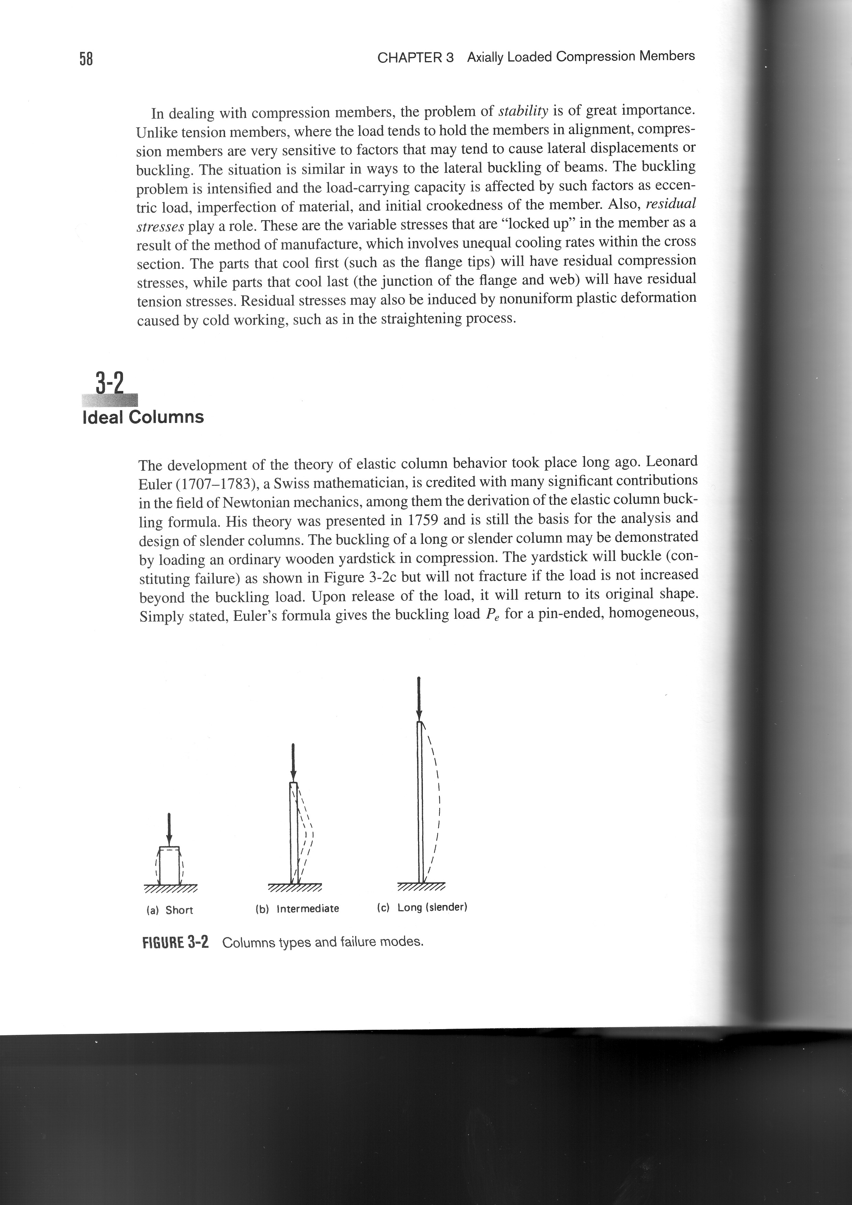
Fig .1 Columns Types and Failure Modes. [Leonard Spiegel,2002]

Buckling, where buckling occurs at compressive stresses within the elastic range are called long columns. A very short and stocky column will obviously not fail by elastic buckling, it will crush owing to general yielding and compressive stresses will be in the inelastic range, these columns are called short columns. A column that fails between these two extremes, will fail by inelastic buckling .This type of column is called an intermediate column. Its failure strength cannot be determined by using either the elastic buckling criterion of long column or the yielding criterion of the short column. Intermediate column fail by a combination of crushing (or yielding) and buckling .There is an estimation of slenderness for the slenderness ratio which eliminates the column types such as (long, intermediate, and short) table (1)
[AL- Jubori Kifah,2005].
Table (1); Column’s Slenderness Ratio (S.R= Le/r) [AL- Jubori Kifah,2005]
Intermediate column (Inelastic stability limit) | Material | Short column (strength limit ) | Long column (Elastic stability limit)
40<S.R<150. | Structural steel | S .R<40 | S.R>150
The critical load for elastic buckling is valid only for relatively long columns .If the column is of intermediate length ,the stress in the column will reach the proportional limit before buckling begins .To calculation critical loads in the intermediate range we need a theory of inelastic buckling .
Tangent –Modulus Theory (proposed by Engesser in 1889)
Consider an ideal pinned-end column subjected to an axial force (p) [fig.2].The column is assumed to have a slenderness ratio () that is less than the critical slenderness ratio and therefore the axial stress reaches the proportional limit before the critical load is reached.
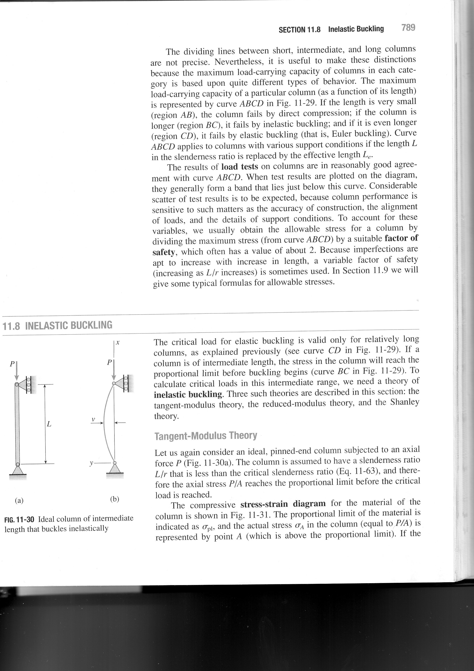
(Fig 2) Ideal Column for Intermediate Length That Buckles In elastically [James,2004]
The compressive stress-strain diagram for the material of the column is shown in (fig.3).The proportional limit of the material is indicated as ( σ${}_{\text{pl}}$) and the actual stress ( σ${}_{A}$) in the column is represented by point (A) which is above the proportional limit. if the load increased so that a small increase in stress occurs ,the relationship between the increment of stress and the corresponding increment of strain is given by the slope of the stress-strain diagram at point (A).This slope equal to the slope of the tangent line at (A),is called the tangent modulus and is denoted by (E${}_{t}$)
Thus E${}_{t}=\frac{dσ}{dε}$ (5)
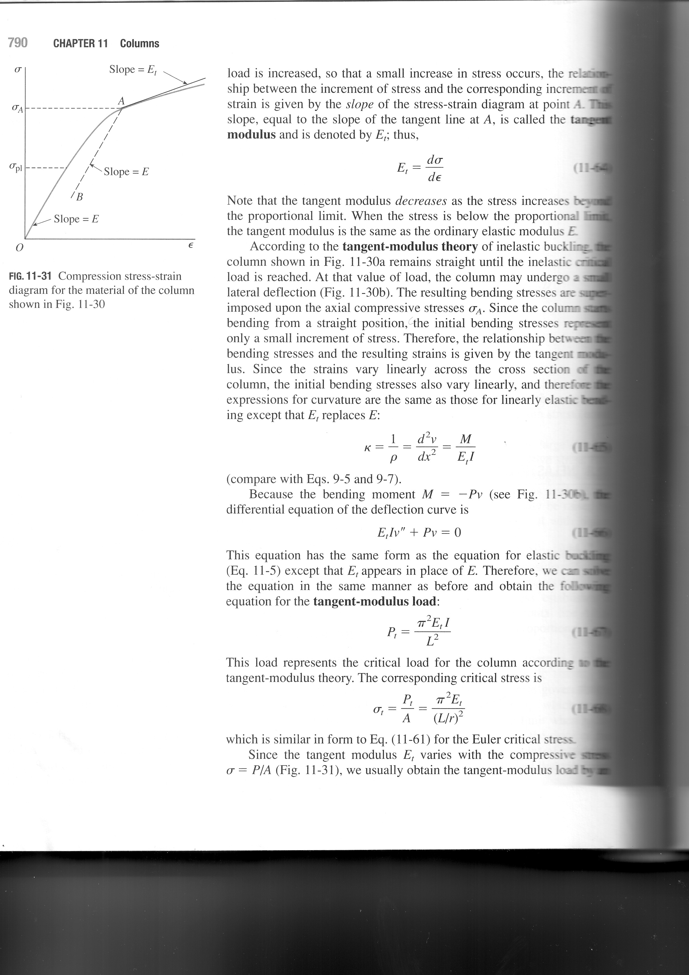
Fig(3) Compression Stress-Strain Diagram. [James.M.Gere,2004]
Note that the tangent modulus decreases as the stress increase beyond the proportional limit.When the stress is below the proportional limit the tangent modulus is the same as the ordinary elastic modulus (E).Since the column starts bending from a straight position, the initial bending stresses represent only a small increment of stress. therefore the relationship between the bending stresses and the resulting strains is given by the tangent modulus,and the equation has the same form as the equation for elastic buckling except that (E${}_{t})$ appears in place of (E).therefore, we can solve the equation in the same manner and obtain the following equation for the tangent –modulus loads.[William,1998] .

F${}_{\text{cr}}=\frac{π^{2}E_{t}I}{L^{2}}−−−−−−−−−−−−−−(6)$ The corresponding critical stress is
7) σ${}_{\text{cr}}=\frac{π^{2}E_{t}}{(\frac{L}{r})^{2}}−−−−−−−−−−−−−−−−($

Experimental work
The objective of this experimental portion of this study is to investigate the failure of circular column with and without nitriding case hardening for carbon steel and to presents the testing description by using a Test –Rig which mainly consists compression system measurement were also made using different types of equipment. The dimensions, mechanical properties and chemical composition of the test specimens are also described. The mechanical properties and chemical composition of the (C35) steel is shown in tables (2) and (3) respectively.
All the materials were received from a state company from mechanical industries Al–Ascandaryah and tested to obtain its chemical compositions in state company of Geological survey and mining. The specifications of tensile test for the materials used in this research has been restricted according to the German specifications ASTM(A370).

Table(2) The mechanical properties of C35
E Gpa. | Elongation% | ult .Mpa σ | y Mpaσ | Alloy
215 | 25 | 608 | 468 | C35

Table (3) Chemical composition of the Steel used
Chemical composition (W_{t}%)
Pb | S | Si | Mn | C | steel
0.035 | 0.035 | 0.2 | 0.6 | 0.45 | standard | C35  Din 50114
0.035 | - | 0.15 | 0.5 | 0.39 | experimental | C35  Din 50114

The specimens having different length to radius ratio as shown in table (4) to obtain a different slenderness ratios (L_{e}/r) to simulate the (short, intermediate, and long) buckling specimens behavior.
Table (4) Slenderness Ratios for Buckling Specimens
Type of column | S.R | Le | L(mm) | item
short | 35  38 | 70  77 | 100  110 | 1  2
Intermediate | 70  126  140  147 | 140  352  280  294 | 200  360  400  420 | 3  4  5  6
long | 161  168  175 | 322  336  350 | 460  480  500 | 7  8  9

Liquid Nitriding:
Nitriding is a surface treatment that introduces nitrogen into the work piece surface at a temperature of (510–580)C⁰,(950–1075)F⁰ at which the steel is in the ferrite condition. Because the nitriding occurs with the steel at temperature less than AC1, a quench to transform the austenite to the martensite is not required, This in turn reduces greatly the distortion and the development of the residual stresses in the work piece. Liquid nitriding (nitriding in a molten salt bath) employs the same temperature range as gas nitriding, that is (510–580)C⁰ the case–hardening medium is a molten nitrogen,fused–salt bath containing either cyanides or cyanides. Unlike liquid carburizing and cyaniding,which employ baths of similar compositions,liquid nitriding is subcritical (that is below the critical transformation temperature). [Wriggers,2007]
Liquid nitriding procedure used in research:
Specimens must be carefully cleaned to remove the oxide, moisture and oil before, by using (5– 10)% HCL solution before taking it to another furnace containing a nitriding salt of sodium and potassium salts with (NH₄CL) as a catalyst to produce the atomic nitrogen. This procedure repeated for different intervals of time (30min, 60min,90min) to get a different thickness of case hardening. After that , the specimens are taken out of the furnace and cooled by air.
Microstructure Examination:
The metallographic samples preparation seeks to find the true structure of the specimens. Grinding, polishing are used to preparing the samples for examination. Abrasive particles are used in fines steps to remove materials from the samples surface. The specimens are successfully ground with fines and fines abrasive media, silicon carbide sand paper are used. After grinding the specimen polishing is performed by a suspension of alumina on a hapless cloth to produce a scratch free mirror finish. After polishing certain microstructural constituents can be seen with the microscope by using a chemical etchant. The microscope optical type, of E plan (40xo.65) used to get the microstructures for different materials with and without nitriding case hardening.
The Test-Rig:
Fig. (4) shows the schematic diagram of the whole test –rig used in this work, the compression system includes a manual hydraulic pump with maximum pressure up to (350 bar).A screwed shaft is used to transfer the pressure from the hydraulic pump to the jaw which supports the specimen. The test rig consists of an electrical motor of (0.5 KW)with (17–34)rpm and it gives motion in two different directions clockwise and counter clockwise, A cycle – counter (indicating the total number of cycle) is fixed on the front of the control plate. The recording digits are (99999.9) which refers to the number of cycles during the test. The number of cycles to failure are recorded from the speed counter (N_{F}).

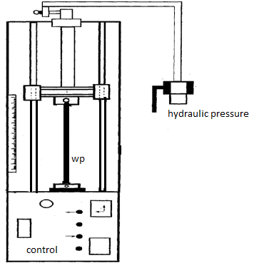
(Fig. 4) shows the schematic diagram of the whole test –rig
Table (5) the Direct Recorder Experimental Data for (C35) Steel
Item. | S.R | δ_{in}(mm)  Initial deviation | δ_{cr}(mm)  Critical deviation | Nf(cycle)  Number of cycle | F_{comp.}(N)  Compration stress
1  2 | 35  38 | 0.4  0.2 | 2  2.3 | 3.2  2.8 | 21209  19792
3  4  5  6  7 | 70  126  140  147  161 | 0.8  0.35  0.5  0.45  0.5 | 3.2  4.6  5  6  5.7 | 2.6  1.6  1.4  1.2  1 | 16369  7663  6972  4923.7  4298
8  9 | 168  175 | 0.7  0.75 | 7.3  7.2 | 0.9  0.7 | 3165  1474

Determination of buckling load using liquid nitriding Case Hardening:
Experimental result for a circular column of slenderness ratio (S.R = 70) and different case hardening see tables (6,7) lead to the true that the buckling load was observed to increase linearly with increase in nitride thickness this means that the nitride thickness an important factor to resist buckling ,as we know the load capacity of slender column is directly depended on the dimension and shape of the column as well as the stiffness of material and because of all the specimens used in tables(6,7) have the same area and slenderness ratio therefore the only factor improve is stiffness of material and it was increased .
Table (6)Shows the Experimental Results for Columns of (C35) Without Hardening.
F(N)comp. | Nf(cycle) | δcr | δin | S.R
16369 | 2.6 | 3.2 | 0.8 | 70 | C35
Table (7) Experimental Results for Case Hardened Steel (C35) Column of (S.R=70).
Nf(cyc.) | Fcomp.(N) | δcr mm | $$δ_{0}\text{mm}$$ | t(µm) | material
2.5 | 19421 | 3.9 | 0.37 | 28 | C35
2.8 | 21355 | 4.2 | 0.35 | 39 | C35
4.1 | 22650 | 4.3 | 0.4 | 46 | C35
Table (6,7) also showed that the number of failure cycles recorded experimentally from the test rig for circular column steel with nitride case hardening is more than the same material without nitride that’s means, using nitride case hardening also improves cycles to failure, the measurement are tested by dial gauge..
Conclusions
The conclusions that were drawn from this study are as follows:
1-The present study showed experimentally that the use of nitride case hardening increase buckling resistance.
2-The comparison of the experimental results with and without nitride case hardening showed that Using the nitride case hardening increase number of failure cycles.
3-The results showed that the thickness of nitride case hardening play an important factor in buckling resistance,i.e. when thickness increase the buckling resistance also increase.
4-The initial deflection of the columns has an important effect on the number of cycles of failure.
References
AL-Jubori, Kifah, Hameed, March 2005,"Column Lateral Buckling Under Combined Dynamic Loading "PhD. Thesis ,University of Technology ,Technical Education Department.
Bazant, Z.p.,2000,"stability of elastic, inelastic, and distintegrating structure", Appl . Math. Mech.
Edwad, F. Byars ,Robert D. Snyder, Helen L.Plants,1983,"Engineering Mechanics of Deformable Bodies" Harper &Row publishers ,New Yourk.
Hibbeler, R.C., 2005,"Mechanics of materials", 2${}^{\text{nd}}$ Ed.,Prentic Hall.
James, M. Gere,2004,"Mechanics of Material ", 6th Ed. ,Thomson Learning Academic Resource Center, U.S.A.
John Case, Lord Chilver ,Carl T.F. Ross,1999,"Strength of Materials And Structures , John Wiley & Sons Inc. ,4th Ed. ,London.
Leonard Spiegel,George F.Limbrunner,2002,"Applied Structural steel Design",4th Ed., Prentic Hall.
Raven, W.J.,2006,"New vision on flexural torsional buckling stability and strength of structural member " doctoral thesis ,Delft.
Samuel,Kidane,2002,"Buckling Analysis of Grid Stiffened Composite Structures "Master Thesis August Louisiana State University, Agricultural and Mechanical college.
William,A.Nash,1998,"Theory And Problem Of Strength of Materials",4th Ed., McGraw –HALL.
Wriggers,P. and chavan, K.,2007,"Beam and shell elements for thin–walled aluminum structures " foundations of vivil and environmental engineering.

