Analytical Studies of Multi-Levels Framelet Transform
for Image Compression

Mithaq N. Raheema Hassan M. Azzawi
Department of Electrical and Electronic Engineering
University of Technology
mithaqnama76@yahoo.com Eng.hasan.mahmood@gmail.com
Abstract:
Many recent studies showed that the wavelet transform step consumes a long computing time during image compression process. Also, to obtain high CR, multiple transform levels must be applied. This paper examines the properties and design of multilevels framelet for image compression applications. This work is focused on high CR obtained, with minimally perceptible loss in image quality, at the multi-levels of transforms. The programming language MATLAB is used for implementing the proposed algorithm. Simulated results show that there are a suitable number of levels of transforms based on the nature of image. Higher subbands of framelet decomposition can be eliminated for saving in computing and communication energies. At higher levels of transform, these subbands are being of large effects to improve the image quality, if there are used, at higher CR.
Keywords: Image compression, Framelet transform, Image quality measurements, Multi-level double density.
الخلاصة:
بينت العديد من الدراسات الحديثة أن استخدام التحويل المويجي يستهلك وقت حساب طويل خلال إجراء ضغط الصور .كذلك يجب تطبيق التحويل متعدد المستويات للحصول على نسبة ضغط عالية. يختبر هذا البحث خصائص وتصميم التحويل المويجي متعدد المستويات لتطبيقات ضغط الصور. يركز هذا العمل على الحصول على نسب الضغط العالية مع أقل خسارة محسوسة في جودة الصورة عند مستويات التحويل المتعددة. تم استخدام لغة البرمجة MATLAB لتنفيذ المخطط المقترحة. بينت نتائج المحاكاة أن هنالك عدد محدد من مستويات التحويل يعتمد على طبيعة الصورة الراد ضغطها. يمكن استبعاد التحليلات الفرعية العالية من التحويل المويجي من أجل توفير طاقات الحساب والمواصلة. ولكن هذه التحليلات الفرعية تصبح ذات تأثير كبير في تحسين جودة الصورة إذا ما أُستُخدِمت في مستويات التحويل العالية للحصول على نسب ضغط كبيرة للصورة.
الكلمات المفتاحية: ضغط الصور، Framelet تحويل، وقياسات جودة الصورة، كثافة مزدوجة متعددة المستويات.

1. Introduction:
A wide range of applications in visual communication requires efficient image compression to fit a large amount of visual data into the narrow bandwidth of communication channels while keeping the visual quality of images acceptable [Jian,2010]. Discrete Wavelet Transform (DWT) has attracted widespread interest as a method of information coding [Kumar,2008].The multi-resolution aspect of wavelets and the flexibility to analyze signals both in time and frequency have enabled their use in a vast number of areas from medical imaging to information security [Sushil,2010]. Joint Photographic Expert Group (JPEG) has developed a new wavelet-based image compression standard, commonly referred to as JPEG 2000.Image compression algorithms using DWT are available in the literature [Sonja, 2001; Sachin, 2005, Kharate, 2005; Vijendra, 2009]. Recent works consists of techniques to eliminate computation of certain high-pass coefficients of the decomposed image from wavelet in order to reduce both computation and communication energies [Anoop,2009].In this work, the redundant information, available in the lower coefficient LL subband of the Double Density DWT (DDDWT),or as called framelet, decomposed image will be explored for further compression with an elimination of the higher subbands.

2. Why Image Compression?
Computers cannot handle continuous images but only arrays of digital numbers. Thus it is required to represent images as two-dimensional (2D) arrays of points. A point on the 2D grid is called a pixel [Bernd, 2005].
Image ﬁles tend to be large. To investigate the amount of information used in a 512*512 binary image, the number of bits P used in this image is:
P = 512 * 512 *1(bit)=262,144 bits=32768 bytes≈0.033Mb …… (1)
A greyscale image of the same size requires:
P=512 * 512 *1(byte) = 262,144 bytes ≈ 0.262Mb ……(2)
In the color images, each pixel is associated with 3 bytes of color information. A 512*512 color image thus requires:
P=512 * 512 * 3(byte) = 786,432 bytes ≈ 0.786Mb ……(3)
Many images are of course such larger than this. Multiresolution algorithms process less image data by selecting the relevant details that are necessary to perform a particular recognition task. It is thus important for reasons both of storage and ﬁle transfer to make these ﬁle sizes smaller, if possible.
3. Image Compression Schemes:
Image compression reduces the amount of data required to represent an image by removing redundant information. An image compression system consists of an encoder that exploits one or more of the redundancies to represent the image data in a compressed manner, and a decoder that is able to reconstruct the age from the compressed data. The compression can either be lossless or lossy. Lossy encoding for images is usually obtained using transform encoding methods. Transform domain coding is used in images to remove the redundancies by mapping the pixels into a transform domain prior to encoding. The mapping is able to represent image information containing most of the energy into a small region in the transform domain requiring only a few transform coefficients to represent. For compression, only the few significant coefficients must be encoded [Ananda,2009].
In the JPEG image compression algorithm, the input image is divided into 8-by-8 or 16-by-16 blocks, and the 2D Discrete Cosine Transform (DCT) is computed for each block. The DCT coefficients are then quantized, coded, and transmitted. The JPEG receiver (or JPEG file reader) decodes the quantized DCT coefficients, computes the inverse 2D DCT of each block, and then puts the blocks back together into a single image. For typical images, many of the DCT coefficients have values close to zero; these coefficients can be discarded without seriously affecting the quality of the reconstructed image.DCT was the major compression technique in earlier JPEG compression techniques. Wavelet transform replaced the DCT in the JPEG 2000 and also found to be better option than DCT in terms of embedding capacity and robustness [Muttoo,2010].
In DWT, the decomposition coefficients are corresponded to vertical high frequencies (horizontal edges), horizontal high frequencies (vertical edges), and high frequencies in both directions (corners). Regions where the image intensity varies smoothly yield nearly zero coefficients. The large number of nearly zero coefficients makes it particularly attractive for compact image coding.
4. Image Quality Measure:
The image quality can be evaluated objectively and subjectively. Objective methods are based on computable distortion measures. Standard objective measures of image quality are Mean Square Error (MSE) and Peak Signal-to-Noise Ratio (PSNR) which are defined as [Ananda, 2009]:
2
……(4)
And
PSNR=20*log10(255/sqrt(MSE)) ……(5)
Where I(x,y) is the original image, I'(x,y) is the approximated version (which is actually the decompressed image) and M,N are the dimensions of the images. MSE and PSNR are the most common methods for measuring the quality of compressed images.
The compression efficiency is defined by the parameter Compression Ratio (CR) and is given by [Ananda,2009]:
CR=Original Data/Compressed Data …….(6)
5. Framelet transform based image compression:
The Double density Discrete Wavelet Transform (DDDWT) proposed by Ivan W. Selesnick [Kannan,2010]. The three-channel filter bank used to develop it corresponds to a wavelet frame based on a single scaling function and two distinct wavelets functions. To use the DDDWT for 2D image processing, it is necessary to implement a 2D analysis and synthesis filter bank structure [Kannan2010]. In DDDWT, the analysis filter bank consists of a low pass H_{o}(z₁) and two high pass filters H₁(z₁) and H₂(z₁) at each decomposition stage. When an image passes through these filters, it is split into three bands. The low pass filter, which corresponds to an averaging operation, extracts the coarse information of the image. The high pass filters, which correspond to a differencing operation, extract the detail information of the image. The output of the filtering operations is then decimated by two.
A 2D-DDDWT can be accomplished by performing two separate one-dimensional transforms. First, the image is filtered along the rows of the image using low pass and two high pass analysis filters and decimated by two. Low pass filtered coefficients are stored on the left part of the matrix and the two high pass filtered on the middle and right. Then, it is followed by filtering the sub-image along the columns by H_{o}(z₂) H₁(z₂) and H₂(z₂) filters and decimated by two. Thus, the image, after one level of decomposition, is split into nine bands denoted by LL, LH₁, LH₂, H₁L, H₁H₁, H₁H₂, H₂L, H₂H₁ and H₂H₂, as shown in Fig (1).
5.1. Multi-Level Double Density Decomposition:
In the second level, the LL band is further decomposed into nine bands. The same procedure can be continued for further decomposition levels, with successive approximations being decomposed in turn, so that one image is broken down into many lower resolution components. This can be called as framlet decomposition tree as shown in the left side of Fig. (2).

3

H₀(Z₁)
↓2
H₀(Z₂)
↓2
H₁(Z₂)
↓2
H₂(Z₂)
↓2
H₁(Z₁)
↓2
H₀(Z₂)
↓2
H₁(Z₂)
↓2
H₂(Z₂)
↓2
H₂(Z₁)
↓2
H₀(Z₂)
↓2
H₁(Z₂)
↓2
H₂(Z₂)
↓2
LL
H₁L
H₂L
LH₁
LH₂
H₁H₁
H₂H₁
H₁H₂
H₂H₂

Fig. (1) An oversampled framelet filter bank for 2D images [Ivan2001].
Compressed Image
Reconst-ructed
Image
↑2+H₂(Z)

↑2+H₁(Z)

↑2+H_{o}(Z)
↑2+H₂(Z)

↑2+H₁(Z)

↑2+H_{o}(Z)
H₂(Z) +↓2

H₁(Z) +↓2

H_{o}(Z) +↓2
H₂(Z) +↓2

H₁(Z) +↓2

H_{o}(Z) +↓2
H₂(Z) +↓2

H₁(Z) +↓2

H_{o}(Z) +↓2
Input
Image
↑2+H₂(Z)

↑2+H₁(Z)

↑2+H_{o}(Z)

Fig. (2) Multilevel framelet transforms tree: left) decomposition and right) reconstruction

5.2. Framelet Reconstruction:
This work studied how the DDDWT can be used to analyze, or decompose, images. This process is called decomposition or analysis. The other half of the process is how those components can be assembled back into the original image without (or with acceptable) loss of information. This process is called reconstruction, or synthesis. The mathematical manipulation that affects synthesis is called the inverse DDDWT. To synthesize an image in the framelet transform, one reconstructs it from the framelet coefficients. Where framelet analysis involves filtering and downsampling, the framelet reconstruction process consists of upsampling and filtering as shown in the right side of Fig. (2).
5.3. Number of Levels:
Since the analysis process is iterative, in theory it can be continued indefinitely. In reality, the decomposition can proceed only until the individual subband consists of a single sample or pixel. In practice, one can select a suitable number of levels based on the nature of the image, or on a suitable criterion such as entropy. Fig.(3) shows the disposition of framelet image coefficients.
4
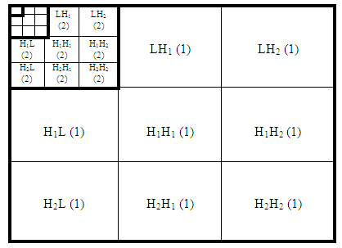
Fig. (3) The disposition of framelet image coefficients. Number in parenthesis represents the level of transform

6. Proposed Multi-level Framelet Compression Algorithm:
This work shows how one can use N-dimensional framelet analysis to compress an image efficiently without sacrificing its clarity.
Preprocessing Part:
- Resize the original image into (K*K) pixels to be a useable in the transform. Where K must be even and K > = length of the analysis filter used. Resizing (zero padding) is the process of lengthening the image component by adding 0's to the bottom and right of the image matrix as shown in Fig. (4).
- Process the image type to be suitable in the algorithm operations. For example, convert the indexed color image to a grayscale image:
GryImage (n,m) = ColorImage (n,m,i) for i= 1, 2, and 3. ……(7)

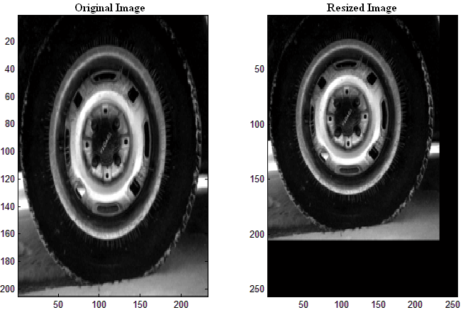
Fig. (4) Zero padding process.
Decomposition Part:
For each level of framelet transform, the following steps are performed:
- Increase the level counter.
- Perform the framelet decomposition.
This generates the coefficient matrices of the level-one approximation (LL) and horizontals, verticals and diagonals details (LL, LH₁, LH₂, H₁L, H₁H₁, H₁H₂, H₂L, H₂H₁ and H₂H₂).
- After decomposing the image and representing it with framelet coefficients C(n,m), compression can be achieved by using quantization.Quantization is based on the energy in each subband of the decomposed image. The coefficients of the subband with higher energy are divided with small value and vice versa.
5
Using the threshold based quantization technique, the coefficients are quantized according to threshold as in equation (8):
C(n,m) > Threshold Retain
C(n,m) ≤ Threshold Discard ..….(8)
The threshold value is used for this purpose is expressed as a fraction of the intensity of the brightest pixel in the image.
- Construct and display approximations and details from the coefficients.
In this analysis work, there are some different studies:
- Case1: Only LL band is further used in an iterated decomposition process, as shown previously in Fig. (2).
- Case2: Only first four subbands LL, LH₁, H₁L, and H₁H₁ are used.
- Case3: Compress each of the subbands coefficients individually.
- Test the stopping criterion: MSE, PSNR, or CR.
If stopping criterion is achieved, go to step 8.
Else repeat from step 3.
- Extract and display the level N approximation and details coefficients from compressed matrix.
Reconstruction Part:
- Reconstruct the Level N approximation. In this process, LL subband is multiplied with corresponding number used in the quantization to reconstruct the image.
- Display the results of a multilevel decomposition.
- Reconstruct the original image from the multilevel decomposition.
Cases (b) and (c) are complex and need to further processes. In which, the used coefficients of all the components of the N-level decomposition are returned concatenated into one matrix, extract the first, second, …,N-level approximation and detail coefficients from compressed matrix, then reconstruct the Level 1,2,…,N approximation and N details. This will be left as future works.
In order to save the computing and communication energies, this work is focused on case (a) only. In which all the higher subbands are eliminated because of their low effects as shown in the experimental tests performed on it. Fig. (5) shows the proposed framelet compression system.

6

Resizing Input Image
Case c
Case b
Process the image type
Reconstruct the original image
Reconstruct the Level N approximation
Achieved SC?
Yes
No
Thresholding
Approximation
Coefficients
(LL)
Case a
Details Coefficients
LH₁, LH₂
and H₁H₁
Start
End
Perform a framelet decomposition
Details Coefficients
LH_{2,} H₁H₂, H₂L, H₂H₁ and H₂H₂
LC = LC + 1

Fig. (5) Flowchart of the proposed system. Where LC is the level counter, SC is the stopping criterion, and N is the number of levels.

7. Results:
The multilevels DDDWT has been developed for image compression. How many level transforms can be performed? This work tries to answer this question. The experiments are performed on the well-known images Lena, Pout, cameraman, peppers and tire. These images can be got from the software package MATLAB. In addition to other not standard images of different types with preprocess. The results can be left to visual examination. However, comparing restoration results requires a measure of image quality. Two commonly measures are used: MSE and PSNR as shown in figures (6) and (7) respectively.
7
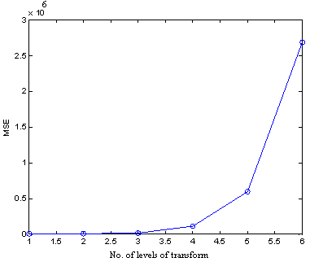
Fig. (6) MSE measurement vs. No. of levels of transform
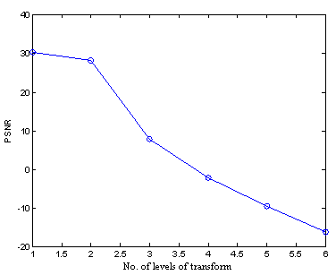

Fig. (7) PSNR measurement vs. No. of levels of transform

Table (1) summarizes the CR values for each level of transform. The quality of the image obtained decreases with the increasing of CR. Also, the larger CR means smaller PSNR and higher MSE.
Table (1): CR values for each level of transform
Levels of Transform | Compression Ratio (CR)
1 | (291*240) / (256*256) ≈ 1:1
2 | (291*240) / (128*128) ≈ 4:1
3 | (291*240) / (64*64) ≈ 17:1
4 | (291*240) / (32*32) ≈ 68:1
5 | (291*240) / (16*16) ≈ 272:1
6 | (291*240) / (8*8) ≈ 1091:1

Fig. (8) shows the output image of framelet containing the coarsest approximation coefficients and all the horizontal, diagonal, and vertical detail coefficients for six levels of transform.
Fig. (9) and (10) show only the approximation coefficient and the reconstructed image for these six levels of transform respectively. One can make several comments regarding figures (8), (9) and (10).
8

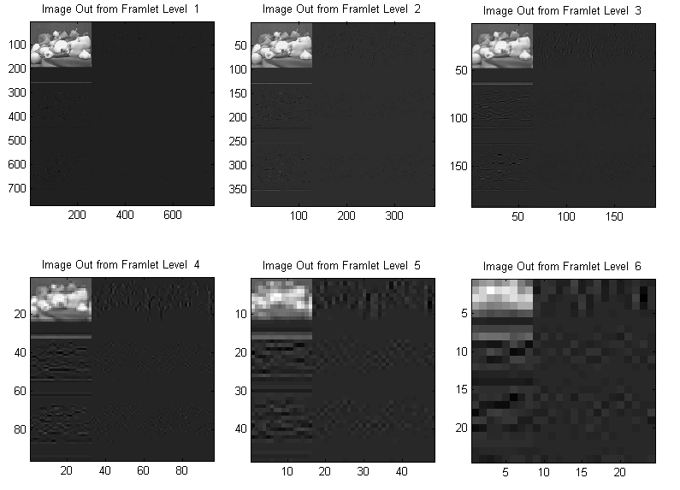
Fig. (8) Output image of framelet for six levels of transform
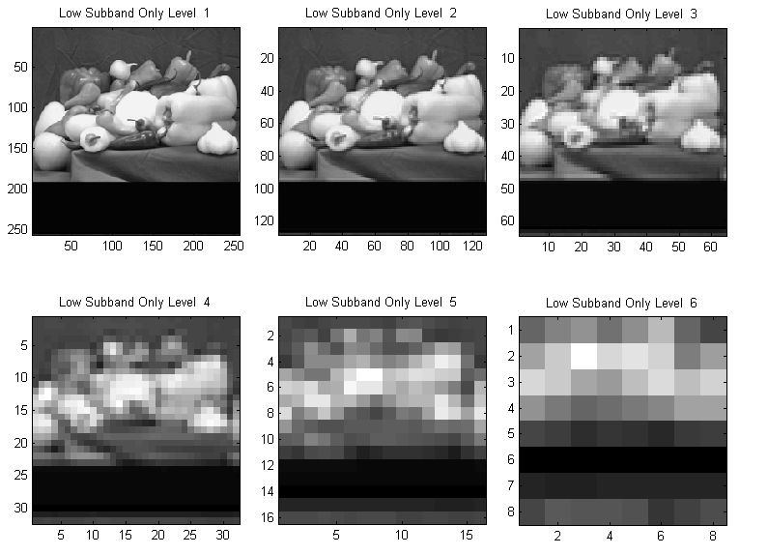
Fig. (9) Approximation coefficient for six levels of transform

9

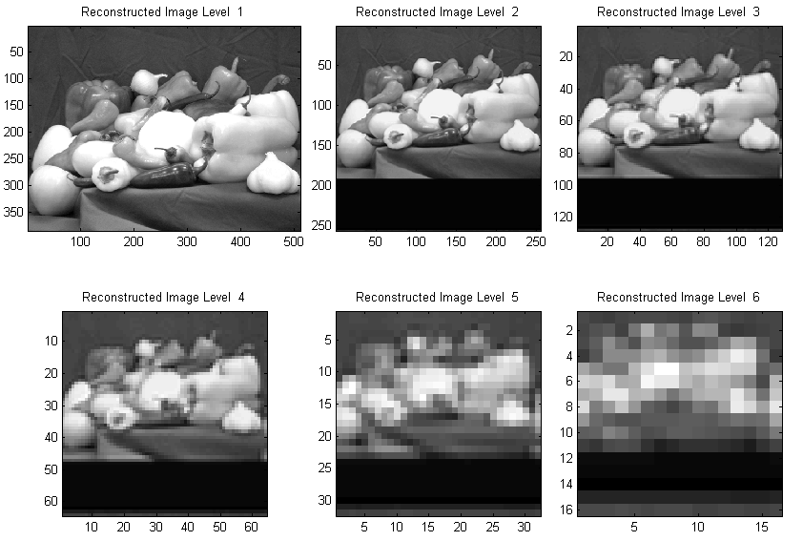
Fig. (10) Reconstructed image from framelet for six levels of transform

As level increase, the compressed image is not as clear as the original image. However, it still contains many of its features. Also, the details are being of large effects with significant information approximate to the LL subband, which means these subbands must be not ignored for further compression. So the notion behind the proposed compression algorithm is based on the concept that the regular image component can be accurately approximated using the following elements: a small number of approximation coefficients (at a suitably chosen level) and some of the detail coefficients.
On the other side, digital images are consisting of pixels. On a square grid, each pixel represents a square region of the image. Fig. (11) shows the same tested image with a different (row * column) pixels as levels of transform decrease. If the image contains sufficient pixels, it appears to be continuous.

a)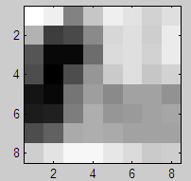 b)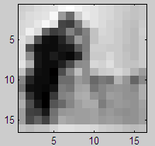 c)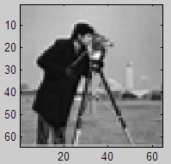 d)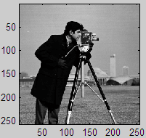

Fig. (11) The same digital image consist of: a) 9*9, b) 16*16, c) 64*64, and d) 250*250 pixels.
For visual observation of digital images, at higher CR (smaller SNR), as shown in fig. (11 a and b), the spatial resolution poor and the gray value discontinuities at pixel edges appear as disturbing lines; which hide the content of the image. As the SNR maintain higher as shown in fig (11 c and d), the effect becomes less pronounced up to the point where one get the impression of a spatially continuous image.
10
In order to investigate the inﬂuence of details subbands to the image compression and reconstruction ability, the simulation results for different details subbands are done using MATLAB code. It is seen that when all the higher subbands are removed, the reconstruction ability is not significantly effects. However, for higher levels of transform the higher subbands removing must be extremely partial for good reconstruction ability.
It has found that the removing of the higher subbands are good choices for limited number of transform levels in the proposed framelet compression algorithm.
Different sets of asymmetric analysis and synthesis filters (synthesis filters are just the flipped version of analysis filters) are tested with semi-identical results. Tables (2-3) show two examples of these filters.
Table (2): First example set of asymmetric analysis filter coefficients for
(K₀, K₁, K₂) = (4, 2, 2).
N | H_{o}(n) | H₁(n) | H₂(n)
1 | 0.14301535070442 | -0.01850334430500 | -0.04603639605741
2 | 0.51743439976158 | -0.06694572860103 | -0.16656124565526
3 | 0.63958409200212 | -0.07389654873135 | 0.00312998080994
4 | 0.24429938448107 | 0.00042268944277 | 0.67756935957555
5 | -0.07549266151999 | 0.58114390323763 | 0.46810169867282
6 | -0.05462700305610 | -0.42222097104302 | 0

Table (3): Second example set of asymmetric analysis filter coefficients for
(K₀, K₁, K₂) = (6, 3, 3).

n | H_{o}(n) | H₁(n) | H₂(n)
1 | 0.05857000614054 | -0.01533062192062 | 0.00887131217814
2 | 0.30400518363062 | -0.07957295618112 | -0.33001182554443
3 | 0.60500290681752 | -0.10085811812745 | 0.74577631077164
4 | 0.52582892852883 | 0.52906821581280 | -0.38690622229177
5 | 0.09438203761968 | -0.15144941570477 | -0.14689062498210
6 | -0.14096408166391 | -0.23774566907201 | 0.06822592840635
7 | -0.06179010337508 | -0.05558739119206 | 0.04093512146217
8 | 0.01823675069101 | 0.06967275075248 | 0
9 | 0.01094193398389 | 0.04180320563276 | 0

8. Conclusions:
This paper deals with the use of framelet transform for image compression employing a selected method of thresholding of appropriate decomposition coefﬁcients.
The proposed technique is based upon the analysis of framelet transform and it includes description of higher subbands effect.
The whole method is verified for simulated standard images and also applied for processing of different image types.
The multilevels framelet compression procedure contains three steps:
a. Decompose: Choose a framelet and levels of transform N. The framelet of the approximation coefficients is performed up to a chosen level of transforms N.
b. Threshold the coefficients: For each level from 1 to N, a threshold is selected and hard thresholding is applied to the approximation coefficients.
11
c. Reconstruct: The compressed image using the altered approximation coefficients from level 1 to N is synthesized.
In the proposed multilevel framelet compression algorithm, an image is decomposed using the double density wavelet transform to obtain LL, H₁L, H₂L, LH₁, LH₂, H₁H₁, H₁H₂, H₂H₁ and H₂H₂ subbands. Then, LL subband is quantized and further compressed.
The proposed technique eliminate the higher subbands, which can result in significant savings in computing and communication energies since eight out of nine subbands are removed from the compressed result.
The image is decomposed using the framelet with appropriate filter banks. The quality of the compressed image depends on the number of decompositions which determines the resolution of the lowest level in the framelet domain.
To achieve high CR, usually part of image information has to be discarded during the compression process, which leads to significant degradation of visual quality of compressed images especially at a low bit rate.
The visual quality of images will be greatly improved if part of the missing information,distributed in higher subbands, during the compression process can be recovered.
As levels increase, the details are being of large effects with significant information approximate to the LL subband, which means these subbands must be not ignored for further compression.

References:
Ananda, G. Sadashivappa and K.V.S. Ananda Babu, 2009,“Evaluation of Wavelet Filters for Image Compression”,World Academy of Science, Engineering and Technology, 51,131-137.
Anoop, Anoop Mathew and Bensiker Raja Singh D.,2009,“Image Compression using Lifting Based DWT”, International Journal of Computers, Information Technology and Engineering , 27-31.
Bernd,Bernd Jähne,“Digital Image Processing”,2005,Springer-Verlag Berlin Heidelberg.
Ivan, Ivan W. Selesnick,2001,“Smooth Wavelet Tight Frames with Zero Moments”, Applied and Computational Harmonic Analysis , 163–181.
Jian, Jian Feng Cai, Hui Ji, Fuchun Shang, and Zuowei Shen,2010,“Inpainting for Compressed Images”, National University of Singapore.
Kannan, K. Kannan, S. Arumuga Perumal and K. Arulmozhi, 2010, “The Review of Feature Level Fusion of Multi-Focused Images Using Wavelets”, Recent Patents on Signal Processing , 28-38.
Kharate, G. K. Kharate, A. Ghatol and P. Rege,2005,“Image Compression Using Wavelet Packet Tree”, ICGST-GVIP Journal, 5 (7), 37-40.
Kumar, K. Veeraswamy and S. Srinivas Kumar,2008,“An Improved Wavelet based Image Compression Scheme and Oblivious Watermarking”, International Journal of Computer Science and Network Security, 8 (4), 170-177.
Muttoo, Sushil Kumar and S. K. Muttoo,2010,“Image Steganogaraphy based on Complex Double Dual Tree Wavelet Transform”, International Conference on Multimedia Information Networking and Security, IEEE, 93-97.
Sachin, Sachin P Nanavati and Prasanta K Panigrahi, 2005, “Wavelets: Applications to Image Compression”, Resonance, 10 (2) (2005) 52-61.
12
Sonja, Sonja, G., Mislav. G. and Branka. Z., 2001,“Performance analysis of image compression using wavelets”, IEEE Transactions on Industrial Electronics., 48 (3), 682–695.
Sushil, Sushil Kumar and S. K. Muttoo, 2010, “An Overview of Wavelet-Like Transforms And Image Data Hiding”, 4th National Conference, Bharati Vidyapeeth’s Institute of Computer Applications and Management, New Delhi, India .
Vijendra, D. Vijendra Babu and N. R. Alamelu, 2009,“Wavelet Based Medical Image Compression Using ROI EZW”,International Journal of Recent Trends in Engineering, 1(3),97-100.
13

