Synthesis and Characterization Of Some New Heterocyclic Compounds Such As: Oxadiazole and Azetidine-2-One Derivatives

Mahmood Shakir Magtoof AL-Tamemay
Science College, Thiqar University

(NJC)

(Recevied on 28 /7 /2011 ) (Accepted for publication 27 /9 /2011)

Abstract
A series of four membered ring the azetidine-2-one 3(a-c) have been synthesized via Schiff bases 2(a-e) with derivative of acetic acid in the presence of triethylamine with phosphorusoxychloride using dry methylene chloride under inert nitrogen atmosphere at 0 ˚C. to furnish the corresponding azetidine-2-one 3(a-c) in moderate yields.on the other hand aseries of five membered ring synthesized Substituted 1,3,4-oxadiazoles are of considerable pharmaceutical and material interest by treatment of a suspension of methyl salicyliate hydrazide (1) in ethanol reflux with hydrazine to give 2-hydroxybenzohydrazide (2) this compound treated with Carbon disulfide(CS₂) in the presence of sodium hydroxide to give 2-mercapto-1,3,4,-Oxadiazole (3)this compound treated with hydrazine in ethanol to give 5-hydrazino-1,3,4-Oxadiazole(4). Finally treatment of (4) with 2-bromobenzaldehyde to gave 1,3,4—Oxadiazole derivateives The structural of these compounds were monitored and confirmed by using spectroscopic tools as IR and ¹HNMR spectra Elemental analysis.
الخلاصة
تم تحضير سلسله من مركبات الازدتين رباعية الحلق الغير متجانسة 3 ( أ-ج) من تفاعل قواعد شيف 2(أ,ب ,ج,د ,ح ) مع مشتق حمض الاستيك وبوجود ثلاثي اثيل امين وفوسفوراس اوكسي كلورايد ,ومثيلين كلورايد في جو من النتروجين الخامل وبدرجة الصفر المئوي لينتج مشتف الازدتين -2- اون 3 ( أ-ج) وبمنتوج حيد . هذا من جهه ومن جهة اخرى حضرت سلسلة من المركبات الحلقية الخماسية 1 ,3 , 4 الاوكسادايازول لما لها من الاهمية الطبية من خلال تفاعل ( 1) بوجود الايثانول مع الهيدرازين والتصعيد ليعطي المركب (2) الذي بدوره تفاعل مع ثنائي كبريتيد الكربون وبوجود هيدروكسيد الصوديم ليعطي (3) والاخير تمت مفاعلته مع الهيدرازين المذاب بالايثانول ليعطي ( 4) والذي يتفاعل اخيرا مع 2-برومو بنزلديهايد لينتج مشتق 1,3,4- اوكسادايازول . وقد تم متابعة وتشخيص النواتج المحضره بواسطة تقنيات الاشعة تحت الحمراء و بروتون وكربون الرنين النووي المغناطيسي بالاضافة الى التحليل العنصري .
Keywords: medicinal chemistry, β-lactam, ketene, Staudinger reaction ,four membered ring,1,3,4-Oxadiazole

Introduction
Substituted 1,3,4-oxadiazoles are of considerable pharmaceutical and material interest, which is documented by a steadily increasing number of publications and patents. For instance, 2-amino-1,3,4-oxadiazoles act as muscle relaxants¹ and show antibiotic activity.² Analgesic, antiinflammatory, anticonvulsive, diuretic and ant emetic properties are exhibited by 5-aryl-2-hydroxymethyl-1,3,4-oxadiazole derivatives, ³ and 2-hydroxyphenyl-1,3,4-oxadiazole acts as a hypnotic and as a sedative.⁴ Some material applications of 1,3,4-oxadiazole derivatives lie in the fields of photosensitizers⁵ and liquid crystals.⁶ The common synthetic approaches to oxadiazoles involve cyclization of diacylhydrazines⁷. A variety of reaction conditions influence the cyclization reaction. Typically, the reaction is promoted by heat and anhydrous reagents including thionyl chloride,⁸ phosphorous oxychloride,⁹ phosphorous pentoxide,¹⁰ triphenylphosphine,¹¹ and triflic anhydride.¹² Alternative synthetic methods comprise the reaction of carboxylic hydrazides with keteneylidene triphenylphosphorane¹³ or base-promoted cyclization reaction of trichloroacetic acid hydrazones.¹⁴ Herein we report a simple method for the synthesis of 1,3,4-oxadiazoles having phenol¹⁵ or thiophenol group like A and B compounds

β -Lactam antibiotics still constitute one of the most widely employed class of antibacterial agents.¹⁶ they continue to attract the attention of synthetic organic chemists as they present a variety of synthetic challenges. Besides this, they are useful as intermediates for α- and β-amino acids, alkaloids, heterocycles, taxoids and other important compounds of biological and medicinal interest.¹⁷ In addition, recently some of the synthetic β -lactams have been reported to be biologically active as cholesterol acyl transferase inhibitors,¹⁸ thrombin inhibitors,¹⁹ human cytomegalovirus protease inhibitors, ²⁰ matrix-metalloprotease inhibitors,²¹ human leukocyte elastase,²² and as cysteine protease²³ .

Results and Discussion
Azetidin-2-ones, commonly known as - β - lactam constitute a well-known class of aliphatic heterocyclic compounds.

While the 1,3,4-Oxadiazole a well –known class of aromatic heterocyclic compounds

Two possible [2+‏2] cycloadditions can be envisaged for the synthesis of β -lactams (Scheme 1). One possibility consists of the [2‏+2] cycloaddition between ketenes and imines to yield β -lactams . This reaction has been explored experimentally and it is also known as the Staudinger reaction between ketenes and imines ²⁴⁻²⁷ In an alternative approach, the [2+‏2] cycloaddition between alkenes and isocyanates leads to β -lactams This reaction has been less extensively used, but it has proven to be useful in the chemical synthesis of interesting compounds 3(a-c).

Scheme 1: [2‏+2] disconnections of the β -lactam ring

FOUR MEMEBERD RING SYNTHESIS:

A series of 3-alkylidene 3-Phenylthio-3-Chloro azetidine -2-one 3(a-c) were synthesized by the Staudinger ketene-imine [2 + 2] cycloaddition as shown below Scheme 2:

The IR spectra of the 3-alkylidene/3-phenylthio3-chloroazetidine-2-one 3(a-c) were characterized by the presence of appeared the carbonyl group (amide carbonyl) at 1758cm⁻¹ and carbonyl ester at 1740cm⁻¹,alkene and substituted ring which occurs within the ranges 3085,2980,1600-1550 and 835-815 cm⁻¹, respectively ²⁸.

The ¹H-NMR of 3-alkylidene β-lactam 3a showed four regions, an aliphatic region including one groups of signals at the region δ 1.2 ppm,corresponding to six equivalent protons2CH₃(6H,triplet ,J coupling ), second region showed methyl group at δ 2.2 (quartet)ppm,also methoxy group at 3.8 ppm (singlet).Finally region two equivalent methylene group at 4.3 ppm. (2CH₂, 4H, quartet, J coupling) The ¹H-NMR of 3-alkylidene β-lactam 3a spectra showed one region, of the aromatic proton at (6.8-7.5ppm) corresponding to four aromatic protons(dd) ,Finally the proton at C3-H (-CH) showed at 6.1ppm and splitting to quartet are shown in (Figure (3-1). The ¹H-NMR of 3-Phenylthio β-lactam 3b showed four regions,an aliphatic region including one groups of signals at δ 1.2ppm corresponding to rwo methyl group and signals at 4.3ppm corresponding to two methylene groups also signal group at δ 3.7ppm corresponding to methoxy group and signal peak at δ 5.3 ppm corresponding to C3-H . Finally the signals of aromatic protons at region δ 6.9-7.5 ppm corresponding to nine protons for two rings. are shown in Figure (3-2). The ¹H-NMR of 3-Phenylthio-3-chloro β-lactam 3c the signal of proton C3-H is absent and a similar observations were found for 3b are shown in Figure (3-3).
The ¹³C NMR spectra 3c of the 3-Phenyl-3-chloro azetidine -2-ones showed The resonance at δ 163.55, 159.15 and 157.35 which were assigned to three carbonyl groups ,the signals of aromatic carbon at range δ(113.9-136.4ppm) and the signals of aliphatic carbons ,the two methyl group at δ 13.9 ppm and two methylene at δ 63.37ppm.Finally the carbon of methoxy group at δ 55.45ppm are shown in (Figure (3-4).

SYNTHESIS OF FIVE MEMEBERD RING:
In the present study2-Bromobenzyldehyde[1 , 3, 4-oxadiazole -2yl] hydrazone 5-(2-hydroxyphenol) 4a and some of their derivatives were synthesized .These synthetic reactions are summarized in Scheme3

The IR spectra of 2-bromobenzaldehyde[5-(2-hydroxyphenyl)1,3,4-oxadiazole-2-yl] hydrazone methane 4a was characterized by the presence of phenoic and amine group which shows signals at 3425 cm⁻¹ and 3392.5 cm⁻¹ respectively as shown in Figure(3-5) and some signals at 2933 ,3033cm⁻¹corresponding to aliphatic and aromatic carbon and also showed strong azomethane signal at 1620 cm⁻¹. and some peaks at1348cm⁻¹,1431cm⁻¹ corresponding to stretching sym and asymmetry of C-O-C

The ¹H-NMR of benzaldehyde(5-(2-hydroxyphenyl)1,3,4-oxadiazole-2-yl)hydrazone methane 4a showed two regions, the aromatic protons give multiplets signals at 6.87-8.87ppm with azomethine proton (CH-N)²⁹.Also showed broad singlet at 10.3ppm corresponding to hydrogen of hydroxyl group bonding with the nitrogen atom
Experimental
All melting points are uncorrected and are expressed in degree(°C), using melting point SMP₃ . IR spectra were recorded asKBr disks using shimadzu FT-IR 8400 using KBr disks. ¹H NMR spectra were recorded using Bruker system AL 300 (300 MHz) and tetramethylsilane (TMS) as internal standard. ¹³C NMR spectra were recorded using Bruker system AL 300 (300 MHz) and tetramethylsilane (TMS) as internal standard ¹³C NMR.
General procedure of imine synthesis 2a

N-(4-Methoxyphenyl)-1,1-diethoxycarbonylimine 2a
A mixture of diethyl ketomalonate (0.7 g, 1 mmol) and p-anisidine (0.5 g, 1 mmol) was refluxed in dry benzene on a heating mental using a Dean-Stark apparatus. The reaction was monitored by TLC .After 4-5 h, when there was no spot left corresponding to the starting materials, benzene was removed under reduced pressure and the crude product 2a (1.0 g, 94%) thus obtained, as a liquid was used as such for the subsequent reactions. It showed following spectral data : IR (CHCl₃) : 1675, 1630, 1515, 1510 cm⁻¹; ¹H-NMR (CDCl₃)  : 1.4 (q, 3H, COOCH₂CH₃), 1.5 (t, 3H, COOCH₂CH₃), 3.8 (s, 3H, OCH₃), 4.25 (q, 2H, COOCH₂CH₃), 4.45 (q, 2H, COOCH₂CH₃), 6.97 (dd, 4H, AB pattern, aromatic protons).

General procedure of azetidine-2-one 3(a-c)

N-(4-Methoxyphenyl)-3-ethylidene-4,4-diethoxycarbonyl azetidin-2-one 3a
To solution of 2-butenoicacid(1a) (0.45 g, 1.5 mmol), imine 2a (0.5 g, 1 mmol) and triethylamine (0.54 g, 3 mmol, 0.75 ml) in 80 mL dry methylene chloride was added dropwise under nitrogen atmosphere at 0ºC, a solution of phosphorus oxychloride (POCl₃) (0.41 g, 0.24 mL, 1.5 mmol) in 20 mL of dry methylene chloride with constant stirring. The reactant was stirred overnight at room temperature. The completion of reaction was monitored by TLC. After the completion, the contents were washed successively with 1N HCl (30 ml), water (3x30 ml , 5% NaHCO₃ (30 ml) and brine (30 mL). The organic layer was separated and dried over anhydrous Na₂SO₄. The solvent was removed under reduced pressure and the crude product was purified by column chromatography using silica gel eluting with 10% ethyl acetate : hexanes. Solvent evaporation furnished pure -lactam 3a (0.66 g, 60%). Its structure was confirmed on the basis of following spectral data: m.p. : 90–92°C ; IR (CHCl₃) : 1758, 1740 cm⁻¹ ; ¹H-NMR (CDCl₃)  : 1.2 (t, 6H, J = 7 Hz, 2xCOOCH₂CH₃),2.2(q, 3H, CH₃),3.77 (s, 3H,
OCH₃), 4.40 (q, 4H, J = 7 Hz, 2xCOOCH₂CH₃), 6.10 (q, 1H, C₋₃-H), 6.8-7.5 (dd, 4H, aromatic protons)

1-(4'-Methoxyphenyl)-3-phenylthio-4,4-diethoxycarbonylazetidin-2-one 3b
To solution of phenylthioacetic acid (0.45 g, 1.5 mmol), imine 2a (0.5 g, 1 mmol) and triethylamine (0.54 g, 3 mmol, 0.75 mL) in 80 mL dry methylene chloride was added dropwise under nitrogen atmosphere at 0ºC, a solution of phosphorus oxychloride (POCl₃) (0.41 g, 0.24 mL, 1.5 mmol) in 20 mL of dry methylene chloride with constant stirring. The reactant were stirred overnight at room temperature. The completion of reaction was monitored by TLC. After the completion, the contents were washed successively with 1N HCl (30 mL), water (3x30 mL), 5% NaHCO₃ (30 mL) and brine (30 mL). The organic layer was separated and dried over anhydrous Na₂SO₄. The solvent was removed under reduced pressure and the crude product was purified by column chromatography using silica gel eluting with 10% ethyl acetate : hexanes. Solvent evaporation furnished pure -lactam 3b (0.66 g, 60%). Its structure was confirmed on the basis of following spectral data: m.p. : 94–95°C ; IR (CHCl₃) : 1758, 1740 cm⁻¹ ; ¹H-NMR (CDCl₃)  : 1.2 (t, 6H, J = 7 Hz, 2xCOOCH₂CH₃), 3.77 (s,3H,OCH₃), 4.40 (q, 4H, J = 7 Hz, 2xCOOCH₂CH₃), 5.20 (s, 1H, C₃-H), 6.8-7.5 (m, 9H, aromatic protons); ¹³C-NMR (CDCl₃)  : 13.8, 14.16, 55.20, 62.11, 62.76, 72.4, 113.9, 121.4, 127.3, 129.32, 129.5, 130.3, 133.9, 157.3, 161.3, 165.5, 165.8; Anal. Calcd. for C₂₂H₂₃O₆NS : C, 61.53; H, 5.36; N, 3.26; Found: C, 61.40; H, 5.29; N, 3.21.

1-(4-Methoxyphenyl)-3-Chloro-3-phenylthio-4,4-diethoxycarbonylazetidin -2-one( 3c)
To a well stirred solution of α- phenylthio-β-lactam 3b( 0.9g, 2mmoles )in 50 ml dry methylene Chloride , under nitrogen at 0 ^{ο}C , was added a solution of sulfuryl Chloride (SO₂Cl₂) ( 0.39g , 2mmol,0.2ml ) in 10 ml dry methylene Chloride in 10 minutes contents were stirred for additional half hour . The progress of reaction was monitored by TLC. Solvent evaporation followed by column chromatography on silica gel using ethylacetate : hexanes(1:10) yielded pure β- lactam 3c (1.0g , 75%) ,IR: 1760,1720 cm⁻¹ ,¹HNMR (CDCl₃) δ1.26 (t,6H, 2XCOOCH₂CH₃),3.78(s,3H,OCH₃), 4.35(q,4H, 2XCOOCH₂CH3),6.83-7.73 (m,9H,aromatic protons) . ¹³CNMR(CDCl₃) δ:13.94, 29.70,55.459 , 63.37 , 113.97, 120.99 121.32 ,127.36, 128.96, 129.15, 129.32,130.31, 130.47, 136.42 , 157.35, 159.15, 163.55

General procedure for synthesis of 2-bromobenzaldehyde[5-(2-hydroxy phenyl) 1,3,4-oxadiazole-2-yl] hydrazone methane 4a and some of their derivative
1-Synthesis of 2-hydroxybenzohydrazine
To mixture of 0.1mole of methylsalicylate with 0.2mole of hydrazine hydrate in 100 ml of absolute ethanol .The mixture was thoroughly stirred and heated under reflux for 5h,the reaction time was monitored through TLC technique after completion of reaction ,the solution was concentrated to small volume and the residue was dissolved in water, this furnished precipitate which was filtered, washed and recrystallized from aqueous ethanol Yield %95, m.p =148-150 C⁰

2-Synthesis of 2-hydroxybenzohydrazine 2-(5-mercapto-1,3,4-Oxadiazole-2-yl)phenol
To mixture of 0.1mole of hydrazide with 0.1mole of KOH in 100 ml of absolute ethanol and add 0.1mole of carbon disulfide. The mixture was thoroughly stirred and heated under reflux for 5h,the reaction time was monitored through TLC technique after completion of reaction ,the solution was concentrated to asmall volume and the residue was dissolved in water,this solution was acidified to pH 2-3 by addition of dil.hydrochloric acid and this furnished a precipitate which was filtered,washed and recrystallized from aqueous ethanol Yield %70, m.p = (203-205) C⁰
3) )Synthesis of 2-(5-hydrazino-1,3,4-Oxadiazole-2-yl)phenol
To mixture of 0.1mole of 2-(5-mercapto-1,3,4-Oxadiazole-2-yl)phenol with 0.1mole of hydrazine hydrate in 100mL of absolute ethanol .The mixture was thoroughly stirred and heated under reflux for 5h,the reaction time was monitored through TLC technique after completion of reaction ,the solution was concentrated to a small volume and the residue was dissolved in water and this furnished a precipitate which was filtered, washed and recrystallized from aqueous ethanol. Yield %70, m.p= 203-205 C⁰
4) Synthesis of Benzyldehyde(5-(2-bromophenyl)-1,3,4-oxadiazole -2-yl)hydrazone-methane 4a
To mixture of 0.02 mole of 2-hydroxybenzohydrazine2-(5-hydrazino-1,3,4-Oxadiazole-2-yl)phenol with 0.02mole of 2-bromobenzaldehyde in 50mL of absolute ethanol .The mixture was thoroughly stirred and heated under reflux for 3h,the reaction time was monitored through TLC technique after completion of reaction ,the solution was concentrated to a small volume and the residue was dissolved in water and this furnished a precipitate which was filtered, washed and recrystallized from aqueous ethanol. Yield % 62.6, m.p = 240-238 C⁰

Acknowledgments
The author wish to thank Punjab University, Chandigarh and UGC, New Delhi for funding
this piece of research work.

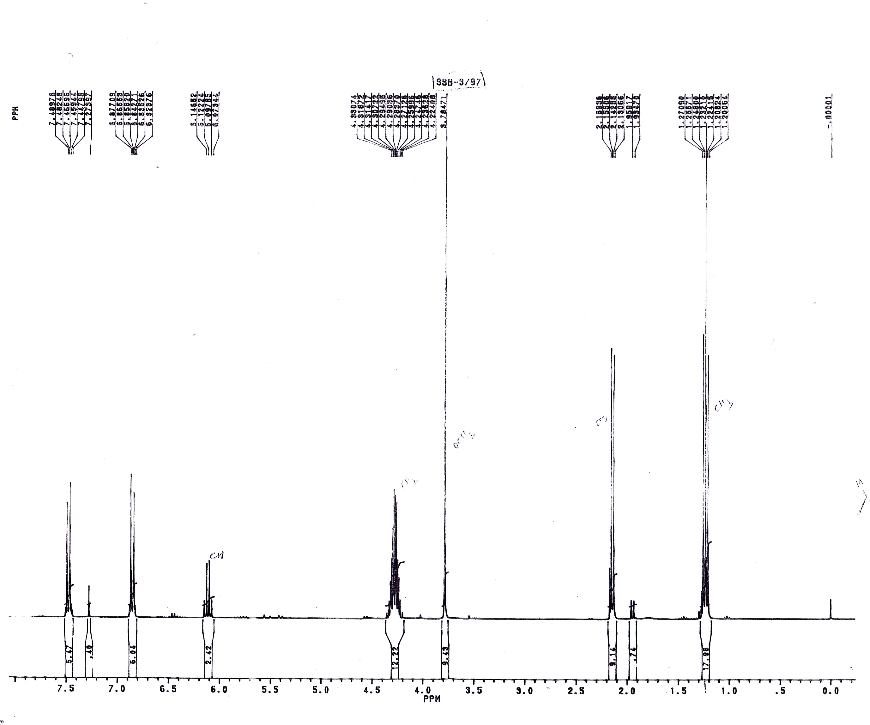

Figure(3-1) ¹H-NMR of N-(4'-Methoxyphenyl)-3-ethylidene-4,4-diethoxycarbonyl azetidin-2-one (3a)
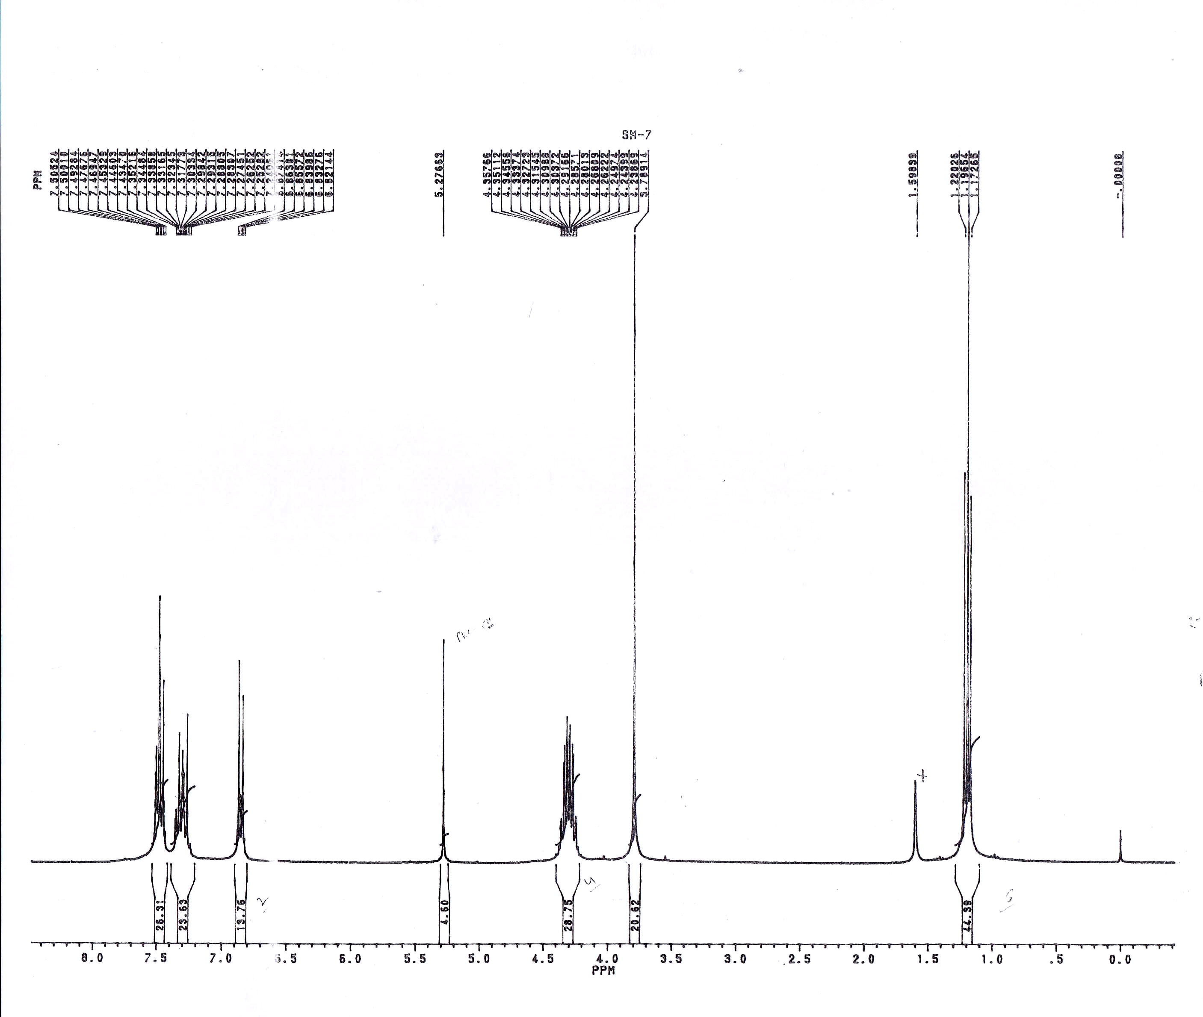

Figure(3-2) ¹H-NMR of N-(4'-Methoxyphenyl)-3-phenylthio-4,4-diethoxycarbonyl azetidin-2- one 3b

Figure(3-3) ¹H-NMR of N -(4'-Methoxyphenyl)-3-phenylthio-3-chloro-4,4-diethoxycarbonyl azetidin-2-one 3c

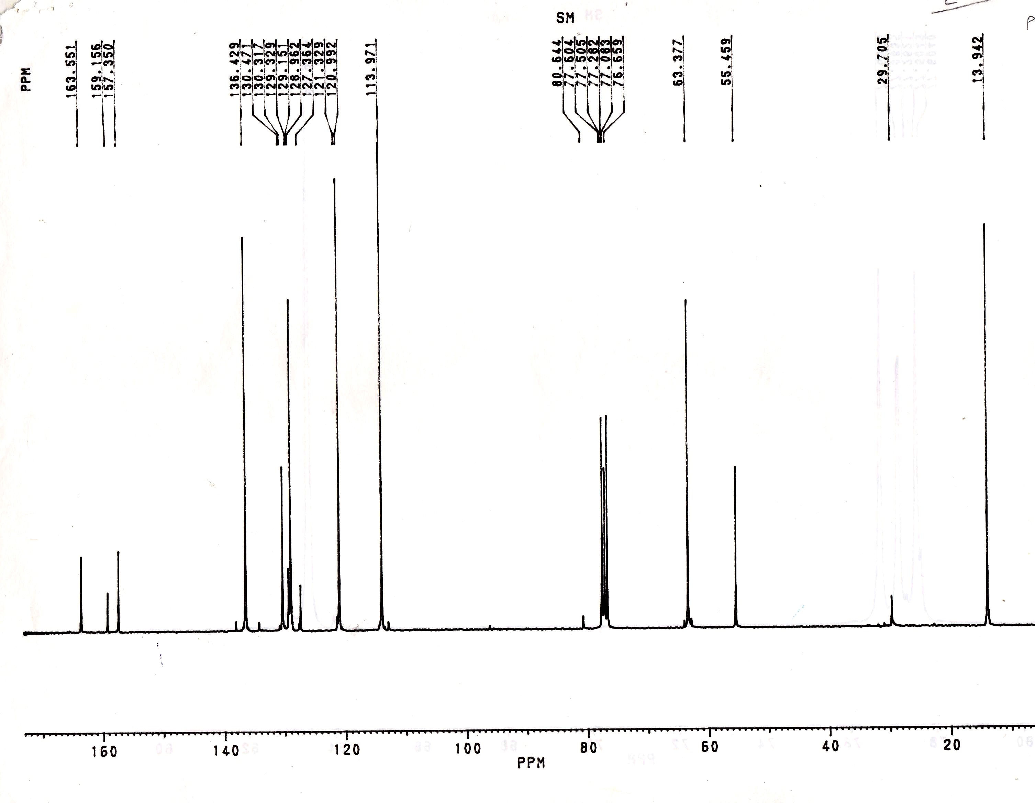

Figure(3-4) ¹³C-NMR of N-(4'-Methoxyphenyl)-3-phenylthio-3-chloro-4,4-diethoxycarbonyl azetidin-2-one 3c

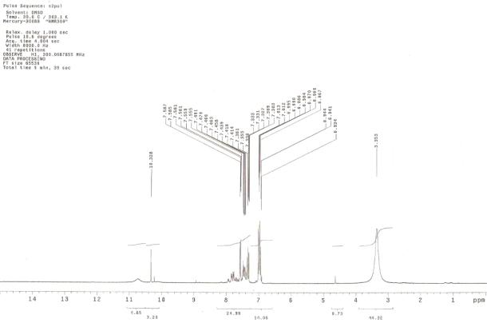

Figure(3-4) ¹H-NMR of Benzyldehyde(5-(2-bromophenyl)-1,3,4-oxadiazole -2-yl)hydrazone-methane 4a

References

1-Yale, H. L.; Losee, K. J. Med. Chem. 1966, 9, 478
2- Ghiran, D.; Schwartz, I.; Simiti, I. Farmacia 1974, 22, 141.
3- Thomas, J. Ger. Offen. 2403357 (1974); Chem. Abstr. ;1974, 81, 136153.
4- Adelstein, G. W.; Yen, C. H.; Dajani, E. Z.; Bianchi, R. G. J. Med. Chem. 1976, 19, 1221.
5- Schinzel, E.; Martini, T.; Spatzeier, W.; Probst, H. DE. P. 3126464 (1983/1981), Hoechst AG; Chem. Abst. 1983, 98, 199850
6- Chudgar, N. K.; Shah, S. N.; Vora, R. A. Mol. Cryst. Liq. Cryst. 1989, 172, 51.
7- (a) See, Hill, J. Comprehensive Heterocyclic Chemistry; Katritzky, A. R., Rees, C. W., Eds.; Pergamon Press: Oxford, 1984; Vol. 6, pp 427-446 and references therein. (b) Bentiss, F.; Lagrenée, M. J. Heterocyclic Chem.; 1999, 36, 1029.
8- (a) Kerr, V. N.; Ott, D. G.; Hayes, F. N. J. Am. Chem. Soc. 1960, 82. (b) Al-Talib, M.; Tastoush, H.; Odeh, N. Synth. Commun. 1990, 20, 1811.
9- (a) Klinsberg, E. J. Am. Chem. Soc. 1958, 80. (b) Theocharis, A. B.; Alexandrou, N. E. J. Heterocyclic Chem. 1990, 27, 1685.
10- Carlsen, P. H. J.; Jorgensen, K. B. J. Heterocyclic Chem. 1994, 31, 805.
11- Brown, P.; Best, D. J.; Broom, N. J. P.; Cassels, R.; O’Hanlon, P. J.; Mitchell, T. J.; Osborne, N. F.; Wilson, J. M. J. Med. Chem. 1997, 40, 2563.
12- Liras, S.; Allen, M. P.; Segelstein, B. E. Synth. Commun. 2000, 30, 437.
13-Löffler,J.;Schobert,R.Synlett.;1997,283.
14- Kaim, L. E.; Menestrel, I. L.; Morgentin, R. Tetrahedron Lett. 1998, 39, 6885.
15- (a) Lee, K.-J.; Kim, S. H.; Kim, S.; Cho, Y. R. Synthesis1992, 929. (b) Kim, H. -O.; Huber, E. W.; Friedrich, D.;
16.-Durckheimer, W.; Blumbatch, J.; Lattrell, R.; Scheunemann, K. H. Angew. Chem., Int. Ed. Engl. 1985, 24, 180–202
17- Ojima, I. Acc. Chem. Res. 1995, 28, 383–389; ( Burnett, D. A.; Caplen, M. A.; Davis, H.R., Jr.; Burrie,R. E.; Clader, J. W. J. Med. Chem. 1994, 37, 1733–1736
18- Han, W. T.; Trehan, A. K.; Wright, J. J. K.; Federici, M. E.; Seiler, S. M.; Meanwell, N. A. Bioorg. Med. Chem. 1995, 3, 1123–1143.
19- Borthwick, A. D.; Weingarte, G.; Haley, T. M.; Tomaszewski, T. M.; Wang, W.; Hu, Z.; Bedard, J.; Jin, H.; Yuen, L.; Mansour, T. S. Bioorg. Med. Chem. Lett. 1998, 8, 365–370.
20-Cainelli, G.; Galletti, P.; Garbisa, S.; Giacomini, D.; Sartor, L.; Quintavalla, A. Bioorg. Med. Chem. 2003, 11, 5391–5399.
21-.Cvetovich, R. J.; Chartran, M.; Hartner, F. W.; Roberge, C.; Amato, J. S.; Grabowski, E. J. J. Org. Chem. 1996, 61, 6575–6580.
22-Zhou, N. E.; Guo, D.; Thomas, G.; Reddy, A. V. N.; Kaleta, J.; Purisima, E.; Menard, R.; Micetich, R. G.; Singh, R. Bioorg. Med. Chem. Lett. 2003, 13, 139–141
23-Smith, D. M.; Kazi, A.; Smith, L.; Long, T. E.; Heldreth, B.; Turos, E.; Dou, Q. P. Mol. Pharmacol. 2002, 61, 1348–1358
24-. Clemente A, Domingos A, Grancho AP, Iley J, Moreira R, Neres J, Palma N, Santana AB, Valente E Bioorg Med Chem Lett , 2001, 11:1065
25-. Koteva KP, Cantin AM, Neugebauer WA, Escher E Can J Chem , 2001, 79:377
26- Cainelli G, Galletti P, Garbisa S, Giacomini D, Sartor L, Quintavalla A Bioorg Med Chem , 2003, 11:5391
27- Kazi A, Hill R, Long TE, Kuhn DJ, Turos E, Dou QP Biochem Pharmacol, 2004, 67:365
28-.Singh GS Tetrahedron , 2003,59:7631
29-. Chudgar, N. K.; Shah, Cryst. 1989, 172, 51.
30-. Bentiss, F.; Lagrenée, M. J. Heterocyclic Chem. 1999, 36, 1029.

