**Synthesis and characterization of new biodegradable polyurethanes containing azo derivatives of 5-aminosalicylic acid**

Mohammed A. Mutar , Rafid K. Kmal and Sabrean F. Jawad

[**Mohammeddw73@gmail.com**](mailto:Mohammeddw73@gmail.com)[**rafid_qais@yahoo.com**](mailto:rafid_qais@yahoo.com)[**ali-hh539@yahoo.com**](mailto:ali-hh539@yahoo.com)

***Department of Chemistry, College of Education, University of Al-Qadisyia***

**(NJC)**

**(Received on 24/9/2014) (Accepted for publication 9/11/2014)**

**Abstract**

The purpose of this study is to develop colon-specific drug delivery systems with pH-sensitive drug release properties.The azo polyurethane were characterized, and the drug content of the azo polyurethane was determined.Their behaviour and hydrolytic degradation was studied in simulated gastric fluid (SGF, pH =4) and simulated intestinal fluid (SIF, pH =7.8).

All synthesized monomers and polymers were characterized by FTIR, 1H-NMR spectra.The release of 5-ASA under physiological conditions (pH = 7.8 and

pH = 4) was investigated at body temperature (37 ºC). The release rate of 5-ASA increased with increasing pH (7.8 > 4).

**Keywords: 5-aminosalicylic acid, biodegradable polyurethanes , azo derivatives.**

**الخلاصة**

ان الغرض من الدراسة هو تطوير الانظمة الخاصة في اطلاق الادوية ﺫات الصفات الحساسة للحامضية. حيث تميزت مركبات الازو للبولي يوريثان في تحديد محتوى الدواء فية. وكذلك تم دراسة سلوك تحلله في السائل المعوي للمعدة عند pH = 4 , و pH = 7.8.

تم استخدام تقنيات ال FTIR ,H1-NMR في تشخيص المونوميرات والبوليمرات التي تم تخليقها.حيث تم تحرير 5-ASA عند نفس الظروف الفسيولوجية اي عند pH = 4 , pH = 7.8 ودرجة حرارة الجسم 37 0C. ان معدل سرعة تحرر 5-ASA تزداد مع زيادة درجة القاعدية اي pH = 7.8 > 4)).

**مفتاح الكلمات: 5- امينو حامض السلسليك , البولي يوريثان القابلة للتفكك, مشتقات الازو**

**Introduction**

There is considerable interest in the colon-specific drug delivery for treating diseases of the large intestine, such as: colitis, colon cancer, irritable bowel syndrome (IBS), Crohn and infectious diseases[1]. For the treatment of inflammatory bowel diseases (IBD) with anti-inflammatory agents, various approaches have been used to target the drug molecules to the colon [2]. These approaches include coating with biodegradable polymers, coating with pH-sensitive polymers, time-dependant formulations and preparing with prodrugs [3]. All of these approaches attempt to reduce the absorption and release of the drug in the stomach and small intestine and facilitate quantitative drug delivery to the colon [4].

Many bacteria including common components of the intestinal microflora possess the ability to reduce azo compounds [5]. Medical therapy for IBD is restricted to aminosalicylates, corticosteroids and immunosuppressants. 5-ASA, which is used for the treatment of rheumatoid arthritis, was found to have potential effect in the treatment of IBD [6]. This compound has an azo bond between 5-ASA and sulfapyridine (SP). The azoreductases in the colon cleave the azo bond releasing the drug, 5-ASA and SP. There are some problems surrounding the use of sulfasalazine primarily, because it causes some adverse effects [7].

Colon is known to be a reductive medium in which azo groups are reduced to the corresponding amines [8]. It has been shown that polymeric azo compounds could be used for colon targeting since reduction and subsequent splitting of the azo bond occurs only in the large intestine, and therefore they are highly site-specific [9].

Orally administered colonic delivery systems are difficult to design because of the anatomic location of the colon at the end of the alimentary canal [10]. This presents a formidable challenge in targeting drugs specifically to this site for local absorption so that systemic absorption is reduced and painful treatments [11], such as enemas, can be avoided [12]. Local treatment of inflammatory bowel disease, for example, would increase the efficiency of drugs used in its treatment [13], such as salicylic acid derivatives (eg, 5-amino salicylic acid [5-ASA] [14]. An approach that can be used in colon-specific delivery is to attach 5-ASA via an azo bond to a polymeric carrier [15].

In this study, the synthesis of a pH-sensitive polymer network consisting of polyurethane azo (PU AZO) is described. Complex-forming constituents of the polymer were covalently linked to each other and to the drug-linked monomer, and drug release properties of the polyurethane azo were studied in simulated gastric fluid (SGF, pH 4) and simulated in testinal fluid (SIF, pH 7.8).

**Materials**

5-ASA(Sigma-Aldrich) ,Phenol(BDH) ,3-Chlorophenol(BDH) Bromophenol(BDH), Resorcinol(Fluka) , m-Cresol(Fluka) , Catechole(Fluka) , Beta-naphthole(BDH) Pyragollal(BDH),Sodium nitrite(BDH),1,6-Hexamethylenediisocynate(HIMEDIA). DMF(BDH),Phosphate Buffer Saline(HIMEDIA), Buffer solution pH=4,7.8(BDH), Hydrochloric acid(BDH) Deionized water (Iraqi local product) .

**Instruments**

Fourier transform infrared (FTIR) spectra were recorded on a SHIMADZU-FTIR-8400S spectrometer with KBr pellets in the optical range of 400–4000cm-1. Nuclear magnetic resonance (1H-NMR) spectra were registered using a Bruker(Jordin), University of Ahil Al-bait, Ultra Shield 300MHZ, spectrometer using d6-DMSO as a solvent .Ultra-violet spectra: were taken on a shimadzu 1650 PC spectrophotometer. pH meter: Hanna, Romania, Fume Hood , K & K Scientific suppler. measuring the degree of fusion (Melting Point) smp30 .

**Experimental part**

**Monomer synthesis**

Synthesis of 2-hydroxy-4-((2,3,4-trihydroxy phenyl)diazenyl) benzoic acid :

In 500 mL conical flask, 5-ASA (1.53 g, 10 mmol) was dissolved in a mixture of concentrated hydrochloric acid (10 mL), water (25 mL) and ice (25 g). The solution was cooled with stirring in an ice bath to 0ºC until it becomes clear, then a solution of sodium nitrite (3.45 g, 50 mmol) in water (7.5 mL) was added dropwise during 10 min, and the reaction mixture was further stirred for 20 min in an ice bath at 0–5 ºC. The solution was added dropwise to monomers were shown in table 2.1 (1.38 g, 10 mmol), in 10% sodium hydroxide solution (25 mL) with stirring in an ice bath for a further 1 h. The produced monomers were precipitated [16]. The product was collected by filtration and washed with water and dried under vacuum at room temperature overnight to give (77%) of brown crystals , m.p= (127 OC)

.



**Scheme( 1 *)Structure of AZO1***

The other compounds were prepared by the same procedure as above using (3-bromophenol, resorcinol, catechole, B-naphthole, and m-cresol) are shown in table (1) .

**Table (1 ) : *synthesis and details data of prepared azo monomers:***

|  |  |  |  |  |
| --- | --- | --- | --- | --- |
| NO. | Monomer | Color | Yield% | M.Wt g/mol |
| 1 | *AZO1* | brown | 77 | 290 |
| 2 | AZO 2 | Low brown | 96 | 336.9 |
| 3 | AZO 3 | High brown | 87 | 274 |
| 4 | AZO 4 | High brown | 74 | 274 |
| 5 | AZO 5 | High brown | 90 | 308 |
| 6 | AZO 6 | High brown | 79 | 272 |



**Scheme (2) *Structure of AZO2* Scheme (3 )*Structure of AZO3*** 

**Scheme (4) *Structure of AZO4* Scheme (5) *Structure of AZO5***



**Scheme (6) *Structure of AZO6***

**Synthesis of Azo-polyurethane:**

Synthesis of Azo polyurethane from (*AZO1*)(PU AZO1):

In a three-neck round-bottom flask, a solution of the above monomers (3.01 g , 10 mmol), in N ,N- dimethylformamide (DMF, 30 mL) was added dropwise to a solution of 1,6-hexamethylenediisocyanate (HDI, 1.68 g , 10 mmol), in dry DMF (20 mL), under a dry nitrogen atmosphere at room temperature. Then the reaction mixture was stirred at 80 ºC for 8 h. The solution was poured into cold methanol to precipitate the polymer [16]. The solid product was collected by filtration, washed with methanol , and dried under *vacuum* at room temperature, yielded 70% black crystals.



***Scheme(7) Structure of PU1***

The other polymer was prepared by the same procedure as above using AZO (2-6) and are shown in table (2) .

**Table 2 : Synthesis and details data of prepared azo polyurethane:**

|  |  |  |  |
| --- | --- | --- | --- |
| NO. | Polymer | Color | Yield% |
| 1 | PU1 | Black | 70 |
| 2 | PU2 | High brown | 75 |
| 3 | PU3 | Black | 92 |
| 4 | PU4 | Black | 88 |
| 5 | PU5 | Black | 79 |
| 6 | PU6 | Black | 80 |



***Scheme(8)Structure of PU AZO2***



***Scheme(9)Structure of PU AZO3***



***Scheme(10) Structure of PU AZO4***



***Scheme(11) Structure of PU AZO5***



***Scheme(12)Structure of PU AZO6***

**UV-visible Spectrophotometric Analysis**

The azo polyurethane solutions were prepared by dissolving in (10ml) DMF as solvent .U.V-Vis spectral absorption bands were obtained using UV–vis spectrometer at room temperature in quartz photochemical cell (1cm) length bath .A known concentration of polymer was introduced into the cell and the absorption spectra was recorded between (350-500) nm.

**Preparation of Calibration Curve**

A standard curve for (5-ASA) was constructed in the range of (0.001 to 0.04) g.L-1 . The solution was prepared by stock solution using deionized water as a solvent. The absorbance of the resulting solution was measured at λ max 450 nm using distilled water as a blank on Shimadzu UV-1650PC spectrophotometer. The standard curve was plotted in the range of (0.001-0.04)g.L-1 , and the regression analysis shows the liner relationship between the concentration of the 5-ASA and the absorbance .



**Scheme (13) chemical structure of (5-amino salicylic acid)**

**Drug (5-ASA) Release**

The release of 5-ASA was followed as a function of time using a UV spectrophotometer at λ max=450nm . The procedure was used as follows: polymer (10mg) was placed in aqueous buffer solution of pH= 7.8 and pH=4 at 37 0C (50 mL) . At specific intervals , aliquots of the buffer (3 mL) were collected for analysis each 5 hrs. for 45hrs.

**Determination of the Total 5-ASA Content**

A sample of polymers (10 ppm) was suspended in PB (30 mL, pH 7.8 and pH 4). The mixture was heated at 60 ºC, and the amount of 5-ASA released was determined using UV spectrophotometry at λ max = 450 nm.

**Results and Discussion:**

Synthesis and Characterization of Azo monomers:

Synthesis and Characterization of 2-hydroxy-4-((2,3,4-trihydroxy phenyl) diazenyl) benzoic acid :

The 2-hydroxy-4-((2,3,4-trihydroxy phenyl) diazenyl) benzoic acid was prepared by the coupling of pyragollal with the diazonium salt of 5-ASA , for 1 hr. at (0-5οC) in ice bath as shown in scheme (1) .The FTIR Spectra of AZO1 in figure (1) , shows the following peaks :

3394 cm-1 (-OH phenolic stretching vibration) ; str. 3085 cm-1 (C-H vibration) ; 1712 cm-1 (ester group C=O) ; 1458 , 1442 cm-1 (azo group N=N) ; 1211 cm-1 (C-O-C phenol) ; 1365 cm-1 (C-N) and 1589 cm-1 (C=C aromatic).

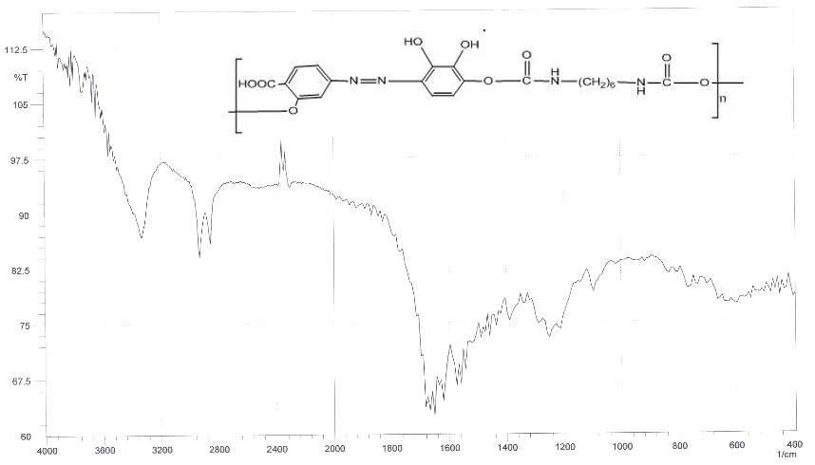

**Figure (1) The FTIR Spectra of AZO1**

**Synthesis and Characterization of 4-((2-bromo-4-hydroxyphenyl) diazenyl) -2-hydroxybenzoic acid.**

The 4-((2-bromo-4-hydroxyphenyl) diazenyl) -2-hydroxybenzoic acid was prepared by the coupling of 3-bromophenol with the diazonium salt of 5-ASA , for 1 hr. at (0-5οC) in ice bath as shown in scheme (2) .The FTIR Spectra of AZO2 in figure (2) , shows the following peaks :

3433 cm-1 (-OH phenolic stretching vibration) ; str. 3031 cm-1 (C-H vibration) ; 1712 cm-1 (carboxyl group C=O) ; 1481 , 1458 cm-1 (azo group N=N) ; 1242 cm-1 (C-O-C phenol) ; 1334 cm-1 (C-N) and 1589 cm-1 (C=C aromatic).

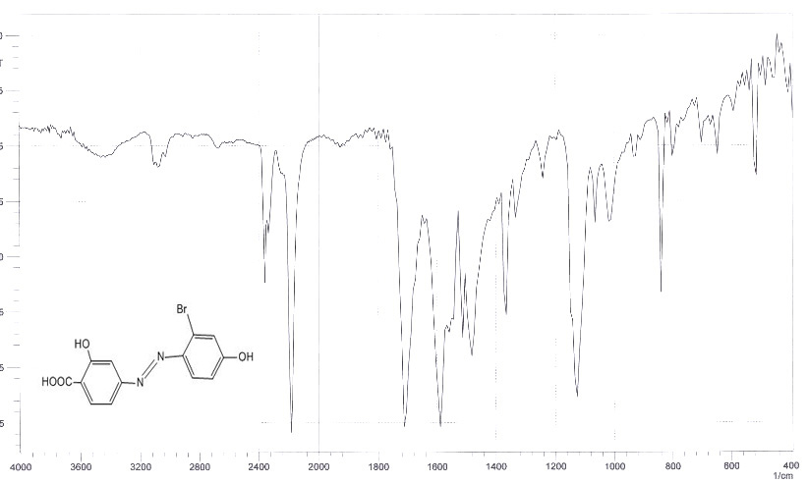

**Figure (2) The FTIR Spectra of AZO2**

**Synthesis and Characterization of 4-((2,4-dihydroxyphenyl)diazenyl)-2-hydroxybenzoic acid:**

The 4-((2,4-dihydroxyphenyl)diazenyl)-2-hydroxybenzoic acid was prepared by the coupling of Resorcinol with the diazonium salt of 5-ASA , for 1 hr. at (0-5οC) in ice bath as shown in scheme (3) .The FTIR Spectra of AZO3 in figure (3) , shows the following peaks :

3402 cm-1 (-OH phenolic stretching vibration) ; str. 3155 cm-1 (C-H vibration) ; 1697 cm-1 (carboxyl group C=O) ; 1434 , 1488 cm-1 (azo group N=N) ; 1211 cm-1 (C-O-C phenol) ; 1388 cm-1 (C-N) and 1589 cm-1 (C=C aromatic).

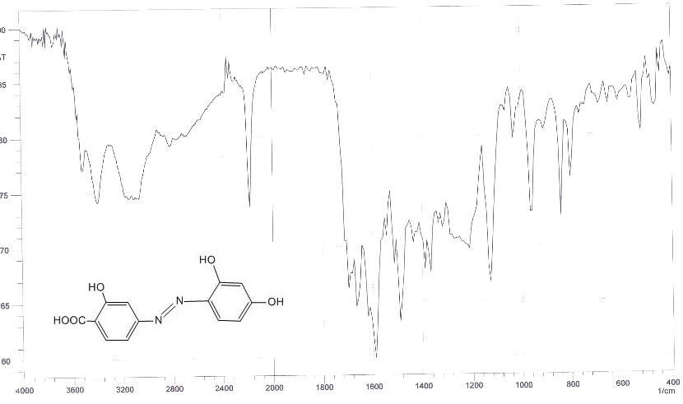

**Figure(3) The FTIR Spectra of AZO3**

**Synthesis and Characterization of 4-((3,4-dihydroxyphenyl)diazenyl)-2-hydroxybenzoic acid :**

The 4-((3,4-dihydroxyphenyl)diazenyl)-2-hydroxybenzoic acid was prepared by the coupling of pyrocatechole with the diazonium salt of 5-ASA , for 1 hr. at (0-5οC) in ice bath as shown in scheme (6) .The FTIR Spectra of AZO4 in figure (4) , shows the following peaks :

3440 cm-1 (-OH phenolic stretching vibration); str. 3085 cm-1 (C-H vibration); 1712 cm-1 (carboxyl group C=O); 1481 , 1512 cm-1 (azo group N=N); 1242 cm-1 (C-O-C phenol); 1365 cm-1 (C-N) and 1589 cm-1 (C=C aromatic).

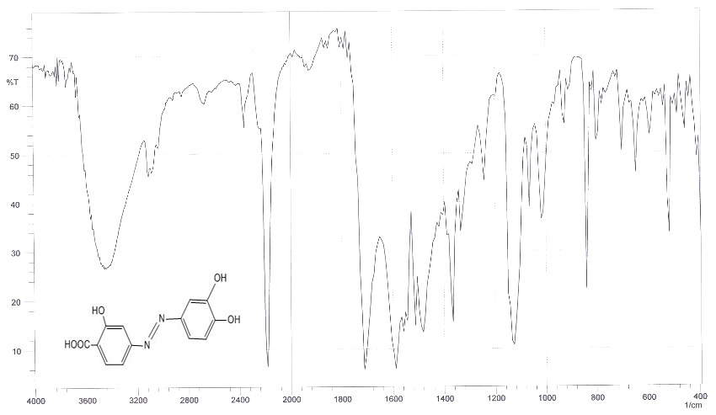

**Figure (4) The FTIR Spectra of AZO4**

**Synthesis and Characterization of 2-hydroxy-4-((4-hydroxy-2-methylphenyl)diazenyl)benzoic acid :**

The 2-hydroxy-4-((4-hydroxy-2-methylphenyl)diazenyl)benzoic acid was prepared by the coupling of m-cresol with the diazonium salt of 5-ASA , for 1 hr. at (0-5οC) in ice bath as shown in scheme (4) .The FTIR Spectra of AZO5 in figure (5) , shows the following peaks :

3317 cm-1 (-OH phenolic stretching vibration); str. 3085 cm-1 (C-H vibration); 1712 cm-1 (carboxyl group C=O); 1465 , 1542 cm-1 (azo group N=N); 1242 cm-1 (C-O-C phenol); 1319 cm-1 (C-N) and 1589 cm-1 (C=C aromatic).

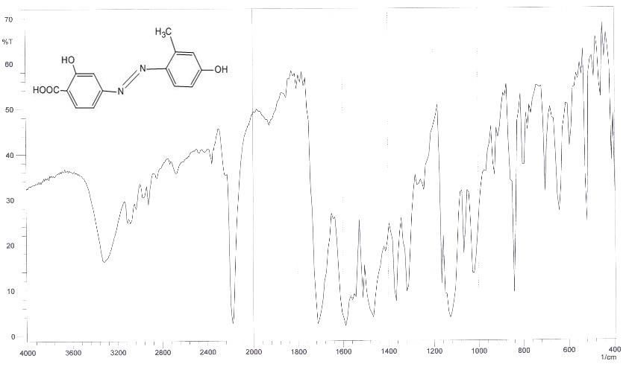

**Figure (5) The FTIR Spectra of AZO5**

**Synthesis and Characterization of 2-hydroxy-4-((2-hydroxynaphthalen-1-yl)diazenyl)benzoic acid :**

The 2-hydroxy-4-((2-hydroxynaphthalen-1-yl) diazenyl)benzoic acid was prepared by the coupling of β-naphthole with the diazonium salt of 5-ASA , for 1 hr. at (0-5οC) in ice bath as shown in scheme (5) .The FTIR Spectra of AZO6 in figure (6) , shows the following peaks :

3332 cm-1 (-OH phenolic stretching vibration); str. 2931 cm-1 (C-H vibration); 1712 cm-1 (carboxyl group C=O); 1404 , 1481 cm-1 (azo group N=N); 1257 cm-1 (C-O-C phenol); 1365 cm-1 (C-N) and 1589 cm-1 (C=C aromatic).

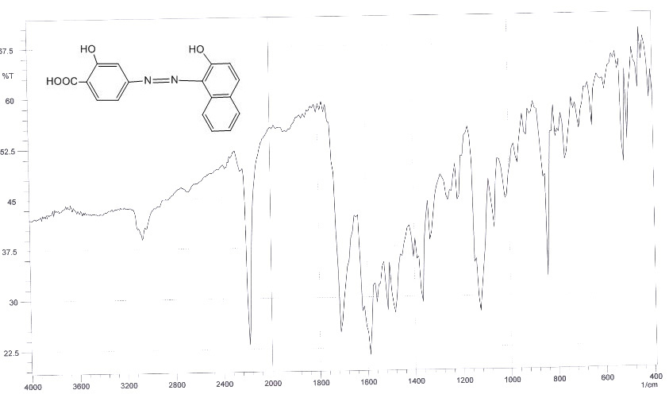

**Figure (6) The FTIR Spectra of AZO6**

***The general equation of the synthesis of all these monomers is :***

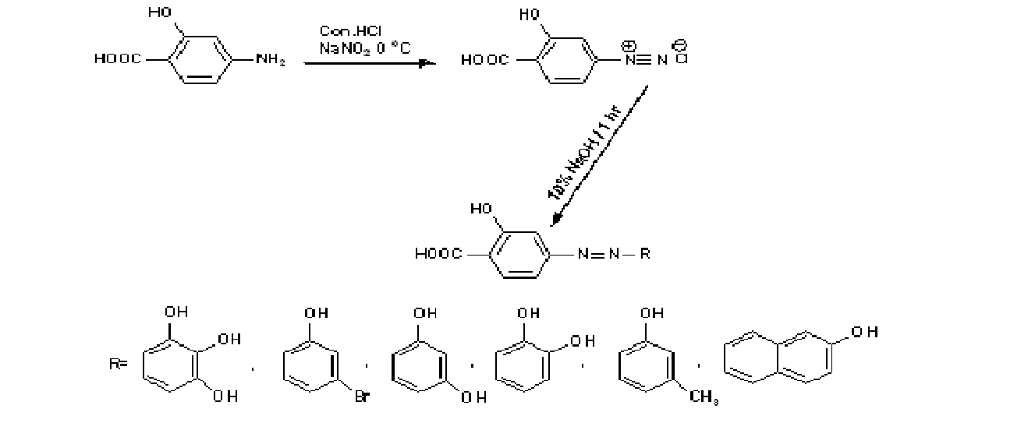

**scheme 14 The synthesis of AZO monomers (pyragollal, 3-bromophenol, Resorcinol, pyrocatechole, m-cresol, b-naphthole) respectively .**

**Syntheses and Characterization of Azo polyurethane:**

**Synthesis and Characterization of (PU1):**

Biodegradable azo-containing polyurethanes (PU AZO1) was prepared by polycondensation of HDI with AZO2, at 80 ºC for 8 hrs. under a dry nitrogen atmosphere as shown in scheme (15) .



**Scheme (15) Synthesis of PU1**

**The FTIR Spectra of (PU AZO1) , as in figure (7) , shows the following peaks :**

3332 cm-1 (-OH phenolic stretching vibration) ;3533 (N-H stretching vibration) ; str. 2931 cm-1 (C-H vibration of polymer backbone) ; 1712 cm-1 (ester group C=O) ; 1458 , 1542 cm-1 (azo group N=N) ; 1388 cm-1 (C-N) and 1666 cm-1 (C=C phenol).



**Figure (7) The FTIR Spectra of PUAZO1**

**Synthesis and Characterization of (PU2):**

Biodegradable azo-containing polyurethanes (PU AZO1) was prepared by polycondensation of HDI with AZO1, at 80 ºC for 8 hrs. under a dry nitrogen atmosphere as shown in scheme (16) .



**Scheme (16) Synthesis of PU2**

H1NMR (400 MHz,d6-DMSO) : δ 1.24-1.41(m,3H,CH2) ; δ 2.5 (s,1H,DMSO) ; δ 2.95 (m,3H,CH2-NH); δ6.36 (s,1H,CH-Ph) ; δ6.89-7.79 (d,3H, Ph) ; δ8.12 (d,2H, O=(C=O)-NH ) ; δ11.08(s,1H, O-C=OH).

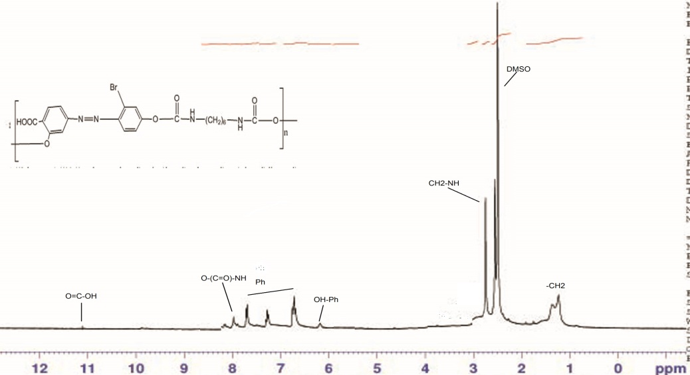

**Figure (8) The 1HNMR Spectra of PUAZO2**

**The FTIR Spectra of (PU AZO2) , as in figure (9) , shows the following peaks :**

3332 cm-1 (-OH phenolic stretching vibration) ;3573 (N-H stretching vibration) ; str. 2931 cm-1 (C-H vibration of polymer

backbone) ; 1712 cm-1 (ester group C=O) ; 1434 , 1458 cm-1 (azo group N=N) ; 1342 cm-1 (C-N) and 1620 cm-1 (C=C phenol.

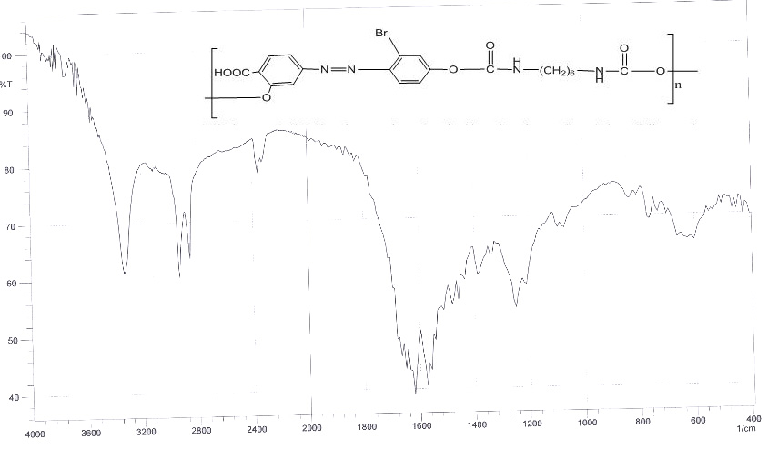

**Figure (9) The FTIR Spectra of PUAZO2**

**Synthesis and Characterization of (PU3):**

Biodegradable azo-containing polyurethanes (PU AZO3) was prepared by polycondensation of HDI with AZO3, at 80 ºC for 8 hrs. under a dry nitrogen atmosphere as in scheme (17) .



**Scheme (17) Synthesis of PU3**

H1NMR (400 MHz,d6- DMSO) : δ 1.13-1.34(m,3H,(CH2)4) ; δ 2.5 (s,1H,DMSO); δ 2.95 (m,3H,CH2-NH);δ 3.32(s,1H,H2O) δ8.04 (d,2H, Ph) ; δ11.08(s,1H, O-C=OH).

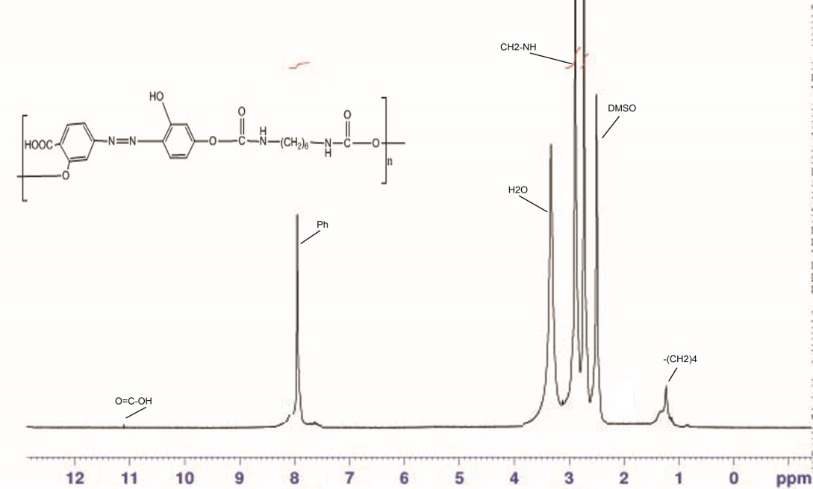

**Figure (17) The 1HNMR Spectra of PUAZO3**

**The FTIR Spectra of (PU AZO3) , as in figure (18) , shows the following peaks :**

3332 cm-1 (-OH phenolic stretching vibration) ;3541 (N-H stretching vibration) ; str. 2931 cm-1 (C-H vibration of polymer backbone) ; 1712 cm-1 (ester group C=O) ; 1481 , 1458 cm-1 (azo group N=N) ; 1388 cm-1 (C-N) and 1620 cm-1 (C=C phenol.

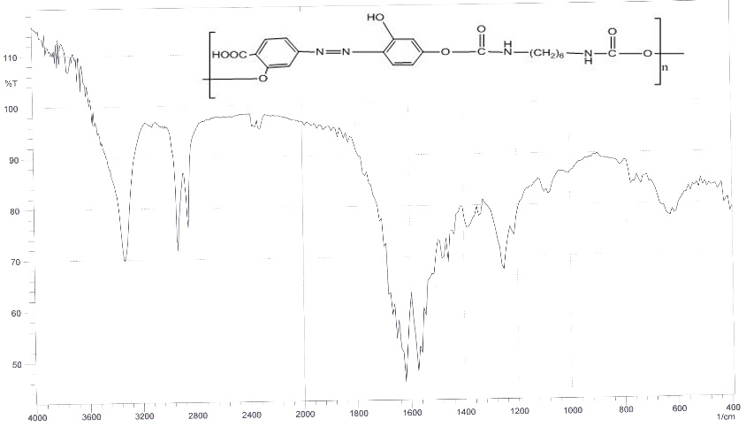

**Figure (18) The FTIR Spectra of PUAZO3**

**Synthesis and Characterization of (PU4):**

Biodegradable azo-containing polyurethanes (PU AZO4) was prepared by polycondensation of HDI with AZO4, at 80 ºC for 8 hrs. under a dry nitrogen atmosphere as in scheme (18) .

 **Scheme (18) Synthesis of PU4**

**The FTIR Spectra of (PU AZO4) , as in figure (19) , shows the following peaks :**

3332 cm-1 (-OH phenolic stretching vibration) ;3567 (N-H stretching vibration) ; str. 2931 cm-1 (C-H vibration of polymer backbone) ; 1712 cm-1 (ester group C=O) ; 1481 , 1458 cm-1 (azo group N=N) ; 1373 cm-1 (C-N) and 1573 cm-1 (C=C phenol.

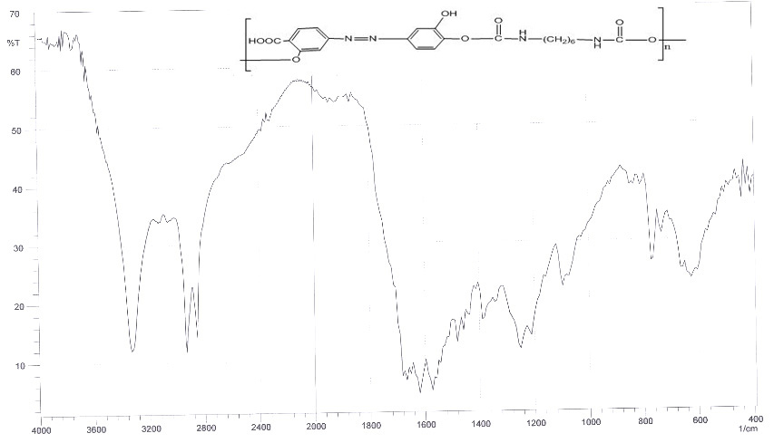

**Figure (19) The FTIR Spectra of PUAZO4**

**Synthesis and Characterization of (PU5):**

Biodegradable azo-containing polyurethanes (PU AZO5) was prepared by polycondensation of HDI with AZO5, at 80 ºC for 8 hrs. under a dry nitrogen atmosphere as in scheme (19) .



***Scheme (19) Synthesis of PU5***

**The FTIR Spectra of (PU AZO5) , as in figure (20) , shows the following peaks :**

3332 cm-1 (-OH phenolic stretching vibration) ;3480 (N-H stretching vibration) ; str. 2931 cm-1 (C-H vibration of polymer backbone) ; 1712 cm-1 (ester group C=O) ; 1473 , 1573 cm-1 (azo group N=N) ; 1326 cm-1 (C-N) and 1620 cm-1 (C=C phenol.

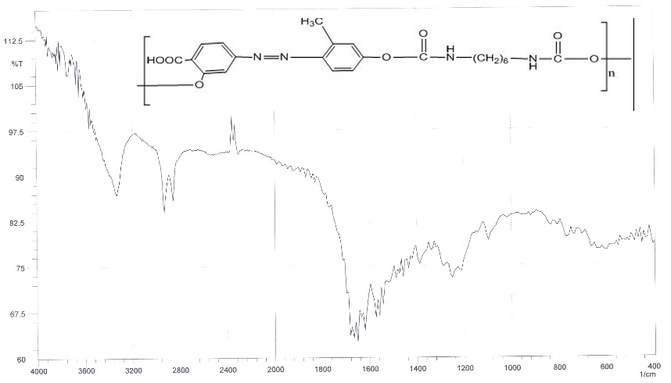

**Figure (20) The FTIR Spectra of PUAZO5**

**Synthesis and Characterization of (PU6):**

Biodegradable azo-containing polyurethanes (PU AZO6) was prepared by polycondensation of HDI with AZO6, at 80 ºC for 8 hrs. under a dry nitrogen atmosphere as in scheme (20) .



**Scheme (20) Synthesis of PU6**

H1NMR (400 MHz, DMSO) : δ 1.24-1.41(m,3H,(CH2)4) ; δ 2.5 (s,1H,DMSO) ; δ 2.95 (m,3H,CH2-NH);δ 3.32(s,1H,H2O) ; δ5.67 (s,1H,Ph-O) ; δ6.97-7-81 (d,3H, Ph) ; δ8.12 (d,2H, O-(O=C)NH ) ; δ11.08(s,1H, O=C-OH), these result were in agreement well with ]17[

.

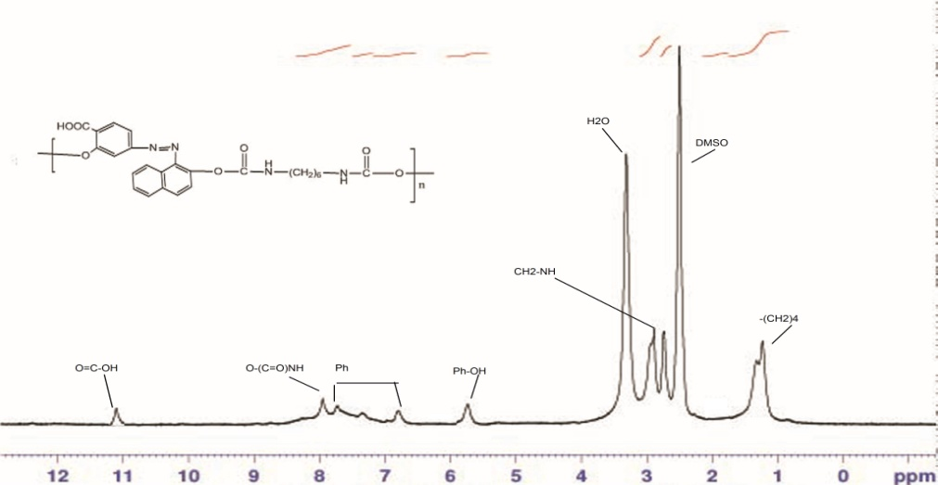

**Figure (21) The1HNMR Spectra of PU6**

**The FTIR Spectra of (PU AZO6) , as in figure (22) , shows the following peaks :**

3332 cm-1 (-OH phenolic stretching vibration) ;3575 (N-H stretching vibration) ; str. 2931 cm-1 (C-H vibration of polymer backbone) ; 1666 cm-1 (ester group C=O) ; 1458 , 1434 cm-1 (azo group N=N) ; 1342 cm-1 (C-N) and 1580 cm-1 (C=C phenol.

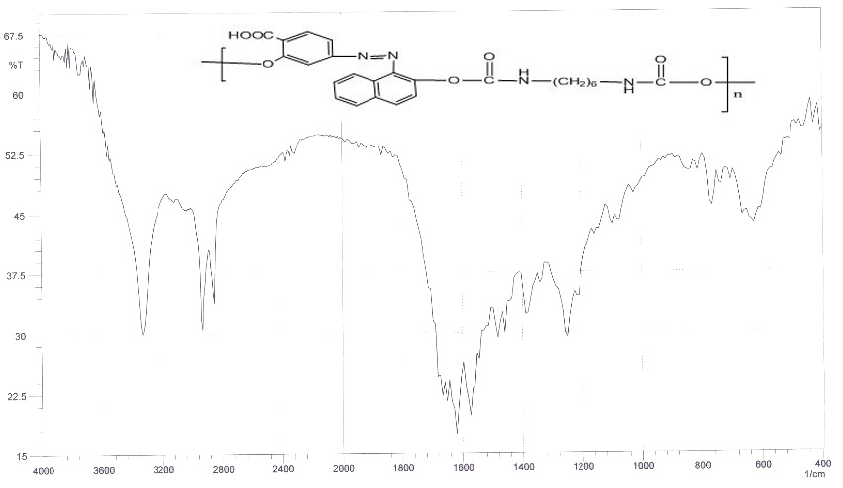

**Figure (22) The FTIR Spectra of PUAZO6**

**The UV–Vis Spectra of Synthesized Azo Polyurethane:**

UV–Vis spectra for the prepared polymers have been found to contain absorption bands around 450 nm as shown in Fig.(23-28).

The Ultraviolet spectra of (PU AZO1); in figure (23), shows the following peaks :

π →π* at 351 mμ to carbonyl group, phenyl ring , amine

n→π* at 463 mμ to azo compound.

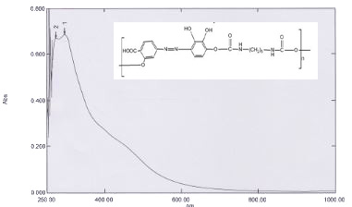

**Figure (23) The U.V-Vis Spectra of PUAZO1**

**The Ultraviolet spectra of (PU AZO2);**

**as in figure (24), shows the following peaks :**

π →π* at 296 mμ to carbonyl group, phenyl

ring , amine n→π* at 368 mμ to azo compound.

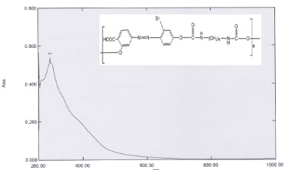

**Figure (24) The U.V-Vis Spectra of PUAZO2**

**The Ultraviolet spectra of (PU AZO3);**

**as in figure (25), shows the following peaks :**

π →π* at 278 mμ to carbonyl group, phenyl

ring , amine n→π* at 415 mμ to azo compound

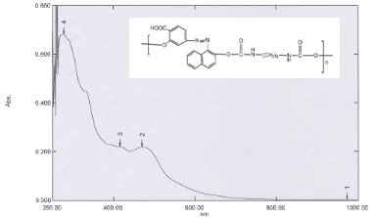

**Figure (25) The U.V-Vis Spectra of PUAZO3**

**The Ultraviolet spectra of (PU AZO4);**

**as in figure (26), shows the following peaks :**

π →π* at 272 mμ to carbonyl group, phenyl

ring , amine n→π* at 437 mμ to azo compound

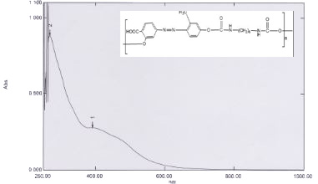

**Figure (26) The U.V-Vis Spectra of PUAZO4**

**The Ultraviolet spectra of (PU AZO5);**

**as in figure (27), shows the following peaks:**

π →π* at 269 mμ to carbonyl group, phenyl

ring , amine n→π* at 391 mμ to azo compound

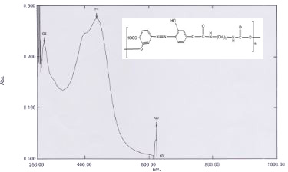

**Figure (27) The U.V-Vis Spectra of PUAZO5**

**The Ultraviolet spectra of (PU AZO6);**

**as in figure (28), shows the following peaks :**

π →π* at 296 mμ to carbonyl group, phenyl

ring , amine n→π* at 340 mμ to azo compound

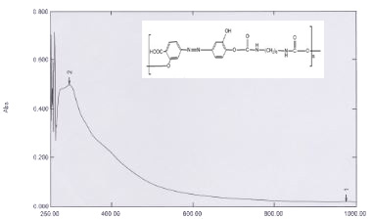

**Figure (28) The U.V-Vis Spectra of PUAZO6**

**In vitro Drug release**

At pH 7.8, polymer 1 released 93%, polymer 2 released 83% ,polymer 3 released 72%, polymer 4 released 86%, polymer 5 released 90% , and polymer 6 released 69% of 5-ASA respectively, after 45 hrs at 37 ºC.

At pH 4, polymer 1 released 67%, polymer 2 released 59% ,polymer 3 released 56%, polymer 4 released 58%, polymer 5 released 60% , polymer 6 released 55% of 5-ASA respectively, after 45 hrs at 37 ºC.

This means that more than 90% of the drug will pass to the colon without hydrolysis. Therefore, this indicated that the system will be useful for colon drug targeting. Generally, as the number of polar groups on the monomeric units along the polymer chain increased, the hydrophilicity of the polymer increased, and the rate of hydrolysis increased, and consequently, the amount of 5-ASA released increased .

As shown in tables (3), the degradation of PU-AZO at 37°C under acidic (pH 4) conditions was the slowest. At pH 7.8, AZO was released gradually and the polymer degradation was complete by 45 hrs. Base catalyzed hydrolysis of the urethane bonds of the polymer is much more rapid under basic conditions than acid conditions .

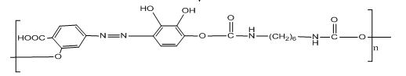

**Scheme 7 Polyurethane 1**

**Table (3) Hydrolysis result of PU AZO1 ,at ( pH=7.8, pH =4 , 37 οC)**

|  |  |  |  |  |  |  |  |
| --- | --- | --- | --- | --- | --- | --- | --- |
| pH=4 | | |  | pH=7.8 | | |  |
| Drug release% | Conc. | Abs. | Time | Drug release% | Conc. | Abs. | No. |
| 38 | 0.038 | 0.0032152 | 1 | 60 | 0.06 | 0.003224 | 1 |
| 44 | 0.044 | 0.0032176 | 5 | 67 | 0.067 | 0.0032268 | 2 |
| 47 | 0.047 | 0.0032188 | 10 | 74 | 0.074 | 0.0032296 | 3 |
| 51 | 0.051 | 0.0032204 | 15 | 79 | 0.079 | 0.0032316 | 4 |
| 54 | 0.054 | 0.0032216 | 20 | 80 | 0.08 | 0.003232 | 5 |
| 59 | 0.059 | 0.0032236 | 25 | 84 | 0.084 | 0.0032336 | 6 |
| 60 | 0.06 | 0.003224 | 30 | 86 | 0.086 | 0.0032344 | 7 |
| 63 | 0.063 | 0.0032252 | 35 | 88 | 0.088 | 0.0032352 | 8 |
| 67 | 0.067 | 0.0032268 | 40 | 91 | 0.091 | 0.0032364 | 9 |
| 69 | 0.069 | 0.0032276 | 45 | 93 | 0.093 | 0.0032372 | 10 |

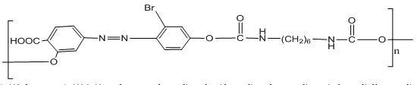

**Scheme 8 Polyurethane 2**

**Table (4) Hydrolysis result of PU AZO2 ,at ( pH=7.8, pH =4 , 37 οC)**

|  |  |  |  |  |  |  |  |
| --- | --- | --- | --- | --- | --- | --- | --- |
| pH=4 | | |  | pH=7.8 | | |  |
| Drug release% | Conc. | Abs. | Time | Drug release% | Conc. | Abs. | No. |
| **14** | **0.014** | **0.003214** | **1** | **22** | **0.022** | **0.0032204** | **1** |
| **18** | **0.018** | **0.0032072** | **5** | **25** | **0.025** | **0.00321** | **2** |
| **21** | **0.021** | **0.0032084** | **10** | **29** | **0.029** | **0.0032116** | **3** |
| **26** | **0.026** | **0.0032104** | **15** | **32** | **0.032** | **0.0032128** | **4** |
| **30** | **0.03** | **0.003212** | **20** | **37** | **0.037** | **0.0032148** | **5** |
| **37** | **0.037** | **0.0032148** | **25** | **48** | **0.048** | **0.0032192** | **6** |
| **41** | **0.041** | **0.0032164** | **30** | **50** | **0.05** | **0.00322** | **7** |
| **44** | **0.044** | **0.0032176** | **35** | **53** | **0.053** | **0.0032212** | **8** |
| **49** | **0.049** | **0.0032196** | **40** | **57** | **0.057** | **0.0032228** | **9** |
| **55** | **0.055** | **0.003222** | **45** | **64** | **0.064** | **0.0032256** | **10** |

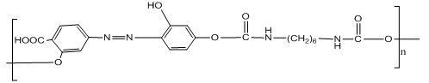

**Scheme 9** **Polyurethane 3**

**Table (8) Hydrolysis result of PU AZO3 ,at ( pH=7.8, pH =4 ,37 οC)**

|  |  |  |  |  |  |  |  |
| --- | --- | --- | --- | --- | --- | --- | --- |
| **pH=4** | | |  | **pH=7.8** | | |  |
| **Drug release%** | **Conc.** | **Abs.** | **Time** | **Drug release%** | **Conc.** | **Abs.** | **No.** |
| **18** | **0.018** | **0.0032072** | **1** | **59** | **0.059** | **0.0032508** | **1** |
| **27** | **0.027** | **0.0032108** | **5** | **66** | **0.066** | **0.0032264** | **2** |
| **33** | **0.033** | **0.0032132** | **10** | **68** | **0.068** | **0.0032272** | **3** |
| **36** | **0.036** | **0.0032144** | **15** | **73** | **0.073** | **0.0032292** | **4** |
| **43** | **0.043** | **0.0032172** | **20** | **75** | **0.075** | **0.00323** | **5** |
| **48** | **0.048** | **0.0032192** | **25** | **77** | **0.077** | **0.0032308** | **6** |
| **50** | **0.05** | **0.00322** | **30** | **82** | **0.082** | **0.0032328** | **7** |
| **53** | **0.053** | **0.0032212** | **35** | **85** | **0.085** | **0.003234** | **8** |
| **56** | **0.056** | **0.0032224** | **40** | **89** | **0.089** | **0.0032356** | **9** |
| **59** | **0.059** | **0.0032236** | **45** | **90** | **0.09** | **0.003236** | **10** |

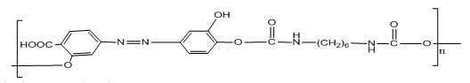

**Scheme 10 Polyurethane 4**

**Table (5) Hydrolysis result of PU AZO4,at ( pH=7.8, pH =4 , 37 οC)**

|  |  |  |  |  |  |  |  |
| --- | --- | --- | --- | --- | --- | --- | --- |
| **pH=4** | | |  | **pH=7.8** | | |  |
| **Drug release%** | **Conc.** | **Abs.** | **Time** | **Drug release%** | **Conc.** | **Abs.** | **No.** |
| **17** | **0.017** | **0.0032172** | **1** | **37** | **0.037** | **0.003238** | **1** |
| **22** | **0.022** | **0.0032088** | **5** | **47** | **0.047** | **0.0032188** | **2** |
| **26** | **0.026** | **0.0032104** | **10** | **58** | **0.058** | **0.0032232** | **3** |
| **31** | **0.031** | **0.0032124** | **15** | **64** | **0.064** | **0.0032256** | **4** |
| **38** | **0.038** | **0.0032152** | **20** | **68** | **0.068** | **0.0032272** | **5** |
| **43** | **0.043** | **0.0032172** | **25** | **77** | **0.077** | **0.0032308** | **6** |
| **46** | **0.046** | **0.0032184** | **30** | **78** | **0.078** | **0.0032312** | **7** |
| **53** | **0.053** | **0.0032212** | **35** | **82** | **0.082** | **0.0032328** | **8** |
| **59** | **0.059** | **0.0032236** | **40** | **84** | **0.084** | **0.0032336** | **9** |
| **60** | **0.06** | **0.003224** | **45** | **86** | **0.086** | **0.0032344** | **10** |

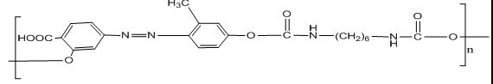

**Scheme 11** **Polyurethane 5**

**Table (7) Hydrolysis result of PU AZO5 ,at ( pH=7.8, pH =4 , 37 οC)**

|  |  |  |  |  |  |  |  |
| --- | --- | --- | --- | --- | --- | --- | --- |
| **pH=4** | | |  | **pH=7.8** | | |  |
| **Drug release%** | **Conc.** | **Abs.** | **Time** | **Drug release%** | **Conc.** | **Abs.** | **No.** |
| **20** | **0.02** | **0.003208** | **1** | **39** | **0.039** | **0.0032156** | **1** |
| **27** | **0.027** | **0.0032108** | **5** | **47** | **0.047** | **0.0032188** | **2** |
| **31** | **0.031** | **0.0032124** | **10** | **49** | **0.049** | **0.0032196** | **3** |
| **35** | **0.035** | **0.003214** | **15** | **54** | **0.054** | **0.0032216** | **4** |
| **38** | **0.038** | **0.0032152** | **20** | **57** | **0.057** | **0.0032228** | **5** |
| **42** | **0.042** | **0.0032168** | **25** | **65** | **0.065** | **0.003226** | **6** |
| **44** | **0.044** | **0.0032176** | **30** | **66** | **0.066** | **0.0032264** | **7** |
| **48** | **0.048** | **0.0032192** | **35** | **69** | **0.069** | **0.0032276** | **8** |
| **53** | **0.053** | **0.0032212** | **40** | **70** | **0.07** | **0.003228** | **9** |
| **56** | **0.056** | **0.0032224** | **45** | **72** | **0.072** | **0.0032288** | **10** |

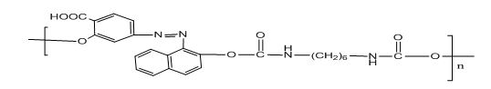

**Scheme 12** **Polyurethane 6**

**Table (6) Hydrolysis result of PU AZO6 ,at ( pH=7.8, pH =4 , 37 οC)**

|  |  |  |  |  |  |  |  |
| --- | --- | --- | --- | --- | --- | --- | --- |
| pH=4 | | |  | pH=7.8 | | |  |
| Drug release% | Conc. | Abs. | Time | Drug release% | Conc. | Abs. | No. |
| 21 | 0.021 | 0.0032216 | 1 | 44 | 0.044 | 0.0032176 | 1 |
| 28 | 0.028 | 0.0032112 | 5 | 45 | 0.045 | 0.003218 | 2 |
| 33 | 0.033 | 0.0032132 | 10 | 55 | 0.055 | 0.003222 | 3 |
| 36 | 0.036 | 0.0032144 | 15 | 59 | 0.059 | 0.0032236 | 4 |
| 40 | 0.04 | 0.003216 | 20 | 64 | 0.064 | 0.0032256 | 5 |
| 43 | 0.043 | 0.0032172 | 25 | 68 | 0.068 | 0.0032272 | 6 |
| 47 | 0.047 | 0.0032188 | 30 | 77 | 0.077 | 0.0032308 | 7 |
| 50 | 0.05 | 0.00322 | 35 | 79 | 0.079 | 0.0032316 | 8 |
| 56 | 0.056 | 0.0032224 | 40 | 81 | 0.081 | 0.0032324 | 9 |
| 58 | 0.058 | 0.0032232 | 45 | 83 | 0.083 | 0.0032332 | 10 |

**Determination of the Total 5-ASA Content**

To determine the total content of the polymers derived from 5-ASA, it was necessary to carry out a fast hydrolysis of the drug from the polymers. Heating the polymeric systems at 60 ºC in phosphate buffer with pH 7.8 and pH 4 hydrolyzed the drug-polymer bond. The fast hydrolysis of 5-ASA in buffer solution led to total 5-ASA contents . At pH 7.8 at 37 ºC, the total amounts of 5-ASA released after two days were found to be 85% , 86% , 80% , 83% , 88% , 60% for polymers respectively. At pH=4 and 37 ºC temperature, the total amounts of 5-ASA released after two days were found to be 57% , 50% , 53% , 56% , 60% , 51% for polymers respectively.

**Table (9) The total amount released of 5-ASA at ( pH=7.8, pH =4 ,** **37 οC)**

|  |  |  |  |  |  |  |  |
| --- | --- | --- | --- | --- | --- | --- | --- |
| **pH=4** | | |  | **pH=7.8** | | |  |
| **Drug release%** | **Conc.** | **Abs.** | **polymer** | **Drug release%** | **Conc.** | **Abs.** | **No.** |
| 60 | 0.06 | 0.003224 | PU1 | 88 | 0.088 | 0.0032352 | **1** |
| 51 | 0.051 | 0.0032204 | PU2 | 60 | 0.06 | 0.003224 | **2** |
| 57 | 0.057 | 0.003244 | PU3 | 86 | 0.086 | 0.0032344 | **3** |
| 53 | 0.053 | 0.0032212 | PU4 | 83 | 0.083 | 0.0032332 | **4** |
| 50 | 0.05 | 0.00322 | PU5 | 80 | 0.08 | 0.003232 | **5** |
| 56 | 0.056 | 0.0032224 | PU6 | 85 | 0.085 | 0.003266 | **6** |

**Conclusion**

Polyurethanes were successfully synthesized by incorporating bioactive 5 ASA molecules into the polymer backbone. Specific amounts of the low molecular weight azo derivatives (AZO1-AZO6) can be released by hydrolytic degradation of the polymers in physiological conditions.

Hydrolytic degradation is pH-dependant and is negligible in acidic conditions . Due to the pH-dependent degradation of the polymers, these polyurethane derivatives of 5-ASA could be effective in treating gastrointestinal disease where it is important to release the drug at the desired site, the colon (basic conditions), rather than the upper intestine or stomach which are neutral or acidic, respectively.

**References**

1. Yang, K.; Kurihara, N.; Fan, K.; Newmark, H.; Rigas, B.; Bancroft, L.; Corner, G.; Livote, E.; Lesser, M.; Edelmann W.; et al. Dietary induction of colonic tumors in a Terzic, J.; Grivennikov, S.; Karin, E.; Karin, M. Inflammation and colon cancer. Gastroenterology; 2010, **138**, 2101–2114.e5.
2. Raton, Kopec˘kova, Rathi, Takada, Rihova, and Berson ***J. iranian polymer.;***1994,**28**,211–222.
3. Giovanni Monteleone, Francesco Pallone and Carmine Stolfi: The Dual Role of Inflammation in Colon Carcinogenesis.  ***Int. J. Mol. Sci.;*** 2012, **13**, 11071-11084.
4. Shakuma, S.; Kopec˘kova, Z. and Kopec˘ek, J. J.; 2001,**75**, 365–379.
5. Lu, Z.; Sakuma, J.; Kopec˘kova, S., and Kopec˘ek J. ***J. iranian polymer.;*** 2002,**78**, 165–173.
6. LomLim, R., and Saramunee K. ***J. iranian polymer*.;**2003**,(88)**,1–9.7.
7. .El-RefaieKenawy, Salem S. Al-Deyab and Mohamed H. El-Newehy, Controlled Release of 5-Aminosalicylic Acid (5-ASA) from New Biodegradable Polyurethanes. Molecules; 2010, **15**, 2257-2268.
8. Mahkam M, Assadi MG, Ramesh M, Davaran S. Linear Type Azo Containing Polyurethanes for Colon-Specific Drug Delivery. ***J Bioact Compat Polym.;*** 2004***,* M** **9**, 45-53.
9. Schacht , E.; Geraert, E.; Kenaw, R.; Molly, K.; Verstraete, W.; Adriaensens P. J.;1996,**39**,327-338.
10. Schroder, H.; Johansson A. ***J.iranian polymer***.; 1973,**3**, 233- 246.
11. . Mahkam, M.; Assadi, M.G.; Zahedifar, R.; Ramesh, M. Linear Type Azo-containing Polyurethanes for Colon-specific Drug Delivery. ***J. Bioact. Compat. Pol.***;2004, **19**, 45–53 .
12. Dubru , D.; Wright K. ***J. iranian polymer***.; 1975, **5**, 563-567.
13. Hanohan, T.; Enderlin E.***,J.iranian polymer***.;1977,**7**,765 -701 .
14. Brown J. ***,J.iranian polymer***.;1981, **41**,1283 -1286.
15. Rana Mazumder, R.; Nath, L.K.; Haque, A.; Maity, T.; Choudhuy, P.K.; Shrestha, B.; Chakraborty, M.; Pal, R.N. Formulation and in vitro evaluation of natural polymers based Microspheres for colonic drug delivery. ***Int. J. Pharm. Pharm. Sci***.;2010,**2**,211–219 .