Preparation and characterization of new azo imidazole ligand and
some Transition Metal Complexes

Rahim T. Mehdi
Dep. Of Chemistry, College of Science, AL-Mustansiria University
and
A. M. Ali
Dep. Of Chemistry, College of Education for Women , University of Kufa

(NJC)

(Received on 6/ 4 /2005) (Accepted for publication on 28/9/2005)

Abstract
New heterocyclic azo dye ligand 2-[1-(2-Hydroxy-5-methyl phenyl)azo]-4,5-diphenyl imidazole (HMAI), was prepared by reacting a diazonium salt solution of 2-amino-4-methyl phenol with 4,5-diphenyl imidazole in alkaline pyridine. Six complexes with Co, Ni, Cu, Zn, Cd, and Hg were prepared and characterized using available techniques. The analytical data show that the metal to ligand ratio in all complexes is (1:2).
الخلاصة
تضمن البحث تحضير صبغة ازو اميدازول جديدة 2-[1-(2-هيدروكسي-5-مثيل فنيل)ازو]-5،4-ثنائي فنيل اميدازول (HMAI) وذلك بمفاعلة محلول ملح الديازونيوم للمركب 2-امينو-4-مثيل فينول مع محلول 5،4-ثنائي فنيل اميدازول في البريدين ، كما تناول البحث تحضير معقدات لكل من الكوبلت ، النيكل ، النحاس ، الخارصين ، الكادميوم والزئبق مع الليكاند المحضره في هذا البحث. وقد شخصت الليكاند ومعقداتها بواسطة التحليل الدقيق للعناصر والتوصيلية المولارية ودراسة الخواص المغناطيسية والأشعة تحت الحمراء والأطياف الالكترونية وقد بينت النتائج ان نسبة (الليكاند:فلز) هي (1:2) لجميع المعقدات.

Introduction
The chemistry of phenyl azo imidazole has expanded in different directions. One of the most important used as analytical reagents^{(1,2)}, in addition to used its as reagents for solvent extraction to determination of some metal ions^{(3,4)}. This class of azo dyes being a (π-acidic) azo imine system (-N=N-C=N-) for this reason a number of these dyes were synthized and their abilities as chelating ligands⁽⁵⁻⁸⁾.
In this paper, we report the preparation of new azo imidazole ligand and the attempt to prepare and identify some transition metal complexes of this ligand.

Experimental
All chemicals were of highest purity and used as supplied by the manufactures, except of 4,5-diphenyl imidazole was prepared as described in the literature⁽⁹⁾.
Mass spectrum of ligand was obtained using G.C-Mass-Shimadzu QP 1000 A Gas-Mass spectrophotometer.
Elemental C.H.N analysis were carried out by perkin-Elmer 2400 Elemental analyzer.
IR spectra were recorded on (Pye-Unicom SP3-300), in the 4000-200 cm⁻¹ range using CsI disc.
The magnetic susceptibility for the prepared complexes were obtained at room temperature using (Farady Method). For this purpose, Bruker Magnet (B.M) had been employed.
Electronic spectrum were recorded using Shimadzu Uv-visible spectrophotometer UV-160A with ethanol as solvent.
The metal content of the complexes was measured using atomic absorption technique by (Shimadzu-AA-160).
Stuart melting point apparatus was used to measure the melting point of ligand and its complexes.
Electric molar conductivity measurements were carried out at room temperature, at concentration (10⁻³M) using conductivity bride model 31A.
Preparation and characterization of ligand (HMAI)
A diazonium solution was prepared by dissolving (1.23g, 0.01 mol) of 2-amino-4-methyl phenol in (30 cm³) of water and (3 cm³) of concentrated hydrochloric acid. The filtered solution was cooled to 0C°, treated with (15 cm³) of aqueous (1.0 M) sodium nitrate dropwise, and stirred for 15 min. 4,5-diphenyl imidazole (2.2 g, 0.01 mol) was dissolved in (150 cm³) of pyridine, and (50 cm³) of 10 % sodium hydroxide and (50 cm³) of 10 % sodium carbonate were added, the diazonium solution prepared above was then added dropwise for coupling. After the mixture had been stirred for an hour at 0-5C°, it was acidified with dilute hydrochloric acid to (ph=5). The precipitate was filtered off, and recrystallizd twice from aqueous ethanol (70%), and then dried in the oven at 70C° for several hours. The yield was (60%) (2.12g) of reddish brown powder. The structural of this ligand as shown below

Preparation of complexes
The complexes were prepared by adding (2mmol) from ligand dissolved in hot ethanol (50 cm³) and added dropwise with stirring astoiciometric amout of (1:2) for Co(II), Ni(II), Cu(II), Zn(II), Cd(II), and Hg(II) chloride salt dissolved in (10 cm³) hot distilled water. The mixture was heated to 50C° for (60 min), then left over night. The solid product thus formed was filtered off, washed with ethanol and dried in a desicator over anhydrous CaCl₂.
Results and discussion
elemental analysis are in agreement with formula of the ligand and its complexes given in (Table 1).
Mass spectrum of ligand (HMAI)
Mass spectrometer data support the proposed structure. The ligand was run using the direct insertion. When the temperature was 178C° the base peak had a measured mass of (354) corresponding to a molecular formula of C₂₂H₁₈N₄O , the calculated formula weight is (354). This formula is the ligand formula. A fragment at (Z/e =220) corresponding to the 4,5-diphenyl imidazole⁽¹⁰⁾. Another fragment at (Z/e =235 and 78) due to 2-amino-4,5-diphenyl imidazole and benzene ring respectively⁽¹¹⁾. The successive fragmentation peaks are shown in Fig.(1)

(Table 1) Physical properties and analysis of ligand and its complexes

No. | Compound | Color | M.p C° | Yield % | Formula | Found (caled) %
 |  |  |  |  |  | C | H | N | M
1 | HL | Reddish-brown | 178 | 60 | C₂₂H₁₈N₄O | 74.29  (74.57) | 4.95  (5.08) | 15.41  (15.82) | -
2 | [CoL₂] Cl. H₂O | Dark green | 210 | 71 | C₄₄H₃₆N₈O₃ClCo | 64.41  (64.50) | 4.28  (4.39) | 13.77  (13.68) | 7.04  (7.20)
3 | [NiL₂] | Green | 241 d | 59 | C₄₄H₃₄N₈O₂Ni | 69.13  (69.04) | 4.46  (4.44) | 14.53  (14.64) | 7.81  (7.67)
4 | [CuL₂] | Green | 197 | 53 | C₄₄H₃₄N₈O₂Cu | 68.53  (68.61) | 4.48  (4.41) | 14.63  (14.55) | 8.15  (8.25)
5 | [ZnL₂] | Dark red | 188 | 64 | C₄₄H₃₄N₈O₂Zn | 68.35  (68.44) | 4.29  (4.40) | 14.38  (14.51) | 8.62  (8.47)
6 | [CdL₂].H₂O | Red | 201 | 51 | C₄₄H₃₆N₈O₃Cd | 63.26  (63.12) | 4.34  (4.30) | 13.45  (13.39) | -
7 | [HgL₂].H₂O | Red | 203 d | 60 | C₄₄H₃₆N₈O₃Hg | 57.01  (57.10) | 3.77  (3.89) | 12.26  (12.11) | -

d= complex metal with decomposition
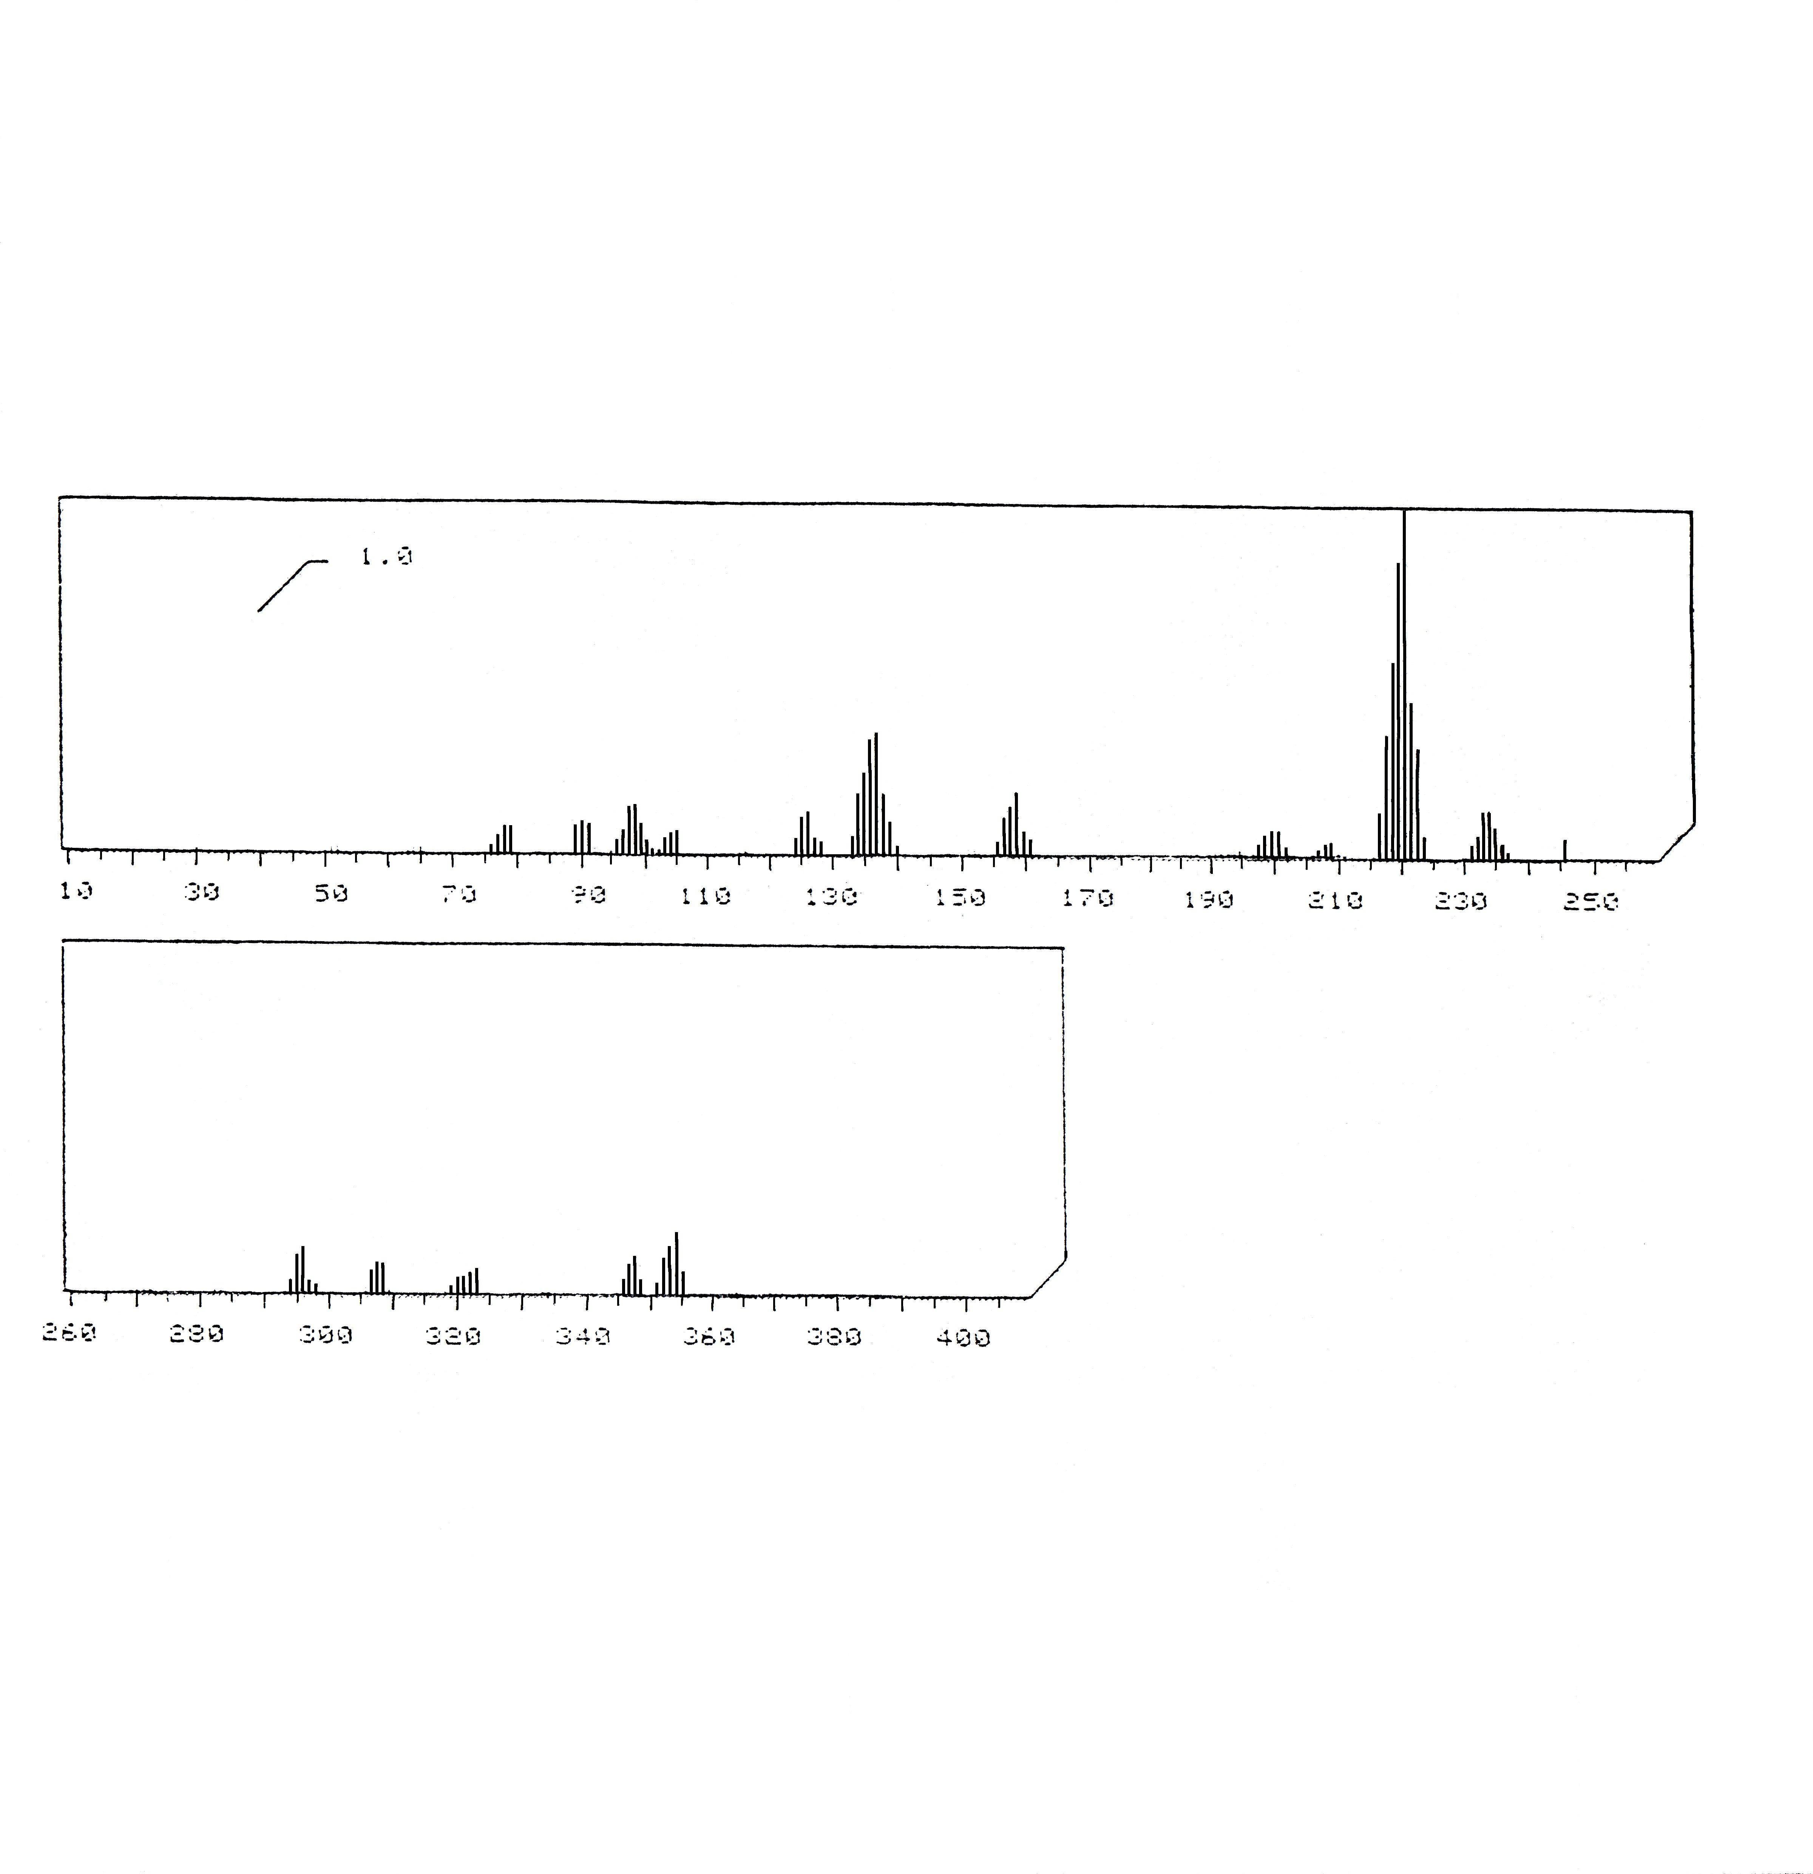

Fig.(1) The mass spectrum of ligand (HMAI)

Infrared spectra
Selected infrared absorption of the ligand and complexes are shown in (Table 2).
The broad absorption around 3250 cm⁻¹ in the spectrum of the ligand is a compsit of a minhydrogen and phenol group⁽¹⁰⁾. In the spectra of Co(III), Cd(II), and Hg(II) the broad band near 3350 cm⁻¹ indicates the presence of water molecule in these complexes⁽⁷⁾. But the spectra of rest complexes weak band observed at 3200 cm⁻¹ assigned to ν(NH) group in imidazole ring does not participate in coordantion⁽¹²⁾.
Spectra of ligand shows two weak bands at 3050 and 2980 cm⁻¹ due to ν(C-H) aromatic and aliphatic respectively. These band are stable in position and intensity in both ligand and its metal complexes.
The spectrum of ligand shows absorption at 1600 cm⁻¹ due to ν(C=N) of heterocyclic ring. It is observed with a little change in shape and shifted to lower frequances 1590-1580 cm⁻¹ in the prepared complexes spectra. These differents suggest the linkage of metal ion with nitrogen of imidazole ring⁽¹²⁾.
The ν(N=N) appear at 1490 cm⁻¹ in the spectra of free ligand. This band apparing at 1475-1465 cm⁻¹ in the spectra of complexes. Both band shift and reduced in intensity due to complex formation.^{(13,14)}
The two mono substituted aromatic rings on the imidazole ring⁽¹⁵⁾ are indicated by the absorption at 690 and 760 cm⁻¹. These bands shows in both ligand and its complexes spectra.
Complexes spectra show new weak band in the 445-250 cm⁻¹ region these band did not present in the spectrum of ligand may be attributed to ν(M-O), ν(M-N), and ν(M-Cl)⁽¹⁶⁻¹⁸⁾.
Thus the above I.R spectra data lead to suggest that the ligand behaves as tridentate chelating agent, coordinating with metals ion by a phenolic oxygen, azo nitrogen and nitrogen in imidazole ring to forming two five membered chelating ring.

Magnetic measurements and Electronic spectra
The spectra data and the magnetic moment of each complexes are listed in (Table 3)

Co(III) complex
The cobalt complex was found to be diamagnetic indicating the low spin behavior of this complex indicates that Co(II) is oxidized to Co(III) during complexation in aqueous solution. These finding are in agreement with earlier observation⁽¹⁹⁾. The electronic spectra of this complex shows two absorption band at 16354 cm⁻¹ and 20415 cm⁻¹ assigned to ¹A₁g → ¹T₁g and ¹A₁g → ¹T₂g transitions, respectively characteristic of octahedral stereo chemistry⁽²⁰⁾.

(Table 2) Selected I.R absorption bands of the ligand and its complexes in cm⁻¹ units

Compound | ν(O-H) | ν(C=N) | ν(N=N) | ν(M-O) | ν(M-N) | ν(M-Cl)
HL | 3250 wbr | 1600  m | 1490  m | - | - | -
[CoL₂] Cl. H₂O | 3350  wbr | 1590  m | 1475  w | 440  w | 345  w | 255  w
[NiL₂] | - | 1580  msh | 1470  w | 435  w | 330  w | -
[CuL₂] | - | 1580  msh | 1465  m | 445  w | 340  w | -
[ZnL₂] | - | 1590  msh | 1475  w | 435  w | 360  w | -
[CdL₂].H₂O | 3300  wbr | 1585  m | 1470  m | 445  w | 385  w | -
[HgL₂].H₂O | 3350  wbr | 1580  msh | 1465  w | 440  w | 380  w | -
HL=ligand (HMAI), w=weak, m=medium, br=broad, sh=sholder

(Table 3) Electronic spectra, conductivity and magnetic moment data of the metal complexes
Complex | Absorption bands (cm⁻¹) | Transition | Conductivity  s.mol⁻.¹cm² | µeff  (B.M)
[CoL₂] Cl. H₂O | 16354  20415 | ¹A₁g → ¹T₁g  ¹A₁g → ¹T₂g | 69.32 | dia
[NiL₂] | 9198  14475  23450 | ³A₂g → ³T₂g(F)  ³A₂g → ³T₁g(F)  ³A₂g → ³T₁g(P) | 7.98 | 3.1
[CuL₂] | 16050 | ²B₂g → ²A₂g | 6.77 | 1.79
[ZnL₂] | - | - | 5.43 | Dia
[CdL₂].H₂O | - | - | 6.23 | Dia
[HgL₂].H₂O | - | - | 7.56 | Dia

Ni(II) complex
The magnetic measurement show that the Ni(II) complex exhibit magnetic moment of (3.1 B.M) lie well with in the rang of octahedral high spin nickel (II) complex⁽²¹⁾. The electronic spectra of this complex show two spin-allowed transitions at 23450 cm⁻¹ and 14475 cm⁻¹ corresponding to ³A₂g → ³T₁g(F) and ³A₂g → T₁g (P) respectively. There are the ν₂ and ν₃ bands⁽²²⁾. The third spin allowed absorption band ν₁ was not observed but were calculated using ν₂ and ν₃ band positions, the calculated value is 9198 cm⁻¹ due to ³A₂g → ³T₂g. ⁽²³⁾

Cu(II) complex
The value of magnetic moment for this complex was found to be (1.79 B.M) due to the presence of one unpaired electron in this compound. The electronic spectra show a broad absorption band around 16050 cm⁻¹. This band is assigned to the transition ²B₂g → ²A₂g. It is reasonable to assign distorted octahedral structure⁽²⁴⁾.

Zn(II), Cd(II), and Hg(II) complexes
The magnetic susceptibility shows that all complexes have diamagnetic moments, and the electronic spectra of these complexes do not show any d-d band.

Conductivity measurement
The lower conductivity value for the Co(III) complex was found 69.32 s.mol⁻.¹cm²(Table 3), in DMF at room temperature, indicating that the complex is (1:1) electrolyte⁽²⁵⁾. But all the rest prepared complexes showed conductivity values ranged between 5.43-7.98 s.mol⁻.¹cm², in the same solvent indicating non conductivity species.
According to these results the following structural formula of these complexes may be proposed

M= Co(III), n=1, x=1
M= Ni(II), Cu(II), and Zn(II) n=0, x=0
M= Cd(II), and Hg(II), n=0, x=1

Fig.(2) The suggest structural formula of Co(III), Ni(II), Cu(II), Zn(II), Cd(II), and Hg(II), complexes

References
- T. Hidetoyo, T. Kiyoshi, A. Yoko, W. Kunihiko, and Y. Sumi; J. Occup Healt., 2002, 44, 60.
- Y. Sumi, MT. Itoh, T. Muraki and T. Suzuki; Histochem Cell Biol., 1996, 106, 223.
- M Siroki, L. Maric, Z. Stefance, and M. J. Herak; Anal. Chim. Acta., 1975, 75 , 101.
- S. Shibata, M. Furukawa, and R. Nakashima; Anal. Chim. Acta., 1976, 81, 131.
- G. K. Rauth, and C. Sinha; Transition Met. Chem., 2002, 27, 756.
- S. Pal, D. Das, P. Ghattopadhyay and C. Sinha; Polyhedron., 2000, 19, 1263.
- A. M. Ali; Ph.D.Thesis ., University of Baghdad., (1999).
- E. Salwinska; Pol. J. Chem., 1979, 53 (11), 2339; cited in Chem. Abstr; 92 (1981) 215345b.
- K. Hofman ″Imidazole and its Derivatives″ , Interscience; New York (1953).
- L. E. Mattison, J. M. Metaxas and C. S. O,Dell; Anal. Chem., ,1969, 41 (12), 1690.
- K. J. K. Al-Adely; Ph.D.Thesis., University of Baghdad., (2000).
- O. Yamauch, and H. Tanaka; Talanta., 1970, 20, 203.
- B. Shunlichiro, D. Carter and Q. Fernand; Chem. Commun., 1967 1301.
- R. C. Dening, and J. Tatcter; J. Amer. Chem. Soc., ; 1986, 90, 5917.
- D. M. White, and J. Sonnenberg; J. Org. Chem., 1924, 29, 1926.
- R. G. H. Clark; Spectrochem. Acta., 1965, 21, 955.
- P. M. Drozdzwski; Spectrochem. Acta.,1982, 38A, 855.
- B. Singh, R. N. Sing, and R. C. Aggarwal; Polyhydron., 1985, 4, 401.
- G. Schetty; Helv. Chem. Acta., (3) 1968, 51, 505.
- J. C. Bailer, H. Emeleus, and R. Nypholm. ″ Comperehesive Inorganic Chemistry″ Pergamon press (1973).
- S. Rao, and K. Hussain Reddy; Indian. J. Chem., 1996, 35A, 681
- C. J. Ballhausen, ″ Introduction to ligand Field Theory″ Mc Graw-Hill, New York (1962).
- W. Manch, and W.C.Fernetins; J. Chem. Educ., 1961, 38, 192.
- L. Sacconi, and M. Champolini;J. Chem. Soc., 1964 276.
- W. J. Geary; Coord. Chem. Rev., 1971, 7, 81.

