

**Iraqi National Journal of Chemistry**

**Journal homepage: http://iqnjc.com/Default.aspx**

**Preparation &identification of new azo-schiff ligand with its complexes**

**Saad M.Mahdi* Abdudallah M.Ali\*\***

**\*Babylon University, College of science, chemistry Dep.**

**\*\*KufaUniversity, College of education for women, chemistry Dep.**

**Abstract:**

This work contains the preparation of the new ligand )Z -N-(1-((E)-(4,5-diphenyl-1H-imidazol-2-yl)diazenyl)phenyl)ethylidene)-4-Bromoaniline(DPIDBA)via coupling of diazonium salt of 4-amino acetophenone with the heterocyclic ring 4,5 diphenyl imidazole in alkaline alcoholic media as preliminary step , then the yield of the coupling reaction was refluxed with4-bromo aniline in ethanol , to produce a new azo-schiff (azo-azomethine) derivative .

In addition, six of chelating complexes of the transition metal divalent ions (Co, Ni, Cu, Zn, Cd and Hg) were prepared for this new ligand, after the fixation of the optimum condition (concentration, pH values and mole ratio percent).

The results indicate that the mole ratio (M: L) are (1:2) for all the prepared complexes. The preparing ligand (Azo- Schiff ) and its complexes were identified with the available technique , such (mass spectroscopy , elementary analysis, Atomic absorption ,UV-Visible spectroscopy , I.R spectroscopy ,electrical molar conductance and magnetic susceptibility for the complexes in its solid form .From the results obtained , octahedral geometry is the predicted geometry for all chelating complexes.

**الخلاصة :**

تضمـن البحـــــــــــــــث تحضيـــــــــــــر العضـــــــــيدة العضـــــــــــــــــوية الــــــــــــــجديدة ((Z-N-(1-((E)-(4,5-diphenyl-1H-imidazol-2-yl)diazenyl)phenyl)ethylidene)-4- Bromoaniline (DPIDBA)وذلك من ازواج ملح الديازونيوم للمـركب 4-امينو اسيتوفينون مع المركب غير المتجانس الحلقة4،5-ثنائي فنيل الاميدازول في محيط قاعدي كحولي كخطوة اولى اعقبها مفاعلة ناتج عملية الازواج مع المركب 4- برومو انلين في الايثانول للحصول على مشتق الازو شيف .كذلك تم تحضير ستة معقدات كلابية لأيونات كلا من (الكوبلت والنيكل والنحاس والزنك والكادميوم والزئبق ) ثنائية التكافؤ مع العضيدة المذكورة بعد تثبيت الظروف الفضلى من تراكيز ودالة حامضية ونسبة مولية ، وقد بينت النتائج ان النسبة المولية فلز-عضيدة هي (2:1) ولجميع المعقدات موضوع الدراسة .

شخصت العضيدة ومعقداتها الفلزية باستعمال الوسائل المتاحة كطيف الكتلة والتحليل العنصري الدقيق وحساب نسبة الايونات الفلزية في معقداتها واطياف الاشعة فوق البنفسجية - المرئية وتحت الحمراء مضافا الى التوصيل الكهربائي المولاري والحساسية المغناطيسية للمعقدات الفلزية في حالتها الصلبة . واستنادا الى النتائج المستحصلة فقد تم اقتراح الشكل الفراغي ثماني السطوح لجميع المعقدات الكلابية .

**Introduction**

Azo compounds (-N=N-) around the two aromatic (homo1 & hetro **2** cyclic) ring, are one of the most important compounds that entered in the industrial field as painting manufacturing**3**,drugs**4**, antibiotics**5**,indeed to its main role in the determinations of huge numbers of ions (act as organic reagents**6**, via its highly sensitivity to a trace amount of these ions and formation of stable chelating complexes).

Azo –azomethene compounds are new (age)compares with azo and Schiff base **7** that have the dual functional groups at nitrogen atom with non-bonding electron pair [ (-N=C-)and (-N=N-)] that owned it special chemical and physical properties.

Azo-Schiff compounds can coordinate in many ways, first of them; it can coordinate via azomethene nitrogen **8**, secondly by using the two type of nitrogen atoms ( azomethene and azo)**9** and finally by the utilizing of azo nitrogen**10** only.

This coordination's with ions varies according to (type of ligand via; number of donating atoms that competence it's to coordinate, position against to the azo and azomethene groups. indeed, that the two functional groups can coordinates11.

Azo-azomethene compounds are utilized in many fields, it entered in the manufacturing of highly stable colored compounds such (colored cellulose)**12** when reacted with cellulose fibers, a new azo-azomethene pigments synthesized that have biological activity towards nine types of bacteria**13**.

It can use these ligands as (selective electrodes) as 5-[(4-nitrophenyl azo)-N-hexylamine] salcylidamine (NPHSA)14that synthesized from the reaction of azo compound 5-(4-nitrophenyl azo ) salicyldehyde with 6-amino hexane. This ligand also used in preparation of (PVC) membrane for Mn(II) ion. three azo-azomethene ligands with their chelating complexes for Cu(II) ion were prepared ,that they have liquid crystal properties15.

**Instrumentation & procedures:**

**Instrumentation**

* (C.H.N) % for ligands was determined by (Micro Analytical unit, 1108 CHN Elemental analyzer).while for chelating ligands by (C.H.N.S.mthEA99) .

* Melting points with (Stuarts SPM300).

*UV-Visible spectroscopic data by (Shimadzu1650PC). Japan .

*Mass spectra by (MSD Direct probe with Acq method low energy).

* IR Data by using (Shimadzu 8400S FTIR test scan series) .

*Molar electrical conductivity measured by (Info lab terminal).

*Balance magnetic Susceptibility Model MSB-MKI .

*All chemicals used in this study with anlar grade gained from (Aldrich, Merck and BDH).

**Procedures**

**Azo** ligand was prepared in two steps, first by preparation of (APAIm) , then condensate it with the amine to obtain the demand azo-schiff as:

The preparation of (APAIm), using Shibata method **16** with some modification by preparation of diazonium salt of p-aminoacetophenone by dissolving the amine (0.01mole,1.35gm ) in 25ml (HCl +H2O) mixture with cooling (0-5) ºC ,then a solution of (0.01 mole NaNO2) was added to the cooling amine solution and keep away in these temperature for 30min.

The diazonium salt solution was dropped on a basic alcoholic solution of (4,5-diphenyl imidazole 0.01 mole ,2.2gm ) with cooling under 5ºC , an orange color observed , these colored solution saved for 24hrs. then the pH value of the solution corrected to 6 with dilute HCl solution to complete precipitation of the orange azo compound ,then precipitant was filtered and wished twice with D.W and dried at room temperature .Recrystallization with a hot ethanol , and then the azo was dried at 90º C, the yield percent was 80% with m.p ( 228-230 º C).

**Azo-azomethene preparation (DPIDBA)**

Azo-schiff compound was prepared by dissolving of (0.002 mole, 0.732 gm) from the previously prepared azo in (150 ml of absolute ethanol), then a solution of amine (0.002 mol e,0.255gm) of 4-bromo aniline in a minimum amount of ethanol was added to the azo solution, the whole solution refluxed for 3hrs. With the addition of 3drops of glyical acetic acid as catalyst and follow the reaction with TLC technique with intervals, the red-orange color observed and the volume reduced by boiling water in bath , then the reduced solution cooled with iced bath to initiate the precipitation of the demand product, a red-orange color ppt. observed, filtered and washed twice with D.W and recrystallized with hot ethanol, dried on 80º C in oven, the recorded m.p (158-159º) with 80.11% yield.

The new azo-azomethene (DPIDBA) prepared from the preparation of the azo compound (APAIm) by coupling (4,5-diphenylimidazole) with p-aminoacetophenone as in

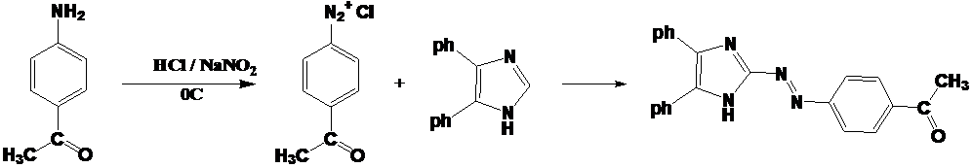

Followed by condensation of the product with p-bromoanilin in acidic catalysis.

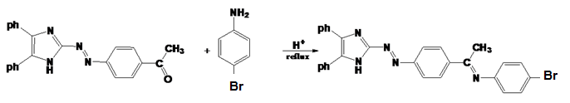

**Solution preparations**

1. Buffer solution: the buffer solution used in this study was ammonium acetate in (0.01M) as a stoke solution, with corrections of the pH values by addition of acetic acid and ammonia as (acidic and basic solutions).

These types of buffer give high degree of complexes extraction in its solutions that produced agreed results, comparing with other buffers.

1. Metal solutions: A stoke solutions (0.01M) of metal chlorides were prepared and diluted to the demand concentrations with buffer at suitable pH values according to the study. Chlorides were selected, due to its good living groups.
2. Ligand solution: a stoke ligand solution (0.01M) was prepared by dissolving of(0.052) gm of ligand in 100ml ethanol, then diluted to the demand concentration with the same solvent.
3. Solid complexes: the solid complexes of **(DPIDBA)** was prepared dependent on the M:L ratio in the study ,that 1:2 ratio is the M:L ratio for all metallic ions , these were prepared by dissolving of(1x10-3) mole of the ligand in 30ml of hot ethanol ,add it to the solution of (0.5x10-3 ) mole of metal chloride in the optimum pH value with stirring and heating of mixture at 50 º C for (1-2)hrs. Then cooling, the colored precipitant observed, filtered and washed with D.W twice and drying in oven, recrystallized with hot ethanol.

The physical properties of the prepared ligand and its complexes show in table(1).

**Table.1 some physical properties to the ligand and its complexes.**

|  |  |  |  |  |
| --- | --- | --- | --- | --- |
| **m.p⁰C** | **Yield %** | **Color** | **M.Wt. g/mole** | **Chemical formula** |
| 158-159 | 80.11 | Deep orange | 520.42 | **C29H22N5Br** |
| 140-141 | 77.56 | Brownish -yellow | 1170.68 | C58H44N10Br2CoCl2 |
| 143-145 | 75.35 | deep violet | 1170.44 | C58H44N10Br2NiCl2 |
| 164-166 | 80.44 | violet | 1175.29 | C58H44N10Br2CuCl2 |
| 188-190 | 78.95 | Deep violet | 1177.14 | C58H44N10Br2ZnCl2 |
| 150-152 | 82.55 | Brown | 1224.16 | C58H44N10Br2CdCl2 |
| 160-162 | 83.85 | Violet | 1312.34 | C58H44N10Br2HgCl2 |

**Results and discussion**

The new ligand and its complexes were identified by (IR and UV-Visible) spectroscopies and elementary analysis (that emphasized the ligand preparation), the ligand particularized by solubility in (acidic and basic) medias, in addition of its solubility in some solvents as(ethanol, methanol, dichloromethane, DMF and DMSO),but insoluble in water.

**Mass spectra**

was given an agreement data with the prepared ligand, that the ligand being fragmented at 158ºC (the ligand m.p) given the mother ion at 519 (m/z) with a relative abundance (18%) and this equivalence to the exact mass of the ligand, indeed to the presence of the fragment (219) that return to the mass of the (4,5-diphenylimidazole),and these adequate to the ligand(DPIDBA) formation. As show in fig..1

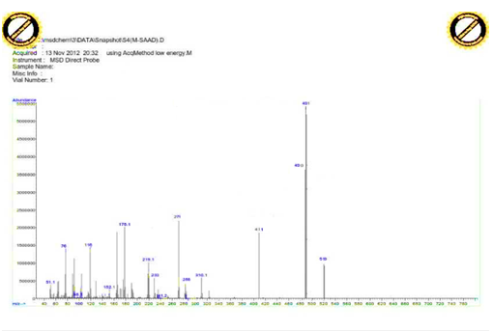

**Fig.1 mass spectra of (DPIDBA)**

**Elementary analysis**

The C.H.N data and the metal percent in the prepared complexes values show an agreement with the theoretical data as show in table (2) , that enhanced to prove these compounds preparation correctly.

**Table (2) the elementary analytical data of the ligand and its complexes.**

|  |  |  |  |  |  |  |  |  |
| --- | --- | --- | --- | --- | --- | --- | --- | --- |
| **Compound** | **C%** | | **H%** | | **N%** | | **M%** | |
| **Formula** | **Cal.** | **Found** | **Cal.** | **Found** | **Cal.** | **Found** | **Cal.** | **Found** |
| **C29H22N5Br = (L)** | 66.93 | 66.56 | 4.26 | 4.11 | 13.46 | 13.18 | ……… | ………. |
| **[Co(L)2Cl2]** | 59.51 | 58.20 | 3.79 | 3.57 | 11.96 | 11.73 | 5.03 | 4.93 |
| **[Ni(L)2Cl2]** | 59.52 | 59.31 | 3.79 | 3.63 | 11.97 | 11.69 | 5.01 | 4.87 |
| **[Cu(L)2Cl2]** | 59.27 | 58.02 | 3.77 | 3.68 | 11.92 | 11.78 | 5.41 | 5.22 |
| **[Zn(L)2Cl2]** | 59.18 | 58.89 | 3.77 | 3.60 | 11.90 | 11.62 | 5.56 | 5.38 |
| **[Cd(L)2Cl2]** | 56.91 | 55.74 | 3.62 | 3.51 | 11.44 | 11.26 | 9.18 | 9.02 |
| **[Hg(L)2Cl2]** | 53.08 | 52.74 | 3.38 | 3.24 | 10.67 | 10.45 | ……... | ………. |

**UV-Visible spectroscopy**

The UV-Visible spectra for the ligand show that it have two main absorption peak, the first at 433nm related to the n π* transition, while the other at high frequency related to the π π* transition as in the as in fig.2

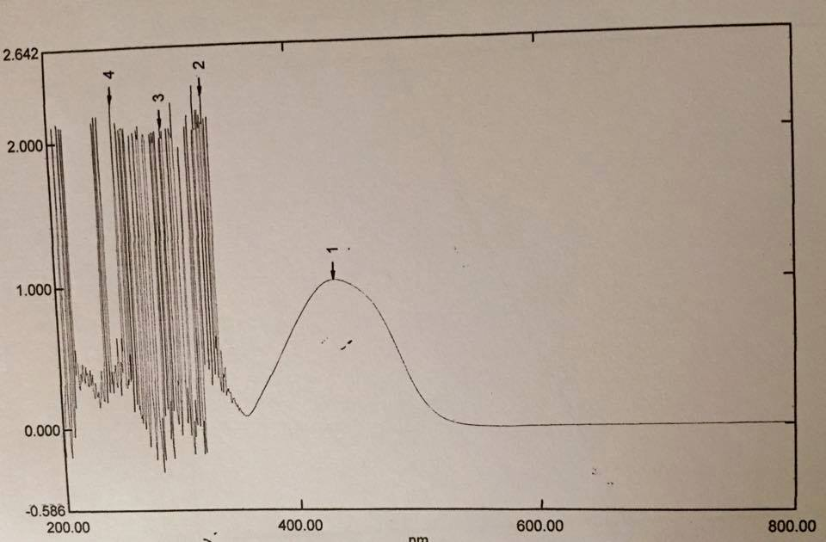

**Fig.2 UV-Visible spectra for the ligand**

When comparison the color& absorption positions between ligand and its metallic ion mixtures, we observed a clear difference in color and shifting in absorption position λmax toward higher wavelength ,this may be refer to the coordination and complexes formation between ligand and these ions 17 , as shown in fig.3

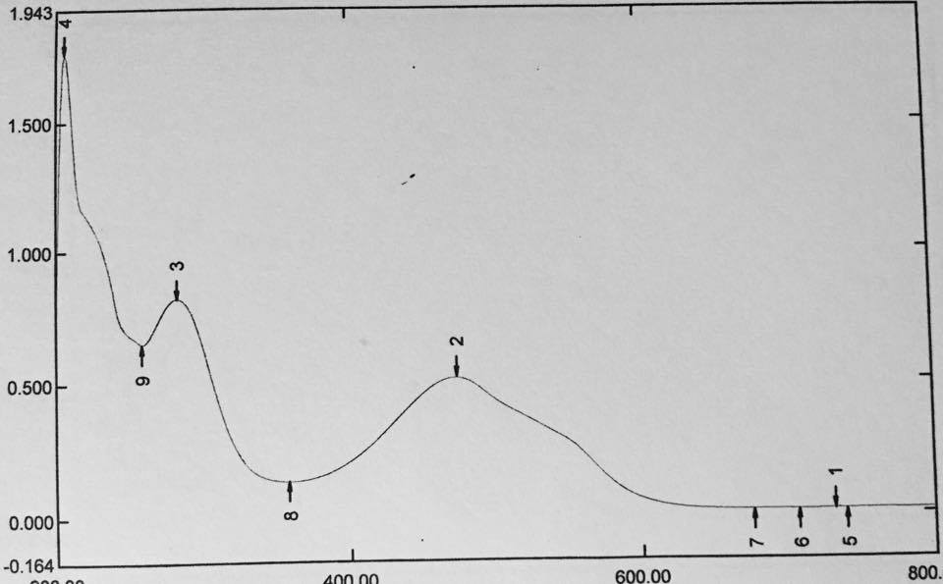

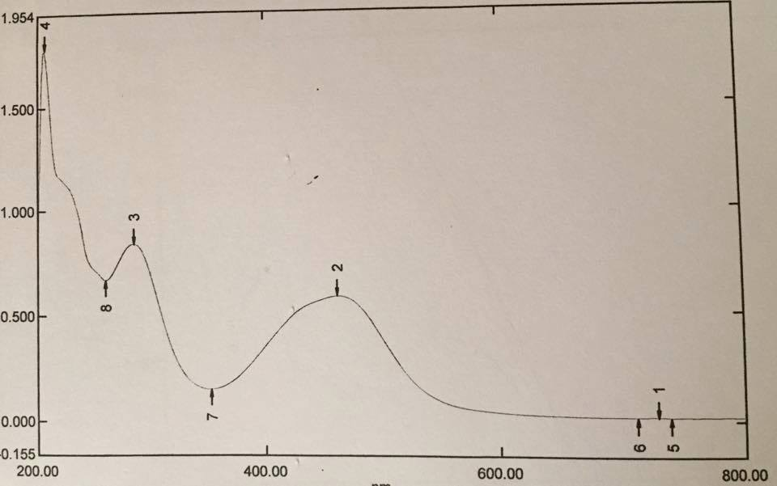

**Co**

**Ni**



**Cu**

**Zn**

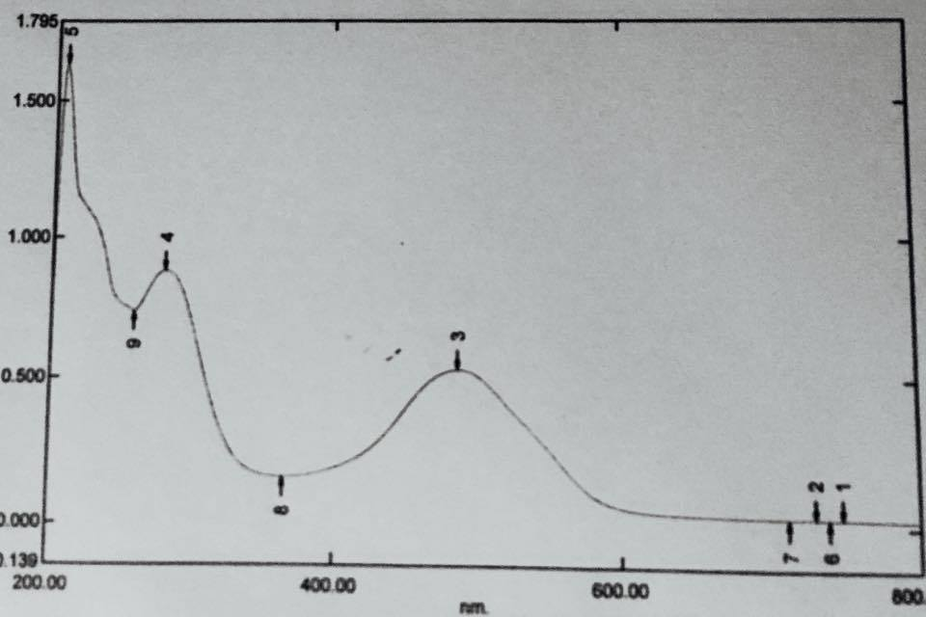



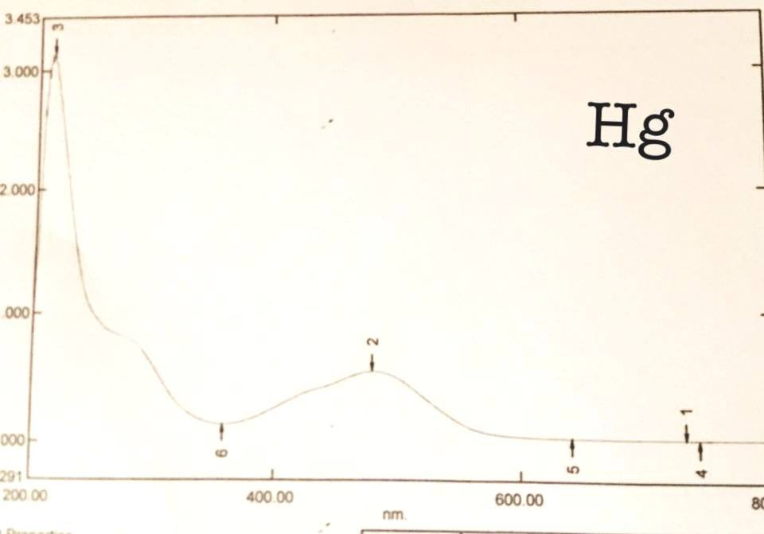

**Cd**

**Fig.3 ligand-metal ions mixtures UV-Visible spectra's**

**Optimal condition determinations**

For an optimal concentration and pH values determination , a series of solution mixtures that contains the same ligand and metallic ions volumes within the range (1x10-3-1x10-6)M , by mixing them at pH(5-9) and measure the absorbance's to these solutions.

From the observation of the work we found that a part of them especially these with (0.5x10-3- 1x10-3) M give a precipitants at mixing, while the lower concentration give out of scale ranges, but we observed that the concentration range (1x10-5-5x10-5) give high agreement to obey beer-lambert law, that enable to chosen for this study, other ranges less than give very week absorption and hence neglected as in table 3 and fig.4

Optimum concentration was determined dependent on the fixation of λmax to a series of solution with different pH values, while optimal pH value determined depends on these mixtures that give high and stable absorbance value at fixed concentration and converging λmax.

The pH-values play principle role in the complexes formation via removal or fixation of proton on the donating atoms, that at the optimal pH-values we could prepare the complexes more precisely.

**Table.3 UV-Visible data for optimal pH determination at optimal concentration**

|  |  |  |  |  |  |  |  |  |  |
| --- | --- | --- | --- | --- | --- | --- | --- | --- | --- |
| **Abs.(λ max)/pH** | | | | | | | | | **Metal ion**  **Opt.conc.** |
| **9** | **8.5** | **8** | **7.5** | **7** | **6.5** | **6** | **5.5** | **5** |  |
| 0.468  (466) | 0.587  (462) | 0.363  (466) | 0.342  (455) | 0.321  (447) | 0.312  (442) | 0.266  (431) | 0.245  (429) | 0.211  (424) | Co (II)  **3× 10 -5 M** |
| 0.388  (485) | 0.441  (482) | 0.517  (473) | 0.434  (468) | 0.412  (462) | 0.358  (457) | 0.331  (446) | 0.381  (444) | 0.266  (439) | Ni(II)  **4× 10 -5 M** |
| 0.381  (511) | 0.462  (505) | 0.482  (501) | 0.503  (490) | 0.531  (487) | 0.403  (466) | 0.357  (455) | 0.204  (430) | 0.098  (428) | Cu(II)  **2× 10 -5 M** |
| 0.515  (459) | 0.533  (462) | 0.571  (451) | 0.590  (438) | 0.532  (440) | 0.481  (437) | 0.337  (439) | 0.263  (436) | 0.340  (439) | Zn(II)  **2× 10 -5 M** |
| 0.684  (452) | 0.751  (441) | 0.803  (437) | 0.772  (440) | 0.744  (439) | 0.633  (438) | 0.552  (440) | 0.361  (439) | 0.344  (440) | Cd(II)  **4× 10 -5 M** |
| 0.482  (498) | 0.537  (480) | 0.517  (477) | 0.505  (471) | 0.485  (465) | 0.411  (460) | 0.336  (458) | 0.291  (453) | 0.231  (442) | Hg(II)  **5× 10 -5 M** |

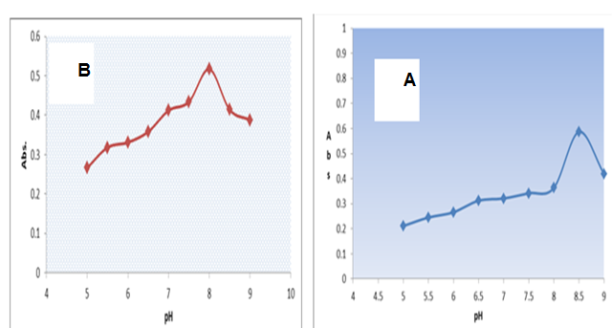





**Fig.4 Optimal pH values for mixing solution with the new ligand at optimal conc. for A=Co+2, B=Ni+2,C=Cu+2,D= Zn+2,E=Cd+2,F=Hg+2**

**Suggested complexes structure**

For determination of complex structures (M:L) they used of the mole ratio method19,the most proper and utilized method in soluble complexes18 and easy to work in, by fixation of one component (metal ion mole) and varying the other (ligand solution), from results we found that the (M:L) ratio were (1:2) for all soluble complexes of the ligand –metal ion mixtures at optimal wavelength and concentration ,as shown:

|  |  |  |  |  |  |
| --- | --- | --- | --- | --- | --- |
| **Absorbance of Complexes** | | | | | |
| **Co(II)**  **462 nm**  **3× 10 -5 M** | **Ni(II)**  **473 nm**  **4×10 -5 M** | **Cu (II)**  **487 nm**  **2× 10 -5 M** | **Zn (II)**  **438nm**  **2×10 -5M** | **Cd (II)**  **437 nm**  **4× 10 -5 M** | **Hg(II)**  **480 nm**  **5 x 10-5M** |







**Fig.5 mole ratio curves for the mixing solutions of the ligand-metal ions at optimal condition**

**Stability constant determination**

The mole ratio study can enhance in the stability constant calculation, via utilizing the absorbance of the mixing solutions in table 4, it could calculated from the following relationships:





α (nαc) (1-α)c



When β = formation constant



When n =1 , but when n=2, hence

And the β value can determine when α( dissociation degree ) are known

**Table .4 Stability constant for the new ligand complexes**

|  |  |  |  |  |  |
| --- | --- | --- | --- | --- | --- |
| **Metal ion Complex** | **Am** | **As** | **α** | **β** | **Logβ** |
| [Co(L2)2Cl2] | 0.633 | 0.585 | 0.07583 | 5.88X1011 | 11.76 |
| [Ni(L2)2Cl2] | 0.545 | 0.515 | 0.05504 | 8.85X1011 | 11.94 |
| [Cu(L2)2Cl2] | 0.555 | 0.530 | 0.04504 | 6.35X1012 | 12.81 |
| [Zn(L2)2Cl2] | 0.632 | 0.590 | 0.06645 | 8.83X1011 | 11.94 |
| [Cd(L2)2Cl2] | 0.842 | 0.800 | 0.04988 | 1.19X1012 | 12.07 |
| [Hg(L2)2Cl2] | 0.575 | 0.538 | 0.06434 | 3.51X1011 | 11.54 |

These results will agreed with Erving-Williams20 series, that the stabilities of these complexes arranged as Co+2 < Ni+2 < Cu+2 > Zn+2 > Cd+2 > Hg+2.

**I.R Spectroscopy**

Infrared spectra can enhanced in interoperation of the functional groups in organic compounds, due to highly interference in the bands of the functional groups that azo owned compounds and there complexes, especially in (1700-1400cm-1)region we depend on some references 21 in the identification, to determine the stretching bands of the ligand groups and compared it with their complexes in (site, shape and sharpness), and knowledge the coordination of the metal ions role on the frequencies of ligand.

First of all, the 2-[(4-acetyl phenyl) azo]-4,5-diphenylimidazole interpreted, it spectra give mid-stretching band at(3410cm-1) related to imidazole (N-H) vibration22, indeed to the two weak stretching bands (3040 and 2940cm-1) related to aromatic and aliphatic (C-H)vibrations ,while a strong stretching band developed in the 1700 cm-1region return to acetyl (C=O)group23, while imidazole (C=N) appear in 1596 cm-1 and the azo group (N=N) in 1456cm-1.

Secondly, for the new ligand (DPIDBA) a new strong stretching band observed at (1681 cm-1) frequency in the spectra, instead of (C=O) band this will characterized to the (C=N) azomethene formation , while the rest bands doesn't affected in Schiff base formation.

In comparisons between the ligand spectra and its coordination complexes spectra, we observe that staying of (N-H) imidazole and (C=N) of the Schiff in the same shape and position, that evident they doesn't participate in coordination24.

While the imidazole azoimine (C=N) and azo group (N=N) affected and shifted toward lower frequencies by (6-30cm-1‑) and (10-15 cm-1) respectively, due to coordination and complexes formation, this were agreed with previous works25.26.

At the end, we must to cite to the (M-N) figure print27 band, these bands appeared in the region (408-460cm-1) at these study complexes spectra.

**Table .5 Infrared spectroscopy data for the ligand(DPIDBA) and their complexes.**

|  |  |  |  |  |  |  |  |
| --- | --- | --- | --- | --- | --- | --- | --- |
| **Compound.** | **ν(N-H)** | **ν(C-H)** | **ν(C=N) imd** | **ν(C=N) shf.** | **ν(N=N)** | **ν(imd.r.de)** | **ν(M-N)** |
| **Azo-acetophenone** | 3410w | 3059w | 1596 m | C=O,1700s | 1456m,1429 m | 1074w | ……… |
| **Azo Schiff(L)** | 3408w | 3051 | 1596 | 1680 | 1456 | 1070 | ……….. |
| **[Co(L)2Cl2]** | 3410w | 3060 w | 1585 w | 1656 w | 1440 m | 1070 w | 460 |
| **[Ni(L)2Cl2]** | 3410 w | 3059 w | 1590 m | 1660 w | 1448 m | 1016m | 460 w |
| **[Cu(L)2Cl2]** | 3410 w | 3061 w | 1588 s | 1660 w | 1446 m | 1070m | 450 w |
| **[Zn(L)2Cl2]** | 3410 w | 3059 w | 1585 m | 1660 w | 1448 m | 1043m | 450 w |
| **[Cd(L)2Cl2]** | 3440 w | 3059 w | 1578 m | 1660 w | 1446 m | 1043m | 450 w |
| **[Hg(L)2Cl2]** | 3420w | 3061 w | 1565 m | 1660 w | 1448 m | 1050m | 460 |

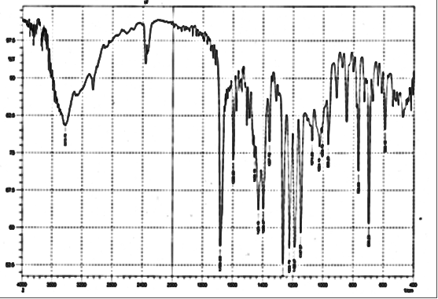

**Fig.6 infrared spectra of azo imidazole**

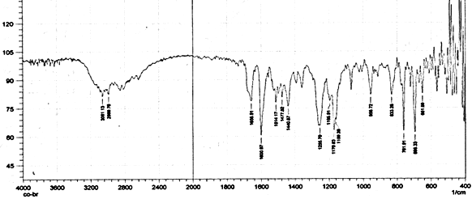

**Fig.7 infrared spectra for the new ligand (DPIDBA)**

**Electrical molar conductivity:**

There results give a supporting to predict the geometrical structure for the prepared complexes28, that the electrical conductivity proportionally to the electrolyte within solution, that the complex solutions have low values or zero-approach values regarded non-ionic complexes and according to these, our study complexes that dissolved in two solvent (ethanol and DMF) with (1x10-3) concentration in 25ºC doesn't have any ionic character, as shown as fellow:

**Table.6 electrical molar conductivity for (DPIDBA) complexes**

|  |  |  |
| --- | --- | --- |
| **Complex** | **Λm (S.mol-1.cm2)** | |
| (EtOH) | (DMF) |
| [Co(L2)2Cl2] | 2.38 | 15.12 |
| [Ni(L2)2Cl2] | 4.04 | 22.38 |
| [Cu(L2)2Cl2] | 8.21 | 28.21 |
| [Zn(L2)2Cl2] | 2.22 | 13.12 |
| [Cd(L2)2Cl2] | 1.44 | 10.75 |
| [Hg(L2)2Cl2] | 7.92 | 24.88 |

**Magnetic susceptibility:**

A complementary tool for complexes structural geometry suggestion (especially the transition metal complexes 29, via study the influences produced from the partially-electronic filled outer orbitals, magnetic susceptibility gives important information such(electronic configuration and oxidation state) for TME , that the number of odd electrons transition ion enhanced which either the complex with high spin or low spin cases.

The magnetic susceptibility determined after a diamagnetic correction for the organic molecules, metallic ions, and inorganic roots dependent on Pascal tables and the () values calculated from the relation (). As in table 7. that the for cobalt complex value is (4.29B.M), this agreed with a presence of three odd electrons in octahedral cobalt (II) complexes30 , while nickel (II) complex give (3.18 B.M), this value indicate the present of two odd electron in octahedral nickel(II)complexes31 and the cupper complex give (1.77 B.M) related to one odd electron in the outer shell of cupper(II) with an octahedral geometry in his complexes 32 , other ions (Zn(II), Cd(II) and Hg(II) does not give a results due to their diamagnetic properties of filled(nd10) orbitals.

**Electronic spectroscopy**

Transition metal solutions characterized with a distinguished color, due to their light absorption in the visible region of spectrum, indeed to a part near ultraviolet and infrared, returned to the abundant of partially filled (d) orbital in these elements and this interpreted the color formation in their complexes.

In the study, they measure the electronic absorption spectra to the solution of solid complexes and found there are approached to the mixture solution of the ligand with the ions under study and more similar to these of the mole ratio solutions, shown that they have red shifting to ligand absorption.

Due to the weakness of (d-d) transition bands or overlapping it with the broad CT(charge transfer) band33, that we cannot study them in details.

**Table.7 some electronic and magnetic susceptibility data.**

|  |  |  |  |  |
| --- | --- | --- | --- | --- |
| NO. | Complex | λmax (nm) | ν.cm-1 | µeff(B.M) |
| 1 | [Co(L)2Cl2] | 466 | 12100 | 4.29 |
| 2 | [Ni(L)2Cl2] | 482 | 15666 | 3.18 |
| 3 | [Cu(L)2Cl2] | 505 | 16000 | 1.77 |
| 4 | [Zn(L)2Cl2] | 440 | 17733 | Dia |
| 5 | [Cd(L)2Cl2] | 441 | 18400 | Dia |
| 6 | [Hg(L)2Cl2] | 477 | 10733 | Dia |

According for results of (CHN, flame atomic absorption, M: L Ratio, enhanced with magnetic susceptibility values, molar conductivity and spectroscopic data) we can suggested the octahedral geometry for all prepared complexes.

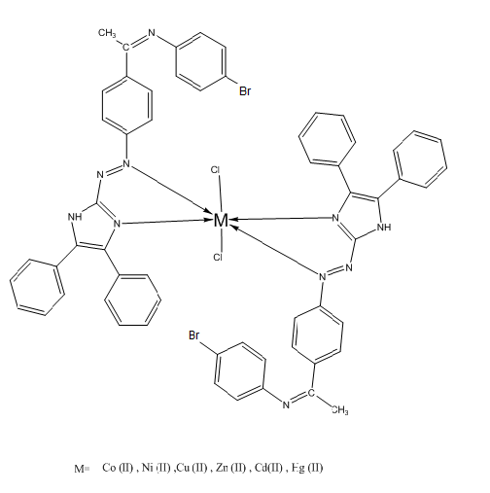

**Suggested geometry for (DPIDBA) complexes**

**References:**

1.K.Sui, S.M. Reng and S.Bahat ; ***Polyhedron*** ,18,631,(1999).

2.A.D.Garnovskii,A.I.Ureav and V.I.Minkin, ***ARCIVOC*** ,iii,29,(2004).

3.M.Komel,F.Galil, L.Abdel wahab and A.Osman. ***J.für parktische che***mie, 313,1011,(1971).

4.D.Zhang, M.Zhang, Z.liu, M.Yu , F.li,T.yi and C.Huang, ***Tetrahedron lett***.47,7093,(2006).

5.V.S.Jolly , P.I.Pathak, and R.Jain ,***J.indian .chem.Soc***.70,505,(1993).

6.Z.Marczenko; (Spectrophotometric determination of elements), John Wiley & Sons. New York,(1976).

7. M. Kand, F.Galil, L. Abdelwahab, and A. Psman; ***J. Fur Park Tische Chemie*.,**313, 1011, **1971**.

8. S. A. Ali, S. H. Gzsr, and W.S. Abdul-Hassan; ***J. Thi-Qar Sci*.**,3,3, 117, **2012**.

9. M. Al-Noaimi, M. Sunjuk, M. El-khateeb, S. F. Haddad, A. Haniyeh, and M. Aldamen; ***Polyhedron*.**,42, 66, **2012**.

10. H.S. Eman, **M.Sc. thesis**, Kufa University, **2012**.

11. M. Al-Noaimi, M. Sunjuk, M. El-khateeb, S. F. Haddad, A. Haniyeh, and M. Aldamen; ***Polyhedron*.**,42, 66, **2012**.

12. A. Hou, C. Zhang, and Y. Wang; ***Carbohydrate Polymers*.**,87, 284, **2012**.

13. H. N. Chopde, J. S. Meshram, R. Pagadala, and A. J. Mungole; ***Int. J. Chem Tech Res*.**,2 ,3, 1823, **2010**.

14. H. Kumar, and R. P. Chaudhary; ***Der Chemica Sinica*.**,1 ,2, 55, **2010**.

15. Z. Rezvani, A. R. Abbasi, K. Nejati and S. M. Seyedah madian., ***Polyhedron***, 24, 1467 ,**2005.**

16. S. Shibata, M.Furukawa, and R.Nakashima;***Anal.Chem.Acta***.81,131,(1976).

17.B.K.Reddy, J.R.Kumar, K.J. Reddy and A.V. Reddy,***Anal.Sci.***19,423,(2003).

18.J. H. Yoe and A. L. Jones***; Ind. Eng. Chem., Anal .Ed***, 16, 11 (1944).

19.G.W. Ewing; “Instrumental Methods of Chemical Analysis”,5th ed. McGraw– Hill, (1985)

20.H.Irving, R.J.Williams.***J.Chem.Soc***.3192,(1953).

21.M.R.Grimmett "imidazole and Benzimidazole synthesis", Academic Press. Harcourt and company publishers, New York .(1997).

22. D.Das , C.Sinha .,***Indian.J.Chem*** .37A, 531,**1998**.

23.A.A. Jarrahpour, M. Motamedifar, K.pikshir,N.Hadi and M.Zarei,***Molecules***,9,815,**2004.**

24. K. Nakamoto, **"Infrared and Raman Spectra of Inorganic and Coordination Compounds"** 6th Ed., A John Wiley & Sons, Inc., Hoboken, New Jersey, Published Simultaneously in Canada, 29, 57-62, 67, 313, **2009**.

25. S. Pal, D. Das, P. Chattopadhyay, C. Sinha, K. Pnneerselvam and T.H . Lu ; ***Polyhedron*** ,19,1263,**2000**.

26.D.Das ,M.K.Nayak ,C.Sinha ;***Trans Metal .Chem*** ,22,172,148, **1997** 27.R.N.Murty, R.N.Dash and D.v.Raman rao,***J.Indian.Chem. Soc.*** 61, 943,**1984**.

28.D.A.Skooge, "fundamental analytical chemistry".5th ed. New York.(1988).

29.B.N.Figgis, "Introduction to ligand field", Inter science, New York , (1967).

30.D.Nichols,"the chemistry of Iron, Cobalt and Nickel", pergamon,Oxford,1st ed.(1973).

31.K.Bizilij,S.G.Hardin,B.F.Hoskings,P.J.Oliver,R.T.Edward and G.Winter, ***Aust.J.Chem***,39,1035,(1986).

32.A.C.Massey and B.F. Johnson "the chemistry of Copper, Silver and Gold", pergamon ,Oxford,(1975).

33. Lever ABP **,”**Inorganic Electronic Spectroscopy**”** 2nd ed , Elsevier, Amsterdam ,**1984**.





N = N

(6%)

(5%)

(18%)

-N2



(7%)

(100%)





(37%)

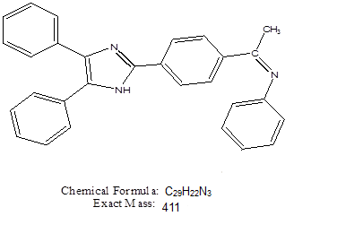

(60%)



(18%)

(43%)



(27%)

(26%)

**Suggested route for DPIDBA fragmentations**