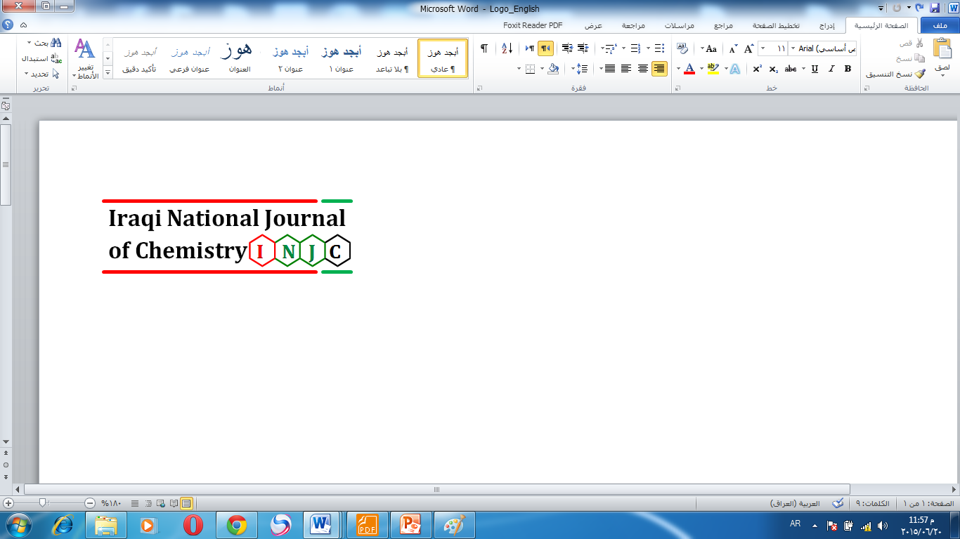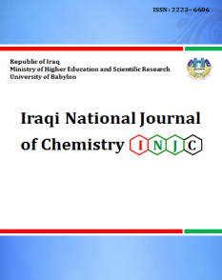

**Iraqi National Journal of Chemistry**

**Journal homepage: http://iqnjc.com/Default.aspx**

**Preparation and identification of a new azo-chalcone ligand (VACAN) and its complexes with some divalent transition metal ions.**

**\*Saad M.Mahdi * Russel I.Aliway**

**\*Chemistry department-College of science – Babylon University**

**E-Mail:** [**saadalhsany@gmail.com**](mailto:saadalhsany@gmail.com)

**Abstract:**

A new azo-chalcone ligand was prepared in this work, by preparation the amino-chalcone first followed by diazoted it and reacting with the coupling component (2-naphthol) at 0ºC to produce the new ligand (VACAN).

Three chelating complexes of divalent transition metal ions (Co, Ni, Cu) were prepared after the fixation of optimal condition of (concentration and pH values)and determination the mole ratio (M:L),the result indicate that the mole ratio for Co2+ ion was(2:1),while the others has (1:1)ratio.

Both the amino-chalcone, the new ligand (VACAN) and its complexes was identified with the available techniques such (Mass spectroscopy (for VACAN), elementary analysis, Atomic Absorption, Uv-Visible spectroscopy, I.R spectroscopy), electrical molar conductivity and Magnetic susceptibility for the solid complexes. From the results obtained we can suggest an octahedral geometry for cobalt complex, square planner geometry for nickel complex and tetrahedral geometry for copper complex was appeared.

**الخلاصة:**

تضمن العمل ببحثنا هذا تحضير ليكاند (ازو- جالكون) جديد ، خلال تحضير الجالكون الاميني اولا ومن ثم تحضير ملح الديازونيوم لهذا المشتق الاميني وازواجه مع مكونة الازواج (2-نفثول ) في درجة الصفر المئوي لتكوين الليكاند الجديد .

حضرت ثلاث معقدات مخلبية لايونات العناصر الانتقالية (Co, Ni, Cu) ثنائية الشحنة بعد تثبيت الظروف الفضلى من تركيز ودالة حامضية ، اضافة لتحديد النسبة المولية لكل عنصر الى نسبة الليكاند (M:L) ، حيث اثبتت النتائج ان النسبة المولية لايون الكوبلت كانت (2:1) ، بينما كانت النسبة المولية لايوني النيكل والنحاس (1:1) . اضافة لاستخراج ثوابت استقرارية كل معقد محضر.

شخص المشتق الاميني للجالكون(VAC) وليكاند الازو-جالكون الجديد (VACAN) باستخدام التقنيات المتوفرة (كالتحليل العنصري الدقيق ومطيافية الانبعاث الذري ومطيافية الاشعة المرئية-فوق البنفسجية ومطيافية الاشعة تحت الحمراء،اضافة لمطيافية طيف تجزؤ الكتلة لليكاند الجديد، كما وحددت توصيلية كل معقد صلب باستخدام التوصيلية الكهربائية المولارية وتحديد قيم الحساسية المغناطيسية لكل معقد باستخدام طريقة فارداي.

من خلال النتائج المستحصلة في هذا العمل وتفسيرها اقترحنا ما يلي:-

* امتلاك معقد الكوبلت الشكل الهندسي ثماني السطوح.
* اتخاذ معقد النيكل الشكل الهندسي للمربع المستوي.
* وامتلاك معقد النحاس الشكل الهندسي رباعي السطوح.

**Introduction**

In the last decades, World sight interested to chalcone chemistry focusing their scientific studies to the synthesis and biodynamic activities1 of chalcone, due to it’s a precursor of flavonoid ,isoflavonid indeed its biological activity such antimicrobiol2 anticancer3 and antioxidant4,chalcone a versatile molecule in the medical and pharmacological fields can synthesized easily and conveniently by (Claisen-Schmidt) condensation reaction between acetophenone and benzaldehyde (or there derivative's) in presence of aqueous alkali media5.

Azo compounds, the well-known compounds have many characteristic which qualifies them to entered in multiple areas such (colors and dyes manufacturing6, painting7, pesticides8 , lubricating oil improvers9) , indeed the most important one the using of azo compounds in the analytical chemistry field to enable them to determinate the trace elements through the formation of a stable chelating rings with them10.

Azo compounds can used in the pharmacological industry and it has suggested that the azoimine linkage might be responsible for the biological activity ,some azo dyes as(Congo red and Evans blue) being studies as HIV inhibitors of viral replication due to the believe of binding between the azo dye with both enzymes(protease and reverse transcriptase) of this virus11.

Azo-chalcone compounds one of the compounds that dried up its literature12, 13 , uncommon compounds and rare species of azo, have important functional groups (especially conjugation) to enhanced color intensity to these compounds.

**Instrumentation & procedures:**

**Instrumentation**

* (C.H.N) % for the ligand and its complexes determined by (Micro Analytical unit, 1108 CHN Elemental analyzer).

* Melting points with (Stuarts SPM300).

*UV-Visible spectroscopic data by (Shimadzu1650PC).

*Mass spectra was done by (Shimadzu GCMS QP2010 ultra)with ionization energy (5-20 eV).

* IR Data by using (Shimadzu 8400S FTIR test scan series) .

*Molar electrical conductivity measured by (Info lab terminal).

*Balance magnetic Susceptibility Model MSB-MKI .

*All chemicals used in this study with anlar grade gained from (Aldrich, Merck and BDH).

**Procedures**

**Chalcone preparation**14**:-**

Amino chalcone (E-1-(4-aminophenyl)-3-(4-hydroxy-3-methoxyphenyl) prop-2-en-1-one VAC) was prepared via reaction of ( p-aminoacetophenone ,0.01mole ,1.35gm) and (vanillin ,0.01mole ,1.52gm ) in absolute ethanol (25ml) ,then stirring and cooling at 5Cº,within 30min.dropping of (3M KOH ) solution to the reaction component with stirring till the solution began more thickening , with continuing the stirring for 24hrs. Decant this thickened solution in iced bath and neutralized with dil.HCl ,the yellow precipitant appear , filter and wash with deionized water several time to remove the trace of acid and salt formed , then air drying the precipitant , recrystallize the product with hot ethanol , the reaction yield was 77% with m.p (122-124 ºC).

**Azo-chalcone preparation**

Azo compound was prepared according to shibata method15, the new ligand

(E)-3-(4-hydroxy-3-methoxyphenyl)-1-(4-((E)-(3-hydroxynaphthalen-2-yl) diazenyl ) phenyl)prop-2-en-1-one(VACAN) produced from preparation of the diazonium salt of the (VAC) by dissolving (5mmole,1.35gm)of VAC in a mixture of (8ml HCl + 15 ml D.W) and cooling it in ice bath, then a NaNO2 solution (5mmole,0.35gm in 10 ml D.W) was dropping to the VAC solution in cooling bath ,the diazonium formed within 15min.

While the coupling component (2-naphthol) solution was prepared via dissolved (5mmole,0.72 gm ) of 2- naphthol in alkaline aqueous solution (2M NaOH) ,and transfer the container to the ice bath , the diazonium was added slowly with stirring to the coupling solution at 0Cº , a brown-red color was developed and the pH was became neutral to complete the azo precipitation.

Whole solution left to the next day then filtered and several times with deionized water to remove the salt traces, then drying in dryer and recrystallized in hot ethanol, the reaction yield was 80% with a m.p (179-181)º C .

**Complex formation**

The divalent transition metal (Co, Ni and Cu) complexes of the new ligand (VACAN) were prepared by taking advantage of mole ratio results, via the condensation of (5mmole) of these elements with its equivalent of the new ligand (VACAN) in absolute ethanol for 1.5 hrs, taking into account the addition of alkali solution (1ml of 2M NaOH) to naphthol deprotonating, finally we observed the formation of colored precipitant, transfer the reaction container to iced bath to complete the precipitation ,then they filtered and washed several time with deionized water and drying , the recrystallization process by using hot ethanol, and the m.ps were recorded, as mentioned later.

**Results**

**Preface**

Our decision in selection this type of ligands and there complexes was taken because of the scarcity of the literature of the (azo-chalcone) ligands, which motivated to work in this field and prepare a new ligand.

There are two steps to reach the demand.

**First**; the preparation of the amino chalcone derivative (VAC) via condensation (p-aminoacetophenone) with vanillin to produce the amino-chalcone (VAC, (E)-1-(4-aminophenyl)-3-(4-hydroxy-3-methoxyphenyl)prop-2-en-1-one),the (C.H.N and infra-red spectrophotometry) results indicate the formation of the amine



This chalcone has stretching band at (3394 cm-1) related to vanillin hydroxyl group and two str.band at (3332 and 3328 cm-1) back to the amine group, while the chalcone carbonyl group appear in 1647 cm-1 region 16 and the methylene group observed clearly at 1514cm-1 ,as in the following figure

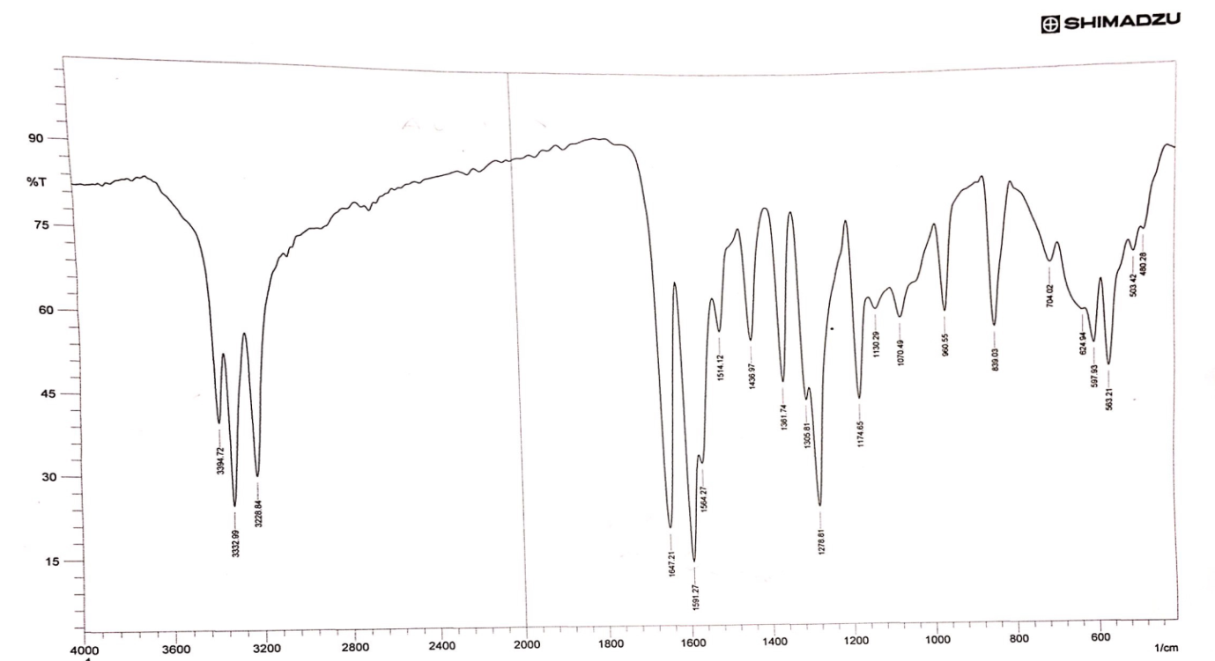

**Fig.1 I.R Spectra of the amino chalcone (VAC)**

The second step was the preparation of the azo-chalcon ligand (VACAN), via coupling the diazonium salt of the amino chalcone (VAC) with (2-nathol) to produce the new ligand (VACAN), and this procedure is a recent method. (C.H.N and I.R) result adopted to ensure the formation of the ligand, that from the I.R Spectra we observe the following:

* The naphthol hydroxyl group has a str.band observed at 3423cm-1, in addition to overlap the vanillin hydroxyl group with it.
* Appearance of two clear str. bands related to azo group at (1441 and 1428) cm-1 respectively17, with keeping of the chalcone bands and absence of the amine group band, and this indicate the azo formation. As in follow

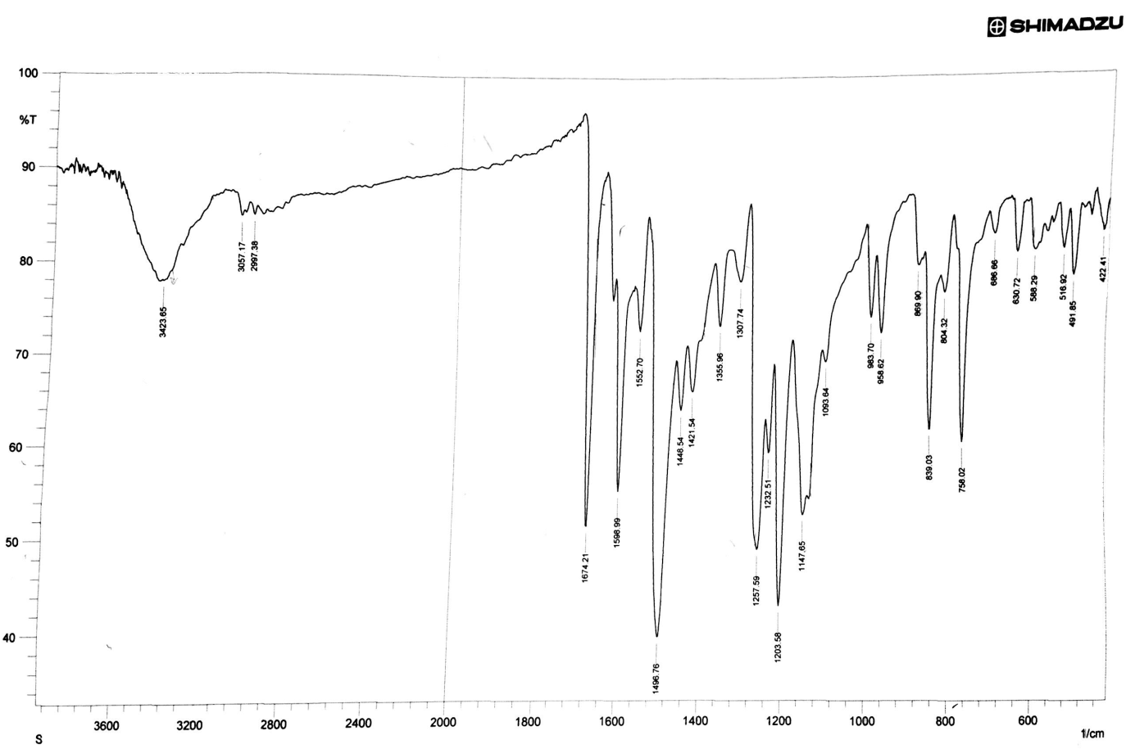

**Fig.2 I.R Spectra of the azo-chalcon (VACAN)**

The new ligand (VACAN) was soluble in many solvents such (ethanol, methanol) and organic solvent (DMF, DMSO, acetone, chloroform, carbon tetrachloride, acetonitrile and dichloromethane), but insoluble in water.

**Mass spectroscopy**

Mass spectroscopy regard as clear and strong evidence to prove the formation of molecules via the observation of the mother ion at molecular weight equivalent value, and this observed in the mass fragmentation spectra of (VACAN) , that the mother ion appear clear band at (424 *m/e*) , this was a good agreement for the formation of the new ligand (VACAN) .the mass fragmentation spectra giving in the following fig.

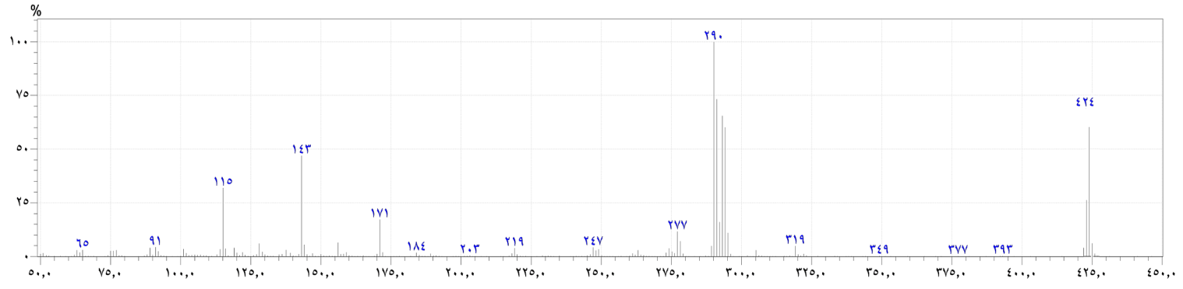

**Fig.3 Mass fragmentation spectra of the Azo- Chalcone ligand (VACAN).**

**UV-Visible Spectroscopy:**

The UV-Visible spectroscopic study for the new ligand will be done for a wide range of concentration , that the (10-3-10-4) M doesn't give known absorption data ,due to the deep color intensity of the ligand and the abs.value record over(3) in the spectrometer ,while when we work in the 10-5 M range it give clear data with an observable λmax value at (443 nm),related to the charge transfer between aromatic rings via azo group, as shown in the following:

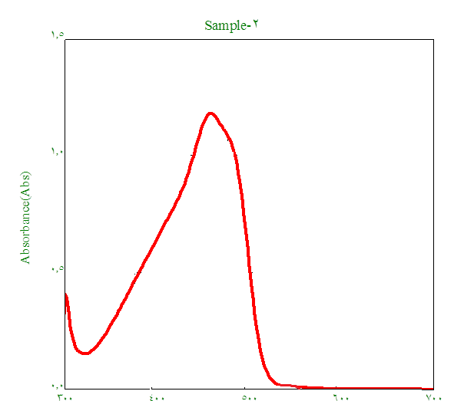

**Fig.4- UV-Visible spectra of (VACAN)**

Three divalent transition metal aqueous solution (Co, Ni, Cu) were mixed with alcoholic solution of the new ligand (VACAN) to formation of aqueous complexes for these metals, we observed they formed a vivid color differ from the ligand color, with a red shitting in the absorption region toward higher wavelength, this may be thought the coordination take part between these ions and the ligand 18, The optimal concentration studied within 10-5M limit.

Copper give (1X 10-5 ) M as an optimal concentration at 496 nm as shown in the following figure.

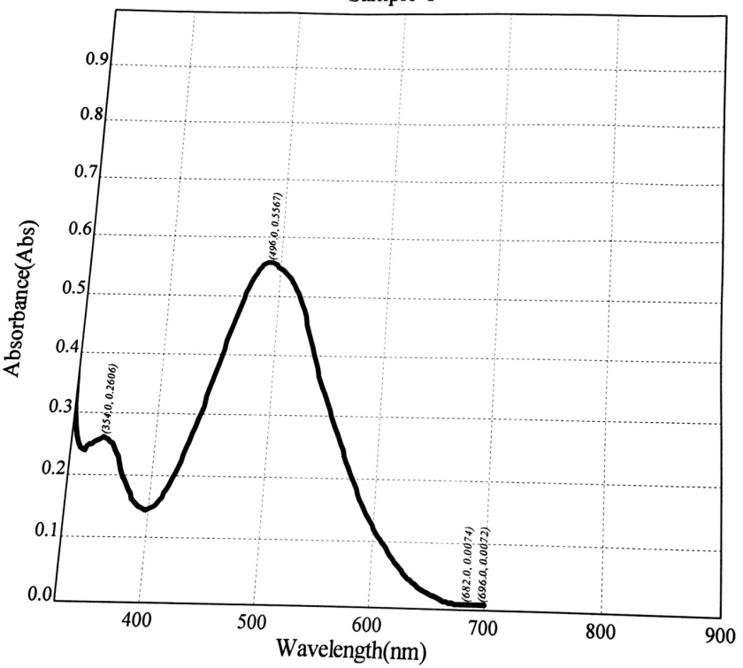

**Fig.5 UV-Visible spectra of (VACAN) copper complex**

Nickel gives a maximum wavelength at (488nm) in an optimal concentration of mixing (3X10-5) M as shown

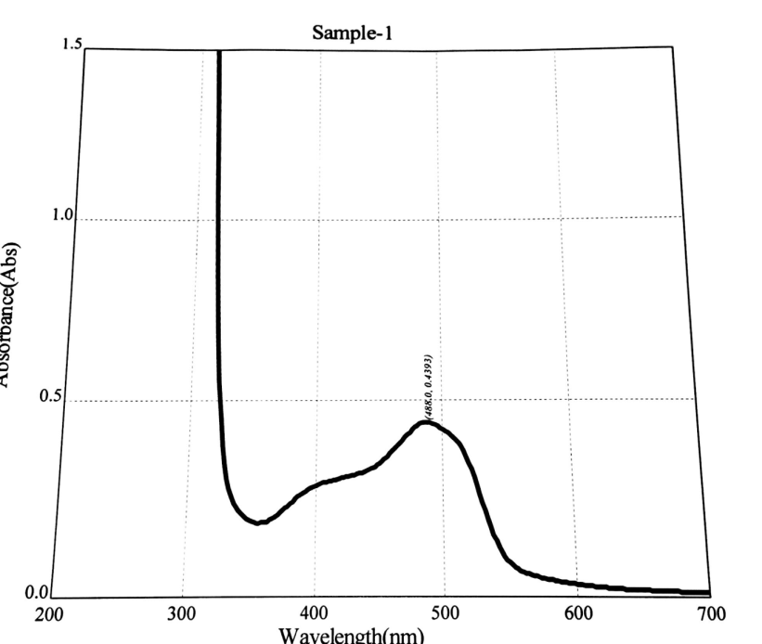

**Fig.5 UV-Visible spectra of (VACAN) nickel complex**

While cobalt give an optimal concentration of mixing with ligand with a value (5X10-5) M at (468nm) as showed.

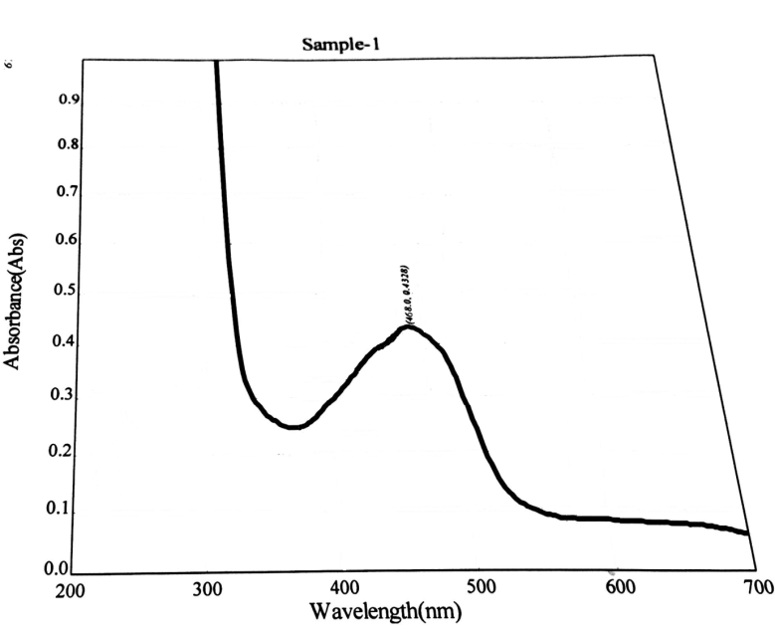

**Fig.5 UV-Visible spectra of (VACAN) cobalt complex.**

**Complexes composition determination**

A mole ratio method19 which is the most fame and simply method for soluble complexes determination20 , was used to determine the complexes composition via fixing one component (metal ion usually ) and variation the other ( ligand) , from the following table we observe that the mole ratios (M:L) were ( 1:1 for copper & nickel) and (1:2 for cobalt) ,as shown in the following :

**Table1.Mole ratio data at optimal condition for each ion**

|  |  |  |  |
| --- | --- | --- | --- |
| **M : L** | **Absorbance of Complexes** | | |
| **Co(II) 486nm**  **5× 10 -5 M** | **Ni(II) 488nm**  **3×10 -5 M** | **Cu (II) 496nm**  **1× 10 -5 M** |
| **1 : 0.25** | **0.131** | **0.163** | **0.135** |
| **1 : 0.5** | **0.194** | **0.278** | **0.297** |
| **1 : 0.75** | **0.244** | **0.386** | **0.483** |
| **1 : 1.00** | **0.297** | **0.482** | **0.560** |
| **1 : 1.25** | **0.334** | **0.485** | **0.563** |
| **1 : 1.5** | **0.385** | **0.484** | **0.562** |
| **1 : 1.75** | **0.406** | **0.486** | **0.566** |
| **1 : 2.00** | **0.424** | **0.491** | **0.573** |
| **1 : 2.25** | **0.428** | **0.487** | **0.571** |
| **1 : 2.5** | **0.429** | **0.489** | **0.564** |
| **1 : 2.75** | **0.425** | **0.491** | **0.566** |
| **1 : 3.00** | **0.428** | **0.493** | **0.568** |

**Fig.8 Cobalt complex mole ratio curve.**

**Fig.9 Nickel complex mole ratio curve.**

**Fig.10 copper complex mole ratio curve.**

**Stability constant calculation:**

Mole ratio study for the complexes in their aqueous solutions tell us in the calculation of stability constant of these complexes, utilizing the absorbencies values of the ligand solution with the ion we want to know its stability constant , this will be done according to the following equations:



α (nαc) (1-α)c



When β = formation constant



When n =1 , but when n=2 , hence



And the β value can determine when α( dissociation constant) are known

**Table.2- VACAN complexes stability constants**

|  |  |  |  |  |  |
| --- | --- | --- | --- | --- | --- |
| Metal ion Complex | Am | As | Α | β | Logβ |
| [Co(L)2Cl2] | 0.428 | 0.424 | 0.0093 | 5.12x109 | 9.710 |
| [Ni(L)Cl2] | 0.493 | 0.482 | 0.0223 | 6.72x107 | 7.820 |
| [Cu(L)Cl2] | 0.568 | 0.560 | 0.014 | 4.97x108 | 8.697 |

From this table, we saw that the cobalt complex was more stable than others; this may explains the formation of stable (1:2) complex with two chelating rings that enhanced the stability.

Then, the solid complexes were prepared and the complexes elementary composition has knowledge via (C, H, N) analysis and the ion percent in their complexes calculated via (atomic absorption) analysis, as shown in the following table:

**Table 3- some physical character and elementary analysis for VACAN and its complexes**

|  |  |  |  |  |  |  |  |
| --- | --- | --- | --- | --- | --- | --- | --- |
| m.p ºC | Elementary analysis | | | | Color | Compound | item |
|  | M%  Cal(found) | N%  Cal(found) | H%  Cal(found) | C%  Cal(found) |
| 122-124 | ……… | 5.20(5.28) | 5.61(5.63) | 71.36(71.55) | Yellow | Amino chalcone [C16H15NO3] | 1 |
| 179-181 | ……….. | 6.60(6.71) | 4.74(4.79) | 73.57(73.82) | Red-brownish | VACAN  [C26H20N2O4] | 2 |
| 175-177 | 6.25(6.55) | 5.94(5.98) | 4.49(4.56) | 66.31(66.52) | Brown | [CoC52H42N4O10] | 3 |
| 169-171 | 10.93(10.98) | 5.22(5.29) | 4.13(4.18) | 58.69(58.90) | red | [NiC26H22N2O5Cl] | 4 |
| 170-172 | 11.73(11.85) | 5.17(5.22) | 4.09(4.11) | 57.67(57.86) | Reddish-orange | [CuC26H22N2O5Cl] | 5 |

The new complexes were identified by using infra-red spectroscopy to ensure their formation and the way of coordination, that the IR spectra's indicate clearly the coordination via 2-naphthol oxygen atom via the appearance of (M-O) stretching band at (451-431) cm-1 and the azo-nitrogen atom via their shifting by(4-17)cm-1 , with the present of (M-N)str. band at ( 495-484)cm-1 ,while the other bands (related to chalcone) remained in their positions .

Indeed complex attached water band was appeared in the (>3400 cm-1) region interfered with the vanillin hydroxyl group, this water oxygen that attached with the complex metal has a characteristic band present at 893 cm-1 , this enhanced the complexes water existence21 in there structures , as showed in the following figures:

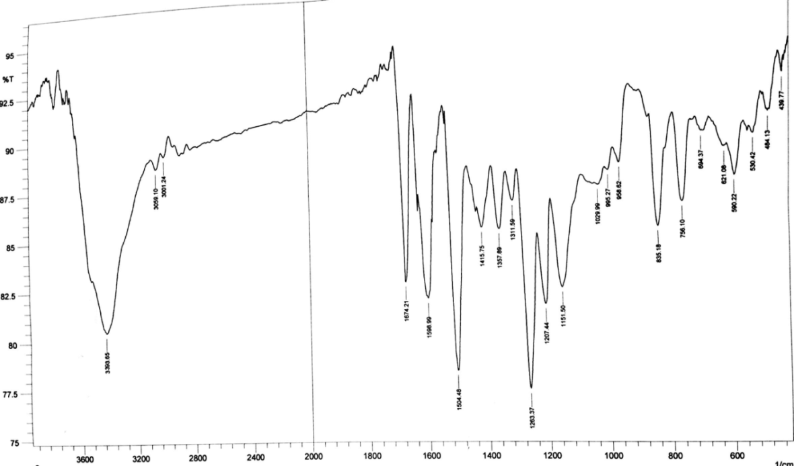

**A**

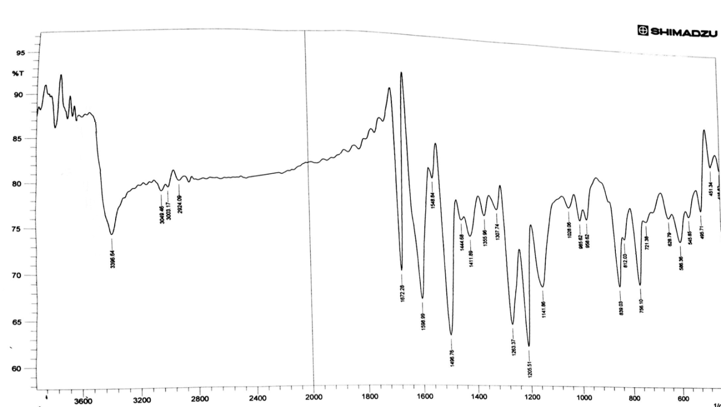

**B**

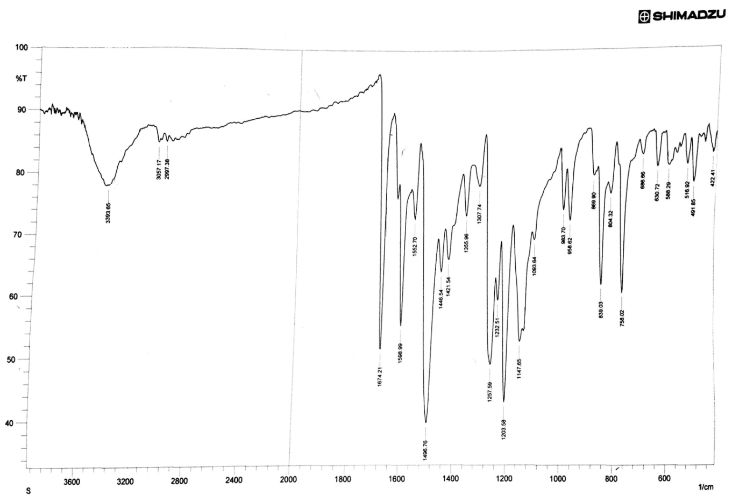

**C**

**Fig.11- I.R spectroscopic data of VACAN (A-Co complex, B -Nickel complex and C- Copper complex).**

**Molar conductivity and magnetic susceptibility:**

Electrical molar conductivity measurement results will support us in the suggestion of the geometrical formula of the prepared complexes by the Knowledge of the ionic formula of the solid complexes solutions22, that the conductivity proportionally with the charged species in solution, so it has low values or approached to zero in non-ionic solutions, our study complexes are measured in two solvents (ethanol and dimethyl formamide) in (1x10-3) M concentration and room temperature condition are non-ionic complexes, agreed with the literature23, as showed in the following :

**Table.4-molar conductivity and magnetic susceptibility for VACAN complexes**

|  |  |  |  |  |
| --- | --- | --- | --- | --- |
| Magnetic susceptibility | Λm (S.mol-1.cm2) molar conductivity | | Complex | |
| B.M | Ethanol | DMF |  |
| 4.03 | 20 | 14 | [Co(L)2(H2O)2] |
| 0 Dia | 23 | 17 | [Ni(L) (H2O) Cl] |
| 1.81 | 19 | 22 | [Cu(L) (H2O) Cl] |

Magnetic susceptibility is one of the complementary parts, to suggest the geometrical formula of complexes especially with transition metal complexes, via the study of the effects of the electron partially filled outer shields, the magnetic susceptibility give important information about complexes such electronic structure and the oxidation state for the metal, hence the determination of odd electrons number indicate the state of the of spin for the complexes (whether high or low).

From the results that observed in the above table, we saw that cobalt complex has (4.03B.M) magnetic momentum value; this will agreed with the present of three odd electron of octahedral cobalt complexes24, orbital contribution increased the momentum value.

While nickel complex has no magnetic momentum value, due to its diamagnetic character owing d8 configuration in low spin (strong field) complexes25.

Finally, copper complex has a momentum (1.81B.M) ,this may indicate the presence of an odd electron in this complex.

The solid complexes solutions were prepared at (1x10-4) M concentration for electronic spectroscopy determination, from the following figures they saw the (MLCT) bands for the complexes solutions were equal to the maximum wavelength (λmax )of the ligand-metal ions mixing solutions ,as we cannot able to determine the (d-d) transition spectra ,due to its forbidden and the limitation of the spectrometer to the 700 nm limit.

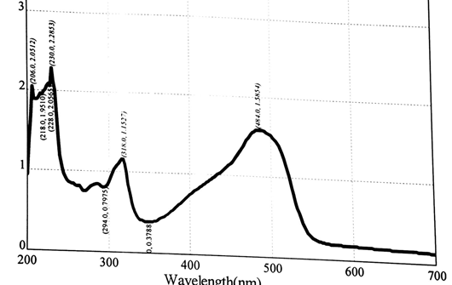

**Co**

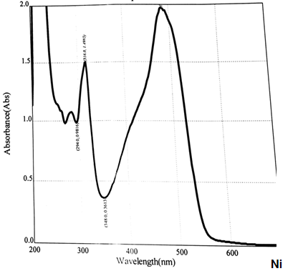

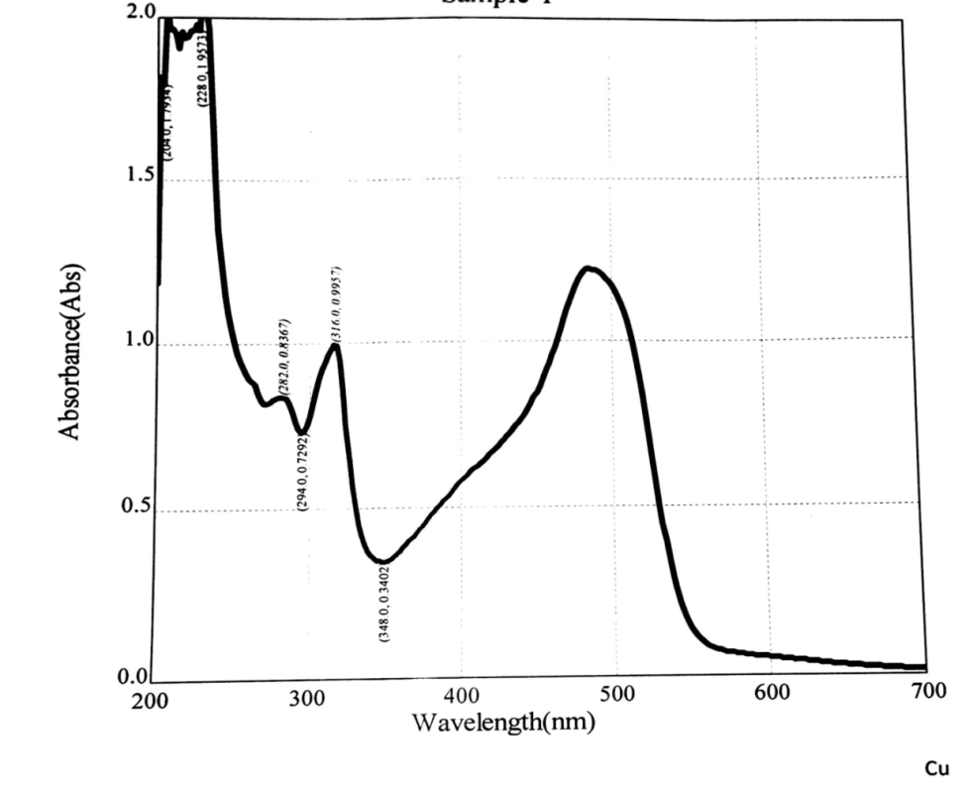

**Fig.12-electronoic spectroscopy of VACAN complexes**

**Suggested geometrical formula:**

Depending on the (C.H.N, molar conductivity values, I.R and UV-Visible data, mole ratio calculation and magnetic susceptibility data) , indeed to the strong evident of ligand formation via mass spectra , we can suggest the geometrical formula for the prepared complexes as shown blew:

An octahedral geometry for **[Co (VACAN)2(H2O)2]**complex with a structure



-Square planner geometry for **[Ni(VACAN)(H2O) Cl]** due to its diamagnetism with a structure



* While copper complex **[Cu(VACAN)(H2O) Cl]**  has a tetrahedral geometry due to its own an odd electron in the highly sterosteric effect orbital (dx2-y2) , with the structure.



**References**

1. R.M. Rohini , K.Dive and S.Devi. ***Der pharma Chemica***.7 (1), 77, (2015).

2. P.M. Rachmale. ***IJPSR***. 3(3) ; 901, (2011).

3. K . Ilango, P. Valentina, G. Saluja. ***Res J Pharm Bio Chem Sci***.1, 354, (2010).

4. H .Yoo, S. H. Kim, J. Lee, H. J. Kim, S. H. Seo, B. Y. Chung, C. Jin, Y. S. Lee. ***Bull. Korean Chem. Soc***. 26, 2057. ( 2005).

5. Andrew S.Jr., C. H. Cock,***“Introduction to Organic Chemistry”***, 2nd ed., Macmillan Publishing Co., Inc., New York; 601, (1981).

6. M. Komel, F. Galil, L. Abdel wahab and A. Osman  ***J.für parktische***

***chemie,*** 313;1101,(1972).

7. Smith .T.P., Malcomber, D.W. and Almasry .M.A. ***US Patent***.5.166.326, (1992).

8. H. Kumar and R.P. Chaudhary , ***Arch .Appl.Sci.Res***.2(5);407,(2010).

9. G.G. Chigarenko, A . PoromarRenko, A.S. Burlov, A.G. Chigarenko ,

I.S. Vasilcheenko , A.I. Urerev , D.A. Garnoviskii , A.D. Garnoviskii ,

***J.Fract.& Wear***.28(4);377, (2007).

10. Z. Marczenko , "***Spectrophotometric determination of elements***" 2nd ed , Ellis Harwood Ltd., Chickester, England,(1986).

11. A.F.Warder, ***Int J Chem Sci App***, 3, 356, (2012).

12.B.S.Dawane, S.S.Chobe, G.G.Manadawad and B.M.Shaikh,***orbital electr.j.chem.Campo Grande,*** 4(1);7, (2012).

13. H.A.Deshpande. H.N.Chopde,C.P.Pandhurnckar and R.J.Parta, Chem.Sci.Trans, 2(2) ;621,(2013).

14. R Ajendra Prasad, A. Srinivasa Rao and R. Rambabu , ***Asian J of Chemistry*** *,*21(2):907, (2009).

15.S. Shibata, M. Furukawa and R. Nakashima; ***Anal. Chem. Acta.***, 81; 131, (1976).

16. A.M.Asiri; ***JKAU***,12;69,**(2000).**

17.S.M.Mahdi ***"PhD Thesis "***, Babylon University, 2013.

18. B.K.Reddy, J.R.Kumar, K.J. Reddy and A.V. Reddy, ***Anal.Sci.***19; 423,(2003).

19.J. H. Yoe and A. L. Jones; ***Ind. Eng. Chem., Anal .Ed***, 16; 11,( 1944).

20. G.W. Ewing**“Instrumental Methods of Chemical Analysis”**, 5th ed. Mc Graw– Hill (1985).

21. M. SÖNMEZ. ***Truk.J.Chem***; **25**, 181 (2001).

22. D. A. Skooge, ***“Fundamentals Analytical Chemistry”****,* 5th. Ed. New York ; 411,(1988)**.**

23. B. Singh, R. N. Sing and R. C. Aggarwal; Polyhedron, 4; 401, (1985).

24.K.Bizilij,S.G.Hardin,B.F.Hoskings,P.J.Oliver, R.T.Edward and G.Winter , ***Aust.J.Chem***,39;1035, (1986).

25.J.Kotz , P.Treichel , J.Townsend and D.Treichel ***"Chemistry &chemical reactivity "*** 9th ed. Cengage learning, USA,; 887, (2015)