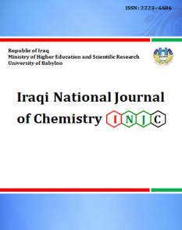
Iraqi National Journal of Chemistry
Journal homepage: http://iqnjc.com/Default.aspx

Spectrophotometric assay of metoclopramide hydrochloride in bulk and in dosage form
Hind A. W. Al-Azzawi¹, Faiz M. Al-Obadi¹ and Theia'a N. Al-Sabha²
¹ Chemistry Department, College of Science, University of Tikrit, Tikrit, Iraq (Email : Hind1985@Gmail.com )
²Chemistry Department, College of Education, Mosul University, Mosul, Iraq
Abstract: A simple, reproducible and sensitive spectrophotometric method for assay of metoclopramide hydrochloride is investigated. The method is based on the Schiff's base formation reaction of metoclopramide with 1,2-naphoquinone sulphonate (NQS) as chromogenic reagent in the presence of micellar cetylperidinium chloride (CPC) and sodium carbonate in aqueous solution to give a highly coloured product with maximum absorption at 471 nm. Beer's law is obeyed in the range of 0.1-26 μg/ml with a molar absorptivity of 4.124×10⁴ l.mol⁻¹.cm⁻¹ and the limit of detection and quantitation are 0.0416 and 0.1386 μg/ml respectively. The accuracy (average recovery %) is 100.72 % and the relative standard deviation (RSD) is better than 0.44%. Also, it was found that the product formed was in ratio of 1:1 product with stability constant of 3.2×10⁷ L.mol⁻¹. The method is applied successfully to the assay of metoclopramide hydrochloride in pharmaceutical formulations and is agreed well with its certified value and with those of British pharmacopoeia method.
Keywords: Metoclopramide; NQS; Schiff's base; Spectrophotometry.

(التقدير الطيفي للميتوكلوبراميد هيدروكلوريد في حالته النقية ومستحضراته الصيدلانية)
هند عبد الوهاب عبد اللطيف ضياء نجم الصبحة
فائز حامد محسن
الخلاصة
تم وصف طريقة طيفية بسيطة وحساسة لتقدير الميتوكلوبراميد هيدروكلوريد. تعتمد الطريقة على تكوين قاعدة شيف من تفاعل الميتوكلوبراميد مع الكاشف 2,1- نفثوكوينون سلفونات بوجود سيتايل بريدينيوم كلوريد وكاربونات الصوديوم في الوسط المائي, حيث أعطى ناتج شديد اللون يمتلك أقصى امتصاص عند الطول الموجي 471 نانوميتر. أمكن تطبيق قانون بير في مدى تركيز 0.1-26 مايكروغرام/مللتر وبلغت الامتصاصية المولارية 4.124 ×10⁴ لتر/مول.سم وبحد كشف وحد كمي 0.01416 و 0.1386 مايكروغرام/مللتر على التوالي. لقد كانت دقة الطريقة ( معدل نسبة الاسترجاع) 100.72% وبتوافقية ( الانحراف القياسي النسبي) أفضل من 0.44%. كما وجد أن الناتج يتكون بنسبة 1:1 وبثابت استقرارية 3.2×10⁷لتر/مول. طبقت الطريقة في تقدير الميتوكلوبراميد هيدروكلوريد في المستحضرات الصيدلانية بنجاح وقورنت النتائج مع المحتوى الأصيل والطريقة القياسية في الدستور البريطاني للأدوية.
الكلمة المفتاحية : (ميتوكلوبرامايد و1 ، -2 نفثوكوينون سلفونات وقاعدة شيف والمطيافية) .

Introduction
Metoclopramide hydrochloride (MCP.HCl), [4-amino-5-chloro-N-(2-diehylaminoethyl)-2-methoxybenzamide hydrochloride] [I] is used as an anti-emetic in the treatment of some forms of nausea and vomiting and to increase gastrointestinal motility. It is of little benefit in the prevention or treatment of motion sickness or in the treatment of nausea and vertigo due to Meniere disease or other labyrinth disturbance[1], also it is used to relieve certain stomach and esophagus problems such as diabetic gastroparesis and gastroesophageal reflux disorder[2].
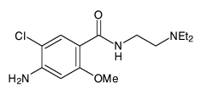

[I]

Various analytical techniques have been reported for determination MCP.HCl in pure or dosage forms including chromatographic methods [3-7], titrimetry [8], voltammetry [9], atomic absorption [10], flow injection [11,12] and ion selective electrode [13]. Of course, the above mentioned techniques are sensitive but expensive except the titrimetric method. Spectrophotometry is the technique of choice even today due to its inherent simplicity. Many spectrophotometric procedures have been applied for determination of MCP.HCl using different reagents including phenothiazine as coupling reagent and ferric nitrate as oxidizing reagent [14], o-phenanthroline or bipyridyl in the presence of Fe III or Ce IV as oxidizing reagents [15], dibenzoyl methane [16], aniline as coupling reagent [17] and p-dimethylaminocinnamaldehyde [18] in addition to other spectrophotometric methods [19-22]. Some of these methods are time-consuming, extraction procedures or heating and require strictly controlled reaction conditions. Others are less sensitive. The British Pharmacopoeia 1998 reported a potentiometric method using perchloric acid for determination of MCP.HCl powder, spectrophotometric method for oral solution and chromatographic method for tablets and ampoules [23]. The potentiometric method requires 250mg of drug, whereas the chromatographic and spectrophotometric methods are time consuming, tedious and many reagents are needed. The present work describes a simple and sensitive spectrophotometric method for assay of MCP.HCl. The method is based on the formation of Schiff's base from the reaction of the drug with 1,2-Naphthoquinone-4-sulphonate (NQS) reagent in aqueous medium.
Experimental
Apparatus
Shimadzu UV-1650 PC UV-Visible spectrophotometer was equipped with a 1.0-cm path length silica cell, Philips PW (9421) pH-meter with a combined glass electrode was used for pH measurements. All calculations in the computing process were done in Microsoft Excel for Windows.
Reagents
All reagents were of analytical-reagent grade which are provided by BDH , Fluka and Molekula companies. A standard solution of 100 µg/ml of MCP.HCl was prepared by dissolving 0.01g in 2.0 ml of ethanol and diluting to the mark with distilled water in 100-ml volumetric flask. The working solution was obtained from appropriate dilution of stock solution. 5×10⁻³ M of NQS reagent was prepared by dissolving 0.065 g in distilled water and making the volume up to 50 ml in a volumetric flask, this solution was prepared fresh as a daily procedure. 0.1 M sodium bicarbonate was prepared by dissolving 5.3 g in distilled water and making the volume up to 500 ml in a volumetric flask. 0.1 % of CPC was prepared in warm distilled water.
General procedure
Aliquots containing 0.1 to 26.0 µg/ml of MCP.HCl, in final dilution, was transferred quantitatively into a series of 25-ml standard flasks. A solution 1 ml of 5×10⁻³ M NQS, 1ml of 0.1 M sodium carbonate and 1.5 ml of 0.1% CPC were added. The mixture then was diluted to the mark with distilled water and kept at 50°C for 10 min for the development of colour, then cooled to room temperature. The absorbance of the resulting solution was measured at 471 nm against the reagent blank.
Analysis of pharmaceutical preparations
Tablet
Ten tablets (each tablet containing 10 mg MCP.HCl) were accurately weighed and pulverized. A portion of the fine and homogenized powder equivalent to 10 mg was accurately weighed and dissolved in about 60 ml of distilled water. The solution was shaken thoroughly for about 10 min. and the residue was filtered through Whatmann no. 42 filter paper into 100 ml volumetric flask. The filtrate was diluted to the mark by repeated washing with distilled water. The filtrate was diluted to get a 100 µg/ml solution of MCP.HCl. An aliquot of diluted drug was taken and the procedure as described above was followed.

Injection
For the analysis of injection, 2ml vial containing 10mg/2ml of MCP.HCl was transferred into 100 ml volumetric flask and diluted up to the mark with distilled water. Working standard was prepared by suitable dilution and the general procedure was followed.

Syrup
The content of MCP.HCl syrup (5mg/5ml) was mixed well and 10 ml of syrup was quantitatively transferred into 100 ml volumetric flask and completed to the mark with distilled water. An aliquot of diluted drug was taken and treated as mention in the recommended procedure.

Results and Discussion
Preliminary test
MCP.HCl reacted with NQS reagent in the presence of sodium hydroxide forming an orange colour of Schiff's base with maximum absorption at 470 nm, where as reagent blank shows low absorbance at this wavelength. However; it was noticed that absorbance was increased when the mixture was heated at 50°C for few mins.
Study of the optimum reaction conditions
To take full advantages of the procedure, the reagent concentrations must be optimized. The parameters were optimized by setting all parameters constant and optimizing one each time at 50°C for 15 min.
Effect of base and pH
To obtain high sensitivity for the product, the effect of some bases such as sodium hydroxide, sodium bicarbonate, sodium carbonate, potassium hydroxide and ammonium hydroxide have been examined. As shown in Figure 1, sodium carbonate gave maximum absorption at 470 nm.

Figure 1: Effect of bases on the absorption of 8 μg/ml MCP.HCl
However; the effect of the sodium carbonate amount and pH were studied and found that 1ml gave maximum absorbance at pH 10.2 (Fig. 2) and recommended in this method.
Na₂CO₃, 0.1M, ml
461
459
458
6.96
9.12
10.2
10.52
10.78
10.9
11.32
pH
Absorbance
458
460
470
459
λ_{max}
(nm)

Figure 2: Effect of Na₂CO₃ concentration and pH on the absorption of reaction mixture of 8 μg/ ml MCP.HCl
Effect of buffer solution
The effect of buffer solution such as ammonium, borate, carbonate and phosphate buffers with pH 10.2 was examined, but a decrease in the absorbance of the product was observed.
Effect of NQS reagent
The effect of changing the NQS concentration on the absorbance of solution containing a fixed amount of MCP.HCl was studied. It is evident that the absorbance increases with increasing NQS concentration and reached maximum on using 1 ml of 5×10⁻³ M NQS (Fig.3) which is recommended in this work.

Absorbance

NQS, 5×10⁻³ M, ml

Figure 3. Effect of NQS reagent concentration on the absorption of reaction mixture of 8 μg/ ml for MCP.HCl in the presence of Na₂CO₃ solution.
.

Effect of temperature and developing time
The reaction time was determined by following the colour development at room temperature and in thermostatically controlled water-bath at different temperatures up to 70°C. The absorbance was measured at 5 min intervals against reagent blank treated similarly. It was observed that the absorbance reached maximum after 10 min at 50°C and remained constant for 20 min, whereas, a decrease in absorbance with increased time and temperature was noticed indicating dissociation, (Fig.4). Hence, 10 min at 50○C was used in this work.
Time, min.
Absorbance
20°C
30°C
40°C
50°C
60°C
70°C

Figure 4. Effect of temperature, developing time and stability period for the absorbance of 8 µg ml⁻¹ MCP.HCl.

Effect of surfactants
The effect of surfactants; cetyltrimethyl ammonium bromide (CTAB), cetylpyridinium chloride (CPC), Tween-80 (TW-80) and TritonX-100 (TX-100), of 0.1 % concentration, on the absorption spectrum of product has been investigated. As shown in Table 1, the cationic surfactant CPC increased the absorbance of MCP.HCl-NQS product, but other surfactants showed negative effect. Therefore CPC was selected in this method. The absorbance increased with an increase in CPC concentration up to 1.5 ml (Fig.5). Therefore 1.5 ml of 0.1 % CPC was selected for further investigation.

Table 1. Effect of surfactants on the absorption NQS-MCP.HCl product
Surfactant | Absorbance | λ_{max}
Without | 0.450 | 470
CPC | 0.541 | 471
SDS | 0.390 | 468
CTAB | 0.410 | 467
Trion x-100 | 0.430 | 467
Tween – 80  Absorbance  CPC, 0.1%, ml | 0.360 | 467

Figure 5. Effect of CPC concentration on the absorption of reaction mixture of 8 μg/ ml for MCP.HCl.

Effect of order of addition
To prove the sensitivity of the proposed method, the order of addition of reagents was tested under the optimum conditions. Table 2 shows that order no. I is the best and applied in the general procedure.

Table 2: Effect of order of addition on the absorption of 8 μg/ ml MCP.HCl
Order Of addition | Order no. | Abs.
drug + NQS + base + CPC | I | 0.540
drug + base + NQS + CPC | II | 0.496
drug + CPC + NQS + base | III | 0.416
drug + CPC + base + NQS | IV | 0.468
drug + base + CPC + NQS | V | 0.421
drug + NQS + CPC + base | VI | 0.420
NQS + base + drug + CPC | VII | 0.512
NQS + base + CPC + drug | VIII | 0.471

Absorption spectra
The final absorption spectra of NQS-MCP.HCl product are plotted under the optimum conditions obtained above. Figure 6 shows that MCP.HCl Schiff base product has a maximum absorption at 471nm versus reagent blank, whereas the reagent blank has low absorbance at this wavelength and has a maximum absorption at 370 nm versus distilled water.
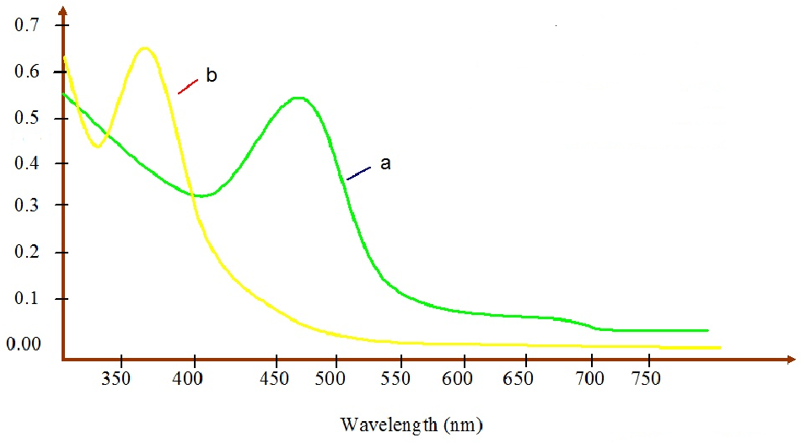
Absorbance

Figure 6. Absorption of spectra of (a) MCP.HCl (8µg/ml) with NQS against reagent blank and (b) reagent blank versus distilled water.

Quantification
In order to investigate the range in which the colored complex adhere to Beer's law, the absorbance of the product was measured at 471 nm after developing the color by following the general procedure calibration graph for a series of solutions containing increasing amounts of MCP.HCl. The Beer's law limits and molar absorptivity values were evaluated and given in Table 3, which indicated that the method is sensitive. The linearity was represented by the regression equation and the corresponding correlation coefficient for the studied determined drug by the proposed method represents excellent linearity. The relative standard deviation (RSD) and accuracy (average recovery %) for the analysis of six replicates of each three different concentrations for MCP. HCl indicated that the method is precise and accurate. Limit of detection (LOD) is in the accepted range below the lower limit of Beer's law range.

Table 3: Summary of optical characteristics and statistical data for the proposed method
Parameter | MCP.HCl
Beer's law limits (μg ml⁻¹) | 0.1-26
Molar absorptivity  (l.mol⁻¹. cm⁻¹) | 4.124×10⁴
LOD (μg.ml⁻¹) | 0.0416
LOQ (μg.ml⁻¹) | 0.1386
Average recovery (%)⃰ | 100.72
Correlation coefficient | 0.9994
Regression equation (Y)⃰⃰ ⃰
Slope, a | 0. 1164
Intercept, b | 0.0176
RSD ⃰ | ≤ 0.44
⃰Average of six determinations.
⃰ ⃰ Y= a X + b, where X is the concentration of drug in μg ml⁻¹
Interference
The extent of interference by some excipients which often accompany pharmaceutical preparations were studied by measuring the absorbance of solutions containing a fixed amount of MCP.HCl and various amounts of diverse species in a final volume of 25 ml. It was found that the studied excipients did not interfere seriously (Table 4). However; an error of 5.0 % in the absorbance readings was considered tolerable.
Table 4: Effect of exciepients for assay of MCP.HCl
Excipient | Recovery% of 8 μg/ml metoclopramide per μg/ml excipient added
 | 200 | 300 | 400 | 500
Glucose | 101.7 | 102.9 | 101.1 | 103.5
Starch | 99.40 | 98.80 | 100.5 | 101.18
NaCl | 102.99 | 98.8 | 101.1 | 101.7
Lactose | 102.9 | 101.1 | 101.7 | 104.19
Acacia | 98.80 | 99.4 | 101.83 | 104.1

Analytical applications
The proposed method was successfully applied to determine MCP.HCl in pharmaceutical preparations. The obtained results were compared statistically by a Student's t-test for accuracy and a variance ratio F-test for precision with the official method [23] at the 95% confidence level with six degrees of freedom, as cited in table 5. The results showed that the experimental t-test and F-test were less than the theoretical value ( t=2.45, F=6.39 ), indicating that there was no significant difference between the proposed method and official method. The proposed method is compared favorably with other reported methods.
As shown in Table 6, the present method is more sensitive than other reported methods and applied to the various pharmaceutical formulations.
Stoichiometry and stability constant
The stoichiometry of the reaction of MCP.HCl with NQS reagent was studied by the molar ratio and Job[25] methods, using solutions of 1x10⁻² M for each drug and NQS reagent. As shown in (Fig. 7) a & b, the results indicate that 1:1 aminophenol to reagent was formed using both above methods. This indicates that amino group present in MCP.HCl is responsible for the formation of the Schiff base product.
According to the results obtained from above stoichiometry, the apparent stability constant was estimated by comparing the absorbance of a solution containing stoichiometric amounts of the MCP.HCl and NQS (As) to one containing an excessive amount of NQS reagent (Am). The average conditional stability constant of the product was calculated by the following equation :
Kc=1-α/ α² C
α =Am-As/Am
where Kc is the association constant (l.mol⁻¹), α the dissociation degree and C the concentration of the product which is equal to the concentration of MCP.HCl. The average Kc is 3.2 × 10⁷ indicate that the product is stable.

Table 5: Assay of MCP.HCl in pharmaceutical preparations using the proposed method and comparison with the official method.
Certified value  (mg) | Average recovery  (mg) | Drug content found (mg) | Recoveryª  (%) | Drug amount present (μg/ml⁻¹) | Dosage  form | Procedure applied
10 mg | 10.13 (0.10,5.55)^{b} | 9.83  10.15  10.40 | 98.35  101.50  104.05 | 5  10  20 | Tablet | Proposed NQS method
10 mg/2ml | 10.17 (0.23,5.84) | 10.22  10.43  9.88 | 102.21  104.30  98.79 | 5  10  20 | Injection
5 mg/5ml | 4.93 (0.80,2.59) | 4.83  4.81  5.15 | 96.63  96.21  103.19 | 5  10  20 | Syrup
250 mg | 252.22 | 235.41  252.22  269.04 | 94.16  100.88  107.61 | 250 mg | Pure form | British Pharmacopoeia
ª Average of three determinations.
^{b} Figures in parenthesis are the calculated values for t and F tests.

Table 6: Comparison of spectrophotometric methods for MCP.HCl determination
Ref. | Application | ε  (l/Mol.cm) | Linearity  (μg ml⁻¹) | λ_{max}  (nm) | Reagent | No.
[14] | Tablets, syrup and drops | 2.05×10⁴ | 0.1-14 | 610 | Oxidative coupling with promethazine | 1.
[18] | Tablets | 2.58x10⁴ | 4-24 | 553 | Schiff's base using p-DMAC ⃰ | 2.
[19] | Tablet and injection | 0.8.0×10⁴ | 1.0-28 | 315 | 2,4-dinitro-1-flouro- benzene | 3.
[20] | Tablet | 3.49×10⁴ | 0.4 – 18 | 550 | Diazotization coupling with 1-naphthol | 4.
Present method | Tablet, injection and syrup | 4.124×10⁴ | 0.1-26 | 471 | Schiff's base using NQS | 5.
Table 6: Comparison of spectrophotometric methods for MCP.HCl determination
⃰ p-Dimethylaminocinnamaldehyde

Absorbance
[MCP.HCl]/[ MCP.HCl]+[NQS]
a
b
[NQS]/[ MCP.HCl]
Absorbance

Figure 7: Continuous variations (a) and mole ratio (b) plots for product of MCP.HCl (1× 10⁻²M) and NQS (1× 10⁻²M) under the optimum conditions.
Reaction mechanisms
A characteristic orange colored product of λ_{max} 471 nm for MCP.HCl was formed when it allowed to react with NQS in the presence of Na₂CO₃ in aqueous medium. Under the experimental conditions, the light yellow alkaline solution of the o-quinoidal NQS reacts with compounds containing one removable hydrogen atom [26] attached to one nitrogen atom, to yield an anionic orange colored paraquinoid imide condensation product with the elimination of NaHSO₃ [27]. When CPC is added to this product, an intense orange colored product was formed as ternary product [28]. A reaction mechanism based on the above reaction is shown in Scheme 1.

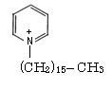
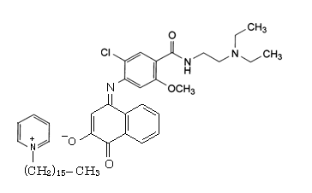
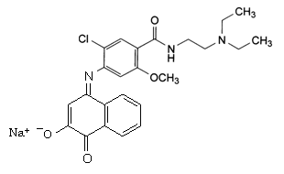
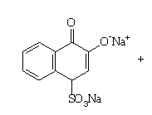
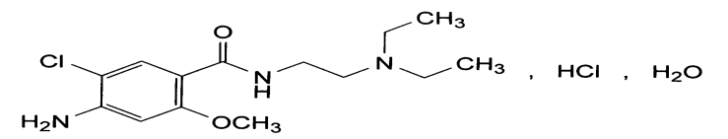
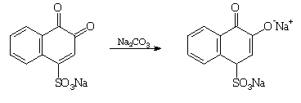
CPC
+
NaHSO₃
Quinoidal
Ternary Schiff's base product
MCP

Scheme 1: Probable product formation mechanism

Conclusion
The proposed method is sensitive (ε=4.124×10⁴ L.mol⁻¹.cm⁻¹), accurate (average recovery range 100.72 %), precise (RSD ≤ 0.44) and simple since it does not need solvent extraction step. Analysis of authentic samples containing MCP.HCl showed no interference from common additives and auxiliary substances in general. The method was applied successfully for determination of MCP.HCl in its pharmaceutical formulations and compared favorably with the official method.

References
1. Martindal, ''The Extra Pharmacopoeia'', 46th ed, 2000, The Pharmaceutical Press, London, 1200
2. C. D. Ponte and J. M. Nappi, Am. J. Hosp. Pharm., 1981, 38, 829.
3. A.A. Fatmi and G.V. Williams, Drug. Dev. Ind. Pharm., 1989, 15, 1365.
4. L. M. Ross, M. J. Eadie, F. Bochner, W. D. Hooper, and J.H. Tyrer, J. Chromatogr. Biomed. Appl., 1980, 9, 175-184.
5. K. W. Riggs, A. Szetz, D. W. Runak, A. E. Mull, B. F. S. Abbote and J.E Axeison, , J. Chromatogr. B. Biomed Appl., 1994, 660 , 315-325.
6. S. M. Bryson, E. M. Mc and L. M. Gibert, J. of Clinical Pharma. and Therap., 2008, 9, 263.
7. R. Vejendla, V. kudidhi1, S. Sravanthi, G. Taruni, M. D. Musthafa, Int. J. Pharm. Phytopharmacol. Res. 2013, 3, 83-86.
8. B. Jawan and L. O was, Inst. J. Pharm., 1986, 28, 44.
9. Z. H. Wang, H. Z. Zhary, S. P. Zhou and J. Dong, Talanta, 2001, 53,1133.
10. M. K. Park, B.R. Lim, K.S. Yu, and K.H. Yong, Yakhar Hoe. Chi, 1978, 22, 27-32.
11. M. Buna, J. Haron, P. Prognen and F. Mah, Analyst, 1996, 121, 1551.
12. N. A. Al-Arfa, Talanta, 2004, 62,255-265.
13. A. A., Al-Haideri, N. I., Abdulla,1 and I. K. Malih, Iraqi J. Pharm Sci., 2012, 21, 70-77.
14. M.Q. Al-Abachi and H. S. Al-Ward, National J. Chem., 2002,7, 363.
15. A. S. Amin and G.H. Ragab, Analytical Sciences, 2003, 19, 747.
16. H. D. Revanasiddappa and B. Manju, J. Pharm. and Biomed. Anal., 2001, 25, 3.
17. J. Shah, J. M. Rasul, K. M. Azam and S. Amin, J. Anal.Chem., 2005,60, 633.
18. B. A. Moussa, J. Pharm. and Biomed. Anal., 2000, 23, 1045.
19. T. N. Al-Sabha and I. A. Al-Hamody, Nat. J. Chem., 2006, 24,561-570.
20. R. Sinan, Baghd. Sci. j., 2010, 7, 1-9.
21. F. M. Abdel-Gawad, N. M. El-Guindi, Anal. Lett., 1995 28, 1437.
22. P. G. Ramappa and H. D. Revanasiddappa, Indian Drugs, 1999, 36, 381.
23. British Pharmacopoeia, The Stationary Office under License from the Controller of Her Majesty’s Stationary Office, London, CD room (2005).
24. L. G. Hargis, “Analytical Chemistry, Principles and Techniques”, Prentice- Hall Inc., New Jersey. (1988) pp. 424- 427.
25. J. Saurina, S. Hemandez-Cassos and R. Taular, Anal. Chem., 1995, 67, 3722.
- P. Nagaraja, K. C. Srinivasa Murthy and H. S. Yathirajan, Talanta, 1996, 43, 1075.
- P. Nagaraja, K. C. S. Murthy and K. S. Rangappa, J. Pharm. Biomed. Anal., 1998, 17, 501.

