THMs REDUCTION IN WATER TREATMENT PLANT BY USING CHLORINE DIOXIED AS DISINFECTANT
Alaa Husaeen Al-Fatlawi¹, Noor Alaa Abd Al-Hussein²
¹Environmental engineering department, Hila, Iraq
² Local environmental researchers center, Babylon University, Hila, Iraq
Email address:
nooralaa21@yahoo.com
AL-Fatlaw, A. H. and Abd Al-Hussein, N. A. , THMs reduction in water treatment plant by using chlorine dioxide as disinfectant . Mesopotomia Environment Journa , 2014 Vol. 1, No.1, pp.19-31.

ABSTRACT
The presence of trihalomethanes (THMs) in drinking water has attracted the attention of both researchers and professionals, because of the harmful effects of these substances on human health. Chlorine dioxide (ClO₂) is an alternative to chlorine because it is an oxidizing agent rather than a chlorinating agent, and therefore, will not form chlorinated disinfection byproducts such as THMs under typical water treatment conditions.
The study was conducted to determine the capability of ClO₂ on the formation of THMs, and coliform bacteria. A small-scale pilot plant of a compact model is designed and constructed at Environmental Engineering Department laboratory (Babylon University).It is simple to operate and made of galvanized iron and locally available materials.
Raw-water source is synthesized water preparation from tap water with average characteristics (pH 8.1, Turbidity 3.04 NTU, Alkalinity 150 mg/L as CaCO₃, Temperature 17.5^{ᵒ}C). Tap water was first passed through a tank and predetermined the concentration of turbidity and total organic carbon. Turbidity and TOC adjustment of water were finally performed by addition of natural clay screened for 200 μm containing leaves and stems of plants and other organic carbon to change the amount of turbidity and TOC of water. Characterizing of synthesized water was done at the Environmental lab of Babylon University. These characteristics are turbidity 27 NTU, alkalinity 140 mg/L as CaCO₃, pH 8.22, temperature 28 ^{ᵒ}C, and total organic carbon 1.4 mg/L Total Trihalomethanes (TTHMs), and their compounds and varieties of water quality parameters were monitored in the pilot plant, by the addition of different doses of chlorine dioxide and alum to synthesized water pipe entering the pilot plant and monitoring THMs concentration. The synthesizedand finished water quality parameters included; Hydrogen ion concentration, Temperature, Turbidity, Total Trihalomethane concentration.
(HS – GC - ECD) with Gas chromatography analysis techniques were used to measure the THMs concentrations. It was noticed that TTHMs concentration increases as temperature, and turbidity increase, and average TTHM levels detected in all runes not exceed the USEPA’s Stage I limit of 80 μg/L while it exceeded the limits in stage II for all sampling measurements.
KEYWORDS: Trihalomethane, DBPs, Drinking Water, Temperature, Turbidity, pH

INTRODUCTION
The formation of disinfection by-products (DBPs) caused by disinfection has become a main safety issue for the public health. Trihalomethanes (THMs) and haloacetic acids (HAAs) are two of the major classes in DBPs, (THMs) contains four species which are chloroform, dichlorobromomethane (DCBM), dibromochloromethane (DBCM), and bromoform; the sum of these four species is denoted as total THMs when analyzing for its concentration in disinfected water [2].
Chlorine dioxide is effective at inactivating waterborne pathogens, it does not react with organic material in water supplies to form trihalomethanes; however, some halogenated by-products are created when chlorine dioxide is used as a disinfectant.
THM formation is strongly dependent upon the chlorine concentration [6,10]. However, there is some disagreement regarding the quantitative relations between chlorine concentrations and the rate of THMs production, linear relationship between chlorine consumption and the production of THMs with a reaction order greater or equal to unity [6 ,14] Despite this, it is also possible that the reaction order might change during the course of the reaction [6].
The concentration of DBPs formed with free chlorine depends on the raw water content but generally free chlorine produces the largest quantities of DBPs when compared to other disinfectants. Numerous studies have been conducted in the past three decades on the harmful effects of DBPs in drinking water supplies. DBPs arecarcinogenic and can cause adverse pregnancy outcomes. In the 1970s, scientists discovered that free chlorine in water reacted with natural organic matter to form chlorinated by-products.
Disinfection by-products (DBPs) in drinking water have been a majorsubject of study over the past 30 years. The majority of these studies havefocused on the formation and control of DBPs, primarily trihalomethanes(THMs), in treatment plants. Disinfectionhas been widely known asa key step in the drinking water system to maintain the safe drinking water for allcustomers[16]. The formation of disinfection by-products (DBPs) caused by disinfection has become a main safety issue for the public health. Trihalomethanes (THMs) and haloacetic acids (HAAs) are two of the major classes in DBPs, (THMs) contains four species which are chloroform, dichlorobromomethane (DCBM), dibromochloromethane (DBCM), and bromoform; the sum of these four species is denoted as total THMs when analyzing for its concentration in disinfected water[15].
The subsequent identification of THMs in chlorinated water supplies led to concerns over their potential health effects. These concerns include potential reproductive effects and the classification of chloroform, bromodichloromethane and certain other disinfection byproducts (DBPs) as carcinogens. The key to understanding why chlorine dioxide is so effective can be found in the differences in the reactions of chlorine dioxide and chlorine with THM precursors, such as humic and fulvic acids. Chlorine dioxide reacts primarily by oxidation; however, chlorine reacts by both oxidation and electrophilic substitution to yield volatile and nonvolatile chlorinated organic substances (THMs), [3]. Chlorine dioxide reacts with THM precursors to make them unreactive or unavailable for THM formation.
Trihalomethanes are volatile substances defined as halogenated methanecompounds that form during chlorination of natural water.The four THMs(THM4) are chloroform (CF), bromodichloromethane (BDCM),dibromochloromethane (DBCM), and bromoform (BF).THMs can be formed from numerous organic compounds present in water,including some ketones (relatively slow THM precursors), aromatic compoundswith specific groups (e.g., resorcinol, which rapidly forms THMs), and humicand fulvic substances [17, 18, 19].In general, THMs are the endproductsof the numerous reactions that may occur between chlorine and organicmaterials [20]. THMs formation depends on a variety of water quality anddisinfection factors including:
• Concentration and chemical properties of the precursors
• Water temperature
• pH
• Bromide ion concentration
• Disinfectant type, dose, and residual
• Contact time
Accordingly, the concentration of DBPs depends on the chemical characteristics of the raw water, the treatmentprocesses at the plant, chemical types and doses employed at the plant, andresidence time in the various treatment units.
Increased pH values lead to increases in THMs formation [13, 9] three-fold increases being reported in the reaction rate per unit of pH [6].The lower the pH, the higher nonionized HCIO form of hypochlorous acid is found, thus increasing its reaction rate with the humic matter. However, THM yields depend rather on the last step of the THM reaction pathway, which is base-catalyzed as with the haloform reaction [12].
EXPERIMENTAL WORK
A small-scale pilot plant of a compact model is designed and constructed at Environmental Engineering Department lab (Babylon University) to produce potable water. The raw water is synthesized water.
The pilot water treatment plant is simple to operate and made of galvanized plate of a components locally available mterials. The schematic layout and mode of operation of the compact pilot plant is shown in Fig. 1.
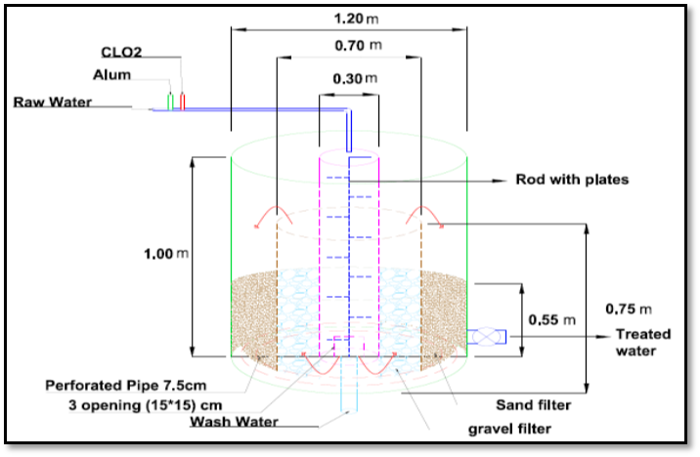
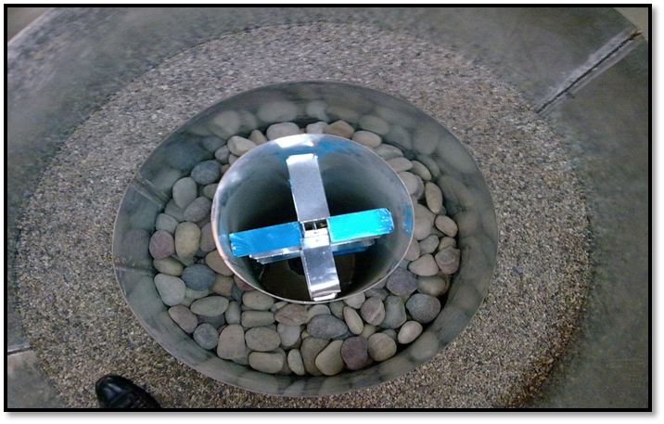
A
B

A

B

Figure (1) A (Schematic layout of Pilot plant used in the study), B (Top view for pilot plant
Raw water (synthesized water) is prepared from tap water with characteristics shown in Table 1. Raw water was first passed through a tank and predetermined the concentration of turbidity and total organic carbon. Turbidity and TOC adjustment of water was finally performed by the addition of natural clay screened for 200 μm contains leaves and stems of plant, and other organic carbon to change the amount of turbidity and TOC of water[8].
The raw water (synthesized water); was analyzed for the measurement of turbidity, pH, temperature, and total organic carbon; which was performed at the Environmental Directorate Lab of Babylon Province. Table 1 shows the characteristics of this water.
Table 1. Average raw (Synthesized) water characteristics
Parameter |  | Value, (average)
Temperature, (ᵒC) |  | 28
Turbidity, (NTU) |  | 27
THMs (mg/L) | CF | 0.02400
THMs (mg/L) | BDCM | 0.05257
THMs (mg/L) | DCBM | 0.0588
THMs (mg/L) | BF | 0.01905
TTHMs, (mg/L) |  | 0.1545
pH |  | 8.22
TOC, (mg/L) |  | 1.4

Trihalomethanes (THMs) Concentration measured by Headspace electron capture detector method (HS-GC-ECD) Gas-liquidmethod with GC Gas chromatography/TOC lab/Ministry of Science &Technology /Environmental and Water Directorate/ Water Technology Center was used to measure Trihalomethanes. Gas-liquid extraction method was used to extract THMs into a nitrogen gas as the extraction solvent. The sample to be extracted was left aside for a period to take room temperature some vials appeared out of the cool box to get room temperature also before extraction.
After that, the 40 mL vial was uncapped and poured 5mL of sample as waste, then 25 mL into 25mL-volumetric flask over the grade. The rest samples were discarded.
The sample was then shake vigorously by hand for about 4 minutes and allowed to stand for 1 minute to facilitate phase separation, 1.0 mL or more of the upper separated layer (the extraction of the THMs into the nitrogen) was transferred by pasture-pipette to a 2-mL glass vial and capped with teflon-lined septa and screw hole-caps. 1 μL was drawn from 2-mL vial via particular micro syringe (equipped with the GC) and injected into the GC through special slot. Fig.2 shows a photo of the GC in which, the THMs analysis for this study, have been carried out.
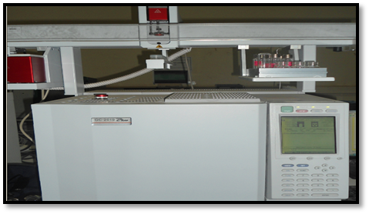

Figure 2 :Gas chromatography for measure TTHMs.
The results showed that the THM formation decrease with increasing chlorine dioxide dose, concentrations of THMs that developed in water pretreated with 2 mg/L ClO₂ were significantly lower when compared to those in water pretreated with the other dose of ClO₂. It is observed that higher THM level at ClO₂ dose of 0.2 mg/L and then tends to decrease slightly with increasing ClO₂ dose. Increasing ClO₂ doses has been shown to have the opposite effect as in chlorine. This finding agrees with the results adapted by [4].
Also the results showed that with increasing the dose of ClO₂ from 1.0 to 2.0 mg/L leads to more reduction in THMs concentration with increasing of about 24 percent agree with the results adapted by [4,5], They found that increasing the doses of ClO₂ leads to increase the reduction in THM formation and approximately 20.74% percent reduction in THM concentrations when 1.0 to 2 mg/L of ClO₂ was applied.
Fig. 3 represents the percent reduction in TTHMs concentration of filtered water after preoxidation with ClO₂. The Figure shows that the removal efficiency increases with increasing chlorine dioxide dose, a similar result found by [5] they concluded that the removal efficiency of THMs from water increase by increasing chlorine dioxide dose. Figure 3 shows that the THMs removal efficiency is highly dependent on chlorine dioxide dosage. It is evident that at higher dosages (more than 1.5 mg/L), the ClO₂ started to achieve higher removal percentages of THMs. This can be attributed to the fact that the chlorine dioxide has a high capacity to remove THMs.

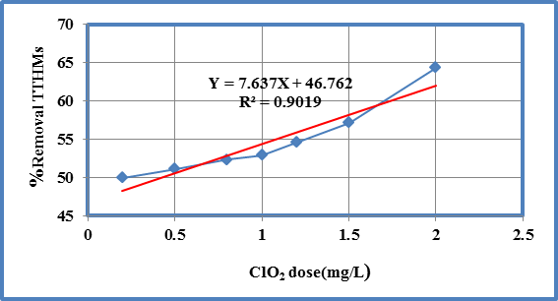
Figure 3: The percent reductions in the TTHMs concentrations after ClO₂ dose

Fig.4 presents a comparison of total THMs measurements with the Us Env. Prot. Agency Stage I, and stage II limits. None of the THM levels exceeded stage I limit (80 μg/L), while, the stage II limit (40 μg/L) was exceeded in all sampling measurements.

Figure 4: Maximum THMs levels detected in the study

Fig. 5 shows the variation of four THMs compound with ClO₂ dose. As shown the dominant TTHMs species during all runs is DBCM, .It decreased slightly with increasing ClO₂ dose, the remaining THMs are bromodichloromethan 33.34% which slightly to decreased with increasing ClO₂ dose.

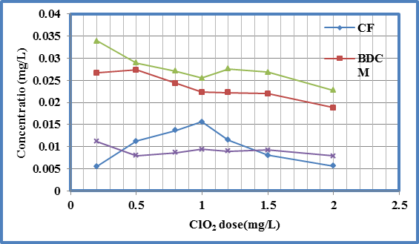
Figure 5: Relative amounts of THMs compounds with ClO₂ dose

Fig. (6), to (9) show the relation between chlorine dioxide dosing and percent reduction of two compounds (chloroform, and bromodichloromethane). Thus, we conclude that BDCM concentration is proportional with ClO₂ dose in the form (Y= 8.846X+46.408) at the range of dose between (0.2-2) mg/L with coefficient of determination (R²=0.9122) as shown in Fig. (7).

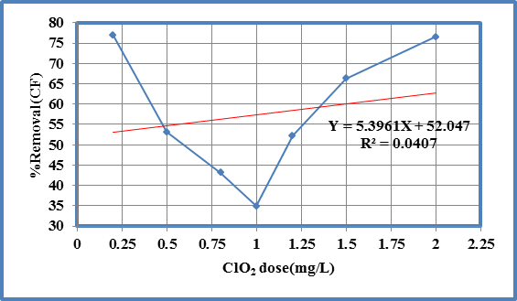
Figure 6: Percent reduction in CF with the ClO₂ dose
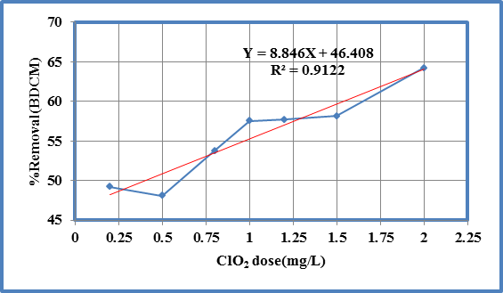
Figure 7: Percent reduction in BDCM with the ClO₂ dose

The correlation is positive between dibromochloromethane percent reduction and chlorine dioxide dose (decrease in DBCM concentrations with increasing chlorine dioxide dose). Thus, one can conclude that DBCM concentration is proportional with ClO₂ dose in the form (Y= 8.298x+44.76) with coefficient of determination (R²=0.752) see Figure 8.

While positive correlations between bromoform percent reduction and chlorine dioxide dose (slightly decrease in BF concentrations with increasing chlorine dioxide dose). Thus, we conclude that bromoform concentration is proportional with ClO₂ dose in the form (Y= 4.927X+49.65) with weak coefficient of determination (R²=0.28) as shown in Fig.9.
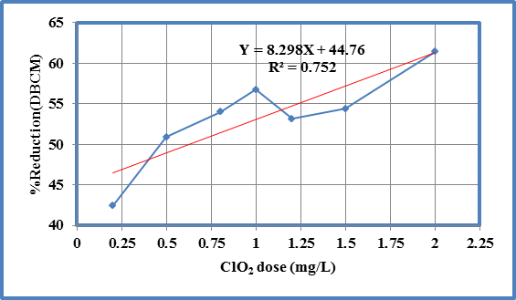
Figure 8: Percent reduction in DBCM with the ClO₂ dose
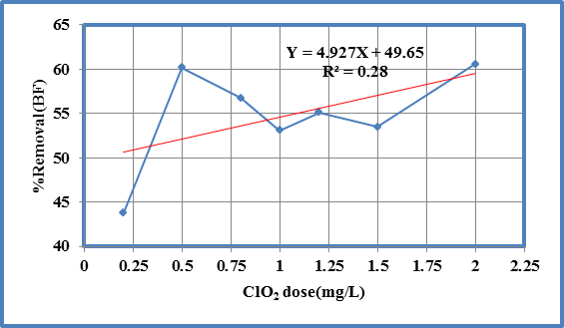
Figure 9: Percent reduction in BF with the ClO₂ dose

In general, all results indicate that the treated water contains mainly the brominate THM species (DBCM and BDCM). The average weight fraction of chloroform (CF) compound ranged from 7.16% to 21.46%, while the average weight fraction of the rest brominated (DBCM, and BDCM) species ranged from about 34.97% to 43.8%, 30.67% to 34.54% respectively as shown in Figure 10. Nearly the same pattern was pointed out by [7].
Figure 10: Weight fraction of individual THM4 to total THM4
EFFECT OF TURBIDITY ON TTHMs FORMATION
Turbidity of filtered water ranges between (4 to 7.36) NTU. Results show that the TTHMs concentration increases significantly with the increasing turbidity. So, conclude that the THMs concentration is proportional with turbidity.
Fig. 11 shows the variation of four THMs compound with turbidity. As show the result of CF, BDCM, BF, and DBCM variation began slightly to decrease with increasing turbidity.

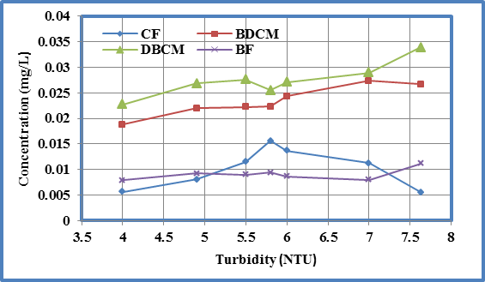
Figure 11: Variation of THMs compounds with turbidity
EFFECT OF pH ON TTHMs FORMATION
Fig. 12 shows the variation of TTHMs with pH in all runs. It has been found that the degree of inactivation by chlorine dioxide increases as pH increases leads to increases of THMs formation. This finding agrees with the results adapted by [1].
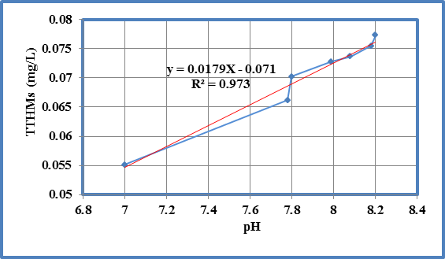
Figure 12: The variation of pH with TTHMs

EFFECT OF TEMPERATURE ON THMs FORMATION
The temperatures ranged in all runs throughout the study period between (24-30) ºC. The variation of temperature with THMs is shown in Figure 13. The results show a slight variation in TTHMs with temperature, but it is very recognized that TTHMs increase as temperature increases, in the form (Y=0.0032X-0.0154) with coefficient of determination (R²=0.823), because the disinfection efficiency of chlorine dioxide decreases as temperature decreases. This finding agrees with the results adapted by [11].
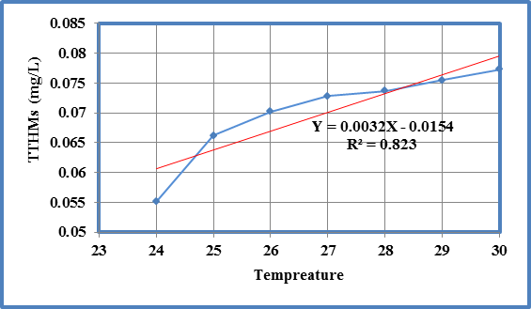
Figure 13: The variation of temperature with TTHMs
CONCLOSION
1- Chlorine dioxide showed a good potential as an alternative disinfectant and oxidant produced lower THMs concentrations but only at doses higher than (1 mg/L). The optimal dose of ClO2 produced high percent reduction of THM formation (64.33 %) is (2) mg/L.
2-The results showed that the THM formation decrease with increasing chlorine dioxide dose, concentrations of THMs that developed in water pretreated with 2 mg/L ClO2 were significantly lower when compared to those in water pretreated with the other dose of ClO2.
3-The relation between pH and THMs formation is in the form (Y=0.018X+0.071) with coefficient of determination R² equal to (0.973), and found that the degree of inactivation by chlorine dioxide increases as pH increases.
4- The results show slight variation in TTHMs with temperature, in the form (Y=0.0032X-0.0154) with coefficient of determination (R²=0.823).
5- Comparison of total THMs measurements with the USEPA Stage I and stage II limits. Shows that none of the THM levels exceeded the stage I limit, while exceeded the stage II limit in all sampling measurements.
6-Dominant TTHMs species during all runs is DCBM, it consists (39.2%) of trihalomethanes.

REFERENCES
[1] Bernarde, M.A., W.B. Snow, and V.P. Olivieri. "Chlorine Dioxide Disinfection Temperature Effects", J. Appl. Bacteriol. 30(1):159at a South Carolina treatment facility", Bethlehem, 1967, PA 18015 888-610-2562.
[2] Dean Gregory, "Impact of ClO₂ on TTHM/HAA-5 formation at a South Carolina treatment facility", Bethlehem, 2005, PA 18015 888-610-2562.
[3] Golfinopoulos1 And. Nikolaou, "Formation of DBPs in the Drinking Water of Athens, Greece: A Ten –Year Study", Global NEST Journal, 2005, Vol. 7, No. 1, pp. 106-118.
[4] Griese, Mark, "Pilot Plant Optimization of the Chlorine Dioxide Treatment Process for Disinfection By-Product Reduction", Conference Proceedings, AWWA Annual Conference, Philadelphia, PA, 1991.
[5] Hulsey, R.A., J.J. Neemann, S.N. Foellmi, and R.C. Hoehn, "Chlorine Dioxide for DBP Control and Filter Enhancement", Conference Proceedings, AWWA Water Quality Technology Conference, Salt Lake City, Utah, 2000.
[6] Kavanough, M. C; Trussell, A. R.; Cromer, J.; and Trussell, R. R.; “An empirical Kinetic model of THM formation: applications to meet the proposed THM standards”, J. Am. War. Works Assoc. 1980, Vol.72, pp.578-582.
[7] McLain, J.L., A. Obolenski, and H.M. Shukairy, "Disinfection by Product Speciation", AWWA, 2002, pp. 141-168.
[8] Mesdaghinia, M. T. Rafiee, F. Vaezi and A. H. Mahvi, "Evaluation of ferric chloride and alum efficiencies in enhanced coagulation for TOC removal and related residual metal concentration ", Center for Environmental Research and Dept. of Environmental Health Engineering, Tehran University of Medical Sciences, 2005.
[9] Onodera, S.; Nishikawa, T.; and Suzuki, S., “Chemical changes in chlorinated water XIV Characterization and determination of halogenated organics formed during chlorination of water from the Tama River”, J. Chromatogr. 1987,Vol. 409,pp. 259-270.
[10] Peters, C. J.; Young, R. J.; and Perry, R., “Factors influencing the formation of haloforms in the chlorination of humic materials”, Envir. Sci. Technol. 1980,Vol. 14, pp.1391-1395.
[11] Ridenour, G.M., R.S. Ingols. "Spermicidal Properties of Chlorine Dioxide", Water & Sewage Works, 1949, Vol. 96 No.8.
[12] Simmon, V. F.; and Tardiff, R. G., “The mutagenic activity of halogenated compounds found in chlorinated drinking water”, In Water Chlorination: Environmental Impact and Health Effects (Edited by Jolley R. L., Gorcher H. and Hamilton D. H.), 1978, Vol. 2, pp. 417-432. Ann Arbor Science, Ann Arbor, MI.
[13] Stevens, A.A.; L.A., Moore; and R.J, Mifltner, "Formation and Control of Non trihalomethane Disinfection By-products", J.AWWA, 1989,Vol. 81, No.8, pp.54-60.
[14] Trussell, R. R.; and Umphres, M. D., “The formation of trihalomethanes”, J. Am. Water Works Assoc,1978,. Vol.70, pp.604-612, A. A., Slocum C. J., Seeger D. R.
[15[ Dean Gregory, "Impact of ClO₂ on TTHM/HAA-5 formation at a South Carolina treatment facility", Bethlehem, 2008, PA 18015 888-610-2562.
[16] Juan Wu, "Chloramine AndMiex Control Of Disinfection Byproducts Formed From An Alluvial Aquifer Water Source", University of Missouri-Columbia,2010.
[17] Doré, M., "Chemical oxidants and water treatment", Technique and documentation. Lavoisier, Editors, 1989.
[18] Krasner, S.W., "Chemistry of Disinfection By-product Formation", Information and Control of Disinfection Byproducts in Drinking Water. Edited by Singer, P.C. AWWA Publishers. 1999.
[19] Singer, P.C., "Assessing Ozonation Research Needs in Water Treatment", J. AWWA, 1990, Vol.82,No.10, pp.78-88.
[20] Johnson, J.D., and J.N. Jensen, "THM and TOX Formation: Routes, Rates and Precursors", J. AWWA, 1986, Vol.78, No.4, pp.156- 162

