Effects of different diet levels of Ephestia kuehniella eggs on life history parameters of Chrysoperla rufilabris (Neuroptera: Chrysopidae) under laboratory conditions
Soolaf Abud Kathiar ¹, Bassim Shehab Hamad², Mustafa Dhari AlMarsoomy²

¹Dep. of Biology, College of Science for women, University of Baghdad, Baghdad, Iraq
²Ministry of Science and Technology, Agricultural research directorate, integrated pest control center, Baghdad, Iraq

Corresponding Author: soolaf_2007@ yahoo.com

To cite this article:

Kathiar S. A., Hamad B. S., Al Marsoomy, M. D. Effects of different diet levels of Ephestia kuehniella eggs on life history parameters of Chrysoperla rufilabris (Neuroptera: Chrysopidae) under laboratory conditions. Mesopotomia Environmental Journal, 2014, Vol. 1, No. 2, pp. 1-7.

Abstract

Larvae of the common green lacewings, Chrysoperla rufilabris, were fed different diet levels (2, 5, 10, 20, 40 and 80) of eggs of the moth Ephestia kuehniella in all three larval instar every day. Demographic parameters, including developmental times, survival rates, adult weights, fecundity, and adult longevity of both males and females were studied. Larvae that were provided highest number (80 eggs) of eggs of E. kuehniella every day had a significantly shorter developmental times (larval period, pupal period, and pre-ovipositional period), gained significantly high weight, and maximum fecundity. All the larvae under the low-levels of eggs (2, 5, and 10) treatments died and failed to pupate. These results might be beneficial for mass-rearing of C. rufilabris and for understanding its population dynamics in the field under different levels of prey populations.

Keywords; Chrysoperla rufilabris, life history parameters, Ephestia kuehniella.

Introduction
Biological control is an important agricultural tool and involves using natural enemies to avoid the problems associated with use of chemical control [1]. Green lacewings (Neuroptera: Chrysopidae) are natural enemies that are often used in augmentative biological control programs [2]. The adults of chrysopids may feed on floral and extra floral nectar, pollen, and aphid honeydew. However, many studies reported that the larvae of chrysopids showed enough potential efficiency to reduce the peak population of many important agricultural pests [3, 4, 5]. The success of an agricultural pest control program using insect predators depends on increasing the longevity and reproduction of predators—which potentially can be achieved by improving the predator diet [3, 6, 4]. Because lacewings are important insect predators that can play an important role in biological control, I examined the effects of different diet levels of E. kuehniella eggs on the growth and development of the lacewing C. rufilabris.
Materials and Methods
The experiments were conducted under 25 ± 2 °C, 65 ± 5 % RH and 16:8 h L:D photoperiod [7]. A C. rufilabris pupae frame was purchased from a commercial supplier (Beneficial Insectary, Inc.) and maintained in the laboratory. The newly emerged adults were confined in transparent plastic cups (11 cm in diameter and 7.5 cm high) and supplied, via cotton swabs, with the standard artificial diet consisting of yeast, sugars, and distilled water in the ratio of 4 g: 7 g: 10 mL, respectively [8]. The top of the plastic cup was covered with black muslin cloth tightened with a rubber band. The eggs laid by females on the walls of the cups and muslin cloth were harvested daily, using forceps to break the stalk beneath the egg. The eggs were placed, with the help of a camel’s hair brush, singly in plastic Petri dishes (10 cm in diameter and 1.5 cm high). Each day until pupation newly hatched larvae were fed Mediterranean flour moths (Ephestia kuehniella) (Lepidoptera: Pyralidae) purchased from a commercial supplier (Beneficial Insectary, Inc.).
The present study was designed to find out the effects of different diet levels of E. kuehniella eggs (Table 1) on demographic parameters of the lacewing C. rufilabris. The eggs collected from the second generation, then thirty eggs on each of five different levels were placed singly in plastic Petri dishes, and then the larval stages were provided E. kuehniella eggs every day as shown in Table 1. All biological parameters were measured, including larvae that develop to pupae, larval period, percentage of adults that emerge from the pupal stage, pupal period, adult weight, adult longevity of both males and females, and fecundity.
We used one-way Analyses of Variance (ANOVA). Tukey tests were used to statistically distinguish individual means when overall significant differences were found. All statistical analyses were carried out on VassarStats (http://vassarstats.net).
Table 1. Daily number of Ephestia kuehniella eggs supplied to individual Chrysoperla rufilabris larvae
Feeding levels | Number of eggs
1 | 2
2 | 5
3 | 10
4 | 20
5 | 40
6 | 80

Results
Larvae diet affected all measured demographic parameters (Table 2, 3, Figs. 1, 2, and 3). The results indicated that the larval, pupal, pre-oviposition periods of C. rufilabris larvae (Table 2, Fig. 2) fed different diet levels were significantly different (P <0.0001). The shortest larval, pupal, pre-oviposition periods were recorded when they were fed on diet levels 5 and 6. However, the first larval instar duration was extended up to 12 day and they died before reaching the second instar, when they were fed on diet level 1. Furthermore, larvae that were fed on levels 2, and 3 did not complete their development and they failed to pupate. Table 3 shows that the maximum survival percentage was in level 6. While, larvae that were fed on levels 1, 2, and 3 did not complete their development. Significantly, adults’ weights (Fig. 1) were higher for individuals reared on diet level 6 (0.0041 for male and 0.005 g for female) than other diets. The results (Fig. 3) reveal that the maximum number of eggs was 900 per female in level 6 and it did not differ significantly from 884.7 eggs per female in level 5. In this case, levels 5 and 6 were clearly the best, followed by level 4. The effect of the diet levels 4, 5, and 6 fed to larvae was similar for male and female longevity (Table 3).

Table 2. Average developmental times (day) (Mean ± SD) for Chrysoperla rufilabris larvae feeding on different diet levels of Ephestia kuehniella eggs
Developmental stages | Daily number of E. kuehniella eggs supplied to individual C. rufilabris larvae
Developmental stages | 2 | 5 | 10 | 20 | 40 | 80
First instar | 12a ± 1.4 | 5.4b ± 1.2 | 4.9b± 0.56 | 4.6b ±0.6 | 3.7c  ±0.5 | 3.2 c ± 0.4
Second instar | - | 17.5a ±1.8 | 5.21b ±1.2 | 3.5c  ±0.6 | 3.7c ± 0.5 | 3.1 c  ± 0.5
Third instar | - | - | - | 18a ±4.4 | 3.1b± 0.3 | 3.6b  ± 0.5
Pupa | - | - | - | 13a ±2 | 7.6b ± 1.2 | 6.9b ±1.3
Means with the same row followed by different letters are significantly different at the 0.05 level as determined by Tukey tests.

Table 3. Survival rate of Chrysoperla rufilabris when larvae reared on different diet levels of Ephestia kuehniella eggs

Developmental stages | Daily number of E.kuehniella eggs supplied to individual C. rufilabris larvae
Developmental stages | 2 | 5 | 10 | 20 | 40 | 80
First instar larvae | 50% | 95% | 100% | 100% | 100% | 100%
Second instar larvae | 0% | 16% | 100% | 100% | 100% | 100%
Third instar larvae | 0% | 0% | 0% | 100% | 100% | 100%
Pupa | 0% | 0% | 0% | 90% | 100% | 100%
Adult emergence | 0% | 0% | 0% | 35.7% | 89.2% | 95%

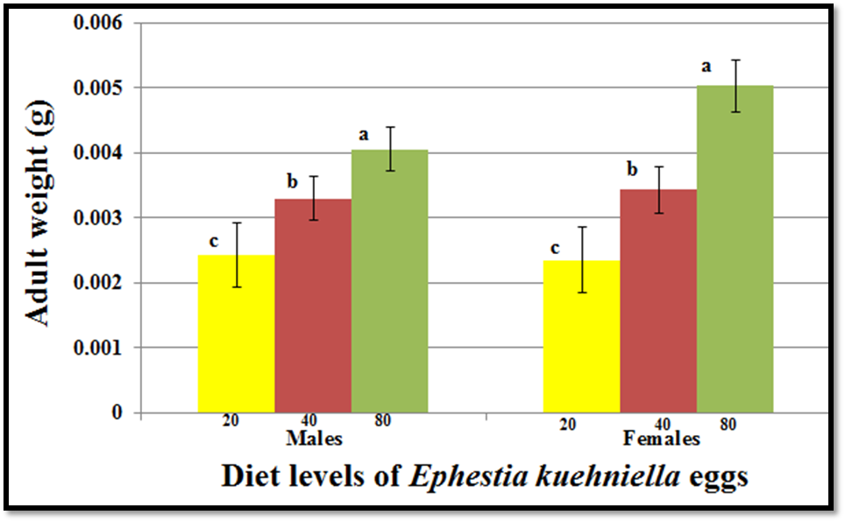

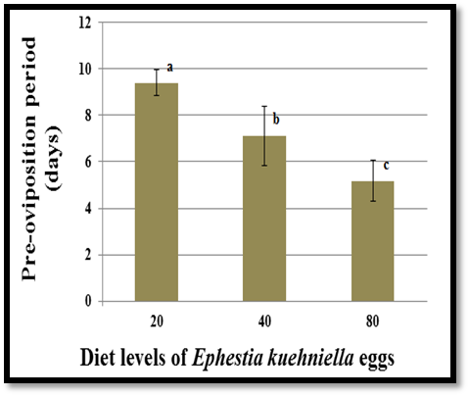
Fig. 1. Adult weight (gram) (Mean ± SD) of Chrysoperla rufilabris males and females, when larvae reared on different diet levels of Ephestia kuehniella eggs. Means with the same letter are not significantly different at the 0.05 level as determined by Tukey tests.

Fig. 2. Duration (Mean ± SD) of pre-oviposition periods of Chrysoperla rufilabris females, when larvae reared on different diet levels of Ephestia kuehniella eggs. Means with the same letter are not significantly different at the 0.05 level as determined by Tukey tests.

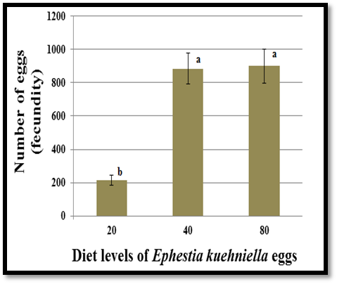

Fig. 3. Number of eggs (Mean ± SD) of of Chrysoperla rufilabris females, when larvae reared on different diet levels of Ephestia kuehniella eggs. Means with the same letter are not significantly different at the 0.05 level as determined by Tukey tests.

Table 4. Longevity (day) (Mean ± SD) of Chrysoperla rufilabris adults, when the larvae reared on different diet levels of Ephestia kuehniella eggs
Daily number of E. kuehniella eggs supplied to individual C. rufilabris larvae | 20 | 40 | 80
Longevity of males (days) | 30.3 ± 5.5 | 25.3 ± 5.1 | 32.2 ± 8
Longevity of females (days) | 34.7  ± 4.7 | 43.5  ± 3.7 | 46.6 ± 7.1

Discussion
Lower numbers of all developmental periods presumably represent improved performance because shorter developmental times mean shorter generation time, and therefore increased population growth rate. The larvae diets of C. rufilabris apparently affect survival, development, adult emergence, body weight, and female fecundity. Larvae that were provided a high number E. kuehniella egg developed faster, had an increased survival and fecundity, and weighted than larvae that were provided a low number E. kuehniella egg. A high number of E. kuehniella eggs (up to 20) every day were needed for larval development of C. rufilabris to reach the pupal and adult stages. The larval instar duration was extended and they died before reaching the pupal stage, when they were fed suboptimal diet levels, such as 2, 5, and 10 eggs of E. kuehniella. The shortest larval and pupal periods were recorded using high diet levels (up to 40 eggs) provided to larvae. Larva diets of C. carnea that contain proteins can promote fast growth and fast completion of the larval and pupal period [9]. Many scientists have reported that the larval diet has an effect on the larval period of the green lacewing as well as the pupal period [10, 11, 12]. We observed a reduction in the pre-oviposition period when larvae of C. rufilabris were offered a high level of protein in their diet. The pre-oviposition period was observed to be extended by diets containing low level of protein. Proteins offered to the larvae proved the most suitable resulted in minimum pre-oviposition period of green lacewings [13, 14]. The insufficient protein content of diets provided to the green lacewing increased the duration of pre-oviposition period; since females are maturing the ovary and development of eggs occur during the pre-oviposition period[15,16].
Fecundity is the most direct measure of population growth rate and, probably, the best measure of the effect of diet. The highest increase in the fecundity was recorded when the larvae of C. rufilabris were provided more than 40 eggs of E. kuehniella compared to the other diet levels under the same laboratory conditions. This result indicates that feeding larvae of C. rufilabris with a few number of E. kuehniella eggs will not provide adequate nutrition for maximum egg production of C. rufilabris. Larvae diets of Chrysoperla spp. that can provide protein are required for maximum egg production (17, 18, 9]. If we wish to sustain populations of natural enemies like lacewings in agricultural fields, we may need to provide sufficient food. This sufficient protein could develop and sustain natural populations of lacewings or sustain lacewings that are added to fields as augmented biological control when pest problems flare up. Use of natural enemies to control pests has economic and environmental benefits.

References
- DeBach, P. Biological control of insect pests and weeds. Chapman and Hall Ltd: London, 1964, pp. 3-20.
- Wang, R. and Nordlund, D. A. Use of Chrysoperla spp. (Neuroptera: Chrysopidae) in augmentative release programmes for control of arthropod pests. Biocontrol News and Information, vol. 15, pp. 15:51N–57N, 1994.
- Canard, M. ; Séméria, Y. and New, T. R. Biology of Chrysopidae . Dr. W. Junk Publishers, The Hague: Netherlands, 1984.
- Tauber, M. J. ; Tauber, C. A. ; Daane, K. M. and Hagen, K. S. Commercialization of predators: recent lessons from green lacewings (Neuroptera: Chrysopidae: Chrysoperla). American Entomologist, vol. 46, pp. 26–38, 2000.
- Pappas, M. ; Broufas, L., G. D. and Koveos, D. S. Chrysopid predators and their role in biological control. Journal of Entomology, vol. 8, pp. 301–326, 2011.
- Thompson, S. N. Nutrition and culture of entomophagous insects. Annual Review of Entomology, vol. 44, pp. 561–592, 1999.
- Ashfaq, M. ; Abida, N. and Gulam, M. C. “A new technique for mass rearing of green lacewing on commercial scale,” Pakistan Journal of Applied Sciences, vol. 2, pp. 925–926, 2002.
- Hagen, K. S. and Tassan, R. L. The influence of food Wheast® and related Saccharomyces fragilis yeast products on the fecundity of Chrysopa carnea. The Canadian Entomologist, vol. 102, pp. 806–811, 1970.
- Cohen, A. C. and Smith, L. K. A new concept in artificial diets for Chrysoperla rufilabris: the efficacy of solid diets. Biological Control, vol. 13, pp. 49–54, 1998.
- Legaspi, J. C. ; Correa, J. A. ; Carruthers, J. I. ; Legaspi, B. C. and Nordlund, D. A. “Effect of short-term releases of Chrysoperla rufilabris (Neuroptera: Chrysopidae) against silverleaf whitefly (Homoptera: Aleyrodidae) in field cages,” Journal Entomological Society , vol. 31, pp. 102–111, 1994.
- Jokar, M. and Zarabi, M. “Surveying effect kind of food on biological parameters on Chrysoperla carnea (Neuroptera: Chrysopidae) under laboratory conditions,” Egyptian Academic Journal of Biological Sciences, vol. 5, pp. 99–106, 2012.
- Khuhro, N. H. ; Chen, H. ; Zhang, Y. ; Zhang, L. and Wang, M. Effect of different prey species on the life history parameters of Chrysoperla sinica (Neuroptera: Chrysopidae). Eur. J. Entomol., vol. 109, pp. 175–180, 2012.
- Syed, A. N., Ashfaq, M. and Ahmad, S. 2008. Comparative effect of various diets on development of Chrysoperla carnea (Neuroptera: Chrysopidae). International Journal of Agriculture and Biology 10:728–730.
- Sattar, M. ; Fatima, B. ; Ahmed, N. and Abro, G. H. Development of larval artificial diet of Chrysoperla carnea (Stephens) (Neuroptera: Chrysopidae). Pakistan Journal of Zoology, vol. 39, pp. 103–107, 2007.
- Vasanthakumar, D. ; Roobakkumar, A. ; Rahman, V. ; Kumar, P. ; Sundaravadivelan, C. and Babu, A. Enhancement of the reproductive potential of Mallada boninensis Okamoto (Neuroptera: Chrysopidae), A predator of red spider mite infesting tea: an evaluation of artificial diets. Archives of Biological Sciences, vol. 64, pp. 281–285, 2012.
- Lee, K. and Lee, J. Rearing of Chrysopa pallens (Rambur) (Neuroptera: Chrysopidae) on artificial diet. Entomological Research, vol. 35, pp. 183–188, 2005.
- Hagen, K. S. Fecundity of Chrysopa californica as affected by synthetic foods. Journal of Economic Entomology, vol. 43, pp. 101–104, 1950.
- Zheng, Y. ; Hagen, K. S. ; Danne, K. M. and Mittler, T.E. Influence of larval dietary supply on the food consumption, food utilization efficiency, growth and development of the lacewing, Chrysoperla carnea. Entomologia Experimentalis et Applicata, vol. 67, pp. 1–7, 1993.

