Improvement of sedimentation process using inclined plates

Rasha salah AL-kizwini
Department of Environmental ,College of Engineering, University of Babylon, Iraq

Corresponding author: rasha_alkizwini2015@yahoo.com
To cite this article:

Al-kizwini, R.S..Improvement of sedimentation Process Using Inclined Plates.Mesop.environ. j., 2015, Vol. 2, No.1, pp. 100-114 .

This work is licensed under a Creative Commons Attribution-NonCommercial-NoDerivatives 4.0 International License.


Abstract:

in this paper, study the effect of inserting inclined plates at angles (30º, 45º and 60º) at flow rate(0.5-2) l/min and detention time (200-50) min, with and without using an alum on the improvement of the turbidity removal efficiency( R) in an up flow settling tank compared without inclined plates, have been investigated by (PDS Sedimentation tank) for treating water from a water solution polluted by kaolinitic clay at initial concentration (360 mg/l ).The results indicate that the plates installed at the basin increased sediment turbidity removal efficiency to (87%) at angle 30° when flow rate equal to (0.5) l/min, detention time (200 min) with using alum and (70%) without using alum, compared without inclined plates, turbidity removal efficiency to (59%) when flow rate equal to (0.5) l/min detention time (200 min) with using alum and (41%) without using alum.
Keywords:PDS sedimentation tank, turbidity, ,inclined plates,alum

Introduction
Sedimentation is a physical water treatment process using gravity to removes suspended solids from water[1].Solid particles entrained by theturbulence of moving water may be removed naturally by sedimentation in the still water of lakes and oceans. Settling basin are ponds constructed for the purpose of removing entrained solids by sedimentation .Clarifiers are tanks built with mechanical means for continuous removal of solids being deposited by sedimentation. Conventional settling units represent around one-third of the total capital cost of water treatment plants because of land and construction costs. Many alternatives have been developed to enhance the performance of settling tanks, increase their hydraulic capacity and decrease their capital or operational costs. Some of these alternatives, such as inclined plates, increase the surface area available for settling and enhance the hydraulic conditions, whereas others, such as alum,improve the settling

properties of the suspension. The selection of an optimum alternative is usually based on economic and environmental objectives [2].
Objective of study
The objective of this experimental study was to improve the sedimentation process using inclined plates at angles (30º, 45º and 60º) with and without alum by using PDS sedimentation tank.
Types of sedimentation tank
There are two basic types of sedimentation tank(settling tank) designs: the rectangular and circular designs. The rectangular tank is designed with an effluent inlet at one end of the tank and an outlet pipe for liquids that have passed through the sedimentation process at the other end of the tank. The rectangular tank relies on the large solid particles settling as they pass slowly through the tank. By the time the liquid reaches the outlet pipe the larger particles have settled to the bottom of the tank. Circular tanks are designed differently, with an inlet pipe at the bottom of the tank positioned close to a sludge removal pipe. The removal pipes for cleaner liquids is located close to the surface of the tank .As shown in figure 1 [3].

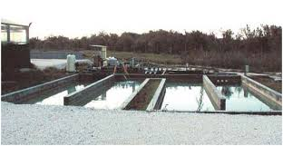
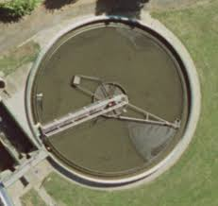

Fig 1: Types of Sedimentation tank
Applications in Water and wastewater Treatment
The application in water treatment included[4]:
1. Settling of coagulated and flocculated waters prior to filtration.
2. Settling of coagulated and flocculated waters in a softening plant
3. Settling of treated waters in an iron and manganese removal plant
The application in wastewater treatment included:
1. Grit removal
2. Suspended solids removal in primary clarifier
3. Biologicalfloc removal in activated sludge

Factors That Affect Particle Settling included [5]:
1. Particle size and distribution
2. Shape of the particles
3. Density of particles
4. Temperature (viscosity and density of water)
5. Electrical charge on particles
6. Dissolved substances in the water
7. Flocculation characteristics of particles
8. Wind
9. Inlet and outlet conditions and shape of basin

zone of settling tank
Inlet Zone
The inlet or influent zone should distribute flow uniformly across the inlet to the tank. The normal design includes baffles that gently spread the flow across the total inlet of the tank and prevent short circuiting in the tank. (Short circuiting is the term used for a situation in which part of the influent water exits the tank too quickly, by flowing across the top or along the bottom of the tank.). The baffle is sometimes designed as a wall across the inlet, with holes perforated across the width of the tank[6].
Settling Zone
The settling zone is the largest portion of the sedimentation basin. This zone provides the calm area necessary for the suspended particles to settle[6].
Sludge Zone
The sludge zone, located at the bottom of the tank, provides a storage area for the sludge before it is removed for additional treatment or disposal. Basin inlets should be designed to minimize high flow velocities near the bottom of the tank. If high flow velocities are allowed to enter the sludge zone, the sludge could be swept up and out of the tank. Sludge is removed for further treatment from the sludge zone by scraper or vacuum devices which move along the bottom[6].
Outlet Zone
The basin outlet zone (or launder) should provide a smooth transition from the sedimentation zone to the outlet from the tank. This area of the tank also controls the depth of water in the basin. Weirs set at the end of the tank control the overflow rate and prevent the solids from rising to the weirs and leaving the tank before they settle out. The tank needs enough weir length to control the overflow rate, which should not exceed 20,000 gallons per day per foot of weir, Most sedimentation tanks are divided into these separate zones[6]as shown in figure 2.
.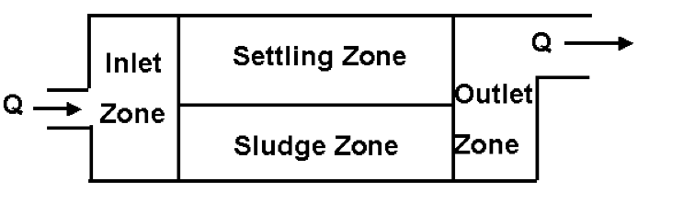
Fig2:Sedimentation basin zone

So= Q/A………………………………(1)
Where:
So = Surface Over Rate (m/hr),
Q=Flow rate (l/min) and
A = surface area(m²)
Detention time (T)=V/Q………………..(2)
Where:
T = detention time (min ),
V= volume of tank=B*L*H (mm³) ,
B=width(mm), L=length(mm) and H=depth (mm)
Types of Sedimentation
Discrete particle settling:
settling of discrete particles in dilute suspensions • particles have no tendency to flocculate • they settle as individual entities and there is no significant interaction with neighboring particles Example: removal of grit and sand in wastewater treatment.
Flocculantsettling ;
settling of flocculant particles in dilute suspensions • as particle settle and coalesce with other particles, the sizes of particles and their settling velocity increases Examples: • removal of SS in primary sedimentation tanks of WWTP • settling of chemically coagulated waters.
Hindered settling or (zone settling):
settling of intermediate concentration of flocculant particles • particles are so close together that interparticle forces are able to hold them in fixed positions relative to each other and the mass of particles settles as a zone at a constant velocity example: biological floc removal in secondary settling basins of WWTP.
Compression settling:
settling of particles that are of such a high concentration that the particles touch each other and settling can occur only by compression which takes place from the weight of particles examples: occurs in the bottom of deep secondary clarifiers • in sludge thickening facilities: As shown in figure 3 [7].

Fig 3:Types of Sedimentation

Effect of sedimentation on Turbidity
Sedimentation may remove suspended solids and reduce turbidity by about 50 to 90 percent, depending on the nature of the solids, the level of pretreatment provided, and the design of the clarifiers. Common values are in the 60 to 80 percent range [8].
Turbidity Removal Efficiency (R) =(inlet-outlet)/inlet *100% ……………………(3)
Where:
R = Turbidity Removal Efficiency (%)

Tube and Plate Settlers
Inclined tubes and plates can be used in sedimentation basins to allow greater loading rates. This technology relies on the theory of reduced-depth sedimentation: particles need only settle to the surface of the tube or plate below for removal from the process flow. Generally, a space of two inches is provided between tube walls or plates to maximize settling efficiency[8].
Inclined plates were used widely in water treatment , but recently have received renewed interest in domestic and industrial wastewater treatment as well as the segregation of mineral particles. Upgrading existing water treatment plants and increasing their hydraulic capacity to meet the ever-increasing demand for drinking water is a challenge to many municipalities in Iraq and elsewhere[2].When inclined plates have been used in a settling tank For up flow plated settling tank as shown in figure (4) using the following equation [9]:

Šo= Ѕo*[( t+w)/(Hcosα+w)]……………………….…. (4) [9]
Where:
Šo= Surface over rate with inclined plates( m/hr).,
Ѕo= Surface over rate without inclined plates (m/hr).,
t = Thickness of plate(mm).,
w=The distance between the plates (mm).,
H= Depth of sedimentation(mm). and
α = Angle of inclination of a plate
In this study t =1mm ,w=30mm, H=250mm, n=number of plates =6
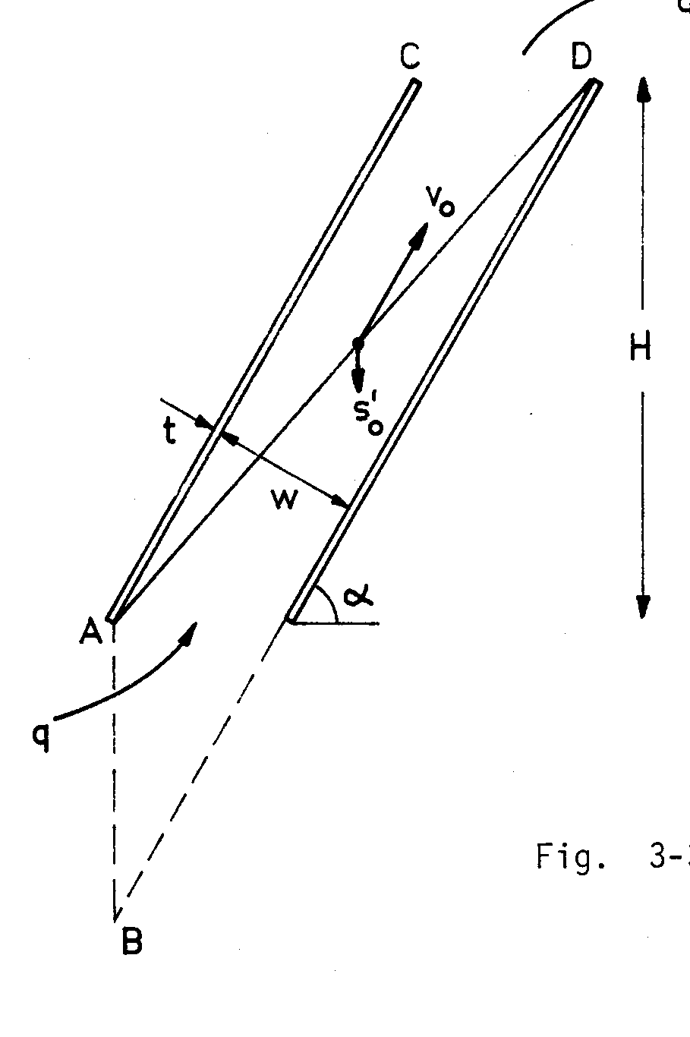
fig4:up flow plated settling tank[10]

Material and Methods
kaolinite
kaoliniteis a clay mineral, part of the group of industrial minerals, with the chemical composition Al₂Si₂O₅(OH)₄. It is a layered silicate mineral, with one tetrahedral sheet linked through oxygen atoms to one octahedral sheet of alumina octahedral. Specific Gravity:2.6 [11] as shown in figure 5.

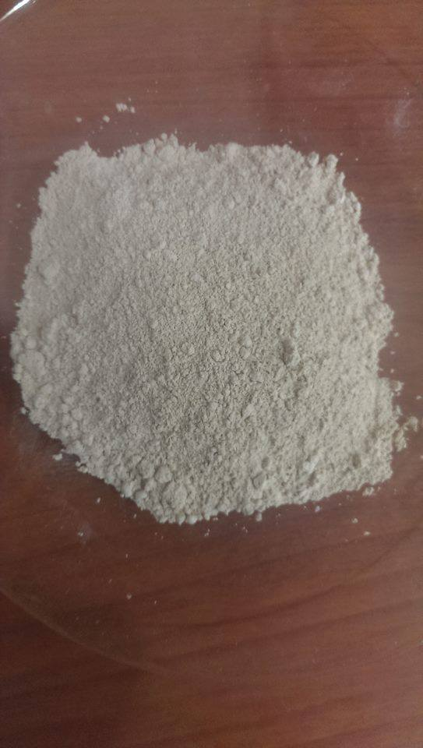
Fig 5 :kaolin clay used in this study
The coagulant:
The coagulant used was Aluminum Sulfate AL(SO₄)2.16H₂O,from which an alum solution was prepared at a strength of 1%and used at different doses[1] as shown in figure 6.
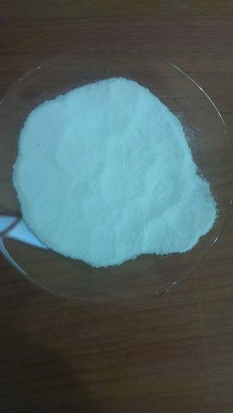
Fig6:Alum used in this study
Jar test apparatus
Optimum concentration of coagulant for alum can be determined using jar test and to be added to the water solution polluted by kaolinitic clay as figure 7.

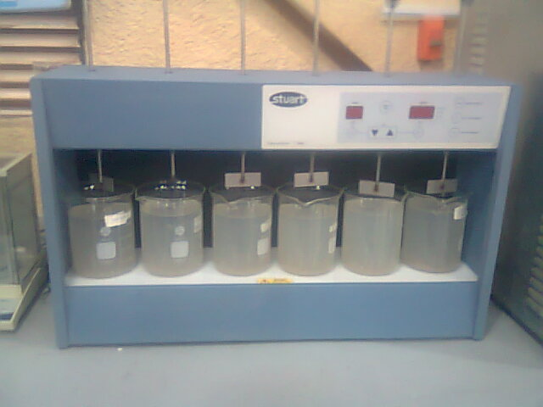
Fig7:Jar test apparatus

PDS sedimentation tank:
the PDS Unit is an equipment to demonstrate the sedimentation process and to familiarize with the settling principle of discrete or flocculated particles settling into a tank. It will also allow studying the hydraulic characteristics of a rectangular sedimentation tank which works in continuous.
Once the fluids are mixed, the current is passed into the sedimentation tank through the inlet weir. Here, the solids in suspension settle at the Bottom as figure 8.

Fig 8:PDS unite
Diagram in the front panel with similar distribution to the elements in the real unit. As shown in figure 9. Sedimentation tank, made of transparent material; length: 1000 mm, width: 400 mm, height: 250 mm. Dye injection and tracer system, which allows to study the fluid current lines into the sedimentation tank. 2 Baffle plates, adjustable in height, what makes easier for you the possibility of changing the flow lines direction and its study.
Suspension installation, consists of:
- Suspension tank of 140 liter.
- Centrifugal pump, flow up to (80) l./min.
- Flow regulation valve.
- Water flowmeter, range:( 0-2) l/min.
Clean water installation, consists of:
- Flow regulation valve.
- Water flowmeter, range:( 0-10) l/min
Accessories included:
- 2 Imhoff cones of 1000 ml., to measure the solids concentrations.
- Graduated test tube of 1 liter.
Cables and Accessories, for normal operation. .[12]

Fig 9 :Process diagram and elements allocation

Result and discussion
Case study No.1
1. Optimum alum dose
Jar tests were performed on the configured samples from (1.0 liter) for each one of six stirrers of water solution polluted by kaolinitic clay at initial concentration of turbidity (360 mg/l ) . Jar test were performed as follows: The preparation of 10,000 ppm of alum solution for tests were performed at concentration (0, 30, 40, 45, 50, and 60 ppm) of alum solution and flash mixed at 100 rpm for 1 minutes, then followed by flocculation at 42 rpm for 15 minutes. The samples were then allowed to settle for 15 minutes until all of the floc had fully settled. Before and after treatment samples were measured turbidity, pH. The goal of the testing was to determine the optimum concentration of coagulant of alum, to be added to the water solution . Results indicated that the optimum concentration of coagulant for alum is (45 ppm) at pH equal to (6) as shown in figures 10 and figure 11.

.

Fig11:Effect different pH on turbidity

Fig10: the optimum dose of alum

2. Turbidity removal efficiency without using inclined plates
Removal efficiency of turbidity (R), measured after settling, without using plates, at condition when flow rate at equal to (0.5-2) l/min, detention time (200-50) min.In the case without using alum,(R )was found equal to (41%-24%).While (R) in the case with using alum was found equal to (59%-48%) as shown in figure(12)
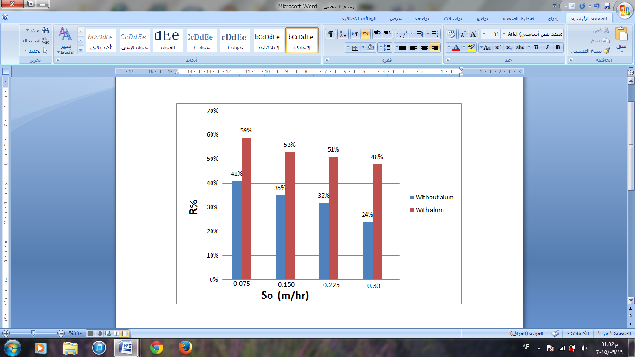
.

Fig12 :The relation between So and R% at initial concentration (360 ppm)
Detention time is inversely proportional to the incoming flow rate – as flow rate increases, the detention time decreases as shown in table (1).
Table1.The relation between So and detention time
0.3 | 0.225 | 0.15 | 0.075 | So(m/hr)
50 min | 67 min | 100 min | 200 min | Detention time(T)
Table 2.Show the relation turbidity at different location in the settling tank
Time | Input | Middle | Output | R%
After 5 min | 246 | 198 | 161 | 34.5%
After10 min | 232 | 167 | 143 | 38.4%
After 15min | 215 | 151 | 127 | 41%

Case study No.2
1. Turbidity removal efficiency with using inclined plates
Removal efficiency of turbidity (R ), measured after settling with using inclined plates as shown in figure (13) ,at condition when flow rate equal to (0.5-2) l/min, detention time (200-50) min. In the case without using alum when α equal to (30º), R was found equal to (70%-48%), at α equal to (45º),R was found equal to (60%-39%) and at α equal to (60º), R was found equal to (62%-48%), While removal efficiency of turbidity in the case with using alum , when α equal to (30º), R was found equal to (87%-61%) , at α equal to (45º),R was found equal to(72%-51%) and at α equal to ( 60º), R was found equal to (80%-66%). The experimental turbidity removal efficiency (R) was plotted against the Šo. The effects of inserting inclined plates at ( 30º,45ºand 60º), in an up flow settling tank on the( R) is shown in Figure(14,15&16). The relation between Ѕo&Šo is shown in table(3).

Table3.The relation between Ѕo&Šo
Q(l/min) | So(m /hr) | Šo(m /hr)
Q(l/min) | So(m /hr) | α = 30º | α = 45º | α = 60º
Q(l/min) | So(m /hr) | Šo =0.13Ѕo | Šo =0.15Ѕo | Šo =0.2 Ѕo
0.5 | 0.075 | 0.01 | 0.0113 | 0.015
1 | 0.15 | 0.02 | 0.023 | 0.03
1.5 | 0.225 | 0.03 | 0.034 | 0.045
2 | 0.3 | 0.04 | 0.045 | 0.06

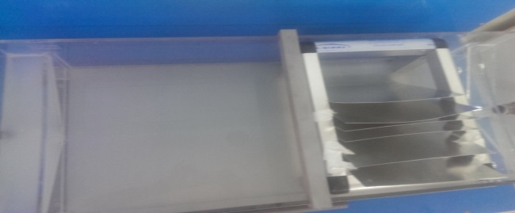
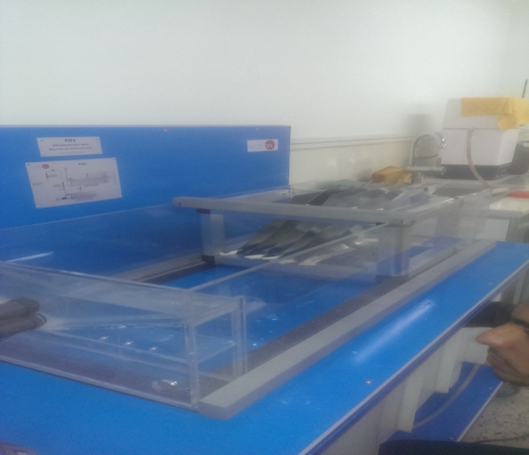
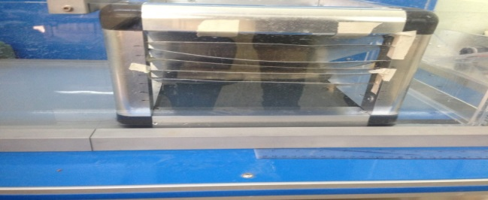
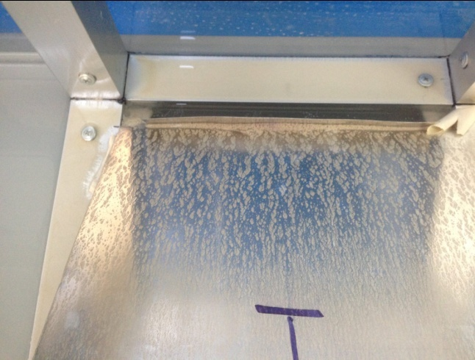
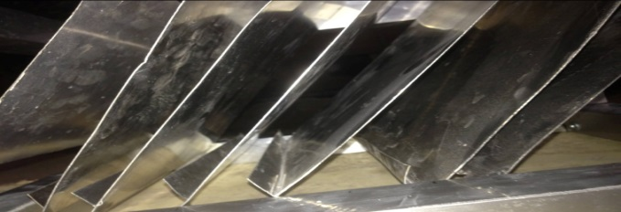
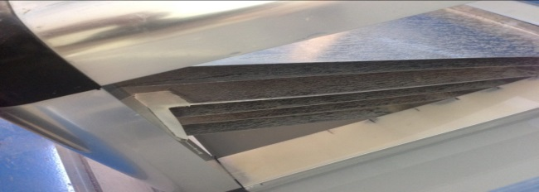

Fig13:Inclined plates in sedimentation tank
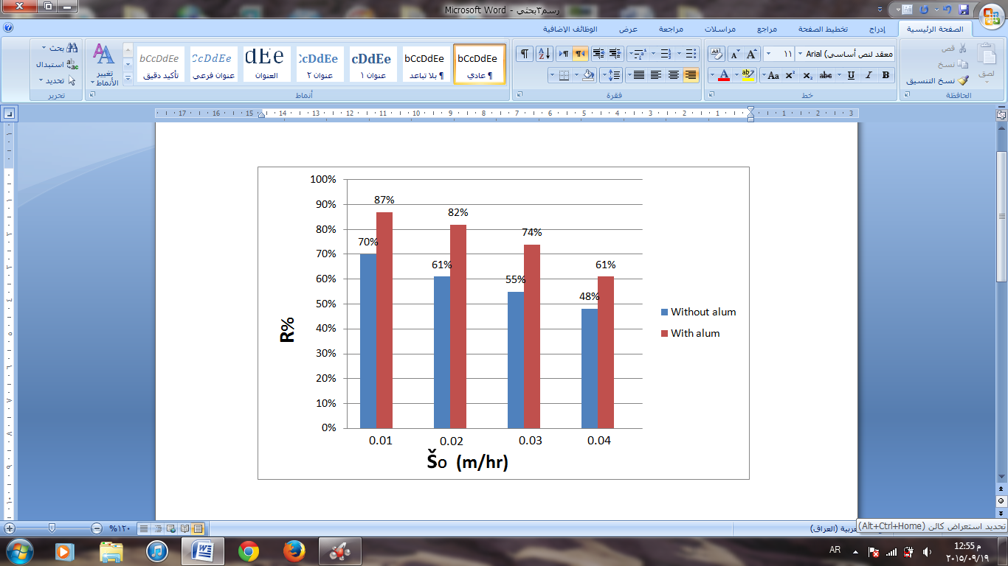

Fig14: The relation between Šo and R% at initial concentration (360 ppm) at α=30º

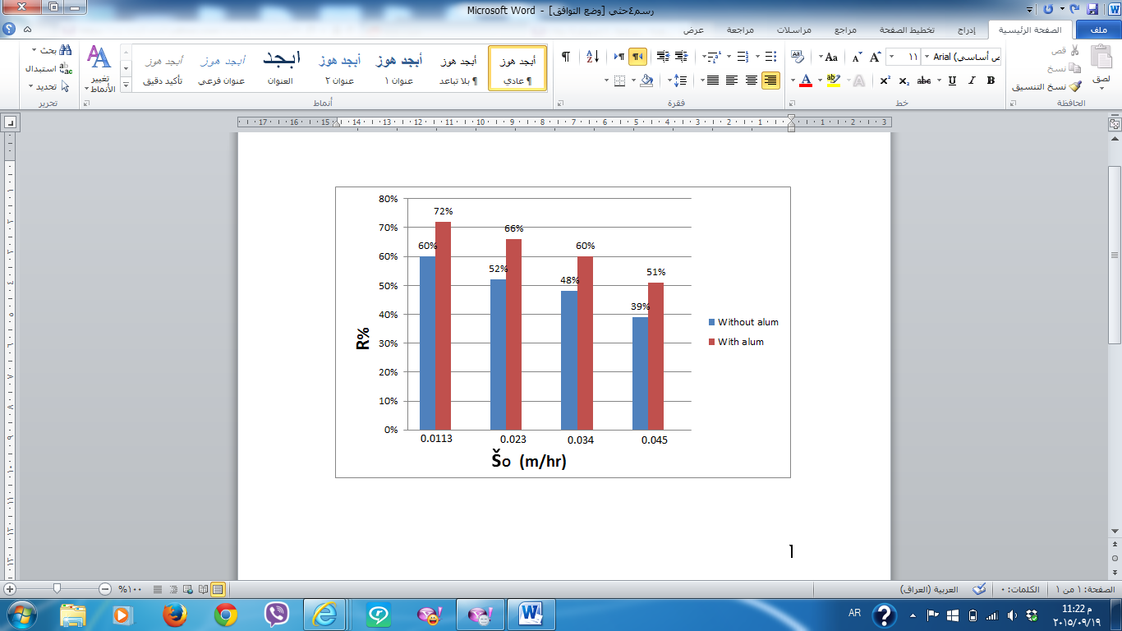

Fig15: the relation between Šo and R% at initial concentration (360 ppm) at α=45º
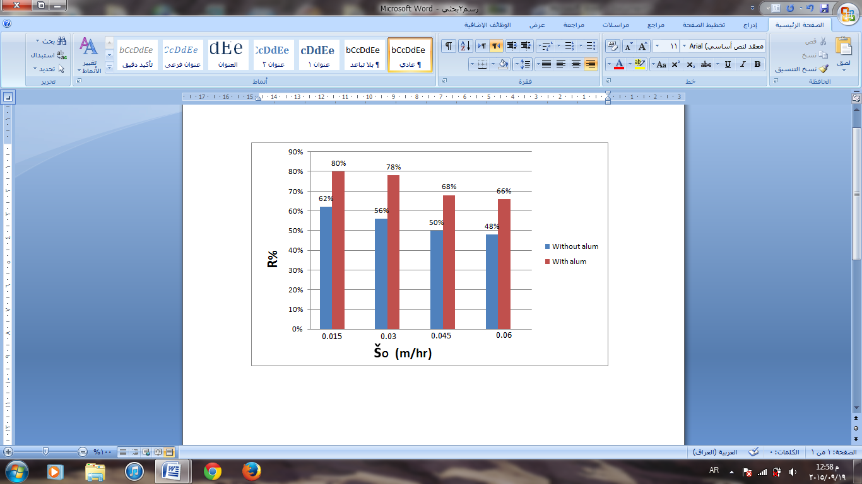

Fig16:The relation between Šo and R% at initial concentration (360 ppm) at α=60º
Conclusion and recomandation
Conclusion
1-Results confirmed that using inclined plates to improve the sedimentation process and as efficient as using coagulant aids like alum.
2-The turbidity removal efficiency increase by using inclined plates with decrease in the surface over rate (Šo).
3-The results indicate that, the plate installed at the basin increased sediment removal efficiency and the best angle is ( 30°).

Recommendations
1-The use of PDS unit has achieved good results therefore suggest Empirical to achieve the best results in the treatment process.
2- Applying the principle of the inclined plates on the large sedimentation basins
3- Study the relation between increase the number of plates and improved the sedimentation process.
4- Use Inclined plates in the field of private sedimentation processes the industrial waste and Sewage.
5-The use of chemicals and other natural material instead of alum as a coagulant assistant in sedimentation basins.

Acknowledgements
Deep thanks must be expressed to sanitary Engineering lab. in civil engineering and staff in Environment Engineering Department for their help.

References
[1]Omelia, C..Coagulation and sedimentation in lakes, reservoirs and water treatment plants. Water Science and Technology, Vol.37, No. 2 : pp. 129-135. 1998.
[2]Saady,N.M. Effect of inclined plates and polyelectrolyte on the performance of settling tanks. Department of Civil and Environmental Engineering, University of Windsor. 2012.
[3]http://www.wastewatersystem.net/2009/06/wastewater-clarifier-sedimentation-tank.htm.
[4]Kocamemi,B.A. Environmental Engineering UnitOperations.Marmara University, Department of Environmental Engineering Istanbul, Turkey, ENVE 301,chapter 10, 2002.
[5]Holmden,Bob.Drinking water and C|&D level certification review . Florida rural water association, 2013.
[6] http//www.mrwa.com/.../Chapter%2013%20Sedmentation.pd.
[7] Hasan, A.F. sedimentation. Civil Engineering Department An-Najah National University Environmental Engineering II for use with Water and Wastewater Engineering ByMackenzie L. Davis. chapter 7, 2013.
[8] Randtke, Stephen J and Horsley , Michael B . Water Treatment Plant Design. AWWA and ASCE , 5th Edition, Copyright. 2012.
[9] Al-Anbari , R. H. Determination of optimum angle of inclination and turbidity removal efficiency of module of curved inclined plates settler". Technical Journal, Vol. 8.2005.
[10] HuismanL . Sedimentation and Flotation Mechanical Filteration. TechnischeUniversities Delft. pp. 15-86, 1986.
[11]https://en.wikipedia.org/wiki/Kaolinite.
[12]http://www.edibon.com/products/catalogues/en/units/environment/waterhandling/PDS.pdf.

