Early Mobilization of the Extensor Tendon Repair by Self Made Splint

Hassn S. Attai
Al-Karkh General Hospital, Baghdad, Iraq.

Received 2 October 2013 Accepted 27 October 2013
Abstract
Background: Acute post traumatic tendon repair immobilized by static splint for several weeks may ended with adhesions and long term rehabilitation. So early mobilization by simple dynamic splint aids to alleviate these problems, but may otherwise lead to tendon lag as the flexor tendons are more powerful than the extensor tendons, and stiff MPJs as their lateral collateral ligaments shortened if they left for long period extended. We tried to use a simple (easy made) dynamic splint in a way of right angled splint at the MPJ, full extension of IPJ and slight extension of the wrist joint, to facilitate early movements within the casts. Traditionally the repaired extensor tendons have been treated postoperatively in static splints for several weeks, leading to formation of adhesions and prolonged rehabilitation. Early mobilization using dynamic splints is common, but associated with many shortcomings. We attempted to study the results of early active mobilization, using a simple static splint, and easy-to-follow rehabilitation plan.
Materials and Methods: From January 2009 to September 2011; 21 cases of extensor tendons in zone 5to 7 were treated with primary or delayed primary repaired (i.e. 2 to 10 days), splinting and early mobilization were undertaken using self-made prefabricated splints. Our results were evaluated according to the degrees of stiffness of the MPJ and the scope of extension of the extensor tendons in their full range while the hands in a table top flat position.
Results: All the 21 patients were followed up for three months. 16 out of 21 patients were 18-35 years of age (76.1%) all were manual workers, and the rest were bellow 18 (23.9%), most of them were injured in zone 3(17 out of 21) and 4 cases in zone 4.
Conclusion: Early movements of a repaired extensor tendons coincidentally with use of easy self-made splint gives better results from preventing adhesion and MPJ stiffness with a good range of extensor tendon movements.
Keywords: Extensor tendon, self-made splint, early movement, dynamic, static splints.
الحركة البسيطة لخياطة الاوتار الباسطة للأصابع باستخدام المساند البسيطة المهيأ ذاتيا"
الخلاصة
الخلفية: ان استخدام المساند الثابته لعمليات خياطة الاوتار للاصابع لعدة اسابيع ربما ينتهي بالتصاقات الاوتار والذي يحتاج الى فترة تاهيل طويله لذلك فان تحريك الاصابع المتضررة المبكر باستخدام مساند حركيه بسيطة يمكن عملها وتهيئتها ذاتيا" يساعد الى درجة كبيره بمنع هذه المشكلة كذلك فان المفصل السلامي – المشطي اذا وضع بصوره مستقيمه بالمساند الثابتة يؤدي الى تحجره وان المسند الحركي البسيط المصنع بزاويه قائمه عند هذا المفصل يمنع هذا التحجر .
الطريقة : تم استخدام المسند موضع البحث لـ21 حالة قطع اوتار باسطه بمختلف مناطق امتداد الاوتار في الكف وقد عولجت بفترة يومين الى سبعة ايام من الإصابة وتجبيرها بالمساند المذكورة ( الحركي البسيط وبزاويه قائمه عند المفصل المشطي السلامي ) ليسهل طيف كامل من حركة مفاصل السلاميات ووضع الاوتار المخاطة في كامل طولها الحقيقي.
النتائج : ان جميع الحالات المعالجة بهذه الطريقة توبعت لثلاثة اشهر بعد العملية وكانت النتائج جيده ومشجعه من حيث طول الوتر وعدم حدوث التصاقات تذكر عدم تحجر نفصل المشط – السلامي
الاستنتاجات : الحركه المبكره للاوتار الباسطه بعد خياطتها بالتزامن مع وضعها بالمسند الحركي البسيط ذو الزاويه القائمه عند مفصل المشط السلامي يمنع استطالة الاوتار وارتخائها وعدم تحجر مفصل المشط السلامي.
ــــــــــــــــــــــــــــــــــــــــــــــــــــــــــــــــــــــــــــــــــــــــــــــــــــــــــــــــــــــــــــــــــــــــــــــــــــــــــــــــــــــــــــــــــــــــــــــــــــــــــــــــــــــــــــــــــــــــــــــــــــــــــــــــــــــــــــــــــــــــــــــــــــــــــــــــــــــــــــــــــــــــــــــــــــــــــــــــــــــــــــــــــــــــــــــــــــــــــــــــــــــــــــــــــــــــــــــــــــــــــــــــــــــــــــــــــــــــــــــــــــــــــــــــــــــــــــــــــــــــــــــــــــــــــــــــــــــــــــــــــــــــــــــــــــــــــ

Introduction
E
xtensor tendon injuries may occur in as common as (61.3%) comparison to flexor tendon injuries[1,2]. They are more vulnerable to laceration because of their superficial location on the dorsum of the hand with minimal amount of subcutaneous tissue between the tendons and the overlying skin. This make them predisposed to more complex injuries, including abrasion, crush, and even avulsion of extensor tendons and often associated with skin loss. Rehabilitation after repair of extensor tendon injuries has been less addressed in the literature than that of flexor tendons [3]. Repaired extensor tendons are immobilized postoperatively in static splints for 4 to 6 weeks as the flexor tendons are more powerful which may lead to tendon lag if they were removed earlier[4,5] but adhesions always almost inevitable from these long standing non movement splinting.
Early mobilization programs for these injuries have been used for many years by several surgeons and therapists. [3, 5-12].Thus a need was felt for a prefabricated handmade simple splint to facilitate early movement without overcoming the counter action power of the flexor tendons[13].

Materials and Methods
A study of 21 cases of fresh extensor tendon injuries that were treated from January 2009-Septembor 2011 in Alkarkh General Hospital. Patients were evaluated for their tendon injuries and determination of their zones of injuries and examined thoroughly for other associated injuries , and any systemic diseases ,then tendons repaired were done under general anesthesia or Piers blocks, primary repair of extensor tendons (within 6-12 h) for some cases whereas delayed primary repair was done in the rest., metacarpophalangeal (MP) joint capsulorraphy was done in 5 cases in whom the wounds were extend. Cut tendons edges were minimally freshened and end-to-end repair of them were done using Polypropylene 3-0. The suture technique applied varied according to the level of repair and thickness of tendons at that level. Horizontal mattress in zones 6 and7 cases and Modified Kessler for zone 5 cases.
Skin closure was done with silk 3-0. A Plaster of Paris slab was applied volar ward with wrist dorsiflexed to 45° and the slab extended up to the MP joints, and then bended downward to 90 degrees where the bandaging reached, the proximal interphalangeal (PIP) and distal interphalangeal (DIP) joints were left free to facilitate movement and to be supported flexion by the powerful from further flexor tendons . Physiotherapy started on the first postoperative day, the splint prepared with Plaster of Paris bandage, The wet plaster bandage was molded over the volar side of the limb with wrist in 45° of dorsiflexion and MP joints flexed at 90°, for thumb injuries the carpometacarpal (CMC) and MP joint were kept in neutral position. The splint was secured with the help of crepe bandage which was fitted just to the level of the MPJ leaving the fingers to be moved freely. ( i . e. controlled active mobilization was begun on the first postoperative day), and the patient was instructed to carry out two types of exercises actively; combined IP and MP joints extension , and joint extension with IP joint flexion in case of fingers.In case of thumb injuries IP joint actively flexed to about 60°. The exercise frequency of the above two exercises was limited to each exercise 6 times in one session and 6 sessions each day for the first 6weeks postoperatively. For easy comprehension of the patient he was taught the formula of 6*6*6.
First change of dressing was on day 5 postoperatively, if dressing was clean, the patients were again reviewed on the 10th to 12th day for suture removal. In cases with infection offending sutures were removed and dressing done and the patient was reviewed every two to three days for dressing till the infection cleared. Patients were instructed to continue active mobilization as advised even in the presence of infection for the remaining time of the 6 weeks period splinting.
After 3-4 weeks postoperatively X-rays were done in those cases with bone injury and if clinical signs of union of the fracture were present the K-wires were removed for those cases with fractures of metacarpals or phalanges that mandated k-wires fixations, and these complex injuries faced in 5 cases 3 out of them were having displaced fracture of metacarpals, and the remaining 2 having only fractured phalanges. The patients were evaluated for extension lag. If extensor lag was greater than 30° the splint was continued to be worn for another two weeks and original exercises were continued but with unlimited frequency. If no extensor lag was found or the lag was less than 30° the splint was discarded during the day and worn at night for a further two weeks.
After four weeks previous exercises were replaced with gentle flexion of MP joints and IP joints steadily increasing to full flexion and power grip. This fist-making was done with unlimited frequency during the day.
At six weeks the splint was completely removed and extensor strengthening exercises were advised, like flexion of IP joints and active extension and flexion at MP joints with wrist neutral to improve the excursion of repaired extensor tendon. This was done with unlimited frequency. If the scar was found adherent it was mobilized with lanolin massage three times a day. The patients were encouraged to do their activities of daily living with the injured hand.

Results
21 patients with extensor tendon injuries mainly in zones 5,6 and 7 were treated and followed up for 3 months period . All of them were males with age ranging between 18-35 years and manual working . The mechanisms of injuries were mostly by electric furniture saw and the remaining cases by sharp glasses falling on either intended or incidental. In 16 cases the dominant hands were injured(76%). The most common tendon injured was extensor digitorum communes (EDC) of the middle digit and extensor indices proprius (EIP) and extensor pollicis longus (EPL) respectively, although combined injuries were faced. 16 cases were treated within 24hours of injuries and the rest within 2-10 days. Excellent results were obtained in 17 patients (80%), the remaining 4 cases were having tendon lag and incomplete extension(20%). Tendon rupture was not noted in any patient, and no tenolysis was required. No re-repair was needed.
Wound infection and offending stitches’ abscesses were gained in 7 cases which were treated conservatively and they started to do well throughout the period of follow up though we lost contact with 5 cases from both groups. Full range of movement was gained for all the 17 cases of the excellent results obtained and reasonable movements in the 2 cases of the second group.

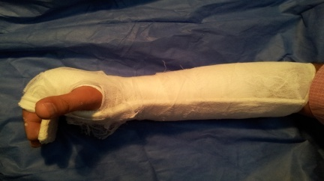
Figure 1 shows a splinted hand with MCP joints flexion 90⁰, IP joints full extension and palmar abduction of the thumb.

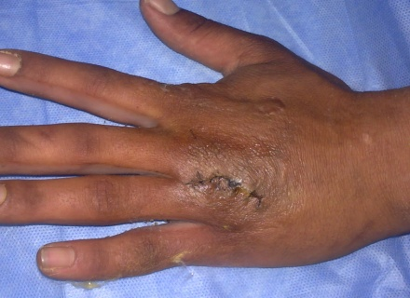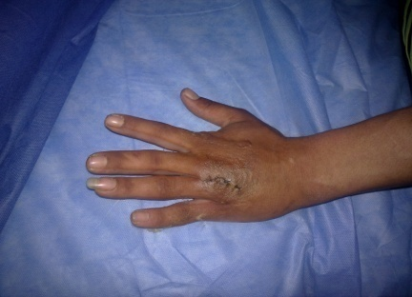
Figure 2 shows 20 yrs old male with cut extensor tendon of the right ring finger in zone V & VI .

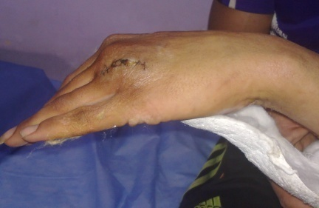
Figure 3 starting daily movements and activity after removal of the cast.

Discussion
Extensor tendon injuries may occur in as common as (61.3%) in comparison to flexor tendon injuries, yet have receive relatively less attention as the patient may adapt their loss of functions in spite of the fact that they are simple to treat as compared to their counteracting flexor tendons but otherwise demanding the same skill and knowledge as required for flexor tendon injuries[14,16]. Adhesions of the tendon to skin are common due to their superficial position and lacking of the soft tissues.
In our study all of the patients were (18-35) years of age and these findings are consistent with other series where young adults were more affected[4,14].This is mainly because of those age group is more vulnerable to trauma if we put in mind that most of our patients were manual workers. Males were more often affected than females with M:F = 19:7, and this is going well with our study as all they were all male patients. The dominant hand was more commonly affected as being seen in our cases in 76% and this is always the case in vast majority of the literatures deal with this issue.
In 5 cases in our series were complex injuries (24%) despite this fact, the early mobilization protocol showed excellent results in (80%) of cases. This is the same as what series of Sylaidis and Logan reveled[15]. Amongst the tendons affected, EDC of the middle finger mainly, EIP, and EPL (81%) were most commonly affected in our series. In the present series three (33%) cases developed superficial infection, this improved after antibiotics and regular dressings. This did not affect the final outcome.
In the repair of extensor injuries over the wrist, the extensor retinaculum has been an issue of debate. Some authors advised excising it completely, while others advocate that it should be preserved to prevent ugly bowstringing on the wrist and painful dislocation on pronation and supination [14]. In the present series retinaculum over the repair was partially opened and left unsutured to decrease the effect of compression on the repaired tendons, yet full range of movement was obtained without any bowstringing and adhesions. At the end of six weeks, 4 patients showed a mild extensor lag (good result). After extensor strengthening exercises the patients were again assessed and results were now excellent, i.e. no extensor lag.

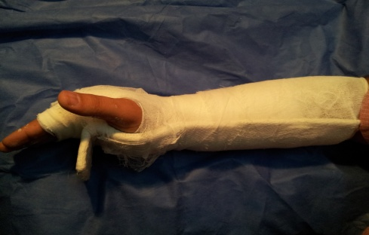
Figure 4 shows a splinted hand with both MP and IP joints extension.
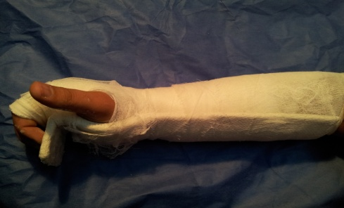

Figure 5 shows a splinted hand with both MP and IP joints flexion.

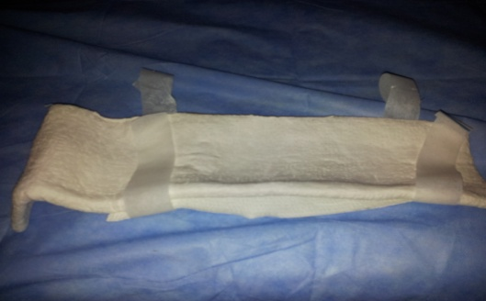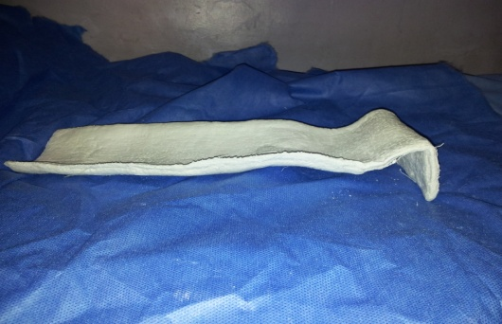
Figure 6 shows a typical fabricated cast with mild extension for the wrist joint, flexion for MP joints, and full extension for the IP joints.
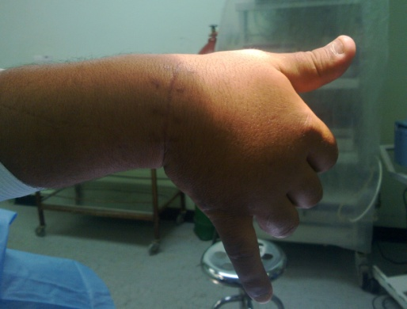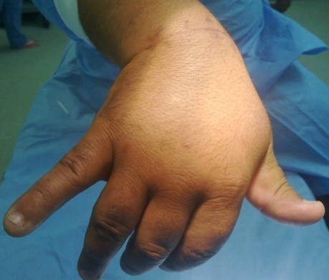

Figure 7 shows 40 yrs man with an extensor cut wrist in zone VII dorsally, and all the extensor tendons are divided except that of the little digit.
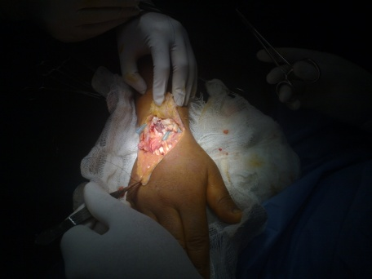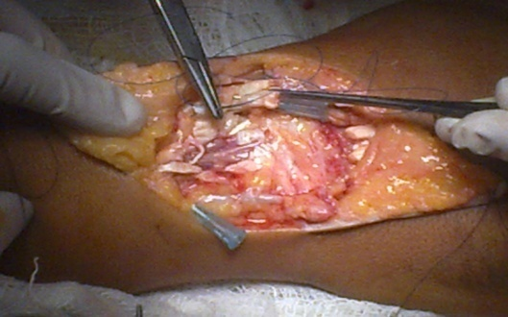

Figure 8 shows the same patient at figure 7 intraoperatively.

The early mobilization of repaired extensor tendons, prevents formation of adhesions as compared to rigid immobilization. The static splint besides being easy to prepare and apply gives equally good results as the dynamic splints. The patient compliance with this easy-to-follow rehabilitation plan was very good, thus helping to attain excellent results. The patients return to work early, thus reducing the amount of workdays lost.

Conclusion
Early movements of a repaired extensor tendons coincidentally with use of easy self made splint gives better results from preventing adhesion and MPJ stiffness with a good range of extensor tendon movements.

References

- Strickland JW: Flexor tendon injuries: I. Foundations of treatment. J Am Acad Ortho Surg 3:44-54, 1995.
- Gelbermann RH, Manske PR: Factors influencing flexor tendon adhesions. Hand clinics 1(1):35-42, 1985.
- Tuncali D, Yavuz N, Terzioglu A, Aslan G. The rate of upper-extremity deep-structure injuries through small penetrating lacerations. Ann Plast Surg. 2005;55:146–8.
- Hunter JM, Schneider LH, Dumont J, et al: A dynamic approach to problems of hand fuction using local anesthesia. CORR 104: 112-115, 1997.
- Kettlekamp DB, Flatt AE, Moulds R: Traumatic dislocation of long finger extensor tendon. J Bone Joint Surg 53A(2): 229-240, 1971.
- Chow JA, Dovelle S, Thomes LJ, Ho PK, Saldana I. A comparison of results of extensor tendon repair followed by early controlled mobilization versus static immobilization. J Hand Surg Br. 1989;14:18–20.
- Rayan GM, Murray D: Classification and treatment of sagittal band injuries. 19A(4):590-594, 1994.
- Slater RR, Jr, Bynum DK. Simplified functional splinting after extensor tenorrhaphy. J Hand Surg Am. 1997;22:445–51.
- Evans RB, Burkhalter WE. A study of the dynamic anatomy of the extensor tendons and implications for treatment. J Hand Surg Am. 1986;11:774–9.
- Newport ML, Shukla A. Electrophysiological basis of dynamic ext. Splinting J Hand Surg Am. 1992;17:272–7.
- .O'Dwyer FG. Quinton DN. Early mobilization of acute middle slip injuries. J Hand Surg Br. 1990;15:404–6.
- Rolph-Roeming K. Early mobilization of extensor tendon lacerations in ZoneIII and IV. J Hand Ther. 1992;5:45.
- Saldana MJ, Chobban S. Results of acute Zone III extensor tendon injuries, Treatment by dynamic splinting. J Hand Surg Am. 1991;16:1145–50.
- Littler JW: The finger extensor mechanism. Surg clin North Am 47:415-432, 1967.
- Sylaidis P, Youatt M, Logan A. Early active mobilization for extensor tendon injuries. J Hand Surg Br. 1999;22:594–6.
Zander CL. The use of early mobilization following complex

