Evaluationof Curing Depth of Bulk-Fill Resin Composite
(A comparative study)

Salam A. Al-Araji* Mohammed A. Ibrahim** Hala A. Ragab**
* College of Dentistry , Al-Kufa University
**Beirut Arab University

Received 4 November 2014 Accepted 1 December 2014
Abstract
This study evaluated the depth of cure (DOC) of recently introduced resin composites for posterior use, bulk filled flowable composite (SureFil® SDR® flow DENTSPLY Caulk) at different depth.
30 specimens were prepared and divided into two Groups,Group 1: specimens with 2 mm depth, Group 2: specimens with 4mm depth. The composite specimens were prepared by using molds of different depth, one of them with was a hole of 4 mm depth and 4 mm internal diameter and the other was with a depth of 2 mm at the same diameter. The hole was bulk filled with SDR flowable composite resin and light cured for 20 seconds with a modern high-intensity LED curing unit (Elipar™ S10, 3M.US.), followed by 24 hours storage in complete darkness incubator at 37 C◦. The degree of conversion was measured on the top and the bottom for both depths using Fourier transform infrared (FTIR) spectroscopy.
A bulk filled flowable (SDR)revealed a significant difference in degree of conversion (DOC) when the bottom surface of the specimen witha 2mm depth (DOC=76.27112163) wascompared with the bottom surface of the 4mm depth specimen (DOC=73.92160935). The 2mm depth wasshown statistically significantly higher mean values degree of conversion than 4 mm depth (P-value = 0.032). There was no statistically significant difference in the degree of conversion mean values between the top and the bottom surfaces of the specimen of the same group (P >0.05).
Upon the result of thisin vitro study, it was found that the degree of conversion of the SDR bulk-fill flowable resin compositewasaffected by depths. As the depth of the resin compositewas increased the degree of conversion was decreased.
Key words: bulk-fill flowable resin composite, degree of conversion, FTIR and Depth of cure.

Introduction
O
ne of the most important problems of restorative and esthetic dentistry today is the failure of completely adhesion of restorative materials to tooth structure, causing microleakage which lead to margin continuity and discoloration^{[6]}. The presence of marginal gaps between the restorative materials, have shown conflicting association with the presence of secondary caries activity, especially in the cervical margin, where there is difficulty in complete polymerization of restorative composite material in such depth^{[11]}. Dental composite restorations have a major drawback: the degree to which they cure is proportional to the amount of light to which they are exposed. So, they polymerize to a certain depth which varies with the penetration of a light beam in the bulk material. This extent of cure has been termed (depth of cure) and has significant influence on both physical and biological properties of restorations^{[9]}.The Depth of cure of composite material was restricted and it depends on many parameters such as thickness, filler particle size, filler loading and polymerization initiator concentration^{[10]}. The curing depth of composite resins is related directly to their thickness^{[1]}.It can also affect the amount of photons from light source received at the top and bottom surfaces of resin composite restoration. Because the polymerization process is initiated by external light, variations in the transmission and attenuation of incident light between specimens of different thicknesses can have a range of outcomes^{[15]}. The presence of partially and fully unpolymerized monomers can result in possible irritating, allergic, or toxic components into the surrounding tissues^{[4]}.
A research on the polymerization in the transmission and attenuation of the light that passes through the various thicknesses of the bulk-fill composite resin is quite limited. So, the present study was examined the influence of resin thickness on the degree of polymerization of bulk-fill composite resin.

Materials and Methods
A total of thirtyready-made specimen molds (DENTSPLY) was used. These molds were prepared by manufacture in different depths of 2 and 4 mm.Thirty samples were made for this test and these samples were divided into two groups:
Group 1: 15 samples of (4 × 4) mm, (diameter) d=4 mm, (height) h=4 mm were prepared using molds of (4mm×4mm).
Group 2: 15 samples of (4 × 2) mm, d=4 mm, h=2 mm were prepared using molds of (4mm×2mm).

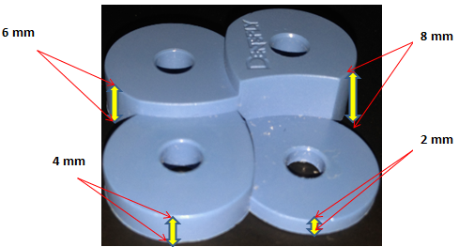
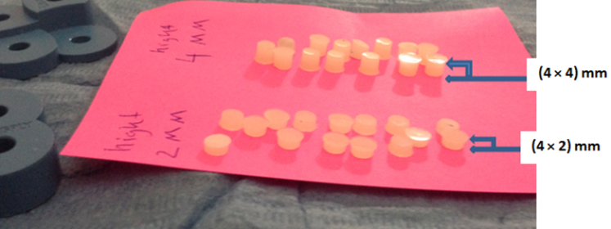
Figure (1):The ready-made mold Figure (2): Sample grouping

A transparent glass slide was placed on a dark non reflective surface and a transparent Mylar strip was placed over it, then a specimen disc was placed above it. The bulk-fill flowable resin composite (SDR, smart dentin replacement, DENTSPLY Company, Germany 22/7/2009) to be cured (which applied as Compula® Tips) was injected into the specimen mold using aCompules® Tips Gun and the hole at the center of the mold was overfilled. A transparent Mylar strip was placed over the filling at the center of the mold and a second glass slide was placed over it.A 200 g of pressure was applied for 45 seconds over the second slide to remove the excess material from the mold; the second glass slide was removed, leaving the Mylar strip in place. The specimen mold, with the filling material at the center and covered with a Mylar strip was cured using a high intensity curing light unit(Elipar™ S10 LED Curing Light: 3M ESPE Dental Products US), maintaining a distance of 1mm between the sample and the outlet of the curing tip. The light was applied at a standard curing mode for the duration of 20 secondsand the intensity was checked randomly throughout the study. After a group of specimens was cured, they were placed in a dry specimen bottle and kept at a dry and constant 37° C, for 24 hours [3, 7].
About 1 mg of the solid sample (abraded from each surface of both groups) was mixed with about 100 mg of pre-dried and desiccated solid KBr.The mixture was finely grounded in a mortar, preferably under an IR lamp to exclude any water vapors, until the sample was well dispersed and the mixture had the consistency of fine flour.
The die was assembled, with placed the bottom anvil flat on the table and the die was slid over the anvil column. The ground mixture KBr/ sample were transferred into the cylinder bore formed by the die and the anvil bottom so that it was evenly distributed across the polished face of the anvil bottom. The excess powder was removed with a straight edge. The second anvil was positioned on top of the assembly and pushed gently.The resulting KBr disc was removed from the KBr die and positioned into a special holder and then it was placed into the path of the IR radiation of FTIR spectrometer (JASCO FT/IR-6300) and its spectrum was recorded.

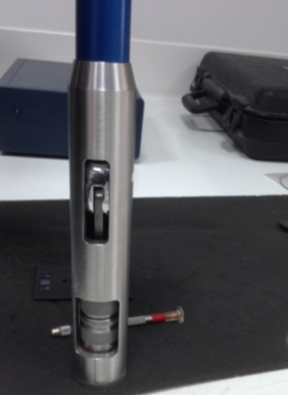
Figure (3): Hand press (ManualKBr/powder pellet press)

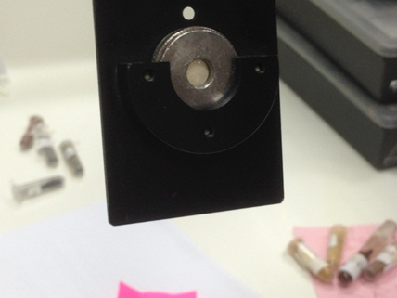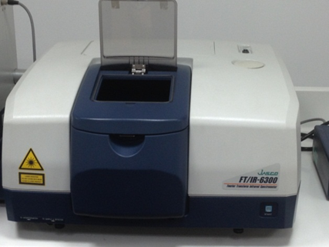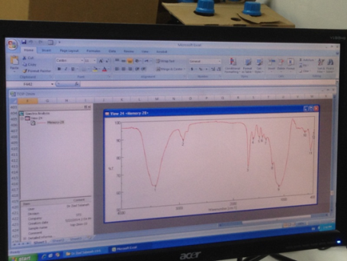
Figure (4): FTIR spectrometer (JASCO FT/IR-6300) and its spectrum after recorded

Results
The results showed that depth had a statistically significant effect on the mean values of degree of conversion. The surface and the interaction between the two variables had no statistically significant effect on mean values of degree of conversion. Since the interaction between the two variables was non-significant, so the effect of each variable (main effect) was independent upon the other variable. So, comparisons were performed between the main effects.

Table (1): Repeated measures ANOVA results for the effect of different variables on mean values of degree of conversion
Source of  variation | Type III Sum  of Squares | df | Mean  Square | F-  value | P-  value
Depth | 131.8 | 1 | 131.8 | 5.1 | 0.032*
Surface | 22.4 | 1 | 22.4 | 1.1 | 0.295
Depth x Surface  interaction | 5.7 | 1 | 5.7 | 0.3 | 0.595

df: degrees of freedom = (n-1), *: Significant at P ≤ 0.05

The mean values of degree of conversion (DOC) for the top surface of the specimenswitha 2mm depth was (78.1) at (3.5) standard deviation (SD), while the mean values for the bottom surface was (76.3) at (3.9) standard deviation (SD).The mean values of degree of conversion values (DOC) for the top surface of the specimens of 2mm depth was (74.5) at (5.2) standard deviation (SD), while for the bottom surface was (73.9) at (6.0) standard deviation values (SD).

Table (2): Descriptive statistics of degree of conversion values
Surface | 2 mm depth |  | 4 mm depth
 | Mean | SD | Mean | SD
Top | 78.1 | 3.5 | 74.5 | 5.2
Bottom | 76.3 | 3.9 | 73.9 | 6.0

Effect of depth on the degree of conversion
The mean values of the degree of conversion values of the specimens with a 2mm depth was (77.2) at (3.8) standard deviation, while the mean values of the specimenswith a 4 mm depth was (74.2) and the standard deviation was (5.5). So, the specimens with a 2 mm depth wasshown statistically significantly higher mean values ofthe degree of conversion thanthespecimens with a 4 mm depth (P-value = 0.032).

Table (3):Descriptive statistics and results of comparison between degree of conversion values of
two depths

2 mm depth |  | 4 mm depth |  | P-value
Mean | SD | Mean | SD
77.2 | 3.8 | 74.2 | 5.5 | 0.032*

*: Significant at P ≤ 0.05

Figure (5): Bar chart representing mean values for comparison between degree of conversion of the two depths

Effect of surface of the specimens on the degree of conversion
The mean value of degree of conversion (DOC) at the top surface of the specimens with a 2mm depthwas (76.3) at (4.7) standard deviation, while the mean value of the bottom surface of the specimens with a 4 mm depth was (75.1) at (5.1) standard deviation.There was no statistically significant difference between degree of conversion values at the top and the bottom surfaces (P-value = 0.295).

Table (4): Descriptive statistics and results of comparison between degree of conversion values at the two surfaces
Top surface |  | Bottom surface |  | P-value
Mean | SD | Mean | SD
76.3 | 4.7 | 75.1 | 5.1 | 0.295

*: Significant at P ≤ 0.05

Figure (6): Bar chart representing mean values for comparison between degree of conversion at the two surfaces

Discussion
This studytested the claim that SDRTM DENSEPLY flowable resin bulk-fill composite can cure as effectively at 4mm depth of the manufacturer’s recommended depth of cure and the mechanical properties of this material not affects by depth.
The degree of conversion of a methacrylic resin composite was defined as the percentage of reacting C=C bonds.This ratio substantially affected many properties including mechanical properties, solubility, dimensional stability, color change and biocompatibility of the resin composite ^{[14]}, ^{[2]}. Thus, the degree of conversion played an important role in determining the ultimate success of a light activated direct restoration ^{[13]}, ^{[16]}. Degree of conversion still remains a challenge in the application of direct composite techniques. The depth of polymerization is of vital importance not only in order to achieve optimum physical and mechanical properties, but also to ensure that, the clinical problems do not arise due to partially polymerized material in the base of the cavity ^{[8]}.
The Degree of conversion in this study was measured by Fourier transformed infrared reflectance spectroscopy (FTIR). This method had been reported to produce highly reliable results. The calculationwas based on the measurement of the net peak absorbance area of the C=C bonds and the aromatic C-C bonds. The net absorbance peak area ratio of curd to uncured material was provided the percentage of converting double bonds. Based on that method, a variety of correlations could be proved.
The result of this study assessed that thespecimens with a 2 mm depth was shown statistically significantly higher mean values ofthe degree of conversion than thespecimens with a 4 mm depth (P-value = 0.032).This may probably be attributed to the fact that light intensity was greatly reduced while passing through the bulk of the composite resin due to light scattering and absorption, which could be led to decrease polymerization effectiveness. This may possibly be ascribed to the optical properties of resins (optical transmission coefficient), which could be varied with the material composition (particle type/contents, size and morphology) ^{[5]}. With the less photon loss, a higher degree of conversion could be expected whencompared the top and bottom surfaceof the same specimen. However, this study revealed an inverse linear correlation between the DOC and subsurface depth, regardless of the exponential decrease in light intensity, which was attributed to the three dimensional crosslinking process. Irradiated photons immediately reached the subsurface and initiated polymerization at the subsurface by crosslinking monomer molecules three dimensionally from the top to bottom. The intensity of these photons, however, may be decreased exponentially with depth. Nevertheless, the insufficient DOC due to the exponential decreased in photons could be compensated by the three dimensional crosslinking which was disagreement with Pascal (Czasch and Nicoleta, 2013), who assessed that the placing the RBCs in 4 mm depth instead of 2 mm depth neither lowered the micromechanical properties nor DOC. Surefil® SDR™ fellow showed significantly higher mechanical properties, but lower DOC values when compared to Venus® bulk fill.
The results of this study were found to be in agreement with (MR. Rouhollahi et.al, 2012) who evaluated the depth of cure of two light-cured core build-up composites (Quixfil and Photocore) in different thicknesses, and assessed that the Curing depth and microhardness were inversely related with thickness.

Conclusion
Upon the result of thisin vitro study, it was found that the degree of conversion of the SDR bulk-fill flowable resin composite was affected by depths. As the depth of the resin composite was increased the degree of conversion was decreased.

References
- Bala O., Uctasli M. and Tuz M. Barcoll hardness of different resin-based composites cured by halogen or light emitting diode (LED). J Oper Dent (2005); 30: p. 69-74.
- Correr S., De Goes M., Consani S., Sinhoreti M. and Knowles J. Correlation between light intensity and exposure time on the hardness of composite resin. J Mater Sci Mater Med (2000); 11: p. 361-364.
- Flury S., Peutzfeldt A. and Lussi A. Influence of increment thickness on microhardness and dentin bond strength of bulk fill resin composites. J Dent Mater (2014); 30: p. 1104-1112.
- Jeroen D., Luc A., Luc C., Ronald M. and VerbeeckH. Comparison of curing depth of a colored polyacid-modified composite resin with different light-curing units. J Quintessence Int (2010); 41: p. 787–794.
- Kim K., Ong J. and Okuno O. The effect of filler loading and morphology on the mechanical properties of contemporary composites. J Prosthet Dent (2002); 87: p. 642-649.
- Koplin C., Jaeger R. and Hahn P. Kinetic model for the coupled volumetric and thermal behavior of dental composites. J Dent Mater (2008); 24: p. 1017-1024.
- Leah F., William M., Natalia M., Emma L. and Garry J. The influence of irradiation potential on the degree of conversion and mechanical properties of two bulk-fill flowable RBC base materials. J Dent Mater (2013); 29: p. 906-912.
- Lelaoup G., Holoet E., Beoelman S. and Devaux J. Raman Scattering Determination of the depth of cure of light activated composites. J Oral Rehabil (2002); 29:p. 510-15.
- Mohamed E., Lubna K., Ossama A. and Hanan H. Depth of Cure and Microhardness of Nanofilled, Packable and Hybrid Dental Composite Resins. Amer J Biomed Engineer., (2012); 2: p.241-250.
- MR. Rouhollahi, M. Mohammadibasir, Sh. Talim. Comparative Depth of Cure among Two Light-Cured Core Build-Up Composites by Surface Vickers Hardness. Journal of Dentistry, Tehran Univ Med Sci., (2012); 9: p. 255-261.
- Nicola B., Massimo G., Jean-Francois R., Tiziano T., Mutlu O. and Antonio Cerutti. Marginal quality of posterior microhybrid resin composite restorations applied using two polymerization protocols: 5-year randomised split mouth trial. J dentist., (2013); 41: p. 436–442.
- Pascal C. and Nicoleta I. In vitro comparison of mechanical properties and degree of cure of bulk fill composites. J Clin Oral Invest (2013); 17: p. 227–235.
- Peutzfeldt A., Sahafi A. and Asmussen E. Characterization of resin composites polymerized with plasma arc curing units. J Dent Mater (2000); 16: p. 330-336.
- Silikas N., Eliades G. and Watts D. Light intensity effects on resin-composite degree of conversion and shrinkage strain. J Dent Mater (2000); 16: p. 292-296.
- Sung-Ae S., Hyoung-Mee R., Bock H., Yong-Hoon K. and Jeong-Kil P. The effect of resin thickness on polymerization characteristics of silorane-based composite resin. J Restorative Dentistry & Endodontics (2014); 39: p. 1-9.
- Yoon T., Lee Y., Lim B. and Kim C. Degree of polymerization of resin composites by different light sources. J Oral Rehabil (2002); 29: p. 1165-1173.

