Theoretical Model Of Multi –Layered Beam
With Partial Connection

Hesham Abd Al–Latef Numan
Civil Eng. Department, Al-Mustansiriya University

Abstract
This paper presents a theoretical study to the behavior of multi-layered beam system with partial connection. An assumed element consists of three layers, the upper and the middle layers are connected by shear connectors and glue, and the middle layer and the lower layer are connected by shear connectors only. Equilibrium and compatibility are satisfied for the forces and displacements at the assumed element. As a result, two simultaneous differential equations of the second order in terms of slip and axial force are obtained. A computer program is written in (visual Basic) to apply suggested theoretical model
Key words: Multilayered Beam, Partial Connection.
الخلاصة
يتضمن هذا البحث دراسة نظرية لتصرف منظومة العتبة المتعددة الطبقات ذات الترابط الجزئي، المكونة من ثلاث طبقات، الطبقة العليا والوسطى مربوطة بالروابط القصية ولاصق، والطبقة الوسطى والسفلى مربوطة بالروابط القصية فقط. معادلات التوازن والتوافق طبقت للقوى والإزاحات خلال عناصر الطبقات . حيث تم التوصل إلى معادلتين تفاضليتين أنيتين من الدرجة الثانية بدلالة الانزلاق والقوى المحورية. كتب البرنامج الحاسوبي بلغة (فيژيوال بيسك) لتطبيق النموذج النظري المفترض.

1. Introduction
In civil engineering construction, the objective of using or selecting any material is to make full use of its properties in order to get the best performance for the formed structure .The merits of a material are based on factors such as availability, structural strength, durability and workability. As it is difficult to find a material, which possesses all these properties to the desired level, therefore; the engineer’s problem consists of an optimization involving different materials and methods of construction.
Methods of improving material utilization can be classified into two categories. The first is to select appropriate materials to form a new product with desired properties, thus resulting in a composite material. Alternatively different materials can be arranged in an optimum geometric configuration. The structure is then known as a composite structure, and the relevant method of building, composite construction.
A large number of composite structures can be produced by the combination of different structural components, including rolled steel beams, built-up sections, timber beams, precast and in situ concrete beams, slabs, steel plates, walls, steel tubes and frames.
In order to make the steel beam and the slab act as a composite structure, the connectors must have adequate strength and stiffness. If there are no horizontal or vertical separations at the interface (i.e. no slip or uplift), the connectors are described as rigid; complete interaction can be said to exit under these idealized circumstances. However, all connectors are flexible to some extent, and therefore partial interaction is always used in practice, failure by vertical separation is unlikely and any uplift would have only negligible effect on the behavior of composite structure. It is, therefore, sufficient to consider only slip in the study of the effects of partial interaction.
Adekola (1968) presented a solution to the partial connection behavior of composite beams allowing for slip and separation at the interface. This solution covers the composite beams with elastic materials and considers the frictional forces at the interface. In this solution, for each component of the composite section, the rate of change of axial force is assumed directly proportional to the slip, and uplift forces is directly proportional to the differential deflection.
Frodin et al., (1987) made a comparison of deflection in composite beams having full and partial shear connection. The investigation is limited to beams with uniformly spaced shear connector. Sections are analyzed to determine the effect of partial shear connection on the central deflection of a simply supported composite beam with uniform spacing of connectors and uniformly distributed loading. Linear partial interaction theory is used to determine the central deflection of each beam with full and partial shear connection. The deflection is compared with those calculated for the composite beams having full shear connection assuming full interaction theory.
In the same year, Vilnay (1987) considered that severe shear and normal stresses concentration in the adhesive layer at the ends of plates may result in premature. This failure mode is indicated by ripping off the concrete cover together with the bonded failure thick plate, if epoxy resin has been used as bonding material.
Jasim and Mohamad (1997) presented study to compute the deflection of continuous composite beams with partial connection and different cases of loading based on Newmark’s approach. The exact solution of the governing differential equations is obtained and the results are so arranged that the deflections of partially composite beams be related to those of corresponding fully composite ones. Charts are constructed to allow the computation of the mid span deflections of beams.
In the same year, Abdul Razak (1997) applied the basic differential equation, attributed to Newmark’s approach for various beam width, variable connector spacing, and various load conditions. However, the steel and concrete are assumed to have linear elastic properties except shear connectors, which are assumed to have non – linear characteristics.
Al- Amery and Hammed (2001) suggested theoretical model of continuous multi – layered composite beams with partial connection based on Adekola’s approach. Two degrees of freedom are allowed in this model, slip and uplift. The governing four differential equations are of the second order in axial force and fourth order in uplift force. Numerical solution is used to solve the four differential equations.

2. Simply Supported layered Beam System with Partial Connection
An element consists of three – layered beam system (a, b and c), length (δx), is shown in Fig. (1), the upper and the middle layer are connected by shear connectors and glue, the middle and the lower layer are connected by shear connecters only.
2.1 The formulation
The formulation of layered beam system consists of three layers based on the following assumptions:
- Materials of layers are linear elastic and each possesses the same elastic modulus in tension and compression.
- The amount of slip permitted by the shear connector and glue is directly proportional to the load transmitted at any given load on the beam.
- The shear connection between layers is continuous along the length (i.e. discrete deformable connections are assumed to be replaced by a continuous shear connection).
- The distribution of strains through the depth of the individual layers is linear.
- Frictional effect forces and uplift force between the layers are neglected.
- At every section of a beam, each layer deflects the same amount, and no buckling of layers occurs.

δx
M_{a} + δM_{a}
M_{a}
F_{a}

V _{a}
Layer (a)
E_{a,} I_{a ,}A_{a}

h_{a}
F_{a} + δ F _{a}
ρ . δ x
M_{b}
F_{a}

F_{c}
h_{b}
V _{b} +δ V _{b}
V _{b}
F_{c} + δ F _{c}
Layer (b)
E_{b ,} I_{b ,}A_{b}

M_{b} + δM_{b}
q₂ . δ x
q₁ . δ x
V_{a} + δV_{a}
V _{c}+ δV _{c}
M_{c} + δM_{c}
M_{c}
F_{c}

V _{c}
Layer (c)
E_{c ,} I_{c ,}A_{c}

h_{c}
F_{c} + δ F _{c}
Layer (a)
E_{a ,} I_{a ,}A_{a}

h_{a}

Upper Layer

F_{a} + δ F _{a}
Mid Layer

Lower Layer

Fig. (1): A Three – layered composite element.

2.1.1 Equilibrium
Longitudinal equilibrium of upper layer gives:
…(1)

Similarly , for middle and lower layer ,respectively:

…(2)

…(3)

 | Taking moments about the center of the upper layer gives:
…(4) | 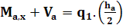  ± δ_{x}
 | Similarly , for middle and lower layer ,respectively:
...(5) | 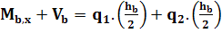  ± δ_{x}
…(6) | 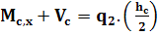  ± δ_{y}
in which (q) is the shear force at interface between elements,(h) is the thickness of layer,(M) is the bending moment,(V) is the shear force, subscripts (a, b and c) denote the upper, middle and lower layer respectively, subscripts (1) and (2) denote upper and lower interface.
The vertical shear at a section, distance (x) from the support, is denoted by (N). Hence.

… (7)

From equations (4), (5), (6) and (7):

… (8)
where:

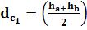 and 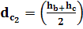

2. 1.2 Compatibility
Assuming equal curvatures for the three layers gives:

… (9)

From elastic beam theory:
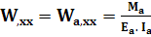

… (10)

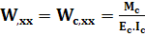
in which (E) is modulus of elasticity, (I) is the moment of inertia.
Differentiating equation (10) once with respect to (x) and rearranging gives:

… (11)

Substituting for (M_{a,x} , M_{b,x} and M_{c,x}) into equation ( 8 ) gives:

. . … (12)
where:
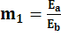 and 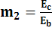

The shear flow (q) is related to the slip (U) by the equations:

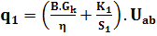 … (13)

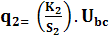 … (14)
in which (B) is the width of the beam ,(G_{k}) is the shear modulus of the adhesive, (η) is the adhesive thickness ,(K) is the shear stiffness of the studs per unit length of interface and (S) is the spacing between shear connectors.
Substituting equations (13) and (14) into equation (12) gives:

W,_{xxx}= (15)

where: I₀ =(m₁.I_{a}+I_{b}+m₂.I_{c} )

Strains (ε) at the interface (1) can be expressed as:

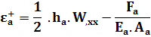 | …(16)
 | …(16)
  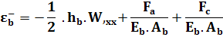
in which (F ) is the axial force and (A) is the cross sectional area.
Similarly for interface (2):

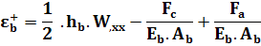 | …(17)
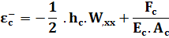 | …(17)
The interface slip strain is given by:

– | …(18)
– | …(18)

Substituting for strains (ε_{a}⁺, ε_{b}⁻, ε_{b}⁺ and ε_{c}⁻) in (18) gives:
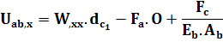 | …(19)
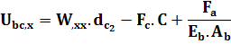

where:
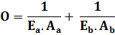

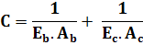
After differentiating equations (19) once with respect to (x) and substituting for (W,xxx) and (F,_{x}) from equations (15), (1) and (3) , then simplifying and rearranging , equations (19)become:

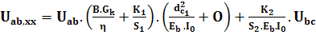  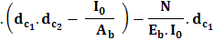 | …(20)
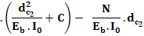 | …(20)
Alternatively, to get the basic differential equations in terms of axial force, the applied external moment (M_{t}) is equal to the sum of the individual moments that each element can be carried together with the composite couples, so:

M_{t} =M_{a}+M_{b}+M_{c}+F_{a}.d_{c1}+F_{c}.d_{c2} | …(21)
Substituting for ( ) from equations (10) gives :

=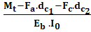 | …(22)
Substituting equation (13) into equation (1) and substituting equation (14) into equation (3), and then, differentiating once with respect to (x), and then rearranging to get the following:
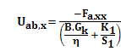 | … (23)
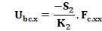 | … (23)
From equations (19), (22) and (23), the following differential equations can be obtained in terms of axial force instead of interface slip:

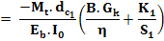 | …(24)

2.2 Numerical Solution
Equations (20) and (24) contain derivatives of second order in terms of slip (U) and axial force (F) respectively, which can be expressed in finite (central) difference form. For example, the derivatives of U at node (i) can be expressed as:

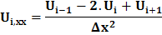

in which (Δx) is the spacing between nodes.
One external node must be specified at each end of the beam to verify the substitution of the differential equations until last node at the beam, and as known, at each node along the beam, there are two simultaneous differential equations, therefore; four additional equations are needed to complete the system of algebraic equations, as illustrated below:
 | When x=0 and L | … (25)
 | When x=0 and L | … (26)
 | When x=0 and L | … (27)
 | When x=0 and L | … (28)

Deflection can also be determined by expressing equation (22) in a finite (central) difference form. Then axial force at each node must be substituted into the governing deflection equation at that node. Therefore; a set of simultaneous equations has been established in matrix form, and this system must be completed by verifying boundary conditions at the ends of the beam, as given below:
W=0 | When x=0 and L | …(29)
W,xx=0 | When x=0 and L | …(30)

Concentrated load (P) can be idealized as a uniformly distributed load (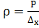), applied over single node spacing.
3. Example
A typical section with the dimensions given in Fig. (2) contains a plate of steel over the composite concrete slab and steel beam . The beam has span (3360 mm), and is subjected to concentrated load (74.2 kN) at the middle span. The other properties are given in Table (1), and shown in Fig. (2-b).
Steel plate
P=74.2 kN
A
A
Concrete Slab
Steel beam
3360
920
60
150
Steel plate
Shear connector
9.5
75
9.5
Glue(Graphite-Epoxy)

Concrete slab
5
(a)
Steel beam

Section (A-A)
b))

Fig. (2): (a) Strengthened composite beam subjected to concentrated load at the middle span.
(b) Section at the beam (all dimensions are in mm).

Table (1):Material Properties (Vilnay, 1987; Jasim and Mohamad, 1997)
Material | Property | Value
Concrete Slab | Characteristic Cube Strength f_{cu} (N/mm²) | 47.5
Concrete Slab | Modulus of Elasticity E_{c}(N/mm²) | 26700
Steel Beam  (I-Section) | Characteristic Yield Strength f_{y} (N/mm²) | 300
Steel Beam  (I-Section) | Modulus of Elasticity E_{s} (N/mm²) | 207000
Shear Connector | Connector Modulus K(N/mm) | 153 x10³
Shear Connector | Diameter(mm)x Height (mm) | 10 x 50
Shear Connector | Spacing (mm) | 146
Shear Connector | Number of Rows | 2
Glue  (Graphite-epoxy) | Shear Modulus of Adhesive G_{k} (N/mm²) | 4.00
Glue  (Graphite-epoxy) | Adhesive Thickness η (mm) | 0.02

4. Results
Fig. (3) shows variation of slip (rate of change of slip values along the beam span). In the left support, the maximum slip occurs which is (0.05 mm).This value increases slowly until it approaches zero (at 0.5L from left support).Then, the slip increases at opposite direction until it reaches the maximum value at right support.

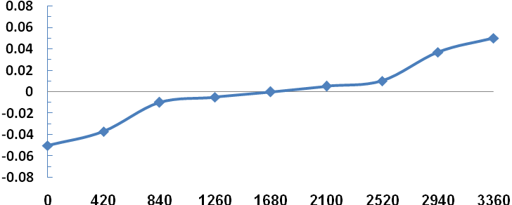
Simple support
Distance along the beam (mm)
Simple support
Slip (mm)
P=74.2 kN

Fig.(3):Variation of slip along the simply supported beam.

Fig. (4) shows variation of axial force (rate of change of axial force along the beam span). In the left support, the axial force value is equal to zero and it increases rapidly until it approaches a maximum value (at 0.5L from left support) which is (170 kN).Then, the axial force value decrease until it approaches zero at the right support.

Axial force (kN)
Distance along the beam (mm)
Simply support
Simply support
P=74.2 kN

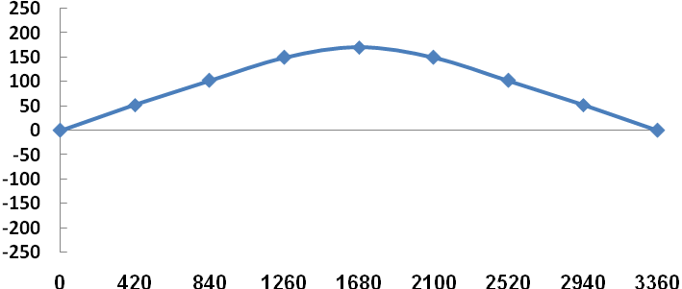

Fig. (4): Variation of axial force along the simply supported beam.

Fig.(5 ) shows variation of deflection (rate of change of deflection along the beam span). In the left support, the deflection value is equal to zero and it increases rapidly until it approaches a maximum value (at 0.5L from left support) which is (6.2 mm).Then, the deflection value decrease until it approaches zero at the right support.

P=74.2 kN
Simply support
Distance along the beam (mm)

Simply support
Deflection (mm)
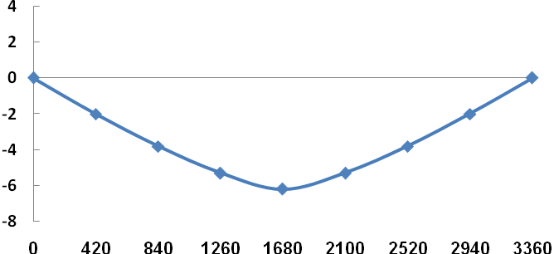

Fig.(5 ): Variation of deflection along the simply supported beam.

5. Conclusions
1. Theoretical model for the analysis of simply supported layered beam system with interlayer slip has been presented in which, the basic equilibrium and compatibility equations are expressed in terms of upper and lower interface slip. Another pair of simultaneous differential equations in terms of axial force in upper and lower layer is obtained as an alternative method. The suggested approach gives reasonable prediction and can be used for any type of material properties, loading and boundary conditions.
2. The numerical solution (finite difference method) can be used even at large intervals with acceptable tolerance since the basic differential equations are of the second order.
3. A computer program is written in (Visual Basic) language to do computation, and it is found adequate, saving time and effort.
4. A more accurate result is achieved when using the layered approach.
5. Approximate relationship between slip and the applied loading present along the whole length of simply supported beam can be noticed.
6. In spite of, the steel plate and concrete slab are connected by shear connectors and glue are reduced displacements (slip and deflection) but are not prevented because both connection are fl0065ible to some extent, and therefore partial interaction is always used in practice..

6. References
Abdul Razak, O.B., (1997). “Effects of Linear and Nonlinear Behavior of Shear Connectors in Composite Beams”, M.Sc. Thesis, Al-Mustansiriya University. 88pp.
Adekola, A.O., (1968). “Partial Interaction between Elastically Connected Elements of a Composite Beam”, Journal of Solids and Structures, Vol.4. pp. 1125-1135.
Al-Amery, R.I.M. and Hammed, S.A., (2001). “Theoretical Model of Continuous Multi-Layered Composite Beams with Partial Connection”, Proceeding of the First National Conference in Civil Engineering, Iraq.
Frodin, J.G., Taylor R., and Stark J.W.B., (1987). “A Comparison of Deflections in Composite Beams having Full and Partial Shear Connection” ,Proc.Instn. Civ.Engrs. Vol.65, Part 2. Pp.307-322.
Jasim, N.A. and Mohamad, A.A., (1997). “Deflections of Composite Beams with Partial Shear Connection”, The Structural Engineer, Vol.75, No.4. pp. 58-61.
Vilnay, O., (1987) “The Analysis of Reinforced Concrete Beams Strengthened by Epoxy Bonded Steel Plates”, The International of Cement Composite and Light Weight Concrete.Vol.10, No.2, Dec. 1987. pp. 73-78.

APPENDIX-A
This appendix contains more details about the computer program with flow chart described the main steps, which used in this program.

Apply the Differential Equations at Each Node
Put the Equations in Matrix Form
Call Inverse of Matrix
Calculate Slip and Interaction Axial Force
Output (print) the Results
End
Input Data Defining Dimensions, Loading, Boundary Conditions, Material Properties for Composite Beam
Start
Call Inverse of Matrix
Calculate deflection

Flow chart showing the three–layered beam system with partial connection.

