Study for the Effect Addition of Radical (CN) on the Electronic Properties for Mono Hydroxy-Benzene Molecule
Abbas Ibrahim Obayes
Physics Department-College of Science- Babylon University.
Abstract
In this work, five molecules are optimized at 6-31G** density functional theory method. Benzene molecule was a reference and mono hydroxyl-benzene. In this study they have been studied five molecules included [ benzene (BZ) , (OH odd) benzene , mono(3)cyano–(1)hydroxyl benzene( 3CN 1OH BZ) ,, Dia(3,4)cyano–(1)hydroxyl benzene( 3,4CN 1OH BZ) ,, Tri(3,4,5)cyano–(1)hydroxyl benzene( 3,4,5 CN 1OH BZ)]. The optimized structures, energies and vibration frequencies for these molecules have been investigated using density functional theory at B3LYP/6-31G** level. These calculations have been performed using Gaussian 09 program. The electronic properties of OH benzene and Cyano-OH benzene molecules group were investigated depending; include the total energy, electronic states, electron affinity, chemical hardness, softness and electrophlicity index. Adding the [OH & CN] radicals to the original ring (benzene molecule) leads to decrease the energy gap and the hardness of the molecule. The results show that these molecules are more effective with small energy gap compared with benzene molecule. This may indicates that these structures represent new electronic materials. The vibration frequencies of [OH & CN] benzene molecules group supplies new data.
الخلاصة :
تم في هذا البحث دراسة تأثير أضافة جذر الهيدروكسيد على الخواص الألكترونية لجزيئة البنزين ثم بأضافة جذر السيانيد (بمواقع مختلفة) على أحادي هيدروكسيد البنزين بطريقة نظرية دالة الكثافة. أعتماد جزيئة البنزين كمرجع, في هذا البحث تم دراسة خمسة جزيئات وهي ( البنزين وأحادي هيدروكسيد البنزين وأحادي سيانيد- أحادي هيدروكسيد البنزين وثنائي سيانيد- أحادي هيدروكسيد البنزين وثلاثي سيانيد- أحادي هيدروكسيد البنزين). التراكيب الهندسية و الطاقات وأطياف الأهتزاز لهذه الجزيئات المدروسة تم تحقيقها بأستخدام نظرية دالة الكثافة عند المستوي B3LYP/6-31G** بأستعمال برنامج Gaussian 09 . الخواص الألكترونية لمجموعة جزيئات هيدروكسيد البنزين تم تحقيقها والتي تتضمن الطاقة الكلية وفجوة الطاقة والجهد الكيميائي و الألفة الألكترونية و الصلادة و المرونة. أضافة جذر الهيدروكسيد ألى جزيئة البنزين الأصلية يقود ألى نقصان في فجوة الطاقة و الصلادة . النتائج توضح أن هذه الجزيئات جدا فعاله مع فجوات الطاقة الصغيرة مقارنة مع جزيئة البنزين, هذا يشير الى أن هذه التراكيب تمثل مواد الكترونية الجديدة أما أطياف الأهتزاز لهذه الجزيئات فأنها توضح نتائج جديدة.
- Introduction :
In organic chemistry, the structures of some ring of atoms are unexpectedly stable. Aromatic compounds are those possessing the ring structure of benzene or other molecular structures that resemble benzene in electronic configuration and chemical behavior [Robert, 2007]. There are many compounds that at first appearance, bear little resemblance to benzene [Peter,(2005)- Schleyer,(2001)], but have a basic similarity in electronic configuration , and they are aromatic too[Katherine,(2007)].
Aromaticity is a chemical property in which a conjugated ring of unsaturated bonds , lone pairs , or empty orbital's exhibit stabilization stronger than would be expected by the stabilization of conjugation alone. It can also be considered a manifestation of cyclic delocalization and of resonance [Bhupinder,(2009)– Evstigneev(2006)]. This is usually considered to be because electrons are free to cycle around circular arrangements of atoms , which are alternately single- and double-bonded to one another [David,(2008)]. These bonds may be seen as a hybrid of a single bond and a double bond, each bond in the ring identical to every other. This commonly-seen model of aromatic rings , namely the idea that benzene was formed from a six-member carbon ring with alternating single and double bonds, was developed by Kekule[Balaban,(2005)].The model for benzene consists of two resonance forms, which corresponds to the double and single bonds' switching positions [ Schleyer,(2005)]. This paper focuses on the electronic properties for hydroxyl benzene molecule and cyano-hydroxl benzene group depends on density functional theory.
Density functional theory (DFT) is today one of the most important tools for calculating the ground state properties of metals, semiconductors and insulators. (DFT) is a quantum mechanical method used in physics and chemistry to investigate the electronic structure of many-electron systems, in particular molecules based up on a strategy of modeling electron correlation via general functional of the electron density [A. Cox.,1995]. DFT is among the most popular and versatile methods available in computational physics and computational chemistry [S. Hayshi,2008]. They calculated the energy of an atom by representing its kinetic energy as a functional of the electron density, combining this with the classical expressions for the nuclear-electron and electron-electron interactions, which can both also be represented in terms of the electron density [B. Debashis,2012- PP. Udhayakala and T. V. Rajendiran,2012].
The most important methods for the preparation of aromatic compounds are the substitution reactions on aromatic compounds. By substitution reactions, the electrophilic and uncleophiles can be introduction in to aromatics [R. Wysokin,2006]. The effect of substituent groups depends on the type of this substituent, atoms or groups of atoms way serve to make the aromatic ring either more reactive. It’s called activating and if less, then its called deactivating. These two terms are in terms of the reactions that fall into the category of electrophilic aromatic substitution.
The cyano radical is a radical with molecular formula CN, it was first detected in 1941 by A.Mc Keller [R. F. Daley,2003]. The cyano radical was one of the first detected molecules in the interstellar medium and had helped the field of astro chemistry a great deal. CN has been observed in both diffuse and dense clouds [J. Beckmann,2001]. CN is detected in regions with hydrogen cyanide and hydrogen isocyanide [H. B. Hassan,2011]. The cyano anion is a potent ligand for many transition metals. The very high affinities of metals for this anion can be attributed to its negative charge, compactness, and ability to engage in π-bonding. The cyano radical exist as a resonance structure, the from depicted with the unpaired electron on the carbon.

- Theoretical Methods and Computational Details :
Figure (1) shows the stricture for molecules under study. Density functional theory have been used to calculate the molecular properties for these molecules at [Becke three parameters with the Lee - Yang – Parr functional (B3LYP )] level with 6-31G** basis sets[N.Levine ;(2009)-Ali (2009)], a basis set is a set of functions used to describe the shape of the orbital’s in an atom. Molecular orbital’s and entire wave functions are created by taking linear combinations of a basis functions and angular functions . All calculations were carried out using the Gaussian 09 program. The exchange-correlation part of the total energy functional remains unknown and must be approximated [Hai-Bo Yi(2009)]. There are many approximation such as local density approximation LDA, generalized gradient approximation GGA, exchange functional of Becke, Lee-Yang-Parr correlation LYP and hybrid functional, we will refer to only the hybrid functional which was used in this work [J.Hutter , (2005)] :

…(1)

Where a_{o} = 0.2 ,, a_{x} = 0.72 and a_{c} = 0.81 are the three empirical parameters.

All calculations in this study are carried out by Koopmans, theorem

  - Total energy
The total energy is the sum of total kinetic and potential energy, at the optimized structure where the total energy of the molecule must be at the lowest value because the molecule is at the equilibrium position, which means the resultant of the effective forces is zero [C. Hattig,2009].
2-2 Ionization potential and Electron affinity
The ionization potential (IP) for a molecule is the amount of energy required to remove an electron from an isolated atom or molecule [C. Hattig,2009]. In koopmans, theorem the .
The electron affinity (EA) of a molecule or atom is the energy change when an electron added to the neutral atom to form a negative ion [C. Hattig,2009]. In koopmans, theorem the .
2-3 Chemical Potential
The fundamental variation principle in density functional theory is the electronic chemical potential, it's measures the escaping tendency of an electronic cloud. It is a constant, through all space, for the ground state of an atom, molecule or solid, and it equals the slope of the Energy versus N curve at constant Potential v ( r )[ S. Iyengar,2003],
………(2)
  - Chemical hardness and Chemical softness

The hardness η is a measurement of molecule resistance to the change or
Deformation . Defined as [S. Iyengar,2003]:
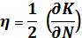 ……………………(3)

In terms of ionization potentials IP and electron affinities EA, the hardness is half of the energy gap between two frontier orbital’s [S. Iyengar,2003].
The soft molecule has a small energy gap. A small energy gap means small excitation energies to the manifold of excited states. Their electron density changes easier than a hard molecule, and due to that, soft molecules will be more reactive than hard molecules.[ J. Shen,2010]
………………..(4)

  - Electrophilicity

Electrophilicity index is a measure of energy lowering due to maximal electron flow between donor and acceptor. Electrophilicity index (ω) is defined as, [J. Shen,2010]
….…………….(5)

Figure (1): stricture for Molecules.

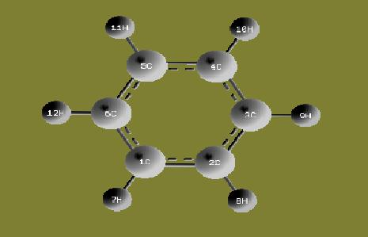
(1) BZ structure
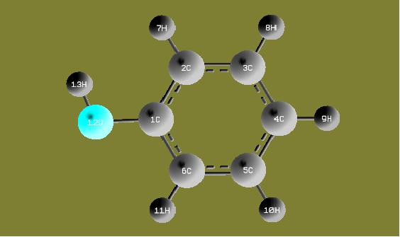
(2) BZ odd OH
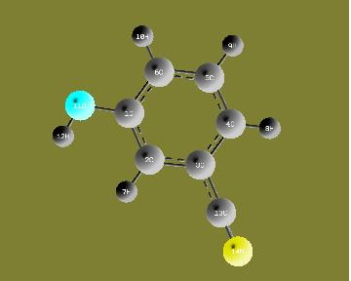
(3) Mono(3)CN- OH BZ
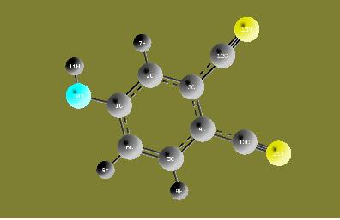
(4) Dia (3,4) CN-OH BZ
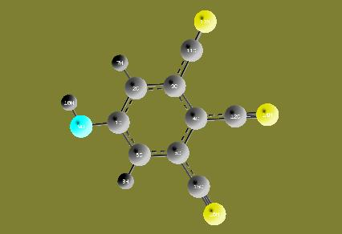
(5) Tri (3,4,5) CN-OH BZ

- Results and Discussion :
In table (1), are displayed the optimized structures of the molecules under study. The optimized structures for the benzene and Phenol molecules have been found in a good agreement with the experimental data, and they have not been found similar studies for other molecules. It is obvious from table (1) that benzene molecule is a plane molecule opposite to other molecules.

Table (1) : Average Bond Lengths in (A˚) , [Robert, 2007- David,(2008)].
Molecule | (Bond ) Label | Current Study B3LYP/6-31G** |  | Exp
BZ | R_{C ̶ C} |  | 1.396 | 1.390
 | R_{C ̶ H} |  | 1.086 | 1.10
Mono OH BZ | R_{C ̶ C} |  | 1.3937 | 1.394
 | R_{C ̶ H} |  | 1.0841 | 1.1202
 | R_{C ̶ O} |  | 1.3679 | 1.1283
 | R_{O ̶ H} |  | 0.9661 | 0.9706
Mono(3)CN OH BZ | R_{C ̶ C} |  | 1.3975 | 1.394
 | R_{C ̶ H} |  | 1.0868 | 1.10
 | R_{C ̶ O} |  | 1.3654 | 1.1283
 | R_{O ̶ H} |  | 0.9638 | 0.9706
 | R_{C ̶ N} |  | 1.1596 | --------
Dia(3,4)CN OH BZ | R_{C ̶ C} |  | 1.3975 | 1.3965
 | R_{C ̶ H} |  | 1.0865 | 1.10
 | R_{C ̶ O} |  | 1.3578 | 1.1283
 | R_{O ̶ H} |  | 0.9644 | 0.9706
 | R_{C ̶ N} |  | 1.1591 | --------
Tri(3,4,5)CN OH BZ
 | R_{C ̶ C}  R_{C ̶ H}  R_{C ̶ O}  R_{O ̶ H}  R_{C ̶ N} |  | 1.3973  1.0868  1.3714  0.9670  1.1585 | 1.396  1.10  1.1283  0.9706  --------

It is clear from table (1) that B3LYP/6-31G** method is an efficient to estimate the optimized structure of benzene molecule, that due to this method characterized by its accuracy to estimate the molecular properties for any compound. The above results show that benzene molecule has a hexagonal structure containing six carbon atoms and six hydrogen atoms conjugated together by covalent bonds in the same plane, and these results agree with the other result in [R. T. Morrison,2007].
Table (2) shows the values of the total energy, symmetry and electronic states for the analyzed structures and the energy gap ( of the studied molecules. The total energy for all study molecules as a linear function of [(OH) & (CN)] radical’s side group number adding to the molecule. The final total energy of the product is the collection of total energy of all small molecules which build the product molecule, that means:
E_{tot} = E_{tot} ( molecules ) + n E_{tot} (radical) ……………. (6)

The decrease of total energy with addition of (OH & CN) radical’s gives molecule becomes more stable with the increase of added CN radicals number .This relation is a linear function, it was found an equation associates the total energy for any benzene molecule and the number of CN radicals:
E_{tot} = E_{tot} (benzene) + n E_{tot} (OH & CN) ….……….. (7)

Where E_{tot} (benzene) = - 232.258 a.u in B3LYP /6-31G** .
It has been found that the forbidden energy gap for these molecule decreases with the addition of (OH & CN) radicals. The result of total energy for benzene in present work is in good agrees with the study [A. M. Ali,2009]. All studied structures here are without imaginary frequencies.

Table (2): Total energy, symmetry, electronic states and energy gap for molecules.
Structure  molecule | Total Energy(a.u) | Symmetry | Electronic States(eV) |  | Energy Gaps (eV)
 |  |  | HOMO | LUMO
1 | -232.258 | D_{6h} | -6.718 | 0.0718 | 6.789
2 | -307.511 | C_{s} | -6.335 | -0.555 | 5.77
3 | -399.762 | C_{s} | -7.033 | -1.85 | 5.183
4 | -492.006 | C_{s} | -7.201 | -2.992 | 4.209
5 | -584.245 | / | -8.005 | -4.113 | 3.892

The figure for the energy gap shows the (LUMO – HOMO) energy gap behavior for the studied molecules group where it is less than that for benzene. The energy gap for benzene from this study is (6.789 e.V) and agrees with the study[K. Sadasivam,2011]. Adding the CN substituent’s to the ring leads to lowering the energy gap, tri (3,4,5)cyano-mono hydroxyl benzene molecule has the lowest value of energy gap (3.892 e.V).
Figure (2): Energies Values Corresponding to Number of Molecules.
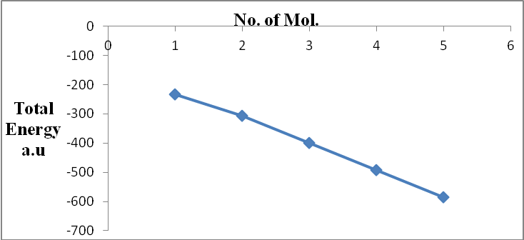
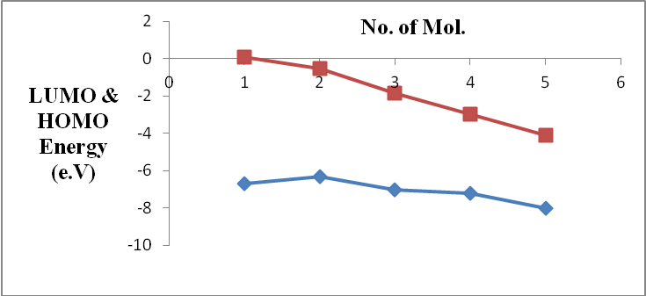

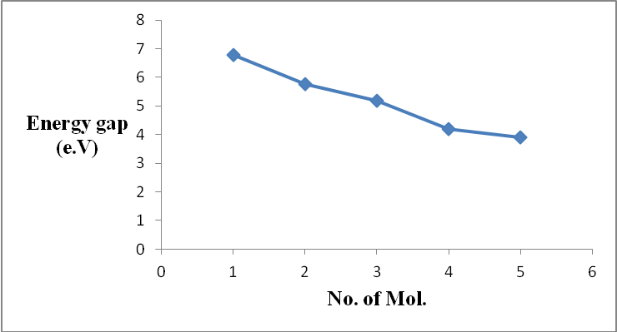

Table (3) lists the calculated ionization potentials (IP) , electron affinities (EA) , chemical potentials (K) , hardness() , softness( S ) and electrophilicities (ω) for the molecules under study .
It is clear from table(3) that the ionization potential for the mono hydroxyl benzene molecule is less than the ionization potential for benzene molecule , this mean that molecule needs to small energy to become cation comparing with other molecules, but at adding the cyano radicals to the mono hydroxyl benzene the results noted the ionization potential for this molecules are more than the ionization potential for benzene molecule this refers to the fact that this molecule needs high energy to become cation comparing with others. The electron affinity for the (mono hydroxyl and cyano mono hydroxyl) benzene molecules group are more than the electron affinity for benzene molecule, these values mean that this molecules need to large energy to become anion comparing with other molecules . It is obvious from this table that the molecules have a chemical potential large than that for benzene molecule. It is note that the values of hardness for the molecules decreases with the increase of (hydroxyl and cyano) radicals, but the softness of the molecules has a reverse behavior versus the effect of (hydroxyl and cyano) radical, it is clear that the softness was increased from (0.152 e.V) for benzene to (0.26 e.V) for Tri-cyano-OH benzene molecule. This increasing of softness is the main future as a sign for that band gap goes to be rather soft. This behavior gives these molecules more electrophilicity than benzene, Tri-cyano- OH benzene has (ω=9.41 e.V) , while benzene has (ω=1.62 e.V). The electrophilicity for these molecules are more than for benzene molecule.
Table (3) : Computed Energies for Molecules under Study.
Molecule | IP in e.V | EA in e.V | K in e.V | in e.V | e.V ω in e.V
1 | 6.718 | - 0.072 | 3.323 | 3.4 | 0.15 1.62
2 | 6.335 | 0.555 | 3.445 | 2.89 | 0.17 2.05
3 | 7.033 | 1.85 | 4.441 | 2.59 | 0.19 3.81
4 | 7.201 | 2.992 | 5.096 | 2.10 | 0.23 6.18
5 | 8.005 | 4.113 | 6.059 | 1.95 | 0.26 9.41

4. IR Spectrum
Figure (3) show the vibration frequencies calculated of benzene molecule using B3LYP/6-31G** method appear peaks at( 691 , 1066.3 , 1528.28 and 3202.34) cm⁻¹. These results have been found in good agreement with experimental data[ Hai-Bo Yi 2009] , where the peaks had been observed at (673 , 1038 , 1469 , and 3210) cm⁻¹ .The strong peak computed by B3LYP/6-31G** observed at 691 cm⁻¹ and weak peak at 1066 cm⁻¹ are due to the bending of (C-H ) bond , the peak observed at 1528 cm⁻¹ is due to the stretching of (C-C) bond , the peak at 3202 cm⁻¹ is due to the stretching of (C-H) bond.
It is clear from figure (3) that the IR spectrum for hydroxyl benzene group molecules characters from that of benzene molecule by multiply the vibration mode due to existing of (O-H) bonds and (C-O) bonds , the stretching and bending of these bonds caused to new peaks or band of peaks to be appeared , the stretching (C-O) bond has been observed at (1200-1700) cm⁻¹ , and the stretching (O-H) bond has been observed at (3200–3600) cm⁻¹ , while the bending of (O-H) bond appeared at (1550–1650) cm⁻¹ .There are two types for stretching vibration symmetric and asymmetric , the symmetric stretching is happened when the bonds of the same atoms vibrate in the same phase , and the asymmetric stretching is happened when the bonds vibrate in different phases .
From comparing the IR spectrum of mono-cyano OH benzene molecule with that of Benzene, it is noted that the differences between them due to the addition of CN group, where the vibrational modes have been increased with increasing of bonds, and the peaks have been increased. In general, the IR spectra of cyano-OH benzene molecules group character from that of benzene by multiply the vibration mode due to existing of (C-C) stretching. This work supplied new data about the vibration frequencies of cyano – OH benzene molecules group.
For mono-cyano-OH benzene, the peak observed at (1643.02) cm⁻¹ is due to the stretching of (C-C) bond and the peak at (3168.29) cm⁻¹ is due to the stretching of (C-H) bond, the bending of (C-H) bond appeared in the range of frequencies (706.48-922.19) cm⁻¹ and the stretching of (C-N) appeared at the peak (3804.84) cm⁻¹.
For di-cyano- OH benzene, the peak observed at (3798.44) cm⁻¹ is due to the stretching of (C-N) bonds, the peak at (1640.76) cm⁻¹ is due to the stretching of (C-C) bond, the peak observed at (3202.25) cm⁻¹ is due to the stretching of (C-H) bond and the peak at (995.77) cm⁻¹ is due to the bending of (C-H) bond.
For tri-cyano-OH benzene, the peak observed at (2341.33) cm⁻¹ is due to the stretching of (C-N) bonds, the peak at (1634.74) cm⁻¹ is due to the stretching of (C-C) bond, the peak observed at (3796.55) cm⁻¹ is due to the stretching of (C-H) bond and the peak at (828.22) cm⁻¹ is due to the bending of (C-H) bond.

Figure (3) show the vibration frequencies for the molecules studied.
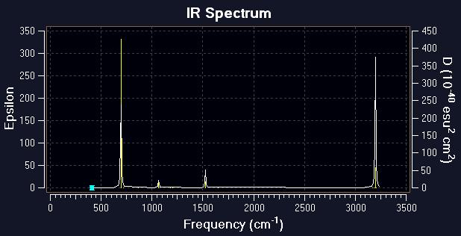
BZ

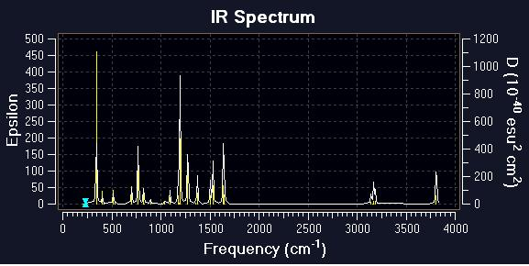
BZ odd OH

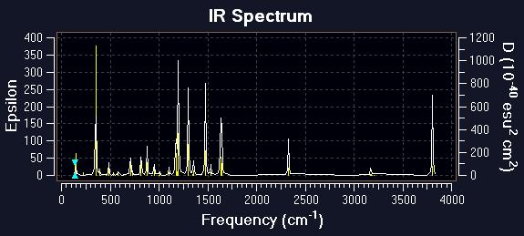
Mono (3) CN OH BZ

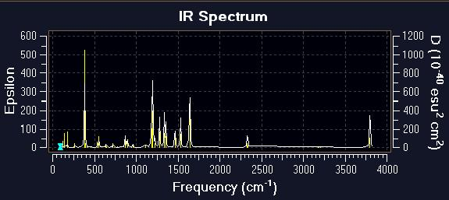
Dia(3,4)CN OH BZ

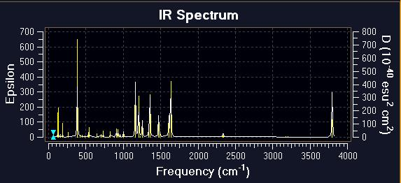
Tri(3,4,5) CN OH BZ

5. Conclusion
Density functional method used in this study , is presented powerful method for studying the physical properties and electronic structure of aromatic molecules , and B3LYP functional level is an efficient of theory for studying these molecules , They have been found that :

The geometry optimization for benzene and phenol have been found in a good agreement with experimental data , while for other studied molecules it has not been found a reference data , so the current work supplies new data for these molecules .
The energies calculated by the (B3LYP/6-31G**) method has been found in good agreement with the previous study (B3LYP/3-21G**) , the comparison has been applied only on benzene molecule , but for other molecules they have not been found a similar studies , thus this study also supplies new data in this aspect .
The energies calculated have been found in a good agreement with the previous studies. The comparison has been applied only to benzene and hydroxal benzene molecules group, but similar studies have not been found for cyano-OH benzene groups. Thus, this study also supplies a new data in this aspect. For all groups, the total energy for a product molecule is a linear function to the substituent's (radical) number, it is decreasing with the increase of substituent’s number, but it is not dependent on the position of the instituents in the ring. The chemical hardness and electronic chemical potential for cyano-OH benzene molecules is lowering values as compared with benzene. The hardness, softness and electrophilicity for the new molecules group are large values as comparing with the original molecules. These new molecules are soft with small energy gaps. Therefore, their electron density changed more easily than the original molecule, these new molecules are more reactive according to their large electrophilicity.
The energy gap , HOMO , and LUMO for benzene molecule using B3LYP/6-31G** have been found in good agreement with previous study B3LYP/3-21G** , with respect to the addition of (OH & CN) radicals on benzene molecule has showed a significant effect on the energy gap. The result of HOMO, LUMO and energy gap for benzene in present method has been found in a good agreement with the previous studies. Adding the substituent’s group to the original molecule showed an effect on the calculation of two states (HOMO, LUMO). The presence of the substituent’s decreases the forbidden energy gap of the studied molecules, this is one of the important results in this study. a small energy gap mean small excitation energies of manifold of excited states. This global property is a field of farther studies and researches.
The molecular electronic states HOMO and LUMO have indirect relation to the effects of correlation radicals – ring through the calculations of hardness and chemical potential. One of the important results obtained in this study is the decreasing of the forbidden energy gap for all molecules.
In IR spectra calculations, it has been used B3LYP/6-31G** method, and it gives a large approach observed peaks computed experimentally benzene and hydroxyl. And for other molecules this study supplies new data for IR spectrum . Adding the radicals lead to increasing the vibration modes and highest stretching vibration wave numbers and this gave suitable positions for OH with carbon atoms in benzene ring .
References :
A. Cox., (1995) “Introduction to Quantum Theory and Atomic Structure”, Lecture in Organic Chemistry, University of Oxford.
A. M. Ali,( 2009) "Investigations Of Some Antioxidant Materials By Using Density Functional And Semiempirical Theories", P.hD. Thesis, University of Basrah, College of Science, Department of Physics.
A. T. Balaban, P. v. R. Schleyer and H. S. Rzepa, ( 2005) "Crocker, Not Armit and Robinson, Begat the Six Aromatic Electrons", Chemical Reviews, Vol.105, P.3436-3447.
A.M. Ali, (2009) " Theoretical Study of Nitrides Molecules : Investigation of DNA Using Density Function Theory ", Ph.D Thesis, Basrah University .
B. Debashis, (2012) “Chemisorptions Effect of Oxygen on the Geometries, Electronic and Magnetic Properties of Small Size Nin (n =1-6) Lusters”, J. Mol. Model., Vol. 18, PP. 737–749.
Bhupinder Mehta , Manju Mehta ; (2009) “ Organic Chemistry ”,university of Delhi.
C. Hattig, (2009) “Electronic Structure: Hartree-Fock and Correlation Methods”, J. Grotendorst, Vol. 42, PP. 77-120.
David Quinonero , Antonio Frontera , Pere M.Deya , Ibon Alkorta , Jose Elguero , (2008), Chemical Physics Letters , Vol.460 , P.406-410.
H. B. Hassan Al-Geaafry, (2011) “A Study of the Electronic Structure of Ermanabenzene Molecules”, University of Babylon, College of Science, M.Sc. Thesis.
Hai-Bo Yi , Han Myoung Lee , Kwang S.Kim, ,( 2009) “ Interaction of Benzene with Transition Metal Cations : Theoretical Study of Structures , Energies and IR Spectra ” , Journal of Chemical Theory and Computation , Vol.5 , P.1709-1717.
Ira N.Levine ;(2009) “ Quantum Chemistry ” , 6th Edition , Chemistry Department , Brooklyn College , City University of New York .
J. Beckmann and K. Jurkschat, (2001) “Stannasiloxanes: From Rings to Polymers”, University of Dortmund, J. Coordination Chemistry Reviews, Vol. 215, PP. 267-300.
J. Shen, (2010) “Quantum Chemistry: Slater Determinant”, http://ccb.ou.edu/teaching.aspx.
J.Hutter , (2005) “ Lecture notes in computational chemistry; electronic structure theory” , Physical chemistry Institute , University of Zurich 190, 8057.
K. Sadasivam and R. kumaresan ,( 2011)"computational and theoretical chemistry", 963,227-235.
Katherine J.Denniston , Joseph J.Topping ,Timothy M.Dwyer ; (2007),“ General Organic and Biochemistry ” , 5th Edition , Towson University .
M.P. Evstigneev , D.B. Davies , (2006) [ Chemical Physics Letters ], Vol.432 , P.248-251.
P. v. R. Schleyer,(2001)"Aromaticity (Editorial)", Chemical Reviews, Vol.101, P.1115-1118.
P. V. R. Schleyer,(2005), "Introduction: Delocalization-π and σ (Editorial)", Chemical Reviews, Vol.105,P. 3433-3435.
Peter R.S.Murray, (2005) “ Principles of Organic Chemistry “ , 2nd Edition , Oxford .
PP. Udhayakala and T. V. Rajendiran, , (2012) “Computational Investigations on the Corrosion Inhibition Efficiency of Some Pyridine Based Alkaloids”, J. of Chemistry, Biology and Physics Sciences, Vol. 2, PP. 172-183.
R. F. Daley and S. J. Daley, (2003) “Organic Chemistry”, www.ochem4free.com.
R. T. Morrison, R. N. Boyd, (2007) "Organic Chemistry", 6th Edition, New York University.
R. Wysokin, J. K. Jaworska and D. Michalska, (2006) “Electronic Structure, Raman and Infrared Spectra and Vibrational Assignment of Carboplatin: Density functional theory studies”, J. Molecular Structure, Vol. 758, PP. 169-179.
Robert Thornton Morrison , Robert Neilson Boyd, , (2007) “ Organic Chemistry ” , 6th Edition ,New York University , USA.
S. Hayshi, (2008) “Theoretical Study of Electronic Structure and Spectroscopy of Molecules Containing Metallic Atoms”, Ph.D. Thesis, University of Paris-Est.
S. Iyengar, (2003) “Atomic and Molecular Quantum Theory”, Indiana University, Chemistry Department.

