Strengthening of Full Scale RC One-Way Slab With Cutouts
Majid Mohammed Ali Kadhim
Babylon university, Engineering College , Architectural Department
Abstract:
In this study the nonlinear finite element method used to analysis full-scale reinforced concrete slab with opening strengthening with overlay concrete or CFRP sheets. The FE model proposal in this study are simulate by using results of experimental work from previous study. The strengthening models proposal in this study by using overlay concrete increase load carrying capacity of slab by amount vary from (5 to 30) % of slab strength, when strengthening by using CFRP sheet increase load carrying capacity from (10 to 65)% of slab strength.
Keywords: FE, RC slab, cutouts, CFRP sheet
الخلاصة
في هذه الدراسة تم استخدام التحليل اللاخطي باستخدام طريقة العناصر المحددة لتحليل سقف خرساني مسلح (بمقاس كبير) وبوجود الفتحات ، تمت التقوية باستخدام طبقة من الخرسانة مرة واخرى بأستخدام الياف CFRP . ان النموذج المقترح في هذه الدراسة باستخدام طريقة العناصر المحددة تم مقارنته مع دراسة عملية من ضمن دراسات سابقة. ان نموذج التقوية المقترح في هذه الدراسة باستخدام طبقة من الخرسانة زاد من تحمل السقف بنسبة تتراوح بين (5 الى 30) % من مقاومة السقف ، بينما التقوية باستخدام الياف CFRP تزيد من تحمل السقف بنسبة تتراوح بين (10الى 65) % من مقاومة السقف.
1. Introduction
Floor and wall structures are some of the most commonly existing structural elements in buildings. Nowadays, rebuilding of existing structures has becoming quite common due to structural and/or functional requirements from the users. The functional requirements entail often that staircases, elevators, escalators, windows, doors and even electrical, heating or ventilation systems, have to be installed. Thus, there exists a great need to introduce sectional openings in floor as well as in wall structures. The structural effect of small openings is often not considered due to the ability of the structure to redistribute stresses. However, for larger openings the static system may be altered when considerable amounts of concrete and reinforcing steel have to be removed. This leads to a decreased ability of the structure to resist the imposed loads and the structure needs therefore to be strengthened.
Many researchers have been study the reinforced concrete two-way solid and rib slab using strengthening with overlay technique [Al-Kubaisy and Zamin 2000, and Yardim et.al. 2008].
Tan and Zhao [Tan and Zhao,2004] reported tests on line loaded one-way spanning simply-supported slabs with cutouts of different sizes and locations and different FRP strengthening arrangements . Casadei et al. [Casadei et al 2003] reported tests on the strengthening of three continuous one-way slabs with cutouts in the positive moment region and a further three slabs with cutouts in the negative moment region adjacent to the continuous support. Slab cutouts in the positive moment region failed in flexure by concrete crushing followed by IC debonding initiating where the FRP intersected diagonal cracking originating from the nearer cutout corner. Slabs ,where cutouts in the negative moment region were made and strengthened with FRP, failed in shear.
Comprehensive investigations on CFRP strengthened slabs with cutouts have been reported by [Vasquez and Karbhari, 2003], and [Casadei et al., 2003]. Vasquez and Karbhari [Vasquez and Karbhari, 2003] tested point loaded one-way simply-supported slabs with central cutouts. The variation of load application position resulted in different bending behavior of the slabs. The FRP-strengthened slabs failed by debonding of the FRP from the concrete substrate with debonding reported to initiate at cracks that propagated from the corners of the cutouts due to stress concentrations that intersected the FRP well away from the plate end. This mode of debonding is known as intermediate crack (IC) induced interfacial debonding or simply IC debonding [Teng et al., 2003] [Teng et al., 2002],and [ Oehlers DJ, Seracino ,2004]. Vasquez and Karbhari [Vasquez and Karbhari, 2003] also reported the results of a linear elastic finite element analysis which revealed stress concentrations at the corners of the cutout zones, as intuitively expected. Their analysis was confined to the service load level of response of the slab. Smith and Kim [Smith and Kim, 2009 ] tested 6 slabs under different load but same strengthening case.
Research on the strengthening of simply-supported one-way spanning[ Arduini et.al. 2004], simply-supported two-way spanning [ Ebead and Marzouk, 2004 ] and one-way spanning cantilever slabs [ Lam and Teng, 2001] with FRP composites has been conducted to date and published in the open literature. Less research by comparison has been published, and consequently less understanding has been gained, on the strengthening of one- and two-way spanning RC slabs with cutouts using FRP composites.
This paper presents behavior of full scale one-way reinforced concrete slab with cutout and ways of strengthening by using overlay concrete and CFRP sheet. The nonlinear finite element analysis use to model different CFRP strengthening arrangement of one-way slab by using ANSYS V12.1 program.
2. Numerical work
2.1. Finite element model
In the present study general purpose finite element program (ANSYS V12.1) was used to model the slab. Three elements type was used to built the 3-dimensional model, as listed below
2.1.1.Brick element (SOLID65 as denoted in ANSYS [ANSYS, 2009]):
This element is used to model the concrete in 3D and reinforced concrete. The element has eight nodes three degree of freedom per node translation in x, y, and z directions. Element with the addition of special cracking and crushing capabilities. The most important aspect of this element is the treatment of nonlinear material properties. The concrete is capable of cracking (in three orthogonal directions), crushing, plastic deformation, and creep. The rebar are capable of tension and compression, but not shear. They are also capable of plastic deformation and creep [ANSYS, 2009]. The geometry, node locations, and the coordinate system for this element are shown in Fig. 1.
1
2
3
4
5
6
X
Y
Z
I
J
K
L
M
N
O
P

Fig.1 SOLID65 geometry [ANSYS, 2009]

2.1.2. Shell Element (SHELL41 as denoted in ANSYS[ANSYS, 2009]):
The element is defined by four nodes, four thicknesses, a material direction angle and the orthotropic material properties. Orthotropic material directions correspond to the element coordinate directions. The element have membrane stiffness (no bending stiffness) so the element is used to model the CFRP laminate. The element may have variable thickness. The thickness is assumed to vary smoothly over the area of the element, with the thickness input at the four nodes. If the element has a constant thickness, only one thickness (in any node) need be input. If the thickness is not constant, all four thicknesses must be input (for four nodes). The geometry, nodes location, and coordinate of the element are shown in Fig. 2. This element used to model the CFRP sheets .
I
J

1
2
3
4
5
6
X
Y
Z
K
L
I
J

1
2
3
4
5
6
X
Y
Z
K
L

Fig.2 SHELL41 geometry [ANSYS, 2009]

2.1.3.Link element (LINK8 as denoted in ANSYS [ANSYS, 2009])
This element can be used to model trusses, sagging cables, links, springs, etc. The 3-D spar element is a uniaxial tension-compression element with three degrees of freedom at each node: translations in the nodal x, y, and z directions. As in a pin-jointed structure, no bending of the element is considered. Plasticity, creep, swelling, stress stiffening, and large deflection capabilities are included [ANSYS, 2009]. The element is defined by two nodes, cross section area, initial stress, and the material properties, the element geometry, node locations, and the coordinate system for this element is shown in Fig. 3. The element used in this study to represent reinforcement in both directions of slab with same nodes of concrete element (SOLID65).
X
Y
Z
x

Fig.3 LINK8 geometry [ANSYS, 2009]

2.2 Materials
2.2.1. Concrete
The concrete in this study is modeled as nonlinear stress-strain relationship. The nonlinear stress-strain relationship is obtained by tested five specimens as shown in Fig. 4, the average curve shown was used to model concrete in FE analysis.

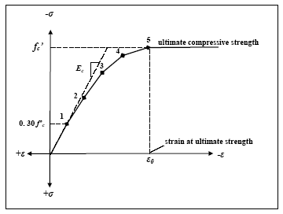
Fig.4 Simplified compressive uniaxial stress-strain curve for concrete [ANSYS, 2009]
In a concrete element (SOLID65) , cracking occurs when principle tensile stress lies outside of the failure surface, see Fig. 5, when cracking occurs the elastic modulus of the concrete element is set to zero in the direction parallel to the principle tensile stress direction. Crushing occurs when the principle compressive stress lies outside of the failure surface, after element crashing the elastic modulus of concrete element is set to zero in all directions.
During this study, it was found that if the crushing option is turned on, the concrete elements lies under the load was crashed after several sub steps of load and the local stiffness of member is reduced, so the crushing capability is turned off.
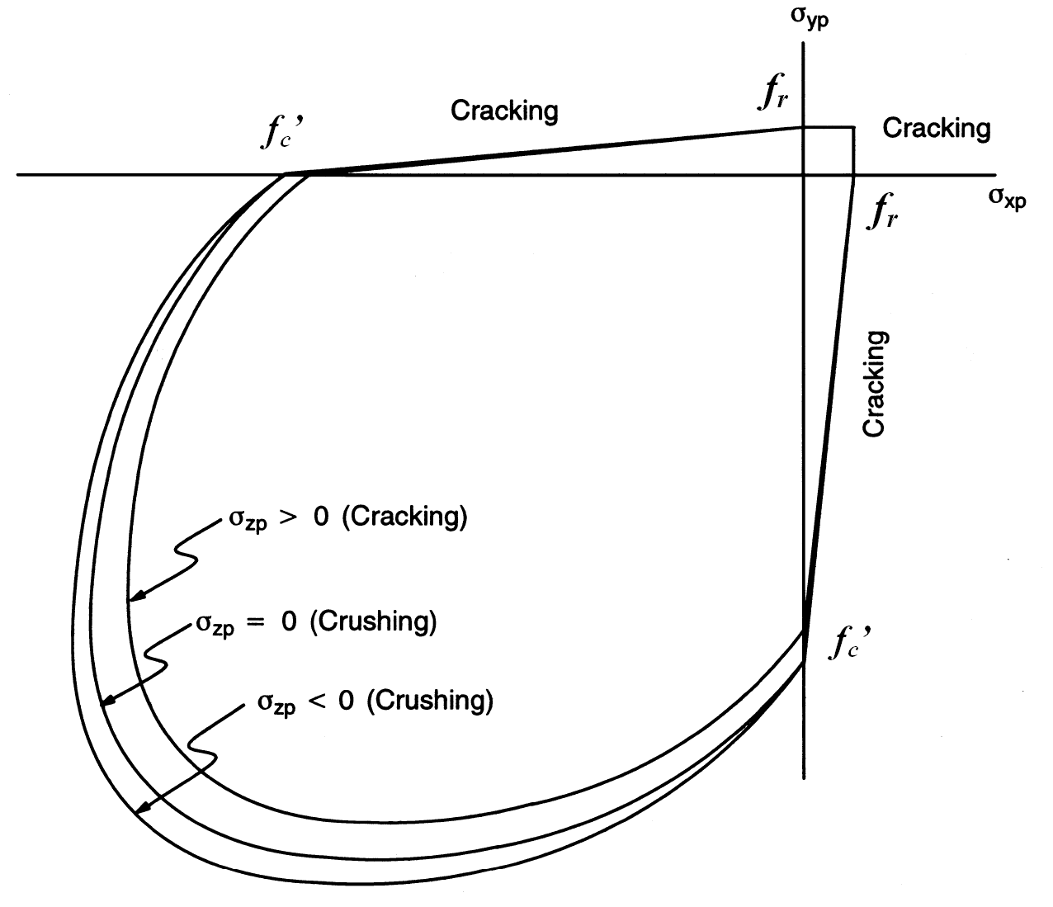

Fig.5: 3D-failure surface for concrete [ANSYS, 2009]

2.2.2. Carbon fiber reinforced polymer (CFRP)
The CFRP composites being modeled here were adhesively bonded to the concrete. The CFRP strips used in tests were 0.176 mm thick. The CFRP material have tensile strength more than 4300MPa and modulus of elasticity =230 GPa as previously determined from tests and reported by [Hadi ,2010].
3.Model Simulation
The proposal nonlinear FE model built by ANSYS program used to model (9) RC slabs tested by [Hadi ,2010]. All slabs (1.2* .0.25)m and depth 0.1m with two ends simply supported as shown in Fig.6. The first slab leave without strengthening and others have strengthening use overlay concrete and CFRP sheet as listed in the table below:
1200 mm
250 mm

Fig.6 Slab details
Table 1: slabs details
Slab No. | Bare slab compressive strength MPa(f'c) | Overlay compressive strength MPa(f'c)
Control | 28.2 | ----
P-QM-25-C25-0 | 27.4 | 28.6
P-QM-50-C25-0
P-QM-25-C40-0 | 28.1 | 41.4
P-QM-50-C40-0
P-QM-25-C70-0 | 28.6 | 75.2
P-QM-50-C70-0
P-QM-25-C25-1 | 26.7 | 30.6
P-QM-25-C25-2 | 26.6 | 31.1

Where :
- P: Positive moment (i.e. placing strengthening in compression zone)
- QM: Quickmask (bonding material between concrete and overlay concrete)
- Thickness of concrete overlay , 25: thickness of overlay concrete =25 mm
50: thickness of overlay concrete =50 mm
- Nominal of compressive strength of concrete overlay
C25 : 25 MPa, C40: 40 MPa, C75: 75 MPa
- Number of CFRP sheets
0: no CFRP sheet , 1: one sheet , and 2: two sheets.
The results of analysis show good agreement between experimental test and FE analysis when compared load deflection curve and failure load of slabs as shown in Fig.s 7-14 .
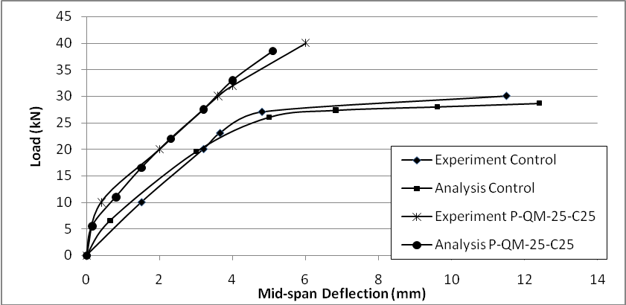
Fig.7 load deflection curve of slabs (Control , and P-QM- 25-C25)
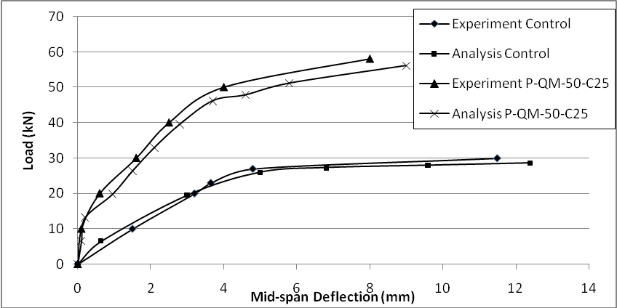
Fig.8 load deflection curve of slabs (Control , and P-QM- 50-C25)
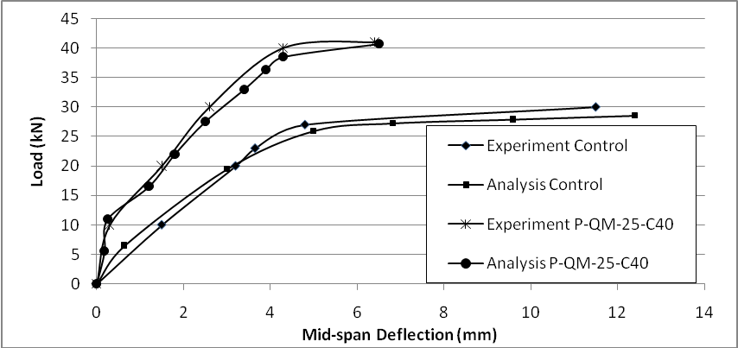
Fig.9 load deflection curve of slabs (Control , and P-QM- 25-C40)
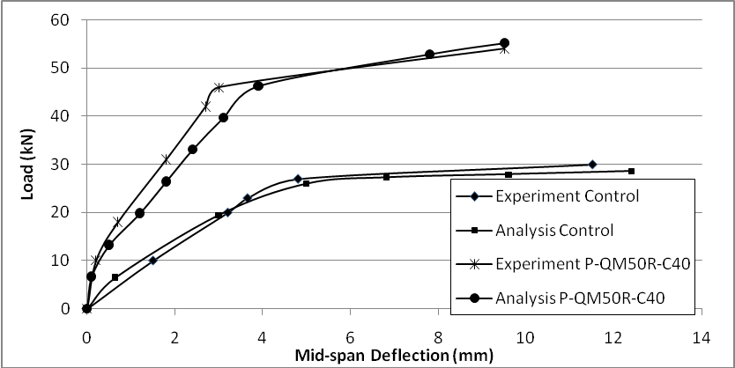
Analysis P-QM-50-C40
Experiment P-QM-50-C40
Fig.10 load deflection curve of slabs (Control , and P-QM- 50-C40)
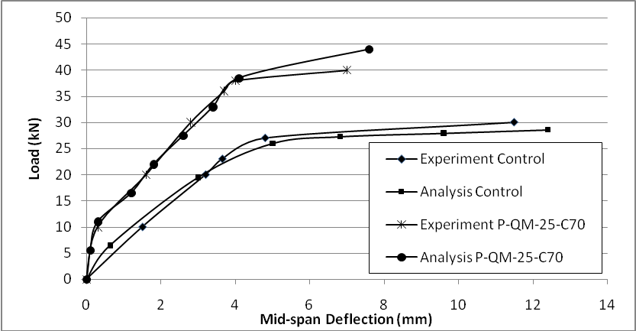
Fig.11 load deflection curve of slabs (Control , and P-QM- 25-C70)
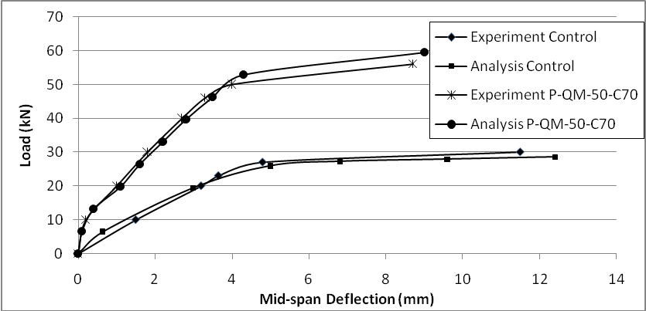
Fig.12 load deflection curve of slabs (Control , and P-QM- 50-C70)
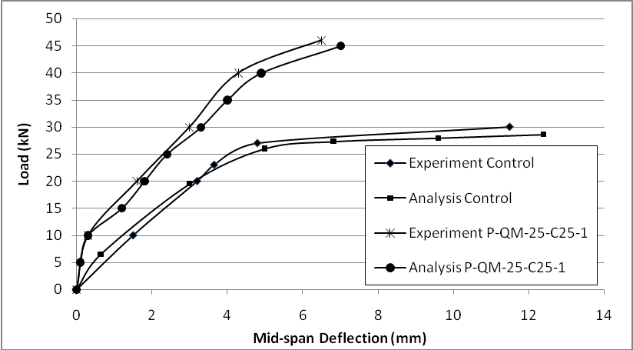
Fig.13 load deflection curve of slabs (Control , and P-QM- 25-C25-1)
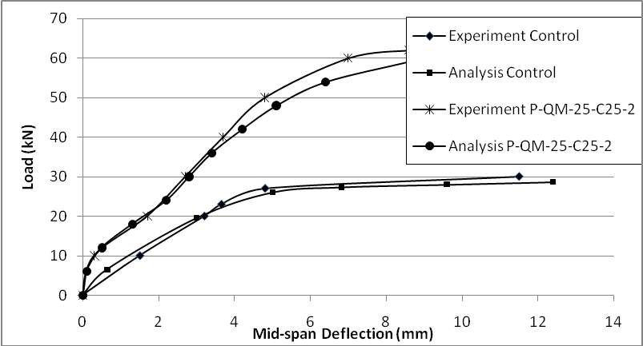
Fig.14 load deflection curve of slabs (Control , and P-QM- 25-C25-2)

4. Results
Eleven full-scale one-way RC slab with (3.6*2.4 m ) and thickness (0.15 m) supported from two edges as simply support and loaded by concentrated force on two lines at distance 0.9m from left and right support of the slab. The reinforced slab cutout from the center (1.2*0.8 m) and strengthening by different shapes of CFRP sheet and overlay concrete as shown in Fig.15.
Two values of concrete strengthening used in this study (40 and 70) MPa, also two thicknesses are suggested as in previous study [Hadi, 2010] as listed in table 2.
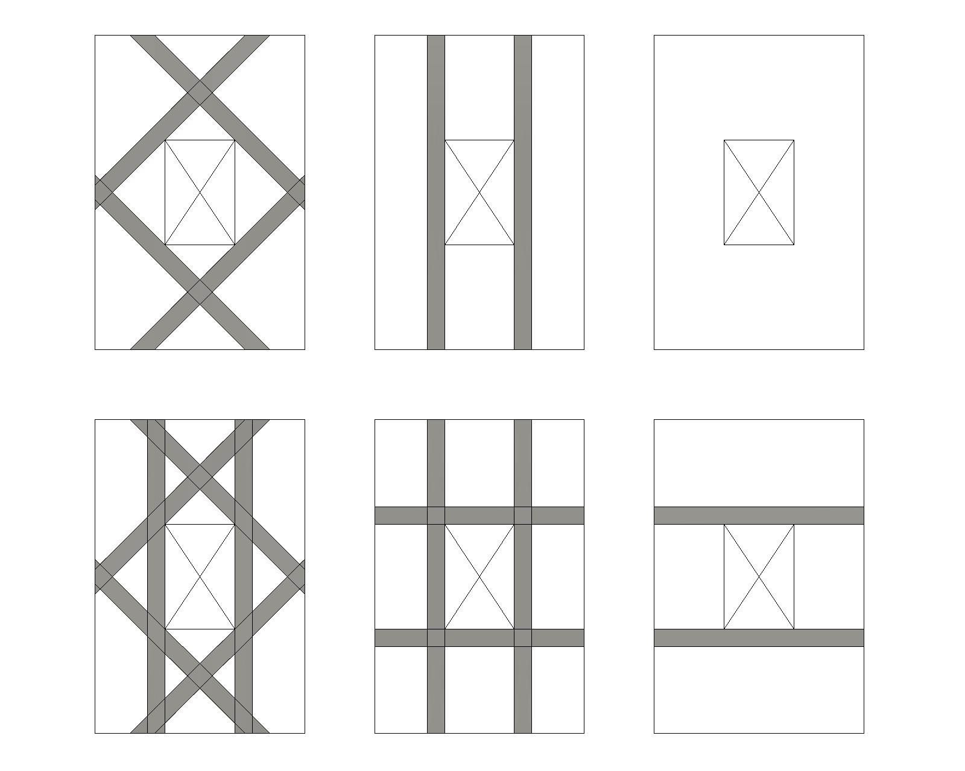
Strength5
Strength4
Strength3
Strength2
Strength1
F- slab with open

Fig.15. show strengthening scheme by CFRP sheets
Table 2. show the properties of slab and overlay concrete for strengthening slabs
Slab No. | Bare slab compressive strength MPa(f'c) | Overlay compressive strength MPa(f'c) | Thickness of overlay concrete (mm)
Control (Slab without open) | 25 | ---- | ----
Slab with open | 25 | ---- | ----
F-P-QM-25-C40 | 25 | 40 | 25
F-P-QM-25-C70 | 25 | 70 | 25
F-P-QM-50-C40 | 25 | 40 | 50
F-P-QM-50-C70 | 25 | 70 | 50
Where :
- F: Full scale
- P: Positive moment (i.e. placing strengthening in compression zone)
- QM: Quickmask (bonding material between concrete and overlay concrete)
- Thickness of concrete overlay , 25: thickness of overlay concrete =25 mm
50: thickness of overlay concrete =50 mm
- Nominal of compressive strength of concrete overlay
C25 : 25 MPa, C40: 40 MPa, C75: 75 MPa

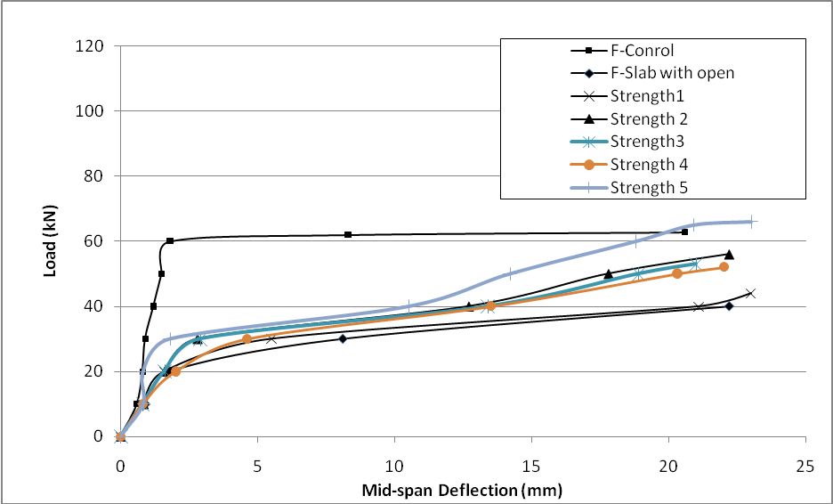
Fig.16 load deflection curve of full scale slabs strengthening with CFRP sheets.

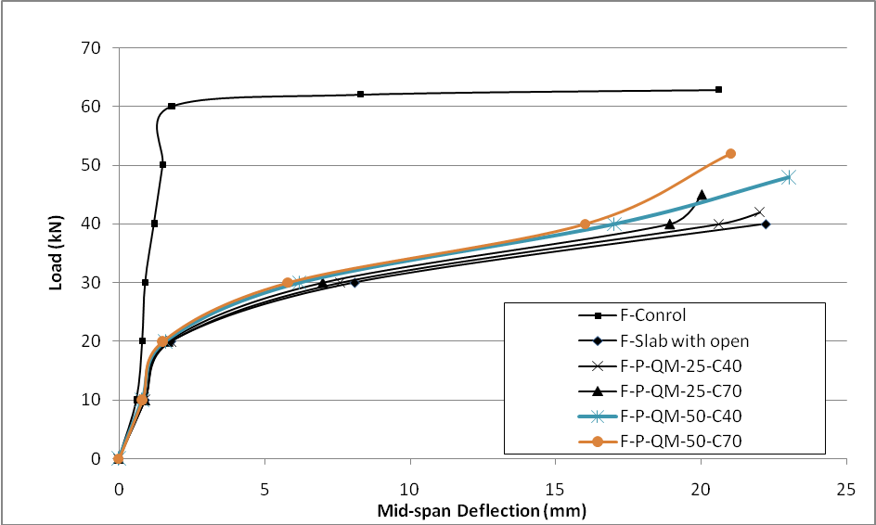
Fig.17 load deflection curve of full scale slabs strengthening with overlay concrete.
The results of analysis slabs show that the strengthening with overlay concrete increase load carrying capacity of slab by amount vary from (5 to 30)% of slab strength and that less efficiency from use the CFRP sheets in strengthening because the strengthening by use CFRP sheets may reached 65% of slab strength (as in (strength5) model suggested in this study (width of layer 20 cm)) and more reason that use CFRP sheet is less cost if compared with use concrete overlay and has less maintenance time .

5. Conclusion
The FE analysis give good agreement with the experimental work and can be regarded as a very powerful and useful tool for analyzing and modeling RC slab strengthening with CFRP sheet or overlay concrete . The following conclusions can be put forward, based on the results of the present study.
- The behavior of full-scale RC slab is same for the lab-scale RC slab under same conditions
- CFRP sheet strengthening increase load carrying capacity of the slab with cutout with different value depending on the arrangement of CFRP sheet and varying from 10 to 65 %.
- The analysis of full-scale slab show that the strengthening by used CFRP sheet more efficiency from used overlay concrete.

References
Ahmed Hassan Hadi. "Strengthening RC One Way Slabs by Overlay Technique and Using CFRP Sheet" M.Sc. thesis , Babylon university. 2010.
Al-Kubaisy MA, and Jumaat Mohad Zamin, " Flexural Behavior of Reinforced Concrete Slabs with Ferrocement Tension Zone Cover", Constr. Building Mater; (2000) 14:245-52.
ANSYS, “ANSYS Help”, Release 12.1 , Copyright 2009
Arduini M, Nanni A, and Romagnolo M. Performance of One-Way Reinforced Concrete Slabs with Externally Bonded Fiber-Reinforced Polymer Strengthening. ACI Struct J 2004;101(2):193–201.
Casadei P, Ibell TJ, Nanni A. Experimental Results of One-Way Slabs With Openings Strengthened with CFRP Laminates. In: Proceedings, Fibre-reinforced polymer reinforcement for concrete structures, FRPRCS – 6, 8–10 July, Singapore, 2003; p. 1097–106.
Ebead U, and Marzouk H. Fiber-Reinforced Polymer Strengthening of Two-Way Slabs. ACI Struct J 2004;101(5):650–9.
Lam L, Teng JG. Strength of RC Cantilever Slabs Bonded with GFRP Strips. J Compos Constr, ASCE 2001;5(4):221–7.
Oehlers DJ, Seracino R. Design of FRP and Steel Plates RC Structures: Retrofitting Beams and Slabs for Strength, Stiffness and Ductility. UK: Elsevier; 2004.
Smith S.T., Kim S.J. Strengthening of One-Way Spanning RC Slabs with Cutouts Using FRP Composites. Constr Build Mater 2009 ; 23: 1578-90
Tan KH, and Zhao HD. , "Strengthening of Openings in One-Way Reinforced Concrete Slabs Using Carbon Fiber-Reinforced Polymer Systems". J Compos Constr, ASCE 2004;8(5):393–402.
Teng JG, Chen JF, Smith ST, Lam L. FRP-Strengthened RC Structures. Chichester, West Sussex, UK: John Wiley & Sons; 2002.
Teng JG, Smith ST, Yao J, Chen JF. Intermediate Crack Induced Debonding in RC Beams and Slabs. Constr Build Mater 2003;17(6–7):447–62.
Vasquez A, Karbhari VM. Fiber-Reinforced Polymer Composite Strengthening of Concrete Slabs with Cutouts. ACI Struct J 2003;100(5):665–73.
Yardim, W. Thanoon, M.S. Jafaar, J. Noorzaei, Shabili R. M. Khan and Kamal N.M, , "Performance Precast Ferrocement Panel for Composite Masonry Slab System" ICCBT-B-(2008) , (36)-pp397- 408

