Study of Mixed Convection In Square Lid-Driven
With Eccentric Circular Body

Najlaa Ali Hussein

College of Engineering-Mechanical Engineering Department
Babylon University

Abstract
In this study, a numerical simulation using a finite element scheme is carried out for a laminar steady mixed convection problem in a two – dimensional square cavity of length (L), containing eccentric adiabatic circular body of radius (r=0.2 L). The vertical walls of the cavity are differentially heated where the right wall is subjected to an isothermal temperature higher than that the opposite left lid. Both the top and the bottom wall of the cavity are adiabatic. Four different cases have been studied based on the location of the circular body. Cases I, II, III and IV refer to the circular is located near the top, right, bottom and left walls of the cavity respectively. Results are presented for upward (+y) and downward (-y) directions of the left lid in vertical axis and for different values of Richardson numbers (Ri=0.1, 1 and 10). The cavity under study is filled with air with Prandtle number is taken as 0.71. Fluid flow and thermal fields and the local Nusselt number are presented for all four case studies. The results shows that the behavior of temperature contours, streamlines and velocity profile is sensitive to the location of the circular body and to the direction of lid and this results explain also, that the maximum values of local Nusselt number occurs when the left lid moving downward (-y) refers to higher heat transfer.
Keywords: Mixed Flow, Combined Convection, Lid-driven Cavity.

الخلاصة
في هذا البحث، تم استخدام الحل العددي بواسطة طريقة العناصر المحددة لدراسة الحمل المختلط المستقر الطباقي ثنائي الأبعاد داخل حيز مربع طوله يساوي(L) يحتوي على جسم دائري غير متمركز ومعزول حراريا نصف القطر له يساوي (0.2 L). الجدران العمودية للحيز مسخنه جزئيا حيث أن درجة حرارة الجدار الأيمن أعلى من الجدار الأيسر المتحرك. اما كل من الجدار العلوي والسفلي للحيز فيكون معزول حراريا. حيث تمت دراسة أربعة حالات مختلفة اعتمادا على موقع الجسم الدائري داخل الحيز وهي الحالة ,I ,II III و IV مشيرا إلى ان موقع الجسم الدائري يكون قرب الجدار العلوي, الأيمن, السفلى والأيسر على التوالي.
تم عرض النتائج لحالتين من حركة الجدار الأيسر عمودياً وهي عندما يتحرك الجدار للأعلى (+y) و عندما يتحرك الجدار للأسفل (-y) وعند قيم مختلفة لرقم (Richardson)وهي (Ri=0.1, 1 and 10). في هذا البحث يكون الحيز مملوء بالهواء قيمة برانتل له يساوي (0.71). كل من جريان المائع وانتقال الحرارة ورقم نسلت المحلي تم تقديمه لكل حالات الدراسة الأربعة. لقد بينت النتائج أن تصرف مخططات درجات الحرارة وخطوط الجريان وسرعة المائع يتأثر بموقع الجسم الدائري ويعتمد على اتجاه الجدار المتحرك سواء كان للأعلى أو للأسفل وقد برهنت النتائج أيضا أن أعلى قيمة لرقم نسلت المحلي تحدث عندما يتحرك الجدار الأيسر للأسفل مما يعني أعلى توزيع لانتقال الحرارة.
1- Introduction

The fundamental problem of combined forced convection and natural convection heat transfer commonly referred to as ( mixed - convection flows) in a closed cavity with lid-driven flows has received an important attention from researchers mentioned below. This type of flow can be found in many academic researches and a wide application area in engineering and science. Some of these applications include cooling of electronic devices, furnaces, oil extraction, glass production, coating and drying technologies, design of heat exchangers, building applications, solar collectors and thermo-hydraulic of nuclear reactor, and among others . In order to understand the complex physical phenomena associated with fluid flow and heat transfer numerous studies of mixed convection driven have been reported extensively in the literature.

Prasad and koseff (1996) described experimentally the combined forced and natural convection heat transfer process within a recirculation flow in an insulated lid-driven cavity of rectangular cross section. The forced convection is induced by a moving lid, which shear the surface layer of the fluid in the cavity, while the natural convection flow is induced by heating the lower boundary and cooling the upper one. They were obtained Gr/Re² ratios from 0.1 to 1000 by appropriately varying the lid speed, the vertical temperature differential and the depth of the cavity which should be useful for design applications. Oztop and Dagtekin (2004) investigated numerically steady state two – dimensional mixed convection problem in a vertical two-sided lid driven differentially heated square cavity. The left and right moving walls are maintain at different constant temperatures while upper and bottom walls are thermally insulated and they were considered three cases depending on the direction of moving walls. Luo and Yang (2007) presented a continuation method to predict the multiple flow solutions for a two-sided lid-driven flow with / without heat transport. This type of flow can be found in many applications within the coating and drying technologies field. Al-Amiri et al., (2007) investigated numerically steady mixed convection in a square lid-driven under the combined buoyancy effects of thermal and mass diffusion. Khanafer et al.,(2007) investigated numerically unsteady laminar mixed convection heat transfer in a lid driven cavity, the forced convection flow inside the cavity is attained by a mechanically induced sliding lid, which is set to oscillate horizontally in a sinusoidal fashion, while the natural convection effect is sustained by subjecting the bottom wall to a higher temperature than its top counterpart. In addition, the two vertical walls of the enclosure are kept insulated. Oztop et al., (2008) studied numerically conjugate heat transfer by mixed convection and conduction in lid – driven enclosure with thick bottom wall. The enclosure is heated from the bottom wall isothermally and the temperature of the top moving wall , which has constant flow speed, is lower than that of the outside of bottom wall. Vertical walls of the enclosure are adiabatic. They found that the heat transfer is an decreasing function of Richardson number and thermal conductivity ratio and also a decreasing function of wall thickness. Oztop et al., (2009) studied mixed convection heat transfer characteristics for a lid-driven air flow within a square enclosure having a concentric circular body. The horizontal walls are adiabatic and the cavity is differentially heated and the left wall is maintained at a higher temperature than the right wall. Three different temperature boundary conditions were applied for the inner cylinder as adiabatic, isothermal and conductive. Oztop et al., (2009) performed a numerical simulation of the conduction-combined forced and natural convection heat transfer and fluid flow for a two-dimensional lid driven square enclosure divided by a partition with a finite thickness and finite conductivity. Noor et al., (2009) studied numerically flow and heat transfer inside a square cavity with double-sided oscillating lids. These results showed that the flow patterns can be categorized into four modes. Basak et al., (2009) studied the influence of linearly heated vertical walls or cooled right wall with uniformly heated bottom wall on flow and heat transfer characteristics due to mixed convection within a square cavity. The finite element method helps to obtain smooth solution in terms of stream function and isotherm contours. Perumal et al., (2010) used finite difference method to compute the flow in a two-sided lid driven square cavity for the parallel and anti-parallel wall motion. They have found that in the case of parallel wall motion the flow configuration involves development of a pair of off-corner vortices and a free shear layer and in the case of anti-parallel wall motion it exhibits corner vortices that appear at a lower Reynolds number compared with the single-sided lid-driven cavity. Cheng and Liu (2010) investigated numerically the effect of temperature gradient orientation on the fluid flow and heat transfer in a lid-driven differentially heated square cavity, they were considered four cases depending on the direction of temperature gradient imposed. Sivakumar et al., (2010) analyzed mixed convection heat transfer and fluid flow in a lid driven cavity with different lengths of the heating portion and different location of it. They found that there is no considerable change in the flow field on reducing the heating portion length at Ri=0.01 and Ri=1, But, in the case of Ri=100 (natural convection dominated flow), the flow field depends strongly on the heating location. Cheng T.S. (2011) investigated the flow and heat transfer in a 2-D square cavity where the flow is induced by a shear force resulting from the motion of the upper lid combined with buoyancy force due to bottom heating. The numerical simulations cover a wide range of Reynolds (10 ≤ Re ≤ 2200), Grashof (100 ≤ Gr ≤ 4.84 * 10⁶), Prandtl (0.01≤ Pr≤ 50), and Richardson (0.01 ≤ Ri ≤100) numbers. The average Nusselt numbers are reported to illustrate the influence of flow parameter variations on heat transfer, and also compared with the reported Nusselt number correlations to validate the applicability of these correlations in laminar flow regimes.
The objective of this work is to study mixed convection in square lid-driven with eccentric circular body, four locations of circular body with two opposite side in lid wall were tested. The detailed analyses of heat transfer and fluid flow were carried out using finite element approach for different values of Richardson numbers (Ri=0.1,1 and 10).

2-Physical model
The sketch of the considered physical model is shown in figure 1(a – d) for four different cases in this work. The model consists of square cavity containing eccentric adiabatic circular body where the top and bottom wall of the cavity are kept as adiabatic and the left lid of it moves in two different direction (+y) refers to upwards moving lid and (–y) refers to downwards moving lid with constant velocity. Vertical walls are differentially heated and isothermal while the right wall has higher temperature than the moving wall. Figure1(a-d) describes (case I, II, III and IV ) in which the circular body is located near the top, right, bottom and left walls of the cavity respectively.
In this study the cavity is square at length (0.15m). The circular body has radius (0.2 L). The distance between the center of the cavity and the center of the circular body is equal to (h=0.25L).

Fig. (1) The Sketch of the Physical Model for Studied Cases
(c) Case (III)
r=0.2 L
h=0.25 L
L=0.15m
L
+y
-y
adiabatic
adiabatic
adiabatic
T_{h}
T_{c}
adiabatic
adiabatic
r =0.2L
h=0.25L
x
y
(d) Case (IV)
r=0.2 L
h=0.25 L
L=0.15m
L
+y
-y
adiabatic
adiabatic
adiabatic
T_{h}
T_{c}
adiabatic
adiabatic
r =0.2L
h=0.25L
x
y
(b) Case (II)
r=0.2 L
h=0.25 L
L=0.15m
L
+y
-y
adiabatic
adiabatic
adiabatic
T_{h}
T_{c}
adiabatic
adiabatic
r =0.2L
h=0.25L
x
y
(a) Case (I)
L=0.15m
r=0.2 L
h=0.25 L
L
+y
-y
adiabatic
adiabatic
adiabatic
T_{h}
T_{c}
x
y

3- Problem Formulation
Consider steady, laminar, incompressible combined convection flow and heat transfer in a two – dimensional square cavity of side length L filled with air, with moving lid and eccentric adiabatic circular body. It is assumed that radiation heat transfer among sides is negligible with respect to other modes of heat transfer. In these conditions, the continuity, momentum and energy equations can be written as follows: Patankar (1980)

$\frac{∂u}{∂x}+\frac{∂v}{∂y}=0$ (1)
$u\frac{∂u}{∂x}+v\frac{∂u}{∂y}=−\frac{1}{ρ}\frac{∂P}{∂x}+υ\left(\frac{∂^{2}u}{∂x^{2}}+\frac{∂^{2}u}{∂y^{2}}\right)$ (2)
$u\frac{∂v}{∂x}+v\frac{∂v}{∂y}=−\frac{1}{ρ}\frac{∂P}{∂y}+υ\left(\frac{∂^{2}v}{∂x^{2}}+\frac{∂^{2}v}{∂y^{2}}\right)+gβ\left(T−T_{c}\right)$ (3)
$u\frac{∂T}{∂x}+v\frac{∂T}{∂y}=\frac{k}{ρ C_{P}}\left(\frac{∂^{2}T}{∂x^{2}}+\frac{∂^{2}T}{∂y^{2}}\right)$ (4)
Where u, v are the fluid velocity components in the x and y directions. The parameters $υ$, $ρ$, k, C_{p}, g and $β$ are the kinematic viscosity, fluid density, thermal conductivity, the specific heat, gravitational acceleration and the fluid volumetric thermal expansion coefficient respectively. These thermo – physical properties of the fluid are taken at the film temperature.
The non – dimensional variables are defined as follow: Holman (1989)
$\text{Re}=\frac{{ρV}_{0}L}{μ}$ (5)
$\text{Gr}=\frac{gβ\left(T_{h}−T_{c}\right)L^{3}}{υ^{2}}={\text{10}}^{6}$ (6)
$\text{Pr}=\frac{υ}{α}=0\text{.}\text{71} (\text{for} \text{air})$ (7)
$α=\frac{k}{ρ C_{P}}$ (8)
Where: Re is Reynolds number, V_{o} is the velocity of moving lid, Gr is Grashof number, Pr is Prandtl number and α is thermal diffusivity.
Richardson number (Ri) is defined by equation (9) which it described the combined convection flow.
$\text{Ri}=\frac{\text{Gr}}{{\text{Re}}^{2}}$ (9)
Where Gr, represent the strength of the natural and is taken as 10⁶ in this study
and Re, represent the forced convection effect.
For Ri → 0 the heat transfer regime is forced convection.
And if Ri ≈ 1 natural convection effects are comparable to the forced convection effects.
And when Ri → ∞ it means natural convection is the dominate mode.

The local Nusselt number along the hot wall of the cavity is defined as:
${\text{Nu}}_{ℓ}=\frac{H_{\text{film}}L_{H}}{k}$ (10)
The film coefficient (H_{film}) values are obtained from ANSYS 12.1 commercial code help as in equation (11):
${\left\{q\right\}}^{T}\left\{η\right\}=H_{\text{film}}\left(T_{h}−T_{f}\right)$ (11)
Where H_{film} is the film coefficient and L_{H} is the length of the heating wall and
$T=\frac{\left(T+T_{c}\right)}{2}$ (12)
The stream function is calculated from its definition:
$u=\frac{∂ψ}{∂y} , v=−\frac{∂ψ}{∂x}$ (13)
It is taken ψ =0 at all walls of the cavity.
Boundary Conditions
The boundary conditions are isothermal on the vertical walls of the cavity and adiabatic on the horizontal walls and on the eccentric circular body.
The relevant boundary conditions are given as follows:
- At the left side of the cavity (vertical moving lid) .
u=0, v=+V_{o} (if lid moves upward direction).
v= -V_{o} (if lid moves downward direction).
The values of the velocity of moving lid (Vo) can be calculated from equations (5) and (9) at each values of Richardson number (Ri=0.1,1 and 10) and (Gr=10⁶)
T=T_{c}=293 K
- At the right side of the cavity (u=0, v=0, T=T_{h}=295.0878 K). The value of hot temperature can be calculated from equation (6).
- At the adiabatic top and bottom walls of the cavity (u=0, v=0, $\frac{∂T}{∂y}$=0 ).
- For the adiabatic eccentric circular body $\frac{∂T}{∂n}$=0 ( where n: is any direction).

4-Numerical Procedure:
The discretization procedure of the governing equation is based on finite element approach using the Tri – Diagonal Matrix Algorithm (TDMA) with the ANSYS 12.1 commercial code. This method is described in detail as in Patankar (1980)The grid system over the computational domain was created using unstructured quadratic element, which were uneven distribution and concentrated near the four corner of the square cavity where higher grid densities are desired. The grid distribution for computational model is shown in Figure (2). In this study, six sets of grids tests were performed, changing from 20x20 to 120x120, to do the calculation for the four cases to check the effect of grid numbers on the results. After comparison 120x120 grid dimension is considered enough for calculation and the comparison of the maximum local Nusselt number with the number of elements is shown in Figure (3) at the value of (Ri=1) which described the mixed convection. The grid distribution provides smooth solution at the interior domain including the corner region. Employing the finite element approach, the governing equations were iteratively solved with the convergence criterion of 10⁻⁶ for each variable. The set of governing equations is integrated over the domain with use of exponential interpolation in the mean flow direction inside the finite element. For a completely unstructured mesh, or an arbitrary numbered system, the method reduces to the Gauss-Seidle iterative method. The set of algebraic equation is solved using Successive Under Relaxation(SUR) technique and 0.1 is taken as under relaxation parameter.

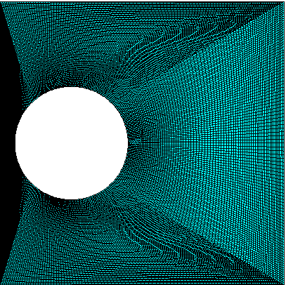
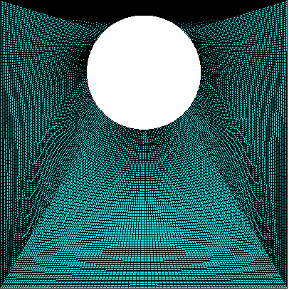
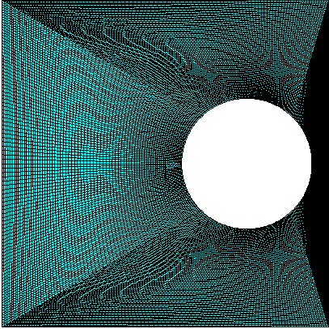
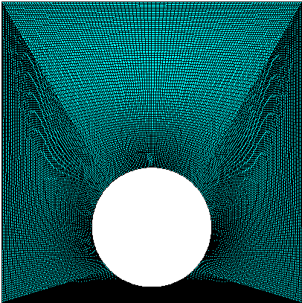
Fig. (2) Grid distribution for studied cases
(d)
x
y
(a)
x
y
(b)
x
y
(c)
x
y

Fig. (3) Comparison of the maximum local Nusselt number with the number of elements for Re=1000 ,Ri=1 and Gr=10⁶

5- Results And Discussion
In this study, the eccentric circular body is located near the top, right, bottom and left wall of the square cavity where the left wall is moving in two opposite direction upward +y and downward –y directions. This work is performed for three values of Richardson number Ri=0.1, 1 and 10 and Grashof number is fixed at 10⁶.
When the left lid moves in the (+y) direction, flow and heat transfer results for four locations of the eccentric circular body is shown in figure (4) at the value of Richardson number (Ri=0.1). When Richardson number is small i.e., (Ri=0.1) which represents the forced convection case, the bouncy force effect is small, so for this case the natural convection contribution is small also. It can be seen that in case (I) small amount of air is lifted at the lateral left and right wall until it contacts the adiabatic top wall of the cavity and then the thermal boundary layers try to move near the circular body. From noticed that both of streamlines and velocity profiles it can be seen that two counter rotating vortices are formed, one small at the top left corner with clock wise direction and the another is big moves in anti-clockwise direction formed downstream the circular body where intensity of stream lines is concentrated near the bottom left corner of the cavity and this stream lines are extended along the right wall and up towards the top wall until it reaches near the circular body and then moves down. In case (II), the isothermal body contour do not change much compared to case (I) and also two vortices are generates, one large vortex down and around the circular body moves in anti-clockwise direction and it clustered near the bottom left corner of the square cavity and the second cell moves toward clockwise direction at the top left corner of the cavity. When the circular body is located near the adiabatic bottom wall i.e., (case III), the interval of the isothermal body contour becomes larger compared to both of cases I and II and three circulation are formed inside the cavity one of this vortices is in clockwise direction at the top left corner and primary circulation in anti – clockwise direction is formed at the top right wall and secondary vortex can be detected near the bottom left corner of the cavity due to the domination of forced convection. The greatest disturbance of isotherms is achieved at case (IV), when the circular body is located near the left lid (moving wall) of cavity due to strong inertial effects produced by the motion of the left wall, It can be noticed from streamlines, the clockwise vortex appear around the circular body and intensity of streamlines is concentrated at the top left corner of cavity, while the anti-clockwise circulation is formed along the right wall but, it clustering at the bottom right corner of the cavity. In general, it can be observed that this behavior of temperature contours and fluid flow profiles refers that the heat transfer process is sensitive to the location of the circular body.
When the lid move downward (i.e., in –y direction) as shown in figure (5) at (Ri=0.1) a different behavior can be noticed in fluid flow and isothermal body contours. The cold air tend to move downward until it reaches the bottom wall and then expanded extensively inside the cavity, while the hot air is lifted up and extended along the top wall in all four cases. It can be noticed that in both of cases (I) and (II) there are two types of vortices, one in anti-clockwise direction formed near the bottom left corner and the another is too large and covered the remaining region inside the cavity moves toward clockwise and there is minor clockwise vortex under the circular body and clustering near the bottom right corner of the cavity. In case (III) the cold air extended larger along the bottom wall and the anti-clockwise vortex is decrease in size and it can be observed that the large major vortex began to increase and diffusing around the circular body. At case (IV), the isothermal body contours have the larger distribution as compared to that when the lid moves in upward direction and the anti-clockwise circulation is larger and concentrated near the right wall while the clockwise circulation is clustering along the all side walls of the cavity.
At Ri=1 (figure 6) when the left lid moving in the (+y) direction the heat transfer mechanism in the square cavity is occurred by the combined mechanisms of natural and forced convection (i.e., the mixed convection is dominant). In this situation the buoyancy forces effect balances the effect of the moving left lid. In both cases (I) and (II) the isotherms contour and fluid flow profiles are comparable, where the amount of air is lifted upward until it touch the top wall and two vortices are formed, one big in anti-clock wise direction near the left bottom corner and the other at the long of the left wall in clockwise circulation and the intensity of this cell is concentrated at the left top corner of the cavity. In case (III) the distribution of isotherms contour are similar with the above cases but, there is some different in streamlines that the anti-clock wise vortex is formed above the circular body and clustering near the right top corner of the cavity. It can be seen from figure (6) case (IV) the cold air at the left lid-driven is lifting upward and tend to move around the circular body and the clock wise vortex is formed along the left wall of the cavity and around the circular body while, the anti-clockwise vortex is formed along the right wall and clustering near the right bottom corner of the cavity.
When the lid moving in (-y) direction and (Ri=1) as shown in figure (7), it can be seen that the distribution of cold air is become larger than the hot air inside the square cavity due to moving of left lid downward and noticed that the clockwise circulation of streamlines extended along the all side of cavity and around the eccentric circular body and becomes more larger that the above case but, the anti-clockwise directions of vortices for all case studies are tend to formed near the left bottom corner of the cavity.
At Ri=10 as shown in figure (8) when the lid moving in (+y) direction, the clockwise vortex formed along the moving wall and clustering at the left bottom corner for all cases but, the other anti-clockwise vortices is formed under down the circular body for case (I) and around it for case (II) and the vortex concentrated near the half lid wall and noticed that the isothermal hot lines tend to lifting upward until it touch the top wall and then extended along it while the cold air distribution appear larger at the bottom part of the cavity. At both cases (III) and (IV) the anti-clock wise vortex formed at the right top corner of the cavity and the isothermal body contour become non – uniformly distributed and the hot air distribution is larger than the cold air, since the buoyancy forces effect on the flow and thermal fields becomes more significant with increasing of Richardson number and as a result the heat is transferred due to convection.
When the lid moves in (-y) direction at (Ri=10) as shown in figure (9), it can be observed that, the intensity of the clock wise vortices circulation becomes more diffusion and concentrated along the all walls of the cavity for all different location of circular body while the anti-clock wise circulation covers most of the cavity size for that for case (I) is formed near the left bottom corner of the cavity and for case (II) formed at the middle size of the cavity and around the circular body and for case (III) the anti-clockwise vortex is formed upward the circular body and it is concentrated near the right top corner and for case (IV) it formed at the middle size of the cavity and two strong minor vortices are formed inside the cavity one near the left bottom corner and the another near the half right wall of the square cavity. Also, it can be seen from the isothermal body contours some of cold air is covered most region of the cavity and tend to move downward while the hot air is lifting up so the isotherms do not change much compared to figure (8) since the forced convection is weaker than the natural convection.
Figure (10) shows the local Nusselt number plots along the hot right side wall for all case studies with lid moving in the upward and downward direction for different Richardson numbers. The distance along the hot right wall taken as from the upper point of the right wall (i.e., at Y=0m) downward the lower point of the right wall (i.e., Y=0.15m) .
Figure 10 (a) shows the local Nusselt number when the lid moving upward i.e., +y direction for case (I). This values of local Nusselt number increase as the distance along the hot wall increases and it have the same behavior for all values of Richardson number (Ri=0.1, 1 and 10). It can be noticed that the maximum value of the local Nusselt number occurs at Y=0.135m and then this value lowered down to Y=0.15m. When the lid moving downward the values of the local Nusselt number higher than when lid moving upward. At (Ri=0.1) the value of the local Nusselt number increases until it reaches at Nu=11 at Y=0.035m and then after that this value of Nusselt number is decreases to the value of Nu=7 at the middle distance of the hot wall of cavity and then increases to Nu=18 at Y=0.13m and then lower down at Y=0.15m. When (Ri=1and 10) the values of local Nusselt number begin to increases until it reaches the maximum values at Y=0.14m and then lower down.
From figure 10 (b) it can be seen that when the lid moving upward the maximum value of local Nusselt number occurs at Ri=0.1. For all values of Richardson number the local Nusselt number increasing until it reaches to the maximum value at Y=0.14m after that this value is lowered down. Below Y=0.09m the values of local Nusselt number at Ri=1 is higher than the value of local Nusselt number at Ri=10 and above Y=0.09 the value of local Nusselt number inversing. When the lid moving down, the values of local Nusselt number at Ri=0.1 increasing to Nu=21 at Y=0.105m and then decreasing in values while at (Ri=10) when the natural convection is dominant here, the values of local Nusselt number increasing to the values Nu=18 at Y=0.14m and then decreasing, and at Ri=1 the behavior of local Nusselt number is the same as when (Ri=10) but it higher than in values and the maximum values of Nu=20 at Y=0.14m.
Compared with the local Nusselt number for case (III) (figure 10 c) at (Ri=0.1, 1 and 10) when the lid moving upward the local Nusselt number have the same behavior i.e., it increasing with increase the distance along the hot wall. And when the lid moving downward the values of the local Nusselt number at (Ri=0.1) increasing in values until it reaches the maximum values at Y=0.11m and then it rapid decreasing in values. At (Ri=1) when the combined convection is dominant, the values of local Nusselt number increases until it reaches at values (Nu=16) at Y=0.1m and then decreasing in values along the hot wall until it reaches at Y= 0.12m and then increasing to the maximum value (Nu=19) at Y=0.14m and then decreasing rapidly at Y=0.15m. At Ri=10 the behavior of local Nusselt number is similar to that when the lid moving upward but, in higher values of local Nusselt number.
Figure 10 (d) described the distribution of local Nusselt number along the hot wall when the circular body located near the lid wall for the two opposite direction of lid moving (i.e in +y and –y) direction for different values of (Ri=0.1, 1 and 10). It can be seen when the lid moving upward for (Ri=0.1 and Ri=1) the values of the local Nusselt number have the same behavior but, this value for Ri=0.1 is higher than at Ri=1. At Ri=10 the value of local Nusselt number is smaller below Y=0.09m and above Y=0.09m the values of the local Nusselt number increasing. When the lid moving downward the maximum distribution of local Nusselt number occurs at Ri=0.1 (Nu=25) and then lower rapidly to the value (Nu=9) at Y=0.11m and then increasing to Nu=11 at Y=0.145m and then decreasing toward at Y=0.15m. When Ri=1 the values of local Nusselt number is higher than it values at Ri=10 at the distance below Y=0.13m and above Y=0.13m the values of local Nusselt number at Ri=10 is become higher than this values of local Nusselt number at Ri=1 and both of them continuous to increase until it reaches the maximum value at Y=0.135m (Nu=19) and then decreasing at (Y=0.15m). From the above discussion of figure(10), it can be noticed that the distribution of local Nusselt number when the lid moving downward have higher values than the values of local (Nu) when the lid moving upward. The maximum values for both of case (a) and (b) varying between (Nu=21 and 19.5) while for both of case (c) and (d) the maximum values of local Nusselt number is higher than the above cases about Nu=25 it mean that higher distribution of heat transfer occurs at cases (c) and (d).

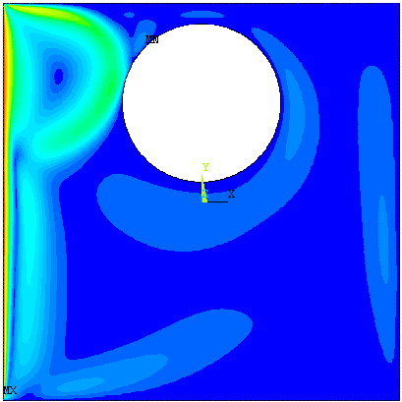
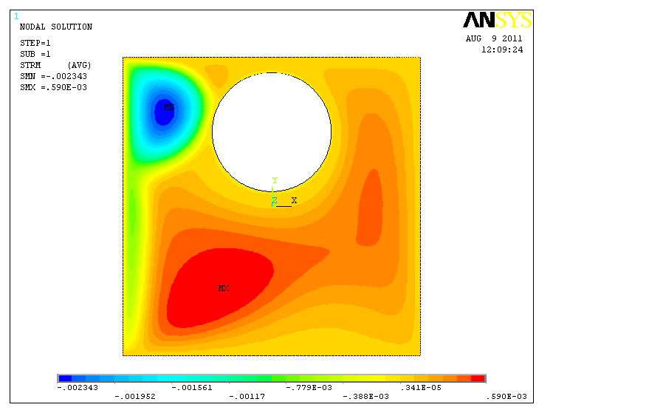
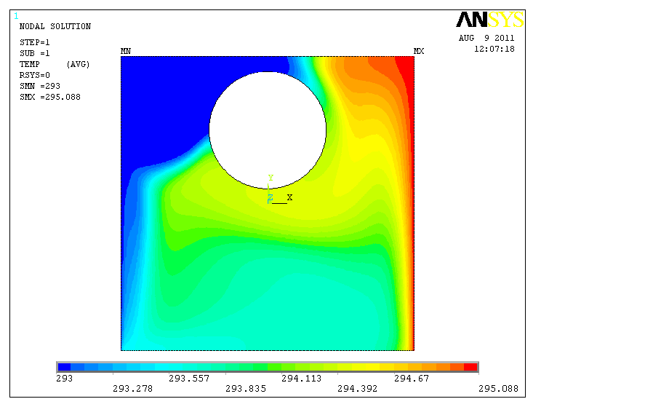
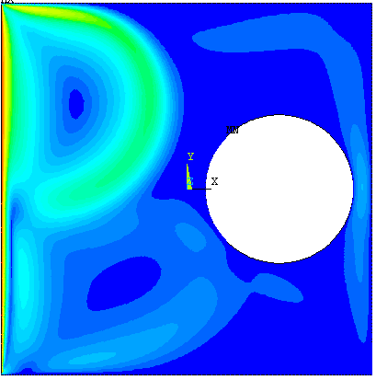
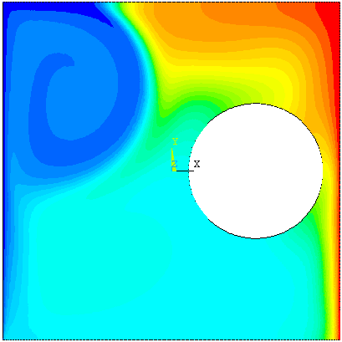
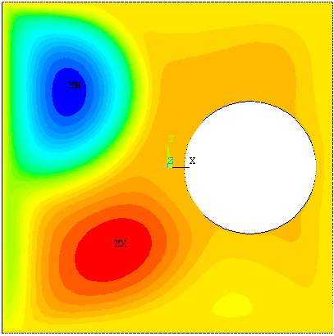
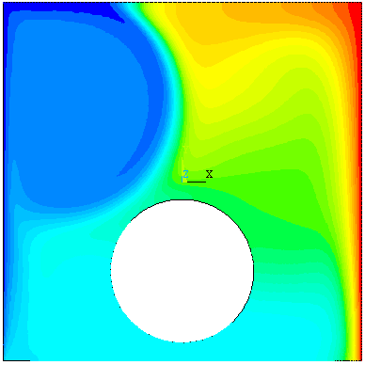
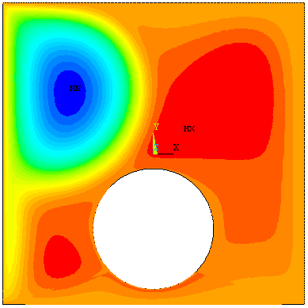
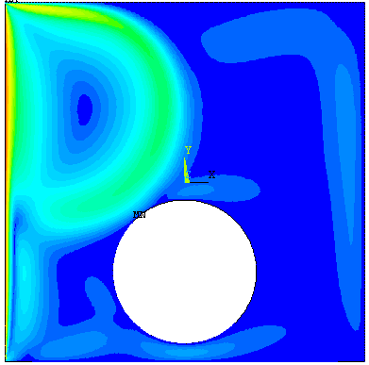
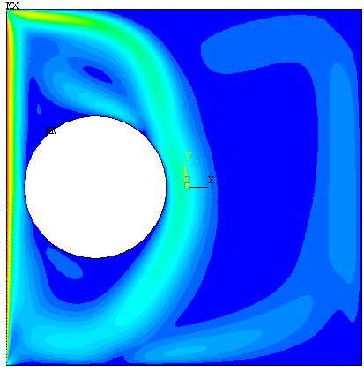
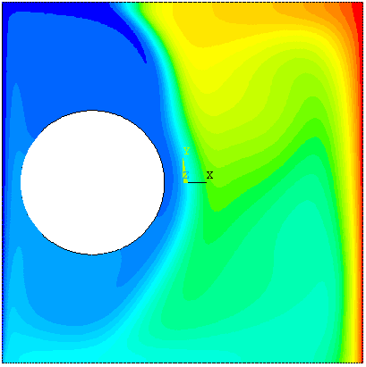
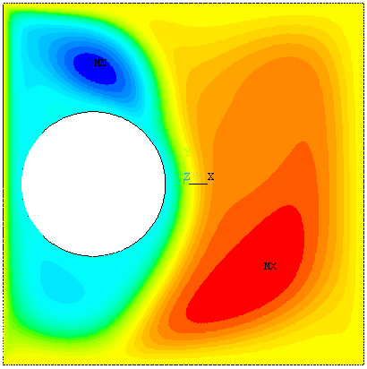
Fig. (4): Isotherms and streamlines and velocity profiles for case studies with lid moving in the +y direction (upward) at the value of Richardson number (Ri=0.1)
Case (I)
+y
Case (II)
+y
(c) Case (III)
+y
(d) Case (IV)
+y
Isothermal Body Contours
Streamlines
Velocity Profiles

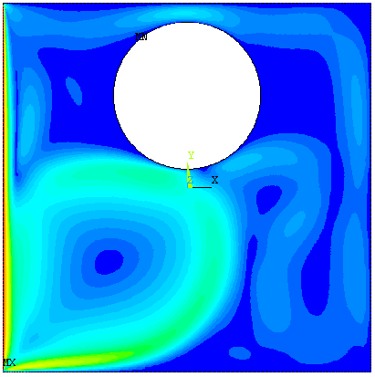
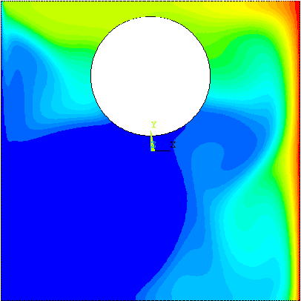
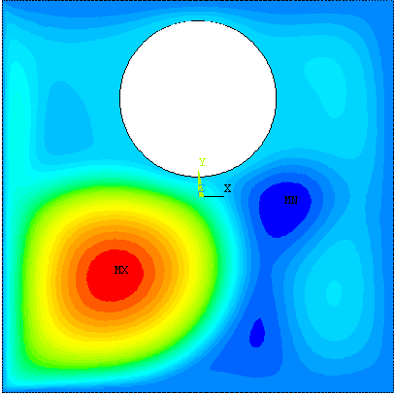
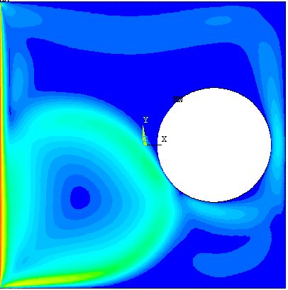
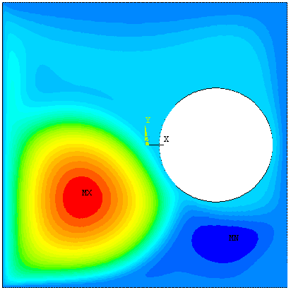
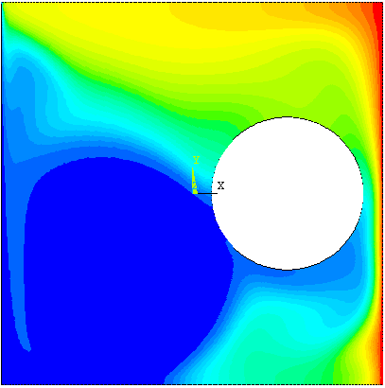
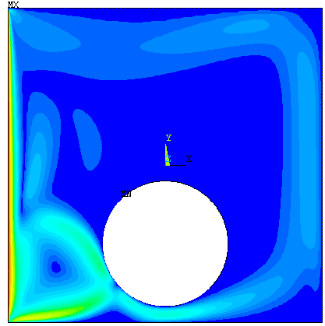
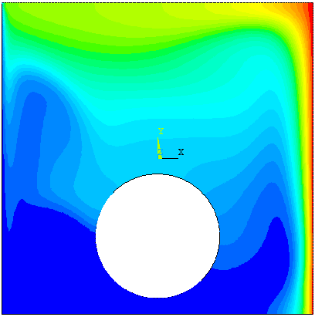
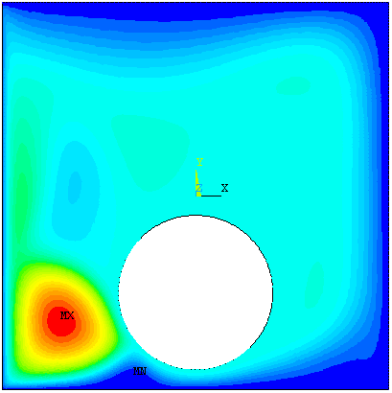
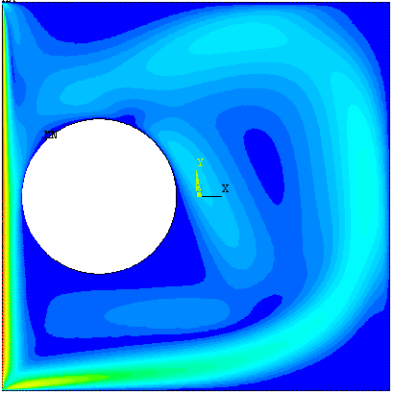
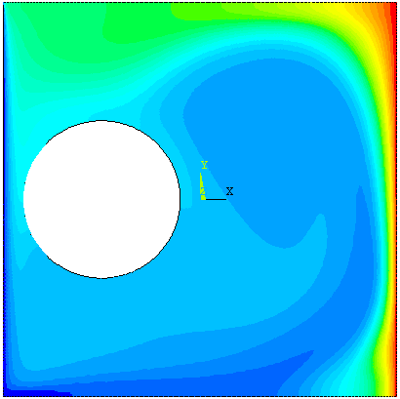
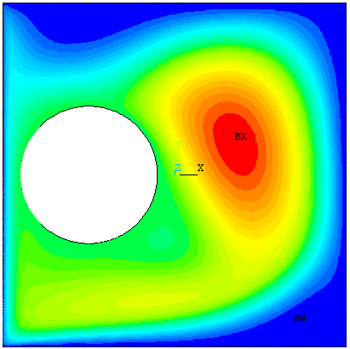
Fig. (5): Isotherms and streamlines and velocity profiles for case studies with lid moving in the -y direction (downward) at the value of Richardson number (Ri=0.1)
-y
Case (I)
-y
Case (II)
-y
(c) Case (III)
(d) Case (IV)
-y
Isothermal Body Contours
Streamlines
Velocity Profiles

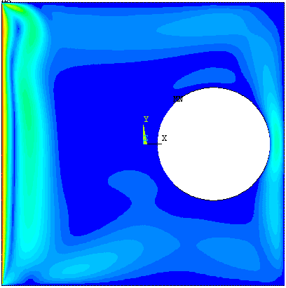
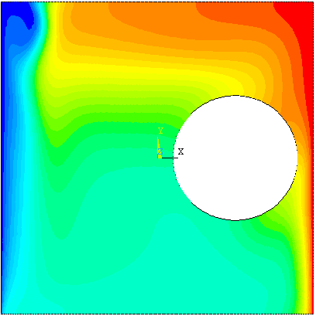
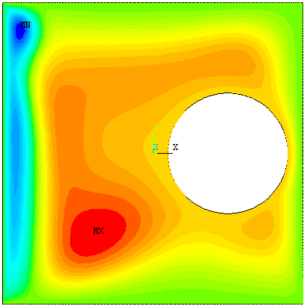
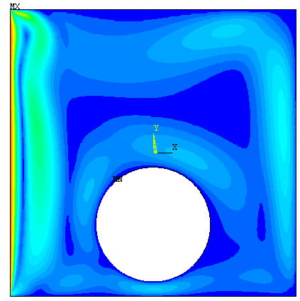
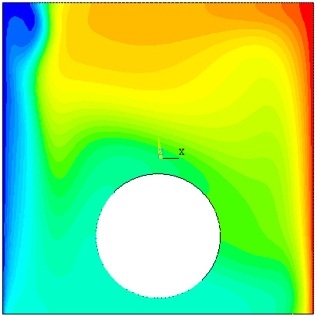
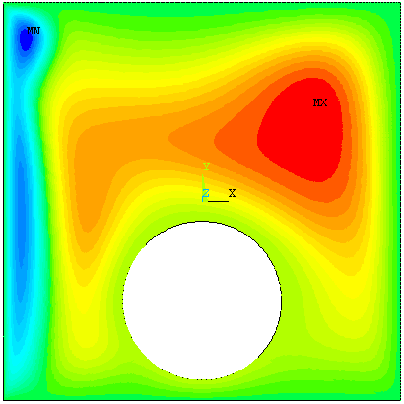
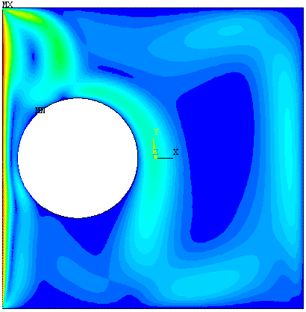
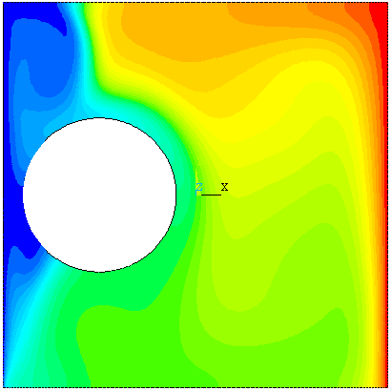
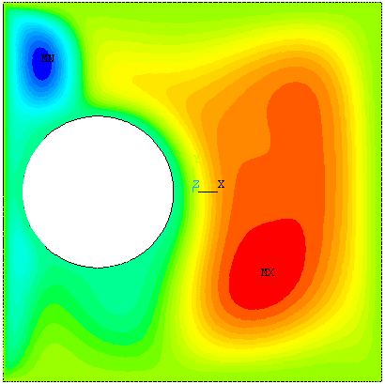
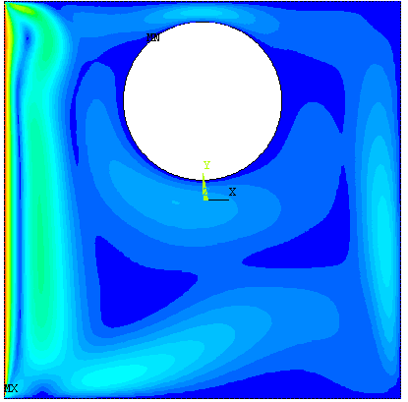
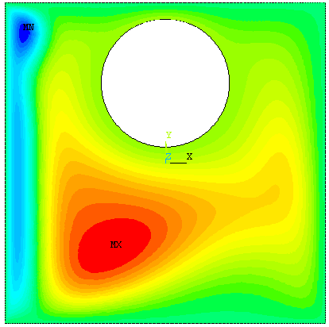
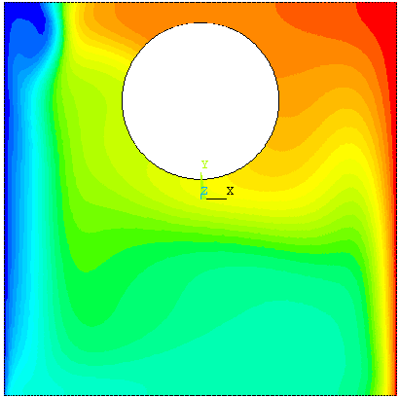
Fig. (6): Isotherms and streamlines and velocity profiles for case studies with lid moving in the +y direction (upward) at the value of Richardson number (Ri=1)
(b) Case (II)
+y
(c) Case (III)
+y
(d) Case (IV)
+y
Case (I)
+y
Isothermal Body Contours
Streamlines
Velocity Profiles

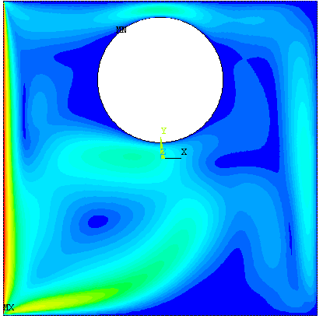
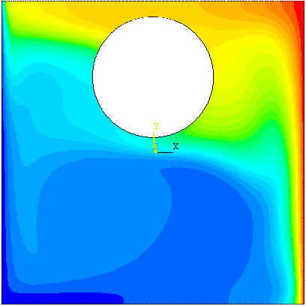
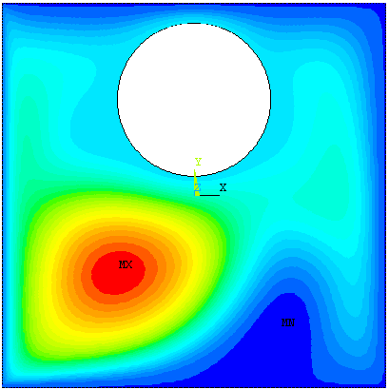
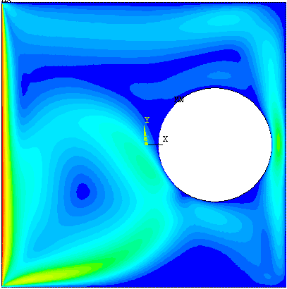
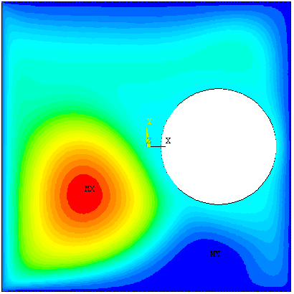
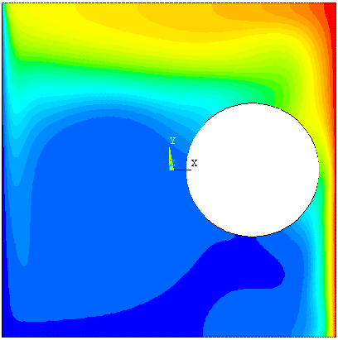
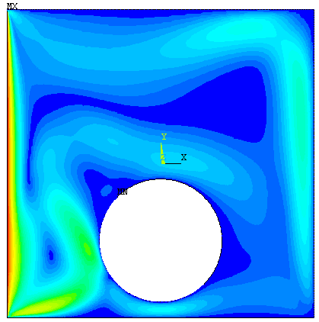
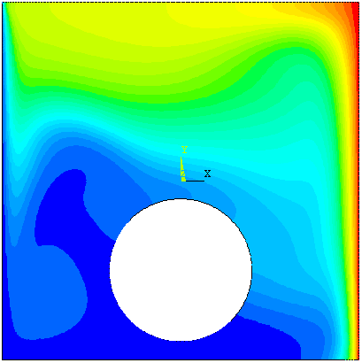
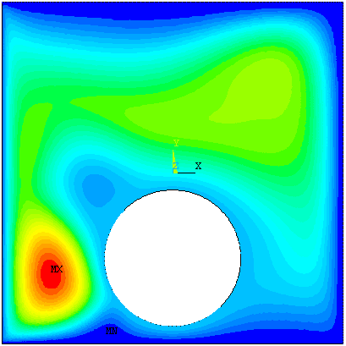
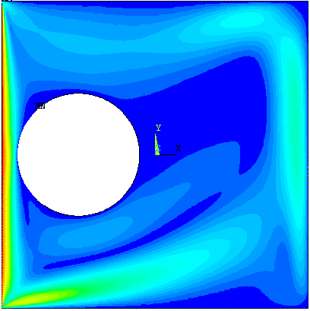
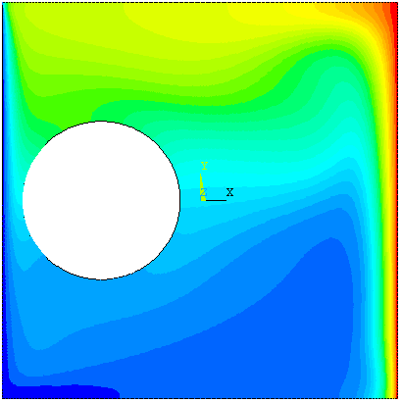
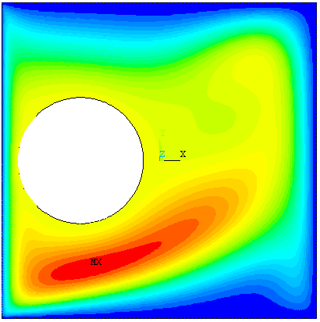
Fig. (7): Isotherms and streamlines and velocity profiles for case studies with lid moving in the -y direction (downward) at the value of Richardson number (Ri=1)
(a) Case (I)
-y
-y
(b) Case (II)
-y
(c) Case (III)
-y
(d) Case (IV)
Isothermal Body Contours
Streamlines
Velocity Profiles

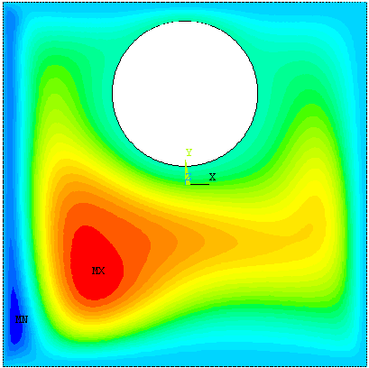
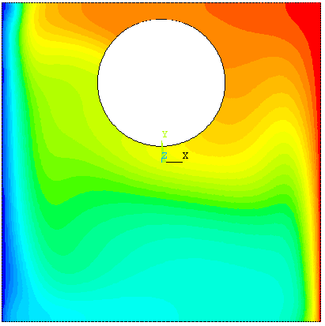
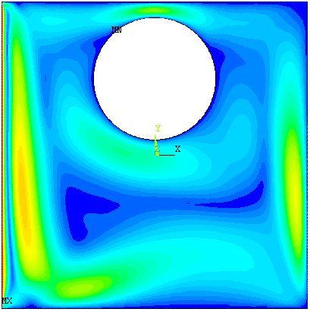
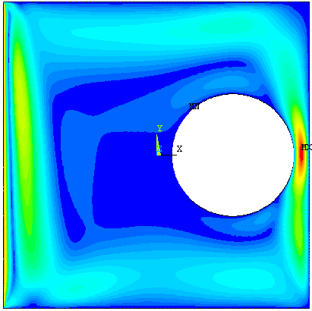
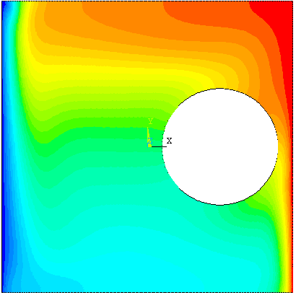
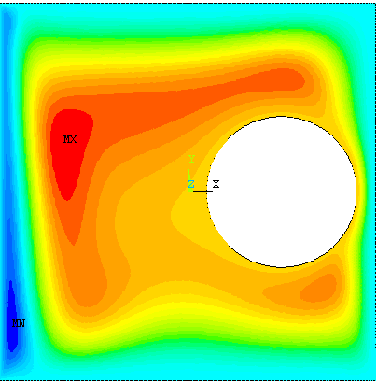
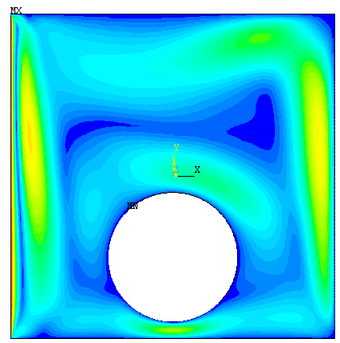
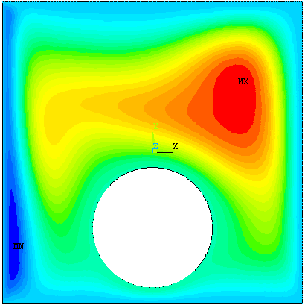
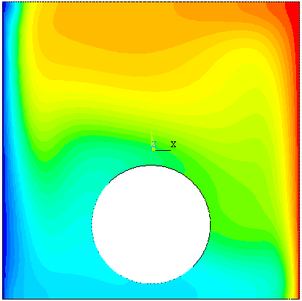
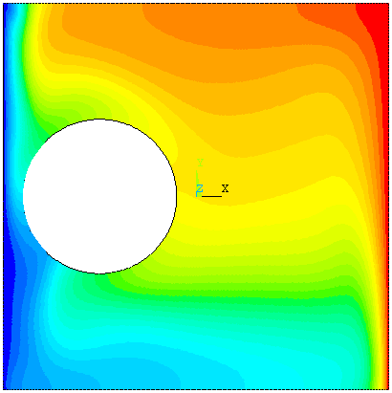
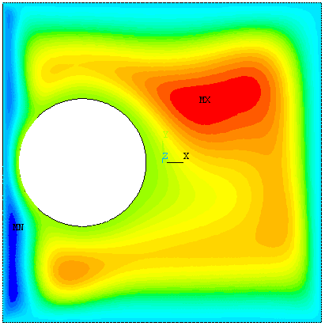
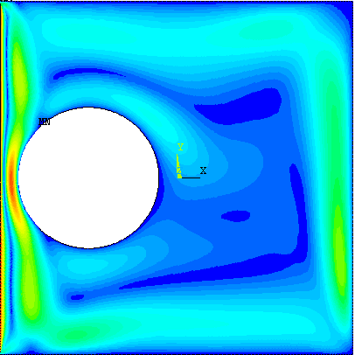
Fig. (8): Isotherms and streamlines and velocity profiles for case studies with lid moving in the +y direction (upward) at the value of Richardson number (Ri=10)
+y
(a) Case (I)
+y
(b) Case (II)
+y
(c) Case (III)
(d) Case (IV)
+y
Isothermal Body Contours
Streamlines
Velocity Profiles

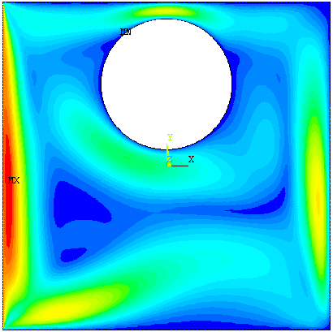
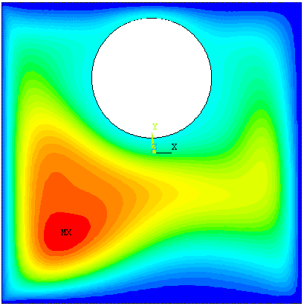
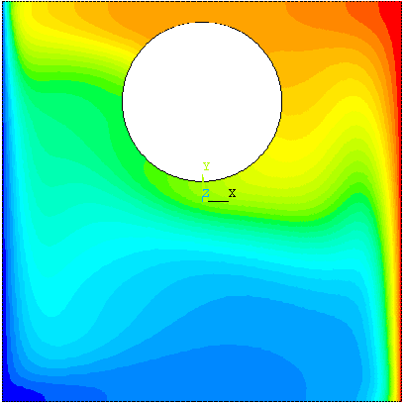
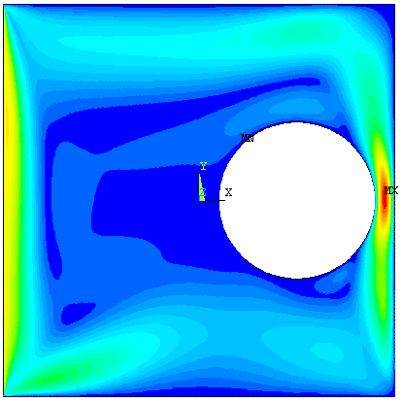
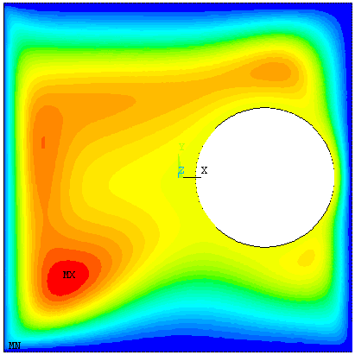
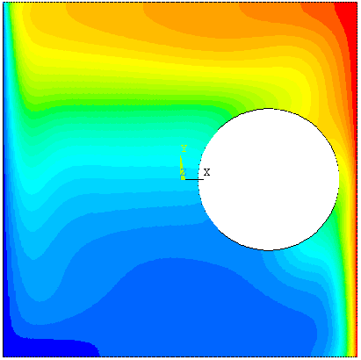
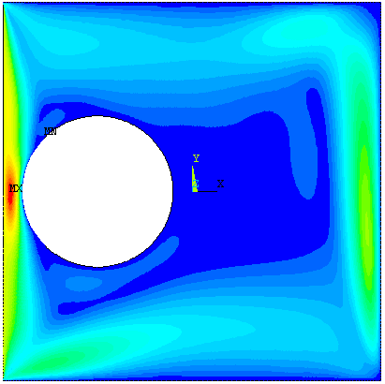
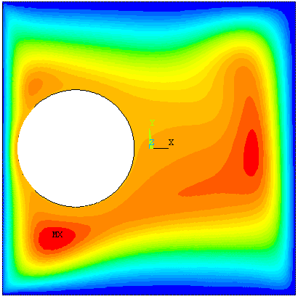
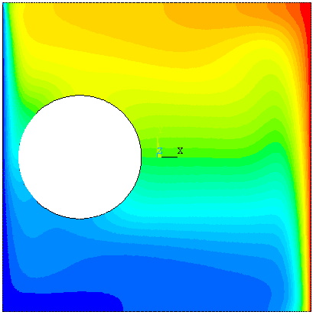
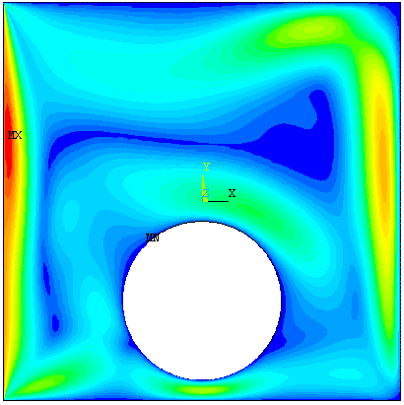
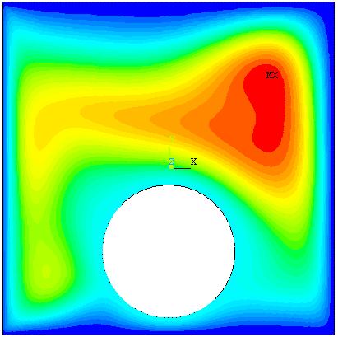
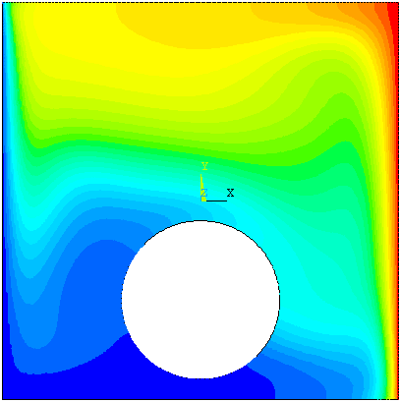
Isothermal Body Contours
Streamlines
Velocity Profiles
Fig. (9): Isotherms and streamlines and velocity profiles for case studies with lid moving in the -y direction (downward) at the value of Richardson number (Ri=10)
-y
(a) Case (I)
-y
(b) Case (II)
(d) Case (IV)
-y
(c) Case (III)
-y

Fig. (10) Local Nusselt number along hot wall for case studies with lid moving in the +y and –y direction at Ri=0.1, 1 and 10
(a) Case (I)
(c) Case (III)
(d) Case (IV)
(b) Case (II)

6- Conclusions
The following conclusions can be drawn from the results of the present work:
1- The behavior of temperature body contours and streamlines refers that the heat transfer process is sensitive to the location of the circular body.
2- The direction of lid makes important effect on heat transfer.
3- Higher heat transfer is observed for the case of downward moving wall.
4- The results show that the local Nusselt number values increases as the distance along the hot right wall increase for most cases with selected upward and downward lid moving.
5- The values of local Nusselt number when the lid moving downward have higher values than that when the lid moving upward.
7- References
Al-Amiri A.M., Khanafer K.M. and Pop I. " Numerical Simulation of Combined Thermal and Mass Transport in a Square Lid – Driven Cavity" International Journal of Thermal Sciences 46 (2007) 662 – 671.
Basak T., Roy S., Sharma P. K. and Pop I. " Analysis of Mixed Convection Flows within a Square Cavity with Linearly Heated Side Wall(S)" International Journal of Heat and Mass Transfer 52 (2009) 2224 – 2242.
Cheng T.S. and Liu W. H. " Effect of Temperature Gradient Orientation on the Characteristics of Mixed Convection Flow in a Lid-Driven Square Cavity" Computers & Fluids 39 (2010) 965–978.
Cheng T.S. "Characteristics of Mixed Convection Heat Transfer in a Lid-Driven Square Cavity with Various Richardson and Prandtl Numbers" International Journal of Thermal Sciences 50 (2011) 197 – 205.
Holman J.P., “Heat Transfer”, McGraw-Hill Book Co., NewYork, 1989.
Khanafer K.M., Al-Amiri A.M. and Pop I. " Numerical Simulation of Unsteady Mixed Convection in a Driven Cavity Using an Externally Excited Sliding Lid" International Journal of Mechanics B/ Fluid 26 (2007) 669 – 687.
Luo W. J. and Yang R. J. " Multiple Fluid and Heat Transfer Solutions in a Two – Sided Lid – Driven Cavity" International Journal of Heat and Mass Transfer 50 (2007) 2394 – 2405.
Noor D. Z., Kanna P.R. and Chern M. J " Flow and Heat Transfer in a Driven with Double – Sided Oscillating Lids in Anti – Phase" International Journal of Heat and Mass Transfer 52 (2009) 3009 – 3023.
Oztop H. F. and Dagtekin I. " Mixed Convection in Two – Sided Lid - Driven Differentially Heated Square Cavity" International Journal of Heat and Mass Transfer 47 (2004) 1761 – 1769.
Oztop H. F, Sun C. and Yu Bo" Conjugate-Mixed Convection Heat Transfer in a Lid-Driven Enclosure With Thick Bottom Wall" International Communications of Heat and Mass Transfer 35 (2008) 779 – 785.
Oztop H. F, Zhao Z. and Yu Bo " Fluid Flow Due to Combined Convection in Lid – Driven Enclosure Having a Circular Body" International Journal of Heat and Fluid Flow 30 (2009) 886 – 901.
Oztop H. F, Zhao Z. and Yu Bo " Conduction – Combined Forced and Natural Convection in Lid – Driven Enclosure Divided by a Vertical Solid Partition" International Communications of Heat and Mass Transfer 36 (2009) 661 – 668.
Patankar, S.V., “Numerical Heat Transfer and Fluid Flow” , Hemisphere Publishing Corporation, New York, 1980.
Perumal D. A. and Dass A. K. " Simulation of Incompressible Flows in Two-Sided Lid-Driven Square Cavities. Part I – FDM" CFD Letters Vol.2 (1) March 2010.
Prasad A.K. and Koseff J.R. " Combined Forced and Natural Convection Heat Transfer in a Deep Lid – Driven Cavity Flow" Int. J. Heat and Fluid Flow 17: 460-467, 1996.
Sivakumar V., Sivasankaran S., Prakash P. and Lee J. " Effect of Heating Location and Size on Mixed Convection in Lid-Driven Cavities" Computers and Mathematics with Applications 59 (2010) 3053_3065.

Nomenclature:
Symbol | Description | Unit
C_{p} | Specific Heat | J/kg.K
Gr | Grashof Number
g | Gravitational Acceleration | m/s²
H_{film} | The Film Coefficient | W/m². K
h | The Distance between the Center of the Cavity and the Center of the circular body | m
k | Thermal Conductivity of Fluid | W/m. °K
L | Side Length | m
L_{H} | Length of the Heating Portion of the Cavity | m
Nu_{l} | Local Nusselt Number
p | Pressure | N/m²
Pr=ν / α | Prandtl Number
{q} | Heat Flux Vector | W/m²
Ri | Richardson Number
Re | Reynolds number
r | Radius of the Circular Body | m
T | Temperature | °K
Tc | Cold Temperatur | °K
T_{f} | Film Temperature | °K
T_{h} | Hot Temperatur | °K
u | Velocity Component in x-Direction | m/s
v | Velocity Component in y-Direction | m/s
V_{o} | Velocity of moving Lid | m/s
X | Cartesian Coordinate in Horizontal Direction | m
Y | Cartesian Coordinate in Vertical Direction | m
Greek Symbols
α | Thermal Diffusivity | m²/s
β | Volumetric Coefficient of Thermal Expansion | K⁻¹
μ | Viscosity | N.s/m²
ν | Kinematic Viscosity of the Fluid | m²/s
ρ | Density of the Fluid | kg/m³
Ψ | Stream Function
{η} | Unit Out Ward Normal Vector

