**Suppression of Antenna's Radiation Sidelobes Using the Invasive Weed Optimization**

**Ali Shaban Hasooni Muthana Khallil Ibrahim**

*University of Babylon / College of Engineering*

**الخلاصة**

**Abstract**

T

he presence of large sidelobe radiation beam levels of an antenna is undesirable as the antenna performance and efficiency will be greatly degraded. Antenna structures especially in array arrangements have the capability to provide interference reduction, improvement of the channel capacity and expanding the range of a signal's coverage. In this paper, Invasive Weed Optimization (IWO) is utilized to optimize the inter-element position of even-element linear antenna arrays (LAA). The objective is to produce as close to desired radiation pattern as possible that exhibits sidelobe level (SLL) suppression. The IWO algorithm can be successfully used to locate the optimum element positions based on symmetric and even-element LAAs of isotropic radiators. The results obtained showed that the IWO algorithm is capable of finding the optimal solution in most cases with superior performance over conventional method

**الخلاصة**

وجود مستوى عالي من الحزم الجانبية للإشعاع في الهوائي غير مرغوب فيه كما إن أداء الهوائي وكفائته سوف تنخفض بصورة كبيرة ، تركيب الهوائي خصوصا في شكل المصفوفة له القابلية لتقليل التداخل وتحسين سعة القناة وتوسيع مدى تغطية الإشارة. في هذا البحث IWO تم استعمال لتحسين مواقع العناصر الداخلية في الهوائي الخطي ولغرض الحصول على نمط الإشعاع المطلوب الذي يلغي الحزم الجانبية الغير مرغوب فيها. و قد استخدمت خوارزمية IWO بنجاح في تحديد المواقع الدقيقة للعناصر الداخلية للهوائي .وجدت النتائج إن خوارزمية IWO أنها قادرة لإيجاد الحلول المتميزة في اغلب الحالات مع أداء متميز على حساب الطرائق التقليدية.

**1. INTRODUCTION**

Numerous studies on antenna arrays have been widely applied in phase array radar, satellite communications and other fields. The array pattern of an antenna array should possess high power gain, lower sidelobe levels, controllable beamwidth [Zaharis,Z., Kampitaki D., Papastergiou,A. Hatzigaidas A., Lazaridis P., and Spasos M., 2006] and good azimuthal symmetry. The desired radiation pattern of the antenna array can be realized by determining the physical layout of the antenna array and by choosing suitable complex excitation of the amplitude and phase of the currents that are applied on the array elements. Thus, evolutional optimization algorithm such as genetic algorithm (GA), simulated annealing (SA), and particle swarm optimization (PSO), and Invasive Weed Optimization (IWO) have been introduced in antenna designs. Each algorithm has shown better performance due to its versatility, flexibility and capability to optimize complex multidimensional problem [Rattan, M., Patterh M. S., and Sohi, B. S. 2008].

Currently, IWO algorithm is applied in many practical problems especially in electromagnetics. It has been used to obtain excitation coefficients of reconfigurable antenna arrays [Mallahzadeh A. R.,2008]; optimize the amplitude, phase, spacing and position of the elements in 37-element hexagon array [. Chen, T. B., Chen Y. B., Jiao Y. C., and Zhang E. S., 2005] and suppress the SLL of linear array [Khodier, M. M. and Christodoulou C. G., 2005, Bevelacqua, P. J. and Balanis C. A., 2007].

In this paper, the IWO is exploited to produce the array radiation pattern that is nearest to the desired objective which exhibits sidelobe level (SLL) suppression and/or null placement. The inter-element position of even element linear arrays is optimized and relocated whilst maintaining uniform excitation over the array aperture.

**2. LINEAR ANTENNA ARRAY SYNTHESIS**

A one-dimensional symmetric LAA is assumed which is placed along the x-axis as depicted in Fig. 1. It has even number of elements up to **N**. Assuming uniform excitation of amplitude, **In** = 1 and phase **βn** = 0, the array factor can be written as:

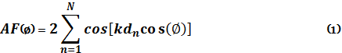

where k, In, βn, Ø , and dn are the wavenumber β= 2π/λ, excitation amplitude, phase, observation angle, and location of the nth element from the reference node at the origin, respectively. IWO will explore for the optimum element positions, dn by aiming at the target objective which reduces the problem of SLL suppression and/or null placement[Mehrabian, A.R.and Lucas C. 2006].



Figure 1: 2N linear array geometry.

**3. INVASIVE WEED OPTIMIZATION METHOD**

To simulate the colonizing behavior of weeds some basic properties of the process is considered below [Mehrabian, A.R.and Lucas C. 2006]:

1) A finite number of seeds are being spread out over the search area.

2) Every seed grows to a flowering plant and produces seeds depending on its fitness.

3) The produced seeds are being randomly dispersed over the search area and grow to new plants.

4) This process continues until maximum number of plants is reached; now only the plants with lower fitness can survive and produce seeds, others are being eliminated. The process continues until maximum number of iterations is reached and hopefully the plant with the best fitness is closest to the optimal solution. The process is addressed in details as follows:

**3.1. Initialize a Population**

A population of initial solutions is being spread out over the D dimensional problem space with random positions.

**3.2. Reproduction**

A certain population of plants is allowed to produce seeds depending on its own and the colony's lowest and highest fatnesses: the number of seeds each plant produces increases linearly from the minimum possible seed production to its maximum level. In other word, a plant will produce seeds based on its fitness, the colony's lowest fitness and highest fitness to make sure the increase is linear.

**3.3. Spatial Dispersal**

Randomness and adaptation in the algorithm is provided in this part. The generated seeds are being randomly distributed over the D dimensional search space by normally distributed random numbers with the mean value equal to zero, but with a varying variance. This ensures that the seeds will be randomly distributed such that they abide near the parent plant. However, standard deviation (SD), **σ**, of the random function will be reduced from a previously defined initial value, **σinitial**, to a final value, **σfinal**, in every step (generation).In simulations, a nonlinear variation has shown satisfactory performance, which is given in Eq.(2)

(2)



where itermax is the maximum number of iterations, σiter is the SD at the present step and n is the nonlinear modulation index.

**3.4. Competitive Exclusion**

If a plant leaves no offspring then it would go extinct, otherwise they would take over the world. Thus, there is a need for some kind of competition between plants for limiting the maximum number of plants in a colony. After passing some iterations, the number of plants in a colony will reach its maximum level by fast reproduction, however, it is expected that the fitter plants have been reproduced more than the undesirable plants. By reaching the maximum number of plants in the colony (Pmax), a mechanism for eliminating the plants with poor fitness in the generation activates. The elimination mechanism works as follows: when the maximum number of weeds in a colony is reached, each weed is allowed to produce seeds according to the mechanism mentioned in the section 3.2. The produced seeds are then allowed to spread over the search area according to section 3.3. When all seeds have found their position in the search area, they are ranked together with their parents (as a colony of weeds).Next, the weeds with lower fitness are eliminated to reach the maximum allowable population in a colony. In this way, the plants and offsprings are ranked together and the ones with better fitness survive and are allowed to replicate. The population control mechanism is also applied to their offspring up to the end of a given run, realizing competitive exclusion.

Consider a set of population or swarm of matrix X, with elements that are referred as plants or agents. Each plant represents possible solution in defined population size, maxplant. For an N-dimensional problem, the position of the i-th plants (i = 1,..., maxplant) is represented as:

(2)

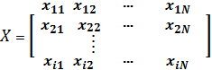

i.e., the position coordinates of the elements. xi1 is limited between two boundaries, U1 and L1, i.e., (L1 · xi1 · U1) and xiN¡1 is limited between two other boundaries, UN and LN i.e., (LN · xiN¡1 · UN). The i-th plant in the solution space is determined by fitness function value which depends on the plant value. Every time the value of the fitness function i.e., F is minimized, the plant values is improved by new generations of seeds, each plant will generate number of seeds which are limited between two boundaries, seedmax and seedmin. These seeds spread over the search space according to equation (2) and will generate new plants,

The IWO is employed to optimize the optimum element position in order to improve the radiation pattern of the LAA, with maxplant = 30. The objective of the algorithm is to find the optimum values G, that corresponds to the minimum value of the fitness function, Fmin. The fitness function identifies how good the value vector of each plant satisfies the requirements of the optimization problem. The fitness function is computed using:



where s is the region where the SLL is suppressed and n is the angle where the nulls are placed. As the fitness function decreases, the radiation pattern improves with related plant's value **xiN** .Therefore, when the fitness function discovers its optimized minimum value, the IWO algorithm will terminate successfully.

**4. RESULTS AND DISCUSSION**

A 2N-element LAA with different numbers of elements and desired radiation pattern have been considered to assess the effectiveness of the IWO in the optimization. The LAA is assumed to be symmetric about the x-axis with uniform interelement spacing of λ0 = λ/2. Initially, the initial plants, X is randomly generated in the range of 0 to 1.5 to produce more diverse possible solutions. Some boundary conditions are also defined to Dn which is allowed to vary from 0.8λ0 to 1.5λ0. The applied parameters are:

Number of initial plants, n_ini=10

Max no. of plants, plant_max_no =60

Max number of seeds, seedmax = 5

Min number of seeds, seedmin = 0

Nonlinear modulation index , n =3

Initial value of standard deviation Sini = 1

Final value of standard deviation, Sf = 0.0000000000001

Maximum of initialization space, zmax: 1.5

Minimum of initialization space, zmin = 0

**Case 1.** A 18-element LAA is simulated for SLL suppression. The element positions for both conventional and IWO methods are given in Fig. 2 which is symmetrical by the y-axis. The radiation pattern is presented in Fig. 4. It is clearly seen that the IWO algorithm provides improvement to the SLL suppression. Almost all sidelobes have been minimized particularly the first SLL and far sidelobes.



**Figure 2: Element position of the 18-element LAA using IWO and conventional methods. Numbers are normalized wrt *¸* λ0*¸λ*/2.**

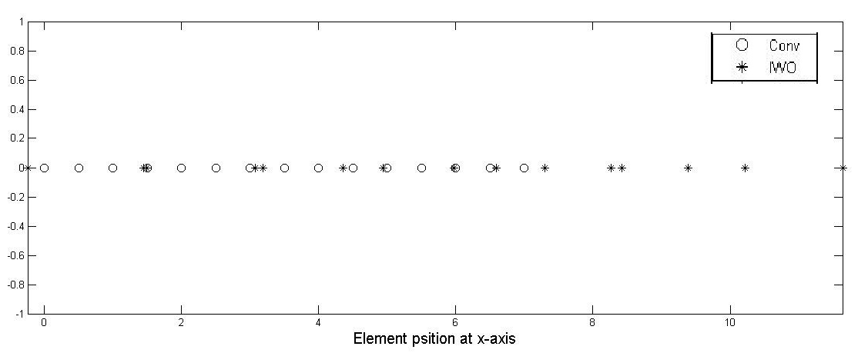

**Figure 3: Element position of the 14-element LAA using IWO and conventional methods. Numbers are normalized wrt ¸ λ0¸λ/2.**

**Case 2.** A 14-element LAA is designed for null placement at 83o and 96o. Fig. 5 shows that deep nulls of -100.5 dB have shown in Fig. 4. From Fig. 5, it can be inferred that smaller beamwidth is obtained by using IWO. In addition, there are also decrements of all SLLs. The total length of the element by using IWO has increased to merely 4.2 which is less than that of the conventional method as in Fig. 4.

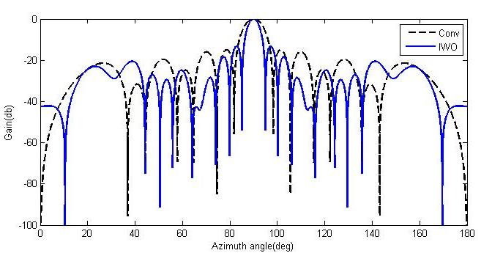

**Figure 4: Radiation patterns of 18-element LAA by using IWO and conventional methods. SLL suppression at (0o, 85o) and (95o, 180o).**

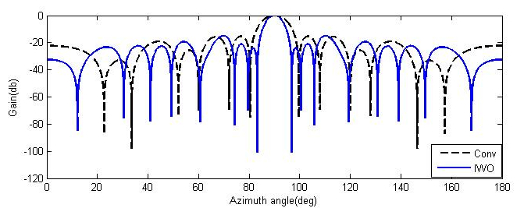

**Figure 5: Radiation patterns of 14-element LAA by using PSO and conventional methods. The null placements are at 83o and 96o.**

**5. CONCLUSION**

The IWO algorithm has been shown to successfully improve the radiation pattern of the LAA as desired. All the design requirements of the radiation pattern simulation for the LAA is presented and highly satisfied. The developed IWO algorithm has successfully optimized the position of the array elements to demonstrate a radiation pattern with either suppressed SLL, null placement, or both.

**REFERENCES**

Bevelacqua, P. J. and Balanis C. A., 2007 “Minimum sidelobe levels for linear arrays, antennas and propagation,” IEEE Transactions on Antennas and Propagation, Vol. 55, No. 12.

Chen, T. B., Chen Y. B., Jiao Y. C., and Zhang E. S., 2005 “Synthesis of antenna array using particle swarm optimization” Asia-Pacific Microwave Conference Proceedings 2005 (APMC 2005), Vol. 3, 4, December 4{7, 2005}.

Khodier, M. M. and Christodoulou C. G., 2005 “Linear array geometry synthesis with minimum sidelobe level and null control using particle swarm optimization,”IEEE Transactions on Antennas and Propagation,Vol.53,No. 8.

Mallahzadeh A. R.,2008“ Application of the Invasive Weed Optimization Technique For Antenna” Configurations *Progress In Electromagnetics Research, PIER* 79, 137–150,

Mehrabian, A.R.and Lucas C. 2006, “A novel numerical optimization algorithm inspired from weed colonization,” Ecological Informatics, Vol.1.

Rattan, M., Patterh M. S., and Sohi, B. S. 2008 “Design of a linear array of half wave parallel dipoles using particle swarm optimization, Progress In Electromagnetics Research M, Vol. 2,.

Zaharis, Z., Kampitaki D., Papastergiou,A. Hatzigaidas A., Lazaridis P., and Spasos M., 2006, ”Optimal design of a linear antenna array using particle swarm optimization”, Proc. of the 5th WSEAS Int. Conf. on Data Networks, Communications and Computers, 69{74, Bucharest, Romania, October 16}.