Sound file hiding in fingerprint image
Tawfiq A. Al-Asadi
Information Technology collage, Babylon University
Ali Abdul Azzez Mohammad Baker
Department of computer science, Babylon University
Abstract
In this paper, we introduce a new method to hide information (.wav sound file) in ridges of fingerprint image, the place where we hide message depend on features extracted from the image (like core, delta, ending and bifurcation) this mean using symmetric key extracted from fingerprint image. The proposed system consist of two stages ,First stage for sound file hiding after determine useless regions while Second stage for extract message from fingerprint image . Hide information in fingerprint image must never alter the positions and numbers of important regions or pixels .Hiding information help automated fingerprint verification system in make more reliable individual identification decision. In this paper we use new technique in way of hiding information depend on the nature of cover image by extract specific features from fingerprint image then determining the edge of object and hide the message between this edge.
Keywords: Fingerprint, (.wav) sound file, Poincare index, Minutiae detect, hide message.
الخلاصة
هذا البحث يقدم طريقة جديدة لإخفاء معلومات (ملف صوت بامتداد.wav) في (ridges) صورة بصمة الأصبع , المكان الذي نخفي بيه البيانات يعتمد على خصائص مستخلصة من الصورة (مثل core , delta , ridge ending , ridge bifurcation) هذا يعني استخدام مفتاح يستخرج من صورة البصمة .
النظام المقترح يتألف من مرحلتين , الأولى لإخفاء بيانات الصوة بعد ايجاد المناطق غير المهمة بينما المرحلة الثانية تستخدم لاستخلاص بيانات الصوت من صورة بصمة الأصبع , إخفاء البيانات في صورة بصمة الأصبع يجب ان لا يغير موقع وعدد المناطق او البكسلات المهمة .
إخفاء المعلومات يساعد نظام مطابقة البصمة باتخاذ قرار أكثر موثوقية لتحديد هوية الشخص . هذا البحث يقدم تقنية جديدة لإخفاء المعلومات تعتمد على طبيعة صورة الغطاء عن طريق استخلاص صفات محددة من صورة بصمة الأصبع وإيجاد حافة الكائن وإخفاء الرسالة بين حدود الحافة

1-Introduction
Fingerprint image used for personal identification for many decades because of many reasons such as reliability, stability, and uniqueness property [Qinzhi 2006].
Fingerprint is a pattern ridges and valleys run in parallel, ridges (ridge lines) are dark whereas valleys are bright as illustrate in figure (1).
Features in fingerprint image extracted into two levels
- Local level for minutiae detects (ending and bifurcation) minutiae are local discontinuities in the fingerprint pattern (as shown in figure (1)) which used in fingerprint matching stage and the similarity between two fingerprints is determined by comparing the two sets of minutiae points.
- Global level for singular point (or singularities) detect ( core and delta) ,core and delta illustrated in figure (1), this process is very important task and used for fingerprint classification system into at most (5) classes according to its geometric properties which are Arch, Tented Arch, Left loop, Right loop and Whorl as in figure(2)
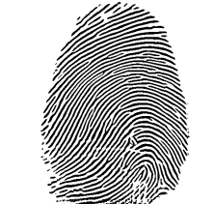
Valley

Ridge
Bifurcation
Ending
Core
Delta
Figure (1) fingerprint image
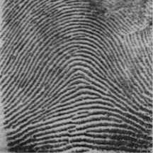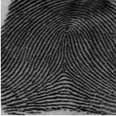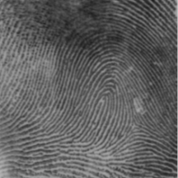
a- Arch b- tented arch c- left loop
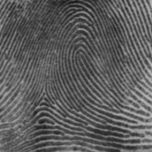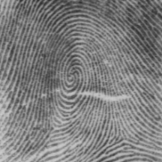
d- Right loop e- whorl
Figure (2) classes of fingerprint images
Classification of fingerprint images into five classes depending on singular points type, number, and position as illustrated in table (1).
Table (1) fingerprint pattern classes
Fingerprint Pattern class | Core  numbers | Delta  numbers | Delta  position
arch | 0 | 0 | -
Left loop | 1 | 1 | right
Right loop | 1 | 1 | left
Tented arch | 1 | 1 | middle
whorl | 2 | 2 | Left and right

Proposed system extract features from fingerprint pattern image in order to avoid ridges which contain or near these features(local and global) and use the rest of ridges in hiding information(like iris, face, signature ,…)to avoid affect in fingerprint pattern which may be lead to detect false properties or reject true properties compare with native image ,this mean ,after hiding information stage the fingerprint image must has the same number and position for each feature (core, delta, ridge ending ,and bifurcation)as original image, this new image stored in database and this information will be extracted only when automated fingerprint verification system fails in person identification then this information help the system in making more reliable decision .
2-sound file (.wav) components
In our proposed system we used sound file (.wav) for person name speech as message to hide in useless region in fingerprint image, a (.wav) file has three areas of information in it: RIFF, FORMAT, and DATA. The RIFF chunk is composed of 12 bytes of data. The breakdown of the bytes in this portion of a (.wav) file is as in table (2)

Table (2) The RIFF chunk of (.wav) sound file
Byte number | Number of bytes | description
1-4 | 4 | the RIFF bytes
5–8 | 4 | total length
9–12 | 4 | .wav format
The FORMAT area is 24 bytes in length, and the bytes are broken down as in table (3)

Table (3) The FORMAT area of (.wav) sound file
Byte number | Number of bytes | description
13-16 | 4 | "fmt "bytes
17-20 | 4 | the length of FORMAT chunks
21-22 | 2 | always 0×01
23-24 | 2 | for mono versus stereo 0×01 = Mono ,0×02 = Stereo
25-28 | 4 | sampling rate listed in Hz
29-32 | 4 | the bytes per second
33-34 | 2 | the bytes per sampling interval
35-36 | 2 | the bits per sample

The DATA area is not a set length because it contains the actually data, or code, that the .wav file actually uses to create the audio sound. The beginning part of this area does have some preset fields that breakdown as in table (4).

Table (4) The DATA area of (.wav) sound file
Byte number | Number of bytes | description
37-40 | 4 | point to the data
41-44 | 4 | the length of data that follows
45-EOF | Length of data | the actual data
The (.wav) file data maybe (8, 16, 24, 32 bits) and natural human voice recorded with sample rate of (11025) Hz.
3-Proposed system
In generl,the proposed system as illustrated in figure(3) was consist of two steges,first one to hidesound file information in fingerprint ridges and this stage can be divided into the following steps:-
1- Fingerprint image enhancement.
2- Fingerprint image segmentation into isolated regions.
3- Singular points detect.
4- Minutiae detection.
5- Hide information using new algorithm into useless regions.
While the second stage for extract information from useless regions in fingerprint image using the following steps:-
1- Fingerprint image segmentation.
2- Singular points detect.
3- Minutiae detection.
4- Determine useless regions to extract message from them.

Message hiding stage
Message extract stage

Fingerprint image
Segmentation
Singular points detect
Minutiae detection

Detect useless regions
Extract Message using new proposed method
(.wav) sound file
Enhancement
Segmentation
Singular points detect
Minutiae detection
Detect useless regions
Use new method to hide message in cover

Stego image

Figure (3) Block diagram of proposed system
3.1-Fingerprint image enhancement

This steps is important to ensure the accuracy of result in next steps, we used Gabor filter to enhance fingerprint image by applying the following
- Fingerprint normalized image
The normalized gray scale value at pixel (i, j) can be calculated by the following equation

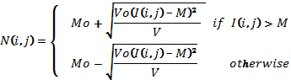 … (1)
Where M₀ and V₀ are the desired mean and variance values while M and V are the mean and variance of Fingerprint image I (i, j).
- Orientation estimation
Orientation can be calculated by sobel vertical and horizontal masks
Z1 | Z2 | Z3 |  | -1 | -2 | -1 |  | -1 | 0 | 1
Z4 | Z5 | Z6 |  | 0 | 0 | 0 |  | -2 | 0 | 2
Z7 | Z8 | Z9 |  | 1 | 2 | 1 |  | -1 | 0 | 1
Image vertical mask horizontal mask
Then we calculate orientation by the following equations
G_{y =} (Z7 + 2Z₈ + Z₉) - (Z1 + 2Z₂ + Z₃) ... (2)
G_{x} = (Z3 + 2Z₆ + Z₉) - (Z1 + 2Z₄ + Z₇) ... (3)
Then fingerprint image will be divided into non overlap blocks of size (s×s) where s=17, the average Magnitude in each block R is
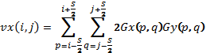 … (4)
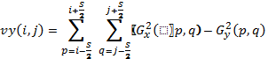 (5)
The block gradient direction is

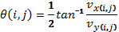 (6)
- Apply Gabor filter

After normalization, we enhance the contrast of the ridges by filtering this 32 × 32 normalized blocks with an appropriately tuned Gabor filter. An even symmetric Gabor filter has the following general form in the spatial domain

G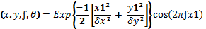 … (7)
X₁= x sin θ + y cos θ … (8)
Y₁= -x cos θ+ y sin θ … (9)
Where ƒ is the frequency of the sinusoidal plane wave along the direction θ from the x- axis, and δx, δy are the space constants of the Gaussian envelope along x and y axes, respectively. We set the frequency ƒ of the Gabor filter to constant value of (0.1) and δx = δy=4, figure (4) show the result of Gabor filter.
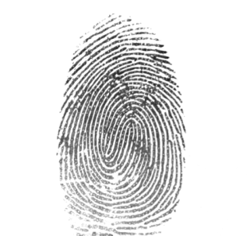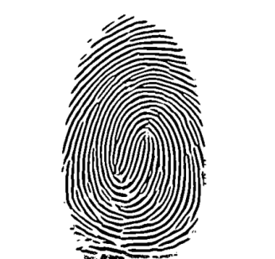
a-Original image b-enhanced image
Figure (4) the result of Gabor filter
3.2- Fingerprint image segmentation into isolated regions
After enhancement step we divided the ridges into isolated regions using edge detection segmentation, we firstly convert the enhanced image into binary image by dividing the image into (17×17) non overlap blocks and calculate the mean for each block using equation (10)
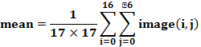 ... (10)
Then the pixel in binary image becomes
Binary image (i, j) =255 if enhanced image pixel (i, j) ≥ block mean
Binary image (i, j) =0 if enhanced image pixel (i, j) < block mean
Then edges detected by simple gradient method on binary image with vertical and horizontal masks [Liu 2008]
1 |  | -1 | 1
-1
Horizontal mask Vertical mask
If binary image (i, j+1) - binary image (i, j) =255 then pixel (i, j) is edge pixel
If binary image (i, j) - binary image (i+1, j) =255 then pixel (i, j) is edge pixel
Figure (5a) show edges detect for fingerprint image
When edge detected we divided image into isolated regions by collecting the pixels inside each closed boundary to construct each region with label for this region as shown in figure (5b and 5c).
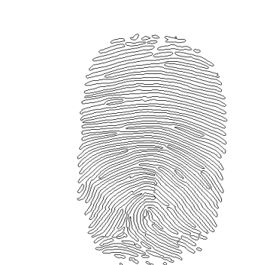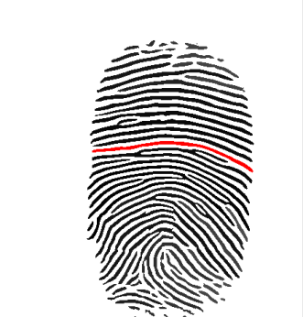
a-edges detection b-segmented image c- region drawing
Figure (5) segmented regions
3.3-Singular points detect
For core and delta detect firstly we compute the orientation for each block with selected size and then compute the Poincare index for each block.
3.3.1-Orientation Computation
Initially we calculate horizontal and vertical gradient (Gx, Gy) for every pixel in the enhanced image using sobel masks as in section (3.1) .Then we divide fingerprint image into non overlap blocks of size (W×W) where W=16, the average gradient in each block R is
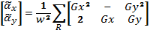 … (11)
The block gradient direction is
,) … (12)
Where
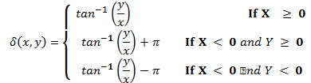 … (13)
3.3.2-poincare index
Poincare index can detect singular points speedy and directly. In Poincare index we used same block size (16×16), Poincare index is the summation of angles difference for (8) neighboring blocks along counter-clockwise direction.
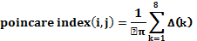 (8)
… (14)
Where
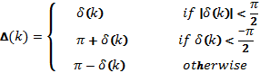 … (15)
δ (𝑘) = 𝜃 (_{(𝑘+1)mod 8},y_{(k+1) mod 8})- 𝜃(x , y) … (16)
δ(1) | δ(8) | δ(7)
δ(2) | ( i , j ) | δ(6)
δ(3) | δ(4) | δ(5)
If Poincare index of any block = 0.5 this block contain core point
If Poincare index of any block = -0.5 this block contain delta point
3.4-Minutiae detection
Most automatic systems for fingerprint comparison are based on minutiae matching; Minutiae are local discontinuities in the fingerprint pattern. A total of 150 different minutiae types have been identified. In practice only ridge ending and ridge bifurcation minutiae types are used in fingerprint recognition. Examples of minutiae are shown in figure (1); we used the same binary image determined in section 3.2.
Then The ridges in binary image are thinned to one pixel thick as in figure (6), we examining the neighborhoods of each pixel in the binary image and decide if the pixel can be deleted or not until one thick pixel ridge .
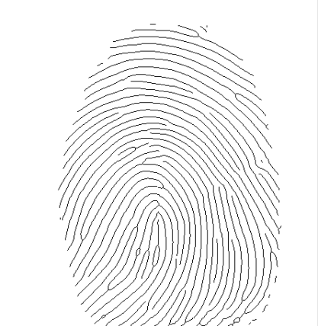
Figure (6) thin image
After thinning phase each pixel in thinned image checked as follow
If the pixel has only one black neighborhood of eight then the pixel is an end of ridge and if the pixel has three black neighborhoods of eight then the pixel is a bifurcation of ridges.
3.5-Hide in useless regions
After we detect core, delta, ending, and bifurcation each region has any feature will be neglect and we will collect the remind regions to hide in.
We used a new technique to hide message in fingerprint image into useless regions by applying the following algorithm for each useless region
For i=1 to number of rows in region
If not all pixels of row (i) = value of boundary then
Begin
Call function to calculate mean of pixels
For j=2 to the number of pixels in the row-1
Covert all pixel in the row to be equal the mean value.
Convert the mean to binary value.
Calculate the number Bits to hide in which are equal to
8- number of Most significant bits that equal to zero.
Hide bits of message into these bits except first pixel which
used as a guide to determine number of bits used in hide
information in each row.
End for
End if
End for
End algorithm
When we apply this algorithm the following states must be checked
1-If all pixels in the row equal to boundary value then the row must be neglected.
2-We leave first and last values of each row because they are edge.
3-For each row verify the two conditions above
A-calculate the mean of row pixels.
B-never hide in the first pixel of row.
C-convert the mean to binary number and perform the
Following.
i-Calculate number of most significant bits equal
to zero.
ii- Reduced these bits and hide in remaining bits
Of each pixels.
For region in figure (7)
1-We ignore the first row because all pixels in this row are edge.
2-For second row mean of pixels (not boundary) equal to ((81+85)/2) =83 which represented in binary
0 | 1 | 0 | 1 | 0 | 0 | 1 | 1

Then we found the number of MSBs equal to zero is (1) then the number of bits will be used in hiding information equal to (7) and we hide only in pixel in column number (3), we let pixel in column (2) as guide to retrieve information in second stage.
For third row the mean of pixels equal to ((55+54+50)/3) =53, in the same way we hide in six least significant bits of pixels in column (3) and (4) only.

0 | 0 | 1 | 1 | 0 | 1 | 0 | 1

Row number |  | Column number |  |  |  |  |  | Row number |  | Column number
 |  | 1 | 2 | 3 | 4 | 5 |  |  |  | 1 | 2 | 3 | 4 | 5
1 |  | 90 | 90 | 90 | 90 |  |  | 1 |  | 90 | 90 | 90 | 90
2 |  | 90 | 81 | 85 | 90 |  |  | 2 |  | 90 | 83 | 83 | 90
3 |  | 90 | 55 | 50 | 54 | 90 |  | 3 |  | 90 | 53 | 53 | 53 | 90
4 |  | 90 | 80 | 82 | 84 | 90 |  | 4 |  | 90 | 82 | 82 | 82 | 90
5 |  | 90 | 78 | 80 | 82 | 90 |  | 5 |  | 90 | 80 | 80 | 80 | 90
6 |  | 90 | 90 | 90 | 90 | 90 |  | 6 |  | 90 | 90 | 90 | 90 | 90
a-input region b-apply algorithm
Figure (7) applying algorithm
3.6-Extract message from cover image
In second stage we applying the same techniques used in section 3.2, 3.3, and 3.4 for fingerprint segmentation,
Singular points detect, and Minutiae detect to determine the useless regions for extract information from it.
By the same way when we need to extract message from fingerprint image we read the first pixel in each row in useless regions then from this value we know the number of pixels used in hiding information by converting this value to binary and calculating the number of MSBs equal to zero, from this value we determined number of bits used in information hiding which equal to 8- number of MSBs equal to zero.
3.7-Experiment Results
Figure (8) explain the results of proposed system
Dimensions of original and stego images are (504 * 532) and the size of message file is (8.66 KB) Peak signal to noise ratio for this state is (25.18) which is calculated using equation (17).
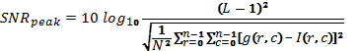

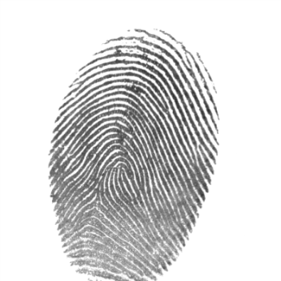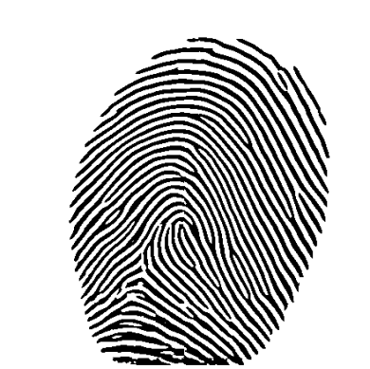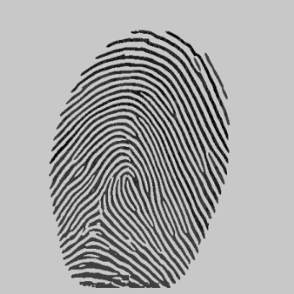
a-original image b-enhanced image c-stego image
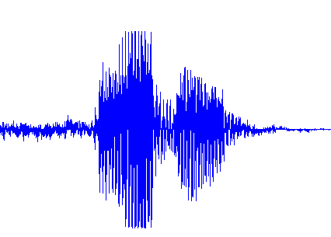
d- Sound wave
Figure (8) result (2) of proposed system
3-Conclusion
1-The gray level of Some useless pixels closer to mean of image so after hiding information these pixels may be access the image mean in both directions ( black pixels become white in convert to binary image or white pixels become black) therefore these pixels must be handle to avoid errors in extract information.
2-Hides of information don't alter the main features of fingerprint image so the system of fingerprint matching doesn't be affected.
3-When automated fingerprint system fail in personal identification, hiding information can play a major rule to assist decision for accept or reject matching decision.
4-Segmentation of image is the key for sound results, any way lead to under segmentation cause to merge many ridges in one region which effect in reducing total number of pixel available for hiding information while the results of over segmentation make the positions of pixels used in hide information more randomize.
5-enhancment step play a major rule in access accurate results s in all other steps so we must apply appropriate and strong way in this step.

References
[Anil 2008] Anil K. Jain, Patrick Flynn, and Arun A.ross, "Handbook of Biometrics", USA, 2008.
[Eric 2003] Eric Cole, "Steganography and the Art of Covert Communication", 2003.
[Liu 2008] Liu Wei, "Fingerprint Classification Using Singularities detection", international journal of mathematics and computers in simulation, 2008.
[Peihao 2007] Peihao Huang, chia-yung, chaur-chin Chen, "implementation of an automatic fingerprint identification system", Taiwan, 2007.
[Qinzhi 2006] Qinzhi Zhang, Kai Huang, and Hong Yan," Fingerprint Classification Based on Extraction and Analysis of Singularities and Pseudo ridges", Australia, 2006.
[salil 2002] Salil Prabhakara, Anil K. Jainb, Sharath Pankantic, "Learning fingerprint minutiae location and type", USA, 2002.
[Sumit 2005] Sumit Tandon," edge detection", university of Texas at Arlington, 2005.

