Isolation and identification of antibiotic-producing actinomycetes

Rabab omran and mohammed fadhil kadhem
Babylon University, college of science, department of biology
Abstract
Fourteen actinomycetes strains were isolated from soils in different locations in hilla city. Antibacterial Primary screening assays showed that five isolates were the most potential antibacterial producers, whereas three isolates had antifungal activity when evaluated by antifungal primary screening assays. Among all these isolates, strain 40A was the most active isolate against pathogenic bacteria and fungi. The characteristics of isolate were studied at the morphological, cultural and physiological level. From the characteristics of strain 40A, the isolate was not Streptomyces, but it could be pseudonocardia for the similarities between them.
Introduction
Actinomycetes are Gram-stain-positive or Gram-stain-variable microorganisms, which show diverse morphological properties that range from cocci to highly differentiated mycelia. Most are saprophytic chemoorganotrophs which grow at neutral pH, but some are acidophiles or alkalophiles (Goodfellow, 2012).
Actinomycetes are the richest microorganisms in the production of antibiotics, secondary metabolites isolated from microbes and exhibits either antimicrobial (antibacterial, antifungal, antiprotozoal), antitumor and/or antiviral activities. All microorganisms produce 16500 antibiotics, where 52% from these compounds being produced by actinomycetes. More than 68% of these actinomycetes metabolites derived from Streptomyces and others from the so called rare actinomycetes (rare action) species ( Berdy, 2005).
The present study is an attempt to isolate rare actinomycetes producing antibiotics, because these rare actinos may produce the most diverse and unique compounds exhibiting low toxicity.
Materials and method
Collection of soil samples
The soil samples were collected from various locations in Hilla city, dried separately at 45 °C for 1 h in a hot air oven and then cooled to room temperature. The soil sample (1 g) was added to a conical flask containing 100 ml of sterile water.
The flasks were shaken for 30 min and their contents designated stock cultures.
Isolation of actinomycetes
A series of culture tubes containing 9 ml of sterile water was taken. From the stock culture, 1 ml suspension was transferred aseptically to the 1st tube (10-1) and mixed well. Further serial dilutions were made to produce 10-5 suspensions. Suspension (0.1 ml) from each culture tube was spread on sterile starch-casein agar medium plates aseptically. The plates were incubated at 27 ± 2 °C for 84 h. The plates were observed intermittently during incubation. The distinctive colony of actinomycetes were selected and purified by multiple streaking methods. The stock cultures of each selected strain was prepared and maintained in transport swab media (AMES media) at +4 °C for the further studies.
Screening of strains for antagonistic activity
1. Primary screening
Preliminary screening for antibacterial activity was done by the cross-streak method (Madigan et al., 2012), on four media (PDA, TSA, NA and MHA). Actinobacteria from transport swab media were streaked across one-third of the plates and the plates incubated at 27 0c for 10 days. After incubation the test bacteria were streaked perpendicular to the actinomycete, and the plates were further incubated at 37 0c for 24 h. The inhibitory effect was determined by the failure of test bacteria to grow near producing actinomycete.
Crawford et al. (1993) method was followed for primary screening of antifungal activity. On the PDA, the actinomycetes from transport swab media were streaked onto one side of plates and the plates were incubated at 30 0C for 72 h, at which time the colonies had just become visible. Then, agar plug from 10 day old culture of test fungi was transferred onto the other side of each plate. Fungal plugs were also placed on uninoculated PDA plates separately as uninhibited controls. Cultures were incubated at 300C, and the plates were examined for inhibition of growth after 5 days. The level of inhibition was defined as the subtraction of the fungal growth radius y0 [in centimeters]) of a control culture from the distance of the growth in the direction of actinomycetes y [in centimeters],where ∆y = y0 – y.
2. Secondary screening
Based on the zone of inhibition, secondary antimicrobial screening was done under submerged fermentation conditions by agar well diffusion assay .The antimicrobial producing actinomycetes were grown on the PDB with pH 8 at 30 0c for 10 days. To obtain the cell-free filtered supernatant after incubation, the culture broth was centrifuged at 8000 xg for 10 min and filtered by millipore filter (0.22). On the muller hinton agar the test microorganisms were swabbed by sterile transport swab ,the wells (6.0 mm diameter, 2.0 cm apart) were cut from MHA using a sterile cork borer and 100 µl of filtered supernatant was loaded into each well for the assay of antagonistic activity . The dishes were preincubated at 4°C for 2 h to allow uniform diffusion into the agar. After preincubation, the plates were incubated at 37°C for 24h for bacteria and at 30°C for 48 h incubation for fungi. The antimicrobial activity was evaluated by the measuring of inhibition zones diameter.
Characterization of antibiotic-producing isolate at the genus level
Morphological identification
The 40 A isolate was stained with gram stain and examined by light microscope at 1000x magnification. The 40A colony on the ISP 1 was examined under light microscope at 400x, to observe the aerial mycelium at the margins of the colony.
Cultural and physiological identification
Cultural features of 40 A isolate were characterized following the directions given by the International Streptomyces Project (ISP) (Shirling and Göttlieb, 1966). The Tryptone-yeast extract agar (ISP 1), yeast extract-malt extract agar (ISP-2), oatmeal agar (ISP-3), inorganic salt-starch agar (ISP-4), glycerol-asparagine agar (ISP-5), peptone-yeast-extract-iron agar (ISP-6), tyrosine agar (ISP-7) were inoculated with 40 A isolate and incubated at 300c for 10 days. The color of aerial mycelium, substrate mycelium color (reverse side of plate) and density of growth were observed after incubation period.
Physiologically, to determine whether the isolate resistance to lysozyme or not, lysozyme basal media with different concentrations of lysozyme (10, 25, 50, 75 and 100 μg/ml) was cultured with 40 A isolate and incubated at 30 0c for 10 days. The resistance was determined by the presence of growth. (Kutzner, 1981).

Results and discussion
Soil screening
Fourteen actinomycetes were isolated from soil samples. The isolates were selected depending on its distinctive morphology on agar which gives rapid clues to its identity.
Primary screening
The results of the primary antibacterial screening assays indicated that, 5 of 14 strains (35.71%) had some antagonistic activity against gram positive and gram negative pathogenic bacteria (Table 1). The results showed that PDA is the best media for detection of antibacterial activity of actinomycetes in the primary screening assay. Most of the strains suppressed in different degree the test bacteria ranging from weak inhibition (+) to very good or complete inhibition (+++). All antagonistic strains had weak or no inhibitory activity against pseudomonas aeuroginosa but repressed other test bacteria in a significant extent.
Antifungal primary screening assays were revealed that three isolates from fourteen (21.4%) had significant antagonistic activity against Microsporum canis and/or Trichophyton mentagrophytes (Table 2).
From the primary screening assay, 40A isolate was the most active strain in its antibacterial and antifungal activity (figure 1).
Table 1. Antibacterial activity of selected actinomycetes strains against gram positive and gram negative pathogenic bacteria.
NA |  |  |  | PDA |  |  |  | TSA |  |  |  | SCA |  |  |  |  | isolate
P | M | S1 | S2 | P | M | S1 | S2 | P | M | S1 | S2 | P | M | S1 | S2 |  | isolate
- | - | - | - | - | - | - | - | - | - | - | - | - | - | - | - | 1. 91A1
 |  | - | - | - | - | - | - |  |  | - | - | - | - | - | - | 2. 91A2
- | - | - | - | ++ | +++ | - | - | + | - | - | - | - | - | - | - | 3. 23 cb A1
- | - | - | - | - | - | - | - | - | - | - | - | - | - | - | - | 4. 23 cb A2
- | - | - | - | - | ++ | - | - | - | - | - | - | - | - | - | - | 5. 29 A1
- | - | - | - | - | +++ | - | - | - | - | - | - | - | - | - | - | 6. 29 A2
- | - | - | - | - | - | - | - | - | - | - | - | - | - | - | - | 7. 90 A1
- | - | - | - | - | - | - | - | - | - | - | - | - | - | - | - | 8. 90 A2
- | - | - | - | - | - | - | - | - | - | - | - | - | - | - | - | 9. 24 A1
- | - | - | - | + | + | - | - | - | - | - | - | - | - | - | - | 10. 24 A2
- | - | - | - | - | - | - | - | - | - | - | - | - | - | - | - | 11. 24 A3
- | - | - | - | - | - | - | - | - | - | - | - | - | - | - | - | 12. 28A 1
- | - | - | - | - | - | - | - | - | - | - | - | - | - | - | - | 13. 28 A 2
- | - | - | - | - | + | +++ | +++ | - | - | - | - | - | - | - | - | 14. 40 A
A= actinomycete, - = no inhibition, + = weak inhibition, ++ = good inhibition, +++ = very good inhibition. SCA= starch casein agar, TSA= trypticase soya agar, PDA= potato dextrose, NA= nutreient agar, P= Pseudomonas aeruginosa, M= Morganella morganii, S1= Staphylococcus aureus, S2= Streptococcus pyogenes.
Secondary screening
The antimicrobial activity of the strain 40A from the liquid culture of four different medium was also tested against S. aureus, M. morganii and T. mentagrophytes. The variable inhibitory effects of strain 40A in secondary screening verified the results which obtained from primary screening.

Characteristics of the strain 40A selected for fermentation
A great variety of morphological, cultural, and physiological and other features of the strain 40A were studied. Colonies of strain 40A are grey or pale brown and wrinkled on ISP2 agar revealed the presence of the vegetative hyphae. (Figure 2).
Table 2. Antifungal primary screening test for actinomycetes isolates.
M.canis | T. mentagrophyte | Isolates
+ | *++ | 1. 91 A1
++ | + | 2. 91 A2
++ | + | 3. 23 cb A1
++ | ++ | 4. 23 cb A2
+ | +++ | 5. 29 A 1
++ | ++ | 6. 29 A 2
+++ | + | 7. 90 A 1
++ | + | 8. 90 A 2
+ | ++ | 9. 24 A 1
+ | - | 10. 24 A2
++ | + | 11. 24 A3
++ | + | 12. 28 A 1
- | - | 13. 28 A 2
+++ | +++ | 14. 40 A
* + + +, very strong inhibition, with zone of inhibition (∆y) of 2.0 cm; ++, strong inhibition, with zone of inhibition of .1.0 cm; +, growth definitely retarded, with obvious zone of inhibition near colony; -, no inhibition.

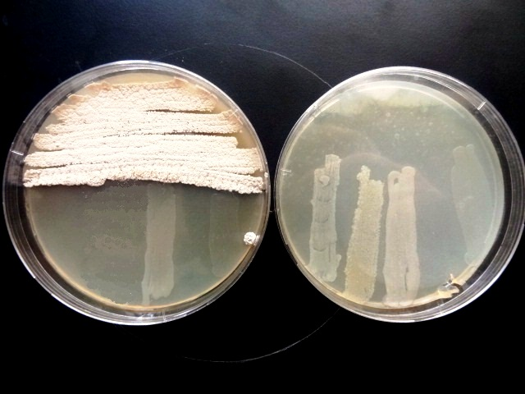
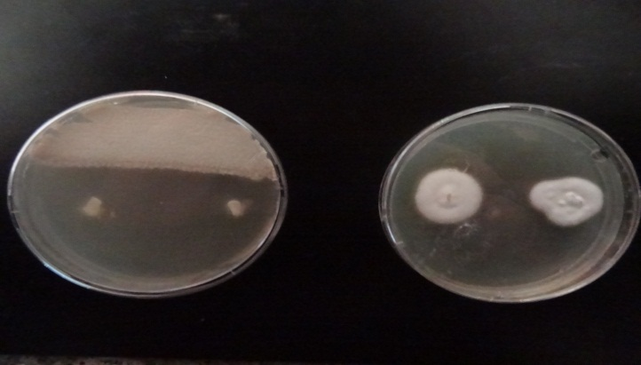
A
B
1
2
T. m
M.c.
2
S2 S1 M P
1
2
1
2

Figure (1). Antibacterial and antifungal Primary screening test for 40A isolate. (A) weak growth of fungi in plate (1) comparing with control plate (2) refer to the presence of antifungal activity by 40A. (B) the growth line absence of test bacteria in the plate (1) after comparing with control plate (2) mean there is antibacterial activity by strain 40A.
Table 3. Antimicrobial activity of fermentation culture broth of the strain 40A (mm).
Time (h) | TM* | Fermentation medium
Time (h) | TM* | FM1 | FM2 | FM3 | FM4
24 | S1 M T. m | - | - | - | -
48 | S1 M T. m | - | - | - | -
72 | S1 M T. m | 1.2 - - | - - - | 1.9 - 12 | - - -
96 | S1 M T. m | 1.6 - 1.2 | 1.4 - 1.2 | 2.1 - 1.6 | 1.2 - 1.2
120 | S1 M T. m | 1.9 - 1.4 | 1.8 - 1.4 | 2.1 - 1.6 | 1.5 - 1.2
144 | S1 M T. m | 1.9 - 1.4 | 1.8 - 1.4 | 2.1 - 1.6 | 1.5 - 1.2
166 | S1 M T. m | 1.9 - 1.4 | 1.8 - 1.4 | 2.1 - 1.6 | 1.5 - 1.2
* TM; Test Microorganisms, S1; S. aureus, M; M. morgani, T.m; T. mentagrophytes.
FM1; Fermentation medium 1 (potato infusion, lactose), FM2; Fermentation medium 2 (potato infusion, dextrose) FM3; Fermentation medium 3 (potato infusion, glucose), FM4; Fermentation medium 4(potato infusion, fructose).
- negative, , inhibition zones including well diameter (6 mm).
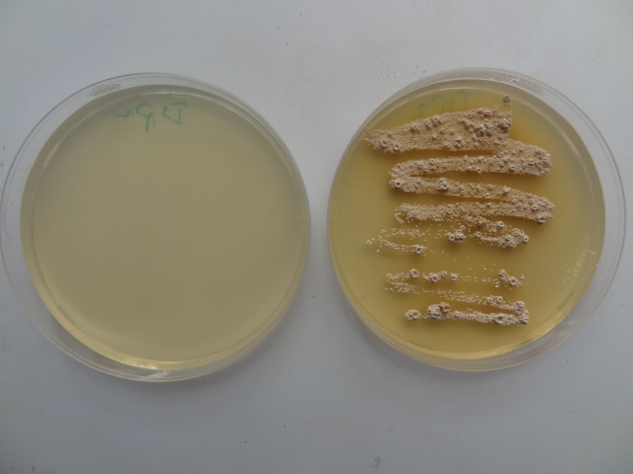
Figure 2. Colonies of strain 40A on yeast malt extract agar (ISP2).
Growth, the aerial and substrate mycelium color and formation of soluble pigments were observed in nine different media after 14 days. The 40A isolate is aerobic, gram positive filamentous bacteria with fragmented aerial and substrate mycelia. During observation with light microscopy on the ISP 1, hyphae is divided by transverse septa and have a zig-zag shape (figure 3 ).
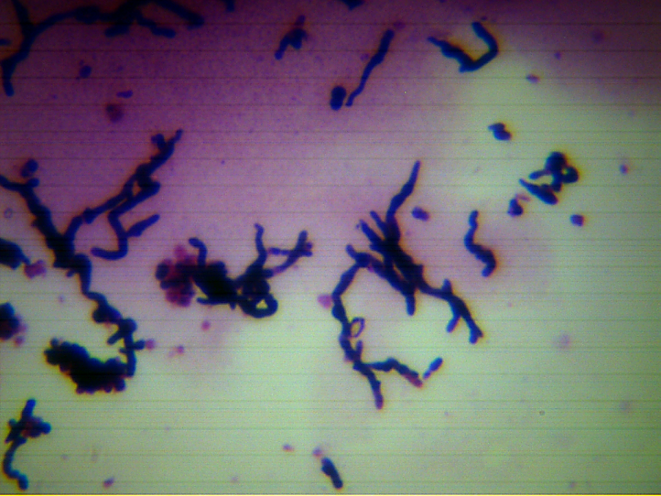
1000x
400x
A
B
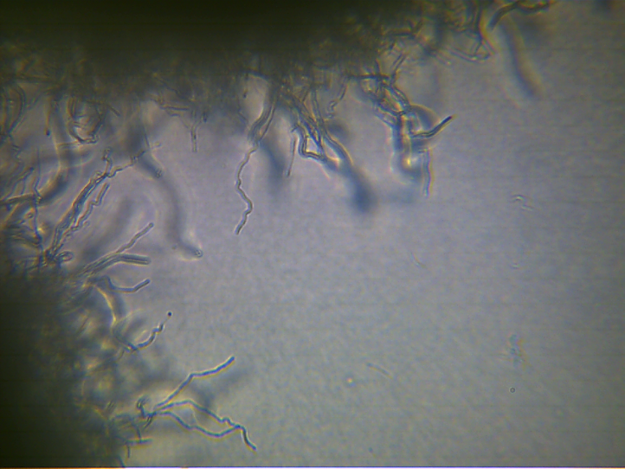

Figure 3. morphological properties of strain 40A (a)aerial mycelia fragmented into small elements through staing with gram stain, (b) septated substrate mycelia with zig-zag shape on the Tryptone-yeast extract agar (ISP 1).
40A isolate showed different color of aerial and substrate mycelia; produced yellow to brown diffusible pigments when grown on the ISP4 and glucose-nitrate agar (Table 4). The strain produced melanoid pigment on both ISP 6 and ISP 7. Physiologically, isolate was resistance to all concentrations of lysozyme.
From these characteristics, the strain 40A is not streptomyces but according to morphological ( Holt, 1994) and physiological features mostly can be pseudonocardia.
Table 4. Cultural characteristics of potential antimicrobial strain 40A
Medium | Growth* | HMC | SMC
Tryptone-yeast extract agar (ISP 1)  yeast extract-malt extract agar (ISP-2)  oatmeal agar (ISP-3)  inorganic salt-starch agar (ISP-4)  glycerol-asparagine agar (ISP-5)  peptone-yeast-extract-iron agar (ISP-6)  tyrosine agar (ISP-7) | +++  +++  +++  ++  ++  ++  +++ | Grey / brown  Grey  Grey  Grey  Grey  Grey  Grey | brown Pale  brown Cream  Grey  Yellow/brown  Grey  Grey  Cream

* HMC; aerial mycelium color, SMC; substrate mycelium color, +; sparse growth, ++; poor growth, +++; moderate growth, ++++; abundant.

References
Bérdy J. (2005) Bioactive Microbial Metabolites. J. Antibiot. 58(1): 1–26.
Crawford DL, Lynch JM, Whipps JM, Ousley MA (1993) Isolation and characterization of actinomycete antagonists of a fungal root pathogen. Appl Environ Microbiol 59:3899–3905.
Goodfellow M. (2012). Phylum XXVI. Actinobacteria phyl. nov. In Bergey's Manual of Systematic Bacteriology. 5th ed.Williams and Wilkins Company, Baltimore, pp. 33.
Holt JG, Krieg NR, Sneath PH, Staley JT and Williams ST (1994). Bergey’s manual of determinative bacteriology. 19th ed. Williams and wilkins, awverly company. pp. 607-617.
Kutzner, H.J. (1981). The family Streptomycetaceae In: Starr, M.P., Stolp, H. Trüper, H.G., Balons, And A. Schlegel, H.G. (eds.): The Prokaryotes – A handbook on habitats, isolation and identification of bacteria Springer Verlag, Berlin. pp. 2028-2090.
Madigan M T, Martinko JM, Stahl DA and Clark DP (2012). Commercial Products and Biotechnology. In Brock biology of microorganisms. 13th ed. Benjamin cumings.pp. 415-416.
Shirling EB, Gottlieb D (1966). Methods for characterization of Streptomyces species. Int. J. Syst. Bacteriol. 16: 313-340.

