Monthly Variation of Some Air Pollutants in Hilla City –Middle of Iraq

Jwad K. manii Ahmed K. Al- jumaylii
Babylon University - geology department.
Sameer Azize
Babylon Environment Protection department.
Abstract:
This study is one of the recent approaches to deal with management of environmental pollution. It was carried out to analysize the pollution levels in the air, of hilla city. The study measured the pollutants concentrations of air such as PM₁₀, NO_{X}, CO, SO₂ and O₃. The results showed that TSP levels measured as (PM₁₀) exceeded the standard level of pollution, the concentration level increased to reach a high concentration in babylon environment department station (693μg/m³),these concentrations exceeded the international standard levels, which indicates existance of pollution. CO concentrations in All stations went below the standard levels, its high concentrations masured in babylon university station air is (7.3 ppm) which is less than the standard levels. The results also revealed that SO₂ concentration less than the standard (0.3ppm) because its average was (11.3ppb),alevel less than that of the International level .O3 average concentration was (54 ppb)and is also less than that of the standard.NO_{X} average concentration was (45.4 ppb)and is also less than that of the standard. As a conclusion Hilla city air is principally polluted with PM10 due to effects dust storm espishaly at summer months, and transportation means and because of commercial and services activities . however the pollutants percentage with (NO_{X}, CO, SO₂ and O₃. found in this study is less than that of the standard levels.The high percentage due to steady increasing of transportation means , traffic jam and bad fuel quality .
1.1 Introduction
Pollution can be defined as an undesirable change in the physical, chemical or biological
characteristics of the air, water or land that can affect health, survival or activities of humans or
other organisms (Smith, 1996; WHO, 1997; Marilena & Elias, 2008). Air pollutants are divided into two main groups: particulates and gases. Because particulates consist of solids and/or liquid material, air pollutants therefore encompass all three basic forms of matter. Gaseous pollutants include gaseous forms of sulfur and nitrogen. Gaseous SO₂ is colorless, yet one can point to the bluish smoke leaving combustion operation stacks as SO₂ or, more correctly, SO₃ or sulfuric acid mist. Nitric oxide (NO) is another colorless gas generated in combustion processes; the brown color observed a few miles downwind is nitrogen dioxide (NO₂), the product of photochemical oxidation of NO (L. K. Wang et all.,2002).. When controls of these facilities did not result in a significant reduction of the problem, it was then discovered that the internal combustion engine was a major cause of this new type of pollution. The result of photochemical oxidation is seen in the brown haze apparent in the upper layer of the atmosphere. The brown haze is a mixture of particulates, oxides of nitrogen, sulfuric-acid mist condensed from the oxidation of sulfur dioxide, and particles produced from photochemical reaction in the atmosphere(Boubel, R. W.et all.,1995) .
1-2 Study area:
The studied area is Hilla location inside Iraq Coordinates: 32°29`N 44°26`E .is a city in central Iraq on the Hilla branch of the Euphrates River, 100 km south of Baghdad. It is the capital of Babil province and is located near the ancient cities of Babylon. It is situated in a predominantly agricultural region which is extensively irrigated with water provided by the Hilla canal. Fig. 1 shows this region. 4 sampling sites were set to collect the air samples according to the standard sampling procedures for nine months Daily sampling were done in 2010, starting The names of the sampling sites are listed in Table 1. The meteorological data were reported by this stations. One portable and three analytical stable stations , which equipped, has been used for sampling. This instrument was able to measure the size distribution of particulate matter in urban and also in the industrial areas.
1.3 Aims:
The main objectives stated for the development of an air quality measurement and air quality determination to check.
♦ Air quality standards to monitor current levels.
♦ To detect individual sources.
♦Assess effects of air pollution on health.

Abo kistawi st.
Envi. Dep. St.
Babylon unvi.. St.
mamera. St.

Figure (1) The position of Air pollution monitoring stations and the map of study area

2.1 Materials and Methods :
In this research we used diffusive sampler to determine of air pollution situation in hilla city.A diffusive sampler is a device capable of taking gas samples from the atmosphere at a rate controlled by molecular diffusion, one portable and three stable stations , which equipped , has been used for sampling and determination. This instrument also was able to measure the size distribution of particulate matter in urban and also in the industrial areas. Fig. 1 shows this region in Hilla city. 4 sampling sites were set to collect the air samples according to the standard sampling procedures. Daily sampling were done in 2010, starting 8.0 AM (the morning rush hour). The monthly mean concentration were calculated in the selected district in Hilla during the study are showing at table 1. The names of the sampling sites and their related geographical coordinates in Hilla city are listed in Table 1 also , During this study the data were available from the Babylon environmental department.
2.2 meteorology
The weather on all scales in space and time acts on the transport and dilution of air pollutants and plays different roles on the air quality that we measure and feel. Meteorology specifies what happens to air pollutants from the time it is emitted from its source until it is detected at some location.
2.2.1 Wind Local wind and temperature patterns play a significant role on the dilution of air pollution. The transport of pollutants emitted into the atmosphere is a function of the local (average) wind direction. During this study the we using data were available from the Babylon environmental department to plot many figures showing the presentation of measured meteorological data is of great importance to understand the physical properties of the local atmospheric conditions. Results from wind measurements are usually presented in the form of frequency distributions. Frequency distributions are either presented as matrixes (wind speed versus wind direction) or as wind roses. Wind roses are used to visualise the frequency distribution of wind speed versus wind direction for different measurement stations figure (2) showing the most commonly wind direction is south west.
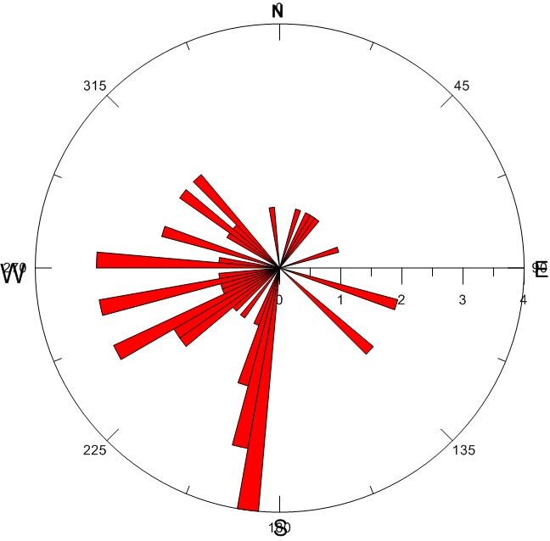

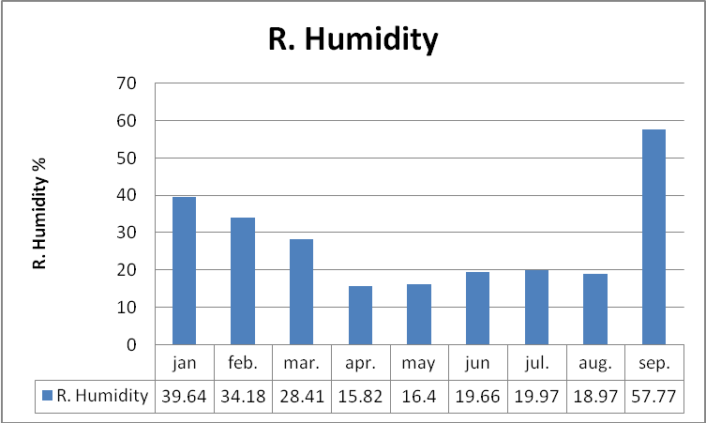

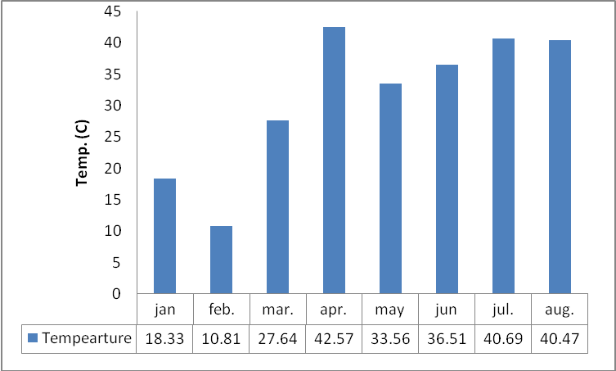

Figure 4: Wind temperature for different measurement sites at hilla city

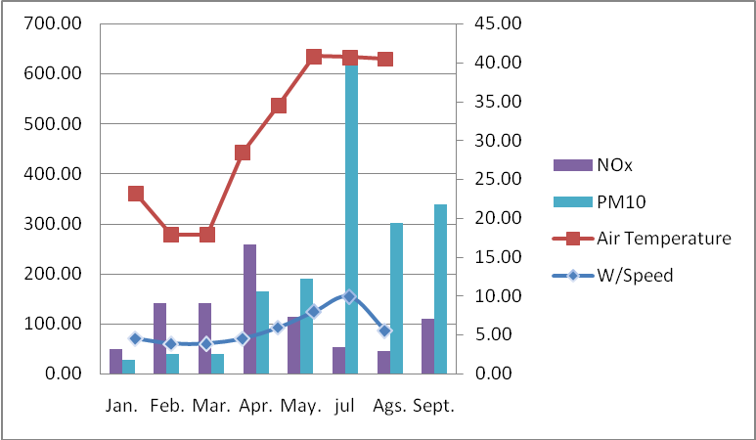
Concentration of (NO_{X},PM₁₀)
Figure 5 The concentration of , NO_{X} and PM₁₀ at one of the hilla sites from January 2010 to September 2010

2.2Discussions:
It is normally not possible to measure all the air pollutants present in the urban atmosphere. We therefore have to choose some indicators that should represent a set of parameters selected to reflect the status of the environment. The results of this study are based on the data were compiled from 4 stations , data were available from the Babylon environmental department. The local siting of the monitoring stations varies considerably, but most of them are located near busy streets or in industrial areas, in urban or suburban environments. We focus on the pollutants included in the health-based guidelines, i.e., carbon monoxide (CO), nitrogen monoxide (NOx),sulphur dioxide (SO₂),and O₃ concentrations.
1- NO_{X} There are a number of oxides of nitrogen, including nitrous oxide (N₂O), nitric oxide (NO), nitrogen dioxide (NO₂), nitrogen trioxide (N₂O₃), and nitrogen pentoxide (N₂O₅), that are referred to collectively as NOx. The two oxides of nitrogen that are of primary concern to air pollution are NO and NO₂. NO is a colorless gas that is a precursor to NO₂ and is an active compound in photochemical reactions that produce smog. NO₂is a reddish brown gas that gives color to smog and can contribute to opacity in flue gas plumes from stacks(Air pollution ,2002).
The mean concentrations of NO_{X} in 4 sampling stations are shown in Fig. 2. The monthly average concentrations of NO_{X} ranged from 6.3 to 107 PPb. As concentration of NO_{X} in Abo kistawii station is much higher than the other stations in study area. we compared these results with the percent ratios of NO₂is a criteria pollutant with a National Ambient Air Quality Standard of 100g/m³), or 0.053 ppm, annual average. The results show that monthly average concentrations were low in the city.

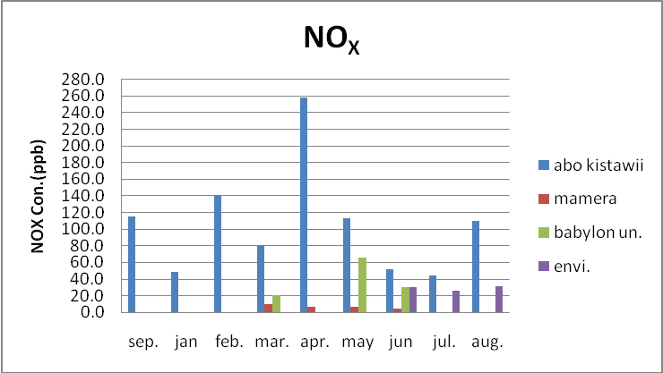
Fig. 6. Monthly average concentrations of NO_{X} at 4 sites in Hilla city

2-CO :
The indicators generated from traffic, such as NOx, SO₂ (diesel buses) and CO, show strong diurnal variations when measured in streets or close to roads(Bjarne S.,2000). Figure 7 show the Monthly average concentrations of CO. The mean concentrations of Carbon monoxide (CO) in 4 sampling stations are shown the higher values belong to those of Babylon university station. The concentrations of CO pollutants were estimated at all stations to be lower than standard values (35 ppm) according to the (NAAQS,2005).

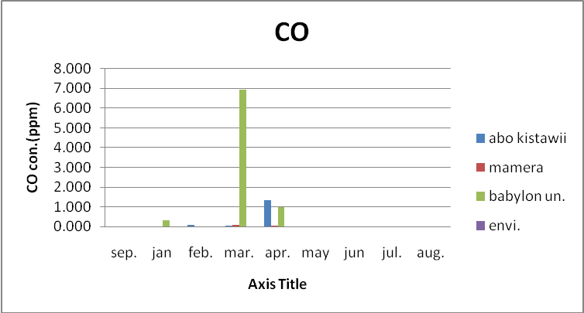

Fig. 7. Monthly average concentrations of CO at 4 sites in Hilla city

Station | Months | SO2 | NOx | CO | O3 | PM10
bo kistawi monitoring station |  | [ppb] | [ppb] | [ppm] | [ppb] | [ug/m3]
bo kistawi monitoring station | mar | - | - | 0.08 | - | 286.21
bo kistawi monitoring station | Apr. | 9.53 | 9.18 | 0.06 | 45.64 | 263.76
bo kistawi monitoring station | May | 21.07 | 6.04 | 0.00 | 51.77 | 170.86
bo kistawi monitoring station | Jun. | 33.62 | 6.38 | 0.00 | 67.28 | 223.82
bo kistawi monitoring station | Jul | 7.33 | 3.97 | 0.00 | 61.61 | 608.30
Mamera monitoring station |  | SO2 | NOx | CO | O3 | PM10
Mamera monitoring station | sep. | 7.748 | 115.495 | 0.418 | 41.235
Mamera monitoring station | jan | 5.694 | 48.518 | 0.106 | 42.275 | 27.468
Mamera monitoring station | feb. | 12.143 | 141.608 | 0.090 | 54.844 | 38.182
Mamera monitoring station | mar. | 12.084 | 80.709 | 0.055 | 51.188 | 82.625
Mamera monitoring station | apr. | 6.371 | 258.609 | 1.330 | 32.228 | 163.676
Mamera monitoring station | may | 3.370 | 113.036 | 0.000 | 57.992 | 188.780
Mamera monitoring station | jun | 1.144 | 51.938 | 0.220 | 56.119 | 639.241
Mamera monitoring station | jul. | 0.000 | 44.460 | 0.000 | 72.267 | 301.135
Mamera monitoring station | aug. | 0.000 | 110.113 | 0.000 | 93.380 | 338.865
Babylon university monitoring station |  | SO2 | NOx | CO | O3 | PM10
Babylon university monitoring station | jan | 18.155 | 20.856 | 0.330 | 31.491 | -
Babylon university monitoring station | mar. | 10.858 | 65.989 | 6.951 | 50.029 | -
Babylon university monitoring station | apr. | 6.344 | 29.698 | 0.970 | 59.680 | 373.525
Babylon university monitoring station | may. | 8.601 | 47.843 | 3.960 | 54.854 | 373.525
babylonenvironment dept. monitoring station |  | SO2 | NOx | CO | O3 | PM10
babylonenvironment dept. monitoring station | jun | 10.233 | 29.985 | 0.000 | 57.673 | 553.097
babylonenvironment dept. monitoring station | jul. | 5.807 | 26.097 | 0.000 | 61.750 | -
babylonenvironment dept. monitoring station | agu. | 11.428 | 31.560 | 0.000 | 59.533 | 834.250
Table 1. Monthly of mean pollutant concentration and names of the monitoring Air sampling sites

3- Ozone O₃:
Ozone is a molecule composed of three oxygen atoms (O₃). In the layer of the upper atmosphere known as the stratosphere, ozone filters out the Sun’s harmful high-energy ultraviolet (UV) radiation. The ozone molecule forms in the stratosphere when UV energy breaks down some\O₂ molecules to make single O-atoms (Bjarne S.,2000). These O-atoms then bond with other O₂ molecules to form O₃. The reverse process also takes place in the stratosphere as UV energy breaks apart O₃ molecules to make O₂ and O. Ozone is an important pollutant in terms of health effects, with clear impacts at all levels of morbidity and an effect on bringing forward death. It is a seasonal pollutant and thus has a much greater effect in the summer months in temperate climes but is a year-round pollutant in areas with long hours of sunshine. The annual pattern of O3 followed strongly the amount of available of solar radiation as they increase toward summer O3 concentration (Jarvel L., et all, 2009) . The concentrations of O₃ pollutants were estimated at all stations of 8-h average Air Quality Limit value of the year of measurements to be lower than standard values (120 ppb) according to the (NAAQS,2005). The highest values were measured at summer season.

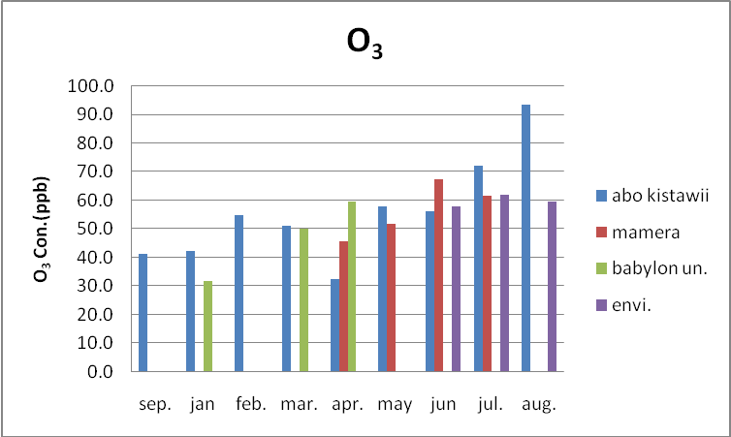
Fig. 8. Monthly average concentrations of O₃ at 4 sites in Hilla city

4- Sulfur dioxide SO₂
In 1990 the WHO determined that for sulfur dioxide levels of around 200 kgm⁻³ (70 ppb), small transient reductions in lung function could be seen in children and adults that could last for as much as two to four weeks. Their interpretation of the research available up to that time
led them to state that if levels of SO₂reached 250 kgm⁻³ (87 ppb), there was a measurable increase in respiratory morbidity amongst susceptible adults and perhaps also in children, these being more marked when levels reached around 400 kgm⁻³ (140 ppb). The monthly average concentrations of SO₂ in the study are ranged from 5.9 to 17.8 ppb as presented in Figure 9

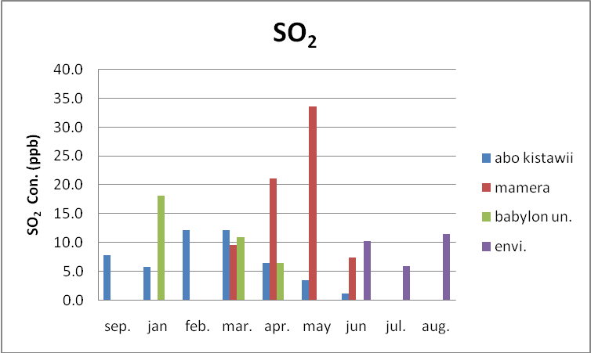
Fig. 9. Monthly average concentrations of SO₂ at 4 sites in Hilla city

5- Concentrations of PM₁₀:
Among the major air pollutants released to the atmosphere, suspended particulate air pollution are considered as one of the major health impact and therefore a large number of related studies have been undertaken in developing countries in the last decade (Douglas et al., 2002; Silibello et al., 2008). Total Suspended Particulate matter is the most important pollutant worldwide, both indoors and outdoors, in terms of human health effects. Particulates, especially fine particles, contain large amounts of inorganic and organic toxic materials, such as heavy metals and polycyclic aromatic hydrocarbons. Effects on mortality, respiratory and cardiovascular hospital admissions have been observed at daily average PM₁₀ (particles below 10 micrometre) levels well below 100(μg/m3)( Bjarne S.,2000). In in 4 sampling stations, annual mean PM₁₀ concentrations range between 222- 693 μg/m³, High PM₁₀ annual mean concentrations are record in envi. station ranging between 553-693 μg/m3. in the selected district with their mean concentrations of PM₁₀ are listed in Table 2. As the mean concentrations of PM₁₀ indicate, The mean concentrations of particulate matter as PM₁₀ in 4 sampling stations in 2010 are shown in Fig. 10. The highest concentration were systemically measure in last summer (June, July and august) .

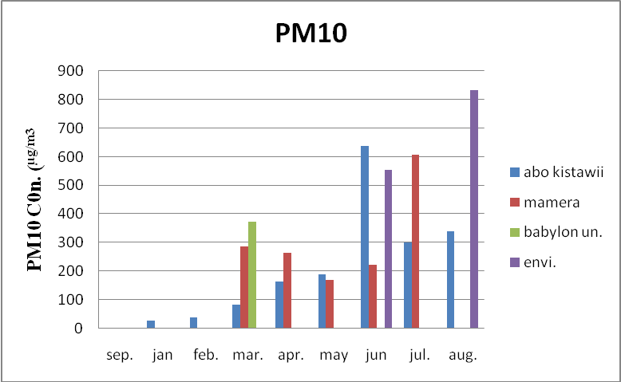
Fig. 10. Annual average concentrations of PM₁₀ at 4 sites in Hilla city

Table 2 National ambient Air Quality Standard, 2005(NAQSA)
Criteria Polution | Average period | Primary NAAQS | WHO
PM10 (Particulate matter<10µm | Annual | 20µg/m | 20µg/m
SO2 (Sulfer dioxide) | Annual | 0.03ppm | 50µg/m
NOX (Nitrogen oxide) | Annual | 0.053ppm | 30µg/m
O3 Ozone | 8h | 0.012ppm | 0.012ppm
Co (carbon monoxide) | Annual | 35 ppm | 9 ppm
Source: United States Environmental Protection Agency (US EPA)

2-3 Conclusion:
Air quality standards and guidelines have been established based upon air pollution impact also to the human health and well being. The best available background material for evaluation of health impacts is the US- EPA criteria documents and the air quality guidelines for Europe (WHO, 1987 and 1995). The air quality guidelines is formulated to ensure that populations exposed to concentrations lower than the guideline values should not inflict harmful effects. In cases where the guideline for a pollutant is exceeded, the probability of harmful effects will increase. When a large number of measurement data are available it is possible to present a spatial concentration distribution. Such a distribution is shown in for a monthly average(SO₂,NO_{X},CO₂,O₃,PM10)-concentration distribution based upon measurements with passive samplers in Hilla city. The concentrations presented in Table 1 can be compared with the corresponding values in National Ambient Air Quality standards (NAAQS,2005 ) .Clearly, the results are dependent on the representativity of the locations of urban monitoring stations. Preliminary results have been the levels of (SO₂, NOx ,CO₂and O₃ were lower than the concentration annual mean from National Ambient Air Quality standards (NAAQS ) and(WHO) table 2. A study has been initiated to investigate according to guideline value (there is no Air pollution in hilla city within the(SO₂, NO_{x} ,CO and O₃. The annual average PM₁₀ concentrations ranged from 222 to 673 μg/m³ at the 4 sites reporting data in 2010. The concentrations exceeded also the Air annual limit value for the protection of human health according to (NAAQS,2005 ) which is 20 μg/m³ . The highest values were measured in the Babylon environment department building station. Air pollution have been recorded in hilla city within the PM₁₀ , as a result of specific meteorological conditions combined with air pollution created by several ground-based sources. people experienced very high levels of pollutants during these episodes. The main sources were traffic, wind speed conditions combined with atmospheric conditions like low rain and high temperature created the problem. To explain the impact of temperature together with wind speed, let us look at the figure (2) joint frequency distribution to establish the relationships between wind speed ,temperature and high concentration PM₁₀ . During these relatively cool months ,low wind speeds were recorded at stations highest values of NO_{X} were measured in the study area.
References:
1-Air pollution control technology hand book ,2002, by CRC Press LLC.
2-Boubel, R. W., Fox, D. L., Turner, D. B., and Stern, A. C., 1994, Fundamentals of AirPollution,3rd ed., Academic Press, San Diego.
3-Bjarne Sivertsen,2000, Understanding Air Quality Measurements , report prepared for NILU P.O. Box 100 N-2027 Kjeller, Norway .
4-Douglas, W. D., Joel, S. and John, D. S. ,2002, Air Pollution and Daily mortality: Associations with particulates and acid aerosols. Environ. Res., 69, 362- 373.
5-L. K. Wang, N. C. Pereira, and Y.-T. Hung .,2002: Handbook of Environmental Engineering, Volume 1: Air Pollution Control Engineering: © Humana Press Inc., Totowa, NJ.
6-Marilena, K. and Elias, C. ,2008, Human health effects of air pollution. Environ. Poll., 151, 362-367.
7- National ambient Air Quality Standard, 2005(NAQSA)
8-Silibello, C., Calori, G., Brusasca, G., Giudici, A., Angelino, E., Fossati, G., Oeroni, E. and Buganza, E,2008. Modeling of PM10 concentrations over Milano urban area using two aerosol modules. Environmental Modelling & Software. 23, 333-343.
9-Smith, K. R.,1996, Indoor air pollution in developing countries: Growing evidence of its role in the global disease burden. In: Indoor Air 96, proceedings of 7th international conference on Indoor Air and Climate. Ed. K. Ikeda and I Iwata. Institute of Public Health,Tokyo, 33.
10-United States Environmental Protection Agency (US EPA).
11-World Health Organization European, 1997, Regional office for Europe, Copenhagen. Air Quality Guidelines for Europe, Series no 23.

