NITROGEN SULFUR HETEROCYCLIC LIGAND via CLICK CHEMISTRY AND THEIR COMPLEXES WITH Ni(II), Pd(II) AND Pt(IV) SYNTHESIS AND SPECTRAL STUDIES
Ashour H. Dawood Eman T. Kareem
Al-Mustansiriyah University Kerbala University – Education College for Pure
Pharmacy College Applied Sciences – Chemistry Department
Atheer M. Madlool³
Kerbala University – Science College
Chemistry Department
Abstract:-
The nitrogen sulfur heterocyclic ligand have been synthesised from two precursors, the first step included the synthesis of the decaalylazide through the reaction between the decayl Iodide and sodium azide, second was prepared by the reaction between the 2,5-dimercapto-1,3,4-thiadiazole with proprgyl bromide, then the two precursors were collected via click chemistry step to obtained the ligand , the complexes were prepared by the addition the salts of metal ions of Ni(II), Pd(II) and Pt(IV) to the ligand solution, three complexes were obtained. The compounds was characterised by FT-IR, UV-Vis, ¹H-¹³C-NMR and Micro elemental analysis C.H.N.S spectroscopies, the molar conductivity and magnetic susceptibility measurements was used for complexes, the solubility of prepared compounds was tested in deferent solvents. From the above studies the suggested geometry is square planar for palladium complex, while the octahedral geometry around the nickel and platinum ions.
Key Words: Heterocyclic ligand, Click Chemistry, Nickel Palladium Platinum Complexes.

Introduction
The interesting of 1,3,4-thiadiazole as a privileged system in medicinal chemistry has prompted the advances on the therapeutic potential of this system⁽¹⁾, 2,5-Dimercepto1,3,4-Thiadiazole is one of the family of five members heterocyclic compounds, two nitrogen atoms containing heterocycles with three sulfur atoms are considered as an important class of compounds in medicinal, industrial, biological chemistry because of their interesting diversified biological application^{(2, 3)}. It used in several applications as organic compound or as a ligand in inorganic complexes, the best method to produce it was reported by JumatSalimon and co-workers⁽³⁾. The modification of this compound and change the moiety included the addition of two triazole rings in both sides was reported and occupied wide range in the synthesis of nitrogen / sulfur contain ligands due to the triazolesconsiderable research mainly due to its usefulness in synthetic organic chemistry and also because of the pharmacological properties shown by some of its derivatives^{(4, 5)}.Sharplessand Meldal^{(6, 7)} improved the regio selectivity of the cycloaddition reactions by using Cu(I)-catalyzed ligation⁽⁶⁾ (click chemistry) of organic azides and terminal alkynes, Gerard van Koten and co-workers⁽⁹⁾ reported a study of palladium and platinum complexes with triazole ligands. The X-ray crystallography of the study was shown that the structure of complexes were square-planar
The synthesis of some triazole, thiadiazole derivatives⁽⁹⁾ and evaluation of their antimicrobial activities compounds1,2,4-triazoles⁽⁹⁾ and1,3,4-thiadiazoles⁽¹⁰⁾ were screened for their antibacterial activity against S.aureus(gram-positive) and E. coli (gram-negative) bacteria.In this study we were synthesised a heterocyclic ligand contain 1,3,4-thaiadiazole ring, and 1,4-substituted1,2,3-triazole ring substituted by aliphatic chain and their complexes with Ni(II), Pd(II) and Pt(IV) were investigated.
Experimental part:
All chemical materials and reagents have been used without purification, so they were supply from Aldrich, Sigma, Fluka, B.D.H and Qualikems companies.
Reagents were purchased from Aldrich, Sigma, Fluka, B.D.H and Qualikems Chemical companies. IR spectra were recorded as KBr and CsI discs using a Shimadzu 8300 FTIR spectrophotometer in range (4000-400) cm⁻¹. Electronic spectra of the prepared compounds were measured in the region (200-1100) nm for 400 ppm solution in DMF at 25 °C using Shimadzu 160 spectrophotometer, with 1.000 ± 0.001 cm matched quartz cell. ¹H, ¹³C- NMR were acquired with BRUKER-400 spectrometer in DMSO-d⁶. The spectra were recorded at Ahl-Albait University Jordan. Elemental microanalysis was performed on a (C.H.N) analyser from EuroEA elemental analyser Al-Kufa University, the magnetic moments were carried out from MSB-Auto (Balance, Magnetic Susceptibility) Al-Nahrain University. Electrical conductivity measurements of the complexes were recorded at 25°C for 400 ppm solution of the sample in DMF using a PW9526 digital conductivity meter.
Preparation of 1-Azido decane:
Sodium azide (2.925 g, 45 mmol) was added to the stirred solution of decyl iodide(4.022g, 15 mmol) in DMSO (50 mL), the suspension was stirred at 70ºC for (4 h.), the reaction mixture was poured in water (100 mL) and extracted with Et₂O (3 × 50 mL), the combined organic layers were washed with saturation solution of NaCl (50 mL), dried over Na₂SO₄ and evaporated under reduced pressure to give 1-Azido octane as a colorless liquid.(%53.19 in yield). Scheme (1)
Preparation of 2,5-bis(prop-2-ynylthio)-1,3,4-thiadiazole:
Propargylbromide ( 24 mmol,2.856g) was added to the stirred solution of 1,3,4-Thiadiazole-2,5-dithiol dipotassium salt ( 24 mmol ,2.856g) in DMF (40mL), stirred at 70ºC for (24 h.), then poured in ice water (80 mL) and extracted with Et₂O (3 × 40 mL), the combined organic layers were washed with saturation solution of NaCl (50 mL), dried over Na₂SO₄ and evaporated under reduced pressure to give 2,5-bis(prop-2-ynylthio)-1,3,4-thiadiazole. Recrystallized by n-hexane the product was precipitated as white needle crystals (%38in yield). Scheme (2)
Preparation of2,5-bis[1-decayl-1H-1,2,3-triazol-4-yl) methylthio]-1,3,4 thiadiazole:
2,5-bis(prop-2-ynylthio)-1,3,4-thiadiazole (0.226g, 1.0mmol.) dissolved in (9mL, mixture solution of (0.0250g, 0.1 mmol) of copper sulfate with (0.0396g, 0.2 mmol) of sodium-L-ascorbate dissolved in distal water with t-Butanol (2:1) in ratio), added (0.457g, 2.5mmol.) of 1-azido decane, stirred at 65ºC for (12 h.), white precipitate was formed, dissolved by (10mL) DCM, dried over Na₂SO₄ , purification by column made of silica gel (mesh 60) dissolved in DCM and evaporated partitions of product under reduced pressure to give 2,5-bis[(1-decayl-1H-1,2,3-triazol-4-yl)methylthio]-1,3,4-thiadiazole.(%83 in yield). Scheme (3)
Preparation of Nickel (II) complex:
Cobalt chloride (0.0170g, 0.1011mmol) dissolved in(5mL) of MeOH added to (5mL) solution of (0.03g, 0.0558mmol) of ligand dissolved in MeOH, refluxed for (2 h.) a yellowish-green precipitate was formed, separated by filter paper, washed by (5mL) of Et₂O and (5mL) of cold MeOH, recrystallized the complex by acetonitrile. Scheme (4)
Preparation of Palladium (II) complex:
Nickel chloride (0.0179g, 0.1011mmol) dissolved in(5mL) of MeOH added to (5mL) solution of (0.03g, 0.0505mmol) of ligand dissolved in MeOH, refluxed for (2 h.) a pale brown precipitate was formed, separated by filter paper, washed by (5mL) of Et₂O and (5mL) of cold MeOH, recrystallized the complex by acetonitrile. Scheme (5)
Preparation ofPlatinum(IV) complex:
Nickel chloride (0.0340g, 0.1011mmol) dissolved in(5mL) of MeOH added to (5mL) solution of (0.03g, 0.0505mmol) of ligand dissolved in MeOH, reflux for (2 h.) a orangish –yellowprecipitate was formed, separated by filter paper, washed by (5mL) of Et₂O and (5mL) of cold MeOH, the complex was recrystallized by acetonitrile.Scheme (4)
Results and discussion:
The ligand was prepared from the collection of two precursors compound 1synthesised from the reaction of the sodium azid with 1-Iododecane and compound 2 was obtained from the reaction of propargyl bromide with 1,3,4-thiadiazole-2,5-dithiol dipotassium salt, after that the click chemistry step was used by Cu⁺¹ as catalyst to obtain the ligandL, then Ni⁺² , Pd⁺²andPt⁺⁴ metal ions added to form the binuclear complexesin 2:1 ratio M:L. the solubility of compounds was recorded in deferent solvents Table(1).
Elemental microanalysis C.H.N.S:
The elemental microanalysis C.H.N.S. of 2,5-bis[1-decyl-1H-1,2,3-triazol-4-yl) methylthio]-1,3,4-thiadiazole appeared a good identity with theoretical measurement of the percentage ratio of the synthesised ligand. Table (2) shown theoretical and calculated percentage of C, H, N and S elements.
FT-IR Spectra data of the precursors, ligands and complexes:
IR spectrum of 1-Azido decaneFig.(1) exhibits bands at(2956 - 2927cm⁻¹) assigned to sym. and asym. stretching of ν(C-H) aliphatic of terminal (-CH₃). The strong characterizedband at (2096 cm⁻¹) attributed to the stretching of ν(N₃).The bands at (1259cm⁻¹) and(1124cm⁻¹) assigned to stretching of ν(C-N) and ν(C-C) respectively^{(11, 12)}.
IR spectrum of 2,5-bis(prop-2-ynylthio)-1,3,4-thaidiazole Fig.(2) displays band at (3210cm⁻¹) due to stretching ν(C-H) bond in terminal alkyne. While the band at (2111 cm⁻¹) characterize ofsymmetry reduces intensity of ν() stretching. The bands at (1396-1375 cm⁻¹) can be attributed to bending of δ(C-H) aliphatic. The bands at (1058cm⁻¹), (952cm⁻¹) and (865cm⁻¹) attributed to ν(N-N), δ(C-H) in plane of alkyne and δ(C-H) out of plan respectively. The band at (698cm⁻¹) referred to ν(C-S) of thiadiazole^{(11, 12)}.
IR spectrum of 2,5-bis[1-decyl-1H-1,2,3-triazol-4-yl) methylthio]-1,3,4-thiadiazole Fig. (3) shows a new band at (1548cm⁻¹) assigned to stretching of ν(C=N) triazole ring,. The bands at (1386cm⁻¹), (1238cm⁻¹), (1058cm⁻¹) due to stretching of ν(N=N), ν(C-N), ν(N-N) tri-azole ring respectively^{(11, 12)}.
IR spectrum of nickel(II) complex Fig.(4) shown bands at (3381cm⁻¹), (3131cm⁻¹) referred to stretching of ν(O-H) of water molecule and ν(C-H) of aromatic ring in triazole, the bands at (1552cm⁻¹), (1465cm⁻¹) and (1381cm⁻¹) assigned to stretching of ν(C=N), ν(C=C) and ν(N=N) respectively, the bands at (1226cm⁻¹) and (1056cm⁻¹) appeared shifting about (20 to 10cm⁻¹)of stretching ν(C-N) and ν(N-N) respectively^{(11, 12)}.
IR spectrum of palladium(II) complex Fig.(5) shown strong band at (3101cm⁻¹) referred to stretching ν(C-H) of aromatic ring in triazole, the bands at (1546cm⁻¹), (1463cm⁻¹) and (1384cm⁻¹) assigned to stretching of ν(C=N), ν(C=C) and ν(N=N) respectively, the bands at (1242cm⁻¹) and (1055cm⁻¹) appeared shifting about (12 to 4 cm⁻¹) of stretching ν(C-N) and ν(N-N) respectively^{(11, 12)}.
IR spectrum of platinum(IV) complex Fig.(6) shown bands at (3510cm⁻¹), (3138cm⁻¹) referred to stretching of ν(O-H) of water molecule and ν(C-H) of aromatic ring in triazole, the bands at (1546cm⁻¹), (1463cm⁻¹) and (1377cm⁻¹) assigned to stretching of ν(C=N), ν(C=C) and ν(N=N) respectively, the bands at (1237cm⁻¹) and (1049cm⁻¹) appeared shifting about (9 to 7 cm⁻¹) of stretching ν(C-N) and ν(N-N) respectively^{(11, 12)}.
¹H-NMR spectrum for the ligand [L]:
The ¹H NMR spectrum of [L] Fig.(7) in DMSO-d⁶ display the signal at (δ = 0.84 ppm, 6H) due to the protons attached to C₁₀, Cֿ₁₀ of methyl groups, the chemical shifts at (δ = 1.10, 1.39, 1.877 ppm, 24H) assigned to C₈, Cֿ₈, C_{4, 5, 6, 7} , Cֿ_{4, 5, 6, 7} ,and C₃, Cֿ₃ respectively. The signal at (δ = 3.08 ppm, 4H) attributed to the protons attached to carbon C₂, Cֿ₂ of the aliphatic chains. The signal at (δ = 4.31 ppm, 4H) assigned to the protons of carbon C₁, Cֿ₁, the chemical shift was affecting by the neighboring group of triazole ring.
The protons of methylene groups which lie between the sulpher atom and triazole ring were appeared at (δ = 4.55 ppm, 4H), the signal at (δ = 8.10 - 7.95 ppm, 2H) attributed to the protons of triazolerings⁽¹²⁾.
¹³C-NMR spectrum for the ligand [L]:
The ¹³C NMR spectrum of [L] Fig.(8) in DMSO-d6 shows the signal at (δ = 21ppm) assigned to C₁₀, Cֿ₁₀ for terminal methyl group of aliphatic chains, the signals at (δ = 23, 27, 28, 31, 32 ppm) due to the carbon atoms C₉, Cֿ₉, C₃, Cֿ₃, C₂, Cֿ₂, C₄, ₅, ₆, ₇, Cֿ_{4,5, 6, 7} and C₈, Cֿ₈ respectively, while the C1, Cֿ1 appeared signal at (δ = 50 ppm), the carbon atoms of triazole rings shows the signals at (δ = 123, 131 ppm), the signal at (δ = 165 ppm) assigned to carbon atoms of thiadiazole ring⁽¹²⁾.
UV-Vis spectra of Ligand and Complexes:
The (UV-Vis) spectrum of [L] Fig.(9) exhibits a broad absorption peak between (251- 296 nm) (39840 - 33783 cm⁻¹) (E_{max}= 3974) assigned to (π→π*) and ( n→π*) transitions⁽¹³⁾.
The (UV-Vis) spectrum of nickel(II) complex Fig.(10)exhibits a broad absorption peak at (283 nm) (35335 cm⁻¹) (E_{max} = 3867 molar⁻¹ cm⁻¹) attributed to the ligand field and charge transfer. While the absorption peaks at (413 nm) (24213 cm⁻¹) (E_{max} = 229 molar⁻¹ cm⁻¹), (639 nm) (15649 cm⁻¹ ) (E_{max} = 88 molar⁻¹cm⁻¹) and (681 nm) (14684 cm⁻¹) (E_{max} = 92 molar⁻¹cm⁻¹) which assigned to the ligand field and d-d transitions type (³A₂g→ ³T₂g), (³A₂g→ ³T₁g^{(F)} ) and (³A₂g→ ³T₁g^{(P)}) respectively, indicated to distorted octahedral structure about Ni²⁺ complex⁽¹³⁾.
The (UV-Vis) spectrum ofpalladium(II) complex Fig.(11)exhibits a broad absorption peak at (322 nm) (31055 cm⁻¹) (E_{max}= 3764 molar⁻¹cm⁻¹) assigned to the ligand field and charge transfer. The absorption peak at (599 nm) (16694 cm⁻¹) (E_{max}= 564 molar⁻¹cm⁻¹) assigned to d-d transition type (B₁g→B₂g).⁽¹³⁾
The (UV-Vis) spectrum of platinum(IV) complex Fig.(12)exhibits a broad absorption peak at (233 nm) (42918 cm⁻¹) (E_{max} = 2214 molar⁻¹cm⁻¹) attributed to the ligand field and charge transfer. While the absorption peaks at (457 nm) (21881 cm⁻¹) (E_{max} = 78 molar⁻¹cm⁻¹) and (547 nm) (18281 cm⁻¹) (E_{max} = 86 molar⁻¹cm⁻¹) which assigned to the d-d transitions type (⁵B₂g→ ⁵A₁g) and (⁵B₂g→ ⁵B₁g) respectively, indicated to distorted octahedral structure about Pt⁴⁺complex⁽¹³⁾.
Conductivity measurements of complexes:
The molar conductivity of complexes in DMF solution shows the nickel and palladium complexes is electrolyte in 1:2 ratio while the platinum complex is electrolyte in 1:4 ratio, these results corresponding with results of magnetic susceptibility and electronic spectra data⁽¹⁴⁾.
Magnetic susceptibility of complexes:
The magnetic susceptibility of the complexes appeared the prepared complexes were paramagnetic with (2.88 BM ) for Ni⁺² and diamagnetic (0.00 BM) for palladium and platinum. Table (3) summarized some physical properties of prepared complexes⁽¹⁵⁾.

References:
- J. K. Gupta, R. K. Yadav, R. Dudhe and P. K. Sharma, Recent Advancements in the Synthesis andPharmacological Evaluation of Substituted 1, 3, 4-Thiadiazole Derivatives, International Journal of PharmTech Research,vol. 2, No.2, 1493-1507, (2010).
- W.Samee and O. Vajragupta, Antifungal, cytotoxic activities and docking studies of2,5-dimercapto-1,3,4-thiadiazole derivatives, African Journal of Pharmacy and Pharmacology vol. 5, No.4, 477-485, (2011).
- J. Salimon, N. Salih, A. Hameed, H. Ibraheem and E.Yousif, Synthesis and Antibacterial Activity of Some New 1,3,4-Oxadiazole and 1,3,4-Thiadiazole Derivatives, Journal of Applied Sciences Research, vol. 6, No.7, 866-870, (2010).
- C. G. Oliva, N.Jagerovic, P. Goya, I.Alkorta, J. Elguero, R.Cuberes, and A.Dordalb, N-Substituted-1,2,3-triazoles: synthesis, characterization and evaluation as cannabinoid ligands, ARKIVOC, vol.2, 127-147, (2010).
- M. Martinelli, T. Milcent, S. Ongeri and B.Crousse, Synthesis of new triazole-basedtrifluoromethyl scaffolds, Beilstein Journal of organic chemistry, vol. 4, No. 19, 2-4, (2008).
- P. Lia and L. Wang, One-Pot Synthesis of 1,2,3-Triazoles from Benzyl and Alkyl Halides, SodiumAzide and Alkynes in Water Under Transition-Metal-Catalyst Free Reaction Conditions, Letters in Organic Chemistry, vol.4, 23-26, (2007).
- L. Lu, J. H. Wu and C. Yang, Preparation of 1H-1,2,3-Triazoles by Cuprous Ion Mediated Cycloadditionof Terminal Alkyne and Sodium Azide, Journal of the Chinese Chemical Society, vol.55, 414-417, (2008).
- B. M. J. M. Suijkerbuijk, B. N. H. Aerts, H. P. Dijkstra, M.L. A. L. Spek, G. van Koten and R. J. M. K.Gebbink, “Click” 1,2,3-triazoles as tunable ligands for late transition metal complexes, Dalton Trans., 2007, 1273–1276, (2007).
- L. H. Lu, J.H. Wu and C. H. Yang, Preparation of 1H-1,2,3-Triazoles by Cuprous Ion Mediated Cycloadditionof Terminal Alkyne and Sodium Azide, Journal of the Chinese Chemical Society, vol.55, 414-417, (2008).
- N. Turan, Z. Ergin, and M. Sekerci, Preparation of complexes of 2-[{5-Amino-1,3,4-Thiadiazole-2-yl)Methyl)-1,3,4-Thiadiazole-2-yl-Imino}Methyl]Phenol with Transition Metal Sulphates, Journal of Chemistry Society Pakistan, vol.32, No.5, 630-637, (2010).
- R. M. Silverstein, and G. C. Bassler “Spectrometric Identification of Organic Compounds” 6th. ed., John Wiley and Sons (1998).
- K. Nakamoto, "Infraredspectra of inorganic and coordination compounds" 4th edition. Wiley, intr., New York (1996).
- A. B. P. Lever, “Inorganic Electronic Spectroscopy 2nd Edition”, New York (1984)
- S. A. Kettle “Coordination Compound” Thomas Nelson and Sons, London, p.3, 186, 212 (1975).
- A. H. D. AL-Qhadeer, Ph.D thesis, Baghdad University, (2006).

Scheme (1) preparation of 1-Azido cecane
Scheme (2) Preparation of 2,5-bis(prop-2-ynylthio)-1,3,4-thiadiazole
Scheme (3) Preparation of2,5-bis[1-decayl-1H-1,2,3-triazol-4-yl) methylthio]-1,3,4 thiadiazole
Scheme (4) preparation of Ni(II) &Pt(IV) complexes
Scheme (5) preparation of Pd(II) complex
Complex | DCM | CH₃CN | Et₂O | Acetone | C₆H₁₄ | MeOH | CHCl₃ | DMSO | DMF
Ligand | + | + | - | ÷ | - | + | + | - | -
[Ni₂(L)(H₂O)₄Cl₂]Cl₂ | - | - | - | ÷ | - | - | - | + | +
[Pd₂(L)Cl₂]Cl₂ | ÷ | ÷ | - | ÷ | - | - | - | + | +
[Pt₂(L)(H₂O)₂Cl₄]Cl₄ | - | - | - | - | - | - | - | + | +
Table (1) Solubility the complexes in dufferent solvents
(+) Soluble (ــ) Insoluble (÷) Sparingly

Compound | Empirical  Formula | M.W | Yield% | m.p⁰C | Colour | Found, (calc) %
 |  |  |  |  |  | C | H | N | S
Ligand | C₂₈H₄₈N₈S₃ | 592.93 | 83.78 | 113.0°C | White | 56.380 | 7.586 | 18.431 | 15.891
 |  |  |  |  |  | (56.72) | (8.16) | (18.90) | (16.22)
Table (2)Melting point and C.H.N.S elemental analysis of ligand [L]
( ) calculated
Table (3) Physical properties of synthesis complexes
No. | Complex | M.p. | Color | Magnetic susceptibility  B.M. | Conductivity  μSem.cm⁻¹ | Suggested geometry
1. | [Ni₂(L)(H₂O)₄ Cl₂]Cl₂ | 235ºC  Dec. | Yellowish - green | 2.88 | 1.69 | Oh
2. | [Pd₂(L)Cl₂]Cl₂ | 122ºC | Pale brown | 0.00 | 1.31 | Sp
3. | [Pt₂(L)(H₂O)₂Cl₄]Cl₄ | 239ºC Dec. | Yellowish-orange | 0.00 | 2.90 | Oh
Dec.: decomposed, B.M.: Bohr magneton
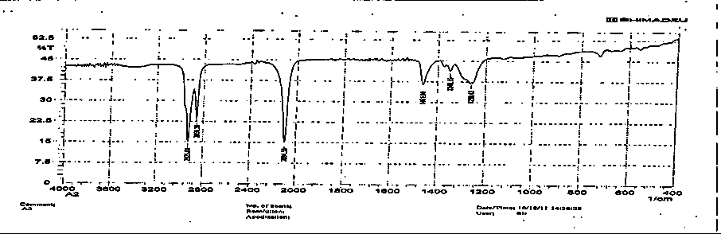
Fig. (1) FT-IR spectrum of 1-Azido deacane
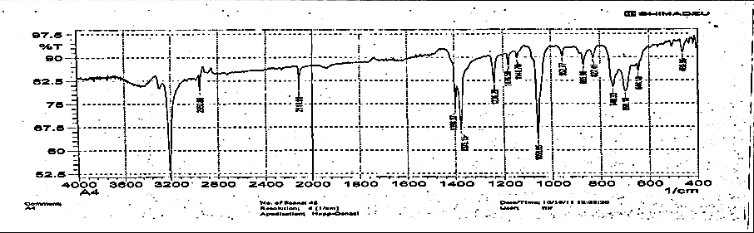
Fig. (2) FT-IR spectrum of 2,5-bis(prop-2-ynylthio)-1,3,4-thaidiazole
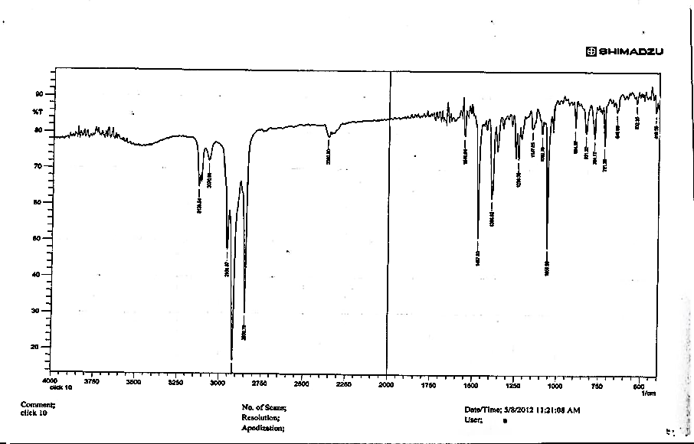
Fig. (3) FT-IR spectrum of ligand [L]
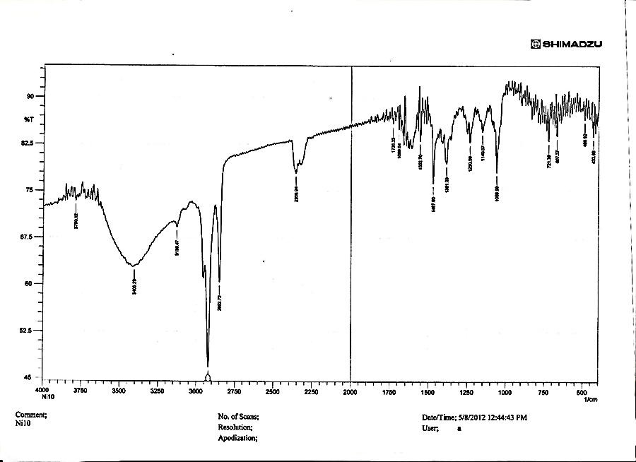
Fig. (4) FT-IR spectrum of [Ni₂(L)(H₂O)₄Cl₂]Cl₂ complex
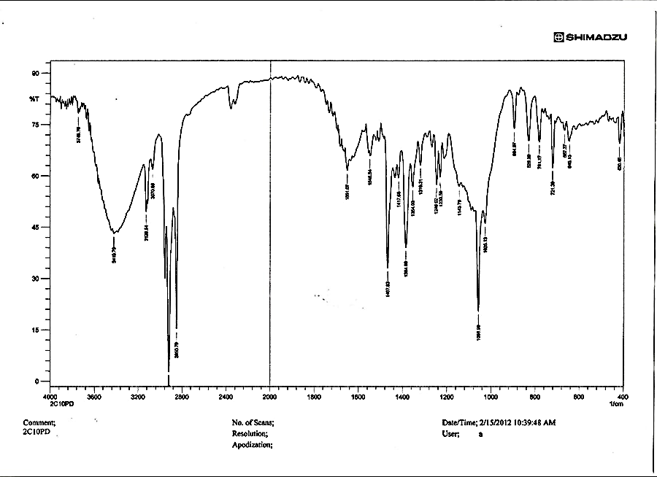
Fig. (5) FT-IR spectrum of [Pd₂(L)Cl₂]Cl₂ complex
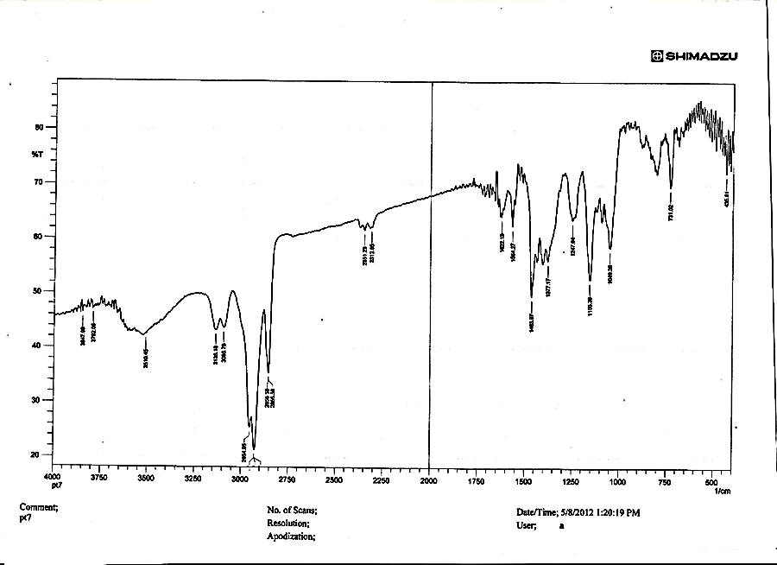
Fig. (6) FT-IR spectrum of [Pt₂(L)(H₂O)₂Cl₄]Cl₄ complex
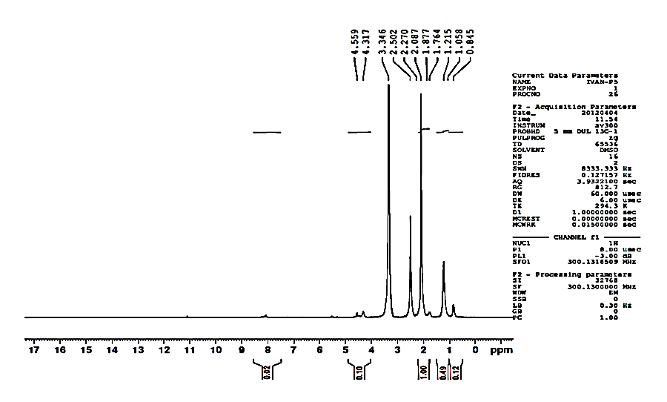
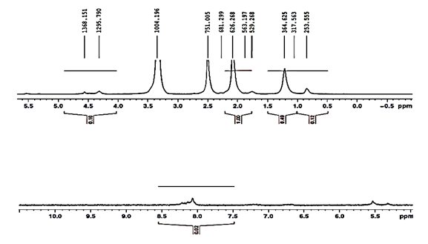
Fig. (7) ¹H NMR spectrum of ligand [L]
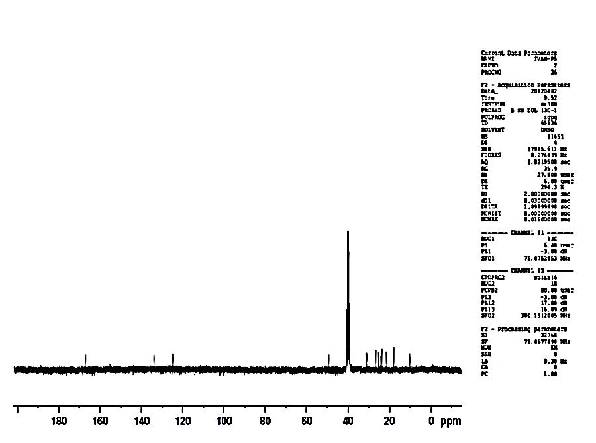
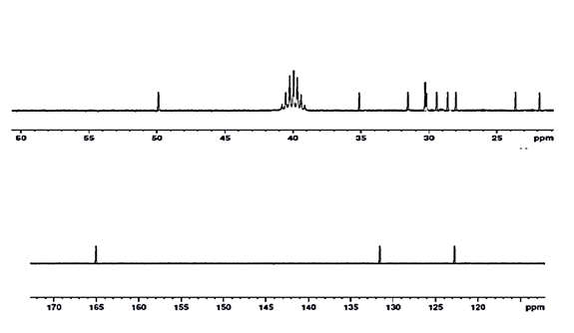
Fig. (8) ¹³C NMR spectrum of ligand [L]
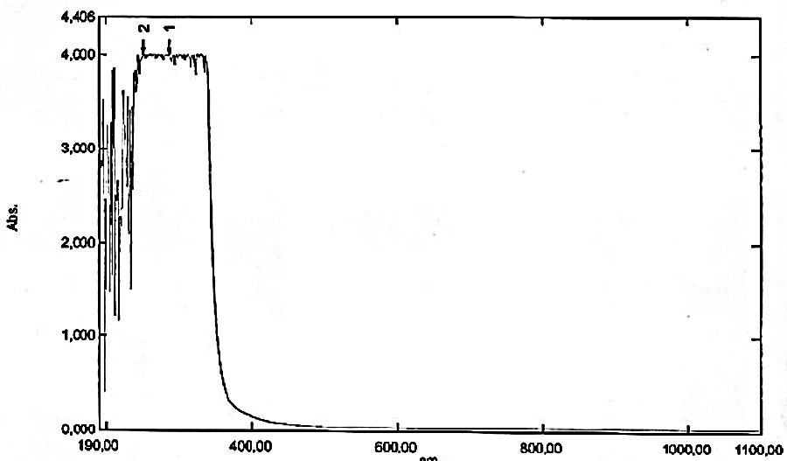
Fig. (9) UV-Vis spectrum of ligand [L]
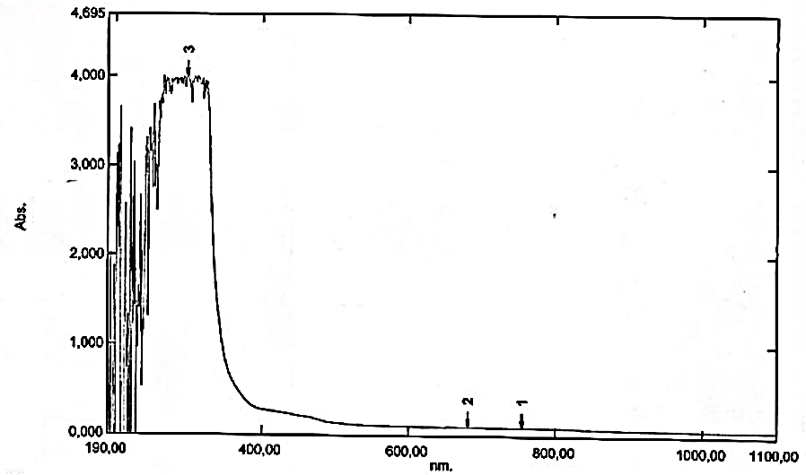
Fig.(10) UV-Vis spectrum of [Ni₂(L)(H₂O)₄Cl₂]Cl₂ complex
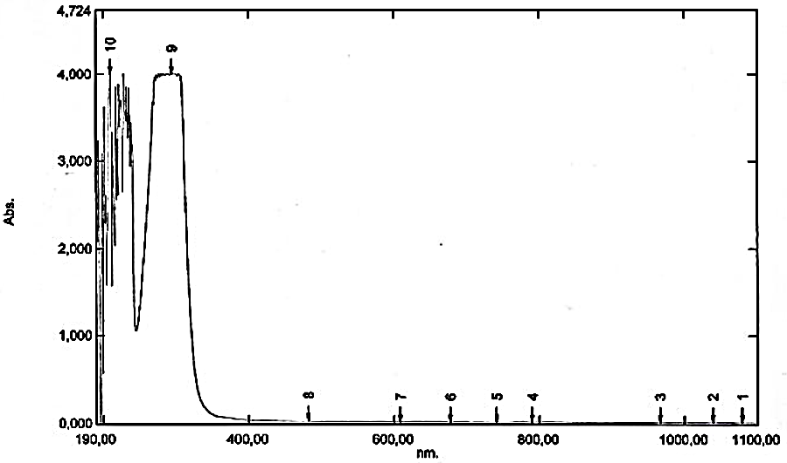
Fig.(11) UV-Vis spectrum of [Pd₂(L)Cl₂]Cl₂ complex
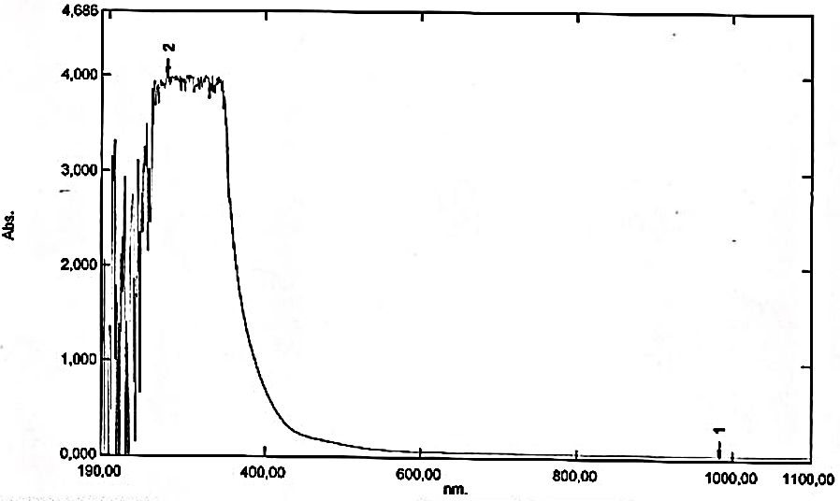
Fig.(12) UV-Vis spectrum of [Pt₂(L)(H₂O)₂Cl₄]Cl₄ complex

