Nosocomial outbreak of carbapenem-resistant Pseudomonas aeruginosa producing metallo beta lactamase in Al-Hilla teaching hospital, Babylon

Eman M. Jarallah Mustafa J. Alammary
Abstract
Metallo-beta-lactamase MBL producing Pseudomonas aeruginosa have been reported to show resistance to carbepenem drugs. Detection of metallo-beta-lactamases producing P. aeruginosa is now important to prevent their spread as dissemination of these bacteria could be fatal to the patients.
The present study was undertaken over period of six months from December-2011 to May-2012 in Al-hilla teaching hospital, to study the incidence of outbreak of MBL producing P.aeruginosa from various clinical specimens. Out of 247 clinical specimens 81 isolates were obtained . These isolates were subjected to susceptibility testing to antipseudomonal drugs as per CLSI guidelines, 32(40%) of isolates were carbapenem resistant P. aeruginosa (CRPA). They were further screened for production of MBL: by EDTA-imipenem synergy method and Carbapenemase production: by modified Hodge test and using E. coli ATCC 25922 for control.
All (CRPA) isolates were MBL producing isolates and carbapenemase producing isolates.

1. Introdution:
Pseudomonas aeruginosa is a frequent nosocomial pathogen that causes a wide range of opportunistic infections and nosocomial outbreaks [Hammami et al.,2011]. Infections by P. aeruginosa are a serious clinical problem, particularly in immune compromised hosts in hospital settings . Moreover, the treatment of these infections is often difficult because of the limited number of effective antimicrobial agents, due to the intrinsic resistance of P. aeruginosa strains and their different modes of growth [Martinez et al.,2011]. Carbapenem ,such as imipenem, meropenem remain one of the best drugs to treat infections caused by p. aeruginosa , but increasing usage of these drugs and other expanded-spectrum antibiotics has resulted in the development of carbapenem –resistant p. aeruginosa. [Vitkauskiene et al.,2011;Sacha et al.,2007;Pournaras et al.,2007;Yousefi et al.,2010;Martinez et al.,2011]. The common form of resistance is mediated by lack of drug penetration(i.e.,porin mutations and efflux pumps) and /or carbapenem hyrolysing beta lactamase enzymes including the metallo beta lactamases (MBL).[ Shanthi and Sekar.,2009;Ishii et al.,2010]. P. aeruginosa is able to acquire (MBL) by horizontal transfer of mobile genetic elements coding for class B carbapenemases (also called metallo-β-lactamases [MBLs]), which hydrolyze all β-lactams except aztreonam [Viedma et al.,2012; Gutierrez et al.,2007;Horii et at.,2007]. The IMP and VIM genes responsible for MBL production are horizontally transferable via plasmids and can rapidly spread to other bacteria , the dissemination of which contributes to the global spread of this resistance mechanism [Zubair et al.,2011; Viedma et al.,2012; Varaiya et al.,2008]. Carbapenemases can be classified into two main molecular families: those with serine at their active site, known as serine carbapenemases, and those with at least one zinc atom at their active site, known as metallo-carbapenemases which are a subgroup of metallo beta lactamases (MBLs)[Bahar et al.,2010]. So, (MBLs) require divalent cations of zinc as co-factor for enzymatic activity and are universally inhibited by ethylenediamine tetra acetic acid (EDTA), as well as other chelating agents of divalent cation[Kumar et al.,2012;Bratu S. and Quale J., 2006]. It found that the tests of modified hodge and EDTA-imipenem Doudle disk synergy were simple to use the screen metallo-B- lactamase producina strains of aeruginosa[Lee et al., 2003] . Detection of (MBL) producing P. aeruginosa is crucial for optimal treatment of patients particularly critically ill and hospitalized patients and to control the spread of resistance[Bashir et al.,2011] .The aim of this study was to determine the occurrence of MBLs among carbapenem-resistant P.aeruginosa clinical isolates in Al-Hilla teaching hospital.
2. Materials and methods:
2.1. Patients and bacterial strains:
This study included clinical isolates of carbapenem resistant P.aeruginosa (CRPA) from patients of Al-Hilla teaching hospital in Babylon city , Iraq , During the period from December 2011 and May 2012. A total of 247 sample included burn swab, ear swab, wound swab, urine & blood culture and bed-patient room, were cultured on blood agar and MacConkey agar plates and incubated at a temperature of 37 °C for 24 h on Mueller Hinton agar plates in order to to assess pigment production. The culture plates were processed using standard microbiological procedures [Olayinka et al.,2009].
Characterization and identification of P. aeruginosa was carried out using a combination of colonial morphology, Gram stain characteristics, motility tests, pigmentation, oxidation-fermentation tests, catalase and oxidase activity tests and pyocyanin production [Paranjothi S and Dheepa R., 2010].
2.2. VITEK 2 system:
The newly launched VITEK 2 Compact, a system for identification and antibiotic susceptibility testing (AST) [Fig.1]. VITEK2 Compact is designed for medium to small-sized laboratories which require an automated system that will cover the majority of their routine tests [BioMérieux ] .This system that produced by BioMérieux company used in this study to identification of bacterial isolates with probability 98% and to determine the MIC of antibiotic to bacterial isolates.
2.3. Antimicrobial susceptibility test :
Antimicrobial susceptibility was tested using the microdilution method, with Mueller-Hinton agar (HIMEDIA,India). The following antimicrobials were tested: ampicillin piperacillin, gentamicin, tobramicin, amikacin, ciprofloxacin, ceftazidime, cefepime, imipenem, meropenem, polymixinB [Martinez et al.,2011]. The antibiotics were purchased from (HIMEDIA Co.,India). All P. aeruginosa strains were screened for resistance to carbapenems(IMP and MEM) by the routine disk diffusion test with 13-15mm inhibition zone according to the guidelines of the Clinical and Laboratory Standards Institute (CLSI). E.coli ATCC 25922 was used as control strain.
2.4. Phenotypic detection of metallo-b-lactamase[MBLs] production:
In this study, IMP-EDTA-disk synergy test developed by [Yang et al.,2002] was used for detection of [MBLs] P.aeruginosa isolates . we prepare 0.5M EDTA solution and sterilized by autoclave. EDTA-IMP-synergy disk prepare by adding EDTA solution to IMP 10 disk and put the disk on Mueller Hinton agar , in the same disk we put only IMP disk as control. After overnight incubation, the established zone diameter difference of less than 7mm between EDTA-IMP-synergy disk and IMP only disk was interpreted as positive result of [MBLs] production[Irfan et al.,2008] [Fig. 2].
2.5. The Modified Hoge test [MHT]:
Carbapenemase production was detected by the [MHT] when the test isolate produces the enzyme(carbapenemase) and allows growth of a carbapenem susceptible strain (E.coli ATCC 25922) towards a carbapenem disk. An overnight culture of indicator organism E. coli ATCC 25922 was adjusted to a turbidity of McFarland No. 0.5 and No. 0.05 and these were used to swab inoculate the surface of the agar plates. After drying the surface, test organisms were heavily streaked from the center to the periphery of the plate using an inoculating loop and a 10-μg imipenem or meropenem disk (HIMEDIA) was placed at the center, and incubated overnight. The Hodge test is interpreted as positive by the presence of distortion of the inhibition zone The result is a characteristic clover leaf-like indentation [Dugal S. and Fernandes A., 2011; Lee et al.,2010] [Fig.3].
3. Result and Discussion:
3.1. Bacterial strains isolation ; A total of 247 clinical samples collected from different sources of patients admitted in Al-Hilla teching hospital, 81(33%) of samples was P.aeruginosa isolates. Most isolates was identified by morphological shape of colonies that cultured on blood agar and MacConky agar, in addition to pyocyanin pigments producing on Mueller Hinton agar. Biochemical tests such as oxidase & catalase production, IMVIC tests ,urase test and TSI fermentation test. VIEK 2 system used for more accuracy identification and for MIC test for antibacterial agents.
3.2. Antimicrobial susceptibility test : out of 81 P.aeruginosa isolate, 32(40%) of isolates was resistant to carbapenem [imipenem 13 (16%), meropenem 19 (23%)] antipseudomonas agent with inhibition zone less than 16mm by using disk diffusion method. Isolates resistant to carbapenem were also resistant to other antibiotics: 52(64%) amikacin, 69(85%)gentamicin, 44(54%)pipracillin, 73(90%) ampicillin, 39(48%) ciprofloxacin, 49(60%) cefepime, 67(83%)ceftazidime, 62(77%)tobramicin, 75(92%) polymixin B [Table.1].
3.3. VITEK 2 system: three isolates tested by VITEK 2 system[BioMérieux ] because of cost of cards. ( 98% ) probability of P. aeruginosa identification after 5 hours analysis. . All isolates was resistant to 13 antimicrobial agent applied in this system.

Fig. 1. VITEK 2 Compact system [BioMérieux ] for identification and antibiotic susceptibility testing (AST)
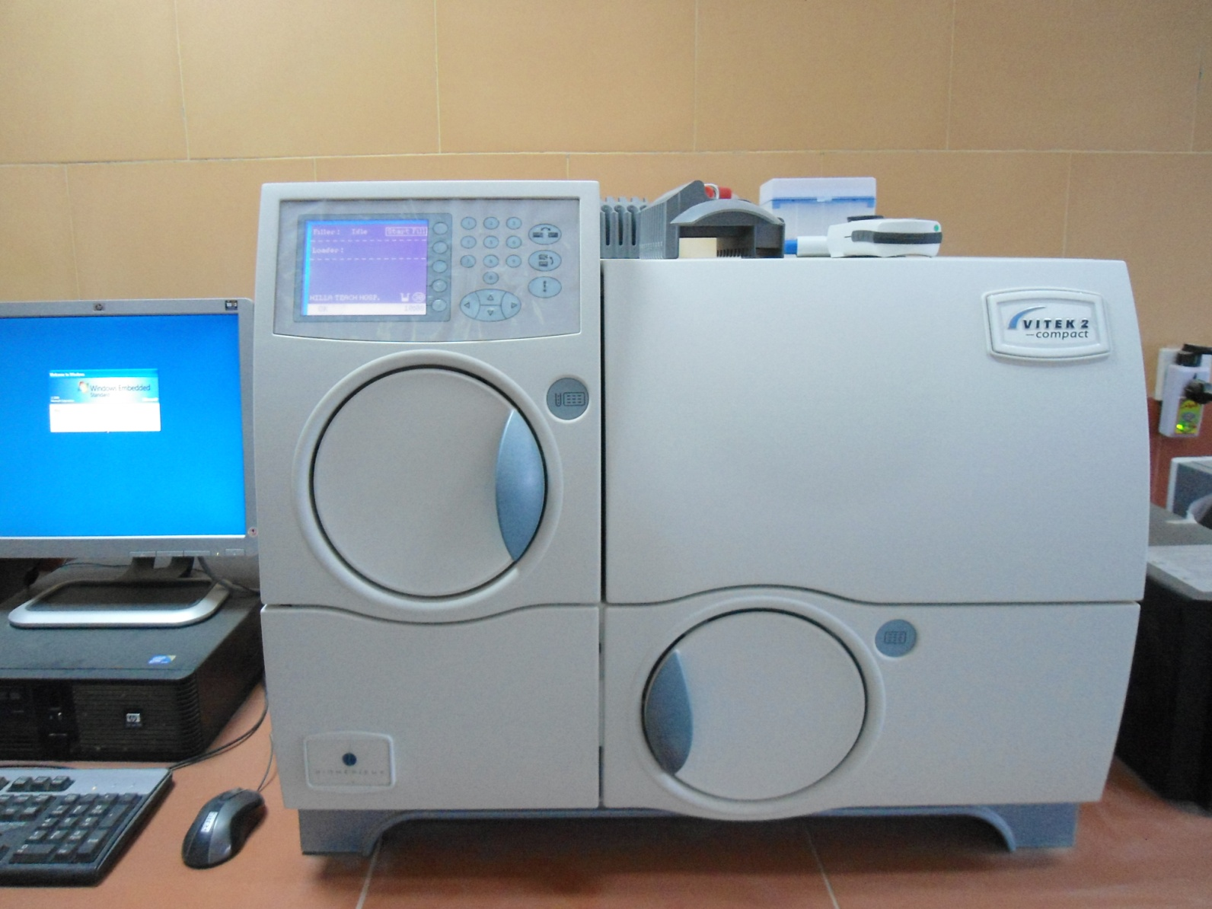

3.4. metallo beta-lactamase production: EDTA-IMP- synergy disk used for detection of metallo-beta lactamase production isolates. Inoculums prepared equal to 0.5 McFarland(equivalent to 1.5 x 10⁸ cfu/ml) and cultured on Mueller Hinton agar, put EDTA-IMP disk and IMP disk alone and incubated overnight. all carbapenem resistant isolates 32 (100%) showed metallo beta lactamase activity with an average differences in inhibition zone 17mm between EDTA-IMP disk and IMP disk alone. Carbapenem sensitive isolates did not show any metallo beta lactamase activity [Fig.2].
Fig. 2. EDTA-IMP-synergy disk and IMP only disk was interpreted as positive result of [MBLs] production.
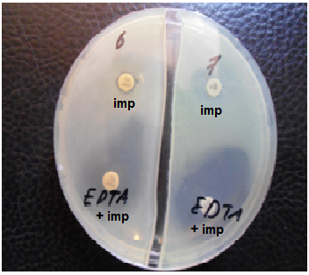

3.5. modified Hoge test: carbapenemase production isolates detected by this test. E.coli ATCC 25922 used as control to differentiation between carbapenem sensitive strains[E.coli ATCC 25922] and carbapenem resistant strains [P.aeruginosa isolates]. All of carbapenem resistant isolates reach to IMP or MEM disk in center while E.coli ATCC 25922 show inhibition zone to forming clover leaf-like shape [Fig.3].

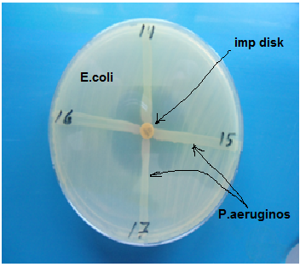
Fig. 3. Modified Hoge test for carbapenemase producing P.aeruginosa isolates detection.

3.6. Epidemiological data: All of 247 sample had been collected and directly cultured from December 2011 to May 2012. Different sources of study samples included out of 247 sample 107(43%) burn swabs, 34(14%) wound swabs, 33(13%) ear swabs, 31(13%) urine samples, 15(6%) blood samples, 27(11%) bed and patient rooms. Most of P.aeruginosa isolates was burn samples[Table. 2] . Because of the P.aeruginosa was nosocomial infection, all samples collected from at least after one week from patients admission.
Table 1. susceptibility of P.aeruginosa isolates to antimicrobial agents according to CLSI*:
Antimicrobial agents | Diameter of inhibition zone in mm with percentage of isolates
Antimicrobial agents | Sensitive | No. (%) | Resistant | No. (%)
Ampicillin | 17 | 8(10%) | 13 | 73(90%)
Amikacin | 17 | 29(36%) | 14 | 52(64%)
Gentamicin | 15 | 12(15%) | 12 | 69(85%)
Pipracillin | 18 | 37(46%) | 17 | 44(54%)
Ciprofloxacin | 21 | 42(52%) | 15 | 39(48%)
Cefepime | 18 | 32(40%) | 14 | 49(60%)
Ceftazidime | 18 | 14(17%) | 14 | 67(83%)
Tobramicin | 15 | 19(23%) | 12 | 62(77%)
Polymixin B | 12 | 6(8%) | 11 | 75(92%)
Imipenem | 16 | 68(84%) | 13 | 13(16%)
Meropenem | 16 | 62(77%) | 13 | 19(23%)
* Clinical and Laboratory Standards Institute (CLSI) 201
Table 2. Distribution of P.aeruginosa isolates among clinical specimens:
Source of samples | Samples No.(%) | P.aeruginosa isolates No.(%) | Carbapenem resistant isolates No.(%)
Burn swabs | 107(43%) | 54(67%) | 29(91%)
Wound swabs | 34(14%) | 5(6%) | 1(3%)
Ear swabs | 33(13%) | 3(4%) | 0
Urine samples | 31(13%) | 7(9%) | 0
Blood samples | 15(6%) | 3(4%) | 1(3%)
Ded & patient room swabs | 27(11%) | 9(11%) | 0
Total | 247(100%) | 81(100%) | 32(100%)
3.7. Discussion: Carbapenems are potent agents against multiresistant Gram negative bacilli, including P. aeruginosa, but their efficacy is increasingly compromised by the emergence and the worldwide dissemination of carbapenem resistance strains, which are implicated in large outbreaks as described in many countries [Hammami et al.,2011]. P.aeruginosa producing MBLs was first reported from Japan in1991[Zubair et al.,2011]. The clinically important MBL families are located in horizontally transferrable gene cassettes and can be spread among Gram-negative bacteria [Bahar et al.,2010]. MBL producing isolates are associated with a higher morbidity and mortality. Moreover given the fact that MBLs will hydrolyze all classes of ß-lactams [such as carbapenems] and that we are several years away from the development of a safe therapeutic antibiotic; their continued spread would be a clinical disaster. The occurrence of an MBL positive isolate poses not only a therapeutic problem but is also a serious concern for infection control management [Bashir et al.,2011].
In this study we were collected the sample after one week to isolate nosocomial acquired P.aeruginosa so, all or most of 81 isolates was 54 burn patients isolates, and susceptibility test show 29 CRPA isolates was burn swab samples, 1 wound swab and 1 blood culture sample. This result lead to that all carbapenem resistant isolates was from burn patients admitted at Al-Hilla teaching hospital, this results were Compatible to another study at Shahid Motahari level I burn hospital in Tehran [Bahar et al.,2010], So we were interpreted the outbreak of MBLs producing bacteria in Iraq's Hospitals causing by travelling of patient between Iran-Iraq hospital because of horizontally transferrable gene cassettes [IMP & VIM] responsible on MBLs feature. The spread of MBLs producing P.aeruginosa isolates should be considered an emerging pandemic specially in Asia [Viedma et al., 2012].
4. References:
Bahar M. A., Jamali S. and Samadikuchaksaraei A. Imipenem- resistant Pseudomonas aeruginosa strains carry metallo-b-lactamase gene blaVIM in a level I Iranian burn hospital. Burn elsiver journal, 2010; 36: 826-830.
Bashir D., Thokar M. A., Fomda B. A., Gulnaz Bashir1, Zahoor D., Ahmad S. and Toboli A. S. Detection of metallo-beta- lactamase (MBL) producing Pseudomonas aeruginosa at a tertiary care hospital in Kashmir. African Journal of Microbiology Research, 2011; 5(2): 164-172.
Bratu S. and Quale J. Global Emergence of Nosocomial Gram-negative Pathogens Possessing Carbapenem-hydrolyzing β-lactamases. Journal of biological sciences, 2006; 6(3): 434-445.
Clinical and laboratory standards institute: performance standards for antimicrobial susceptibility testing CLSI, 2011; 31(1).
Dugal S. and Fernandes A. carbapenem hydrolysing metalloßlactamases: a review. international journal of current pharmaceutical research,2011; 3(3): 9-17.
Hammami S., Boutiba-Ben I. B., Ghozzi R., Saidani M., Amine S., and Redjeb B. S. Nosocomial outbreak of imipenem-resistant Pseudomonas aeruginosa producing VIM-2 metallob-B- lactamase in a kidney transplantation unit. Diagnostic Pathology, 2011; 106:(6)1-5
Horii T. How Can Antimicrobial Resistance in Pseudomonas aeruginosa Be Controlled? Yonago. Acta. medica., 2007;50: 1-8.
Ishii Y., Eto M., Mano Y., Tateda K., Yamaguchi K. In vitro potentiation of carbapenems with ME1071, a novel metallo-beta-lactamase inhibitor, against metallo-beta-lactamase- producing Pseudomonas aeruginosa clinical isolates. Antimicrob. Agents Chemother. , 2010; 54(9): 3625-3629
Irfan S., Zafar A., Guhar D., Ahsan T., Hasan R., Metalo-b-lactamase producing clinical isolates of Acinetobacter species and pseudomonas aeruginona from intensive care unit patients of a tertiary care hospital. Indian journal of medical microbiology, 2008; 26(3):243-245
Gutierrez O, Juan C, Cercenado E, Navarro F, Bouza E, Coll P, et al. Molecular epidemiology and mechanisms of carbapenem resistance in Pseudomonas aeruginosa isolates from Spanish hospitals. Antimicrob Agents Chemother. 2007;51:4329–35.
Kumar S. H., De A. S., Baveja S. M and Gore M. A., prevalence and risk factors metallo-b-lactamase producing pseudomonas aeruginosa and acinetobacter species in burns and surgical wards in tertiary care hospital. Journal of laboratory physicians, 2012; 4(1): 37-42.
Lee K., Lim Y., Yong D., Yum J. and Chong Y. Evaluation of the Hodge test and the imipenem-EDTA double-disk synergy test for differentiating metallo- β- lactamase producing isolates of Pseudomonas spp. and Acinetobacter spp. J Clin Microbiol, 2003; 41 : 4623.
Lee K., Kim C. K., Yong D., Jeong S. H., Yum J. H., Seo Y. H. Docquier J. D. and Chong Y. Improved performance of the modified Hodge test with MacConkey agar for screening carbapenemase-producing Gram-negative bacilli. Journal of Microbiological Methods, 2010; 83: 149–152.
Martinez L. R., Jimenez L. L., Ostuni V., Fuste E., Vinuesa T., Vinas M. A mechanism of carbapenem resistance due to a new insertion element (ISPa133) in Pseudomonas aeruginosa. international microbiology, 2011; 14: 51-58.
Olayinka A. T., Olayinka B. O.,and Onile B. A., Antibiotic susceptibility and plasmid pattern of Pseudomonas aeruginosa from the surgical unit of a university teaching hospital in north central Nigeria. International Journal of Medicine and Medical Sciences, 2009;1(3):79-83.

Paranjothi S and Dheepa R. screening for multidrug resistance bacteria pseudomonas aeruginosa in hospitalized patient in hosur, krishnagiri (dt) international journal of pharma and bio sciences, 2010 :(1) 3 1-15.
Pournaras S., Ikonomidis A., Markogiannakis A., Spanakis N., Maniatis A. N., Tsakris A. Characterization of clinical isolates of Pseudomonas aeruginosa heterogeneously resistant to carbapenems. , 2007; 56(1): 66-70.
Sacha P., Zorwaski M., Hauschild T., Wieczorek P., Jaworowska J., Jakniuk P. and Tryniszewska E. the presence of blaIMP genes on plasmids DNA isolated from multidrug-resistant pseudomonas aeruginosa strains at university hospital in bialystok (poland)-first report. folia histochemica
et cytobiologica, 2007; 45:(4) 405-408.

Santhi M. and Sekar U. Multi-drug resistant Pseudomonas aeruginosa and Acinetobacter baumannii infections among hospitalized patients: risk factors and outcomes. J. Assoc Physicians India, 2009; 57: 638-640.
Varaiya A., Kulkarni N., Kulkarni M., Bhalekar P., Dogra J. Incidence of metallo-beta-lactamase producing Pseudomonas aeruginosa in ICU. Indian J. Med. Res., 2008; 127: 398-402.
Viedma E., JuanC., Villa J., Barrado L., Orellana M., Sanz F., Otero J., Oliver A. and Chaves F. VIM-2–producing Multidrug-Resistant Pseudomonas aeruginosa ST175 Clone, Spain Emerging Infectious Diseases, 2012; 18: (8) 1235-1239.
Vitkauskiene A., Skrodeniene E., Dambrauskiene A., Baksyte G., Macas A and Sakalauskas R. Characteristics of Carbapenem-Resistant Pseudomonas aeruginosa Strains in Patients with Ventilator-Associated Pneumonia in Intensive Care Units. Medicina (Kaunas), 2011; 47:(12) 652-656.
Yang D., Lee K., Yum J. H., Shin H. B., Rossolini GM, Chong Y. Imipenem-EDTA disk method for differentiation of metallo-beta-lactamase- producing clinical isolates of Pseudomonas spp. and Acinetobacter spp. J. of Clinical Microbial, 2002; 40: 3798–801.
Yousefi S., Farajniaa S., Nahaeib M. R., Akhic M. T., Ghotaslouc R., Soroushc M. H., Naghilid B. and Jazanie N. H. Detection of metallo-β-lactamase–encoding genes among clinical isolates of Pseudomonas aeruginosa in northwest of Iran. Diagnostic Microbiology and Infectious Disease, 2010; 68: 322–325
Zubair M., Malik A. and Ahmad J. Prevalence of metallo-beta-lactamase-producing Pseudomonas aeruginosa isolated from diabetic foot ulcer patients Diabetes & Metabolic Syndrome. Clinical Research & Reviews, 2011; 5: 90–92.

