Oxidant and Antioxidant Activities of Copper and Selenium in Leukaemic Patients

Prof. Dr. Ra'id M.H. Al-Salih
Thi-Qar university . College of Science
Prof. Dr. Wafa Al-Taei Prof.Dr. Moen E. Al-Jeboori
Baghdad university College of Education Ibn-elhaitham
Abstract
Two trace elements (copper and selenium) were evaluated in the present study during four types of leukaemia :(acute lymphocytic and myelocytic leukaemia (ALL,and AML))and( chronic lymphocytic and myelocytic leukaemia(CLL and CML)) which compared with normal values of healthy subjects . The study also attempted to shed a light on possible relation between the mentioned elements and lipid peroxidation marker (malondialdehyde (MDA)). An elevation in serum copper was observed during all studied types of leukaemia , with positive correlation between copper and MDA levels . Also correlation between serum copper and albumin levels could be obtained .Selenium level was found to be decreased during all types of leukaemia with negative correlation between its levels and serum MDA .
Introduction
Trace elements in appropriate biochemical definition are the minerals to which the human body needs daily in amounts about 100 mg . This amount is requisite for body to performs its biological activities efficiently . However the diminished or raised levels of these elements in the body may lead to disorders in metabolic processes by which various diseases may appear . While on the contrary most infections can cause an alterations in trace elements levels in human body depending on the kind of disease.
Accordingly , it is necessary to study some of the trace elements in patients with various types of leukemia .
The presence of free copper can consider toxic because it enters as a catalyst in Habber Weiss free radical generation reaction [1 ] .
$O_{2}$+ H2O2$\vec{{\text{Cu}}^{+2}}$ .OH + -OH + O2
Therefore copper excess, to a greater extent, works as enhancement agent for disease development [2,1].
Although copper , in plasma , bound with caeruloplasmin , metallothionein , and albumin , but it is able to generate free radical on protein molecule surface and lead to partial destruction of this molecule by produced .OH radical [3 ] .
On the other hand red blood cells , in general , need copper to form by marrow ; therefore copper decreased levels can cause anaemia [4-7 ] .
In contrast with copper, selenium have antioxidant role against free radical processes in biological system. It generally has a variety of functions .The main one is its role as antioxidant agent [8] . This is by selenium dependent-glutathione peroxidase antioxidant activity. Moreover selenium has been shown to have anti – proliferative , anti – inflammatory , anti – viral and immune altering effects [9] . Furthermore it has also been shown that selenium at physiologic concentration can effectively inhibit the over all proliferation of human lymphocytes in response to various immune stimuli in vitro .
There was evidence for increase risk of gastrointestinal , urinary and mammary cancers at low selenium concentration [10,11] . Another studies illustrate that the low selenium daily intake the high incidence of liver and lung cancer [12] .

Subjects and Methods
Selection of Subjects
The study conducted in Al – Nassyriah General Hospital , Maternity and Children Hospital in Nassyriah , and AL – Kadhimyah Hospital in Baghdad. One hundred and five subject aged ( 2 – 57 ) years were included in this study . They have been classified into five groups as the following : -
- ALL – group : included twenty patients(18 male, 2 female) with acute lymphocytic leukaemia .
- AML group : included twenty five patients(19 male, 6 female) with acute myelocytic leukaemia .
- CLL group : included twenty patients(17 male, 3 female) with chronic lympocytic leukaemia
- CML group : included twenty patients(18 male, 2 female) with chronic myelocytic leukaemia
- CTR group : included twenty healthy subject(15 male, 5 female) , so that the normal control values for all studied parameters were obtained from them
Collection of Blood Samples
( 6 mL ) of blood have been withdrawn from study subjects by venipuncture between ( 9 – 12 A.M.) . ( 2 mL ) of blood sample were transferred into an anticoagulant tube to use it directly in haematological tests . The remainder were transferred into disposable tube and centrifuged ( 750 xg , 10 min. ) within 15 min. after collection , the produced serum stored at – 20 C˚ , unless used into work immediately .
Methods of Analysis
Determination of Serum Free Copper and Selenium:
Concentrations of the two elements in serum samples were measured by flame atomic absorption method. In this method ,light of hollow-cathode(HC) lamp is absorbed by ground state atoms in a lean air-acetylene flame. The amount of light absorbed is directly proportional to the concentration of atoms in the gaseous state in the light path and hence to the concentration of copper, zinc and selenium in the solution.
Preparation of Stock Solutions
-Copper stock solution was prepared by dissolving copper nitrate (3.7980g) in 250 mL of deionized water and diluted to 1 liter .
- Selenium stock solution was prepared by dissolving selenium (1 g) in 15 mL of (HCL) and 5 mL of HNO₃ and diluted to 1 liter.
Procedure:
Determination of free Cu²⁺, Se²⁺ in the serum were carried out by flame and flameless atomic absorption spectrophotometric method.
All serum were deproteinized by the addition of an equal volume of 1.2 N TCA . After centrifugation , several dilutions of the supernatant were made before the determination of the free ions of the elements by the atomic absorption spectrophotometer .
Statistical Analysis
Data present were the means and standard deviations . Analysis of students-t-test also made to compare between the studied groups and each others, where appropriated to test the significance of differences of means among all studied groups. Value of equal or less than p≤0.05 was considered significant . The associations of parameters with each others were evaluated as correlation coefficient (r) values.
Results And Discussion
Lipid peroxidation status
Lipid peroxidation (LPO) can be considered as one of several processes which is initiated by oxygen free radicals(OFRs) attack to cell membrane in whole human body [13,14].Therefore this process reflects the presence of (OFRs) and their generation in the target organ .Generally there is a range of methods available for measuring markers of lipid peroxidation in vivo that can be measured in serum and urine as indicators of oxidative stress[15 ].However the test for malondialdehyde (MDA),an end product for LPO, has been used for years to measure the lipid peroxidation in vivo[16 ].
The results of the present study which were shown in table (2),illustrate a significant elevation in serum MDA levels in all patient groups compared to control group.
Whereas no significant differences can be observed between ALL and AML ,as well as ,CLL and CML, in serum MDA levels. However a significant elevation can be observed in serum MDA levels in patients with acute lymphocytic and granulocytic leukaemia in comparison chronic two types of leukaemia .
Leukaemia is the most common type of cancer . The cases of leukaemia are not certain in most of cases of this disease. Yet several studies referred to implication of free radicals(FRs) in the pathogenesis of leukaemia [17,18 ].
In fact ,the increase in leucocytes count during leukaemia as well as stimulation of phagocytes, lead to further free radicals generation by normal respiration of these cells.
Consequently ,membrane lipid peroxidation process increases rapidly and causes elevation in MDA concentration that was reported in the present study .These results are compatible with study of singh et al [18] which also referred to that serum MDA estimation in leukaemia can be of help in diagnosis and to predict the chances of relapse.
Copper
The levels of serum copper in all studied groups was shown in table (3) and supported by figure (1). The table showed elevation in serum copper, slightly , in all patient groups compared to control group. Also no significant differences can be observed among all patient groups.
Copper in human body distributes mostly in enzymes and many proteins. The highest amount of plasma copper (about 93%) binds to caeruloplasmin, and 7% is found in albumin and amino acids bound fractions. It is notable that the caeruloplasmin copper is not released until the protein is catabolized . Yet the albumin copper is probably the means used to transport copper to the liver, red blood cells , bone marrow , kidneys, and tissues [5]
On the other hand anaemia was reported in this study (table 1) during all studied types of leukaemia . Copper is found in red blood cells , incorporated into erythrocuprein portion , which may have come from the copper in the bone marrow during formation of the normoblasts ( a red blood cell precursor ) [6 ]. Consequently the decreases in erythrocyte synthesis by bone marrow during leukaemia may be another cause for serum copper elevation . However no significant correlation between copper levels and erythrocytes count, was found.

Selenium
Selenium is trace element which naturally occurs in foods . It has been considered toxic when taken internally .The toxicity of it due to replace sulfur with it in various biological molecules, because it is below sulfur in periodic table and likes it in chemical properties [19].Normally this state is too toxic for metabolic systems .
However several studies illustrated that trace amounts of selenium are essential for preventing many types of cancer such as colon , skin, and prostate cancers [19 , 20].
Our results , in the table (4) , illustrated significant decrease in serum selenium levels in leukaemic patients in comparison with control subjects .Figure (3) showed also these results.
Selenuim has been reported that it is an integral part of the body natural antioxidant glutathione peroxidase enzyme. It is known that this enzyme performs scavenging of toxic H₂O₂ and hydroperoxide (ROOH) which are generated in biological system by known mechanism [21 ].Therefore the activity of GSH-Px associated with selenium levels.
In the present study, it was reported that lipid peroxidation processes increase during leukaemia and lead to further toxic reactive oxygen species that include hydrogen peroxide. Consequently an increase in GSH-Px activity is required to scavenge the generated H₂O₂.Accordingly the low serum selenium levels which is observed in leukaemic patients may be due to selenium supply for the high active glutathione peroxidase . Our results agree with results of study of Gupta et al [20] which also illustrated that the cancer incident and mortality associated with diminished serum selenium levels.
References
1-Halliwell, B.; FEBS Lett. 92:321(1978)
2-Tűmer,Z., and horn, N.Ann.Med.,28:121(1996)119- Awasthi, Y.C.,
3- Gutteriage, J. M. C. & Willins, S. I.; Biochem. Biophys. Acta. 759:38(1983)
4- Dowdy, R. P. Amer.J.Clin.Nutr., 22:887(1969)
5- Freiden, E. Cerulopasmin, Nutr.Rev. 23:87(1970)
6- Graham, G. G. New Enh. J. Med., 285:857(1971)
7- Al-Rashid, R. A., & Spangler, , J. New EngJ. Med., 285:841(1971)
8- Takahashi, K., Avissar, N., Whiten, j., & Cohen, H., Arch. Biochem, Biophys ;256:677(1987)
9- Combs, G. F., Jr., & combs, S. B., Annu. Rev. Nutr;4:257(1984)
10- Lou, H., & Wu-R.F.Y., Chung-Hua. Chung-Liu-tsachih; 17:112(1995)
11- Zilva, G. F., & Pannall, P. R ;"Clinical Chemistry in Diagnosis & Treatment" Luk, (medical Book) LTD 49 Newman street, London(1984)
12- Pories, W. J., Mansour, E. G., & Strain, W. H., Ann. Enoy. Acad Sci; 199:265(1972)
13- Flagg, E.W., Coates, R. J & Green berg, R.S., Journal of The American Collage of Nutrition; 14:419(1995)
14- Chio, A. M., Knobil, K., Otterbein, S. L., Eastman, D. A & Jacoby, D. B., Am. J. Physiol; 271:383(1996)
15- Gutteridge, J.M.C.,&Quinlan, G.I.; Biochem. Biophys. Acta. 1156:144(1993).
16-Diplock, A.t.; Tech.Pub. 1:154(1985).
17- Dalal, N. S., Newman, J., Pack, D., Leonard, S. & Vallyathan, V.; Free Rad. Biol. Med. 18:11(1995)
18- Vallyathan, V., Mega, J.F., Shix & Dalal, N. S.; Am. J. Respir. Cell. Mol. Biol. 6:404(1992)
18- Singh V., Ghalaut P. S., Kharbs., & Singh G. P. Indian. J. Med. Sci. 55:215(2002)

19-Consumpton Of small amounts of seleeniu in oods increases the prevalence of cries. Chem.. Eng. New,48:37(1970)
20- Gupta, S., Narange, K, Krishna S.K., & Yadav, S., Indian. J. Cancer, 31:192(1994)
21-Richter C, Gogvadze V, Laffranchi R, Biochim Bioph ra,-Orlando-S-F; Boldt,-David-H Br-J-Haematol. 117 : 727 (1302)
Table (1) The clinical and characteristic data of the study subjects
Groups | n | sex |  | Age(year) | Erythrocytes (10¹²/L) | Hb(mg/dL)
Groups | n | m | f | Age(year) | Erythrocytes (10¹²/L) | Hb(mg/dL)
CTR | 20 | 5 | 15 | (10-53) | 4.39±0.3ª | 12.7±0.2ª
ALL | 20 | 2 | 18 | (2-12) | 3.19±0.6^{b} | 7.2±0.8^{b}
AML | 25 | 6 | 19 | (2-28) | 3.42±0.6^{b} | 7.6±0.7^{b}
CLL | 20 | 3 | 17 | (41-56) | 3.81±1.1^{b} | 10.1±0.8^{c}
CML | 20 | 2 | 18 | (32-51) | 4.01±0.9^{b} | 10.5±1.2ª
n: Number of Subjects
-Each value represent mean ±S.D. values with non –identical superscripts (a,b,c,d) where considered significantly different (p≤0.05).
Table (2): Serum MDA Levels in All Studied Groups.

Serum MDA (nmol.L ⁻¹) | n | Group
12.4 ±0.61ª | 20 | CRT
193.5 ±22.2^{b} | 20 | ALL
186.8 ±19.9^{b} | 25 | AML
101.3 ±23.2^{c} | 20 | CLL
105.1 ±14.8^{c} | 20 | CML
-Legend as in table (1)
Table (3):Serum Free Copper Levels In All Studied Groups.
Copper conc. (ppm) | n | Groups
1.39 ± 0.052ª | 20 | CTR
1.82 ± 0.091ª | 20 | ALL
1.78 ± 0.082ª | 25 | AML
1.57 ± 0.083ª | 20 | CLL
1.58 ± 0.092ª | 20 | CML

-Legend as in table (1)

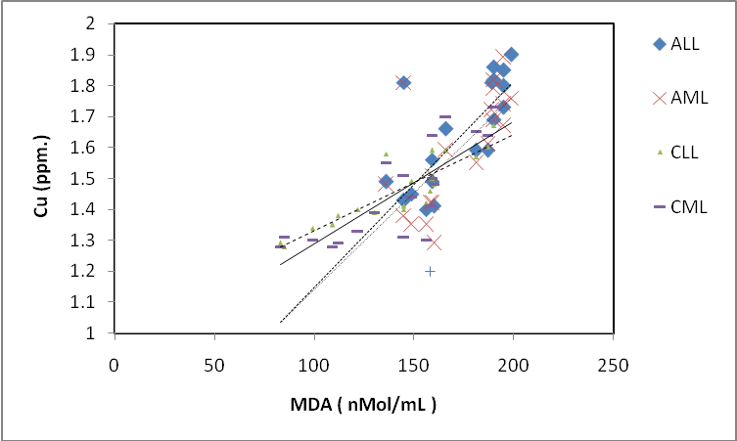
Fig.(2)Correlation between serum free copper and MDA Levels in All Patient Groups.
r_{ALL}=0.76
r_{AML}=0.73
r_{CLL}=0.80
r_{CML}=0.81

Table (4): Selenium Levels in All Studied Groups.

-Legend as in table (1)
Selenium conc. (ppm) | n | Group
0.095 ± 0.002ª | 20 | CTR
0.047 ± 0.003ª | 20 | ALL
0.059 ± 0.005ª | 25 | AML
0.062 ± 0.003ª | 20 | CLL
0.069 ± 0.002ª | 20 | CML

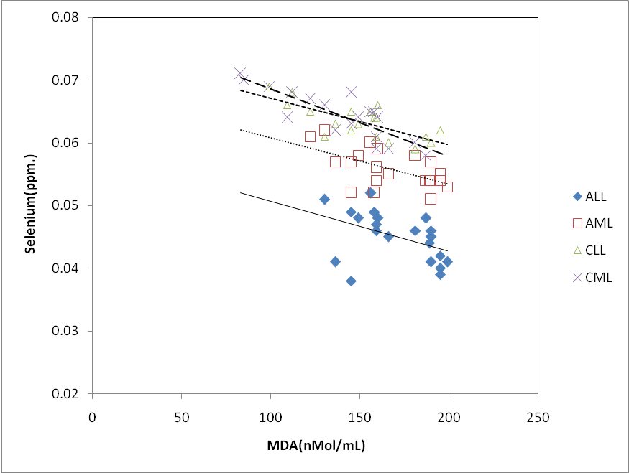

Fig.(4)Correlation between Serum selenium and MDA Levels in All Patient Groups.
r_{ALL}=-0.62
r_{AML}=-0.61
r_{CLL}=-0.58
r_{CML}=-0.64

