Photocatalytic Degradation of Cobalamin by Metalized TiO2

Ahmed F. Halbus and Falah H. Hussein
Chemistry Department, College of Science, Babylon University, Hilla, IRAQ
E-mail: ahmed_fozy71@yahoo.com
Abstract
The purpose of this study was to investigate experimentally the degradation of cobalamin by suspensions of platinum and other metals supported on Hombikat UV100 . The effect of temperature on the efficiency of photodegradation of cobalamin was studied in the range 278-298K using UVA source of irradiation. The activation energy was calculated according to Arrhenius plot, and was found equal to 22 ±1 kJ.mol⁻¹ for TiO₂. The results showed that pH of reactants was changed at the end of reaction towards 7 independent on the initial pH .
The results of the total organic carbon (TOC) analysis indicate that the rate of degradation of dye was faster than the total mineralization. Decolorization and mineralization of cobalamin in the absence of light and/or catalyst were performed to demonstrate that the presence of light and catalyst is essential for the degradation of this cobalamin. The results show that the activity of different types of metals used in this study was in the following the sequence:
Pt/TiO₂ > Pd/TiO₂ > Au/TiO₂
Key words:- photocatalytic degradation , cobalamin , metalized titanium dioxide.
1. Introduction
Cobalamin is a complex organometallic compound which is formed by the situated of the cobalt atom in a corrin ring[1-3]. The central metal ion in the cobalamin is cobalt. Four of the six coordination sites are provided by the corrin ring and the fifth is provided by a dimethylbenzimidazole group. The sixth coordination site, the center of reactivity, is variable as it can be a cyano group (-CN), a hydroxyl group (-OH), a methyl group (-CH₃) or a 5'-deoxyadenosyl group (here the C5' atom of the deoxyribose forms the covalent bond with Co), respectively, to yield four cobalamin forms [4].
In recent years, the interest has been focused on the use of semiconductor in photocatalytic degradation of different types of pollutants . The band gap of mostly used semiconductor (TiO₂ and ZnO) is ~ 3.2 e.V. Therefore photocatalytic activities are shown only under UV irradiations. However, the presence of colored compounds on the surface of the semiconductor can absorb a radiation in the visible range and then is excited by a process called photosensitization . The hydroxyl group radical (.OH),which is formed by the photocatalytic process, from the photosensitization processes,will oxidize all the organic compounds to CO₂ and H₂O(mineralization)[5] .
Several processes were used for the treatment of pollutants such as biodegradation, catalytic oxidation, chemical treatment (chlorine, ozone, hydrogen peroxide), and degradation by high-energy ultraviolet light [6,7]. One of the active methods to treat the colored wastewater is advance oxidation process (AOP) including photocatalysis degradation systems which use a semiconductor (TiO₂ or ZnO) and UV light [8]. One of the best materials which have good ability to destroy the organic materials and active species to un-harmful material by using light/semiconductor system [9]. The photocatalytic activity of semiconductors can be enhanced by using different techniques[7-15]. Zhou et al. showed that doping of titanium dioxide with metal ( M-TiO₂) nanocomposites gives higher activity in visible-light for degradation of Rhodamine-B (RhB) in water [7].
Wang et al. observed that the calcination temperature of titanium dioxide at 500°C caused to double the activity of titanium dioxide for photocatalytic degradation of methyl orange(MO) [8]. Wu et al. studied a comparison between the photocatalytic activity (PC) and photoelectrocatalytic activity (PEC) of methylene blue (MB) [11]. They were noticed that the photoelectrocatalytic activity is more efficient than photocatalytic activity. There are different studies using doped metal on titanium dioxide surface to enhance the activity of catalyst or to reduce the band gab of semiconductor [10-15]. The aim of this study was to investigate the photocatalyst degradation of cobalamin using different types of metals namely Pt/TiO₂ , Pd/TiO₂ and Au/TiO₂ . The effect of different parameters was studied to estimate the best condition for degradation of cobalamin . The structure of cobalamin is shown in figure 1.
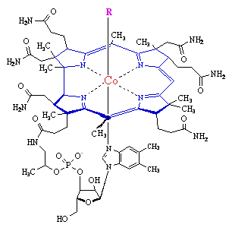
Figure 1: Structure of Cobalamin.
2. Experimental
Photocatalytic reactions were carried out in a batch photoreactor with the radiation source type Philips (CLEO), Poland, mercury lamps containing 6 lamps with 15W for each. Aqueous suspensions of metal /TiO₂ (HombikatUV100) containing cobalamin in beaker, under magnetic stirring, were irradiated in light of wavelength 365 nm with an irradiation intensity of (0.5-3 mW.cm^{－2} ).
In all experiments, the required amount of the catalyst was suspended in 100cm³ of aqueous solution of cobalamin . After illumination, 2ml was taken from the reaction suspension, centrifuged at 4,000 rpm for 15 minutes in an 800B centrifuge, and filtered to remove the particles. The second centrifuge was found necessary to remove fine particle of the metal /TiO₂ (HombikatUV100). After the second centrifuge, the absorbance of the cobalamin was measured at 361 nm and 550 nm respectively using Cary 100Bio UV-visible spectrophotometer shimadzu. The measurements at the two wavelength produced an equivalent results, when compared with the prepared calibration curves.
2.1. Photodeposition of metal on TiO₂
M-TiO₂ samples were prepared by photodeposition method [16] . The samples were prepared by suspending 0.5 g of TiO₂ powder in 100 ml of (50% methanol and 50% deionized water) by sonication for three minutes, followed by the addition of the desired amount of as-prepared metal salt solution under continuous magnetic stirring. Then reaction vessel for loading irradiated over night with light intensity 1 mW/cm² "Philips 4 lamps" under inert environment by argon gas. After irradiation change in color was obtained, and separation the powder obtained by centrifuged . Finally the product was thoroughly washed with distilled water, then the obtained powder was dried at 60 °C in an oven overnight.
3. Results and Discussion
The photocatalytic decolorization rate of cobalamin is described by pseudo first-order kinetics according to the Langmuir–Hinshelwood model, so the rate of photocatalytic decolorization of cobalamin could be expressed by the following equation:

C_{t}= C_{o} e ^{–kt} (1)
where C_{t} represents cobalamin concentration at time t of irradiation , C_{o} is the initial concentration, k is the apparent reaction rate constant of the pseudo-first order kinetics, and t irradiation exposure time [5].

C_{t}/ C_{o} =e^{-kt} (2)
ln C_{t}/ C_{o} = - kt (3)
(4) ln C_{o}/C_{t} = kt or
The photodecolorization efficiency (P.D.E) of cobalamin was calculated from a mathematical equation adapted from measurements of decolorization used before [17,18]:

P.D.E = × 100

C_{o} - C_{t}
C_{o}
(5)

where C_{o} is the initial concentration of cobalamin, C_{t} represents cobalamin concentration at time t of irradiation.
3.1. Mineralization of Cobalamin for Pt/TiO₂ in The existence Oxygen Gas and Nitrogen Gas.
The results in figure 2 show the relationship between the total organic carbon (TOC) degradation% and irradiation time in the existence oxygen gas and nitrogen gas. under the experimental conditions, initial cobalamin concentration of 40 ppm, solution pH equal to 7.8 ,light intensity is equal to 1.3 mWcm⁻², Pt/TiO₂ concentration 175 (mg/100ml) and the temperature equal to 298.15K .

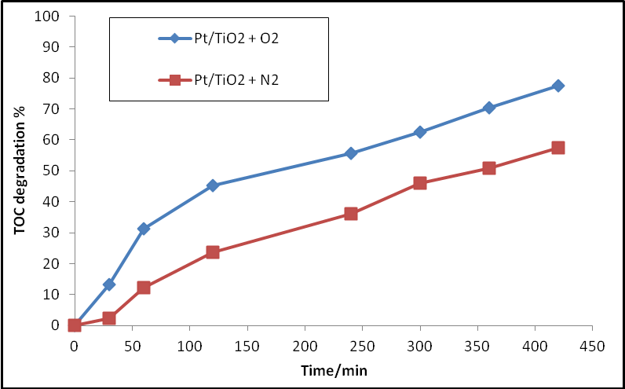

Figure 2: Mineralization of cobalamin by Pt/TiO₂ in the existence oxygen gas and nitrogen gas.
The results in figure 3 and 4 show the relationship between Photodegradation efficiency (PDE) and irradiation time for Pt/TiO₂ in the existence of oxygen gas and nitrogen gas.

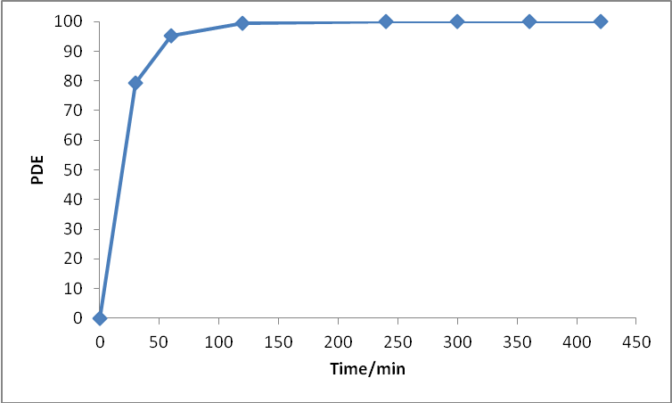

Figure 3: PDE with irradiation time for Pt/TiO₂ in the existence oxygen gas.
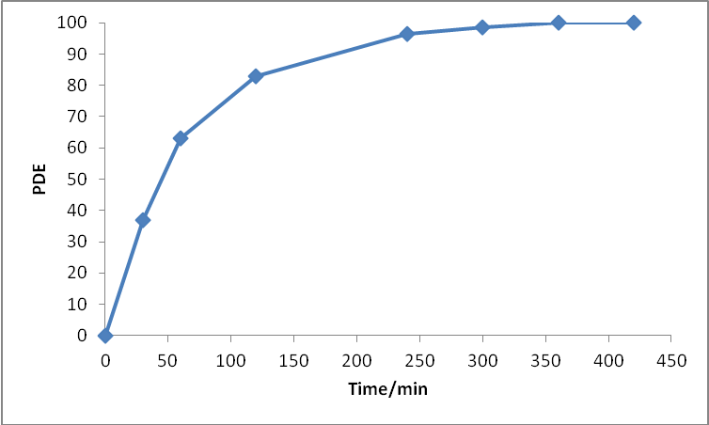
Figure 4 : PDE with irradiation time for Pt/TiO₂ in the existence nitrogen gas.
3.2. Mineralization of Cobalamin for Pd/TiO₂ in The existence Oxygen Gas and Nitrogen Gas.
The results in figure 5 show the relationship between the total organic carbon (TOC) degradation% and irradiation time in the existence oxygen gas and nitrogen gas, under the experimental conditions, initial cobalamin concentration of 40 ppm, solution pH equal to 7.8 ,light intensity is equal to 1.3 mWcm⁻², Pd/TiO₂ concentration 175 (mg/100ml) and the temperature equal to 298.15K .

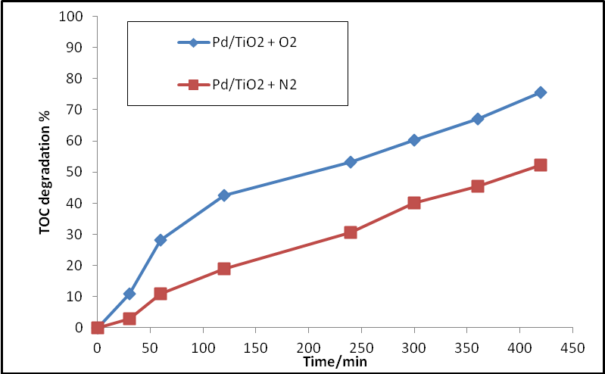

Figure 5: Mineralization of cobalamin by Pd/TiO₂ in the existence oxygen gas and nitrogen gas.

The results in figure 6 and 7 show the relationship between photo degradation efficiency (PDE) with irradiation time for Pd/TiO₂ in the existence of oxygen gas and nitrogen gas.

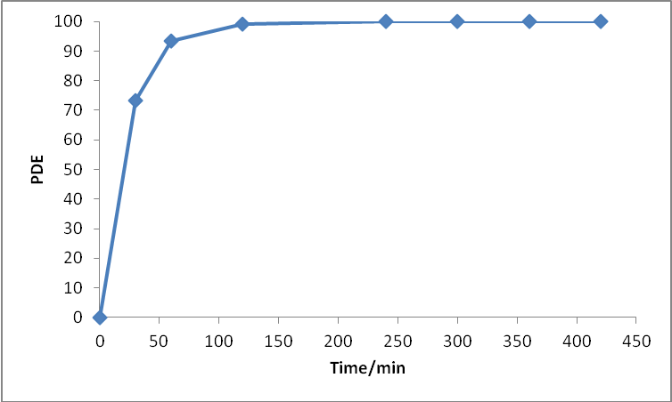

Figure 6: PDE with irradiation time for Pd/TiO₂ in the existence oxygen gas.

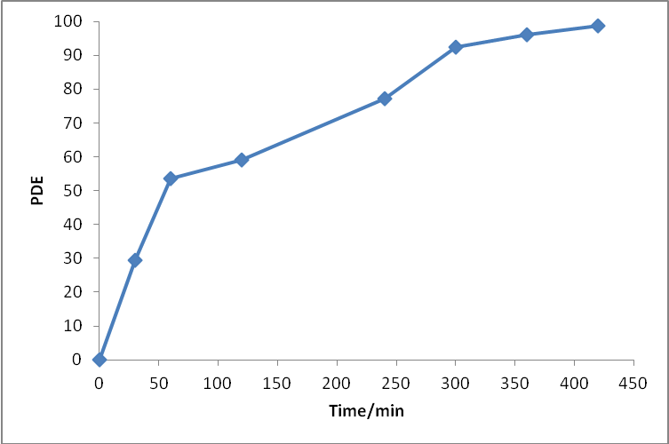

Figure 7: PDE with irradiation time for Pd/TiO₂ in the existence nitrogen gas.

3.3. Mineralization of Cobalamin for Au/TiO₂ in The existence of Oxygen Gas and Nitrogen Gas.
The results in figure 8 show the relationship between the total organic carbon (TOC) degradation% with irradiation time in the existence oxygen gas and nitrogen gas, under the experimental conditions, initial cobalamin concentration of 40 ppm, solution pH equal to 7.8 ,light intensity is equal to 1.3 mWcm⁻², Au/TiO₂ concentration 175 (mg/100ml) and the temperature equal to 298.15K .

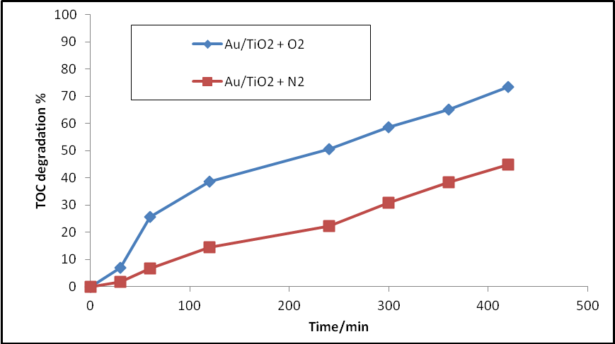

Figure 8: Mineralization of cobalamin by Au/TiO₂ in the existence of oxygen gas and nitrogen gas.
The results in figures 9 and 10 show the relationship between photo degradation efficiency (PDE) with irradiation time for Au/TiO₂ (HombikatUV100) in the existence of oxygen gas and nitrogen gas.
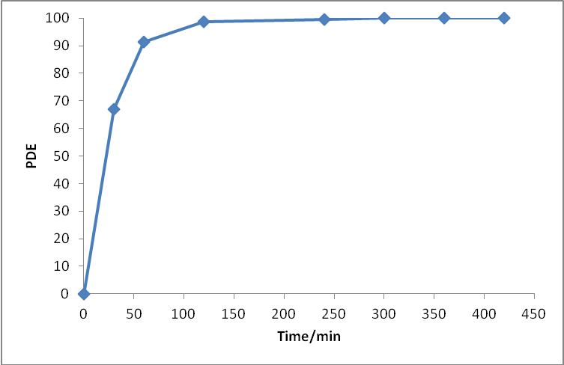

Figure 9: PDE with irradiation time for Au/TiO₂ in the existence oxygen gas.

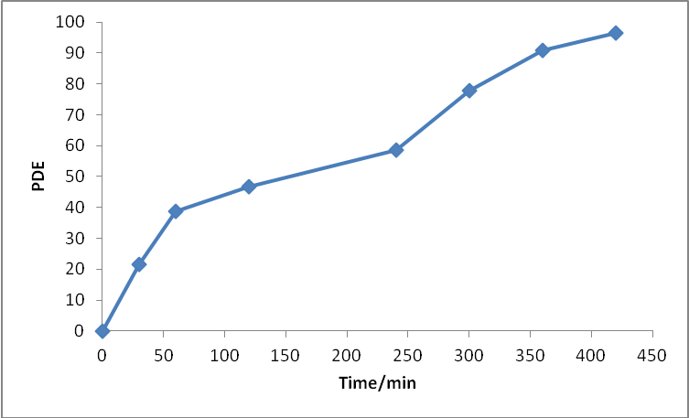

Figure 10: PDE with irradiation time for Au/TiO₂ in the existence nitrogen gas.
4. Conclusions
Investigation of the photocatalytic degradation of Cobalamin under different experimental conditions led to the following conclusions:
The photocatalytic process can be expressed by both, the pseudo first order reaction kinetics according to the Langmuir-Hinshelwood kinetic model pH was changed at the end of reaction towards 7 (neutral).
The controlled experimental indicates that the presence of UV light, oxygen, and catalyst were essential for the effective destruction of cobalamin. It is important to choose optimum degradation parameters to obtain a high photocatalytic degradation rate. Photocatalytic degradation of cobalamin is faster than the decrease of total organic carbon (TOC). The recombination process was inhabited by using metal doped titanium dioxide, that cause an increasing the separation between photoelectron and photohole.

References
- L. Quaroni, J. Reglinski, and W. E. Smith, “Surface enhanced resonance raman scattering from cyanocobalamin and 5'- deoxyadenosylcobalamin,” Journal of Raman Spectroscopy, vol. 26,pp. 1075-1076, 1995.
- A. F. Halbus and F.H. Hussein, " Heterogeneous photocatalytic decolorization of cobalamin in the presence of aqueous titanium dioxide suspensions" Asian Journal of Chemistry, vol.24, no.12, pp.1-3,2012 .
- A. F. Halbus and F.H. Hussein, " Rapid Decolorization of cobalamin, " accepted for publication , International Journal of Photoenergy,495435,2012.
- G. Jaouen, “Bioorganometallics: biomolecules, labeling, medicine, ” Wiley-VCH, Weinheim ,2006.
- F. H. Hussein, A. F. Halbus, H. A K. Hassan , and W.A K. Hussein, “Photocatalytic degradation of bismarck brown G using irradiated ZnO in aqueous solutions,” E-Journal of Chemistry,vol.7,no.2, pp.540-544,2010.
- J. A. Byrne, P. A. Fernandez-Ibanez, P. S.M. Dunlop, D.M. A. Alrousan, and J.W. J. Hamilton , “ Photocatalytic enhancement for solar disinfection of water: a review, ” International Journal of Photoenergy, vol. 2011, Article ID 798051, pp.1-12,2011.
- M. Zhou, J. Zhang, B. Cheng, and H. Yu, “ Enhancement of visible-light photocatalytic activity of mesoporous Au-TiO₂ nanocomposites by surface plasmon resonance,” International Journal of Photoenergy, vol. 2012, 2012.
- G. Wang, L. Xu, J Zhang, T. Yin, and D. Han, “ Enhanced photocatalytic activity of TiO₂ powders (P25) via calcination treatment,” International Journal of Photoenergy, vol. 2012, 2012.
- D. Roberts, and S. Malato, “ Solar photocatalysis a clean process for water detoxification, ” Science of the Total Environment. ,vol. 291, pp. 85-97, 2002.
- H. Znad, M. H. Ang, and M. O. Tade, “ Ta/TiO₂-and Nb/TiO₂-mixed oxides as efficient solar photocatalysts: preparation, characterization, and photocatalytic activity, ” International Journal of Photoenergy , vol. 2012, 2012.
- X. Wu, Z. Huang, Y. Liu, and M. Fang , “ Investigation on the photoelectrocatalytic activity of well-aligned TiO₂ nanotube arrays,” International Journal of Photoenergy , vol.2012, 2012.
- X . Cheng, X. Yu, Z. Xing, and L. Yang , “Enhanced visible light photocatalytic activity of mesoporous anatase TiO₂ codoped with nitrogen and chlorine, ” International Journal of Photoenergy , vol. 2012, 2012.
- C. H. Huang, Y. M. Lin, I.K.Wang, and C. M.Lu , “ Photocatalytic activity and characterization of carbon-modified titania for visible-light-active photodegradation of nitrogen oxides, ” International Journal of Photoenergy ,vol. 2012, 2012.
- Q. Wang, D. Gao, C. Gao, Q. Wei, Y. Cai, J. Xu, X. Liu, and Y. Xu, “Removal of a cationic dye by adsorption/photodegradation using electrospun PAN/O-MMT composite nanofibrous membranes coated with TiO₂, ” International Journal of Photoenergy , vol. 2012, 2012.
- J. Wang, Q. Cai, H. Li, Y.Cui, and H.Wang, “A reviewon TiO₂ nanotube film photocatalysts prepared by liquid-phase deposition, ” International Journal of Photoenergy, vol. 2012, 2012.
- F . H . Hussein, and R . Rudham, “Photocatalytic dehydrogenation of liquid propan-2-o1 by platinized anatase and other catalysts,” Journal of the Chemical Society, Faraday Transactions, vol. 80, no.1, pp. 2817-2825,1984.
- F. H. Hussein, and T. A. Abassa, “Photocatalytic treatment of textile industrial wastewater, ” International Journal of Chemical Sciences, vol. 8, no. 3, pp. 1353-1364,2010.
- A. F. Halbus “photocatalytic degradation of cobalamin” M.Sc. Thesis, College of Sciences, University of Babylon, Iraq, 2012.

