Preparation of Gold Nanoparticles by Pulsed Laser Ablation in NaOH solution

Raheem Gaayied Kadhim Maryam falah noori
Babylon university /colloge of the scince
Abdulrahman Khalaf Ali
School of Applied Sciences – University of Technology
Abstract
Noble metal gold NPs were synthesized by pulsed (Q-switched, 1064-Nd: YAG,10 ns pulse duration and E=750 mJ) laser ablation of gold metal plates immersed in double distilled and deionised water DDDW and other aqueous solution of NaOH with various concentrations. Absorbance spectra of the produced nanoparticles solution was measured by uv-vis spectrophotometer which show sharp and single peaks 525 nm, indicating the production of pure and spherical Au NPs with average size of 51 nm, respectively. The morphology and size was estimated by SEM.
Keyword: Nobel, Pulsed, Nanoparticles, Gold, Liquid, Nd: YAG, NaOH solution

Introduction
Nanotechnology is the rapid emerging field to overcome the existing issues in the research and development sector [1]. Pulsed laser ablation in liquid media (PLAL) has become an increasingly important alternative approach for synthesis of colloidal suspensions with novel functional properties. In particular, the fabrication of metallic nanoparticles (NPs), mostly gold and silver, has attracted much interest due to their surface plasmon resonance related properties that are potentially useful for their biological applications [2].Also; it requires ambient conditions without extreme temperature and pressure. It has been shown that size control can be achieved by changing the laser wavelength, supplementary laser irradiation of colloids, laser fluence, and liquid environment and by using surfactants [3].The pulsed laser ablation in liquids PLAL has become an increasingly popular top-down approach for producing metallic colloids[4].The method involves carving nanomaterials out of bulk materials [5].The top down method is where material is removed from the bulk material, leaving only the desired nanostructures. Common top down the techniques are photolithography and electron beam lithography (generation of the mask).Top down techniques suffer from the need to remove large amounts of material.Approach where nano-objects are constructed from larger entities without atomic-level control [6].Noble metal nanoparticles such as Au NPs have been a source of great interest to their unusual physical properties, especially due to their sharp plasmon absorption peak at the visible region. The resonance frequencies depend on particle shape and size and stable for a long period of months. Moreover, exhibited absorbance, which provide as a powerful detection tools and shows, promise in enhancing the effectiveness of various targeted cancer treatments. Therefore it's a source of great interest of application due to their novel electrical, optical, and catalyst properties[7].Gold is used for nanoparticle applications because it is unreactive and is not sensitive to air or light [8] The size control of the noble metal nanoparticles fabricated by laser ablation could be achieved by adding specific molecules to the aqueous fabrication environment, which physically or chemically interact with the surfaces of the forming particles, to limit their growth. Ionic surfactants, [9,10] cyclodextrins, [11] and sodium chloride [12] were successfully used to limit the noble metal particle size. In some cases, the exact mechanism limiting the growth of the particles remains unclear.
As reported in previous literatures, we found that the preparation of metal nanoparticles via PLAL method suffers from low production yields and the rate of NPs generation strongly depends on experimental parameters. Moreover, the size and size distribution of the NPs prepared by PLAL tends to be broadened due to the ejection of large fragments and agglomeration and the process is not controlled.
In this paper, we have reported synthesis of gold NPs by nanosecond Nd: YAG laser ablation of gold target immersed in of double distilled deionized water DDDW and in various concentrations of NaOH solution. The optical properties and morphology of colloidal gold NPs prepared at different concentrations were investigated.

Materials and methods:
Gold NPs were synthesized by pulsed laser ablation of gold target in double distilled and deionized water DDDW and other aqueous solution of NaOH with various concentrations at room temperature. The gold target (purity of 99.99%) was fixed at bottom of glass vessel containing of 1 ml of double distilled deionized water DDDW or NaOH solution.The ablation was achieved using focused output of pulsed Nd: YAG laser (type HUAFEI) operating with a repetition rate of 1 Hz and pulse width of 10 ns. Ablation is carried out with laser operating at 1064 nm wavelengths at fluence set in 61 J/cm².The spot size of the laser beam on the surface of the metal plate was 1 mm in diameter by the distance between the focusing lens and the metal plate at 10 cm.The pulse energy was (750 mJ).The liquid thickness was 1mm.The number of laser shots applied for the metal target at 25 pulses. Size and shape measurements investigated by scanning electron microscope SEM (FEL Quanta 200, Netherlands) SEM view of periodic structures formed under scanning laser ablation in NaOH solution.The absorbance spectra of the nanoparticles solution measured by UV-VIS double beam spectrophotometer (type CECIL C. 7200).The Experimental setup of PLAL process was shown as in Fig. 1.
Results and discussion
Fig.2 shows the absorbance spectra of gold colloids prepared by laser ablation of a gold plate immersed in DDDW or in sodium hydroxide (NaOH) solution at various concentrations, ranged as (2.5- 20)mM , for laser energy of 750 mJ, λ=1064 nm.The figure show broadband in the visible region with maximum peaks around 525 nm. Indeed, presence of NaOH solution enhances the absorbance peaks compared water. The inset in Fig.2 illustrates the change in the absorbance peaks as a function of NaOH concentrations. The optimum absorption for the formation of Au nanoparticles in various concentrations was of NaOH which optimizes the formation efficiency, reduces the size and size distribution.The absorption peaks of Au nanoparticles are rapidly decreased when NaOH concentrations changed from 2.5 to 20 mM. The abundance of gold nanoparticles is attributed to the presence of OH⁻ ions, which in particular increase of the efficiency of the formation of Au NPs; this fact was confirmed by Sylvestre et al [13]. According to our results, the optimum NaOH concentration to produce maximum amount of Au NPs is 2.5 mM. Selected sample were also examined using a SEM was shown as in Fig. 3.

Conclusions
In summary, we successfully demonstrated the synthesis of high purity gold NPs colloid at room temperature by Nd: YAG laser ablation of gold target in NaOH solution.The optical properties of NaOH are strongly affected by laser fluence and wavelength.The gold NPs exhibited high absorption in visible region and lowered absorption in UV and IR regions.The average size of gold NPs increased with laser fluence.The synthesized gold NPs have spherical shape and the size distribution is nearly Gaussian. The effect of water temperature on characteristics of gold NPs is underway. The nanoparticles obtained by laser ablation were partly oxidized, with Au-O compounds present at the nanoparticles surface.These compounds contribute to the negative surface charge of the nanoparticles.The addition of OH⁻ to the solution increases the absolute value of this negative charge and leads to the formation of smaller nanoparticles.This is accompanied by the reduction of the particle size and is a strong indication that the simultaneous functionalization of Au nanoparticles can be achieved during their fabrication by laser ablation. We concluded that two main mechanisms influence the size of NPs. Firstly, the interaction between freshly ablated gold and surrounding solution determines the surface chemistry of produced gold NPs. Secondly, interactions between NPs under laser irradiation lead to fusion of gold colloids.
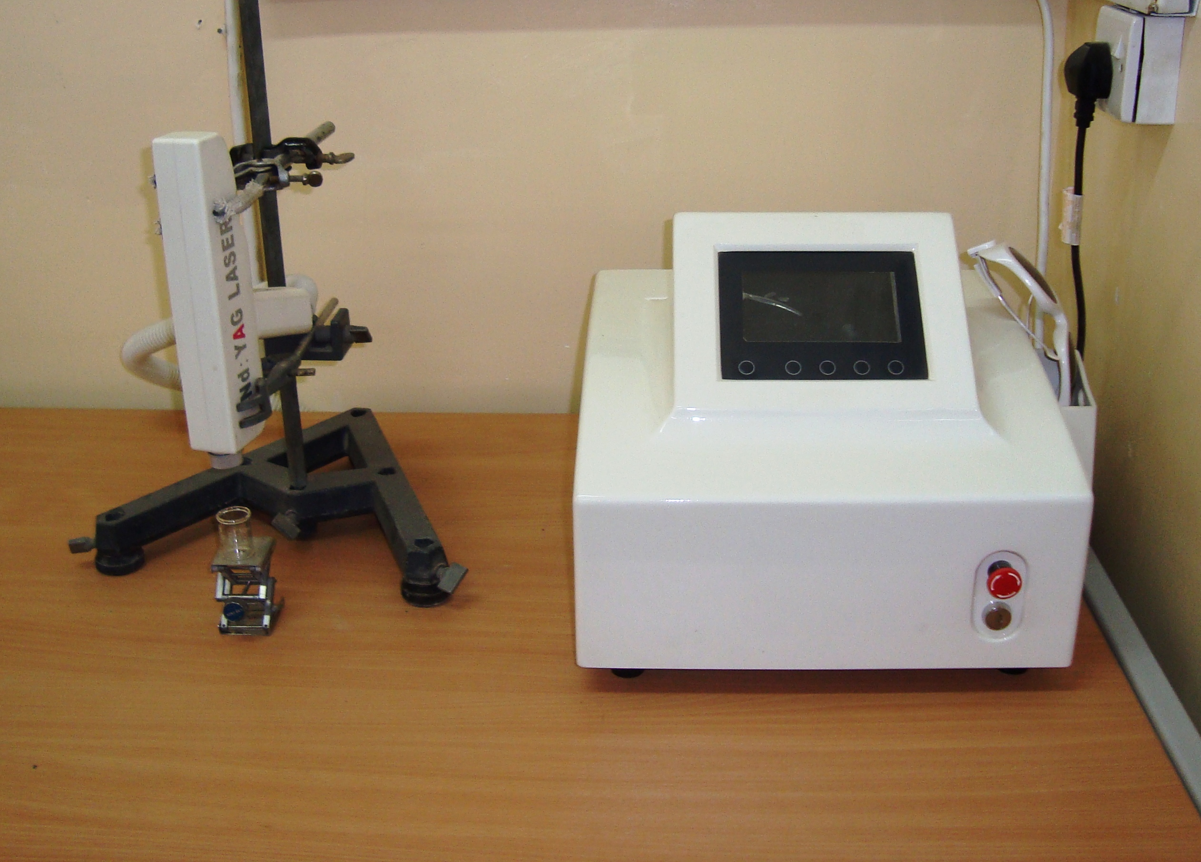
Focusing lens

Au Target
Glass vessel cell
NPs solution
plasma
Laser Nd: YAG

Fig.1: Experimental setup for nanoparticles synthesis by PLAL process.

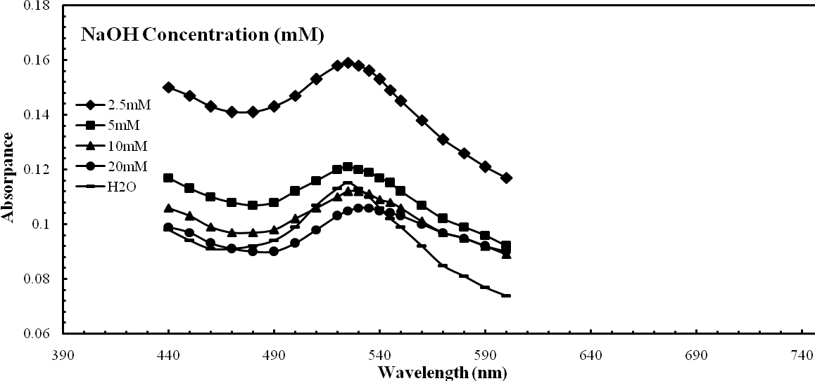
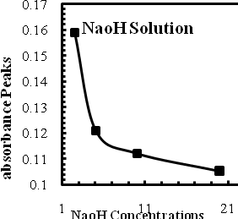

Fig.2: Absorbance spectra of gold colloids prepared by laser ablation of a gold plate immersed in DDDW or in NaOH solutions at various concentrations, ranged as (2.5- 20)mM, for laser energy of 750 mJ/pulse, λ=1064 nm and laser shots is 25 pulse. The inset illustrates the change in the absorbance peaks as a function of NaOH concentration.

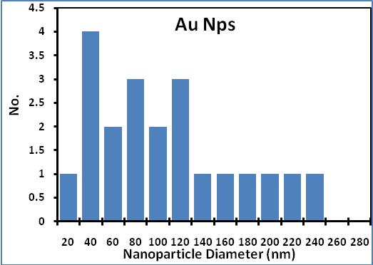
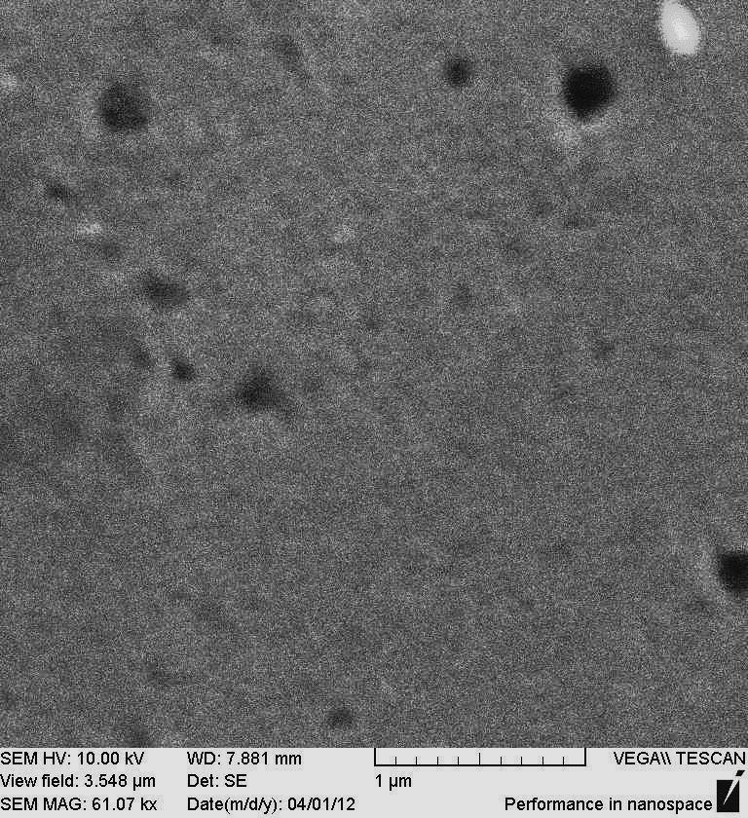
100 nm

Fig.3: SEM images and size distributions of gold nanoparticles, produced by laser ablation of metal plats immersed in DDDW, (λ=1064 nm and laser shots of 25 pulses). The laser energies are 550mJ/pulse.
References
- R. Zamiri, B.Z. Azmi, M. G. Naseri , H. A. Ahangar · M. Darroudi and F. K.Nazarpour, "Laser based fabrication of chitosan mediated silver nanoparticles", Appl Phys A (2011)105:255–259.
- D. Riabinina, J. Zhang, M.d Chaker, J. Margot and D. Ma ,"Size Control of Gold Nanoparticles Synthesized by Laser Ablation in Liquid Media", ISRN Nanotechnology Volume (2012), Article ID 297863, 5 pages.
- G. Bajaj, R.K. Soni "Effect of liquid medium on size and shape of nanoparticles prepared by pulsed laser ablation of tin" Appl Phys A (2009) 97: 481–487.
4. J.Sylvestre, A.V.Kabashin, E.Sacher, M.Meunier and J.T.Luong "Stabilization and Size Control of Gold Nanoparticles during Laser Ablation in Aqueous Cyclodextrins" J. AM. chem. soc. 126 (2004) 7176-7177.
5. J. C. Miller, R. M. Serrato, J. M. R-Cardenas and G. A. Kundahl "The handbook of nanotechnology" (2005).
6. S. Eustis "Gold and silver nanoparticles: characterization of their interesting optical properties and the mechanism of their photochemical formation" Doctoral Thesis, (2006), Georgia Institute of Technology.
7.A.S.Kupiec, D. Malina, M. Zimowska and Z. Wzorek ,"Characterization of gold nanoparticles for various medical application", Digest Journal of Nanomaterials and Biostructures,Vol. 6, No 2, April - June (2011),p. 803– 808.
8. V. Kattumuri "Gold nanoparticles for biomedical applications: synthesis, characterization, in vitro and in vivo studies" PhD thesis,(2006), University of Missouri– Columbia.
9. F. Mafune, J. Kohno, Y. Takeda, T. Kondow "Formation of Stable Platinum Nanoparticles by Laser Ablation in Water" J. Phys. Chem. 107 (2003) 4218-4223.
10. F. Mafune, J. Kohno, Y. Takeda, T. Kondow "Formation and Size Control of Silver Nanoparticles by Laser Ablation in Aqueous Solution" J. Phys. Chem. 104 (2000) 8333.
11. J. Sylvestre, A. V. Kabashin, E. Sacher, M. Meunier, J. T. Luong "Stabilization and Size Control of Gold Nanoparticles during Laser Ablation in Aqueous Cyclodextrins" J.AM. CHEM. SOC. 126 (2004) 7176-7177.
12. C. H Bae, S. H. Nam, S. Park "Formation of silver nanoparticles by laser ablation of silver target in liquid in NaCl solution" Applied surface science, 197 (2002) 628-634.
13.J. P. Sylvestre, S. Poulin, A. V. Kabashin and E. Sacher "Surface Chemistry of Gold Nanoparticles Produced by Laser Ablation in Aqueous Media" J. Phys. Chem. 108 (2004) 16864-16869.

