Quantum yield of formaldehyde formation from methanol in the presence of TiO2 and platinized TiO2 photocatalysts

Luma M. Ahmed ª, Falah H. Hussein^{b}
ª Chemistry Department, College of Science, Karbala University, Karbala, IRAQ
^{b} Chemistry Department, College of Science, Babylon University, Hilla, IRAQ
Luma_chemical@yahoo.com
Abstract:
In this paper, the quantum yield of formaldehyde formation was measured under different experimental condition. The quantum yield values were found to be affected by different factors such as type of catalyst, dose of catalyst, initial pH of photo-reacted suspension and temperature.
The photocatalytic dehydrogenation of methanol was carried out using TiO₂ and Platinized TiO₂. The photocatalytic reaction was followed under oxygen or nitrogen atmosphere. The liming quantum yield using TiO₂ and Platinized TiO₂ is 0.5.
Optimum pH values for titanium dioxide (Hombikat) and platinized titanium dioxide in the existence of oxygen resulting in maximum quantum yield are 7.06 and 7.08 respectively. However, the optimum pH value for platinized titanium dioxide in the existence of nitrogen gas in maximum quantum yield is 7.15.
Two mechanisms for photocatalytic dehydrogenation of methanol with a limiting quantum yield of 0.5 are discussed.
Key words: TiO_{2,} Platinized TiO_{2,} Photocatalyst, Methanol, Formaldehyde, Quantum yield.
1. Introduction:
Photocatalytic oxidation of aliphatic alcohols to aldehydes or ketones with aqueous TiO₂ or platinized TiO₂ suspension is more widely reported by irradiation of UV light [1-5].
TiO₂ continues to be the preferred as a photocatalyst due to its strong oxidation capacity, strong resistance to chemical and photocorrosion, high photochemical and biological stability, non-toxicity and very low cost [6-7]. TiO₂ particles absorb, scatter, or transmit light, so they can't absorb all the incident light that will make the calculation of quantum yield in heterogeneous photocatalytic processes is difficult [8-9]. The quantum yield at a given wavelength is described the photon efficiency of photochemical process, the optimum value of it is unity (Φ_{λ}=1) that depends on the ability the absorbing species or chromospheres to absorb the photon with generates a product, but most photoreaction have quantum yield less than one (Φ_{λ} 1) because the photophysical deactivation processes is taking place, while when the quantum yields are very small (Φ_{λ} 0.01) that due to the conversion process to product is very slow. Some time the quantum yield is more than one (Φ_{λ} 1) that attitude to find the photoinduced chain reaction which needed a light only for the initiation step [10].

This work focus on values quantum yield of formed formaldehyde by purged O₂ and N₂ environment, in the presence of aqueous TiO₂ and platinized TiO₂ (Hombikat UV 100) suspension solutions.
2. Experimental:
Commercial titanium dioxide type Hombikat UV 100 supplied by (Sachtleben, Germany) consists of 100% anatase with surface area more than 250 g/ cm², was employed throughout all experiments.
Hexachloroplatinic acid hexahydrate (Riedel-De-Haen AG, Seelze, Hannover, Germany), Methanol (HPLC grade, 99.8 %, Sd fine-CHEM limited, Mumbai, India), Methanol A.R quality (99.85 %, Hayman, England), Formaldehyde (40%, Chemanol, Kingdom Al-Arabia Al-Sudia), were used without further purification.
Platinized titanium dioxide (0.5 (w/wt)%) was prepared by photodeposition of platinum particles on surface of commercially titanium dioxide (Hombikat UV 100) by purged with N₂ in suspension solution under UV-A light by a Philips Hg lamp (efbe-Schon, 90 W, Germany)[2,5].
All photocatalytic experiments were performed by employing 100 cm³ of 40 mM methanol mixed with certain weight of naked TiO₂ or 0.5 % platinized TiO₂, by employing a magnetic stirrer to produce a suspension solution. The distance between the lamps and the surface of Pyrex glass container was 12.5 cm. At predetermined times; 2.5 cm³ of reaction mixture was collected in a plastic test tube and centrifuged (4000 rpm, 15 minutes) in an 800 B centrifuge. The filtrated solution was carefully removed by a syringe to new plastic test tube and centrifuged again to remove the fine particles of naked TiO₂ or 0.5 % platinized TiO₂ at the same top conditions. Nash method was employed to determine the produced formaldehyde at a wavelength 412 nm [11-13].The light flux density (light intensity) for Philips Hg lamp was determined by employing the chemical actinometric (ferrioxalate actinometric) solution [14-16 ]. In all experiments, the calculated light intensity was 0.1570 μ Ens. S⁻¹.
3. Results and Discussion:
3.1 Effect of catalyst dose:
Figure 1 displays the quantum yield of formaldehyde formation as function of catalyst dose. The values of quantum yield in presence of aqueous TiO₂ and platinized TiO₂ solutions were found to be directly proportional to catalyst dose at ranged (50-200) mg/100 mL, that beyond to increase of active sites on surface of catalyst, while at higher catalyst mass, the values of quantum yield of formaldehyde formation decline. This behavior is due to the screening effect which attributed to increase the turbidity of the solution and ultraviolet rays start getting scattered [17].
The maximum quantum yield value for photooxidation of methanol solution to formaldehyde was noted at a plateau region where catalyst mass equal to 175 mg/ 100 mL in present O₂ and N₂,
The photoreaction for producing a formaldehyde was faster in present a platinized TiO₂ with purged N₂ in methanol solution, this issue emphasized that only formaldehyde produced and no further oxidized products i.e. formic acid or CO₂ and H₂O occurred [18].

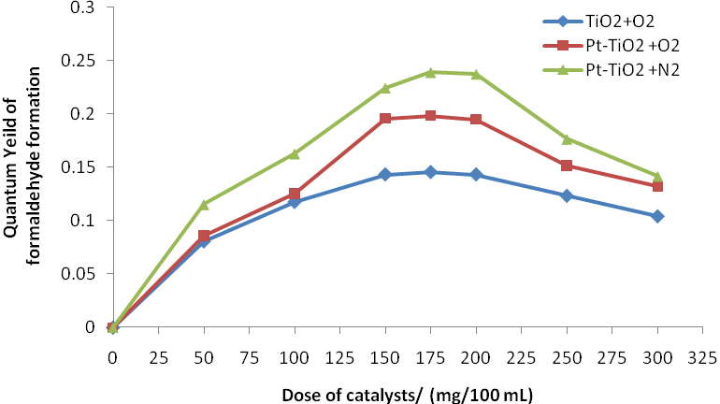

Figure 1: HCHO yield as a function of TiO₂ and platinized TiO₂ dose, light intensity 0.157 x 10⁻⁶ ensien.s⁻¹, methanol concentration 40 mM, temperature of reaction 278 K.
3.2 Effect of pH
The results indicate that photooxidation of methanol to formaldehyde is strongly dependent on the pH value of aqueous TiO₂ and platinized TiO₂ suspension solution. This effect is relevant for the adsorption and dissociation of reactant (methanol), and adsorption of HO⁻ ions over the surface of used catalysts [19]. However, the initial pH of suspension solution dominants on the ionization state of the surface hydroxyl groups over TiO₂ for the naked or platinized, this pH called zero point charge(pH_{ZPC}),which described: the net electrical charge density on a surface for naked or platinized TiO₂ is remained neutral), the surface is has acid-base equilibrium [20]:
Ti^{VI} - OH + H⁺ Ti^{VI} - OH⁺², (pK₁) pH  pH_{ZPC} (1)
Ti^{VI} - OH + OH Ti^{VI} - O– + H₂O, (pK₂) pH > pH_{ZPC} (2)

Figure 2 shows, that the formed formaldehyde from the photooxidation of methanol was followed at different pH values from 1-12. The optimum pH values of quantum yield for reaction in O₂ -purged suspension of titanium dioxide and platinized titanium dioxide were 7.06 and 7.08 respectively. However, the optimum pH value for platinized titanium dioxide in N₂ -purged suspension in maximum quantum yield is 7.15, this implies the reaction is achieved by two mechanisms, either by purged O₂ suspension, that produced formaldehyde and further materials (formic acid or CO₂ and H₂O), or by purged N₂ suspension which removed all O₂ from suspension solution and only produced formaldehyde[18].
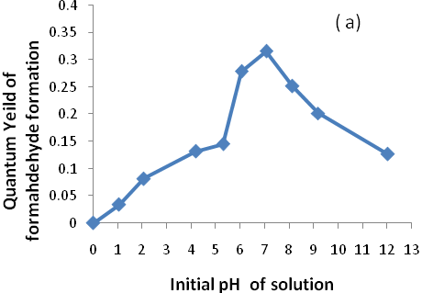
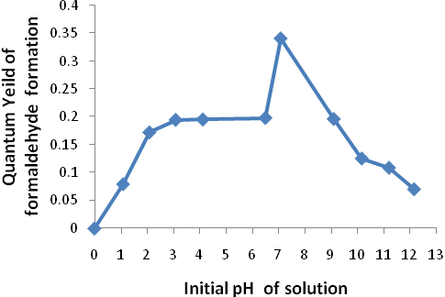
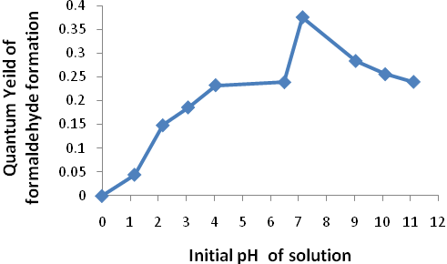
(b)
(c)

Figure 2: HCHO yield as a function of initial pH of solution for (a) TiO₂ with purged O₂ (b) platinized TiO₂ with purged O₂ and O₂ (c) platinized TiO₂ with purged N₂. At light intensity 0.157 x 10⁻⁶ ensien.s⁻¹, methanol concentration 40 mM, temperature of reaction 278 K. ( is initial pH for TiO₂ and platinized TiO₂ suspension solution without controls by acid –base solution which equal 5.3 and 6.5 respectively)

3.3 Effect of temperature
The effect of temperature on the quantum yield of formation formaldehyde is monitored in the range 303 -278 K. Figure 3 shows, the quantum yield values in finding TiO₂ and platinized TiO₂ suspension solutions in presence of O₂ were curvedly proportion with increase of temperature, that referred to generate a further oxidize compound with formaldehyde. However, the quantum yield value in deoxygenated platinized TiO₂ suspension solutions was linearly proportion with increase of temperature, that rationalize to convert methanol to formaldehyde only[2,18].
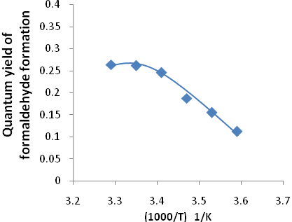
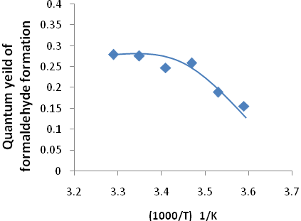
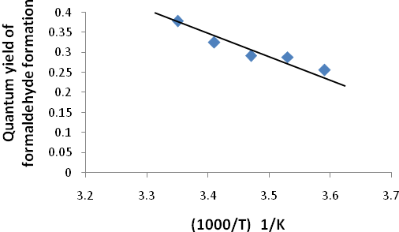
(c)
(b)
(a)

Figure 3: HCHO yield as a function of temperature for (a) TiO₂ with purged O₂ (b) platinized TiO₂ with purged O₂ (c) platinized TiO₂ with purged N₂, at light intensity 0.157 x 10⁻⁶ ensien.s⁻¹, methanol concentration 40 mM.
3.4 The mechanism of photooxidation of methanol in the presence and absence of oxygen:
When the photon fills on the suspension solution of methanol with catalyst either TiO2 or platinized TiO2 (Pt/TiO₂), the photoelectron is promoted from valance band to conductive band and created a (e⁻- h⁺) pair, then the photohole and photoelectron input in serious of reactions according the following equations[3,5, 18].
- In the presence of oxygen:
TiO₂ or Pt/TiO₂ + hν (e⁻ - h⁺) e⁻ + h⁺ (3)
Pt_{n} + e⁻ Pt⁻_{n} (4)
O₂ + e⁻ O₂^{-.} (5)
H₂O H⁺ + ⁻OH (6)
O₂^{-.} + H⁺ .OOH (7)
.OOH + H⁺ H₂O₂ (8)
H₂O₂ 2.OH (9)
⁻OH + h⁺ .OH (10)
CH₃OH +.OH .CH₂OH + H₂O (11)
Formaldehyde formation with a limiting quantum yield of 0.5 could be occurred in the following possibilities:
2.CH₂OH HCHO + CH₃OH (12)
.CH₂OH +.OH HCHO + H₂O (13)
.CH₂OH +O₂ HCOOH + .OH (14)
.CH₂OH + O₂^{-.} HCOOH + ⁻OH (15)
- In the absence of oxygen:

Pt/TiO₂ + hν (e⁻ - h⁺) e⁻ + h⁺ (16)
Pt_{n} + e⁻ Pt⁻_{n} (17)
H₂O H⁺ + ⁻OH (18)
⁻OH + h⁺ .OH (19)
CH₃OH +.OH .CH₂OH + H₂O (20)
Formaldehyde formation with a limiting quantum yield of 0.5 could be occurred in the possibilities:
2.CH₂OH HCHO + CH₃OH (21)

The interaction of formed H₂O from equations (20) with Pt⁻_{n}, the hydroge gas produces by essentially process called reverse of hydrogen spillover.
Pt⁻_{n} + H₂O Pt_{n}-H+ ⁻OH Pt_{n} +1/2 H₂ + ⁻OH (23)
The last equation indicates that hydrogen gas is released and ⁻OH is regarded which adsorbs on the catalyst surface.
3.5 Conclusions:
The quantum yield of formaldehyde depends on the catalyst dose, pH of solution and temperature. The optimum conditions to get a best photooxidation of methanol are 175 mg/ 100 mL from TiO₂ or platinized TiO₂, initial pH equal 7, and temperature around 298 K. further, the purged of nitrogen in solution obtains the best results comparatives with presence of oxygen, due to the presence of N₂ will prevent conversion a produced formaldehyde to formic acid.
Acknowledgment
The authors wish to thank Lebinze-Hanover University for providing by TiO₂ UV 100.
References:
[1] P. Harvey, R. Rudham, and S. Ward, "Photocatalytic Oxidation of Liquid Propan-2-ol by Titanium Dioxide", J. Chem. Soc, Faraday Trans.1,vol. 79, pp. 1381-1,390 1983.
[2] F. Hussein, and R. Rudham,"Photocatalytic Dehydrogenation of Liquid Propan-2-ol by Platinized Anatase and Other Catalysts", J. Chem. Soc, Faraday Trans.1,vol. 80, pp. 2817-2825, 1984.
[3] F. Hussein, G. Pattenden, R. Rudham, and J. Russell, "Photo-oxidation of Alcohols Catalysed by Platinised Titanium Dioxide", Tetrahedron Letters, vol. 25, no. 31, pp. 3363-3364, 1984.
[4] F. Hussein, and R. Rudham,"Photocatalytic Dehydrogenation of Liquid Alcohols by Platinized Anatase", J. Chem. Soc, Faraday Trans.1,vol. 83, pp. 1631-1639, 1987.
[5] L. Ahmed, F. Hussein, and Ali Mahdi, " Photocatalytic Dehydrogen-ation of Aqueous Methanol Solution by Naked and Platinized TiO₂ Nanoparticles", Asian Journal of Chemistry; vol. 24, no. 12, pp. 5564-5568 , 2012.
[6] H. Yang, S. Zhu, and N. Pan, "Studying the Mechanisms of Titanium Dioxide as
Ultraviolet-Blocking Additive for Films and Fabrics by an Improved Scheme", Journal of Applied Polymer Science, vol. 92, pp.3201–3210, 2004.
[7] A. Fujishima, T. Rao, and D. Tryk, " Titanium dioxide photocatalysis", Journal of Photochemistry and Photobiology C: Photochemistry Reviews 1, pp.1–21, 2000.

[8]X. Yi-bing, and Y. Chun-wei, "Calculation Method of Quantum Effeciency to TiO₂ Nanocrystal Photocatalysis Reaction", Journal of Environmental Sciences, vol. 14, no. 1, pp. 70-75, 2002.
[9] A. Mills, and S. Hunte, "An overview of Semiconductor Photocatalysis", Journal of Photochemistry and Photobiology A: Chemistry, vol. 108, pp. 1-35, 1997.
[10] M. Oelgemöller, and O. Shvydkiv, " Review Recent Advances in Microflow Photochemistry", Molecules, vol.16, pp.7522-7550, 2011.
[11] T. Nash, "The Colorimetric Estimation of Formaldehyde by Means of the Hantzsch Reaction", Biochemical Journal, vol. 55, pp. 416-421, 1953.
[12] C. Castell, B. Smith, "Measurement of formaldehyde in Fish Muscle using TCA Extraction and Nash Reagent", Journal Fisheries Research Board of Canada, vol. 30, no. 1, pp. 91-98, 1973.
[13] A. Ismail, D. Bahnemann, L. Robben, V. Yarovyi, M. Wark, "Palladium Dope Porous Titania Photocatalysts: Impact of Mesoporous Order and Crystallinity", Chemistry of Materials, vol. 22, pp.108-116, 2010.
[14] M. Montalti,A.Credi,L.Prodi, andM.T.Gandolfi, Handbook of Photochemistry,3rd edition, Taylor & Francis Group,LLC,CH12,PP.601-603, 2006.
[15] S. Ahmed, "Photo electrochemical study of ferrioxalate actinometry at A glassy carbon electrode", Journal of Photochemistry and Photobiolog y A: Chemistry, vol. 161, PP. 151-154, 2004.
[16] J. Rabek, Experimental methods in the Photochemistry and Photophysics , part 2, John Wiley & Sons: Chichester, CH IV, PP. 59-63, 1982.
[17] A. Dixit, A. Mungray, and M. Chakraborty, " Photochemical Oxidation of Phenol and Chlorophenol by UV/H₂O₂/TiO₂ Process : A Kinetic Study", International Journal of Chemical Engineering and Applications, vol. 1, no. 3, pp. 247-250, 2010. And reference there in.
[18] C. Wang, R. Pagel, D. Bahnemann, and J. Dohrmann, "Quantum Yield of Formaldehyde Formation in the Presence of Colloidal TiO₂-Based Photocatalysts: Effect of Intermittent Illumination, Platinization, and Deoxygenation" J. Phys. Chem.B, vol. 108, pp. 14082-14092, 2004. And reference there in.
[19] A. Ökte, M. Resat1, and Y. Inel, " Quantum yields and relative photonic efficiencies ofsubstituted 1,3-dihydroxybenzenes", Journal of Photochemistry and Photobiology A: Chemistry, vol. 134, pp.59–70, 2000.
[20] K. Suttiponparnit, J. Jiang, M. Sahu, S. Suvachittanont, T. Charinpanitkul,and P. Biswas, "Role of Surface Area, Primary Particle Size, and Crystal Phase on Titanium Dioxide Nanoparticle Dispersion Properties", Nanoscale Res Lett , vol. 6, no. 27,pp. 1-8, 2011. And reference there in.

