Study The Effect of Amino Radicals on the Electronic Properties of Cyclobutadiene Rings
Hayder M. Abduljalil , Hussein Fadhal Hussein
Physics Department - College of Science - University of Babylon - Iraq
Abstract:
The present work deals with the electronic structure of organic molecules in form ring, containing semiconductor atoms. Cyclobutadiene is the original ring before replacing the amino radicals. The present study includes six molecules. Density functional theory with B3LYP/3-21G** level has been used to find the electronic structure and physical properties of the studied molecules. It used to investigate the energy gap, total energy, ionization potential, electron affinity and electrophilicity. The calculations are carried out by employing the Gaussian 03 program.
The ionizations potential, electron affinity, chemical potential and electrophilicity have been found with varying differences for each molecule, so this study supplies new data in this feature.
The studied molecules are more reactive, also the energy gap decrease with increasing the amino radicals added compare with the original ring. This means that replacing of the amino radicals lead to new electronic materials such as 1,2,3,4-tetraamino-cyclobutadiene molecule.
Keywords: cyclobutadiene, energy gap, ionization potential, electron affinity , electrophilicity.
1-Introduction:
Cyclobutadiene is four atoms of carbon bonded together by strong covalent bonds, in form cycle, it is an even attendant ring [1], anti- aromatic[2,3], this system have π-electron densities of unity in its ground neutral state[4]. A series of theoretical and π interactions[5] and cation -π interactions[6] the interaction of anions and cations on different faces of the same π-system have been studied[7].
Cation -π interactions that play important roles in many forefront sciences [8], the importance of this kinds of interaction within various areas of scientific research is widely recognized ,and this mode of interaction has been the subject of several recent review and perspectives articles[9-11].
Free radicals are molecules or atoms that have an unpaired electron in their valence shell. The reactivity of an atom is determined by the number of electrons in its valence. Usually, electrons that are paired together in an orbital contain much less energy than an electron that sits in an orbital alone[16]. For an atom, having less energy means being more stable, and since atoms are constantly trying to achieve greater stability, the unpaired electrons will try to pair themselves up with other free electrons. Hence, atoms or molecules which have unpaired electrons will react readily with other atoms and molecules [17].
Amino Group Is nitrogen bonded with two hydrogen atoms by hydrogen bond, often have a significant impact on the physical-chemical properties and reactivates of relevant chemicals. A very important group is the amino group that is present in chemistry, radicals (often referred to as free radicals) are atoms, molecules, or ions with unpaired electrons on an otherwise open shell configuration. These unpaired electrons are usually highly reactive, so amino radicals are likely to take part in reactions. Amino radicals play an important role in electronic states, reorganization energy, total energy, ionization potential and chemical potential [18,19].
2-Theory:
Quantum Mechanic is a very successful model for understanding the electronic structures of semiconductor structures, many models are used to study semiconductor structures properties in addition to other different kinds of models to resemble of any structures, Density functional theory (DFT) is a quantum mechanical modeling method used in this work with B3LYP/3-21** level, there are many approximations such as local density approximation, generalized gradient approximations and hybrid functional, we will used the hybrid functional, it has shown to be highly successful for determination of properties such as energy gap, ionization potential, electron affinity and chemical potential [20-22].
It should be approximated with a common density functional, the weighted sum of these results is known as the functional of B3-LYP [23,24]:
(1)
Where a_{o}, a_{x} and a_{c} are three empirical parameters and the best value of these parameters had been found as follow (a_{o}=0.20, a_{x}=0.72 and a_{c}=0.81)
The energy gap (E_{g}), total energy (E_{tot}), ionization potential (IP), electron affinity (EA) and electrophilicity (W) for cyclobutadiene molecules are calculated in this work in B3LYP/3-21G** DFT in the following equations [25-27]:
E_{tot} ≈ E_{tot} (cyclobutadiene) + n E_{tot} (NH₂) [28]. (2)
Where E_{tot} (cyclobutadiene ) = -153.834 in (a.u), n is the number of amino groups and E_{tot} (NH₂) = -55.578 in (a.u).
E_{g}= E _{LUMO} – E _{HOMO} (3)
Where E_{g} is the forbidden energy gap.
E _{LUMO} is the energy of the lowest unoccupied molecular orbital.
E _{HOMO} is the energy of the highest occupied molecular orbital
IP = - E_{HOMO} (4)
EA = - E_{LUMO} (5)
W = K²/2η (6)
Where K is the chemical potential and η is the hardness.
3-Results and Discussion:
We have studied six rings in this work and will referred to every molecule as number in the figures and tables to the shortcut, table (1) shows the molecules, number of molecules and the chemical formula, figure (1) shows the optimized structure of the molecules and table (2) shows the energy gap (E_{g}), total energy (E_{tot}), ionization potential (IP), electron affinity (EA) and electrophilicity (W) for cyclobutadiene molecules.
Table (1):The molecules, number of molecules and chemical formula for amino-cyclobutadiene mol.
Chemical formula | Name of Mol. | No. of Mol.
C₄H₄ | cyclobutadiene | 0
C₄H₃NH₂ | 1-monoamino-cyclobutadiene | 1
C₄H₂(NH₂)₂ | 1,2-diamino-cyclobutadiene | 2
C₄H₂(NH₂)₂ | 1,3-diamino-cyclobutadiene | 3
C₄H(NH₂)₃ | 1,2,3-triamino-cyclobutadiene | 4
C₄(NH₂)₄ | 1,2,3,4-tetraamino-cyclobutadiene | 5

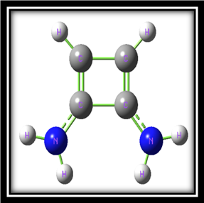
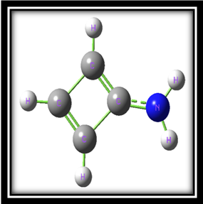
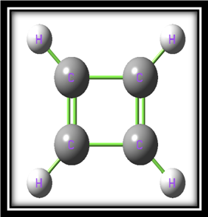
Figure(1-0) Figure(1-1) Figure(1-2)

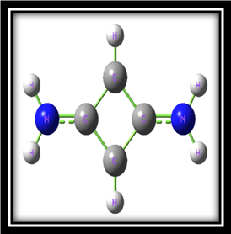
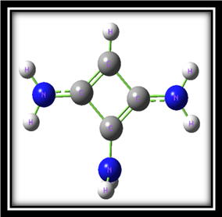
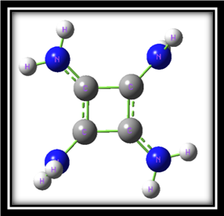
Figure(1-3) Figure(1-4) Figure(1-5)

Table (2):some parameters of cyclobutadiene molecules.
5 | 4 | 3 | 2 | 1 | 0 | No. of Mol.
-3.254 | -3.285 | -3.286 | -3.734 | -4.453 | -5.618 | E_{HOMO}(eV)
-0.634 | -0.663 | -0.550 | -0.382 | -1.129 | -1.903 | E_{LUMO}(eV)
2.619 | 2.622 | 2.736 | 3.351 | 3.323 | 3.715 | E_{g}(eV)
374.11- | 319.05- | 263.98- | 263.97- | 208.91- | 153.83- | E_{tot} (a.u)
3.254 | 3.285 | 3.286 | 3.734 | 4.453 | 5.618 | IP(eV)
0.634 | 0.663 | 0.550 | 0.382 | 1.129 | 1.903 | EA(eV)
3.807 | 2.344 | 1.486 | 1.443 | 1.345 | 1.264 | W(eV)

Figure(2):The relation between E_{HOMO}, E_{LUMO} and no. of mol.
Depending on the results of electronic states for the studied molecules, the electronic properties such as the energy gap (E_{g}), total energy (E_{tot}), ionization potential (IP), electron affinity (EA) and electrophilicity (W) for cyclobutadiene molecules are computed. From figure (2) the addition of NH₂ groups has effect on HOMO and LUMO energies, but its effect on HOMO energy is more than on LUMO energy. Approximately, the main change occurs at HOMO level in comparison with LUMO level. Generally this change depends on the number of NH₂ groups.

Figure(3):The relation between energy gap and no. of mol.
Generally it has been found that the forbidden energy gap for the cyclobutadiene molecules decreases with the addition of substituent NH₂ groups. Figure (3) shows these results and the variation mode. This variation means that energy gap of cyclobutadiene molecules will be soft with replacing more and more groups. The 1,2,3-triamino-cyclobutadiene has the lower value of energy gap than the 1,3-diamino-cyclobutadiene, but the 1,2,3,4-tetraamino-cyclobutadiene has the least value. This means that this molecule the more soft than the others.

Figure(4):The relation between total energy and no. of mol.
The results in figure (4) declare that 1,2-diamino-cyclobutadiene and 1,3-diamino-cyclobutadiene approximately have the same value of total energy. Generally, this indicates that the total energy is independent of the position of the NH₂ side group in the ring and depends only on the number of this side group.

Figure(5):The relation between ionization potential and no. of mol.
The relation between the ionization potential and the number of NH₂ groups was shown in figure (5), it is clear from this figure that the ionization potential for the amino-cyclobutadiene molecules group is less than ionization potential for cyclobutadiene molecule, but the 1,2,3,4-tetraamino-cyclobutadiene molecule has the least. Generally this means that this molecule needs small energy to become cation comparing with other molecules.

Figure(6):The relation between electron affinity and no. of mol.
Figure (6) shows the controlling of groups number on the electron affinity of studied compounds. It is clear from this figure that the electron affinity has positive values for all compounds. This may be an indication to a resistance for receiving an electron, this figure indicates that the electron affinity for the amino-cyclobutadiene molecules group is lees than the electron affinity for cyclobutadiene molecule, the electron affinity computed for 1,3-diamino-cyclobutadiene and 1,2,3,4-tetraamino-cyclobutadiene molecules is the lowest, and for 1,2-diamino-cyclobutadiene the electron affinity has a special lower value when compared with others. With respect to electron affinity for 1-monoamino-cyclobutadiene and 1,2,3-triamino-cyclobutadiene computed. Generally these values mean that these molecules need a small energy to become anion comparing with cyclobutadiene molecule.

Figure(7):The relation between electrophilicity and no. of mol.
Figure (7) shows the relation between the electrophilicity and the number of molecules, from this figure the electrophilicity computed for 1,2-diamino-cyclobutadiene and 1,3-diamino-cyclobutadiene is approach, but 1,2,3,4-tetraamino-cyclobutadiene has large electrophilicity compared with the others. Generally for the all molecules, the presence of NH₂ groups increases the electrophilicity that of cyclobutadiene relatively, high electrophilicity means high activity.
3-Conclusions:
1- B3LYP functional level is an efficient of density function theory for studying the properties of these molecules.
2- The energy gaps for all new molecules are smaller than for the original molecule, molecule has the smallest energy gap than the others, a small energy gap means small excitation energies of manifold of excited states.
3- The total energy for cyclobutadiene is suitable result for each alternant rings, and this work supplies new data in this aspect because they have not been found similar studied for NH₂ radicals-cyclobutadiene molecules group.
4- According to Koopman theorem in calculations, the ionization potential and electron affinity decreases with increasing of NH₂ radicals.
5- The electrophilicity increases with increasing of replacing NH₂ radicals, this varying depends on the electronic states, which may predict the reactive molecules with other atoms, molecules and groups.
References
- V. I. Minkin, M. N. Glukhovtsev and B. Y. Sinkin, "Aromaticity and Antiaromaticity", Wiley, New York, (1994).
- S. K. Ritter, Chem. Eng. News, 82,Vol. 9, (2004).
- Z. Chen, C. Corminboeuf, T. Heine, J. Bohmann and P. V.R Schleyer, J. Amer. Chem.Soc., 125, 13, 930, (2003).
- John P. Lowe and Kirk A. Peterson; "Quantum Chemistry",3^{r} Edition , Elsevier, Inc, London, (2006).
- M. Mascal, A. Armstrong, M, D. Bartberger, J. Am. Chem. Soc.124, 2674, (2002).
- B. L. Schottel, H. T. Chifotides and K. R. Dunber, Chem. Soc. Rev. 37, 68, (2008).
- I. Alkorta, D. Quinonero, C. Garau, A. Frontera, J. Elguero and P. M. Deya, J. Phys. Chem A111, 3137, (2007).
- K. S. Kim , P. Tarakeshwar and J. Y. Lee,Chem.Rev.100,4145, (2000).
- P. Metrangolo and G. Resnati, Science, 321, 918-919, (2008).
- L. Pavesi, and R. Turan, "Si Nanocrystals", Wiley-Vch, (2010).
- Yoshizawa, K., Kang, S.Y., Yamabe, T., Naka, A.and Ishikawa, M. Organometallics , 18, 4637, (1999).
- 12. Ichinohe, M., Sanuki, K., Inoue, S. and Sekiguchi, A. Silicon Chem, 3, 111, (2005).
- K. Hong. J. Kim, J. H. Lee, J. Shin, and U. Chung Journal, American Chemical Society, 10 (1671), (2010).
- P. Lorenzo and T. Rasit; "Siliscon Nanocrystals Fundamentals, Synthesize and Applications", Lavoisier Librairie, (2010).
- L. Khriachtchev; "Silicon Nanophotonics", University of Helsinki, Finland, (2009).
- Beckman, K. and Ames, B. ; "The free radical theory of aging matures" Physiol Rev. 78: 548-81, (1998).
- Aubrey D.N.J de Grey; "The Mitochondrial Free Radical Theory of Aging" Pg. 36, (1999).
- Egli, T.; "Biodegradation of metal-complexing aminopolycarboxylic acid", J. Biosci. And Bioeng., 92, 89-97 (2001).
- Nowack, B., and A. T. Stone; "Degradation of nitrilotris (methy1enep- hosphoric acid) and related amino(phosphonate)", (2000).
- Nzengung, V. A., E. A. Voudrias and P. Nkedi-Kizza; "Organic cosolvent effects on sorption equilibrium of hydrophobic", (2002).
- S.C. Miller; "Principles of Modern Physics",University of Colorado, (1970).
- F. Brouwer; "Ch5:Quantum Chemistry in Molecular Modeling" ,Lab of Organic Chemistry, University of Amsterdam, (1995).
- M. Head-Gordon and T. Head-Gordon, Chem. Phys. Lett., 220, (122), (1994).
- X. G. Gong, Q.Q. Zheng, and Yi-Zhen He, J.Phys.,7(577), (1994).
- J. huter; "Lecture notes in computational chemistry; electronic structure theory", Physical Chemistry Institute, University of Zurich, 190, 8057, hutter@pci.unizh. Ch, (2005).
- Anupama Ghosh, K. Venkata Rao, Rakesh Voggu and Subi J.George ; "Chemical Physics Letters" , Vol.488, pp.198-201, (2010).
- Gaussian 03, Revision B.01, M. J. Frisch, G. et. al.; Gaussian, Inc., Pittsburgh PA, (2003).
- J.A. Pople and D.L. Beveridge; "Approximate molecular orbital theory", Mc. Graw-Hill, (1970).

