Study the Electronic Structure of Tetragermanium-Cyclobutane Molecule

Density Functional Theory

Mostafa Salim Mohammed Hayder M. Abduljalil
Physics Department-College of Science-University of Babylon
Abstract:
Abstract
This work reports a theoretical study to investigate the electronic structure and electronic properties for a saturated molecules group by using density functional theory (DFT) at B3LYP level with bases set 6-31G. Cyclobutane molecule is original molecule before substitute carbon atoms by germanium atoms. The effect of substitute on cyclobutane molecule discussed based on the calculated electronic properties. The electronic properties included total energy, energy gap, ionization potential, electronic affinity, hardness, softness, electronegativity and electrophilicity, have been found with varying differences for each molecule, with comprehensive analysis of the calculated highest-occupied (Homo) and lowest-unoccupied orbital (Lumo) energies. These calculations have performed using Gaussian 03 package.
Keywords: Cyclobutane, DFT, energy gap, ionization potential.
1. Introduction
Semiconductors are widely used and have important applications in manufacture and technology especially in instruction of the electronic devices, thus there are many studies for the electronic structure and physical properties of the semiconductors. The semiconductors have different uses according to the difference of their physical properties [Merdan, 2002]. Since the mid-20th Century, the electronics industry has enjoyed phenomenal growth and is now the largest industry in the world. The foundation of the electronics industry is the semiconductor device. To meet the tremendous demand of this industry, the semiconductor device field has also grown rapidly. Coincident with this growth, the semiconductor device literature has expanded and diversified [Sze, 2007].
Cyclobutane molecule can be study as a semiconductor, because it is consisting from four-member carbon [Norman, 2002]. Cyclobutane is interesting because it provides a bridge between the very reactive for a hydrocarbon [Wiberg, 2005], and it is one of the important saturated rings molecules [Morrison, 2002], antiaromaticity [Bally,2003]. The dissociation of cyclobutane is form two ethylene molecules [Yusheng, 2007]. The structure of cyclobutane presents some interesting questions, the C−C−C bond angle is 88, indicating that it adopts the optimization of cyclobutane system is not planar conformation [Smith, 2007]. In 1885, Adolph von Baeyer studied the angle strain in cycloalkanes and show that the C−C−C bond angle of 90o for cyclobutane [Daley, 2003].
The study of organic ring systems is an attractive research field that allows work on the solution of fundamental questions in chemistry and physical and the development of materials with interesting properties on a molecular. There are typical questions associated with the nature compounds of chemistry are: (i) preferences between different ring sizes, (ii) the magnitude of ring strain, (iii) the nature of the bonding and (iv), the chain lengths [Jens, 2011].
Density function theory is one of the most popular and successful quantum mechanical approaches. It is now adays routinely applied for calculating, e.g., the bonding energy of the molecules in chemistry and the band structure of solids in physics. First applications relevant for fields traditionally considered more distant from quantum mechanics, such as biology and mineralogy are beginning to appear. Superconductivity, atoms in the focus of strong laser pulses, classical liquids, magnetic properties of alloys have all been studied with DFT [Capelle, 2006]. There are many approximations such as local approximation (LA), local density approximation (LDA), local spin density approximation (LSDA) and generalized gradient approximation [Jones, 2006].
In recent years, there has been a growing interest in (DFT) from the quantum chemistry community, It was given a theoretical basis in 1984, by Runge and Gross. They recently developed a density functional theory, which can be used for general molecules [Gisbergen, 1996].
. Theoretical methods and computational details:
The molecular properties for the new molecules is computed under the Becke three parameters with Lee-Yang-Parr functional [B3LYP] level [Tatsuo, 2002] with large 6-31G basis set. However, a long time required for employing this level and this time increases with increasing germanium atoms used to describe the studied molecules.
The mathematical equations were use in the calculations included:
- Ionization potential (IP): is the amount of energy required to remove an electron from an isolated atom or molecule, and expressed as the energy difference between the positive charged energy E(+) and the neutral energy E(n).
$$\text{IP = E}(+)\text{ -E}(n)\text{.}\text{.}\text{.}\text{.}\text{.}\text{.}\text{.}\text{.}\text{.}\text{.}\text{.}\text{.}\text{.}\text{.}\text{.}\text{.}\text{.}\text{.}\text{.}\text{.}\text{.}\text{.}\text{.}\text{.}\text{.}\text{.}\text{.}\text{.}\text{.}\text{.}\text{.}\text{.}\text{.}\text{.}\text{.}\text{.}\text{.}\text{.}\text{.}\text{.}\text{.}\text{.}\text{.}\text{.}\text{.}\text{.}\text{.}\text{.}\text{.}\text{.}\text{.}\text{.}\text{.}\text{.}\text{.}\text{.}\text{.}\text{.}\text{.}\text{.}\text{.}\text{.}\text{.}\text{.}\text{.}(1)$$
- Electron affinity (EA): is the energy change when an electron is added to the neutral atom to form a negative ion, and expressed as the energy difference between the neutral energy E(n) and the negative charged energy E(–), as in the following relation:
$$\text{EA = E}(n)\text{ - E}(−)\text{.}\text{.}\text{.}\text{.}\text{.}\text{.}\text{.}\text{.}\text{.}\text{.}\text{.}\text{.}\text{.}\text{.}\text{.}\text{.}\text{.}\text{.}\text{.}\text{.}\text{.}\text{.}\text{.}\text{.}\text{.}\text{.}\text{.}\text{.}\text{.}\text{.}\text{.}\text{.}\text{.}\text{.}\text{.}\text{.}\text{.}\text{.}\text{.}\text{.}\text{.}\text{.}\text{.}\text{.}\text{.}\text{.}\text{.}\text{.}\text{.}\text{.}\text{.}\text{.}\text{.}\text{.}\text{.}\text{.}\text{.}\text{.}\text{.}\text{.}\text{.}\text{.}\text{.}\text{.}\text{.}(2)$$
From equations (1) and (2), we can calculate the hardness (μ) and the softness [Ali , 2009]:
$$μ\text{ = }(\text{IP - EA})\text{ /2 }\text{.}\text{.}\text{.}\text{.}\text{.}\text{.}\text{.}\text{.}\text{.}\text{.}\text{.}\text{.}\text{.}\text{.}\text{.}\text{.}\text{.}\text{.}\text{.}\text{.}\text{.}\text{.}\text{.}\text{.}\text{.}\text{.}\text{.}\text{.}\text{.}\text{.}\text{.}\text{.}\text{.}\text{.}\text{.}\text{.}\text{.}\text{.}\text{.}\text{.}\text{.}\text{.}\text{.}\text{.}\text{.}\text{.}\text{.}\text{.}\text{.}\text{.}\text{.}\text{.}\text{.}\text{.}\text{.}\text{.}\text{.}\text{.}\text{.}\text{.}\text{.}\text{.}\text{.}\text{.}\text{.}(3)$$
$$S\text{ =1/}(\text{2 }μ)\text{.}\text{.}\text{.}\text{.}\text{.}\text{.}\text{.}\text{.}\text{.}\text{.}\text{.}\text{.}\text{.}\text{.}\text{.}\text{.}\text{.}\text{.}\text{.}\text{.}\text{.}\text{.}\text{.}\text{.}\text{.}\text{.}\text{.}\text{.}\text{.}\text{.}\text{.}\text{.}\text{.}\text{.}\text{.}\text{.}\text{.}\text{.}\text{.}\text{.}\text{.}\text{.}\text{.}\text{.}\text{.}\text{.}\text{.}\text{.}\text{.}\text{.}\text{.}\text{.}\text{.}\text{.}\text{.}\text{.}\text{.}\text{.}\text{.}\text{.}\text{.}\text{.}\text{.}\text{.}\text{.}\text{.}\text{.}\text{.}\text{.}\text{.}\text{.}\text{.}\text{.}\text{.}(4)$$
$$ω={κ^{2}}/(2μ)\text{.}\text{.}\text{.}\text{.}\text{.}\text{.}\text{.}\text{.}\text{.}\text{.}\text{.}\text{.}\text{.}\text{.}\text{.}\text{.}\text{.}\text{.}\text{.}\text{.}\text{.}\text{.}\text{.}\text{.}\text{.}\text{.}\text{.}\text{.}\text{.}\text{.}\text{.}\text{.}\text{.}\text{.}\text{.}\text{.}\text{.}\text{.}\text{.}\text{.}\text{.}\text{.}\text{.}\text{.}\text{.}\text{.}\text{.}\text{.}\text{.}\text{.}\text{.}\text{.}\text{.}\text{.}\text{.}\text{.}\text{.}\text{.}\text{.}\text{.}\text{.}\text{.}\text{.}\text{.}\text{.}\text{.}\text{.}\text{.}\text{.}\text{.}\text{.}(5)$$
Where
μ: is the hardness and define that the measurement of molecule resistance to the change or deformation in molecular orbitals.
S: is the softness of the molecules [Ghosh, 2004].
ω: is the electrophilicity which species that stabilize upon receiving an additional amount of electronic charge from the environment.
κ: is the electronic chemical potential.
- Energy gap (E.gap): is the different between the lowest unoccupied molecular orbital and highest occupied molecular orbital according to the Koopmans theorem [Kampen, 1999].
$$E_{\text{gap}}{\text{ = E }}_{\text{Lumo}}{\text{ - E}}_{\text{Homo}}\text{.}\text{.}\text{.}\text{.}\text{.}\text{.}\text{.}\text{.}\text{.}\text{.}\text{.}\text{.}\text{.}\text{.}\text{.}\text{.}\text{.}\text{.}\text{.}\text{.}\text{.}\text{.}\text{.}\text{.}\text{.}\text{.}\text{.}\text{.}\text{.}\text{.}\text{.}\text{.}\text{.}\text{.}\text{.}\text{.}\text{.}\text{.}\text{.}\text{.}\text{.}\text{.}\text{.}\text{.}\text{.}\text{.}\text{.}\text{.}\text{.}\text{.}\text{.}\text{.}\text{.}\text{.}\text{.}\text{.}\text{.}\text{.}\text{.}(6)$$
3. Results and Discussion:
The electronic structure and electronic properties of the cyclobutane studied and then substitute one, two, three and four carbon atoms by one, two, three and four germanium atoms, to get tetragermanium-cyclobutane. The optimization of geometry for each molecule is shows in Figure (1). Table (1) is present the total energy and table (2) show the electronic state (Homo and Lumo) for studied molecules. The electronic properties of cyclobutane and new molecules are shows in tables (3-6). Table (3) includes energy gap, table (4) included ionization potential and electronic affinity, table (5) included hardness and softness and table (6) include electrophilicity and electronegativity. Where the sample ŋ is means the number of the molecules.

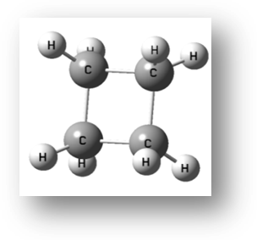
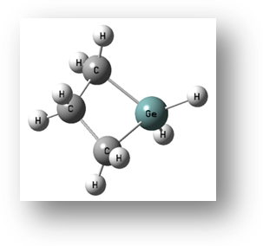

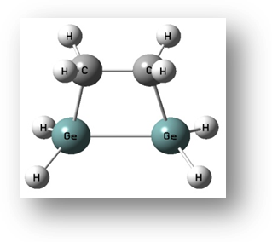
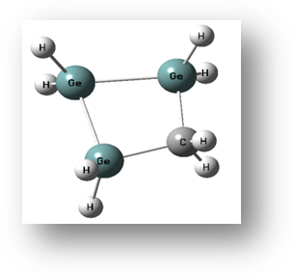
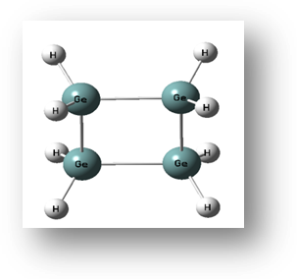
cyclobutane
4-monogermanium-cyclobutane

3,4-digermanium- cyclobutane

2,3,4-trigermanium- cyclobutane

tetragermanium- cyclobutane

Fig. (1): The schematic representation for cyclobutane its group.

Table (1): Total energy results for cyclo-molecules group and comparison of the total energy result with previous studies for cyclobutane.
ŋ | Molecules | Total energy (a.u)
ŋ | Molecules | Present study | Previous study
1 | cyclobutane | -157.232 | -156.1390 [ Kristyan, 2001]  -157.24612 [ Kenneth, 2001]  -156.96467 [ Curtiss, 1997]
2 | 4-monogermanium-cyclobutane | -2194.34 | ---
3 | 3,4-digermanium-cyclobutane | -4231.46 | ---
4 | 2,3,4-trigermanium-cyclobutane | -6268.59 | ---
5 | tetragermanium-cyclobutane | -8305.71 | ---

Table (2): Homo and Lumo energy result for cyclo-molecules group.
ŋ | Molecules | Lumo  (eV) | Homo  (eV)
1 | cyclobutane | -0.17116 | -8.19486
2 | 4-monogermanium-cyclobutane | -0.2732 | -7.51268
3 | 3,4-digermanium-cyclobutane | -0.54912 | -7.09962
4 | 2,3,4-trigermanium-cyclobutane | -0.78096 | -6.92901
5 | tetragermanium-cyclobutane | -1.04436 | -7.13745

Table (3): Energy gap results for cyclo-molecules group and comparison of the energy gap result with previous studies of cyclobutane.
ŋ | molecules | E.gap (eV)
ŋ | molecules | Present work | Previous study
1 | cyclobutane | 8.02370 | 8.3 [Monica, 2007]
2 | 4-monogermanium-cyclobutane | 7.23948 | ---
3 | 3,4-digermanium-cyclobutane | 6.55050 | ---
4 | 2,3,4-trigermanium-cyclobutane | 6.14805 | ---
5 | tetragermanium-cyclobutane | 6.09308 | ---

Table (4): Ionization potential and electronic affinity result for cyclo-molecules group and comparison of the ionization potential result with previous studies of cyclobutane.
ŋ | molecules | IP (eV) |  | EA (eV)
ŋ | molecules | Present study | Pervious study | EA (eV)
1 | cyclobutane | 8.19486 | 9.92 [ John, 1999] | 0.17115
2 | 4-monogermanium-cyclobutane | 7.51268 | --- | 0.27319
3 | 3,4-digermanium-cyclobutane | 7.09962 | --- | 0.54911
4 | 2,3,4-trigermanium-cyclobutane | 6.92900 | --- | 0.78095
5 | tetragermanium-cyclobutane | 7.13744 | --- | 1.04435

Table (5): Hardness and softness result for cyclo-molecules group.
ŋ | molecules | μ (eV) | S (eV)
1 | cyclobutane | 4.01185 | 0.12463
2 | 4-monogermanium-cyclobutane | 3.61974 | 0.13813
3 | 3,4-digermanium-cyclobutane | 3.27525 | 0.15266
4 | 2,3,4-trigermanium-cyclobutane | 3.07402 | 0.16265
5 | tetragermanium-cyclobutane | 3.04654 | 0.16412

Table (6): Electronegativity and electrophilicity result for cyclo-molecules group.
ŋ | molecules | EN (eV) | ω (eV)
1 | cyclobutane | 4.18301 | 2.18073
2 | 4-monogermanium-cyclobutane | 3.89294 | 2.09337
3 | 3,4-digermanium-cyclobutane | 3.82437 | 2.23277
4 | 2,3,4-trigermanium-cyclobutane | 3.85498 | 2.41716
5 | tetragermanium-cyclobutane | 4.09090 | 2.74663
Figures (2-A) and (2-B) represent the decreasing total energy and energy gap with respect to the increasing of replaced germanium atoms. The same behaviors appear when we see Lumo level, but opposite behavior appear when we see Homo level, as we see in figure (2-C). The ionization potential is smaller than organic cyclobutane but the electronic affinity of new molecule is larger than the organic cyclobutane, as we see in figure (3). The hardness is decreasing with increasing replaced carbon atoms by germanium atoms. Nevertheless, we see that the softness is increasing by small magnitude, and it is approximately amount constant. The electronegativity and electrophilicity of the new molecules is less than the electronegativity of organic cyclobutane then began increasing by small magnitude with increasing the replaced carbon atoms by germanium atoms as we see in figure (4).

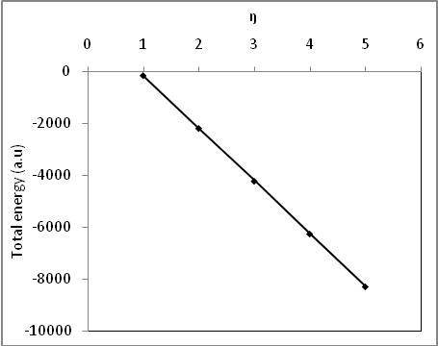
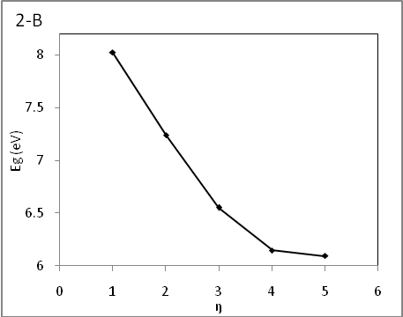
2-A

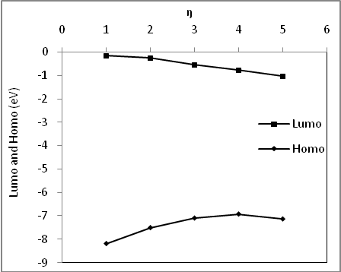
2-C

Fig. (2): Relationship, between total energy in (2-A), energy gap in (2-B) and Homo and Lumo energy in (2-C) with respect to the number of the molecules
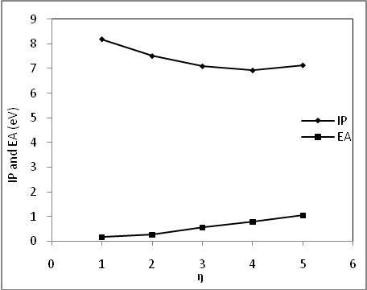
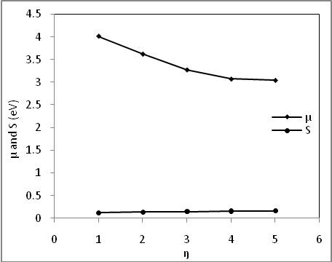

Fig.(5): Relationship, between hardness and softness with respect number of the molecules

Fig. (3): Relationship, between ionization potential and Electronic affinity with respect to the number of the molecules

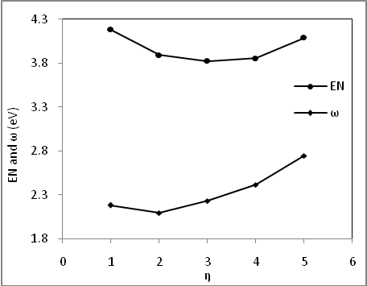
Fig.(4): Relationship, between electronegativity and electrophilicity with respect number of the molecules

- Conclusions
- The results in this study show that the calculated total energy, energy gap and ionization potential for cyclobutane have been found a good agreement with the previous studies. For other molecules, we have not found a reference data, so this study supplies a new data in this aspect.
- One of the important results was obtain in this study, is the decreasing of the total energy and energy gap. This declares that these molecules are more stable with more reactive than the original molecule. Moreover, these molecules are the nearest to semiconductor because the both Homo and Lumo levels become more adjacent.
- All the new studied molecules need small energy to become cation because ionization potential is smaller than original cyclobutane, but the electronic affinity are larger than the original cyclobutane.
- The hardness for new molecules was lowering values as compared with cyclobutane, therefore all the new molecules are softer, and this reduces the resistance of a species to lose electrons.
- Germanium atoms effect on the electronic properties depended on the increasing of atoms.

References:
M. G. Merdan, “Self- Consistent Field Conclusions for the Effect of Pressure and Temperature on some Properties of Grey Tin Crystal”, MSc. Thesis, Department of physics, University of Babylon, Collage of Science, (2002).
S. M. Sze and K. Ng. Kwok, “Physics of Semiconductor Devices”, Department of Electronics Engineering, University of National Chiao Tung, John Wiley & Sons, Taiwan, Third Edition, (2007).
K. H. Norman and L. Allinger, “Molecular Mechanics (MM4) Study of Saturated Four-Membered Ring Hydrocarbons”, University of Georgia, Department of Chemistry, Molecular Structure, Vol. 3581, P. 215-237, (2002).
K. Wiberg, “Cyclobutane-Physical Properties and Theoretical Studies”, Yale University, Department of Chemistry, John Wiley & Sons, New Haven, (2005).
R. T. Morrison, “Organic Chemistry”, New York University, Asoke K. Ghosh Publishing, New Delhi, Sixth Edition, (2002).
T. Bally, “Cyclobutadiene: The Antiaromatic Paradigm”, University of Fribourg, Chemistry Department, Vol. 2, P. 6616-6619, (2003).
D. Yusheng, W. Zhenyi, W. Yubin, and A. Roland, “Effect of C-C-C Bond Bending Vibration on the Photodissociation of Cyclobutane”, University of Posts and Telecommunications, Bio-Informatics Institute, Applied Surface Science, Vol. 253, P. 6400-6403, (2007).
M. B. Smith and J. March, “March’s Advanced Organic Chemistry”, John Wiley & Sons, Canada, Sixth Edition, (2007).
R. F. Daley and S. J. Daley, “Organic Chemistry”, www.ochem4free.com, (2003).
J. Beckmann and K. Jurkschat, “Stannasiloxanes: From Rings to Polymers”, University of Dortmund, Coordination Chemistry Reviews, Vol. 215, P. 267-300, (2001).
K. Capelle, “A Bires Eye View of Density Functional Theory”, Department de Fisica, Univirsil de Sao Paulo, Caixa Postal, (2006).
R. O. Jones, “Introduction to Density Functional Theory and Exchange-Correlation Energy Functional”, John Von Neumann Institute for Computing, Computational Nanoscience, Vol. 31, P. 45-70, (2006).
S. J. A. Gisbergen, V. P. Osinga, R. Gritsenko, S. J. G. Nijders and E. J. Bearends, “Improved Density Functional Theory Results for Frequency-Dependent Polarizabilities, By the Use of an Exchange-Correlation Potential with Correct Asymptotic Behavior”, Department of Physical and Theoretical Chemistry, Boelelaan, (1996).
T. Tatsuo, N. Tanaka and Y. Koichi, “Density Functional Study on the Reactivity of Oxidized Aluminum Surfaces: Effects of Adsorbed Metallic Atoms (Au, Cu, Ti, V)”, Department of Chemical System Engineering, University of Tokyo, Vol. 409, P. 66-73, (2002).
C. D. Ghosh and S. Bhattacharyya, “Molecular Orbital and Density Functional Study of the Formation, Charge Transfer, Bonding and the Conformational Isomerism of the Boron Trifluoride (BF3) and Ammonia (NH3) Donor-Acceptor Complex”, University of Kalyani, Department of Chemistry, Molecular Sciences, Vol. 5, P. 239-264, (2004).
H. M. Kampen, “Energy Level Alignment at Molecular Semiconductor/GaAs(100) Interaces: Where is the LUMO”, University of Chemnitz, Institut fur Phyik, Germany, (1999).
S. Kristyan, A. Ruzsinszky and I. G. Csonka, “Reproducing Gaussian-3 Total Energy Using Fitted Atomic Correlation Parameters for the Rapid Estimation of Correlation Energy from Partial Charges Method and Hartree-Fock Results”, George Washington University, Department of Chemistry, Physical Chemistry, Vol. 105, P. 1926-1933, (2001).
B. W. Kenneth, “Antiaromaticity in Monocyclic Conjugated Carbon Rings”, Yale University, Department of Chemistry, Chem. Rev., Vol. 101, P. 1317-1331, (2001).
A. L. Curtiss, K. Raghavachari, C. R. Paul and J. A. Pople, “Assessment of Gaussian-2 and Density Functional Theories for the Computation of Enthalpies of Formation”, Materials Science Divisions, Chemical Technology, Vol. 106, No. 3, ( 1997).
K. Monica, K. Miriam and A. Yitzhak, “Theoretical Study of Ladder Polysilanes”, Technion-Israel Institute of Technology, The Schulich Faculty of Chemistry, Organometallic, Vol. 26, P. 2806-2814, (2007).
A. D. John, “Langes Handbook of Chemistry”, University of Tennessee, Knoxville, Mc Graw-Hill, Fifteenth Edition, (1999).

