Sulfonation and Substitution of Poly Vinyl Alcohol with Amino Antibiotics

Prof.Dr.Firyal M.A. Abeer A.M.
Shurooq S. K. Wessal M. Kh.
Department of Chemistry, College of Science, Al –Mustansiryah University
And Nedhal M. Kh.
Department of Chemistry, College of Science, DiyalaUniversity
Abstract
Colon specific drugs release were synthesized from modification of PVA by sulfonation of hydroxyl groups were carried out by usingchlorosulfonic acid at 0ºC.The substitution of sulfonyl group with amino antibiotics such as amoxilline and cephalexinewere occurred ,with high conversion percentage,the novel prepared drug polymers were characterized by H.NMR, FT.IR and UV. Spectroscopies. Physical properties were studied and controlled drug release behaviors were studied in different pH values at 37ºC. The swelling % were calculated in acidic medium at 37ºC to protected the prodrug polymer from hydrolysis in acidic stomach environment , and let it to hydrolyzed in basic medium of intestinal, as specific site. It was found that the rate of release showed dependence on the pH of the medium within the colon pH.
Introduction
Polyvinyl alcohol is used as carrier polymer to attachment of non-steroids, anti-Inflammatory drugs(1).The best approach to prepare polymeric carriers of pharmaceutically active compounds is to modify preformed polymers(2).
This method offers the advantage of the availability of wide range of polymer type,and also simplicity of the employing of hydrophilic polymers with biodegradableBackbones led to the preparation of polymers systems for oral or topical administration one of the limitation of the reaction on polymers is the fact that the reactivity of the drug on the polymer may be low when it is directly attached on the main chains of the polymer(2-5),this may be caused by steric hindrance of the neighboringside groups.Many modified polymer bonded with drug were prepared
(6-7).
Poly(styrene sulfonyl chloride) was prepared by modification of poly styrene with chlorosulfonic acid at(0-5)ºC(8),then the poly (P-N-substituted sulfon amides styrene derivatives were synthesized, also sulfo -nation of polystyrene has been studied by a number of researchers(9,10).
Polyhydric synthetic polymers such as poly vinyl alcohol are generally used in pharmaceutical material as ahydrophilic nonionic polymer,it has found many applications.As gel carriers diluents and solubilizers and widely used in suspension diffusion matrix and coating processing(2).
The use of biodegradable and biocompatible polymers in drug delivery systems has recently been attracting considerable interest.,for many purpose,the carriers supplied are generally composed of relatively high molecular weight (11).
The new research(12)included the preparation of sulfonated phenol formaldehyde resin,then substituted with different amines and amoxic -illin which could use asdrug polymer in different applications.
Sulfonamides areorganic sulfur compounds that contain the radical SO₂NH₂, they are used as antibiotic to treat bacterial infections humans and animals (13).Sulfonamides work by interfering with abacteriums production of folic acid which the bacterial cells need for energy and reproduction .sulfonamides are distributed throughout the body and in the soft tissues(12).

Experimental
Materials and Instruments
Amoxicillin and Cephalexin were purchased from Aldrich.PVA,chlorosulfonicacid were obtained fromBDH.(H-NMR) spectra were recorded by Shimatzu spectrophotometer, thermogravimetric analysis is using NETSCH germatebau Gmbit model STA402 the FT.IR spectra were recorded by aShimatzu spectrometer.UV spectra were recorded using Shimadzu(UV-Vis) 160.
Sulfonation of PVA (P₁)
3gm of PVA (Mw 72.000) was solubilized into 10ml of anhydrous DMF was introduced in around bottomed flask equipped with condenser and separatory funnel which contained chlorosulfonic acid, 4ml was added drop wise with vigorously stirred about 2hrs, the sulfonated PVA was obtained after evaporated the solvent under vacuum, washed the polymer with diethyl ether 60%conversion with [µin] =0.75 dl/g. it was dissolved in ethanol and water. Table (1) lists the physical properties
Substitution of sulfonated PVA (P₂-P₃)
(10 g.,0.01 mole) of prepared sulfonated PVA was dissolved in 50ml of DMF and (0.01mole))of solubilized antibiotic such as Amoxilline or Cephalexin in 10ml DMF was added gradually, the mixture was stirred and heated at 50ºC about 30min.The solvent was evaporated and clear–brown polymerwas obtained.
Table -1:Physical properties of poly vinyl drug sulfonate (P₂,P₃)
S.PºC | Solubility | µ dl/g. | Conversion% | Color | Drug | Poly.No.
252-260 | Water  Ethanol | 0.78 | 70 | White yellow |  | P₂
220-230 | Water  Ethanol | 0.79 | 60 | Yellow brown |  | P₃
Controlled drug released:
0.1 gof P₂ or P₃ drug polymer was placed in 100 ml of buffer solution with PH1.1 and 7.4 at 37ºC.At periodic intervals 3ml of solution sample buffer with drawing and tested at using UV-Vis-spectrophotometer,the release study was carried out daily for 4daysit was calculated the weight% release of dry respect to time.
Swelling studies:
Dynamic swelling studies of P₂ were made as follows:
P₂ or P₃ were swollen in solution with pH1.1(KCl:HCl) at 37ºC to determine the parameters of swelling and diffusion. Swollen gels removed from the water bath at regular intervals were dried superficially with filter paper. Weighted and placed in same bath.
To investigate the time – department swelling behavior of P₂ in acidic solutions,we performed dynamic swelling studies. The swelling S% is calculated from the following relation:-
S%=(M₁-M_{o})/M_{o} ×100
Where = M_{o} is the mass of dry polymer at time 0.
M₁ is the mass of swollen polymer at time t.

Result and Discussion
The sulfonated of PVA was carried out by using chlorosulfonic acidas shown In the following equation.
The prepared drug polymers (P₂,P₃) were soluble in water because of the presence of unreactedSO₃H groups through the backbone of the polymer chains,which could enhanced the solubility in water and this advantage acts for improvement of insoluble drugsand the PVA is used ascarrier polymer for attachmentof drug via hydrolytically labile sulfonate bonds .This behavior of bioactive polymer system have very interest in this work.The polymeric prodrug couldhydrolysis through chemical bond and it isslowly release.
The suggest mechanism of hydrolysis of drug polymer is as shown below:
Drug=Amoxicilline, Cephalexin.
Fig(1)shows the controlled drug release of the prodrug polymer P₂,P₃ in different pH values of hydrolysis was carried out in pH 7.4 is higher than acid medium due to the more OH⁻ nucleophilic attack as shown in the above mechanism.Fig (2) FTIR spectrum showed the characteristicabsorption of SO_{2,}which appeared at 1170-1380cm⁻¹ symmetricandasymmetric,the other absorption was observed at 3300cm⁻¹ due to the NH sulfonamide.The absorption of –OH unreacted was observed at 3450cm⁻¹, and at 2960cm-1 for C-H aliphatic.
Fig (3) and (4)FTIR spectrum of P₂ and P₃revealed the unreacted –SO₃Hgroup at 3450cm⁻¹ ,the other absorption was observed at 3300cm⁻¹ of characteristicNHabsorption of sulfonamide, and υ C=O at 1720cm⁻¹ of β-Lactam, υ C-H aliphatic at 2950cm⁻¹ and υ C-H aromatic is appeared at 3070cm⁻¹. The υC=C aromatic is revealed at 1600cm⁻¹ of phenyl ring.
Table 2: Swelling % of P₂ and P₃ in acidic medium at room temperature.

No. | S% at 1 day | S% 2 days | S% at 3 days | S% at 4 days
P₂ | 0.9 | 1.3 | 1.8 | 2
P₃ | 1.1 | 2.1 | 2.5 | 2.9
These results indicated the chemical stability of the prepared drug polymers P₂ and P₃ in acidic medium as stomach acidic environment to protect the drug polymer from hydrolysis.This advantage enhanced the application uses as a stable coated drug polymer, and to let the drug polymer to hydrolyzed in an intestinal basic medium.
Also the aim of this work is to synthesized drug substituted polymer which successful for long term drug delivery and highly desirable situation and sustained released for drug delivery systems with greater specificity of actions.
Fig(5) showed TGA of the prepared polymers P₂&P₃which indicated the thermal stabilities ranged between 252-260ºC for P₂ and 220-230ºC for P₃ .
This technique is based on measuring the weight loss as a function of time at constant temperature or as a function of temperature at constant rate of heating . The change in weight was measured as a function of temperature which gave valuable information about the thermal stability of the P₂ and P₃ polymers which attributed to sulfonamide groups through the back bone of the polymer chains.
We concluded from this work that the swellable characteristics of the prepared drug polymers were more water-swellableas a hydrolysis are more reactivity in pH 7.4 than the acidic medium.

¹HNMR spectrum Fig.(6) of P2 was obtained, DMSO –d6 as a solvent with TMS as internal standard . H appeared the following peaks as shown in the polymer structure.

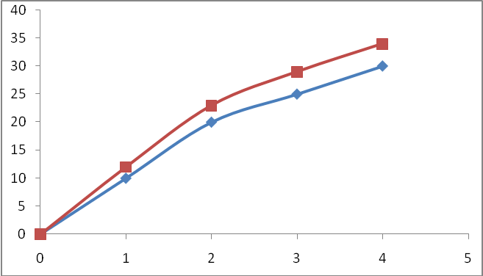
Time-day
Weight% drug released
pH7.4
P₃
P₂

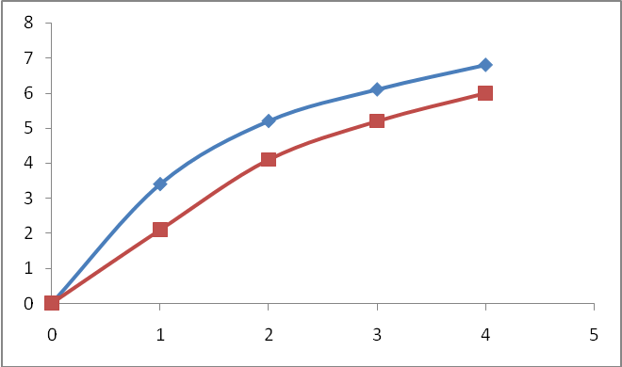
Weight% drug released
Time-day
pH1.1
P₃
P₂

Fig.1: Controlled drug released of P₂,P₃

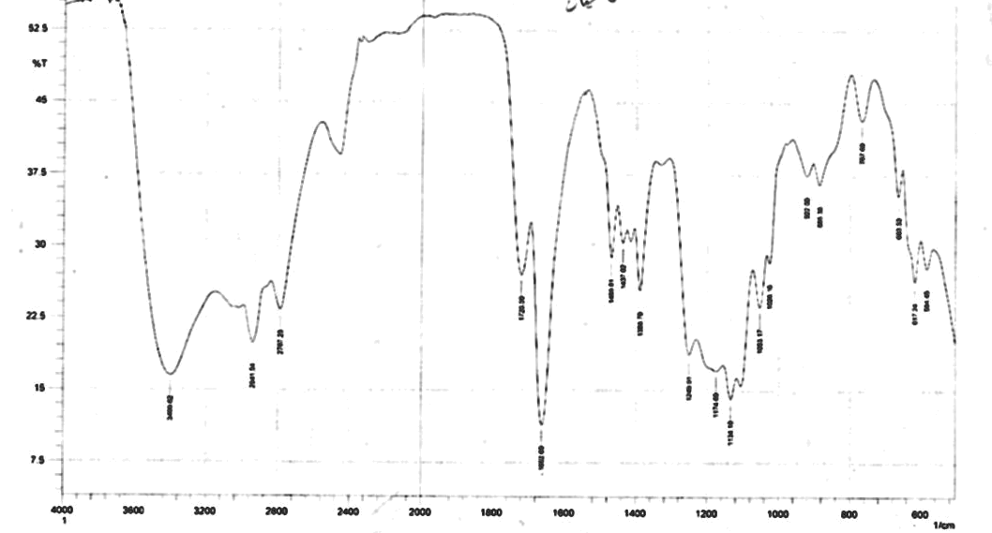

Fig(2):FT.IR spectra of PVA(P₁)

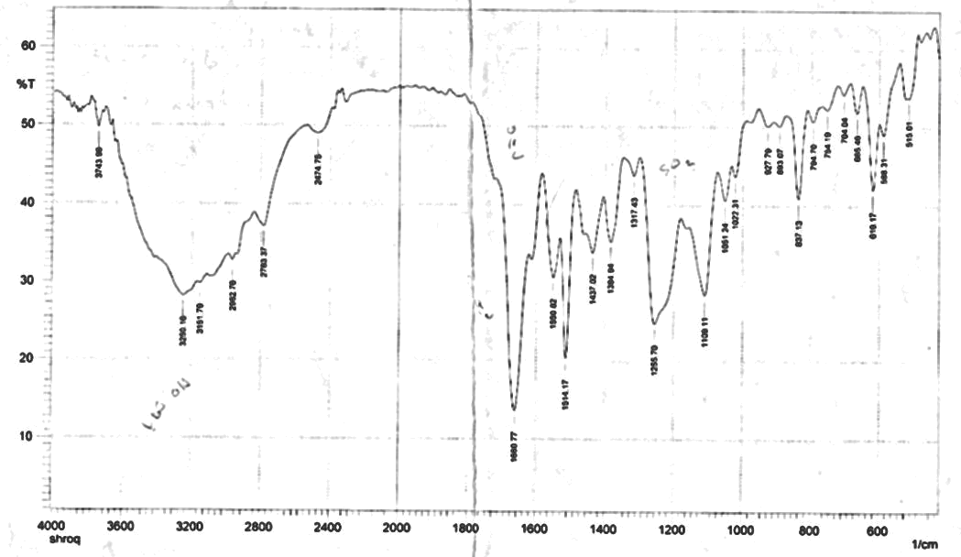

Fig(3):FT.IR spectra of (P₂)

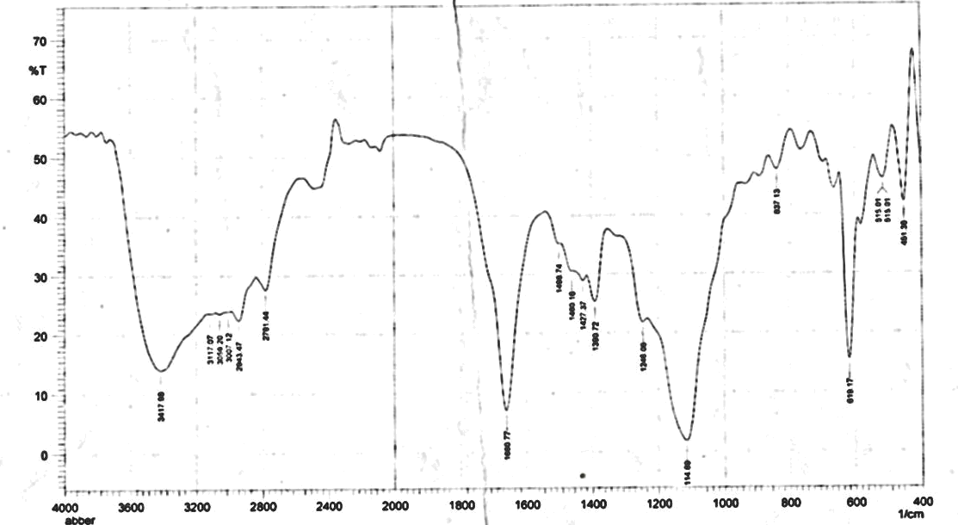

Fig(4):FT.IR spectra of (P₃)

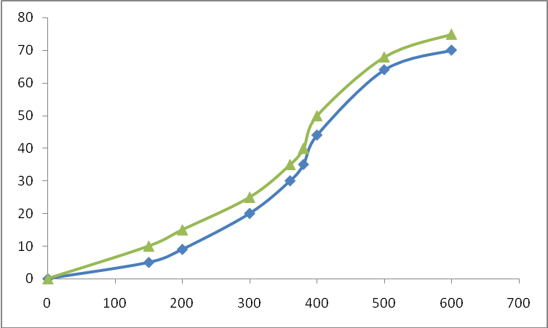
P₃
P₂
Temp.ºC
Wt loss%
Fig(5):Thermal analysis of P₂& P₃

References
Soudabeh D. and Ali A.,Synthesis and Hydrolysis of Modified poly vinyl alcohols containing Iburofen Pendant Groups, J.Iranian polym. Vol.(5) No(3) (1996).
Harris F.W., Medical Application of Controlled Release , , 103-128 ,Eds-CRC Press Boca Raton Fla (1984).
Kathryn E., Chemical and Engineering News.Articales( Polymer Exploited for Drug)P.2-4 (2006).
Firyal M.A., Abbas N.M. and Khudheyer J.K.,Modification of PVP with paracetamol J.of Babylon No(4)(2010).
Kotwat V.,Maris S., Nazwa I.,Biodegradable polymers , Indian of Pharm.Sci.Vol.(6),P.616-625(2007).
Firyal M.A.,Abbas N.Mand Khudheyer J.K.,Synthesis of paracetamol acrylate and study of its drug release, the fifth Sci.Conference, College of Sci.,Babylon University Vol.(5) (2010).
Prakash B.,Neclima A.,SnehithV.,Ramesh C.,Development Retentive Drug Delivery system of Cephalexin by using factorial Design,Ars.Pharm.J.Vol.50 P.8-24(2009).
Firyal M.A.,Emad M. and Abeer A.R.,Synthesis of N-substituted sulfonamide polystyrene,J.of College of Education No.(5) P(365)(2010).
Turbak,A.F.,Ind.Eng.Chem.Prod.Res.Dev.1,275(1962).
Ardeshir K., DavoodS.Minoo S. Synthesis and characterization of poly (8-hydroxy quinoline- P-styrene sulfonate J.Iranian polymer 16(S) P.309-317(2007).
Kazumiohs I.,Masara and Hironobu F.,New biodegradable polymers and their applic -ation in drug delivery system., International J. of Pharmaceutics 81, P.31-38 (1992).
Firyal M.A.,Abass T.A. and Murtatha A., Preparation of sulfonamide derivatives of phenolic resins , J.Education J.of college No.(6) P 433-447(2011).
Scheaermann, .H.,Aunchenherzinulmanns,Encyclopidia oftech.Vol.(33), Ed(1984), Munchen, Uraban and SchwarZenbery.

