Synthesis and photocatalytic activity of TiO2 Nanoparticles

MAJEED A. SHAHEED and FALAH H. HUSSEIN *
Chemistry Department, College of Science ,Babylon University, Hilla, Iraq
E-mail: majeedshaheed@yahoo.com
Abstract
Titanium dioxide (TiO₂) nanoparticles have been synthesized by sol gel method. The synthesized nanoparticles followed by calcinations at different temperatures in the range 200-800°C for 2 hours. Both the evolution of the crystal size and nature of the phases were studied as a function of annealing temperatures. These materials display a good thermal stability up to 400°C, in term of crystal size, and up to 600°C, regarding the crystalline phase. The phase purity and crystallite size of as grown TiO₂ particles were characterized via X-ray diffraction (XRD). The characterized results indicated that the synthesized TiO₂ powders had a pure two phases anatase and rutile structures and the average particle sizes were about 5-53 nm.
The synthesized TiO₂ nanoparticles exhibited 1.0053% time higher photocatalytic activity for Bismarck Brown R than that of commercial Hombikate (UV100) .
Keywords: TiO₂ nanoparticles, sol gel, Bismarck Brown R, photocatalytic activity.

1. Introduction
Titanium dioxide has been modern the novel applications in wide areas of science and technology as well as has multiple properties like semiconducting, piezoelectric, pyroelectric, catalysis and optoelectronics [1]. Generally, the possibilities of fabricating the nanostructured materials make oxide nanoparticles to increasing gained interest over past decade therefore these causes showed novel properties compared with bulk materials [2]. Many literatures recently reported that TiO₂ nanoparticles, which are semiconducting compound, have received a great response from various areas, such as industry or academic research [3]. Previous literatures reported that the synthesis and characterization of one-dimensional (1D) nanostructured materials such nanotubes, nanorods, and nanowires have received considerable attention due to their unique properties and novel applications [4]. The production of colloidal nanoparticles has been enabling in the modern with advantageous optical, electronic and magnetic properties specifically tailored to particular applications [5].
Yunhua Chen et al. reported different methods to prepare nano-TiO₂ by using Titanium tetrachloride (TiCl₄), hence its precursor for preparation of TiO₂ nanoparticles by sol gel method, therefore cheap and have high content of titanium [6]. It was proved that Titania nanoscale (TiO₂) particles synthesized by oxidation of titanium tetraisopropoxide (TTIP) which is precursor to preparation method. Sol–gel process was important for synthesizing of nanoparticles semiconductor which have been the most commonly used routes of the synthesis of TiO₂ nanopowder. The sol-gel method increase the possibility of obtaining of ultrafine powders which have an extremely large specific surface area and exhibit a strong tendency to agglomerate during synthesis and/or subsequent processing [7].
There are many catalysts not only TiO₂ nanoparticles but also ZnO nanoparticles which has attracted intensive research effort for its unique properties and versatile applications in transparent electronics, piezoelectric devices, ultraviolet (UV) light emitters, chemical sensors and spin electronics, therefore, its proposed to be a more promising UV emitting phosphor due to its larger exciton binding energy (60 meV). This property leads to a reduced UV lasing threshold and yields higher UV emitting efficiency at room temperature the increase in surface area of nanoscale Zinc Oxide compared to larger powders has the potential to improve the efficiency of the photocatalysis processes [8]. It was reported that TiO₂ and ZnO with smaller size has a larger redox potential for photocatalytic decomposition of organic contaminants under UV irradiation. The prepared TiO₂ and ZnO nanoparticles can be regarded as an ideal photocatalysts for environmental puriﬁcation at industrial scale at a central pH environment [9].
Photocatalytic degradation of organic and inorganic pollutants on different types of semiconductors has been studied by several researchers. Bismarck brown R and G, are as dyes which have become one of an important industry pollutants that lead to environmental contamination [10]. The oxidative degradation of adsorbed colored organic or inorganic molecules is attributed to indirect reaction at the positive holes, which is formed in the valence band of semiconductor and then migrates to the surface of catalyst and participates in interfacial oxidation-reduction reactions, but in presence of nanoparticles, the band gap was reduced, hence, reduction in recombination process [11]. Previous literature reported that the photocatalytic decolorization process can be expressed by both; the pseudo first order reaction kinetic and the Langmuir-Hinshelwood kinetic model [12].
In this work, preparation of titanium dioxide by using sol-gel process, studying the effect of particle size distribution and the comparison of photocatalytic activity between the bulk and the produced nanoparticles are investigated.

2. Experimental
2.1 Materials and methods
TiCl₄ (99.99%) was purchased from Flucka Company. Absolute ethanol have (99.98%) purity, supported from Gainland chemical company (GCC). Bismack brown R as contaminant which have molecular formula (C₂₁H₂₄N₈2HCl) and molecular weight (461.4 g/moL),) supplied from Fluka company). The peparation of TiO₂ nanoparticles were carried out at ambient conditions.
2.2 Preparation of TiO2 nanoparticles
The TiO₂ nanoparticles was prepared by following modification method using a procedure reported previously [13]. The process was described as follows:
Therty milliliter of TiCl₄ was added dropwise into 100 milliliter of absolute ethanol in reaction vesel, this reaction performed under fume hood with continuous stirring in ambient conditions due to exothermic reaction and TiCl₄ is highly volatile and also hydrogen chloride is released as soon as the addition, the above solution converts of colorless to yellow suspension solution which produced TiO₂ nanopowder by drying process at 85°C in an oven for 15 hours. Finally, TiO₂ nanopowder was obtaining in different phases by division of each produced powder into seven amounts and the resulted powder have been treated in furnace at temperatures equal to 200, 300, 400, 500, 600, 700, 800°C according to the sample divisions. This method is summarized in figure 1.
2.3 Characterization
X-ray diffraction was performed using a Philips X-ray diffractometer (PW 1730) with automatic data acquisition (APD Philips v3.6B), using Cu Kα radiation (λ = 0.15406 nm) and working at 40 kV/30 mA. The diffraction patterns were collected in the 2Ɵ range of (20º- 60º) with a 0.05º step size and an acquisition time of 2.0 second per step. The diffractometer was calibrated before every measurement. The XRD estimation of crystallite size was based on the Scherrer formula [14].
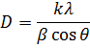
In this equation, λ the X-ray wavelength equal to 0.154 nm, k is a constant taken as 0.89, β is the line width at half maximum height, and θ is the diffraction angle.
2.4 Photocatalytic activity measurement
The photocatalytic activity was measured through the decolorization rate of dye. A reaction system was setup by adding 0.175mg of each sample powder into 100 mL of 5ppm of Bismarck Brown R aqueous solution, the solution was stirred in dark for 30 minute to allow the system to reach adsorption desorption equilibrium and irradiated with UV light (Type795 S, 230 volt, 50Hz, 75 Watt,UV type3) at ambient temperature. After the irradiation of 30 minute, Finally, each 4mL of suspension solution was taken out of the reactor and centrifuged at a rate of 4000 rpm to isolate and remove the photocatalyst.
Finally, absorbency of the supernatant solution was measured of scanning using a Uv-vis/spectrometer PG instrument Ltd-Japan at the Bismarck Brown R. Figure (2) shows maximum absorption wavelength of 459 nm. also calibration curve of different concentrations of dye was prepared, and ploted in figure (3).
3. Results and discussion
3.1 Preparation of TiO2 nanoparticles
In an experimental, a colloidal suspension, or a sol, is formed from the hydrolysis and polymerization reactions of the precursors, which are usually metal inorganic compounds such as titanium tetrachloride (TTC) and absolute ethanol. Complete polymerization and loss of solvent leads to the transition from the liquid sol into a solid gel phase using drying temperature, also hydrocarbon compounds were vibrated.
3.2 Characterization
X-ray diffraction (XRD) has been used to characterizing and determining the morphology and crystallinity of the as prepared powder, [15]. Figures (4) and (5) report the typical XRD spectra of pure TiO₂ nanopowders. In order to compare the samples preparation method. The two pronounced TiO₂ diffraction peaks (101) and (110) appear at 2θ = 25◦ and 27.5◦, respectively.
The crystallite size of TiO₂ nanoparticles which was deduced from Scherrer’s equation, gave the values of about (5-54) nm for TiO₂ powders, respectively, annealed at the range between (200-800°C). Diffraction peaks related to the transformation from anatase to rutile phase as were observed in the XRD pattern, confirming the two phases of the synthesized nanopowder.
The morphological and Surface area of crystallites are quite essential for photocatalytic activities of the materials. The particle sizes seem quite suitable for suspending in dye solution under magnetic stirring. The phase transformation from anatase to rutile began at 700°C of calcinations, similar results obtained in literature [16].
Figure (6) shows that phase transitions in TiO₂ nanoparticles were behave polynomial and accompanied by the increase in the size of TiO₂ particles, which was more pronounced and the phase transfer from anatase to rutile phase at temperatures above 600°C, hence, growth of particles by agglomiration process, sociated with the rutile formation.

3.3 Photocatalytic activity
The photocatalytic activity of as prepared samples was investigated in presence of UV light for photocatalytic decolorization of Bismarck Brown R. As seen in figure (7) structure of Bismarck Brown R [17] as azo dye and organic contaminant. The removal fractions of Bismarck Brown R decrease with time under UV light, the results observed in figures (8) and (9) which appeared the Effect of TiO₂ nanoparticles on photodecolorization of Bismarck Brown R. Decolorization of this dye is employed for the photocatalytic property evaluation of the samples. The comparison of photocatalytic activity (P.C.A) between the prepared samples and Hombikate (TiO₂ UV 100) were performed, these results show the sample have highest P.C.A and decolorization effeciency (D.E) =99.33%, exhibited 500°C annealing temperature and TiCl₄/ETOH :V/V=1/3 of additives, than TiO₂ UV100. Similar literature reported the anatase exhibited activity higher than the rutile, although it was less active as compared with Degussa (P25) [18].
The photocatalytic reactions included two pathways. When the light energy is less than the band gap of the illuminated TiO₂ nanoparticles, it will be absorbed by the adsorbed dye molecules. In presence of the visible light Dye molecules will be sensitized TiO₂ mainly follow reductive pathways, since they are initiated by the electrons injected from the excited dye. Hence, The decolorization of dyes is described as photosensitization processes, is also characterized by a free radical mechanism [19,20]. The results show the time-dependent proﬁle of decolorization efficeincy of Bismarck Brown R in the UV light illuminated suspension of dye with TiO₂ nanoparticles were tested in this study, the activity of TiO₂ nanoparticles was compared with Hombikate (TiO₂ UV 100), The photocatalytic decolorization of dye were resulted, as seen in figures (10) and (11).
All types of the prepared catalysts can be carried out with kinetic model. Therefore, they are following by pseudo first order reaction. Figures (12) and (13) showed the change of lnCₒ/C_{t} with irradiation time at different types of TiO₂ nanoparticles.
The variations of photocatalytic activities of the synthesized TiO₂ nanoparticles and TiO₂ reference could be appeared in figure (14), by depending on values of rate constant in kinetic model.

4. Conclussion
TiO₂ nanoparticles were successfully synthesized via sol gel using TiCl₄ and Absolute ethanol as additives. XRD analysis confirmed the formation of two phases nanoparticles of anatase and rutile. The peaks analysis of XRD pattern showed only the presence of two phases pure crystal structure in all the samples with an average particle size of about 5-54nm, which may find their applications as UV shielding material. The results appeared that the excellent TiO₂ nanoparticles exhibited 500°C annealing temperature and 1/2 volumetric percentage of precursors. Sol gel is the excellent method to synthesis of TiO₂ nanoparticles semiconductor, increasing of efficiency of photocatalytic degradation for pollutions due to increase in surface area and decreasing in particle size distribution and also the generation of nanoparticles lead to a high-throughput and cost-effective procedures.
Aknowledgment
The research upon which this paper is based was supported by advanced of physical chemistry University of Babylon is acknowledged for his assistance with experimental design and analysis. Also the authors thank the support from ministry of science and technology.

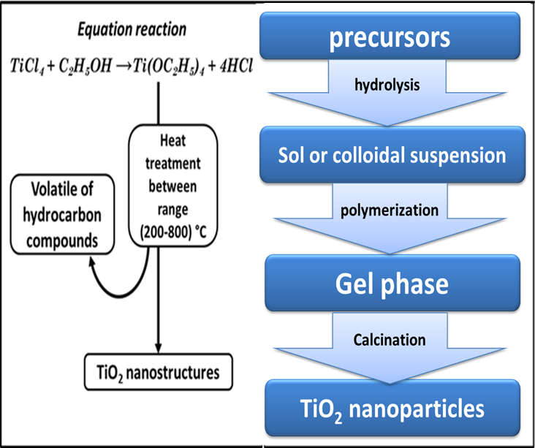
Figure 1: Summarized procedure for preparation of TiO₂ nanoparticles by sol gel method.

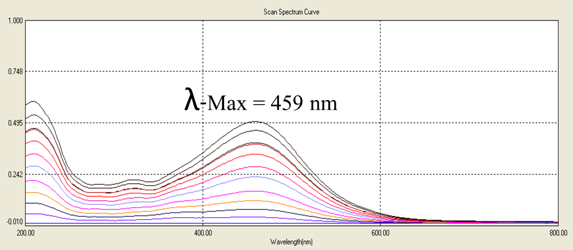
50 ppm
45 ppm
40 ppm
35 ppm
30 ppm
25 ppm
20 ppm
15 ppm
10 ppm
5 ppm
Figure 2: UV-Visible spectra of different concentration of Bismarck brown R.

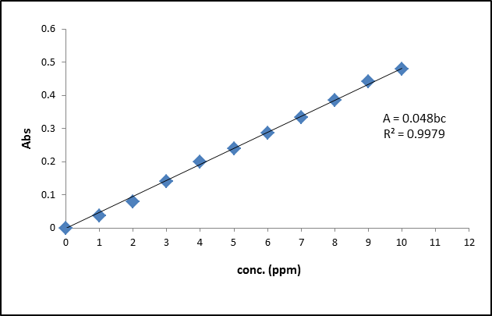
Figure 3: Calibration curve at different concentration of Bismarck Brown R.

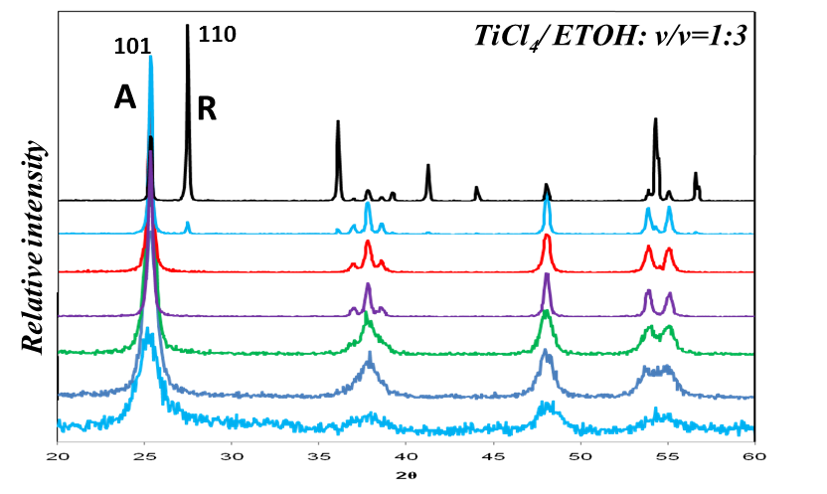
Figure 4: XRD pattern of the synthesized TiO₂ nanoparticles with calcination temperatures between 200°C-800°C for 2 hours. A: anatase, Rrutile. [v/v(TiCl₄:ETOH)=1:3].

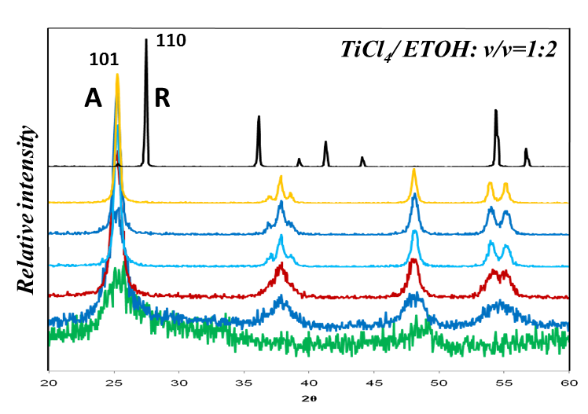
Figure 5: XRD pattern of the synthesized TiO₂ nanoparticles with calcination temperatures between 200°C-800°C for 2 hours. A: anatase, Rrutile. [v/v(TiCl₄:ETOH)=1:2].

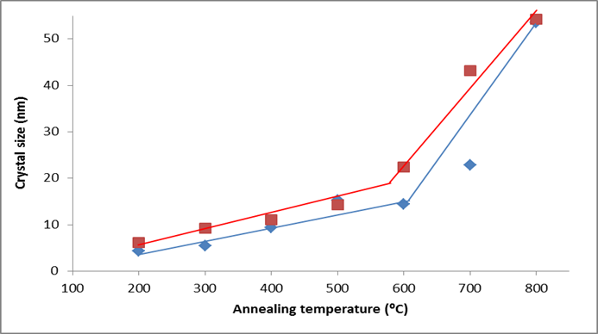
Figure 6: Average particle size of TiO₂ nanoparticles at different calcination temperatures.

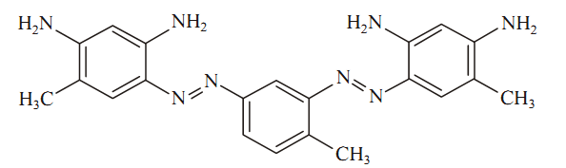
Figure 7: Structure of bismarck brown R [5]

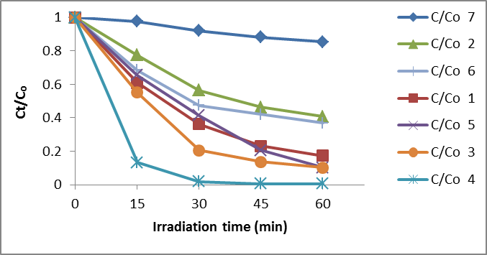
Figure 8: Effect the types of TiO₂ nanoparticles on photodecolorization of Bismarck brown R. (TiCl₄/ETOH: V/V=1/3).
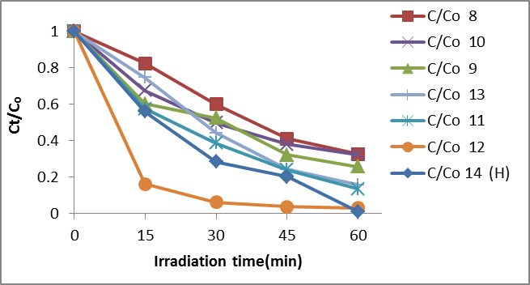
Figure 9: Effect the types of TiO₂ nanoparticles on photodecolorization of Bismarck Brown R. (TiCl₄/ETOH: V/V=1/2). (H): Hombikate .

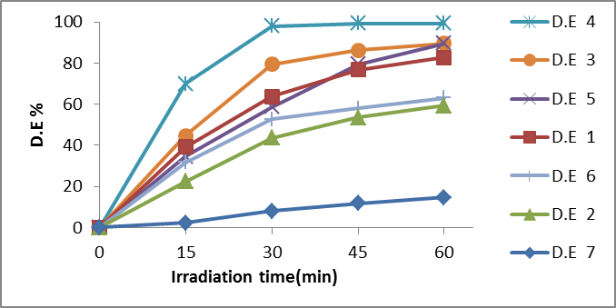
Figure 10: Photocatalytic decolorization of Bismarck Brown R at different TiO₂ nanoparticles. (TiCl₄/ETOH: V/V=1/3).
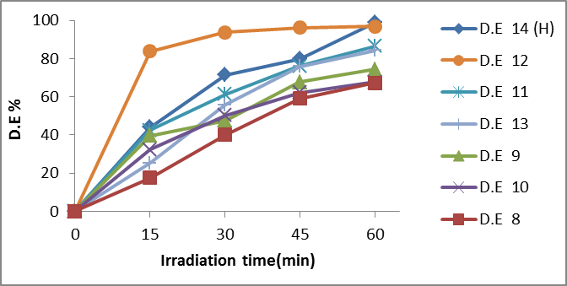
Figure 11: Photocatalytic decolorization of Bismarck Brown R at different
TiO₂ nanoparticles. (TiCl₄/ETOH: V/V=1/2).

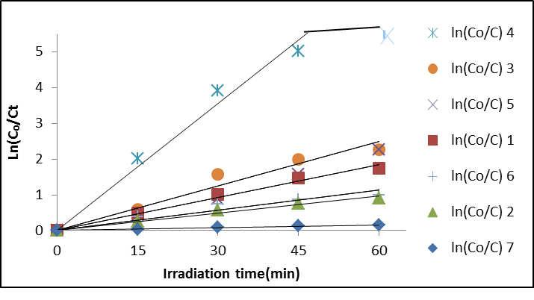
Figure 12: The change of lnCₒ/Ct with irradiation time at different types of TiO₂ nanoparticles. (TiCl₄/ETOH: V/V=1/3).

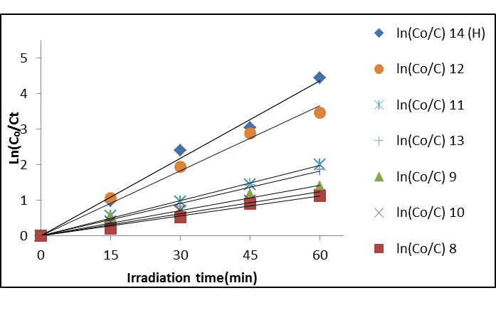
Figure 13: The change of lnCₒ/Ct with irradiation time at different types of TiO₂ nanoparticles. (TiCl₄/ETOH: V/V=1/2).

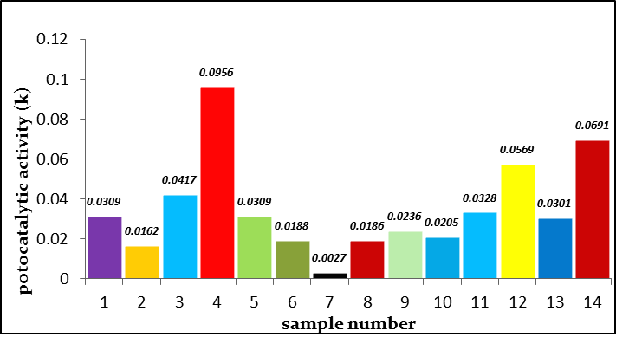
Figure 14: Comparison of Photocatalytic decolorization of Bismarck brown R on TiO₂ nanoparticles.
References
[1] Deepali Sharma, Sapna Sharma, B.S. Kaith, Jaspreet Rajput and Mohinder Kaur, Synthesis of ZnO nanoparticles using surfactant free in-air and microwave method, J. of applied Surface Science, 257 (2011) 9661– 9672.
[2] D.W. Zeng, C.S. Xie, B.L. Zhu and W.L. Song, Characteristics of Sb2O3 nanoparticles synthesized from antimony by vapor condensation method, J. of Materials Letters, 58, 312– 315, 2004.
[3] Hui Shun Chin, Kuan Yew Cheong and Khairunisak Abdul Razak Controlled synthesis of Sb2O3 nanoparticles by chemical reducing method in ethylene glycol, J. of Nanopart, Res (2011) 13:2807–2818.
[4] Sorapong Pavasupree, Supachai Ngamsinlapasathian, Masafumi Nakajima, Yoshikazu Suzuki and Susumu Yoshikawa, Synthesis, characterization, photocatalytic activity and dye-sensitized solar cell performance of nanorods/nanoparticles TiO₂ with mesoporous structure, Journal of Photochemistry and Photobiology A: Chemistry (2006).
[5] Andrey A. Lutich, Alexander S. Urban, Fernando D. Stefani and Jochen Feldmann, Laser shooting single gold nanoparticles - a novel lithographic strategy. Authorized licensed use limited to: IEEE Xplore.
[6] Yunhua Chen, An Lin and Fuxing Gan, Preparation of nano-TiO2 from TiCl4 by dialysis hydrolysis, J. of science direct, 167, 109–116, 2006.
[7] Kranthi K. Akurati, Andri Vital, Ulrich E. Klotz, Bastian Bommer, Thomas Graule and Markus Winterer, Synthesis of non-aggregated Titania nanoparticles in atmospheric pressure diffusion flames, J. of Powder Technology 165 (2006) 73–82.
[8] Zhiyong Fan and Jia G. Lu, Zinc Oxide Nanostructures: Synthesis and Properties, Journal of Nanoscience and Nanotechnology, Volume 5, Number 10, October 2005 , pp. 1561-1573(13).
[9] JIAGUO YU and XIAOXIAO YU, Hydrothermal Synthesis and Photocatalytic Activity of Zinc Oxide Hollow Spheres, J. of Environ. Sci. Technol, vol. 42, pages. 4902–4907, 2008.
[10] Ahmed F. Halbus and Falah H. Hussein, Rapid Decolorization of Cobalamin, journal of photoenergy, Accepted 12 July 2012.
[11] Falah H. Hussein, Ahmed F. Halbus, Hussein A K. Hassan and Wisam A K. Hussein, Photocatalytic Degradation of Bismarck Brown G Using Irradiated ZnO in Aqueous Solutions, E-Journal of Chemistry, 2010, 7(2), 540-544.
[12] Falah H. Hussein, Mohammed H. Obies and Abass A-Ali Drea, Photocatalytic decolorization of Bismarck Brown R by using of suspension of Titanium dioxide, Int. J. Chem. Sci.: 8(4), 2010, 2736-2746.
[13] F. Di Fonzo, C.S. Casari, V. Russo, M.F. Brunella, A. Li Bassi, and C.E. Bottani, Hierarchically organized nanostructured TiO₂ for photocatalysis applications, nanotechnology, vol. (20), No. (1) 2009. Doi: 10.1088/0957-4484/20/1/015604.
[14] Zheng Min and Wang Bao, One-step synthesis of antimony-doped tin dioxide nanocrystallites and their property, Trans Nonferrous Met, china, 19, (2009), 404-409.
[15] Gerko Oskam and Felipe de Jes´us Peet Poot, Synthesis of ZnO and TiO2 nanoparticles, J. of Sol-Gel Sci Techn, vol. 37: pages.157–160, 2006.
[16] M.J. Pawar, P. B. Kaware and R. V. Bijewar, Ce³⁺ Doped TiO₂ Nanoparticles; Synthesis and Photocatalytic Activity, Int. J. Emerg. Sci., 2(1), 149-160, March 2012.
[17] Falah H. Hussein, Mohammed H. Obies and Abass A-Ali Drea, photodecolorization of bismarck brown R in the presence of aqueous Zinc oxide suspension, Int. J. Chem. Sci.: 8(4), 2010, 2763-2774.
[18] Yasuaki Kitamura , Noriyuki Okinaka, Tamaki Shibayama , Orlando Omar Prieto Mahaney, Combustion synthesis of TiO₂ nanoparticles as photocatalyst, Powder Technology 176 (2007) 93 – 98.
[19] F. Hussein, Photochemical Treatments of Textile Industries Wastewater, advance in treating textile effluent, peter. J. Hauser, (Ed), ISBN: 978-953-703-704-8, InTech. (2010).
[20] Wooyul Kim, Takashi Tachikawa, Tetsuro Majima, and Wonyong Choi, Photocatalysis of Dye-Sensitized TiO₂ Nanoparticles with Thin Overcoat of Al₂O₃: Enhanced Activity for H₂ Production and Dechlorination of CCl₄.

