The Global coverage observations of the greenhouse effect and global warming from the Satellite remote sensing - space craft.
Jasim Mohammed Rajab Hussein
Dept. of Physics, College of Science, University of Mosul, Iraq
Jasim_rijab@yahoo.com
Introduction
The global warming and climate change have become the topic of serious discussion not only within the scientific community, since the early 80s, but also the international and the general political communities
Minute changes in the temperature of the human body can lead to sickness and even death. Similarly, the earth is highly sensitive to small changes in temperature. There is growing consensus that, since the start of the industrial revolution in the 19th century, the concentration of greenhouse gases (GHGs) in the atmospheric has increased due to continuous increases in anthropogenic emissions resulting from increased human activity, industrialization, and deforestation. This increase in GHGs concentration has lead to a rise in atmospheric and ocean temperatures, melting glaciers and ice caps, and increasing sea levels, which have caused regional shifts in precipitation patterns and increases in the occurrence of severe weather. Natural causes alone cannot satisfactorily explain the observed warming.
The greenhouse effect (GHG’s) and global warming
First,
- Let’s get one thing straight.
- The greenhouse effect and global warming is NOT the same thing ???
- The greenhouse effect is a phenomenon created by retention of heat by the gases in the atmosphere, through absorption of the infrared light produced or reflected by the earth which warm a planet’s lower atmosphere and surface, which was suggested by Joseph Fourier in 1824 and investigated quantitatively by Svante Arrhenius in 1896.
- Global warming is the increase in the average measured temperature of the Earth's near-surface air and oceans since the mid-20th century, and its projected continuation.

Second,
Let’s establish : why there is a greenhouse effect ??
Is the greenhouse effect a good thing ???
The surface of the Earth is warmer than it would be in the absence of an atmosphere because it receives energy from two sources: the Sun and the atmosphere.
A planet's climate is decided by its mass, its distance from the sun and the composition of its atmosphere. Mars is too small to keep a thick atmosphere. Its atmosphere consists mainly of carbon dioxide, but the atmosphere is very thin. The atmosphere of the Earth is a hundred times thicker. Most of Mars' carbon dioxide is frozen in the ground. Mars' average surface temperature is about -50°C. Venus has almost the same mass as Earth but a thicker atmosphere, composed of 96% carbon dioxide. The surface temperature on Venus is +460°C. Earth's atmosphere is 78% nitrogen, 21% oxygen, and 1% other gases. Carbon dioxide accounts for just 0.03 - 0.04%. Water vapor, varying in amount from 0 to 2%, carbon dioxide and some other minor gases present in the atmosphere absorb some of the thermal radiation leaving the surface and emit radiation from much higher and colder levels out to space.

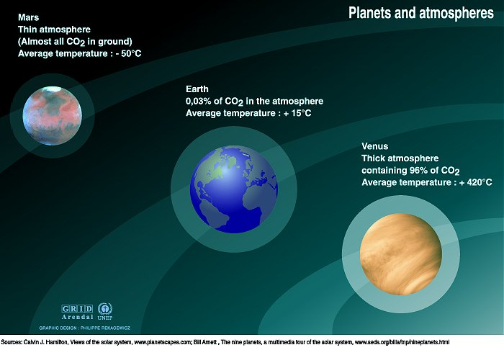

These radiatively active gases are known as greenhouse gases because they act as a partial blanket for the thermal radiation from the surface and enable it to be substantially warmer than it would otherwise be, analogous to the effect of a greenhouse. This blanketing is known as the natural greenhouse effect. This natural phenomenon is very important for life on earth because it maintains worldwide average temperatures around 18ºC; if not for the greenhouse effect, the earth would be uninhabitable.

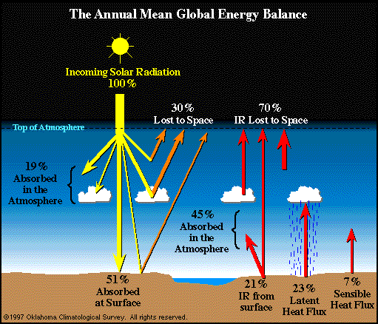
Earth's energy budget
30% of the incident energy is reflected, consisting of:
- 6% reflected from the atmosphere
- 20% reflected from clouds
- 4% reflected from the ground (including land, water and ice)

The remaining 70% of the incident energy is absorbed:
51% absorbed by land and water, and then emerging in the following ways:
- 23% transferred back into the atmosphere as latent heat by the evaporation of water, called latent heat flux
- 7% transferred back into the atmosphere by heated rising air, called Sensible heat flux
- 6% radiated directly into space
- 15% transferred into the atmosphere by radiation, then reradiated into space
19% absorbed by the atmosphere and clouds, including:
- 16% reradiated back into space
- 3% transferred to clouds, from where it is radiated back into space
When the Earth is at thermal equilibrium, the same 70% that is absorbed is reradiated:
- 64% by the clouds and atmosphere
- 6% by the ground
Fourth,
Greenhouse gases
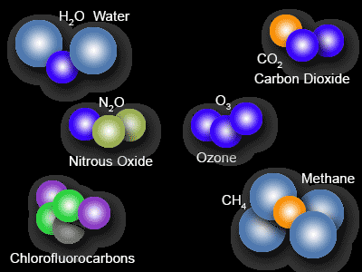
- Many GHGs occur naturally in the atmosphere, including primarily H₂O_{water vapor,} CO₂, CH₄, N₂O, chlorofluorocarbons (CFCs) and O₃, while others are synthetic.
In the earth's atmosphere, the dominant infrared absorbing and emitting gases, which have different influences on the greenhouse effect, are CO₂ 9-26%, H₂O_{vapor} 36-70% (not including clouds), and CH₄ 4-9% and O₃ 3-7%.
Although the emission of greenhouse gases and other factors, such as changes in land use, make only a minor contribution to global warming (1%) compared to the solar input, this slight modification to the energy budget is still significant and contributes to the observed increase in oceanic and atmospheric temperature.
Equilibrium is maintained as long as the quantity of GHGs in the atmosphere stays the same and as long as the energy coming from the sun is continuous. The GHGs are emitted from both terrestrial ecosystems (forest, soils) and natural aquatic ecosystems (lakes, rivers, estuaries, wetlands) and from anthropogenic sources.
Fifth,
Intergovernmental Panel on Climate Change (IPCC) and Global Warming
Over the past century, atmospheric CO₂ has increased due to human activities from 270 to 380 (ppm). During the last ten years (1995–2005 averages: 1.9 ppm per year).
Due to the burning of fossil fuels and agricultural activities, the CH₄ concentration has increased from a pre-industrial value of about 715 ppb to 1732 ppb in the early 1990s, and it was 1774 ppb in 2005.

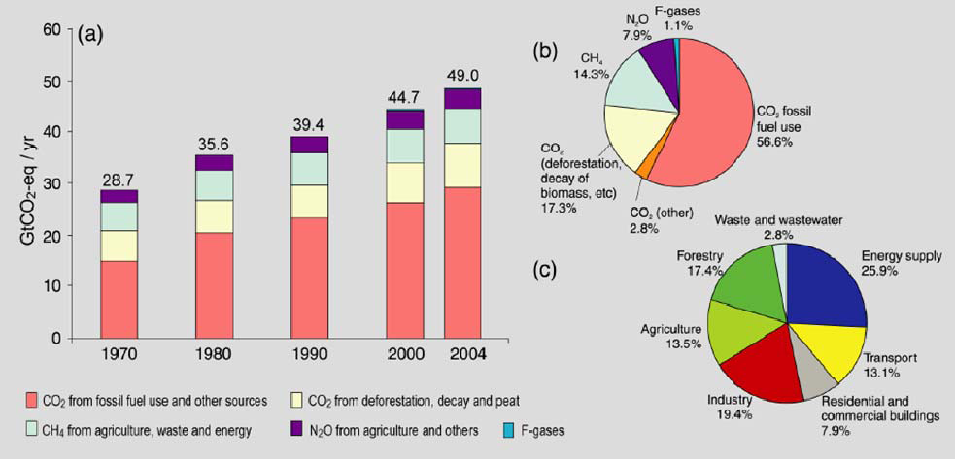

- Global annual emissions of anthropogenic GHGs from 1970 to 2004.
- Share of different anthropogenic GHGs in total emissions in 2004.
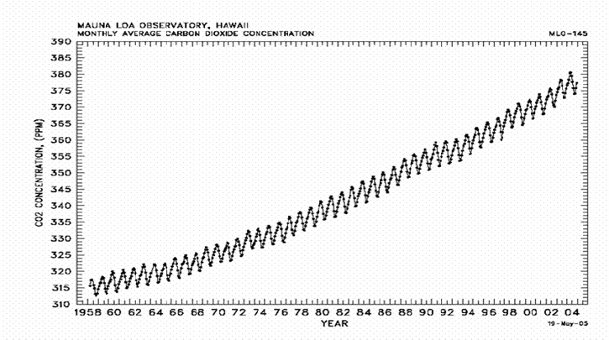
- Share of different sectors in total anthropogenic GHG emissions in 2004 (IPCC, 2007).
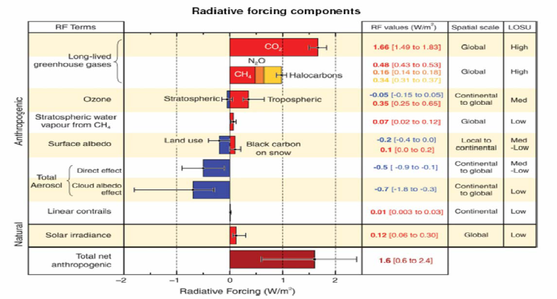

- The global average net effect of human activities since 1750 has resulted in warming, with a radiative forcing of +1.6 [+0.6 to +2.4] W/m⁻². The CO₂ radiative forcing increased by 20% from 1995 to 2005.
- The combined radiative forcing due to CO₂, CH₄ and N₂O from 1750 to 2005 was +2.3 W/m⁻².
- Due to emissions of ozone-forming chemicals (nitrogen oxides, carbon monoxide, and hydrocarbons), the troposphere ozone has changed, which has resulted in a slight negative forcing of -0.05 [-0.15 to +0.05] W/m⁻² in the stratosphere and a positive radiative forcing of +0.35 [+0.25 to +0.65] W/m⁻² in the troposphere.
Finally,
The increase of global temperatures is a reaction to increasing forcing at a rate of about 0.2°C per decade over the past 30 years. Since the dawn of the industrial revolution, the global average temperature has increased about 0.7º to 1.4º. During the last twenty years, acceleration in the warming of the surface temperature and a decrease in snow cover has been observed. Furthermore, a consistent increase in the level of the sea has been documented since 1930.
The GHGs lead to problems for the environment, especially in areas with ambient air temperature, and they also have negative impacts on health. Therefore, it is necessary to observe and accurately document not only changes in temperature but also changes in the atmosphere GHGs to assess their impact on the environment. There are many different methods for collecting data, including meteorological and trace gas measurements from ground-based instruments, data from airborne instruments (balloons and aircraft), and satellite remote sensing.

Figure shows the change in the global surface temperature, global average sea level, and northern hemisphere snow cover since 1850, relative to the 30 year 1961-1990 climatological average.
Remote Sensing Space Platforms
Remote sensing is the science and art of obtaining information about an object, area, or phenomenon through the analysis of data acquired by a device that is not in contact with the object, area, or phenomenon under investigation.
Ground-based methods such as making field observations, taking in situ measurements and performing land surveying. Using ground-based methods, you operate in the real world environment.
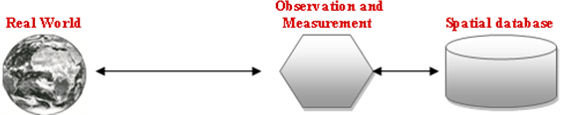
Image remote sensing methods, which are based on the use of image data acquired by a sensor such as aerial cameras, scanners or radar. Taking a remote sensing approach means that information is derived from the image data, which form a (limited) representation of the real world.
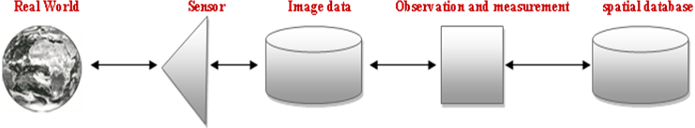
Earth Observation (EO), spaceborne remote sensing
Satellite remote sensing
- Over the past three decades, the abundances of atmospheric gases have been measured using balloons, airplanes and sparsely distributed measurement sites. The observations were mostly confined to the surface of the site. The measurements are unable to make continuous recordings of global variation over the long-term, and cost a lot of money and staff. Therefore, there is a lack of data both in the lower - particularly over land - and upper troposphere.
- The satellite remote sensing has very good global coverage and can provide continuous data with high spatial and temporal resolution.
- The early development of remote sensing as a scientific field is closely related to developments in photography. In 1839, Daguerre and Niepce reported the first photographs. Balloons were used in 1858 to take photographs of large areas.
- The first recorded aerial photographs were taken from an airplane piloted by Wilbur Wright in 1909 over Centocelli, Italy. In the mid-1930s, colour photography became available, and the field was further advanced with development of films that were sensitive to near-infrared radiation, which was particularly useful for haze penetration. Aerial photography was used for the recognition and classification of vegetation types and for the detection of damaged and diseased vegetation by Colwell in 1956.
- The active microwave systems have been used since the early twentieth century, especially after World War II, to detect and track moving objects, such as ships and planes.
Remote Sensing Space Platforms
- The systematic orbital observations of the earth started in 1960 with the launch of the first meteorological satellite, named Television Infra Red Observation Satellite (TIROS I).
- TIROS I was one of ten application satellites (TIROS, 1960 till 1965) using a low-resolution imaging system, and it was launched primarily to provide images of cloud formations.
- The first Earth Resources Technology Satellite (ERTS-1, later renamed Landsat-1) was launched in 1972, representing one of the major milestones in the field of Earth remote sensing. This satellite provided the first multispectral images that could be used to assess the value of satellite use for Earth resource observation.
- The visible and IR spin-scan cameras carried by the Synchronous Meteorological Satellite (SMS) and Skylab satellite (1972) carried a radiometer and a radar scatterometer. The Seasat satellite, launched in 1978, carried imaging radar, a scatterometer, and an altimeter.
- The Earth Observing System (EOS) program has been developed by NASA since 1980s. This program is an integrated, multi-satellite, long-term programme that will facilitate observation of the earth’s land, atmosphere, and oceans as an integrated system. The EOS is providing data for in-depth scientific investigation of the functioning of the earth as a system through a constellation of satellites. Remote sensing of the earth by satellite has seen a rapid expansion during the last decade, and it has entered a new era since the launch of the Terra and Aqua satellites in December 1999 and May 2002, respectively.

Orbital meteorological and remote sensing systems
Current projects | Earth Observing System (EOS) | TRMM · Landsat 7 · QuikSCAT · Terra · ACRIMSAT · NMP/EO-1 · Jason-1 · OSTM/Jason 2 · Meteor 3M-1/Sage III · GRACE · Aqua · SORCE · Aura · CloudSat. CALIPSO. NPOESS · ESSP · Aquarius · LDCM · SMAP
Current projects | A-train satellites | Aqua · Aura · CALIPSO · CloudSat · GCOM-W1 (Shizuku)
Current projects | Geostationary meteorological satellites | Elektro-L · Fengyun-2 · GOES · INSAT · Meteosat · MTSAT (Himawari)
Current projects | Other satellites | CBERS · COSMIC (FORMOSAT-3) · COSMO-SkyMed · DMSP · DMC · Envisat · EROS. ERS · Fengyun · FORMOSAT-2 · GOSAT (Ibuki) ·IKONOS · Landsat · MetOp · Meteor · NOAA-N' · QuickBird · RADARSAT-1 · RADARSAT-2 · SMOS · SPOT · TerraSAR-X · THEOS
Former projects | Completed | ADEOS (Midori) · ADEOS II (Midori 2) · FORMOSAT-1 · Geosat · GMS (Himawari) · ICESat · Nimbus · Parasol · SEASAT · SeaWiFS · TIROS · TOPEX/Poseidon · UARS · Vanguard.
Former projects | Failed | OCO · Glory
Former projects | Cancelled | NMP/EO-3

A-train satellites
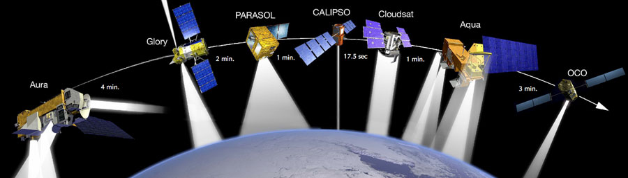
- Terra: was launched on December, 1999 NASA
- Aqua: was launched on May 4, 2002 NASA
- Aura: was launched on July 2004 NASA
- PARASOL: is a French-built Earth observing research satellite was launched on December, 2004. It carries an instrument called POLDER which studies the radiative and microphysical properties of clouds and aerosols.
- CloudSat: It uses radar to measure the altitude and properties of clouds, was launched on May, 2006.
- CALIPSO: is a joint NASA (USA) and CNES (France) environmental satellite, was launched on May, 2006
- OCO: Orbiting Carbon Observatory was lost in a launch failure on February 24, 2009. The Japanese (GOSAT) Greenhouse Gases Observing Satellite mission was successfully launched on January 23, 2009.The OCO and GOSAT Science Teams formed a close partnership in calibration and validation activities.
- The Japanese satellite GCOM-W1 was launched on May 18, 2012.
Terra (Satellite)
It is the flagship of the Earth Observing System (EOS). The name "Terra" comes from the Latin word for Earth. The satellite was launched on December 18, 1999, and began collecting data on February 24, 2000.
Terra carries five remote sensors designed to monitor the state of Earth's environment and ongoing changes in its climate system.
- ASTER - Advanced Spaceborne Thermal Emission and Reflection Radiometer. Provides images to create detailed maps of surface temperature of land, emissivity, reflectance, and elevation.
- CERES - Clouds and the Earth's Radiant Energy System. measure both solar-reflected and Earth-emitted radiation , and Cloud properties.
- MISR - Multi-angle Imaging SpectroRadiometer. measure the intensity of solar radiation reflected by the Earth system in various directions and spectral bands. aerosol properties
- MODIS - Moderate-resolution Imaging Spectroradiometer. the instruments image the entire Earth every 1 to 2 days, designed to provide measurements in changes of Earth's cloud cover and radiation budget.
- MOPITT - Measurements of Pollution in the Troposphere. CO & CH4
Aqua (satellite)
It is the second major component of the Earth Observing System (EOS) preceded by Terra (launched 1999) and followed by Aura (launched 2004). The satellite was launched on May 4, 2002.

Aqua carries six instruments:
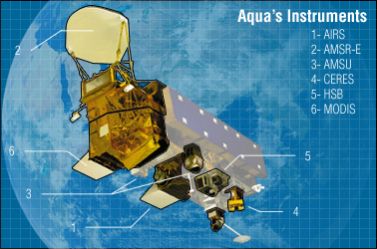
- AMSR-E — Advanced Microwave Scanning Radiometer-EOS — measures cloud properties, sea surface temperature, near-surface wind speed, radiative energy flux, surface water, ice and snow.
- MODIS — Moderate Resolution Imaging Spectroradiometer, also measures cloud properties and radiative energy flux, also aerosol properties; land cover and land use change, fires and volcanoes. This instrument is also aboard Terra.
- AMSU-A — Advanced Microwave Sounding Unit — measures atmospheric temperature and humidity.
- AIRS — Atmospheric Infrared Sounder — measures atmospheric temperature and humidity, land and sea surface temperatures. Some of GHS’s traces.
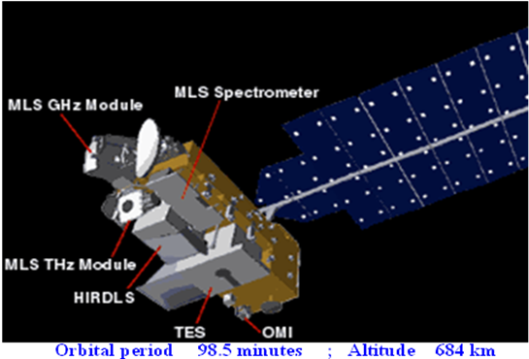
- HSB — Humidity Sounder for Brazil — VHF band equipment measuring atmospheric humidity.
- CERES — Clouds and the Earth's Radiant Energy System, Flying Models 3 and 4, measure broadband radiative energy flux.
Aura (Satellite)
It is the third major component of the Earth Observing System (EOS) following on Terra and Aqua. The name "Aura" comes from the Latin word for air. The satellite was launched on July 15, 2004.
Aura carries four instruments for studies of atmospheric chemistry:
- HIRDLS — High Resolution Dynamics Limb Sounder — measures infrared radiation from ozone, water vapor, CFCs, methane and nitrogen compounds.
- MLS — Microwave Limb Sounder — measures emissions from ozone, chlorine and other trace gases.
- OMI — Ozone Monitoring Instrument — uses ultraviolet and visible radiation to produce daily high-resolution maps.
- TES — Tropospheric Emission Spectrometer — measures tropospheric ozone in infrared wavelengths, also carbon monoxide, methane and nitrogen oxides.
CALIPSO (Satellite)
CALIPSO — Cloud-Aerosol Lidar and Infrared Pathfinder Satellite Observations is a joint NASA (USA) and CNES (France) environmental satellite, was launched on May, 2006.
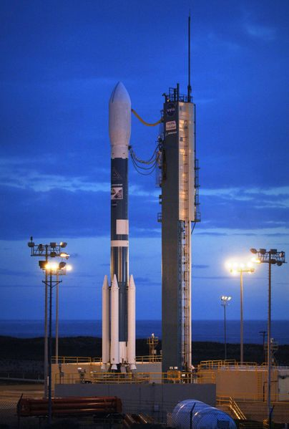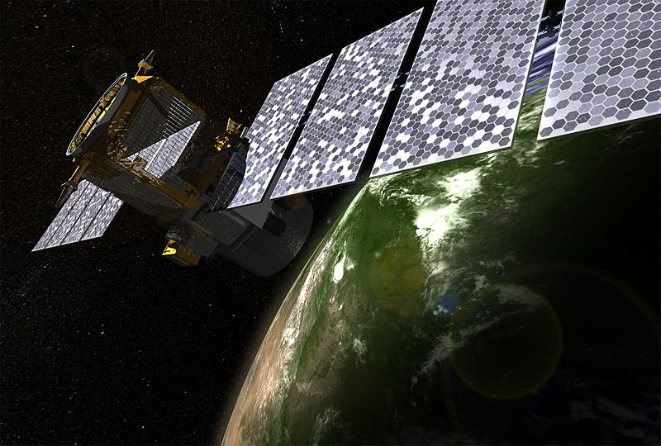
CALIPSO carries three instruments to monitor aerosols and clouds 24 hours a day.
- CALIOP — Cloud-Aerosol Lidar with Orthogonal Polarization - a lidar that provides high-resolution vertical profiles of aerosols and clouds.
- WFC — Wide Field Camera.
- IIR — Imaging Infrared Radiometer - used to detect cirrus cloud emissivity and particle size.
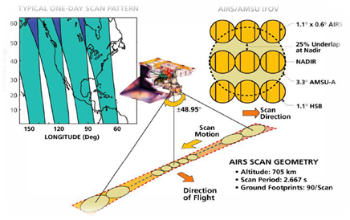
Atmospheric Infrared Sounder (AIRS)
The AIRS instrument views the atmospheric infrared spectrum in 2378 channels with a nominal spectral resolving power λ∕∆λ ranging from 1086 to 1570 covering more than 95% of the earth surface and returning about three million spectra daily in the 3.74-4.61 μm, 6.20-8.22 μm and 8.8-15.4 μm infrared wavebands at a nominal spectral resolution.
The primary scientific achievement of AIRS has been to improve weather prediction and to study the water and energy cycle, also provides information on several greenhouse gases, CO₂, CH₄, CO and O₃.
The AIRS instrument and its two companion microwave instruments, the Advanced Microwave Sounding Unit (AMSU) and the Humidity Sounder for Brazil (HSB), form the integrated atmospheric sounding system.

AIRS Technology-Specifications
Instrument | AIRS
Size | Stowed: 116.5 × 80 × 95.3 cm  Earth shade deployed: 116.5 × 158.7 × 95.3 cm
Spectral Range | IR: 3.74 – 15.4 µm, 2378 channels with λ∕∆λ= 1200 resolution  VIS/NIR: 0.4 – 1.1 µm with 4 channels
Instrument Field of View | IR: 1.1 degree (13.5 km at nadir from 705 km altitude)  VIS/NIR: 0.2 degree (2.3 km from 705 km altitude)
Mass / Power | 177 kg / 22o Watt
Aperture | IR: 10 cm ; VIS/NIR: 0.2 to 1 cm
Swath Width | 99 degree (1650 km from 705 orbit altitude)
Scan Sampling | IR: 90 × 1× 1.1 degree ; VIS/NIR: 720 × 8 × 0.2 degree
Spatial Coverage | Scan Angle: +/- 49.5 around nadir IFOV: 0.185
Ground Coverage | +/- 49.5 degrees around nadir
Ground Footprint | 90 per scan, 22.4 ms footprint
Temporal Coverage | Global, twice daily swath (daytime and night-time)
Spectral Resolution | 13.5x13.5 km in the nadir
Radiometric Calibration | +/- 3% absolute error

AIRS tracks Swath width 1650 km

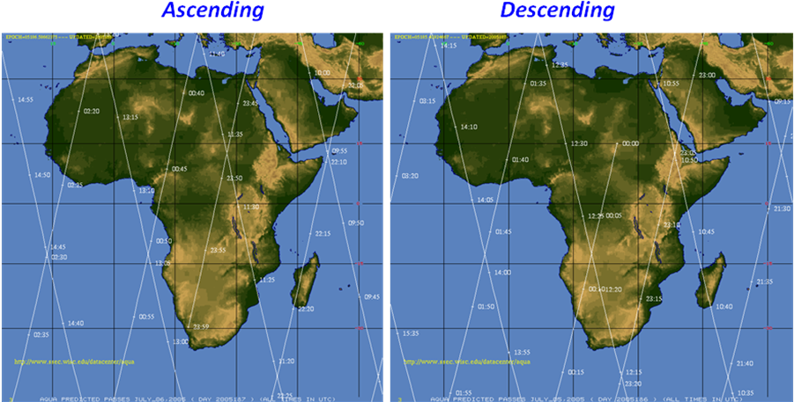
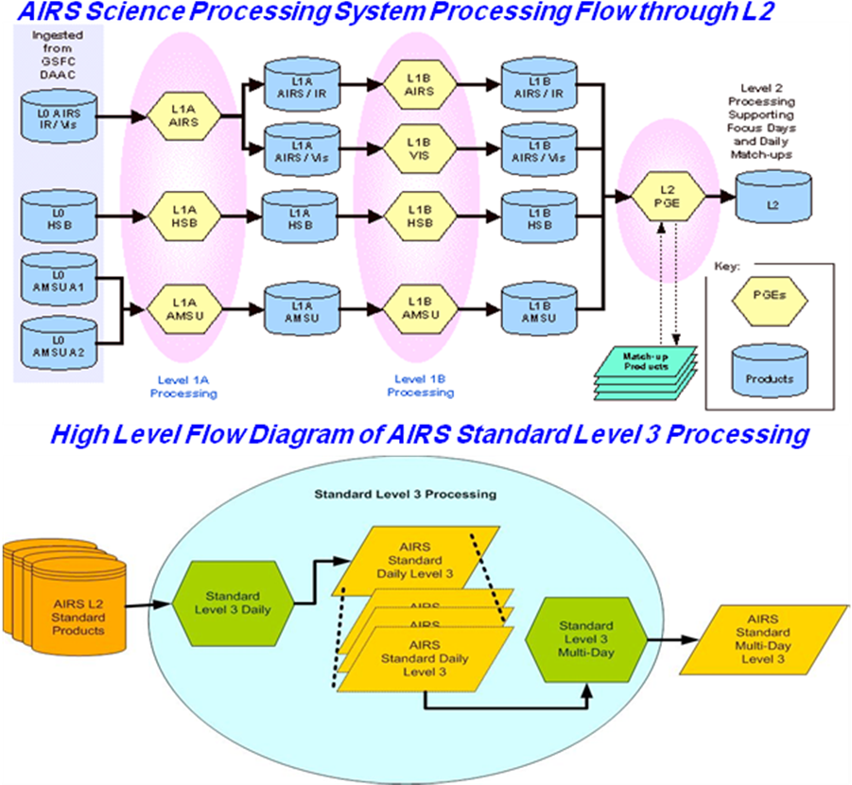

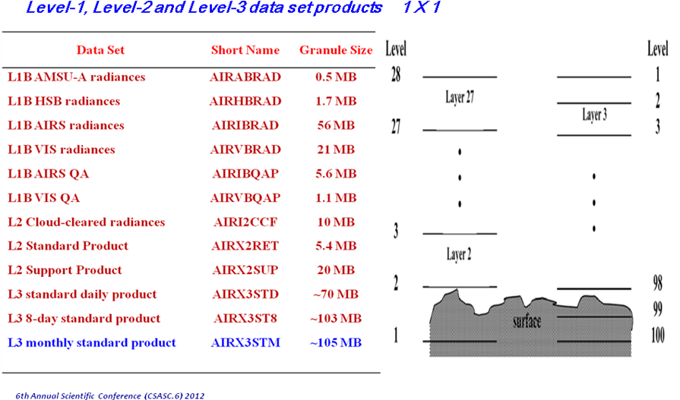
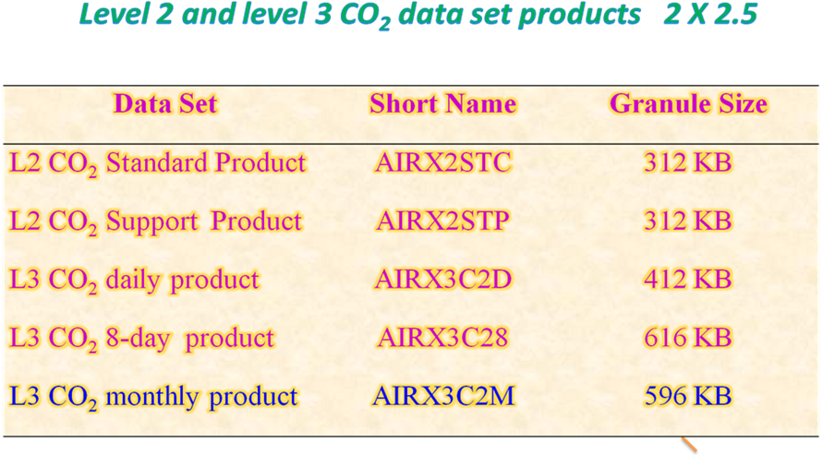
Hierarchical Data Format (HDF)
Is an effective format for general scientific data, which is important for analysis of geospatial data. It is designed to facilitate data access in heterogeneous computing environments, but it does not provide a standardized structure to store spatial location (i.e., geolocation) information.
L3 monthly standard product
Name | Type | Extra Dimensions | Explanation
TotalCounts_A  TotalCounts_D | 16-bit integer | None | Total counts of all points that fell within a 1°x1° grid cell whether they were included in the final L3 product or not.
TotCldLiqH2O_A  TotCldLiqH2O_D | 32-bit floating  point | None | Mean total integrated column cloud liquid water. (kg/m²)
TotCldLiqH2O_A_err  TotCldLiqH2O_D_err | 32-bit floating  point | None | Error estimate of total integrated column cloud liquid water. (kg/m²)
TotH2OVap_A  TotH2OVap_D | 32-bit floating  point | None | Total integrated column water vapor burden. (kg/m²)
TotH2OVap_A_err  TotH2OVap_D_err | 32-bit floating  point | None | Error estimate for total integrated column water vapor burden. (kg/m²)
TotO3_A  TotO3_D | 32-bit floating  point | None | Total integrated column ozone burden. (Dobson units)
TotO3_A_sdev  TotO3_D_sdev | 32-bit floating  point | None | Standard deviation for total ozone. (Dobson units)
SurfAirTemp_A  SurfAirTemp_D | 32-bit floating  Point | None | Temperature of the atmosphere at the Earth’s surface. (Kelvin)
SurfSkinTemp_A  SurfSkinTemp_D | 32-bit floating  point | None | Surface skin temperature. (Kelvin)

SurfPres_A  SurfPres_D | 32-bit floating  Point | None | Mean surface pressure. (mb)
OLR_A  OLR_D | 32-bit floating  point | None | Outgoing long-wave radiation flux. (watts/m2)
ClrOLR_A  ClrOLR_D | 32-bit floating  Point | None | Clear-sky outgoing longwave radiation flux. (watts/m²)
EmisIR_A  EmisIR_D | 32-bit floating  Point | 4 | IR surface emissivity on a frequency grid (832, 961, 1203, 2616 cm⁻¹.)
CloudTopPres_A  CloudTopPres_D | 32-bit floating  point | None | Combined cloud top pressure (weighted by cloud fraction). (mb)
CoarseCloudFrc_A  CoarseCloudFrc_D | 32-bit floating  point | 3 | Cloud fraction at coarse cloud resolution. 3 layers: low, middle, high. (Unitless)
CoarseCloudTemp_A  CoarseCloudTemp_D | 32-bit floating  point | 3 | Cloud top temperature at coarse cloud resolution. 3 layers: low, middle, high. (Kelvin)
CoarseCloudPres_A  CoarseCloudPres_D | 32-bit floating  point | 3 | Cloud layer pressure at coarse cloud resolution. 3 layers: low, middle, high. (millibars)
FineCloudFrc_A  FineCloudFrc_D | 32-bit floating  point | 12 | Cloud fraction at fine cloud resolution. 12 vertical layers. (Unitless)
RelHumid_A  RelHumid_D | 32-bit floating  point | 12 | Relative humidity profile in 12 Standard pressure levels from 1000. to 100. mb. (Percent)
H2OVapMMR_A  H2OVapMMR_D | 32-bit floating  point | 12 | Water vapor mass mixing ratio at 12 standard pressure levels from 1000. to 100. mb (gm/kg dry air)
Temperature_A  Temperature_D | 32-bit floating  point | 24 | Atmospheric temperature profile in 24 standard pressure levels from 1000. to 1.0 mb. (Kelvin)
TropPres_A  Trop_Pres_D | 32-bit floating  point | None | Pressure of the tropopause. (millibars)
TropHeight_A  Trop_Height_D | 32-bit floating  point | None | Height of the tropopause. (meters)
TropTemp_A  TropTemp_D | 32-bit floating  point | None | Temperature of the tropopause. (Kelvin)
CO_total_column_A  CO_total_column_D | 32-bit floating  point | None | Retrieved total column CO. (molecules/cm2)
CO_VMR_eff_A  CO_VMR_eff_D | 32-bit floating  point | 7 | Effective CO volume mixing ratio for 7 trapezoid layers between 45 and 100. (ppmv)
CO_Verticality_A  CO_Verticality_D | 32-bit floating  point | 7 | CO verticality (sum of averaging kernels) at 7 trapezoid layers. (Unitless)
CO_eff_press_A  CO_eff_press_D | 32-bit floating  point | 7 | Effective pressure of CO retrieval for each of 7 trapezoid layers. (millibars)
CH4_VMR_eff_A  CH4_VMR_eff_D | 32-bit floating  point | 3 | Effective CH4 volume mixing ratio for 3 trapezoid layers between 51 and 73. (ppmv)
CH4_eff_press_A  CH4_eff_press_D | 32-bit floating  point | 3 | Effective pressure of CH4 retrieval for each of 3 trapezoid layers. (millibars)

(Source: Documentation about AIRS at AIRS website by NASA, http://disc.sci.gsfc.nasa.gov/AIRS/documentation/v5_docs)

The AERONET (AErosol RObotic NETwork)
The AERONET (AErosol RObotic NETwork) program is a federation of ground-based remote sensing aerosol networks established by NASA and PHOTONS (Univ. of Lille 1, CNES, and CNRS-INSU) and is greatly expanded by collaborators from national agencies, institutes, universities, individual scientists, and partners. The program provides a long-term, continuous and readily accessible public domain database of aerosol optical, microphysical and radiative properties for aerosol research and characterization, validation of satellite retrievals, and synergism with other databases. The network imposes standardization of instruments, calibration, processing and distribution.
AERONET collaboration provides globally distributed observations of spectral aerosol optical depth (AOD), inversion products, and precipitable water in diverse aerosol regimes. Aerosol optical depth data are computed for three data quality levels: Level 1.0 (unscreened), Level 1.5 (cloud-screened), and Level 2.0 (cloud-screened and quality-assured). Inversions, precipitable water, and other AOD-dependent products are derived from these levels and may implement additional quality checks.
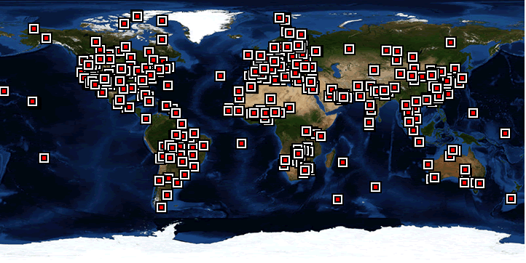


GIOVANNI
Giovanni- The Bridge Between Data and Science
http://disc.sci.gsfc.nasa.gov/giovanni/overview/what-is-giovanni
Giovanni is a Web-based application developed by the GES DISC that provides a simple and intuitive way to visualize, analyze, and access vast amounts of Earth science remote sensing data without having to download the data. Giovanni is an acronym for the GES-DISC (Goddard Earth Sciences Data and Information Services Center) Interactive Online Visualization ANd aNalysis Infrastructure.
From the researcher's point of view, Giovanni is comprised of a number of interfaces, each tailored to meet the needs of specific fields of Earth science research. Each interface, known as an instance, provides functions and parameters applicable to that specific area of Earth science. For example, the A-Train Instance provides an interface designed for research of clouds and aerosols, utilizing data from instruments aboard the A-Train satellites such as CloudSat, Aqua, Aura, and CALIPSO.

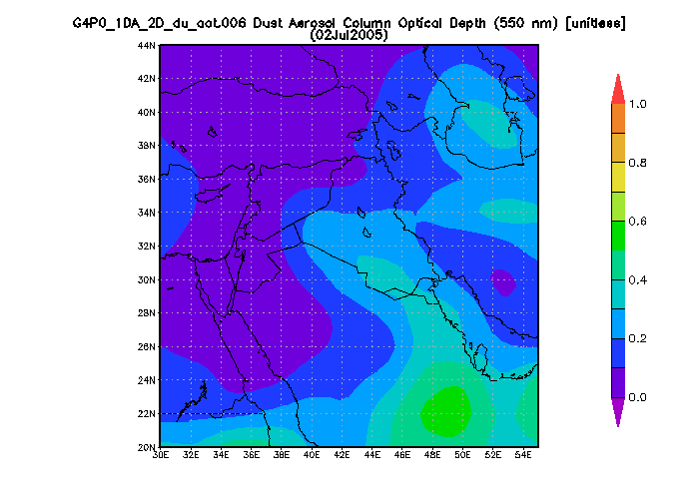
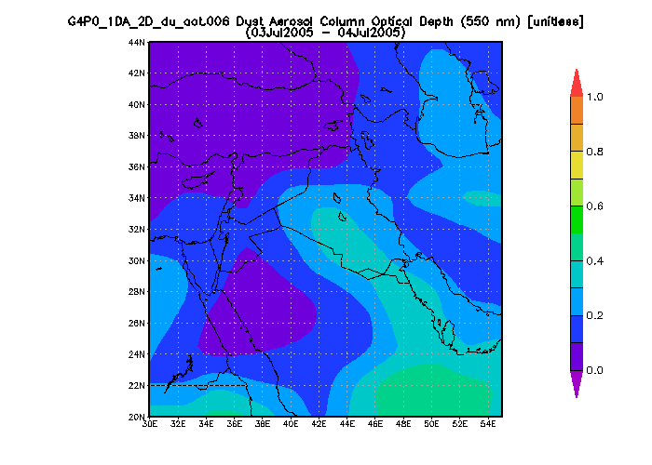
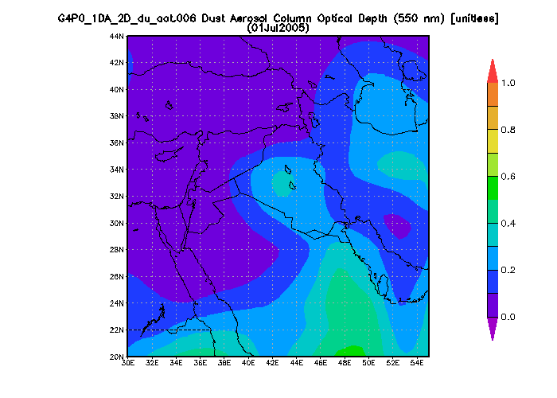
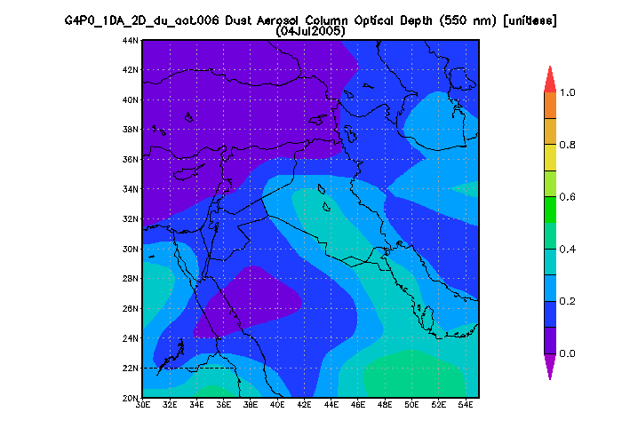

- The satellite remote sensing has very good global coverage and can provide continuous data with high spatial and temporal resolution, recordings of global variation over the long-term, and doesn’t cost a lot of money and staff.
- Supply simultaneous observations of the Earth’s atmospheric in different altitudes, land surface, and ocean surface temperatures; water vapor; cloud amount and cloud height, meteorological parameters, and GHGs.
- Provide the determination of the factors that control global energy and water cycles, investigation of atmosphere-surface interactions, improving numerical weather prediction, assessing climate variations and feedbacks and detection of the effects of increased carbon dioxide, methane, ozone and other greenhouse gases.
- Provide the researchers and scientists with wealth of information about the daily global atmosphere observations, which increase their capabilities in assessing the global warming and greenhouse effects.

