Using Open Source Spproach to Develop a System for Iraqi Education Curriculums
George Ajam
University of Babylon, College of IT
george@uobabylon.edu.iq
Abstract
Technology made wide contributions in sharing knowledge. Researchers who are aiming to develop educational curriculum used to hold seminars and conferences and rarely webinars to exchange ideas.
Iraqi educational systems suffered from decades of isolation and dictatorship. Developing curriculum may take lot of efforts and research to fill that gap. Security situations added difficulty of traveling which would get eliminated by using our system.
We are going to propose a system design to allow researchers and administrators in educational institutions to work collaboratively using open source system wiki which is enhanced to do certain tasks and customized to take input of curriculum from people who don’t know styles or formats of a wiki.
Introduction
The Internet became the new environment to deal with and share information, the importance of it still rising and a method to develop curriculums of the Iraqi educational system is very important.
All new technology goes to one direction which is the easy of use of information by users without prior knowledge to programming or coding.
Successful projects like Wikipedia made its contribution to widen the knowledge and spread information globally [1]. Wiki-leaks represent another example which still exploiting sensitive information about global security and governmental misuse of power allowing for information sharing and availability in simple way [2][3].
Matthew J. Salganik et. al. used Wiki as a way to enhance the method of surveying people instead of the normal interview which is expensive so he could enable quantification[4]. Minqi Pan also proposed a semantic wiki of mathematics utilizing automated reasoning techniques [5].
In this paper we will develop wiki-Manahij (A wiki for curriculum, where Manahij is the Arabic word of curriculum) the targeted beneficiaries are the educational system represented by the Ministry of Higher Education and Scientific Research (MoHESR). We'll show the implementation and design of the idea beside given technical details as the purpose of it is to allow even locally schools (with only Intranet) to learn and adapt to the tool, but the general concept is to allow all schools and colleges to use the system in a central domain in order to allow for wide sharing and collaboration.
The data sample of this paper is taken from the forth stage of Computer Science/College of Science curriculum.
Why Wiki-Manahij
- Difficulties of gathering committees to discuss the evolvements of curriculums because of security situation, difficulty of going to some regions, and decreasing the availability of researchers as they have commitments and heavy work.
- It's difficult to get required information from all of the Universities/Colleges at once.
- Organizing a conference in Germany / TU Berlin allowed Iraqi academics to look seriously of the curriculum development then followed by a conference in Qadisiya University in Iraq but the problem of continuing the development of such important issue remain open.
Wiki Concept
Wiki allows the users to create web pages, edit web pages and like them easily. Wiki in English is an abbreviation to (wiki wiki) means fast in Hawaii Language and started with capital letter to refer to the first site created in 1994. The American developer of the Wiki called (Ward Cuuningham) called his first site (WikiWikiWeb) in 25th Mar. 1995. He thought of using (Quick-Web) on his website then he used the term (wiki wiki) which was used on the buses that move fast in Honolulu Airport between it's exists and entrance points due to the similarity in of the quick update and editing by the public people. Cuuningham described the Wiki as a "Simple Database that can work on the web"[1].
Objective of Wiki-Manahij:
- Getting a clear idea of the educational workflow in every University, College or Institute in Iraq.
- Connecting all Iraqi Universities to system, to ease the exploring of specializations available and the curriculums offered.
- Giving an idea to visitors or any researcher to the position where the questioned school is standing on from the site in the curriculums comparing to other schools.
- Connecting people and allowing for sharing in fast and reliable way.
- Getting feed back and receiving suggestions to develop the curriculums.
- Getting ideas and suggestions from not only committee members and allowing for wide contributions.
- Allowing for student transfer between Iraqi Universities or from abroad when students can compare what subjects and curriculum equivalent to them in which school.
- Giving credit to good curriculums allowing schools to be motivated for more renewal and adjust with the future trends in standards.
- Allowing the potential students to know what's waiting for them of curriculum before applying to central admission college program by MoHESR.
The hosting Environment
We've tested our project in Ubuntu/Linux Operating system as it has characteristics compete the licensed operating system. It's available freely on the Internet or can be ordered from the website for free also or purchased with very low fee that's only used to support the Media CD and the production of it.
Ubuntu can be used with Graphical User Interfaces (GUI) or without it. It can be run a live directly from the CD without the need for installation but in our case we needed an installation. Ubuntu also has a Long Term support (LTS) to stable releases that last for 5 years just like those with Debian.
Requirements:
  - A stable release of the latest Media Wiki (we'll use 1.16.2)
  - A web server like Apache. (If you don't use Ubuntu and use XP or Windows 7 you can use Internet Information Server (IIS)).
  - PHP language version (5.0) or higher (With Support to PHP Standard Library).
  - Perl Compatible Regular expressions.
  - Database server (MySQL 4.0 or Higher)

Wiki Manahij Proposed System
The structure of the system we've developed consists of the following parts: A Web Server (Apache) upon Ubuntu Operating system, Core of wiki, PHP language support extensions, and Database that can be managed with PHPMyAdmin web-based database management system.
The Wiki has its own format when editing pages, and our design suggest that we allow user to enter data simple by writing them into an open source editor for text and HTML or by copy paste them from any kind of editor. The system processes that data and converts them into wiki format. Simple illustration in the flow chart below:
Input Data
Check if the Data in Wiki Format
NO
Process the data and make the new format compatible to the wiki Format
Is there any formatting need to be manipulated?
YES
NO
YES
Add changes to the edited page to perform the necessary update.
Start
Finish

ابونتو
خادم ويب
اباتشي
الويكي

Figure (1) Flow chart of the proposed system

Getting Wiki-Manahij Up and Running
We need to get (mysql-server, php5-mysql and phpmyadmin packages installed by following the following shell script codes:
$sudo apt-get install phpmyadmin
$sudo apt-get install apache2 mysql-server php5-mysql
The below figure will show all other dependencies required to finish the installation:

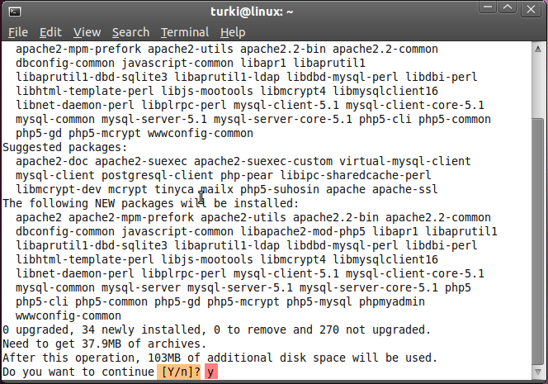
Figure (2) Installation of MySql, php5-mysql and phpmyadmin
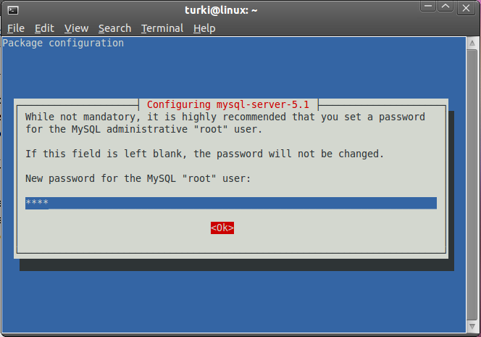
Figure (3) Setting a root user's password

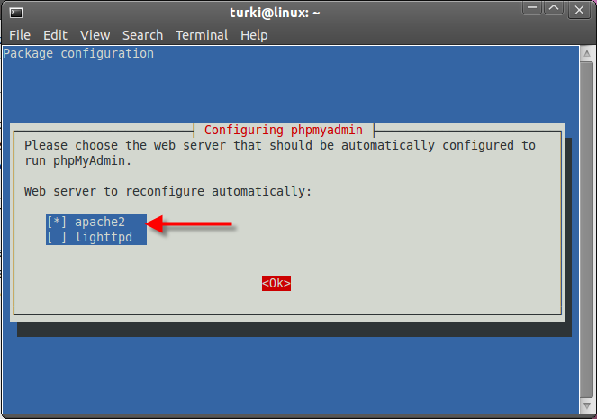
Figure (4) Selecting the Web server Apache 2 to run with phpmyadmin

After getting Apache running and phpmyadmin we can create a database and get Wiki Media installed. Installing the latest version is required to make sure new updates and security are at the latest.
Managing the Wiki
For managing a Wiki, a file called LocalSettings.php can be found in the main folder of the Wiki which can be edited and updated, a search for the following line if not available
Then we need to add it at the end of the document.
$wgGroupPermissions['*' ]['edit']
The addition can be customized such as:
// Update Customization
//to visitors so we can prevent un registered users from adding information
$wgGroupPermissions['*' ]['edit'] = false;
$wgGroupPermissions['*' ]['createpage'] = false;
$wgGroupPermissions['*' ]['createtalk'] = false;
//users are allowed to do the edit or creating pages or talks
$wgGroupPermissions['user' ]['edit'] = true;
$wgGroupPermissions['user' ][ 'createpage'] = true;
$wgGroupPermissions['user' ]['createtalk'] = true;
//Wiki Administrators
$wgGroupPermissions['sysop']['edit'] = true;
$wgGroupPermissions['sysop']['createpage'] = true;
$wgGroupPermissions['sysop']['createtalk'] = true;
The setting in LocalSettings.php file with false refer to (Not enabled) while true means (enabled).
Results
Since a matter such as curriculum used to be a concern with humanitarian specialists in that field of study only, using Wiki to document, publish, enhance and discuss an important thing like curriculum, we excepted that a users growth from students and faculty. Students would be interested if they plan to transfer or study chances, while faculty would try better serve the cause of make a better curriculum to his students.
Recommendations and Future Work:
- Providing Support from MoHESR by adding like to our work and helping in providing data.
- Improve collaboration between Universities, Colleges and Institute by adding their curriculum information.
- Adding more Languages to make Global exchange for knowledge about curriculums.
- Adding Research papers, Master thesis and doctorate dissertations about developing curriculums development.
- Investing the experts and encouraging to share their knowledge and to develop the content of Wiki-Manahij.
- Adding Trac SVN (Subversion Control System).
Conclusions
The administration of the Wiki is very simple as it allows users to control creating pages and simply edit them later. The content of curriculum if adapted by an Institution/College the MoHESR must gave prior approval. Updating the Wiki doesn't necessary mean that it would accept updates from normal users even some faculty members sometimes, but changes to the better is encouraged and it will make the study or the official attempt to change easier in the future. Visitors have the ability to vote, students also which allow for sharing and collaborative suggestions across different regions/schools. Our addition to the system allowed even simple users without prior knowledge to update and edit Wiki-Manahij to allow for more possibilities.
References
[1] Wikipedia, the Free Online Encyclopedia, www.wikipedia.org
[2] Dr. Faiza Dosoqi Ahmed, Informatics Journal, No. 22, Dept. of IT, College of Computer Science and IT, Imam Mohammed bin Soud Islamic College. http://informatics.gov.sa/details.php?id=230. Accessed 28-4-2011.
[3] Ritchard Stallmen, Report, Khalid M. Msihij, Al Riyad Newspaper, http://alriyadh.com , last access 28-3-2011.
[4] Matthew J. Salganik, Karen E.C. Levy, "Wiki surveys: Open and quantifiable social data collection", Princeton University, Feb, 2012, accessed in 3-11-2012
http://arxiv.org/pdf/1202.0500.pdf
[5] Minqi Pan, "T2Ku: Building a Semantic Wiki of Mathematics", Capital Normal University, Jan, 2012, last accessed, 3-11-2012 http://arxiv.org/pdf/1201.5681.pdf.

