The Frequency and Adequacy of the Haemodialysis as Important Factors in Anaemia Treatment and Response to Recombinant Human Erythropoietin in Chronic Renal Failure

Mohammed Hashim Aljefery
Dep. Of Nephrology and Artificial Kidney Unit, Merjan Teaching Hospital

Abstract
In this study we have 60 (35 male & 25 female) volunteers patients of CRF due to different causes with anaemia, all the patient on haemodialysis program. They take Epoetin (Epirax) treatment 50 IU/ Kg/ dose twice weekly subcutaneously. The patients are 35 male and 25 female of different body weight (15 – to 75 Kg) and different ages ranging from (12 to 68 years). This study started on 20-10-2010 and end on 10-6-2011 during this time the Hb, PCV, BU, SCr, S-electrolyte (Na⁺, K⁺ and Ca⁺² ) are taken 2 times/ week before the dialysis session, the body wt taken after the dialysis also 2 times/ week. Patient divided into 4 groups (Group 1:- have 3dialysis session/ week 4 hours duration for each sessionGroup 2 :- 2 dialysis session / week 4 hours for each session, Group 3 :- 3 dialysis session / week 3 hours for each session, Group 4 :- 2 dialysis session/ week 3 hours for each session).
In this study we are trying to evaluate the effect of the frequency and adequacy of the dialysis on the responsiveness to the rHUEPO treatment of anaemia in haemodialysis CRF. Where the inadequate dialysis is another factor of poor response to rHUEPO , although the recent studies showed that moderately increased dialysis adequacy cannot influence morbidity and mortality in HD patients but inadequate dialysis is identified as an important factor of poor response to rHUEPO in HD
We conclude:- the group 1 had the better results than the other groups which confirms the idea that not only the efficacy or only the adequacy of the dialysis effect the EPO responsiveness but both of them had a vital role and importance in the EPO responsiveness and thereby in the management of the anemia in CRF on HD program P<0.0001.
Introduction
Anaemia is one of the most common and morbid complications of chronic kidney disease, causing unpleasant symptoms and reducing the quality of life. The availability of recombinant human erythropoientin (rHUEPO) in 1989 has been one of the most important developments in the care of this population in past several decades(Steven & Allen, 2010).
Administration of (rHUEPO) to patients with chronic renal failure (CRF) has been established as a safe and effective means of kidney and regulates the proliferation and differentiation of erythroid precursor cells(Krantz, 1991; Mira et al., 2003) Erythropoietin requirement to reach aspecified target hemoglobin level varies in patients, the reason being multifactorial – Approximately 5 – 10% of renal patients do not achieve target hemoglobin levels despite doses in excess of 200 IU/ Kg/ week (Macdougall, 1995). This happened in patient either to hyporesponsiveness or resistance to the rHUEPO. Among causes of hyporesponsiveness to rHUEPO, the most common one is iron deficiency, either functional or absolute. Other conditions involved in rHUEPO resistance are: vitamin B12/ folate deficiency, chronic inflammation, secondary hyperparathyroidism, Hemolysis, Aluminum toxicity, malnutrition, chronic blood loss, angiotensin converting enzyme inhibitors, (ACE inhibitors), infection, hemoglobinopathies, antibodies against rHUEPO. (Sudhake et al., 1993; Drueke, 2001; Peter et al., 2002; Kwach & Balakrishnan, 2006; Francesco et al., 2006; Ryan et al., 2008; Kamyar et al., 2009).
Regarding to these factors, the iron deficiency is the most common causes of rHUEPO resistance(Drueke, 2001) and iron supplementation is recommended in order to achieve upper limits of ferritin levels in haemodialysis (HD) patients. In this population, intestinal iron absorption is reduced even in iron – deficient patients and intravenous (IV) iron preparation are usually administered. Thus vitamin B12 and folate deficiency via hyperhomocysteinemia are concomitantly risk factors for rHUEPO resistance (Brattstorm & Wilcken, 2000; Paraskevi & George, 2003).
The inflammatory indices are increased in end stage renal failure (ESRF) patients; the inflammation state in these patients is due to factors related to uremic itself, to dialysis procedure and possibly to co – morbidities that they present (atherosclerosis, diabetes, subclinical infections, advanced age, etc.) oxidative stress is another factor possibly interrelated to inflammation in HD patients (Jana et al., 2005; Brain et al., 2008). rHUEPO resistance induced by oxidative stress is possibly mediated through direct suppression of erythroid progenitor cells, oxidative damage of red blood cells (RBC) membrane – reducing RBCs survival – increased lipid peroxidation in erythrocytes and impaired iron availability(Canaud et al., 1999; Locatelli et al., 2003; Jana et al., 2005; Brain et al., 2008).
It is questionable how EPO interferes with oxidative stress. Some studies have shown that EPO antioxidant properties(Krantz, 1991; Jelkmann, 1992; Michael et al., 1997) and others that increases the need for antioxidant treatment due to increased consumption of vit E, and this is one of the adverse effect correlate with high doses, frequently used in rHUEPO resistance(Cristol et al., 1997; Galli et al., 1998; Miya et al., 2000).
The other factor that affect the rHUEPO treatment is secondary hyperparathyroidism is a common complication of ESRF. An inverse relation between intact parathormone (PTH) levels and rHUEPO resistance has been detected in patients undergoing HD. PTH can directly inhibit erythropoiesis via inhibition of EPO synthesis, bone morrow erythroid progenitors suppression and indirectly via marrow fibrosis(Sudhake et al., 1993; Rao et al., 1993).
Malnutrition is a common problem in ESRF patients. It is potential rHUEPO factor. The recently described malnutrition – inflammation – atherosclerosissyndrome correlates increased inflammatory to decreased nutritional indexes and atherosclerosis in ESRF patients.
In this study we are trying to evaluate the effect of the frequency and adequacy of the dialysis on the responsiveness to the rHUEPO treatment of anaemia in haemodialysis CRF. Where the inadequate dialysis is another factor of poor response to rHUEPO , although the recent studies showed that moderately increased dialysis adequacy cannot influence morbidity and mortality in HD patients (Fudu et al., 1996; Locatelli, 2003) but inadequate dialysis is identified as an important factor of poor response to rHUEPO in HD (Movilli et al., 2001). Dialysis dose and frequency are related to the removal of uremic inhibitors of erythropoiesis (Pierratos, 2004).
This study is done in nephrology and artificial kidney unit in Merjan teaching hospital, Babylon, Iraq.

The aim of the study
To study the effect of the frequency and adequacy of HD on the rHUEPO treatment of the anaemia in haemodialysis patients of CRF and evaluate the changes in responsiveness according to the changes in the frequency and adequacy of the dialysis.
Material and method:
In this study we have 60 (35 male & 25 female) volunteers patients of CRF due to different causes with anaemia, all the patient on haemodialysis program. They take Epoetin (Epirax) treatment 50 IU/ Kg/ dose twice weekly subcutaneously. The patients are 35 male and 25 female of different body weight (15 – to 75 Kg) and different ages ranging from (12 to 68 years). This study started on 20-10-2010 and end on 10-6-2011 during this time the Hb, PCV, BU, SCr, S-electrolyte (Na⁺, K⁺ and Ca⁺² ) are taken 2 times/ week before the dialysis session, the body wt taken after the dialysis also 2 times/ week. Patient divided into 4 groups (Group 1 have 3dialysis session/ week 4 hours duration for each session)
- Group 2 →2 dialysis session / week 4 hours for each session
- Group 3→ 3 dialysis session / week 3 hours for each session
- Group 4 → 2dialysis session/ week 3 hours for each session

Results
We find from our results the response to the erythropoietin is differ from patient to patient; that mean the response to the EPO affected by many factors(Fudu et al., 1996; Peter et al., 2002; Francesco et al., 2006; Ryan et al., 2008).
The results indicated that the frequency and efficacy of the HD play an important role in the treatment of the anemia in CRF on hemodialysis program.(Fudu et al., 1996; William et al., 1999; Movilli et al., 2001; Locatelli 2003). We find not only the adequacy have an important role; the frequency also play an important role in the treatment of anemia by increasing the responsiveness to the EPO treatment (Fudu et al., 1996; Movilli et al., 2001; Locatelli 2003; Pierratos, 2004).
From our results the group 1(25%) which including the more time (4hours) than other the three groups and more frequent (3 times sessions/week) had the better results in management of the anemia in comparison to the other groups p<0.0001. (Look at table1, 5) Also from the results we find the duration of the session in comparison between the group 4 (three hours session/2 times a week) and the group 2 (4 hours session /2 times a week) is different in its results , the group 2 had a better results in PCV levelthan the group 4 which indicate the adequacy of the dialysis session (or the dose of the dialysis) play a vital role in the EPo responsiveness p<0.0001 and t test -8.7 and therefore had an important role in the management of the anemia in CRF on the HD program HD program. (Look at table 2)
The frequency of the HD also play an important role whereas the comparison between the group 4 ( 3hours/ 2 dialysis session / a week) and the group 3 (3 hours / 3 times/ a week) and between the group 2 (4 hours/ 2 times/ a week) and group 1 (4 hours/ 3 times/ a week); we find the group 1 p<0.0001 and group 3 p<0.0001 had a better results than group 2 and group 4correspondly which indicate the frequency of the HD had a vital and important role in the management of anemia in CRF hemodialysis patients by increase the responsiveness of the EPO. (Fudu et al., 1996; William et al., 1999; Francesco, 2004). (Look at table 3, 4)
The last marker, the group 1 had the better results than the other groups which confirms the idea that not only the efficacy or only the adequacy of the dialysis effect the EPO responsiveness but both of themhad a vital role and importance in the EPO responsiveness and thereby in the management of the anemia in CRF on HD program P<0.0001. (Movilli et al., 2001; Pierratos, 2004; Francesco, 2004)

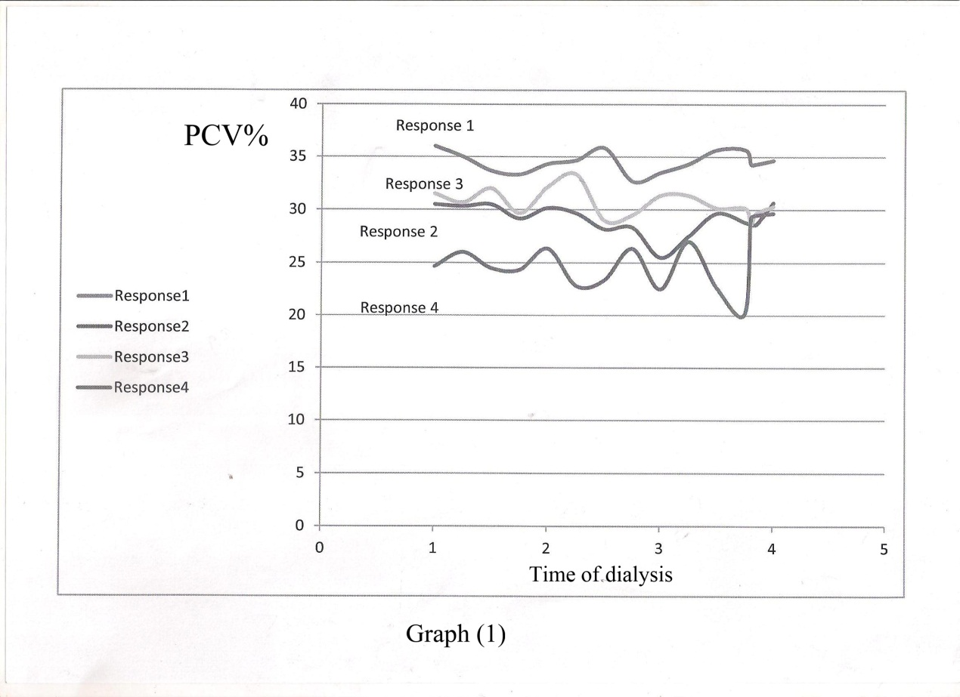

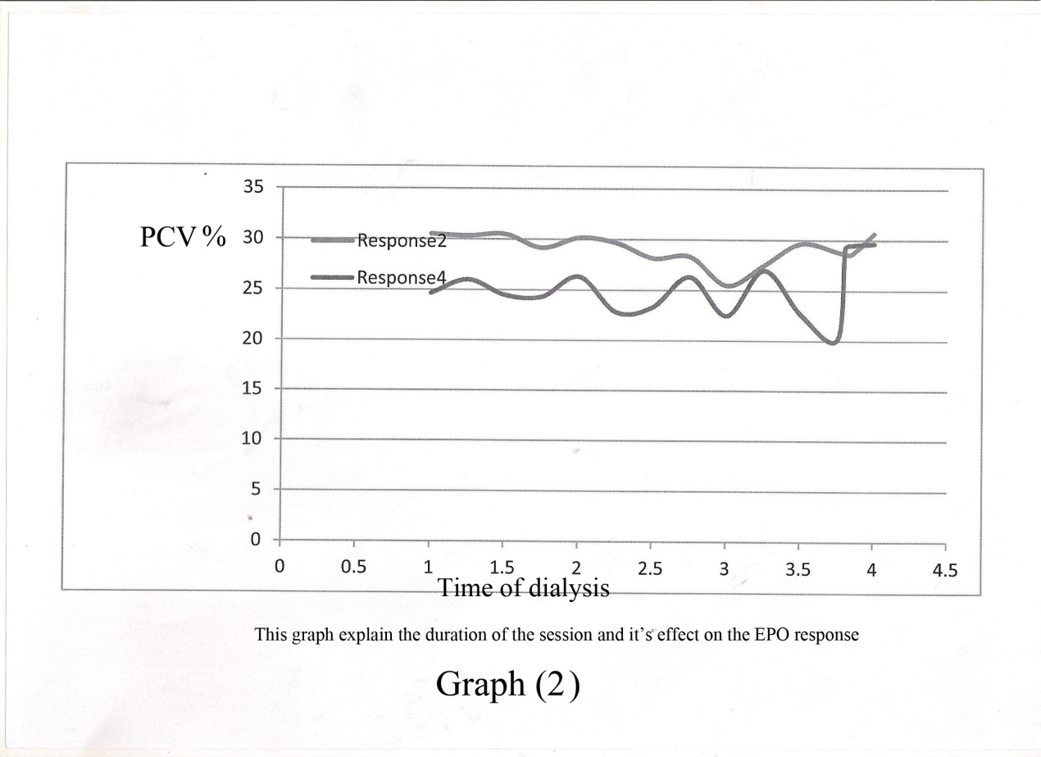

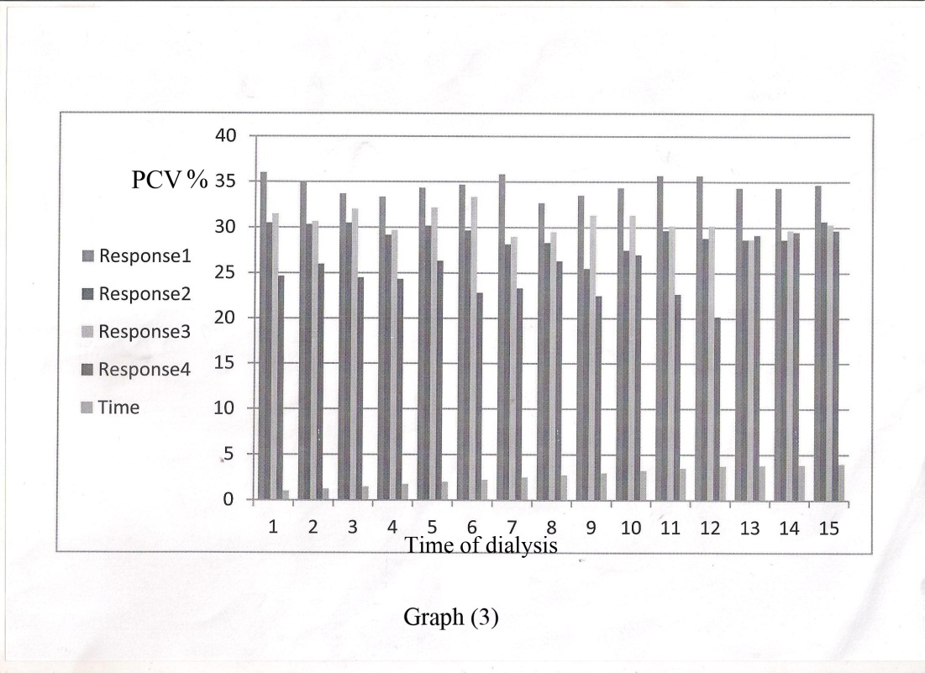

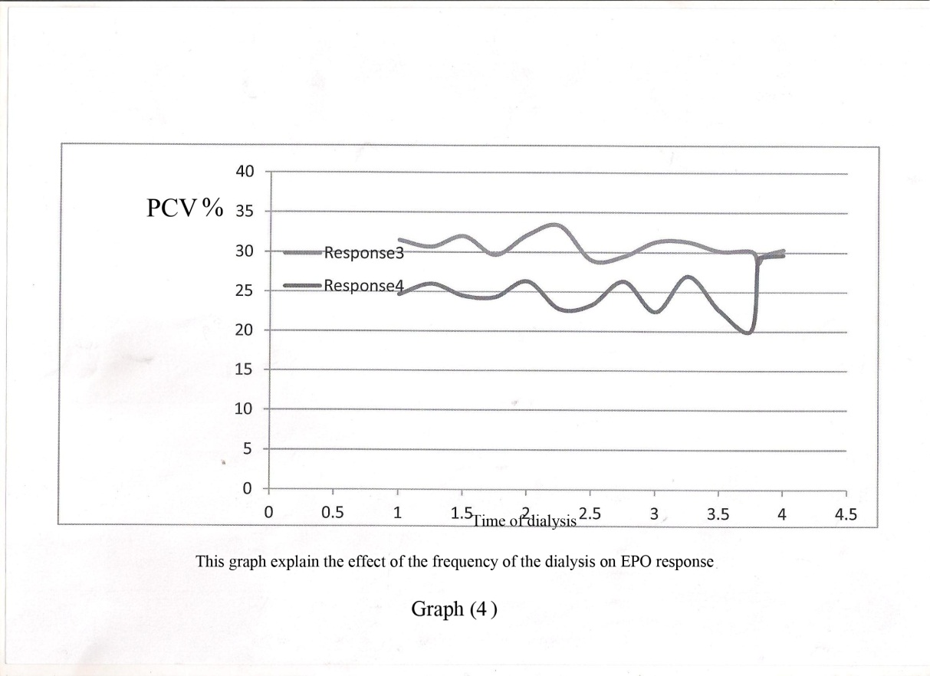

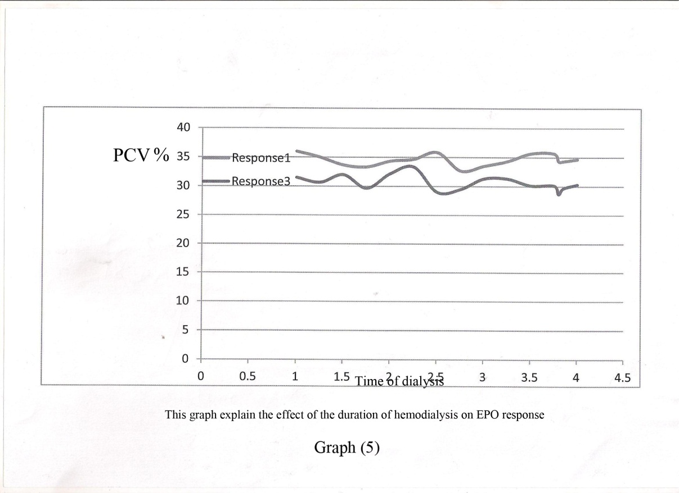

Discussion
Anaemia secondary to end – stage rental disease (ESRD) is an important but complex syndrome that directly contributes to significant morbidity and mortality in this patient population(Chan et al., 2005). The main causes of uremia – associated anaemia are (1) relative erythropoietin (EPO) deficiency (Nissenson et al., 1991; Mira et al., 2003) Hypo proliferative bone marrow function(Krantz, 1991; Krantz, 1991; Rao et al., 1993; Rao et al., 1993) reduced survival of red blood cells (RBCs)(LYJ et al., 2004). Optional renal replacement therapy may play a role in correcting the anaemia by removing small and possibly middle/large molecules that inhibit erythropoiesis (Locatelli & Vecchiol, 2003). Although the role of dialysis dosage person the response to Epotherapy has been proposed(Movilli et al., 2001), it has been largely underexamined in the past.
Although recent study showed that moderately increasing dialysis adequacy cannot influence morbidity and mortality in hemodialysis patients, inadequate dialysis is identified as an important factor of poor response to recombinant human erythropoietin (Held et al., 1996; Young et al., 1997; Young, 1998) in haemodialysis patients. Dialysis dose and frequency are related to the removal of uremic inhibitors of erythropoiesis (Locatelli et al., 2001) and dialysis adequacy may optimize rHUEPO responsiveness (Movilli et al., 2001). Movilli et al (2001) showed that inadequate dialysis was associated with higher epoetin requirement.
Therefore our result which confirmed the duration of the dialysis (dose of the dialysis and the frequency agreed with many author regarding the idea of well removal of uraemic inhibitors of erythropoiesis and getting the target responsiveness to the rHUEPO (Young 1997; Young, 1998; Wilkliam et al., 1999; Locatelli et al., 2001; Movilli et al., 2001; Pierratos, 2004; Franbcesco et al., 2004;). Therefore by optimizing rHUEPO responsiveness an adequate dialysis treatment can contribute to the reduction of the cost of rHUEPO (Movilli et al., 2001).
Christopher T. et al showed that the conversion from conventional haemodialysis [(CHD); three times a week, 4 hour per session] to nocturnal home hemodialysis NHD; five to six times a week, 6 to 8 hour per session) results in a three – to four – fold increase in uraemia clearance (Pierratos, 2004). This improvement is associated with an increase in hemoglobin level and a reduction of EPO requirement ((Pierratos, 2004). Given that hematopoietic progenitor cells (HPCs) are responsible for the maintenance of RBC, these observation led to the speculation that NHD may improve hemoglobin level in patients with ESRD without further EPO demand by improving mobilization of bone marrow – derived HPCs into the circulation enhanced HPCs survival and growth, or both. Therefore NHD enhances the removal of substances that may be toxic or inhibitory to HPC, thereby improving HPC mobilization growth, and function and resulting in ameliorating anaemia management in patients with ESRD.
In another aspect Juan Carlos Ayus.et al (2005) showed that; the short hemodialysis associated with improved fluid volume overload and reduction in left ventricular hypertrophy and reduce the inflammatory markers like C – reactive protein and improved phosphorus control, in addition increased albumin, for these reasons there are improvement to EPO response and finally improve the hemoglobin level.
The national Cooperative Dialysis study (NCDS) established that higher dialysis dose resulted in reduced morbidity(Owrie et al., 1991) and observational data from patients treated with thrice – weekly and quotidian hemodialysis suggested that even higher levels of urea clearance are associated with better clinical outcomes (Kailash, 2006) and suggested that optimal control of extracellular fluid volume and blood pressure are rational goals given the large body of evidence linking these characteristic to better health outcomes. Longer dialysis duration or more frequent dialysis treatment may aid in achieving these clinical objectives (Kailash, 2006).
William R et al (1999) confirmed that one potential benefit of chromic hemodialysis (HD) regimens of longer duration orgreater frequency than typical three – times – weekly schedules is enhanced solute removal over a relatively wide molecular weight spectrum of uremic toxins.
In summary the frequency and the duration of the hemodialysis play an important role in management of the anaemia of CRF and directly modulate the dose and responsiveness of the rHUEPO through either removal of the uremic toxins or counteract against the factors which causes the hyporesponsiveness or resistance to the rHUEPO.

References
Brain D. Bradbury, Cathy W. Critchlow Rweir , Ron Stewart, Mahesh Krishnan and Raymond H Hakim. (2008). Impact of elevated C-reactive protein levels on erythropoiesis –stimulating agent (ESA) dose and responsiveness in hemodialysis patients. Nephrol Dial Transplant; 24(3): 919-925.
Brattstorm L, Wilcken D (2000). Homocysteine and cardiovascular disease : cause or effect ? Am J CLin Nutr;72: 315-340.
Canaud B , Cristol J, Morena M, Leray-Moragues H, Bosc J, Vaussenat (1999). Imbalance of oxidants and antioxidant in hemodialysis patients . Blood purify; 17:99-106.
Chan CT, Lish, vermas (2005). Nocturnal hemodialysis is associated with restoration of impaired endothelial progenitor cell biology in end – stage renal disease. Am J physiol Renal physiol 2005; 289: F679 – F684.
Cristol JP, Bosc JY, Badios et al (1997). Erythropoietin and oxidative stress haemodialysis, beneficial effects of vitamin E supplementation. Nephrol Dial Transplant ;12: 2312-2317.
Drueke T. (2001). Hypo responsiveness to recombinant human erythropoietin . Nephrol Dial Transplant , 7;25-8.
Francesco Locatelli, Lucia Del vecchioand someone Andrulli (2004). Dialysis: its role in optimizing recombinant erythropoietin treatment. Nephrol Dial Transplant 16 w suppl. 7x29 – 35.
Francesco Locatelli, Simeone Andrulli, et al. (2006). Nutritional –inflammation status and resistance to erythropoietin therapy in hemodialysis patients. Nephrol Dial Transplant; 21;991-998
fudu I O, Feldma nJ, Friedman EA: (1996). The intensity of hemodialysis and the response to erythropoietin in patients with end –stage renal disease. N EnglJ Med 1996i334: 450-425
Galli F, RavidatiS, Chiarantinil L, Campus G, Canestrari F, Buoncristiani U. (1998). Bioreactivity and Biocompatibility of a vitamin E –modified multi-layer hemodialysis filter.Kideny Int. 54: 580-589.
Held JP, Port FK, WolfeRA etal. (1996). The dose of hemodialysis and patient mortality. Kidney Int ; 50: 550-556.
Jana Smrzova ,Jozef Ballaa and Peter Barany. (2005). Inflammation and resistance to erythropoiesis – stimulating agents – what do we know and what needs to be clarified? Nephrol Dial Transplant 20(Suppl 8) ; viii2-viii7.
Jelkmann W. (1992). Erythropoietin structure, control of production and function physical Rev. April 72(2): 449-89.
Juan Carlos Ayus, M. Reza Mizani, Steven G Achinger, Ravi Thadhani, Alan S. Co and Shuko lee. (2005). Effects of short Dial versus conventional Hemodialysis and Inflammatory Markers: A prospective, controlled study. J Am Soc Nephrol; 16: 2778-2788.
Kailash Jindal et al (2006). Haemodialysis clinical practice Guidelines for the Canadian society of Nephrology: Hemodialysis adequacy in adult. J Am Soc Nephrol 2006; 17: 4-7.
Kamyar Kalantar-Zadeh, Grace H lee , Jessica E.Miller, et al. P (2009). Predictors of hypo responsiveness to Erythropoiesis- stimulating Agents in Hemodialysis patients patients. AmJ Kidney Dis. May; 53(5): 823-834.
KrantzSB. Erythropoietin. Blood 1991 Feb 1;77(3): 419-34.
Kwach C, Balakrishnan VS. (2006). Managing erythropoietin hyporesponsiveness. Semin Dial 19(2); 146-51.
Locatelli F, Canaud B, Eckardt KU, StevinKel P,Wanner c,Zoccali C.Oxidative (2003). Sstress in end-stage renal disease: an emerging threat to patient outcome .Nephrol Dial Transplant;18:1272-1280.
Locatelli F, Del. Vecchiol: (2003). Dialysis adequacy and response to erythropoietic agents: what is the evidence base? Nephrol Dial Transplant 2003 18 [suppl 8]: viii 29 – viii 35.
Locatelli F, Vecchiol, AndrulliS: (2001). Dialysis: it's role in optimizing recombinant erythropoietin. Nephrol Dial Transplant ; 16 [suppl 7] 29-35.
Lowrie EG, Laird NM, Parker TF, Sargent JA (1981). Effect of the hemodialysis prescription of patient morbidity: Report from the National cooperative Dialysis study. N Engl J Med; 305: 1176-1181.
LYJ, Marticorena R, Donnelly S: (2004). Red blood cell survival in chronic renal failure. Am J Kidney Dis ; 44: 715- 712
Macdougall IC. (1995). Poor response to erythropoietin.Br Med J;310: 1424-5.
Michael N et al .(1997). Effect of Recombinant Human Erythropoietin on Transfusion Risk in coronary Bypass patients . Ann Thorac Surg,64: 1686-1693.
Mira varagunam, Daniel J.McCloskey, Paul J.Sinnott, Martin J.Rsftery, and Muhammed M.Yaqoob. (2003). Angiotensin-converting Enzyme Gene polymorphism And Erythropoietin Requirement. Peritoneal Dialysis. 23; 111-115.
Miya ZaKi H, Matsuoka H, Itabe H et al. (2000). Haemodialysis impairs endothelial function via oxidative stress: effect of vitamin E-coated dialyzer. Circulation; 101: 1002-1006.
Movilli E, Cancarini GC, Zani R, camerini C, Sandrini M, Mariorca R. (2001). Adequacy of dialysis reduces the dose of recombinant erythropoietin independently from the use of biocompatible membranes in hemodialysis patients. Nephrol Dial Transplant Jan: 16 (1): 111-4.
Nissenson AR, Nimer SD, Walcott DL: (1991). Recombinant human erythropoietin and renal anaemia. Ann Intern Med; 114; 402 – 416.
Paraskevi Tseke and George Tsirpanlis. (2003). Is Recombinant–human erythropoietin resistance another predictor of cardiovascular disease in end-stage renal failure patients ; 3th congress of Nephrology in Internet.
Peter Stenvinkel and peter and Peter Barany. (2002). Anemia ,rHUEPO resistance, and cardiovascular disease in end- stage renal failure : links to inflammation and oxidative stress . Nephrol Dial Transplant (Suppl 5): 32-37.
Pierratos A: (2004).New approaches to hemodialysis. Annul Rev Med; 55; 179 -189.
Rao Ds, shih MS, Mohini R: (1993). Effect of serum parathyroid hormone and bone marrow fibrosis on the response to erythropoietin in uremia. N Engl J Med; 171: 328
Ryan D et al. (2008). Greater EpoetinAlfa Responsiveness is Associated with Improved survival in Hemodialysis patients CJASN July (3): (4) 1077-1083.
Schwartz DI, Pierratos A, Richardson RM, Fenton SS, Chan CT: (2005). Impact of nocturnal home hemodialysis on anemia management 2005 in patients with end – stage renal disease. Clin Nephrol , 63: 202-208.
Steven Fishbane and Allen Nissenson. (2010). Anemia management in chronic kidney disease. Kidney international 7815-Sg(August 2010) doi: 10-1038/ ki2010-188.
Sudhake D. , Rao, Mei-shu Shin, and Ravider Mohini . (1993). Effect of Serum parathyroid Hormone and Bone Morrow Fibrosis on the response to Erythro poietin in Uremia. N Engl.J Med; 328;171-175.
William R, Lark, et al (1999). Quantifying the effect of changes in the hemodialysis prescription on effective solute removal with a mathematical model. Jam Soc. Nephrol; 10; 601 -609.
Young EW, Woods JW, Segieda GE, Held PJ, Port FK, Bloembergen WE. (1997). Predictors of target hematocrit among erythropoietin – treated HD patients. Jam sol Nephrol; 8: 259A (abstr).
Young EW. (1998).Dialysis dose, membrane type and anaemia control. Am-J Kidney Dis; 32 [suppl.4]: 5157-160.

