Strengthening Glass for Bullet Impact

Fadhil M. Hassoun
Engineering College, Materials Engineering Departments, Babylon University
Majid M. Shukur Firas J. Hammod
Materials Engineering College, Department of nonmetallic, Babylon University

Abstract
Thermal tempering as a hardening technique for glass was investigated to resist bullet impact. During this process, the glass was heated in a vertical furnace at different temperatures then cooled, firstly by forced air at different times then quenched to room temperature by using an oil. Stress profile was done to know the optimum condition. Etching process for glass with Hydrofluoric acid with concentrations of 5% and 10% was conducted to modify fracture strength of glass. The glass was laminated with acrylic to support the glass impact strength against bullets. The fracture strength was modified with 377.5% for only tempered glass while it became 390.3% for etched at (10% HF) and tempered at (650^{ο}C) glass.
Keywords: Thermal tempering, Etching, impact strength.
الخلاصة
لقد تم في هذا البحث تقسية الزجاج المنزلي باستخدام التصليد الحراري, حيث تم تسخين الزجاج في فرن عمودي و لعدة درجات حرارية مختلفة, و من ثم اخمد بنفخ الهواء لفترة محددة ثم بالزيت ليبرد إلى درجة حرارة الغرفة. استخدمت أيضا" عملية الإزالة الكيميائية- Etchingمع حامض الهيدروفلوريك بتراكيز(%5 و% 10) لزيادة مقاومة الزجاج. الزجاج المقسى استخدم كموديل تطبيقي مع بوليمر الاكريليك و تم فحصه بنجاح في مقاومة صدمة اطلاقة البندقية. لقد تحسنت مقاومة الكسر للزجاج بعد عملية المعالجة الحرارية بنسبة 377.5% ، بينما أصبحت 390.3% للزجاج المعالج بالإزالة الكيميائية (10% HF) و معالجة حرارية عند (650^{ο}C).
الكلمات الرئيسية/ المعالجة الحرارية، الإزالة الكيميائية، مقاومة الصدم
1. Introduction
Glass has a unique combination of desirable properties for various engineering applications, such as transparency, hardness, durability and low cost. The problem is that glass exhibits brittle fracture and can be easily damaged, which in turn leads to low strengths and design stresses. Thermal tempering is one approach to increase fracture stress of glass. In this process, a glass is heated to a temperature near the softening point and then rapidly cools with air jet to cool to room temperature. The exterior layers of glass is cooled and contracted while the interior of the glass is relatively viscous. When the interior shrinks, the surfaces are rigid and they are compressed by the contraction of the interior. Toughened glass is four to five times stronger than ordinary glass and, if it is broken, it disintegrates into small fragments with dulled edges, which are unlikely to cause serious injury(George et al.,1984).
Glass is very sensitive to flaws which are formed during physical contact and during cleaning glass surfaces. Chemical etching is one of the techniques that is used to remove these flaws from glass surfaces where it decreases the density of flaws on the glass surfaces (Ray and Stacey,1969). Laminating process is a technique that has been made to improve fracture control of glass to increase the safety by avoiding spalling of glass fragments after failure has started. Transparent materials are an effective part of protection systems. A sandwiching of annealed glass with a thinner layer of plastic (Polyvinyl Butyral or similar bonding agent) is usually used to produce glass armors with different thickness depending on the protection level. Annealing glass is usually used in this application to minimize cost and the ability of making curved products. Chemically or thermally toughened glass can be used in this field for additional strength and for their fracture shape(Callister,2000).
Many companies and authors have been developed the techniques for strengthening soda-lime glass. (Jafari et al.,2005), used diluted Hydrofluoric acid of 40% concentration at room temperature to etch soda-lime glass. (Glebov et al.,2002), have reported the effect of UV irradiation on the rate of etching. The authors of the present paper have investigated the effect of thermal tempering process upon the strength of soda-lime glass.
2. Experimental Procedure
Soda-lime glass was used as a raw material. A vertical furnace and cooling apparatus were made for thermally strengthening glass. The glass was cut into beams with rectangular cross section; normal size of (120 x 25 x 5 mm). The glass bars were heated for four initial treating temperatures (575, 600, 625, and 650^{ο}C), then taking out the furnace and quickly cooled by air jet for different cooling times (25sec, 0.5min, 1min, and 2min) at (17^{ο}C) then quenched in oil. The air cooling temperature was the same as of ambient temperature. An acid bath was used as etching bath for treating the beams of Soda-lime glass. This bath was Hydrofluoric acid which diluted by distilled water. The concentrations of the acid bath were (5% and 10% HF). A polyethylene container was used to contain the acid etching bath. The time of etching was rating from 15 to 75 minutes. The fracture strength was measured by three-points bending (cross head speed: 5mm/min).
laminating process was done by sandwiching as-received and thermally toughened soda-lime glass with acrylic sheets. Epoxy resin was used as glue material to bond the glass with acrylic sheets under high compression. The laminating samples were tested under impact of Kalashnikov bullet at a distance of 10 m (Laible,1980)
3. Results and Discussion
3.1 Strength of Thermally Toughened and Etched Glasses
The relationship between fracture strength and initial treating temperatures of thermally treated glass is shown in Figure (1). This test is done according to (JISR 1601,1981) Cooling process in this Figure is done by using air jet to different cooling times at air temperature (17^{ο}C) then cooled by forced air to different times finally in oil to cool at room temperature. Fracture strength of thermally tempered glass increased with increasing initial treating temperatures up to 650^{ο}C. One can conclude, that the small air cooling time (25seconds) gives the higher fracture strength in comparison with other times. This behavior refers to increasing temperature difference between the surface and the core of thermally treated glass, which leads to induce compressive stresses at glass surfaces (Saha and Cooper,1984). At the times below (25sec.), glass tends to fracture because of high thermal difference.Figure (2) shows the effect of etching time on the fracture strength of etched glass. It is clear that the strength is increased with etching time at the two concentrations. The reason returns to decreasing flaws density at the glass surfaces. The fracture strength of etched glass at 5% is better than that of 10% which may return to modifying the surface glass state at 5%.
3.2 Coupling of Thermally Treating and Etching Processes
Figure (3) represents the relationship between fracture strength and initial treating temperatures of etched glass. Etching process, in this Figure, was done by submerged the glass samples in acid bath to 75 minutes at 35^{ο}C. The strength also increased with increasing initial treating temperatures up to 650^{ο}C. From this Figure, the fracture strength of samples that etched at 10% HF is higher than that of that etched at 5% HF. It is clear that the result is reverse of that Figure (2). This may back to differential distribution of flaws on etched glass surface.
Fracture Strength, MPa

*Air temperature is 17^{ο}C.
*Different times of air blowing.

Initial Temperature, ºC

Fig. (1) Fracture strength of glass treated by quenching at 17^{ο}C.
Fracture Strength, MPa

Etching time, min

Fig. (2) Effect the etching time on the fracture strength of glass.
Fracture Strength, MPa

Initial Temperature,ºC

Fig. (3) Fracture strength of etched glass that thermally treated (air jet for 25 seconds then quenched in oil).
3.3 Impact Test Results
laminating glass was tested under impact by shooting it with automatic Kalashnikov bullet (7.62mm). This test is done according to (NIJ standard 01081.01). The thicknesses of these samples were rating from 16 to 40 mm. For all samples after testing the glass and acrylic layers have obvious cracking as a result of bullet impact. The vicinity region around hole of the tested sample, is cracked very heavily, and appeared as a powder, opaque of comminution region. A comminuted glass is ejected during the impact. Radial cracks have propagated away from the comminuted region to the edge of each glass layer while the acrylic is cracked during impact due to the nature of brittle fracture like glass. Acrylic layers do not show the comminuted fracture because they are ejected as a small pieces away (in front of and behind) the sample. As a matter of fact, the bullet will cause a large diameter damage in the sample.
From table (1), one can clearly see that the resistance to bullet through the laminated glass increase with increasing target thickness. The glass state (treated or untreated) is an important condition to limit the areal density of the laminated glass. As shown in table (1) the areal density (which is the ratio of the weight to the area of the sample) of sample (5) is 78.5Kg/m² while that of sample (6 and 7) is 93Kg/m². Finally, sample (5) appears optimum state from the aspect of thickness and performance.

Table(1): Shot summary
No. of target | Glass state | Target thickness, mm | Areal density, Kg/m² | Firing distance, m | Fracture mode of samples constituents
1 | As received glass | 16 | 27.8 | 10 | Small pieces of glass and acrylic
2 | As received glass | 24 | 44.5 | 10 | Small pieces of glass and acrylic.
3 | As received glass | 32 | 61.8 | 10 | Small pieces of glass and acrylic.
4 | As received glass | 40 | 78.5 | 10 | Small pieces of glass and acrylic.
5 | Treated  (By etching and heat treatment) | 40 | 78.5 | 10 | Very small pieces of glass or powdered and small acrylic pieces
6 | As received glass | 49 | 93 | 10 | Small pieces of glass and acrylic
7 | Treated  (by etching and heat treatment) | 49 | 93 | 10 | Very small pieces of glass or powdered and small acrylic pieces

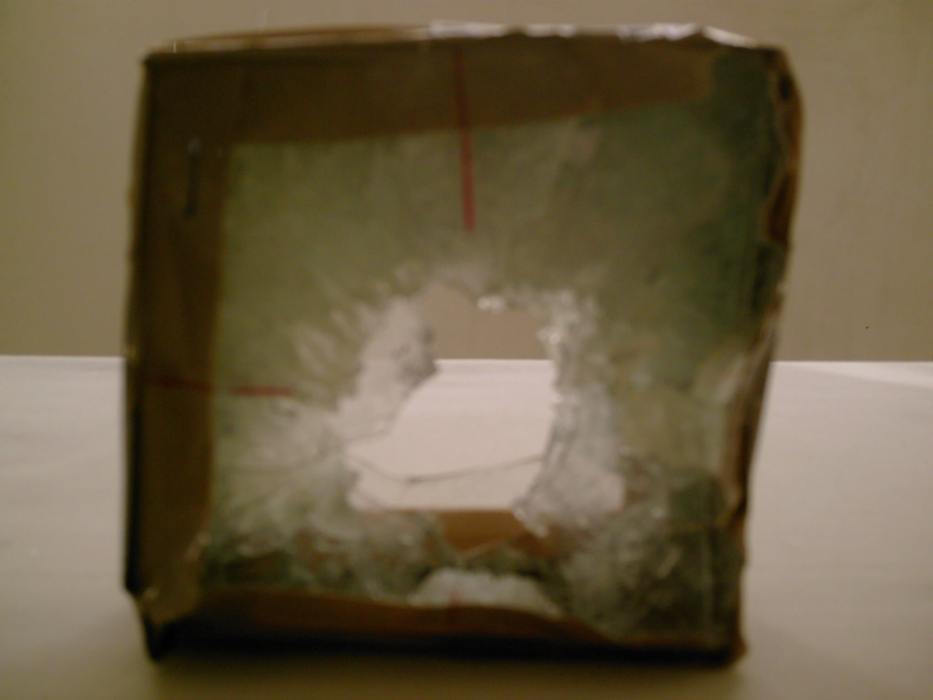
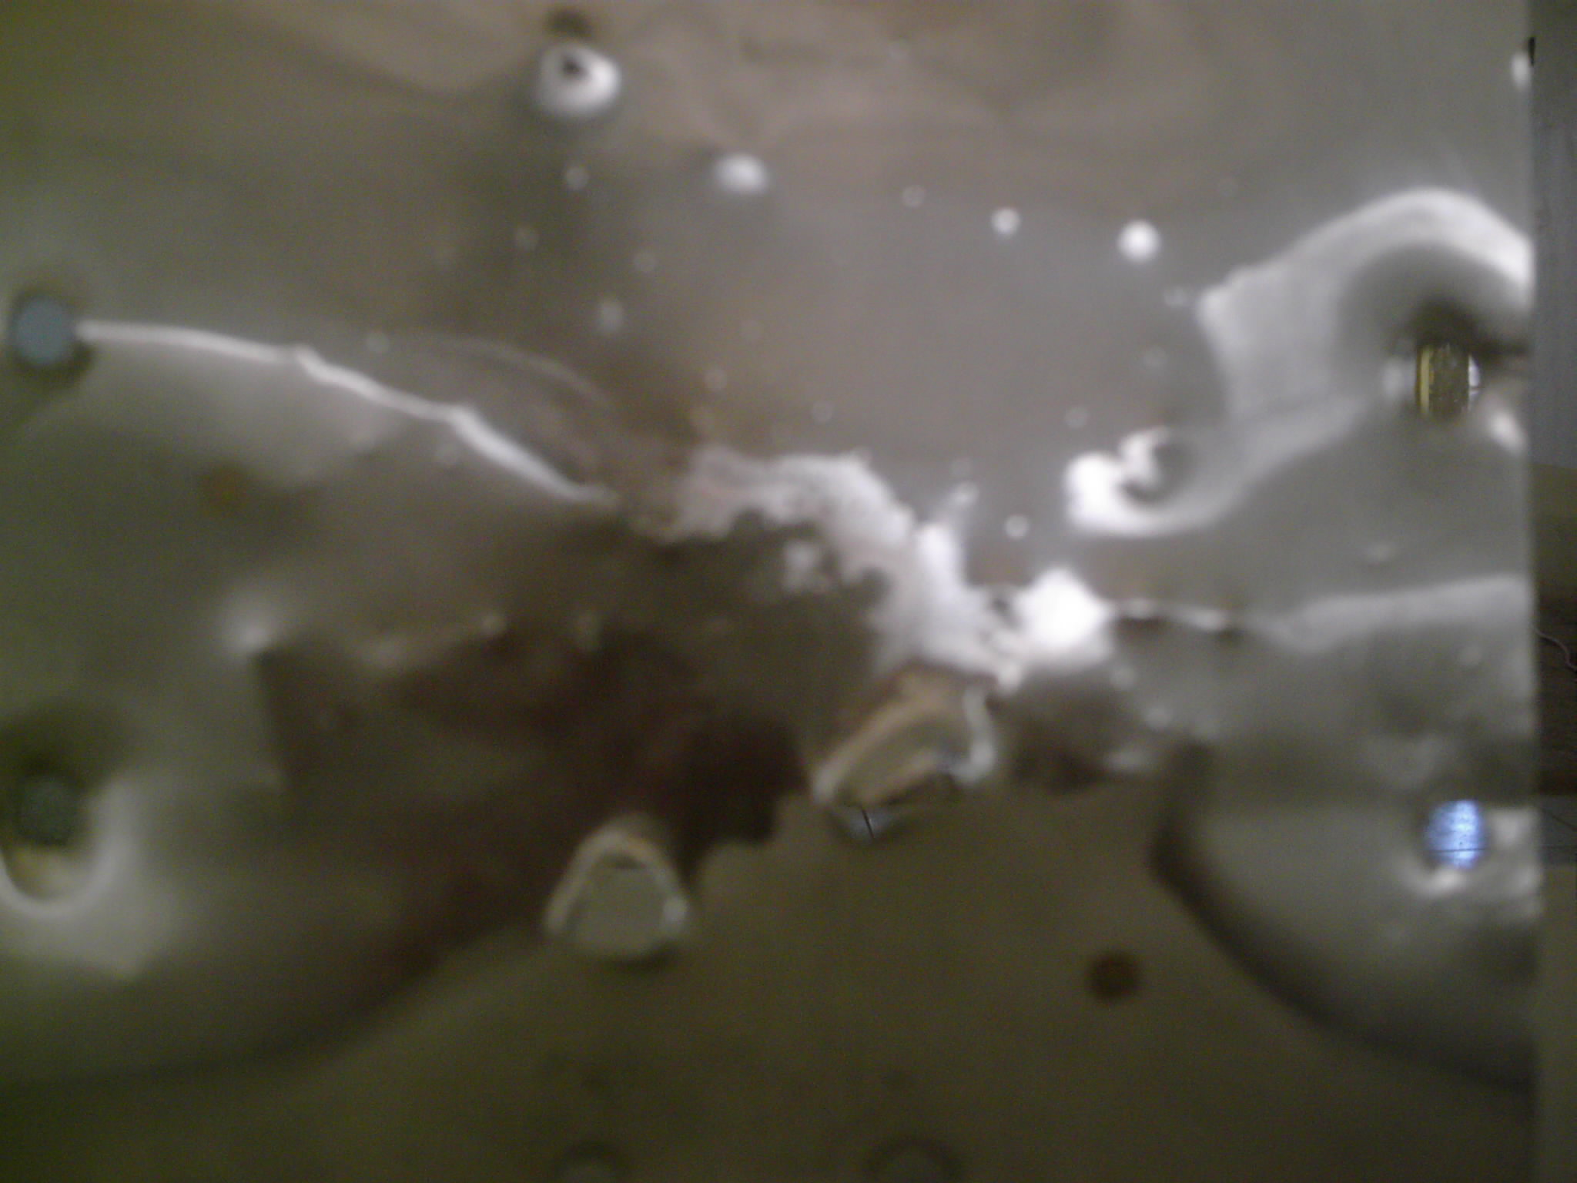

Fig. (4) Front view of laminated Fig. (5) Back view of witness
sample after shooting test. plate after shooting test

4. Conclusions
*heat treated +etched
* Thickness=40mm
1. The fracture strength of glass can be raised by heat treatment. The best treatment were by heating the glass up to 650ºC and then rapidly cooled by air jet to 25 seconds (air temperature is 17 ºC), finally quenched in oil.
2. The increment in HF concentration and etching time with constant of HF concentration can decrease the fracture strength of glass because of the over etching. In this study the best etching is at 10% HF for 75min.
3. The effect of etching on the heat treated glass does not sensibly increase the strength of heat treated glass.
4. Toughness of glass can be increased by combination it with a polymer because the polymer makes bridge among cracked glass and it holds the pieces of cracked glass together.
5. 40mm thick laminated glass which contains treated (etched and heat treated) glass can be used to avoid a bullet of automatic Kalashnikov rifle about distance of 10m
5. References
Callister D. William, 2000,"Materials Science and Engineering",5th edition,USA.
George W. Mc Lellan and Errol B. Shand,1984," Glass Engineering Handbook ", Mc Graw-Hill Company, Inc., 3rd edition, USA.
Jafari G. R., Mahdavi S. M., Iraji Zad A. and Kaghazchi P.,2005, "Characterization of Etched Glass Surfaces by Wave Scattering", Iran. http://arxiv.org/PS_cache/physics/pdf/0503/0503032.pdf
Laible R. C.,1980," Ballistic Materials and penetration mechanics", Elsevier Scientific Publishing Company, USA.
Leonid B. Glebov, Larissa Glebova and Olena Lobatiuk,2002,"Photoinduced Chemical Etching of Silicate and Borosilicate Glasses", J. Glasstech. Ber. Glass Sci. Technol., 75 C2 .
Ray N.H. and Stacey M.H.,1969,"Increasing the Strength of Glass by etching and Ion-exchange", Journal of materials Science, 4, pp. 73-79.
Saha C. K. and Cooper A. R.,1984," Effect of Etched Depth on Glass Strength", Journal of the American Ceramic Society , Vol. 67 (8), Pp.(C158 - C160).

