Determination of the Macrophage Chemiluminesence Response in Polyvinyl Chloride Polymer Particles as a Function of Pollution Stress

Faik H. Mohammed
Department of Physiology , SadamCollege of Medicine
Ali H. AL-Hashimi
Department of Physiology , College of Medicine , University of Basrah
Layla O. Khalid
Department of Physiology , College of Medicine , University of Basrah

Abstract
Stimulation of phagocytic cells in whole blood by PMA solution by mean of luminol-dependent chemilumineces were clearly affected by PVC particles. This effect is size-dependent a 3 µ size PVC has maximum effect. This may be due to surface receptor available at the cell membrane surface, yet to be identified.
الخلاصة
سُجِلت إشارة للخلايا البيضاء البلعومية في عينات الدم عند مُعاملتها بحبيبات بولي فنايل كلورايد وتم قياس ذلك بواسطة التألق الكيميائي المنوط باللومينولللمثير السائل(PMA)وكان التأثير يعتمد على حجم حبيبات البوليمر حيث إن أقل حجم (3 مايكرون) يعطي أكبر تأثير. مما يدل على إحتمال وجود مناطق أستقبال خاصة عند غشاء الخلية تعتمد على حجم حبيبات البوليمر المؤثرة.
Introduction
During the manufacture of polyvinyl chloride (PVC) polymer, small scattered particles are carried out and fly in the air. Mobilizes significant quantities of PVC particles may be taken on respiration.
Allen et.al. (1972) have reported that polymorphonuclear leukocytes (PMNL) emit flashes of luminescence during phagocytosis of bacteria as a result of respiratory burst which lead to production of highly reactive molecules in PMNL , e.g:superoxideanions,hydrogen peroxide singlet oxygen & hydroxyl radicles.
Respiratory burst is oxygen dependent & a transitory process lasting not more than 30-60secAlfred I.T et.al.( 1976) which is regarded as an essential step in host defense against micro organisms, it can be also correlated with metabolic activation of hexose monophosphate shunt because of increase in the production of (NADP⁺)William( 1989).
Pulmonary alveolar macrophages and peritoneal macrophagesdo not elicitchemiluminescence (CL) response after ingestion of zymozan particles. However in the presence of luminol (5-amino-2,3-dihydro-1,4-phthalazinedione) a CL was observed following phagocytosis of zymozan particles,Claes et.al. (1991),.
Since pulmonary alveolar macrophages represent the respiratory system’s first line of defense against foreign polymer particles, studies were initiated on the effects of PVC particles on phagocytosis by PMNL of human in whole blood in vitro.
Materials and method
The blood samples were obtained from20 healthy volunteers medical students and members of the staff, sodium citrate was used as anticoagulant&the samples were kept at 4 until the use.The volume of each sample is about 2ml, 1ml used as control & the other 1ml used as test sample (treated with PVC).

Reagents
- Tris-HCl solution was prepared as following: 24.23 gm of tris (FlukaGarante, Switzerland) was dissolved in 1000 ml distilled water. Then 25 ml of tris solution mix with 42 ml of 0.1NHCl (FlukaGarante, Switzerland) and completed to 100 ml with distilled water to have 0.2 M tris-HCl buffer, pH = 7 Mohammed et.al. (1995).
- Luminol solution (Sigma chemical company, USA) was prepared by dissolving 0.02 gm of luminol in 2 ml of 0.2M NaOH to get the stock solution. The stock solution was diluted to 100 ml with deionized water (Basrah petrochemical Instillation) and kept prior to use.
- CL inducer: In order to activate PMNL to burstLuminol-dependent CL we use:
*PMA solution(phorbolMyristate Acetate) for control samples.
* A medium of 19 ml of tris-HCl solution, 2.4 gm of NaCl (RidelDehaen) and different sizesand weight of PVC in gm were diluted to 250 ml with distilled water. PVC in this medium was used as a suspended agent, for test samples.

Chemiluminesence Measurement
1.Chemiluminesence Measurement of control samples
The reaction mixture consist of 1 ml chemiluminesence inducer of PMA solution, 0.1 ml NaOH and 0.1 mlluminol in a 5 ml beaker. 0.01 ml of whole blood was add to the above mixture (at zero time indicated by arrow in Fig. 1) and agitated well before it was placed into the measuring cuvette of the photon counting system. CL was continuously recorded on a chart recorder, until the CL peaked and demonstrated a definite decline. Triplicates samples were performed for variability.
2. . Chemiluminesence Measurement of test samples
Then to see the effect of PVC , in addition to the above mixture , we add to the above mixture 1ml of . Chemiluminesence inducer of PVC particles.
Reaction conditions are PH=7.4 &temperature =37C° for control & test samples.
The number of WBCs in control & test samples were estimated using haemocytometer& the relative of chemiluminscence taken for the same number of cells.
Results
Fig. (1) demonstrates the CL obtained from PMNL before & after exposure to PVC polymer particles in presence of luminol. CL was measured using photon counting system Al-Hashimi and Mohammed (1997). As shown in Fig. (1), CL rose (within about 3 minutes from the time of contact of the polymer particles with PMNL) from background to a maximum value after about 10 minutes and then gradually decayed to background level over the next several minutes.
The magnitude of the CL response (phagocytosis)to polymer particles increased with polymer size & with macrophage concentration. Glutathione (SH-group) in reduced form inhibited the CL response in dose dependent manner (Figures not shown), the complete inhibition of CL were shown at about 2.5 µg/ml.
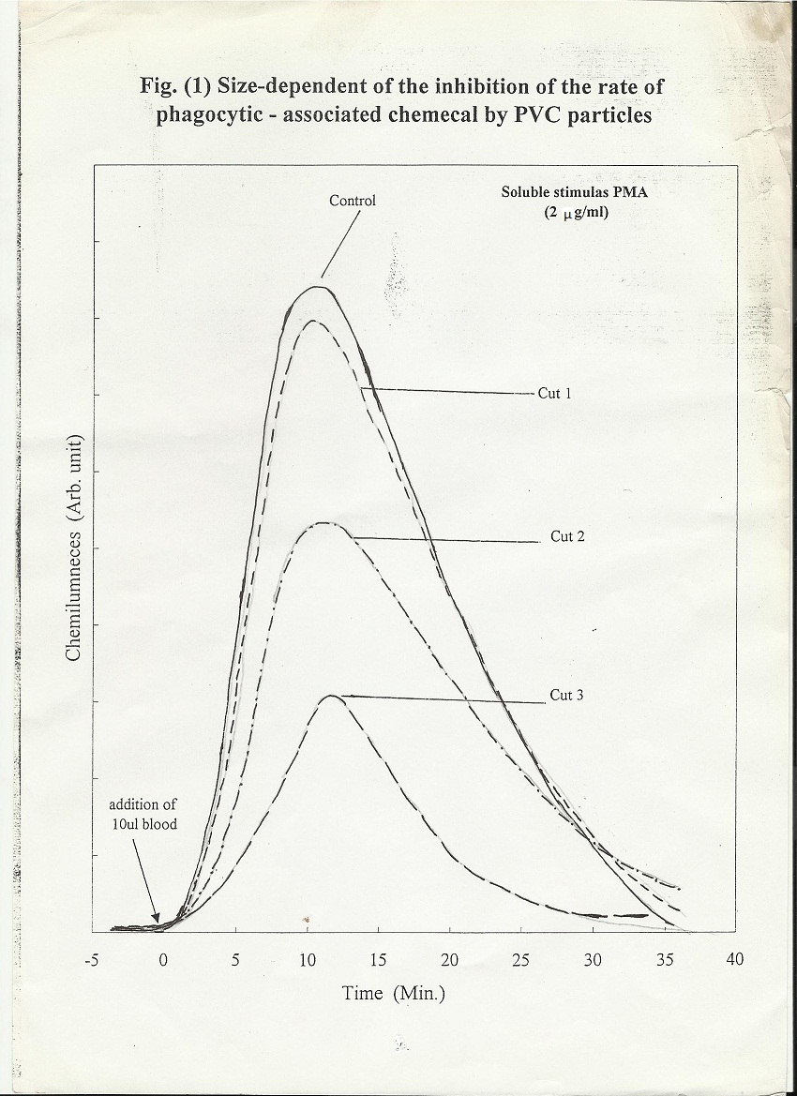
Discussion
SH-group removed anions (+ + 2H⁺ = H₂O₂ + O₂) virtually eliminated CL at 2.5 µg/ml., indicating noninvolvement of H₂O₂ in the CL. Both OH. radical scavengers. e.g. ethanol at 5 µg/ml and singlet oxygen scavenger dimethylfuranat 5 µg/ml inhibited the response by about 50%. Since little information is available concerning the reaction of OH with luminol to produce light, it is possible that both and are generated during the phagocytosis by PMNL and these radicals might react (+ = OH⁻ +₁₂) to generate singlet oxygen ₁₂Thaw et.al. (1981) which in turn is responsible for luminol oxidation to generate light.
To evaluate further the potential health hazards of PVC, size-fractionated was tested in this system. As shown in Fig. (1), 3 mg/ ml of 3 µ particles (cut 3) and 6 µ particles (cut 2) inhibited the response about 62% and 34% respectively, where as 20 µ particles (cut 1) had no significant effect.
Since biological activity depends on chemical state and local concentration of surface-related compound Biochemistry (1993) and Buescher et.al. (1995)significant enrichment with increasing particle size caused remarkable inhibition of and dependent phagocytosis associated CL in PMNL by 3 µ and 6 µ PVC particles. This may be due to surface receptor identity for size of certain enzyme available at the cell membrane surface yet to be identified.

References
Alfred, I. T., Edward, J. G. and Babior, M. B. (1976). Blood 48:967.
Allen, R. C., Stijernholm, R. C. and Steele, R. H., BiochemBiophys. Res. Comman. 47, 679 (1972).
Al-Hashimi, A. H. and Mohammed, F. H. (1997) An ultra-high sensitive photon counting system and its application to biochemical measurements. Basrah J. Science Vol. 15, No.1. (1-7).
Biochemistry (1993) Zubay. Third edition. Volume (1) Energy, cells and catalysis Editior: Kevin Kane Chapter.9 pp. 219-253 Mechanisms of enzyme catalysis WCB publishers.
Buescher, E. B. Caither, T. Nath, and Gallin, J. I. (1985): Abnormal adherence-related functions of neutrophile, monocytes and Epstein-Barrvirus-Transformed B cells in a patient with C₃bi receptor deficiency. Blood 65: 1382-1390.
Claes Dahlgren, PerFollin, Agneta Johansson, Ronny Lock, Helen Lundquist and AsaWalan (1991) “Chemiluminescence as a mean of following the function of phagocytic cells”. Trends in photochemistry and photobiology, 2 (1991).
Mohammed , F. H., Al-Hashimi, A. H. and Gathban, G. S. (1995) Chemiluminescence study of phagocytic function of whole blood in stimulation by barium sulphate crystals. Med. J. of Basrah University (MJBN) 13: 169-182.
Thaw, H. H., Det Maestro, R. F., Arro, E. Brunk, U. T. and Arfors, K. E. (1981). Acute toxicity of active oxygen species on human GLIA cells from oxygenated oxy-radical in chemistry and biology. Pp. 757-760. Academic press. Inc. ISBN-0-12-592050-4.
William, F. Ganong, M. D. “Review of medical physiology” (1989). Prentice Hall international Inc., 14 ed. Sec. 2 PP: 436-458.

