Synthesis and Spectroscopic Studies of Some Furfuraldehyde Schiff Bases Complexes

Akram A. Mohammed
Department of Chemistry, College of Education,University of Mosul
Mosul, Iraq

(NJC)

(Received on 21/ 12 /2004) (Accepted for publication on 23/3/2005)

Abstract
Different types of complexes with different stoichiometries were isolated for Co(II), Ni(II) and Cu(II). These complexes having the general formulae [M(L)₂Cl₂] and [Cu(L)₂]Cl₂ (where M is Co(II) and Ni(II) and L is Schiff base formed by condensation of furfuraldehyde and butylamine (FBA), or hexylamine (FHA) ). These complexes have been prepared and characterized by elemental analysis, molar conductivity measurements, study of the infrared and UV-visible spectra and by magnetic susceptibility measurement. Elemental analysis suggests the stoichiometry to be 1 : 2 (metal : ligand). For cobalt and nickel, coordination of the inorganic anions was noticed to give hexacoordinated complexes with octahedral structure, while copper complexes are tetracoordinated with square planar geometry. Infrared spectra of all the complexes agree with the coordination to the central metal atom through nitrogen of azomethine group and furan ring oxygen atoms and Schiff bases behave as bidentate ligands with O and N donor atoms. Conductance measurements suggest the non-electrolytic nature of the cobalt and nickel complexes and the 1:2 electrolytic nature of the copper complexes.
الخلاصة
تضمن هذا البحث تحضير ودراسة عدد من معقدات الكوبلت والنيكل والنحاس مع ليكاندين من نوع قواعد شيف. تم اشتقاق الليكاندين من تفاعل الفورفرال مع بيوتيل آمين (FBA) وهكسيل آمين (FHA). تم الحصول على المعقدات من تفاعل هذين الليكاندين مع الاملاح الفلزية المناسبة تحمل الصيغة العامة [M(L)₂Cl₂] وكذلك الصيغة [Cu(L)₂]Cl₂ حيث Co = M او Ni ، (FBA) = L او (FHA) (أي ان نسبة الفلز والليكاند 1 :2). شخصت المعقدات الناتجة بطرق التحليل الدقيق للعناصر وقياسات التوصيل المولاري واطياف الاشعة تحت الحمراء وفوق البنفسجية والحساسية المغناطيسية. دلت الدراسات المختلفة على عمل الليكاندين بشكل ثنائي السن والتناسق من خلال ذرة نتروجين مجموعة الأزوميثان وذرة أوكسجين حلقة الفيوران. كما لوحظ ايضا في حالة الكوبلت والنيكل تناسق الايونات اللاعضوية السالبة لتكون المعقدات سداسية التناسق لها بنية ثماني السطوح. اما في حالة معقدات النحاس فقد اتضح ان للمعقدات التناسق الرباعي ذو بنية المربع المستوي. دلت قياسات التوصيل الكهربائي على ان معقدات الكوبلت والنيكل ذو طبيعة متعادلة وان معقدات النحاس ايونية بنسبة 1 : 2

Introduction
During the past two decades, considerable attention has been paid to the chemistry of the metal complexes of Schiff bases containing nitrogen and other donors ^{[1-4]}. In recent years considerable interest has been aroused in the comparative donor properties of oxygen and nitrogen when both are present in the same molecule. This may be attributed to their stability, biological activity ^{[5-7]} and potential applications in many fields such as oxidation catalysis ^{[8]}, electrochemistry ^{[9]}, analytical chemistry ^{[10-11]}, etc. In the present study, a series of new Schiff bases have been synthesised using furfural and butylamine (BA) or hexylamine (HA). These bidentate ligands form 1:2 complexes with Co(II), Ni(II) and Cu(II) ions.

Experimental
All the chemicals used throughout these investigation were of Analar, B. D. H., Aldrich or Fluka grade, used as supplied without further purification.

Reagents
CoCl₂ . 6H₂O (99.99 %), NiCl₂ . 6H₂O (99.99 %) CuCl₂ (99.99 %), furfuraldehyde (98 %), butylamine (98 %), hexylamine (98%).

Synthesis of the ligands
An ethanolic solution of furfuraldehyde (0.002 mol, 25 ml) was added with an ethanolic solution of (BA) or (HA) (0.002 mol, 25 ml) and refluxed for 16h. After the concentration of the solution, the precipitate was separated, filtered, washed with cold ethanol and air-dried and no further purification carried out.

Synthesis of the complexes
A mixture of furfuraldedyde (0.004 mol, 50 ml), and (BA) or (HA) (0.004 mol, 50 ml) in ethanol was added to an ethanolic solution of metal chlorides (0.002 mol, 50 ml). The mixture of reaction was refluxed for 20h. The excess of solvent was then distilled. The compounds separated were filtered, washed with ethanol and air-dried.
Analysis and physical measurements
The ligands and their complexes were analysed for carbon, hydrogen and nitrogen using a 1106 CE microanalyser. The metal contents were determined according to standard procedure ^{[12]}. Conductivity measurements were carried out for 10⁻³M solution in N,N-dimethylformamide (DMF) using LF-42 digital conductivity meter at 25Cº. Infrared spectra were recorded on Pye-Unicam SP-1100 spectrophotometer as KBr discs at the range 400-4000 cm⁻¹. The electronic spectra were recorded on a Shimadzu UV-160 spectrophotometer for 10⁻³M solution of the complexes in DMF at room temperature using quartz cell. Magnetic susceptibility measurements were made by the faraday method at room temperature using Bruker BM6 apparatus. Diamagnetic corrections for the ligand was calculated using Pascal’s constants ^{[13]}.

Results and discussion
The complex combinations of Co(II), Ni(II) and Cu(II) with (FBA) and (FHA) (Fig. 1) appears as powders.

a.

b.
Figure 1. The structure of a. (FBA); b. (FHA)

All the complexes are new which synthesised in good yield by the reaction of the metal salts and the two ligands, in neutral medium. Their molecular formulae [M(L)₂Cl₂] and [Cu(L)₂]Cl₂ (M=Co, Ni ; L= FBA, FHA) are in good agreement with the obtained analytical data (Table 1) indicating 1:2 metal-to-ligands stoichiometry for all of them.
The complexes are air stable at room temperature but they decompose without melting at temperature above 250Cº. All the complexes are insoluble in water but they are soluble in DMF. For the copper complexes, their electrical conductances in DMF (Table1) ranging between 128-143 cm² ohm⁻¹ mol⁻¹ indicating 1:2 electrolytic nature, while for the cobalt and nickel complexes, the lower values of molar conductivity suggesting non electrolytes ^{[14]}.
The active site of the ligands and their bonding to the metal atoms was characterized by careful comparison of the main infrared absorption bands of the free ligands and their complexes (Table 2). Each ligand contains furan ring and azomethine group. The main characteristic bands located in the free ligands spectra at 1624-1637 cm⁻¹ and 1280-1287 cm⁻¹ which were due to the azomethine (–C=N) and furan ring (C–O–C) stretching vibrations, respectively. In the infrared spectra of the all complexes ; these two bands suffer some sort of perturbation which showed a negative shift of about 21-28 cm⁻¹ and 20-29 cm⁻¹ for the stretching vibrations of azomethine and furan ring, respectively. These perturbation in the spectra suggested coordination through both azomethine nitrogen and furan ring oxygen atoms ^{[15,16]}. Further support for such coordination was obtained from the observation of new bands (not found in ligands spectra) at 496-505 cm⁻¹ and 441-450 cm⁻¹. These bands were tentatively assigned to M–O (metal – furan oxygen) and M – N (metal – azomethine nitrogen) modes, respectively ^{[17]}.

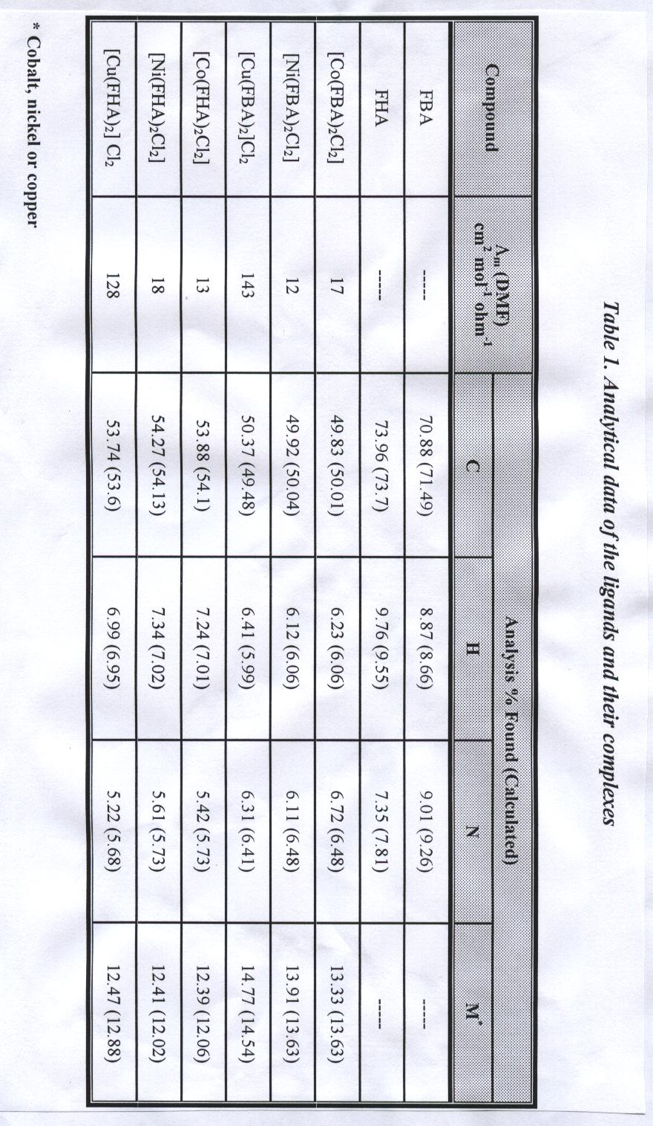
Table 2. Important I. R. spectral bands (cm⁻¹)
Compound | ν (C=N) | ν (C–O–C) | ν (M–O) | ν (M–N)
FBA | 1624 | 1280 | ----- | -----
FHA | 1637 | 1287 | ----- | -----
[Co(FBA)₂Cl₂] | 1600 | 1257 | 496 | 441
[Ni(FBA)₂Cl₂] | 1597 | 1251 | 500 | 447
[Cu(FBA)₂]Cl₂ | 1603 | 1260 | 502 | 444
[Co(FHA)₂Cl₂] | 1616 | 1258 | 500 | 450
[Ni(FHA)₂Cl₂] | 1609 | 1261 | 498 | 443
[Cu(FHA)₂] Cl₂ | 1614 | 1266 | 505 | 450

The ligands are characterized by two absorption bands in the UV-region. A high intensity band at 30303 cm⁻¹ is attributed to π → π* transition of furan ring and a second band with lower intensity appeared at 28169 cm⁻¹ is attributed to n → π* transition of azomethine group. Both bands showed a red shift on coordination with a metal ion. These observation represent a further indication for the coordination of the ligands to the metal ions. The electronic spectral bands and μ_{eff} values given in Table 3. For cobalt(II) complexes, three bands were observed and assigned to ⁴T₁g → ⁴T₂g, ν ₁, ⁴T₁g → ⁴A₂g, ν₂, and ⁴T₁g → ⁴T₁g (P), ν₃ transitions, respectively in an octahedral field. Nickel (II) complexes exhibit three bands attributed to ³A₂g → ³T₂g, ν₁, ³A₂g → ³T₁g (F), ν₂, and ³A₂g → ³T₁g (P), ν₃, transitions. The position of these bands referred to octahedral geometry ^{[18-19]}. For copper (II) complexes only one broad band was observed in their electronic spectra. This band is attributed to the ²B₁g → ²Eg, transition which is consistent with square planar geometry around copper (II) ion ^{[20]}. The above assumption was supported by magnetic data. All the complexes were found to be paramagnetic with magnetic moments (Table 3) consistent with three, two and one unpaired electrons for cobalt(II), nickel(II) and copper(II), respectively.

Table 3. Electronic spectral data, magnetic moments of the complexes
Compound | Electronic bands (cm⁻¹) |  |  | μ_{eff}  (BM)
Compound | V1 | V2 | V3 | μ_{eff}  (BM)
[Co(FBA)₂Cl₂] | 11299 | 17241 | 21276 | 4.63
[Co(FHA)₂Cl₂] | 11173 | 16949 | 20833 | 4.52
[Ni(FBA)₂Cl₂] | 11428 | 15503 | 24390 | 3.16
[Ni(FHA)₂Cl₂] | 11363 | 15384 | 24096 | 3.01
[Cu(FBA)₂]Cl₂ | 20000 | ----- | ----- | 1.82
[Cu(FHA)₂] Cl₂ | 19801 | ----- | ----- | 1.79

Conclusions :
From the above discussion and from the data given in Tables 1,2 and 3, it is concluded that the ligands of Schiff bases coordinating through nitrogen of azomethine group and furan ring oxygen atoms. Also additional coordination of the inorganic anions was observed for cobalt and nickel complexes giving
hexacoordinated metal ions with an octahedral structure. On the other hand, copper(II) ion coordinated with the nitrogen of azomethine group and furan ring oxygen atoms only giving tetracoordinated compound. Since the electronic band of the copper complexes located above 18000 cm⁻¹, square planar structure was suggested for copper(II) complexes ^{[20]}. The proposed structural formulas of these compounds are presented in the Figure 2.

( a. )
2⁺

( b. )

Figure 2. The structural formulas of the complexes
a. [M(L)₂Cl₂] (M=Co(II), Ni(II) ; L= FBA or FHA) ;
R=CH₃, CH₂CH₂CH₃
b. [Cu(L)₂]Cl₂ (L= FBA or FHA) ; R=CH₃, CH₂CH₂CH₃

References
- Djebbar, S. S., Benali, B. O., and Deloume, J. P., Polyhedron, 1997, 16, 2175.
- Bhattacharyya, P., Parr, J., and Ross, A. T., J. Chem. Soc. Dalton, 1998, 3149.
- He, L., Gou, S. H., and Shi, Q. F., J. Chem. Crystallogr., 1999, 29, 207.
- Wu, J. C., Tang, N., Liu, W. S., Tan, M. Y., and Chan, A. S. C., Chin. Chem. Lett., 2001, 12, 757.
- Al-allaf, T. A., and Sheet, A. Z., Polyhedron, 1995, 14, 239.
- Highfield, J. A., Mehta, L. K., Parrick, J., and Wardman, p., Bioorg. Med. Chem., 2000, 8, 1065.
- Das, A., Trousdale, M. D., Ren, S., and Lien, E., J. Antiviral. Res., 1999, 44, 201.
- Djebbar, S. S., Benali, B. O., and Deloume, j. P., Transit. Metal. Chem., 1998, 23, 443.
- Hamada, Y. J., IEEE Trans. Electron Devices, 1997, 44, 1208.
- Patel, P. R., Thaker, B. T., and Zele, S., Indian J. Chem., 1999, A 38, 563.
- Bhavna, T. M., and Pralhad, G., J. Mol. Catalysis, 1992, 2, 109.
- Vogel, A. I., “A Textbook of Quantitative Inorganic Analysis”, 1981, Longman Inc., 4th ed., New York.
- Selwood, P. W., “Magnetochemistry”, 1956, Inter science, New York.
- Geary, W. J., Coord. Chem. Rev., 1971, 7, 81.
- Dawod, M. M., Kalili, F. I., and Seyam, A. M., Polyhedron, 1989, 8, 21.
- Sharma, S. R., and Bahel, S. C., J. Indian Chem. Soc., 1982, 59, 877.
- Madan, S. K., and Donohus, A. M., J. Inorg. Nucl. Chem., 1969, 28, 1303.
- Michael, J., and Watton, R. A., J. Inorg. Nucl. Chem., 1975, 37, 17.
- Madan, S. K., and Muellar, D. I., J. Inorg. Nucl. Chem., 1966, 28, 177.
- Ferguson, J., Theor. Chem. Acta., 1965, 3, 287.

