Kinetic study of adsorption of phenol on the novel polymer prepared AUFP from aqueous solution.
Ayad F. al-Kaim  College of Scienc  for women | Abass N. Al-Shirifi  College of Scienc | Ammar H. al-Dujaili  College of education  Ibn Al-Haitham
University o f Babylon |  | University of Baghdad

(NJC)

(Receivedon 10/2/2007) (Accepted for publication on 10/7 /2007)

Abstract
This work includes the synthesis and characterization of new adsorbent of attapulgite-urea-formaldehyde polymer (AUFP). The Chemical structural formula of this adsorbent was confirmed by FTIR spectroscopy and XRD diffraction technique. The results showed that the urea was linked to attapulgite by hydrogen bonds through the NH₂ moieties. The disappearance of NH₂ stretching band from the IR spectrum of the complex during polymerization with formaldehyde gave good indication of polymer formation. The adsorption ability of attapulgite and AUFP toward phenol has been studied using UV-Visible spectrophotometry. This technique has been utilized to construct the relation between the amount of the adsorbate (phenol) and the equilibrium concentration (isotherms).
The shape of the isotherm obtained from the adsorption of phenol on the attapulgite and AUFP were found to be comparable in all cases to the Freundlich equation and were similar to S-curve type according to Gilles’s classification. Ability of the adsorbents to adsorb the phenol is in the following order AUFP < A.
The adsorption phenomena on these adsorbents were studied at different temperatures 298, 308 and 318 K. The above sequence in activity of the adsorbents surfaces remained unchanged as the temperature changed.
The extent of the adsorption found to decrease as the temperature increased, i.e., exothermic adsorption. The thermodynamic functions ΔH, ΔG and ΔS were calculated and were explained in the mean of the chemical structure of the adsorbate. Kinetic of adsorption was studied using Lagergren’s equation and the adsorption rate constant K_{ad} was calculated. The kinetic results indicated that the adsorption was pseudo first order and the rate determining step was demonstrated.

Activation energy was calculated using Arrhenius equation and was found to be dependent on the nature of the adsorbents surfaces.

الخـلاصـة
تم في هذا البحث تحضير معقد داخلي لليوريا مع الاتابلكايت ومن ثم بلمرة جزيئات اليوريا الموجودة في قنوات الاتابلكايت وفجواته للحصول على بوليمر الاتابلكايت اليوريا فورمالديهايد. تم تشخيص بوليمر الأتابلكايت-يوريا-فورمالديهايد بواسطة تقنيتي حيود الإشعة السينية (XRD) ومطيافية الإشعة تحت الحمراء (FTIR) حيث أوضحت تلك القياسات بإن ارتباط جزيئات اليوريا مع الاتابلكايت كان عن طريق التآصر الهيدروجيني كما أن البوليمر كان قد تكون داخل قنوات الاتابلكايت.
درست عملية امتزاز وحركية الامتزاز وتأثير درجة الحرارة عليهما بالنسبة للفينول (phenol) كمادة ممتزة على سطح معقد الاتابلكايت-بوليمريوريا-فورمالديهايد كمادة مازة بواسطة مطيافية الإشعة المرئية الفوق بنفسجية.
كما أن ايزوثرمات الامتزاز تأخذ الشكل (S) حسب تصنيف (Giles) ويكون الامتزاز باعث للحرارة لمركب الفينول.
تم دراسة حركية امتزاز هذا المركب على السطح الماز وفقاً لمعادلة
Lagergreen حيث كانت حركية الامتزاز لهذه المركبات قريبة من حركية المرتبة الأولى وفقاً لهذة المعادلة بين الدقيقة (30) ولحين الوصول الى الإتزان ومنها تم استخراج ثابت معدل السرعة.
أوضحت دراسة تأثير درجة الحرارة على حركية الامتزاز أن التغيرات في قيمة ثابت معدل سرعة الامتزاز K_{ad} تكون طفيفة بتغير درجة الحرارة ومنها تم استخراج طاقة تنشيط (E_{a}) عملية الامتزاز حيث وجد إنها تتبع نفس ترتيب ثابت معدل سرعة الامتزاز بين المركبات الفينولية قيد الدراسة.
بينت قيم الانثالبي ∆H وطاقة التنشيط وK_{ad} على أن عملية الامتزاز يرافقها عملية تبادل ايوني للفينول على سطوح الأجسام المازة.

Water Pollution
Water quality can be affected by different form of pollution, chemical, biological and physical ⁽¹⁾. These polluting factors can influence natural and human environment directly by creating conditions that limit water utilization for specific purpose. Where possible, states identify the pollutants that degrade water quality and indicators that document impacts of water quality degradation. Indicators of water quality degradation include physical, chemical and biological parameters. Examples of biological parameters include species diversity and abundance. Examples of physical and chemical parameters include pH, turbidity and temperature. The main aim from this treatment is to improve water. There are many methods for this aim such as using oxidation chemicals for water pollution treatment by using strong oxidizing agent as the ozone ⁽²⁾, molecular oxygen ⁽³⁾, and hydrogen peroxide ⁽⁴⁾. Due to the industrial resins can be used as an ion exchanger ⁽⁵⁾, or used the natural substances for the same purpose such as (zoelite)⁽⁶⁾. But when it found high concentration from the pollutants in water can use (chemical extraction method)⁽⁷⁾. Adsorption method on the surface of activated carbon, silica gel and porous clay can be used when the concentration of the polluted substances become very low, and can not be removed by methods used previously⁽⁸⁻⁹⁾.
Adsorption process can be defined as the attachment of particles to a surface⁽¹⁰⁻¹¹⁾, or is the collection of a substance on to the surface of adsorbent solids ⁽¹²⁾. It occur on the surface of the solid and results from valence forces or molecules in the outer – most layer of the solid which are not so fully utilized as in the interior of the solid. The extent of adsorption depends also on the concentration or pressure and on the temperature ⁽¹³⁾.
Physical Adsorption (physisorption)
There is a Van der Waals interaction, for example, a dispersion or dipolar interaction between the adsorbate and the substrate. Van der Waals interactions have a long range but are weak, and the energy released when a particle is physisorbed is of the same order of magnitude as the enthalpy of condensation. The enthalpy of physisorption can be measured by the monitoring the rise in temperature of sample of known heat capacity, and typical value is in the region of (20 kJ/mole). This small change is insufficient to lead to bond breaking ⁽¹⁴⁾. So a physisorbed molecule retains its identity, although it might be distorted by the presence of the surface.

Chemical Adsorption (Chemisorption)
In chemisorption the molecules or atoms stick to the surface by forming a chemical “usually covalent “ bond, and tend to find sites that maximized their coordination number with substrate, the enthalpy of chemisorption very much greater than for physisorption; and typical values are in the region of (200 kJ/mole). The distance between the surface and the closest adsorbate atom is also typically shorter for chemisorption than for physisorption ⁽¹¹⁾. The theoretical treatment of adsorption from solution, however is generally more complicated than that of gas adsorption, since adsorption from solution always involves competition between solute and solvent or, between the component of a liquid mixture for the adsorption site. Adsorption from solution behavior can often be predicted qualitatively in terms of the polar /non-polar, nature of their solid of the solution component. In solution, physical adsorption is far more common than chemisorption ⁽¹⁵⁾.
The Clay
Clays are composed mainly of silica, alumina, and water; frequently with appreciable quantities of iron, alkalis, and alkali earth ⁽¹⁶⁾. Two structural units are involved in the atomic lattices of most clay minerals. One unit consists of closely packed oxygen or hydroxyls in which alumina, iron or magnesium atoms are embedded in one octahedral combination, so that they are equidistant from six oxygen’s or hydroxyls. The second unit is built of silica tetrahedrons. Which are arranged to form a hexagonal network that is repeated indefinitely to form a sheet of composition SiO₆(OH)₄⁽¹⁶⁾. Attapulgite structure is commonly called a chain layer. It is unique mineral structure that manifests ribbons of alumino–silicate layers to be joined at their edges. Attapulgite crystals are needles shaped (circular) rather than flat or flake – like ⁽¹⁷⁾, which have high surface area ⁽¹⁸⁾. Attapulgite is superior kaolinite, because it is an open structure enclosing channels into which organic compound ⁽¹⁹⁻²⁰⁾. It is composed of arimorphic layer arranged in chain (bands) which are joined through oxygen. It has smaller trimorphic unit, intermediate between di – and tri octahedral in character. These minerals have been considered to belong to the category of (chain –lattice silicates). However; since they bear a closer relationship to the phyllosilicates than to the chain silicates ⁽²¹⁾.
Phyllosilicates are essentially made up of layers formed by condensation of sheets of linked Si(O,OH)₄tetrahedral with those of linked M2(OH)₆ ctahedral, where M is divalent cation ⁽²¹⁾.

The attapulgite is a kind of crystalloid hydrous magnesium aluminum silicate mineral having a special laminated chain structure in which there ⁽²²⁾, the chemical structure of one layer of attapulgite can be written in the form 2[(OH₂)₄(Mg,Al,Fe)₅(OH)₂Si₈O₂₀]4H₂O⁽²³⁾.
The project includes synthesis of the complex AUC and AUFP by the treatment of the clay attapulgite with urea then by the polymerization of the complex AUC with formaldehyde to obtained attapulgite urea formaldehyde

polymer by the interaction of the polymer urea – formaldehyde with holes of the clay. Then it studies the ability of clay A and AUFP as the adsorbent surfaces of phenol from its aqueous solution and studies the effect of temperature on adsorption of all adsorbent surfaces.
Experimental
Chemicals
The chemicals used for this work are listed in Table (1) together with the purity and sources. All chemicals were used without further purification.

Table .1. Chemical and their purity and manufacture used in this study.
Purity % | Source | Chemical
99 | BDH | Phenol
99 | Aldrich | Urea
98 | Aldrich | Formaldehyde
37 | BDH | Hydrochloric Acid

Instruments
The flowing instruments were used in this study
- Uv-Visible Spectrometer, Cintra (5) GBC Scientific Equipment (England).
- Digital pH-Meter, Knick (England).
- Digital balance, Sartoris, BP 3015 (Germany).
- Oven, Heracus (D-6450), Hanau, (England).
- Centrifuge machine, Hettich: EDA. 35 (Japan).
- Shaker Bath, SB-16-Te, Tecam, Temperor, England.
- FT.IR –8300 Schimadzu, single beam bath Laser, Japan.
- X-Ray diffractometry Philips.

Properties of Clay
Attapulgite clay used in this study was obtained from the general company for geological survey and mining, Baghdad, Iraq. It was obtained from Akashatt area in Iraqi western desert. It

was collected from an opened mine. It is a buff material, yellow-light orange powder and is practically insoluble in water, organic and inorganic acids and in solutions of the alkali hydroxides. The chemical analysis of attapulgite is listed in Table (2).

Table 2. The chemical analysis of attapulgite
Chemical | Wt. %
SiO₂ | 44.66
Al₂O₃ | 13.36
CaO | 13.71
Fe₂O₃ | 4.2
MgO | 3.2
SO₃ | 0.23
Loss on ignition | 17.97
Total | 97.33

Preparation of Clay Powder
Attapulgite clay was supplied in the powder form. It was suspended in HCl solution of pH=3 to remove carbonate and it was washed with an excess amount of distilled water to remove the soluble materials. Then it was dried in the oven at 388 K for twenty-two hours then kept in airtight containers. Using the available sieve (200 mesh) the maximum particle size obtained was (75μm). Which was used in all experiments through out this work.
Preparation of Attapulgite -Urea Complex.
Sample of 5g of attapulgite clay was placed in (100 ml) stoppered
433
Erlenmyer flask, and 50 ml of saturated solution of urea was added to it. The urea solution was prepared by dissolving the required amount in distilled water to produce nearly saturated solution of 16.7 M of urea, and the mixture was kept at room temperature for time extending from 2-16 days. After decantation of the supernatant solution, the wet sample was washed with distilled water, then dried in an oven at 378 K , and then kept in desecator; the urea-attapulgite complex obtained was labeled AUC.

Preparation of Attapulgite –Urea
Formaldehyde Polymer
Sample of 5g of AUC was placed in (25 ml) conical flask, and (5ml) formaldehyde was added to the mixture, about 5 minute, the reaction take place in acidic media. The mixing process continued about half an hour then the mixture was put in water bath at 298 K for two hours to complete the cross linkage between the AUC and formaldehyde, and putting in closed container for one week.
Equilibrium time of adsorption systems
To determine the equilibrium time that is needed for the adsorption system

to reach equilibrium at a given temperature, the following procedure was carried out: A concentration of (20 ppm) for phenol, that putting in 10 ml glass bottles was shaken with (0.02g) from the adsorbent attapulgite (A), and attapulgite–urea-formaldehyde polymer (AUFP). Then the concentration of adsorbate solutions were determined spectrophotometrically at different intervals 15, 30, 45, 60, 75, 90, 105, 120, 150, and 185 minutes, until reaching equilibrium. Equilibrium times of adsorption systems studied are listed in Table 3.

Table .3. Equilibrium time for each pair adsorbent –adsorbate system.
Adsorbate | Adsorbent | Equilibrium time /(min)
Phenol | A  AUFP | 120  120

Adsorption Isotherm
To determine the adsorption isotherm for phenol on the adsorbents A and AUFP. The following procedure was carried out: A volume of (10ml) from each of the six different concentration of phenol solution the ranging used from 5 - 30 ppm at a certain (pH=7) and temperature was shaken with 0.02 g of the adsorbents, by using thermostat shaker bath at speed 70 cycles per minute. After the period of equilibrium time, the mixture was allowed to settle and the clear liquid was centrifuged at (3000rpm) for (10 minutes). The equilibrium concentrations were obtained by usual manner of comparing the experimental data with calibration curves.
434

Effect of temperature
The study of the effect of temperature were obtained by agitating the solution of (10 ml) of phenol or , concentration ranges from 5 to30 ppm with a 0.02 g of adsorbents A and AUFP in (25 ml) glass bottles. These bottles were sealed and agitating in a constant temperature 298, 308, and 318 K until the equilibrium time for each adsorbents are attend and the solution were separated by a combination of centrifugation and filtered. The clear solution was analyzed by U.V spectrophotometer at suitable wavelength of phenol 269 nm.
Kinetics Study
Kinetic study was obtained by agitating the solution of (10 ml) of phenol at different concentration from 5 -30 ppm and composition with a (0.02 g) of adsorbents A and AUFP in (25 ml) glass bottles. These bottles were sealed and agitating in a constant temperature thermostat 298, 308, and 318 K at different time 15, 30, 45, 60, 75, 90, 105, 120, 135, 150, and 180 minutes. For each adsorbent the solution were separated by a combination of centrifugation and filtered. The clear solution was analyzed by U.V spectrophotometer at suitable wavelength of phenol 269 nm.
435

Results and Discussion

Characterization of Adsorbents
The synthesized compounds, attapulgite (A), and attapulgite -urea -formaldehyde polymer (AUFP) were characterized by FTIR spectroscopy and X-ray diffraction technique.
The characteristic FTIR absorption bands of urea (U), A, and AUFP are given in Tables (4-6) and are illustrated in Figures (1-3). The bands 3421-3820 cm⁻¹ in attapulgite spectrum could be attributed to ν_{O –H} vibration in different environments, i.e., terminal silanol –OH, bridge Si– O – Si (Al) and the hydrogen bonded Si (Al) OH ^{(24,25)}. The bonded water absorption broad bands are found at 3421 cm⁻¹ and the bending vibration of H₂O is found at 1645 cm⁻¹. The latter has as expected suffered shift to higher frequency as compared to molecular water. The spectrum also clearly shows the characteristic asymmetric stretching vibrations, which appear as strong band at 1036 cm⁻¹ and a prominent shoulder at 920cm⁻¹ due to different phillipsite. The spectra of A, AUFP and Urea are displayed in Figures (1-3). The ν_{O–H} bands of attapulgite, as detected in samples A and are observed in the AUFP. The medium strong vibration of the bounded OH appearing at 3542 cm^{–1} has shifted to 3561cm⁻¹ in AUFP .When considering the –NH₂ vibrations, it is

observed that in spectra of urea, the ν_{asy} (NH₂) appears to have given rise to strong bands 3439 cm^{–1} for urea where the spectra are measured in KBr matrix. In AUFP, this appears as medium strong and medium band at 3354cm⁻¹. The ν_{sym} (NH₂) which appears at 3345cm⁻¹ in urea has correspondingly observed band in AUFP. The changes observed in the bending NH₂ and ν_{asy} NCN bands are of special interest. The ν_{asy} (NCN) appearing as strong bands at

1466 cm⁻¹ in urea ,has showed marked lower frequency shifts to 1385cm⁻¹. This behavior indicates that of the two tautomeric structures, structure I seems to predominate over structures II in the AUC admixture. Furthermore, the band at 1606 cm^{–1} in urea, which is usually attributed to ν(CO) with a contribution from bending NH₂, has in AUFP showed a considerable shift to 1645 cm⁻¹, thus supporting the views of the predominance of structure II.

Table 4. The characteristic IR. absorption bands of A.
Group | -OH | -OH | -OH | Si-O-Si(Al) | Si-O-Si(Al) | Si-O-Si(Al)
νcm⁻¹ | 3720 | 3421 | 1645 | 1035 | 920 | 790

Table 5. The characteristic IR. absorption bands of AUFP.
Group | -OH | -NH₂  (sym) | -CH₂ | C=O | N-C-N  (asy) | C-H  bending | Si-O-Si(Al)
νcm⁻¹ | 3690 | 3354 | 2974 | 1645 | 1554.5 | 1384.8 | 1037.6

Table 6. The characteristic IR. absorption bands of Urea.
Group | -NH₂  (asy) | -NH₂  (sym) | -NH₂  H-bond | C=O | C=NH₂ | N-C-N
νcm⁻¹ | 3450 | 3344 | 3259 | 1685 | 1606 | 1465
436
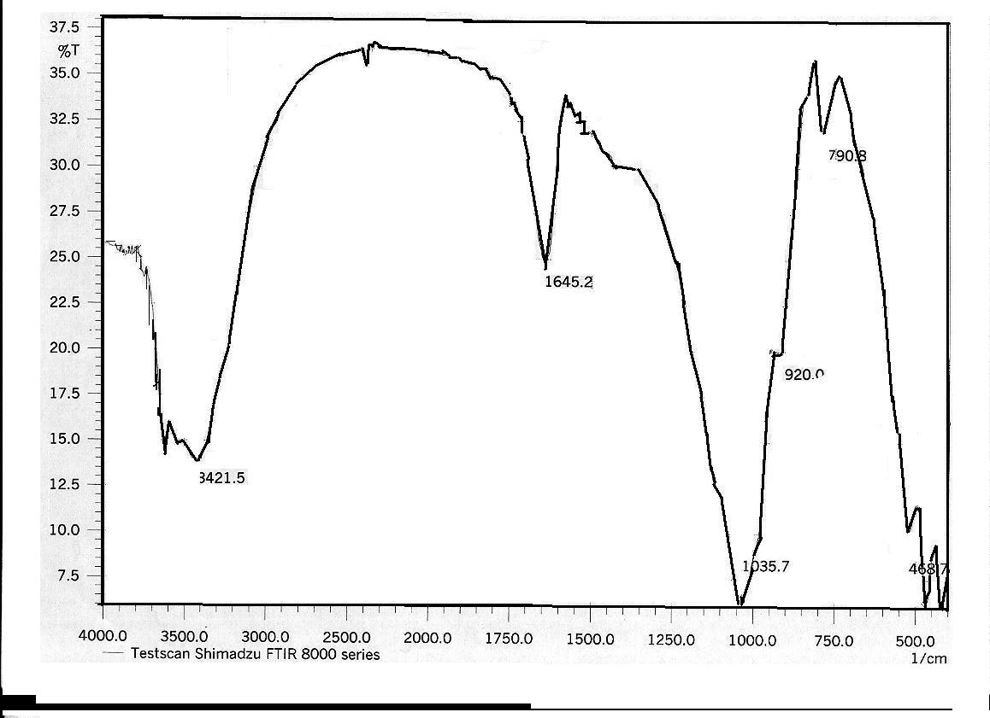
Figure (1). IR Spectrum of A.

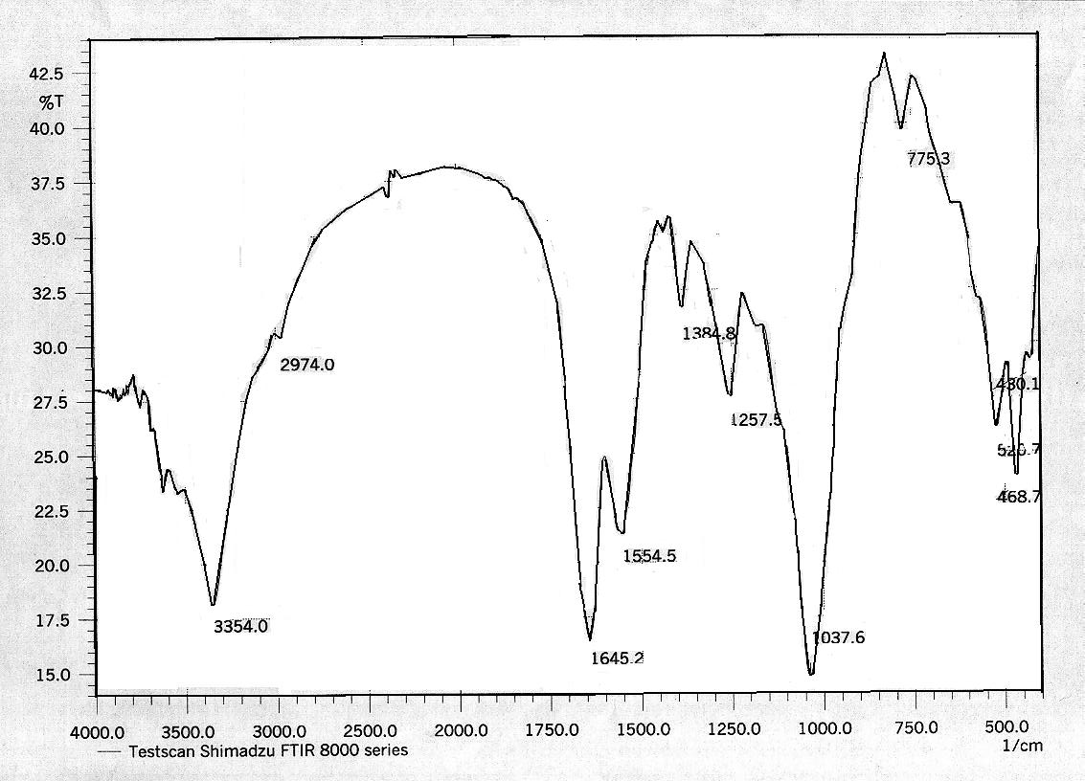
Figure (2) IR Spectrum of AUFP.

437

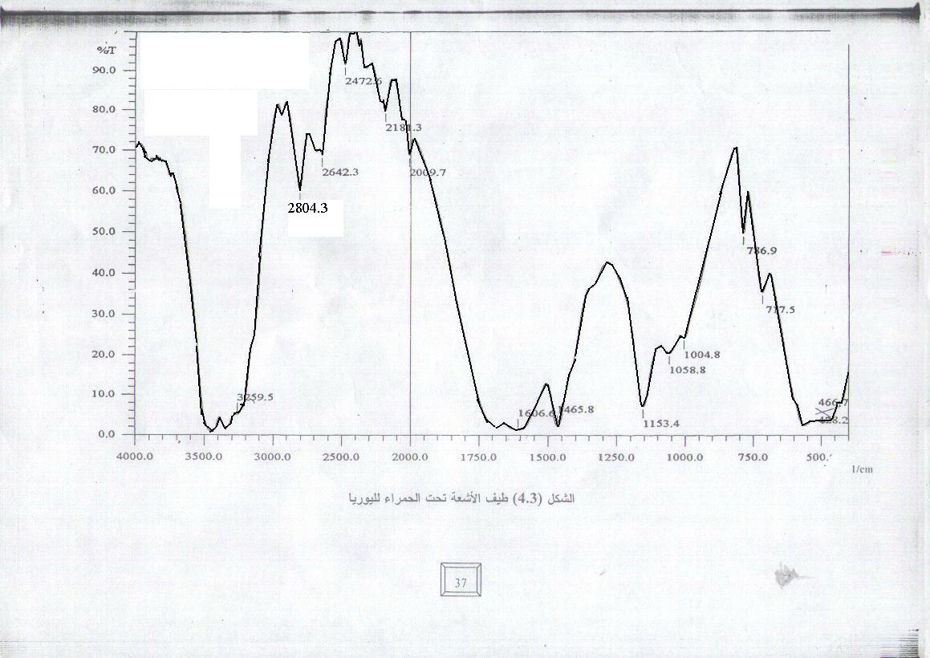
Figure (3). IR Spectrum of Urea.

The characteristic attapulgite bands in the region 1200- 400 cm^{–1} seem to have hardly been effected by the presence of urea as shown in Figure 2. Taken together with the observed shifts in ν_{NH2}, it seems that the interaction is among urea molecules and with the matrix is mainly through the hydrogen bonding with –NH₂ moiety, the shift in those band are listed in Table (7).

Table (7). The shift in characteristic IR. band of U, and AUFP.
Vibration | Urea | AUFP | ∆
ν_{NH2} | 3439 | 3354 | -85
ν_{CO} | 1606 | 1645 | +39
ν_{NCN} | 1466 | 1384 | -82

All adsorbent are also characterized by X-ray diffraction patterns, the lattice distances obtained for the original attapulgite, and AUFP samples, along with their intensities, are listed in Table 8 and illustrated in Figures (4-5).

Table (8). The X-ray diffraction spacing d and angle 2θ of A, and AUFP .
Compound | 2θ | d/Aº | Intensity %
A | 20.9 | 4.242 | 75.48
A | 26.7 | 3.329 | 98.7
AUFP | 20.7 | 4.272 | 69.7
AUFP | 26.4 | 3.365 | 97.26
$2θ$
438
438

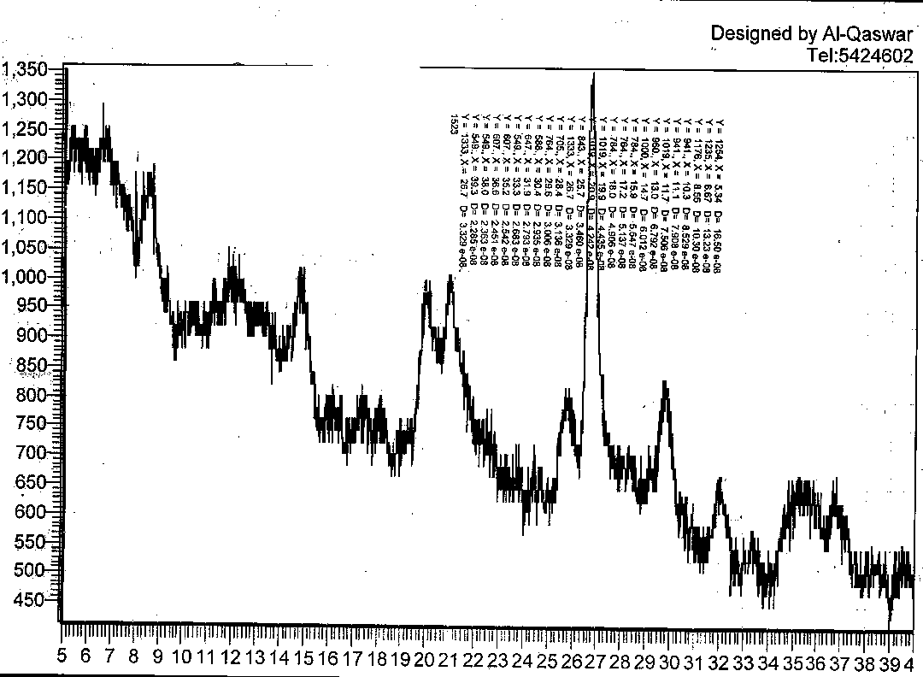
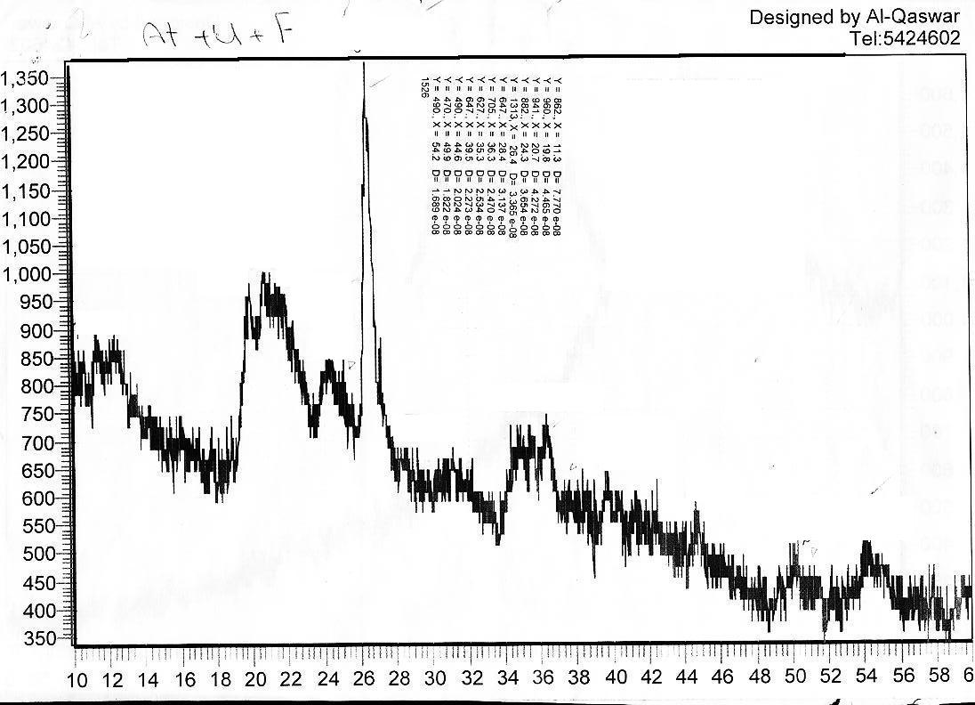
Figure 4. X-ray diffraction pattern of A.
Intensity
2
Figure 5. X-ray diffraction pattern of AUFP.

439

The diffraction pattern of A as shown in Figure 4 shows that A has many diffraction peaks, as is typical of high degree of crystallinity with characteristic attapulgite diffraction spacing 4.242 and 3.329 A⁰ with intensity 75.5% and 98.7% respectively. The treated of AUC with formaldehyde seems as shown in figure 5 to have no effect on diffraction pattern of the original sample. The two distinguished peaks occur at 4.272 and 3.365 A⁰ with almost the same intensity of the attapulgite samples. This could be interpreted by the fact that formaldehyde releases urea and polymerized with active group forming

urea –formaldehyde polymer. The polymer formed interacts with attapulgite at the surface through the hydrogen bond forces. On the other hand, the formaldehyde molecules interpenetration the attapulgite retains its crystalline lattice structure with the same spacing and intensity as shown in figure 5.
Adsorption Isotherms
Adsorption at equilibrium conditions was determined for phenol on A, and AUFP adsorbents. The adsorbed quantities at equilibrium concentrations were calculated by using the following equation:

(1)

Where Q_{e} is the amount adsorbed per unit mass of adsorbent, C_{o} and C_{e} (mg/L) are the initial and equilibrium concentration respectively, m(g) is the weight of adsorbates and V(L) is the volume of solution.
Plots of the Q_{e} (mg.g⁻¹) against equilibrium concentration C_{e}(mg/L) for phenol onto A, and AUFP, Figure 6 showed multilayer adsorption at relatively high concentration concerning the heterogeneity of the surface S type of Gilles classification which is conform of the Freundlich adsorption model.
These plots are obtained by using the average values obtained from three replicates. The data are listed in Tables 9 for adsorption of phenol.

440

Figure 6. Adsorption isotherm of phenol on Attapulgite and AUFP at 298 K.

Table 9 Adsorption isotherms values of phenol on the A, and AUFP at 298 K.
C_{o} mg/L | C_{e} mg/L | Q_{e} mg/g | ln C_{e} | Ln Q_{e} |  | C_{e} mg/L | Q_{e} mg/g | ln C_{e} | ln Q_{e}
C_{o} mg/L | Attapulgite |  |  |  |  | AUFP
5 | 1.77 | 1.62 | 0.25 |  | 0.21 | 1.43 | 1.79 | 0.15 | 0.25
10 | 4.50 | 2.75 | 0.65 |  | 0.44 | 3.40 | 3.30 | 0.53 | 0.51
15 | 7.23 | 3.89 | 0.85 |  | 0.59 | 5.75 | 4.63 | 0.76 | 0.66
20 | 10.02 | 4.99 | 1.00 |  | 0.70 | 8.10 | 5.95 | 0.90 | 0.77
25 | 12.70 | 6.15 | 1.10 |  | 0.79 | 10.30 | 7.45 | 1.01 | 0.87
30 | 14.20 | 7.90 | 1.15 |  | 0.89 | 11.65 | 9.02 | 1.07 | 0.95

In Figure 7 a linear form of Freundlich isotherm with correlation factor more than 98 are presented by plotting lnQ_{e} as a function of lnC_{e} of phenol adsorbed on A, and AUFP. The value of 1/n was calculated from the

slop of the straight line which gives an indication for the intensity of adsorption, while the intercept with y-axis gives K Freundlich constant which is the measure of the adsorption capacity. Freundlich constants are listed in Table 10 of phenol.

441

Figure 7. Linearized Freundlich plot for phenol on A and AUFP.
at 298 K

Table 10. Freundlich constants of phenol on the A, and AUFP at 298 K.
Adsorbent Surface | A | AUFP
Freundlich constants of phenol
1/n | 0.724 | 0.735
K (mg/g) | 0.998 | 1.039
R² | 0.9794 | 0.9887

442

Attapulgite surface is heterogeneous and this feature could be attributed by the different properties of the unsaturated adsorption sites which lead to different characters of these sites ⁽²⁶⁾. Also AUFP was precipitated as crud powder during the synthesis procedure. So, all of these adsorbents are with different imperfection and orientation of their crystal lattice. Surface imperfection and the presence of impurities can also play an important role in this respect. The adsorption on different active sites occurs throughout different types of forces leading to the formation of clusters or packed line of the adsorbed molecules on the surface. The maximum quantities adsorbated of phenol on two adsorbents follow the order AUFP> A.
These differences in adsorbents ability of adsorption could be attributed to the differences in the surface morphology. Structurally, AUFP is described as composed of attapulgite stuck with urea- formaldehyde polymer in which each attapulgite surface is shared between two adjacent polymer. Thus, AUFP showed be capable of adsorption layer amount of phenol .

This is supported by the large adsorptive capacity of AUFP as demonstrated by the present results. The influence of isotherm shape on weather adsorption is favorable or unfavorable has been consider by Weber and Chakravorti ⁽²⁷⁾. For the Freundlich-type adsorption process the isotherm shaped can be classified by a term K a Freundlich constant adsorption and 1/n intensity of adsorption capacity. Values of 1/n < 1 represent favorable adsorption and values 1/n> 1 represent unfavorable adsorption. The results for phenol adsorption systems of this study are favorable.
3.3 Temperature Dependence of the Adsorption
The effect of temperature variation on the adsorption extent of phenol on the two adsorbents surface A, and AUFP has been studied at neutral media pH= 7. Table 11. and Figures 8-9 illustrates the general shapes of phenol adsorption isotherm at 298, 308 and 318 K. it can be seen that as the temperature increased, the adsorption quantity decreased.

443

Table 11.Adsorption quantities of phenol on the Attapulgite and AUFP surface at different temperature.
Attapulgite
318 K |  | 308 K |  | 298 K |  | C_{o}
Q_{e} mg/g | C_{e} mg/L | Qe mg/g | C_{e} mg/L | Q_{e} mg/g | C_{e} mg/L | C_{o}
1.14 | 2.72 | 1.34 | 2.33 | 1.62 | 1.77 | 5
2.29 | 5.42 | 2.50 | 5.00 | 2.75 | 4.50 | 10
3.41 | 8.18 | 3.63 | 7.74 | 3.89 | 7.23 | 15
4.54 | 10.93 | 4.78 | 10.44 | 4.99 | 10.03 | 20
5.69 | 13.61 | 5.89 | 13.21 | 6.15 | 12.70 | 25
7.43 | 15.15 | 7.62 | 14.76 | 7.90 | 14.20 | 30
AUFP
318 K |  | 308 K |  | 298 K |  | C_{o}
Q_{e} mg/g | C_{e} mg/L | Qe mg/g | C_{e} mg/L | Q_{e} mg/g | C_{e} mg/L | C_{o}
1.65 | 1.7 | 1.718 | 1.565 | 1.788 | 1.425 | 5
2.875 | 4.25 | 3.095 | 3.81 | 3.3 | 3.4 | 10
4.2 | 6.6 | 4.42 | 6.16 | 4.625 | 5.75 | 15
5.54 | 8.92 | 5.738 | 8.52 | 5.95 | 8.1 | 20
7.06 | 10.88 | 7.24 | 10.52 | 7.45 | 10.3 | 25
8.55 | 12.9 | 8.765 | 12.47 | 9.0175 | 11.965 | 30

Figure 8 .Temperature dependence of the adsorption
of phenol on the attapulgite surface.
444

Figure 9.Temperature dependence of the adsorption
of phenol on the AUFP surface.

The study of the temperature effect on adsorption will also help in calculation the basic thermodynamic functions Gibbs free energy) ∆G), enthalpy (∆H) and entropy (∆S) of the adsorption process .
The equilibrium constant (K_{e}) of the adsorption process at each temperature, is calculated from the equation

(2)

Where Q_{e} is the amount adsorbed in milligram per one gram adsorbent, C_{e} is the equilibrium concentration of the adsorbent expressed in mg/L, 0.02g represents the weight of the adsorbate that has been used, and 0.01L represents the volume of the phenol or , solution used in the adsorption process. The change in the free energy could be determined from the equation:

445

∆G = -RTlnK_{e} (3)

Where R, is the gas constant (8.314 J.K ⁻¹.mole⁻¹), T is the absolute temperature

in Kelvin. The enthalpy of adsorption may be obtained from the Clausis-Clapeyron equation:

lnX_{m} = -∆H/RT+constant (4)

When X_{m:} is the maximum value of adsorption at a certain value of equilibrium concentration (C_{e}). Table 12 give X_{m} values at different temperatures for phenol.
Plotting lnX_{m} versus (1/T) should produce a straight line with a slope -∆H/R as shown in Figures (10-11).

Table 12. Maximum adsorption quantity Xm values of phenol on the A and AUFP surfaces at different temperature.

Phenol
AUFP |  |  |  | Attapulgite
lnX_{m} | C_{e}=11.9mg/L | T/(K) | lnX_{m} |  | Ce=14.2 mg/L | T/(K)
2.199 | 9.0175 | 298 | 2.067 |  | 7.9 | 298
2.134 | 8.45 | 308 | 1.927 |  | 6.87 | 308
2.069 | 7.92 | 318 | 1.828 |  | 6.1 | 318

Figure 10. Plot of ln X_{m} versus 1/T of phenol on
the adsorbent surface for attapulgite.

446

Figure 11. Plot of ln X_{m} versus 1/T of phenol on
the adsorbent surface for AUFP.

The change in entr
opy

(∆S) was calculated from Gibbs-Helmholtz
equation:⁽¹¹⁾

∆G=∆H - T∆S ( 5)

Table (13) gives the quantitative thermodynamic data of phenol on the adsorbent surfaces A and AUFP. Table 13 shows that ∆H values of phenol is negative indicating that the adsorption process is exothermic reaction . All process of adsorption consider spontaneous from the negative value of ∆G. While, ∆S have positive value for each phenol and, that refer the interaction of molecules caused random of the total system.

Table 13. Thermodynamic function ∆G, ∆S and, ∆H of phenol on the adsorbent surfaces A, and AUFP.
Phenol
∆H / (kJ/mole) | ∆S/ (J/mole.K ) | ∆G / (kJ/mole) | Adsorbent
-5.121 | 43.65 | - 18.131 | AUFP
-10.202 | 24.077 | -17.378 | Attapulgite
447

Adsorption Kinetics
The kinetics of solute adsorbed from solution (solvent-solute )phase to the surfaces of adsorbent particles is controlled either by the film or external diffusion, pore surface diffusion and adsorption on the pore surface or the combined effect of more than one of these(29). The film or surface mass transfer is an important rate –controlling step and is a function of
particle size, hydrodynamic conditions, system physical properties, etc. The contact time data can be effectively used to test if the adsorption or sorption process is a rate – controlling step. Figures 12-13 show the plots of ln Qe-Qt against contact time. All plots give straight line, indicated that the adsorption of phenol have obeyed the pseudo-first order equation of Lagergren equation (30) which is generally expressed as follow:

dqt /dt = k1(Qe-Qt) ( 6)

Where Qe and Qt (mg/g) are the sorption capacity at equilibrium and at time t, respectively and k₁ is the rate constant of pseudo-first order sorption (min⁻¹). After integration and applying boundary conditions t=0 to t=t and Q_{e}=0 to Q_{t}=Q_{t}, the integrated form of equation (6) becomes :

ln(Q_{e}-Q_{t}) = -k₁t +lnQ_{e} ( 7)

This kinetic indicate that system
variables, should be more extensively tested and that several kinetic models and correlation coefficients should be used to test experimental sorption data if a mechanism cannot be confirmed. The variables should include agitation speed, sorbent diameter, solute concentration, sorbent mass and solute temperature. Our experiments data carry out by depending on the Lagergreen equation.

448
Figure. 13. kinetic study of adsorption of phenol on the
AUFP surface at 298 K.
Figure. 12. Kinetic study of adsorption of phenol on the
attapulgite surface at 298 K.
449

Temperature Dependence of the rate of Adsorption
Temperature effect on adsorption process normally achieved by measuring the activation energy and adsorption rate constant

K_{ad} =Ae^{-Ea. /RT} (8)

According to Arrehniuse equation the dependency of rate constant of adsorption K_{ad} on temperature are limited over a narrow range of temperature. Where K_{ad} the adsorption rate constant, A is the pre-exponential factor, Ea is activation energy and R and T have the usual physical meaning. The pre - exponential factor A has the same units as the adsorption rate constant, equation (8) can be written in logarithmic form:

lnK_{ad}=lnA –Ea/RT ( 9)

According to this equation a straight line should be obtained when ln K_{ad} is plotted against the reciprocal of the absolute temperature (1/T) The parameter A, which is given by the intercept of the straight line at 1/T =0, and Ea, which is obtained from the slope of the straight line (-Ea/R), collectively the two quantities are called the Arrehenius parameters.
Activation energy Ea of adsorption of phenol on the adsorbent surfaces at temperature rang 298- 318 K are calculated. Ea values are listed in Table 16. Values of K_{ad} are calculated from Figures 14-15 and listed in Tables 14 and 15. These values are found to be increased for some adsorbent and decreased for the other with increases of temperature. Increasing behavior could be attributed to the possibility of diffusion rate of the adsorbent more than desorption rate for the adsorption process. While the decreases of Kad values with increase of temperature could be interpretated in term of that the gained thermal energy from the adsorbate molecules decreases from their bounded energy to the adsorbent surfaces, leading to increase the desorption rate of intra – molecules from intra-layer lattice surfaces of adsorbent.

450

Table 14. Kinetics adsorption of phenol on the adsorbent surfaces for each (Attapulgit, and AUFP) at different temperature.

Attapulgite
ln (Qe-Qt) |  |  | Time  (min)
318 K | 308 K | 298 K | Time  (min)
1.027 | 1.028 | 1.045 | 15
0.717 | 0.722 | 0.746 | 30
0.354 | 0.359 | 0.366 | 45
-0.108 | -0.127 | -0.015 | 60
-0.382 | -0.575 | -0.462 | 75
-0.787 | -0.935 | -1.093 | 90
-2.353 | -2.079 | -2.207 | 105
AUFP
ln (Qe-Qt) |  |  | Time  (min)
318 K | 308 K | 298 K | Time  (min)
1.006 | 0.993 | 1.009 | 15
0.701 | 0.720 | 0.720 | 30
0.4 | 0.454 | 0.454 | 45
0.131 | 0.139 | 0.139 | 60
-0.283 | -0.310 | -0.305 | 75
-1.05 | -0.787 | -0.787 | 90
-1.832 | -2.079 | -2.079 | 105

Figure. 14. Pseudo- first order adsorption kinetic of phenol
on the attapulgite surface at different temperature.

451

Figure. 15. Pseudo- first order adsorption kinetic of phenol
on the AUFP surface at different temperature.

Table 15. A comparison of rate constant of the pseudo -first order Kinetic for each phenol at different temperature.
Phenol
K_{ad} /(min.⁻¹) |  |  | Temperature  Adsorbent
318 K | 308 K | 298 K | Temperature  Adsorbent
0.0244 | 0.0288 | 0.0268 | Attapulgite
0.0218 | 0.0174 | 0.0227 | AUFP
Table 16. Activation energy values for phenol

Activation energy (kJ/mole ) |  | Adsorbent  Compound
AUFP | Attapulgite | Adsorbent  Compound
18.35 | 5.492 | Phenol

452

Conclusions:
1. The adsorption isotherms show that the quantity of adsorption for phenol by AUFP and attapulgite from their aqueous solutions increase by increased their concentration.
2. The adsorption capacity of phenol on the AUFP is high when compared with attapulgite.
3. The adsorption of phenol on the two adsorbent surfaces is exothermic process.
4. The adsorptivity of phenol on the AUFP is better than that of attapulgite surface.
5. The adsorption kinetics of phenol on the two adsorbent surfaces obeyed the pseudo-first order equation and show that the adsorption is complex due to different factors that control the rate of reaction.

Nomenclature:

Q adsorption capacity mg/gm

K_{f} Freundlich constant.
K_{L} Langmuir constant.
X_{m} the maximum monolayer adsorption.
q_{e} equilibrium adsorption capacity.
V volume of the solutions, L
W weight of attapulgite or AUFP, gm.
C_{o} initial solution concentration, mg/L.
Ce equilibrium solution concentration, mg/L.
q_{t} adsorption capacity at time t.
R² correlation coefficient
t time, min
K_{ad} rate constant of pseudo- first order adsorption, min⁻¹.
1/n adsorption intensity.
A attapulgite clay.
AUFP attapulgite-urea-formaldehyde polymer.

453

References
1. Maulood B.K.,Al-Saadi H.A.,and Al-Zubaidi F.S.”Ecology” 1st edition, Mousel University Press, Mousel ,1992.
2.Kochany .J.R.,Environ.Sci. Technol.,1992, 26,262 .
3.Taube, W.C.,J.Am.Chem.Soc.,1980, 62 (9) ,33579 .
4.Chi.C.W.and Dranitt, S.S., Chem.Eng.Proc., 1979, 52,412 .
5. Kunin, R., Chem.Eng.Pro.1977, 50, 91 .
6 .Shone, R.E and Mayer G.S., J. Chem., 1982 ,54,1164 .
7.Adam, N.K.,”Physical Chemistry “3rd edition, Oxford University Press ,1962.
8.Weber, W.J.Asec, A.M. and Morris.J.C. J. Saint Eng.Dir, Amer.Soc.Cir Enger.,1963 , 89, (5A3) 31.
9. Maron S.H. and Lando J.B., “Fundamentals of Physical Chemistry “, Macmillan, Pulishing Co. London ,1974 .
10.Alfred M., “Physical Pharmacy “4th edition, Texas University press , Texas ,1993.
11. Atkins, P.W.,”Physical Chemistry “,7th edition, Oxford University presses Oxford , 2002.
12. Alexeyev V.N.,”Quantitative Analysis”2nd edition, Moscow University press. Moscow, 1970.
454
13. Daniels F. and Alberty R.A., “Physical Chemistry “2nd edition, New York, 1978 .
14.Jalal K. and Abd A.A., 4th Scientific Conference, Scientific Research Council, 1980, 1, part 1.
15.Jalal M.S., “Surface Chemistry” 1st end Baghdad University press, Baghdad ,1980.
16. Grim, R.E. “Clay Mineralogy” 2nd edition, McGraw Hill , New York, 1968 .
17. Ozin G. A. and Godber J., J. Phys. Chem.,1989 , 93 .
18. Enviromental Science and Energy “Attapulgite Clay and Its Applications to Water Treatment” Summaries and Thesis, 2003.
19.Jupp G.and Rau H., J.Appl.Chem.,1969, 19, 120-124 .
20.Shmoyama A. and Johns W.P., J.Nature Phys.Sci., 1972, 64, 237-243 .
21.Theng, B.K.G.,”The Chemistry of Clay – Organic Reaction”. Lower Hutt, New Zeeland ,1974 .
22. Brief Introduction of The Attapulgite Clay, Summaries and Thesis “ 2003 .
23.Mattson,J.S., Mark. H.B.,Malbin M.D.,Webber W.J. and Crittenden,J.C ,J.Colloid
Int.Sci.,1969 ,31(1),116 .
24.Nakamura T., Tamura T. and Tanada S., J .of Health Sci, 2003 , 49 (46) , 520 –523.
25.Glasston S.Laider K.J.and Eyring H.”The Theory of Rate Processes University Utah Press,University of Utah , 1941.
26. Leasan H.M. and Bhandari A. “Evaluation of Atrazine Binding to Surface Soils”, Proceeding of the 2000 conference on Hazardous Waste Research, 2004 ,76-89 .
27.Jupp G.and Rau H.,
J.Appl.Chem.,1969 , 19, 120-124 .
28.Bekkouche S.,Bouhelassa M.,Sulah N.H.and Meghlaoni F.Z., J. of Science chemistry Desalination.;2004,166, 355-362 .
29.Ratanuman W.,David A.,White G.and Radu R.,j.Chem.E.; 1999, 77, Part B,88-92 .
30.Al-Ameene A. M.Sc.Thesis, Ibn Al-Haitham, college of education, University of Baghdad , 1996 .

455

