Thermodynamic study on pKa values of some imines and their acids conjugate derived from different aromatic carbonyl compounds

Adel Saead Pitriz Azzouz Dunia Pitriz Bakzo
Chemistry Department College of Education, Mosul University

(NJC)
(Received on 23/6/2013) (Accepted for publication 27/2/2014)

Abstract
The project was concerned with synthesis of mono acidic or diacidic Schiff bases having oxime or phenol groups or a combination of them respectively . Other syn and anti oximes were derived from 2-acetyl pyridine , and others included and synthesized by a standard methods .
Potentiometric titration was found previously , an accurate , simple and fast method for determination of pKa for acids or pKa for acid conjugates of Schiff bases using NaOH and HCl titrant respectively . This method was applied successfully in this investigation for the determination of ionization constants of imines in a range of temperature (293-313)K . This encourage the workers in this study to deal with thermodynamic parameters such as ∆Gْ , ∆Hْ and ∆Sْ for the ionization reactions of imines at 10% ethanol solvent as interpreted and discussed .

Keywords : pKa , Aromatic imines , Schiff bases , syn or anti oximes , Thermodynamic parameters.

خلاصة

يتضمن البحث تخليق قواعد شيف الحامضية او القاعدية و الحاوية على مجاميع اوكزيمية او فينولية او مجموع كليهما. كما يحوي البحث على اوكزيمات سين و انتي المشتقة من 2-اسيتايل بردين و مركبات اخرى و بطرق قياسية. لقد وجد ان التسحيح المجهادي هي طريقة دقيقة , سريعة و بسيطة في تقدير pKa للأحماض او pKàللاحماض القرينة و عند استعمال مادتي NaOH و HCl كمواد مسححة على الترتيب . الطريقة المذكورة طبقت بنجاح في تعين ثوابت التأين للايمينات في مدى من درجات الحرارة المطلقة و المحصورة بين 233-333. ذلك شجع الباحث بالدراسة الثرمو ديناميكية و لتفاعلات تأين الأيمينات في مذيب 10% ايثانول مع مناقشة و تفسير هذه المتغيرات.

مفتاح الكلمات : ثرموديناميك : ثابت التوازن : الايمينات : الاحماض القرينه وتفاعل التاين

Introduction
The chemistry of imines in forms of oximes and Schiff bases had met a great deal attentions during the last three decades . This was for their multiple applications in many fields as chemistry¹ , biology^{2,3} , medicine^{4,5}, industry⁶ and others^{6,7} .
One of the most important factors that affecting chemical reaction is the temperature This factor was studied extensively by many workers dealing with kinetics and thermodynamic studies⁸. The concept of temperature affects on chemical reactions as associations between phenol and benzil mono benzylidene⁹ aniline and of substituted benzoic acids¹⁰ , in addition to tautomerisum reactions of phenolic Schiff base¹¹ or some benzoin¹² compounds and macro bi imines¹³ derived from benzoin and acetyl acetone and pKa studies on acids derived aromatic and aliphatic carbonyl compounds¹⁴ and imines ¹⁵ synthesized from N- formyl pi pyridine .
This investigation is an extension for the last work , it deals with thermodynamic study for fifteen imines in forms of Schiff bases and oximes in syn or anti isomeric forms . Thermodynamic parameters accompanied ionization reactions in these imines and their acid conjugates , such as ∆G◦ , ∆H◦, ∆S◦ were calculated and discussed .

Experimental
Pure 3-hydroxyl benzaldehyde, 4-hydroxybenzaldehyde, other aldehydes, hydroxylamine. HCl, sodium hydroxide and acid HCl were purchased from of Fluka or BDH origin.
Syn aldoximes were prepared by standard method^{9,10}. Syn 3-hydroxybenzaldoxime or 4-hydroxybenzaldoxime were prepared by mixing equivalent¹⁰ amounts of their aldehydes with hydroxylamine HCl. The collected oximes were purified by recrystallization from 50% ethanol-water by volume. Their anti isomers were prepared by charcoal method¹⁰ in benzene solvent.

pKa determination
The pKa of any syn or anti aldoxime under study was determined by manufacturing glass cylindrical cell of maximum capacity about 30 ml. The cell contains two walls for insertion of pumped water from thermostat to maintain a fixed temperature during pKa determination. The whole cell assembly was completely insulated from the surrounding by thick insulation material.
20 ml of 0.01 M solution of any oxime in 10% ethanol, was placed in the cell. After equilibrium temperature was attained a successive 0.2 ml of 0.1 N NaOH was added, till 1.4ml of base was added, followed by measuring the final equilibrium pH of solution. The pK₁ for phenolic group in any oxime was estimated at a range of volumes of (0.8-1.0) ml of base, hence the average pK₁ was calculated. Similarly, the pK₂ for oxime group was calculated at range of volumes of (1.2-1.4) ml of base.
The pK₁ or pK₂ was calculated by using a standard method¹, using the equations (1-2):
$\text{pKa}=\text{pH}+\text{log}\frac{\left[\text{acid}\right]}{\left[\text{salt}\right]}$ . . .(1)
Both pK₁, and pK₂ for phenolic and oxime groups for any oxime isomer were calculated at a temperature range (293-333) K.
The for acids conjugates were determined by titrations of imines with 0.1M HCl using the following equation :-
$\text{pKa}=\text{pH}+\text{log}\frac{[{\text{BH}}^{+}]}{[B]}$ . . . (2)

Table (1): Shows the imines prepared in this investigation

Structure | Nomenclature | Comp. No.
 | Syn-methyl-2-pyridyl ketoxime | 1
 | Anti-methyl-2-pyridyl ketoxime | 2
 | Syn-3-hydroxy benzaldoxime | 3
 | Anti-3-hydroxy benzaldoxime | 4
 | Syn-4-hydroxy benzaldoxime | 5
 | Anti-4-hydroxy benzaldoxime | 6
 | Syn-4-methoxy benzaldoxime | 7
 | Anti-4-methoxy benzaldoxime | 8
 | Methyl-2-pyridyl ketonylidene-0-hydroxyaniline | 9
Structure | Nomenclature | Comp. No.
 | Methyl-2-pyridyl ketonylidene-m-hydroxyaniline | 10
 | Methyl-2-pyridyl ketonylidene-p- hydroxyaniline | 11
 | Methyl-2-pyridyl ketonylidene-4-amino naphthol | 12
 | Methyl-2-pyridyl ketonylidene-p-bromo aniline | 13
 | Methyl-2-pyridyl ketonylidene-p-chloro aniline | 14
 | Methyl-2-pyridyl ketonylidene-p-methoxy aniline | 15

Instrumentations
- The U.V. spectra of syn and anti aldoximes were measured by double beam computerized U.V. 1601 Shimadzu spectrophotometer, using matched quartz cells of dimensions 1x1x3 cm³.
- The IR spectra of solids and liquid aldoximes had measured by using a computerized FTIR Brucker Tensor 27 spectrophotometer.
- Memmert Searl L200 water thermostat.
- The melting points of solids syn and anti oximes was measured by using Electrothermal melting point apparatus.
- The pH of any solution during potentiometric titration, was measured by WTW Weilheium German company model 82362.
- The conductivity of syn and anti isomer of aldoximes under study, was measured by Weilheium company model D8120.
- In order to fix the temperature of aldoximes solution during pKa determination, a pumped water apparatus was bought from local market.
- All graphs needed for thermodynamic study was performed by using Excel computer programme.

Results and Discussion
In our earlier publications¹⁵ , it was observed that pKa values of an imines derived from N-formyl pi pyidine , show an depression by an increase in temperature . This interesting result encouraged the workers in this investigation to deal with thermodynamic parameters evaluation on imines under study . The last includes the evaluation of ∆G◦ , ∆H◦ and ∆S◦ thermodynamic parameters for the ionization reactions of imines and for their conjugate acids forms .
These thermodynamic parameters such as ∆G◦ , ∆H◦ and ∆S◦ were calculated from standard equations shown in our previous publications^{9,10} using equations (3-5) of the forms :-

∆G◦ = -RT ln Ka ………(3)

Ka = Ionization constant of imine
R = 8.314 J.mole⁻¹.deg. ⁻¹
T = Absolute temperature

Table (2) : Thermodynamical parameters for imines at different temperatures in 10% ethanol
$$\overline{{\text{ΔS}}^{∘}}$$  J.mole⁻¹.k⁻¹ | $$\overline{{\text{ΔG}}^{∘}}$$  J.mole⁻¹ | $$\overline{{\text{ΔH}}^{∘}}$$  J.mole⁻¹ | ΔSº  J.mole⁻¹.k⁻¹ | ΔGº  J.mole⁻¹ | ΔHº  J.mole⁻¹ | Ln k | Temp.  k | Com.  No.
-117.99 | 73991.2 | 37060.1 | -117.99  -117.96  -117.99  -117.98  -118.02 | 71043.2  73332.2  74386.2  75009.7  76184.6 | 36471.8  37590.6  37452.4  36903.1  36882.8 | -29.16  -29.11  -28.59  -27.93  -27.52 | 293  303  313  323  333 | 1
-112.98 | 73674.8 | 38312.2 | -113.00  -112.98  -113.02  -112.96  -112.95 | 71599.1  71993.4  74305.3  74188.6  76287.8 | 38488.8  37761.9  38930.1  37703.3  38676.8 | -29.39  -28.58  -28.55  -27.63  -27.56 | 293  303  313  323  333 | 2
+29.1 | 38513.9 | 47620.2 | +29.099  +29.080  +29.070  +29.094  +29.130 | 38927.2  38474.9  39355.3  37919.8  37892.1 | 47453.3  47284.3  48454.5  47317.1  47591.6 | -15.98  -15.27  -15.12  -14.12  -13.69 | 293  303  313  323  333 | 3#
52.5 | 56876.4 | 73300.2 | +52.450  +52.470  +52.480  +52.460  +52.510 | 56646.3  58446.2  58421.8  54896.3  55971.2 | 72013.1  74344.9  74846.8  71840.4  73455.5 | -23.25  -23.20  -22.45  -20.44  -20.22 | 293  303  313  323  333 | 3##
-147.3 | 56673.7 | 10556.0 | -147.34  -147.31  -147.35  -147.36  -147.33 | 53721.2  55134.1  56735.0  58173.6  59604.8 | 10550.3  10499.8  10612.1  10575.2  10542.7 | -22.05  -22.89  -21.80  -21.66  -21.53 | 293  303  313  323  333 | 4#
-102.1 | 60039.3 | 28144.1 | -102.03  -102.09  -102.08  -102.07  -102.10 | 58113.1  58933.5  59859.8  60937.5  62352.4 | 28218.6  27997.7  27906.9  27965.9  28631.2 | -23.86  -23.39  -23.00  -22.69  -22.52 | 293  303  313  323  333 | 4##
-5.6 | 35819.5 | 34072.7 | -5.58  -5.59  -5.58  -5.57  -5.59 | 35884.2  35223.8  36356.3  35443.3  36190.0 | 34250.2  33529.8  34610.4  33642.9  34330.2 | -14.73  -13.98  -13.97  -13.20  13.07 | 293  303  313  323  333 | 5#
-35.9 | 43141.7 | 31915.7 | -35.83  -35.84  -35.88  -35.87  -35.89 | 42960.1  41987.2  43073.3  43491.0  44196.8 | 32462.3  31126.5  31841.5  31905.5  32242.67 | -17.64  -16.67  -16.55  -16.20  -15.96 | 293  303  313  323  333 | 5##
-150.3 | 52953.0 | 5900.6 | -150.3  -150.4  -150.3  -150.3  -150.4 | 49890.2  51445.0  53053.0  54475.9  55901.1 | 5841.5  5889.8  6006.1  5929.4  5836.1 | -20.48  -20.42  -20.39  -20.29  -20.19 | 293  303  313  323  333 | 6#
-98.96 | 54998.2 | 24022.8 | -98.93  -99.01  -98.93  -98.97  -98.97 | 53118.2  53895.7  54973.4  55697.1  57306.7 | 24131.0  23896.6  24008.7  23728.4  24349.5 | -21.81  -21.39  -21.13  -20.74  -20.70 | 293  303  313  323  333 | 6##
-161.47 | 70152.5 | 19613.2 | -161.52  -161.45  -161.46  -161.46  -161.44 | 66852.1  68634.9  70149.0  71557.5  73519.2 | 19527.0  19714.8  19662.8  19404.9  19756.5 | -27.44  -27.25  -26.98  -26.65  -26.56 | 293  303  313  323  333 | 7
-141.74 | 68380.9 | 24017.9 | -141.73  -141.73  -141.74  -141.76  -141.72 | 65556.4  67187.6  67925.0  69779.8  71455.7 | 24028.7  24244.2  23561.1  23991.6  24263.7 | -26.91  -26.67  -26.10  -25.98  -25.81 | 293  303  313  323  333 | 8
-131.88 | 69117.7 | 27840.8 | -131.85  -131.92  -131.89  -131.88  -131.84 | 66177.0  67877.3  69616.3  70280.7  71637.4 | 27546.3  27907.1  28333.7  27681.3  27735.5 | -27.17  -26.94  -26.75  -26.17  -25.88 | 293  303  313  323  333 | 9
-61.71 | 71090.1 | 51775.5 | -61.70  -61.69  -61.70  -61.72  61.73 | 70589.4  69416.2  70723.3  72156.7  72564.9 | 52510.5  50725.4  51410.7  52220.7  52010.2 | -28.98  -27.56  -27.18  -26.87  -26.21 | 293  303  313  323  333 | 10
-19.84 | 71283.2 | 65072.6 | -19.76  -19.78  -20.11  -19.76  -19.81 | 71560.9  69877.9  71427.9  71505.0  72044.1 | 65772.1  63885.4  65135.1  65121.5  65448.8 | -29.38  -27.74  -27.41  -26.63  -26.02 | 293  303  313  323  333 | 11
-28.00 | 72425.0 | 63659.8 | -27.96  -28.02  -28.01  -28.01  -28.01 | 71757.2  71958.9  72820.5  72407.8  73180.7 | 63565.0  63467.3  64052.6  63359.9  63854.1 | -29.46  -28.46  -27.98  -26.96  -26.43 | 293  303  313  323  333 | 12
68.16 | 28115.3 | 49448.5 | 68.18  68.16  68.13  68.18  68.13 | 29199.9  28868.1  28373.2  27465.5  26669.8 | 49178.0  49521.3  49698.4  49487.0  49357.9 | -11.99  -11.46  -10.90  -10.23  -9.63 | 293  303  313  323  333 | 9*
50.20 | 26090.8 | 41802.7 | 50.23  50.16  50.21  50.20  50.19 | 26812.6  26790.4  26122.6  25781.1  24947.3 | 41529.0  41989.1  41839.5  41994.6  41661.3 | -11.01  -10.63  -10.04  -9.60  -9.01 | 293  303  313  323  333 | 10*
51.65 | 34446.0 | 50612.0 | 51.65  51.62  51.64  51.66  51.66 | 35344.1  34847.3  34663.6  34045.9  33329.0 | 50478.8  50488.6  50827.8  50733.0  50531.8 | -14.51  -13.83  -13.32  -12.68  -12.04 | 293  303  313  323  333 | 11*
88.88 | 21629.1 | 49448.5 | 88.87  88.90  88.87  88.87  88.89 | 23050.0  22545.5  21997.7  21061.9  19490.5 | 49090.3  49481.0  49812.9  49766.2  49092.1 | -9.46  -8.95  -8.45  -7.84  -7.04 | 293  303  313  323  333 | 12*
78.56 | 14797.4 | 39392.6 | 78.53  78.56  78.60  78.53  78.56 | 16771.2  15722.4  13651.5  13923.2  13954.6 | 39780.0  39525.3  38253.5  39287.7  40116.5 | -6.88  -6.24  -5.25  -5.18  -5.04 | 293  303  313  323  333 | 13*
111.71 | 18591.0` | 53557.2 | 111.68  111.73  111.74  111.69  111.72 | 20834.5  19189.3  19299.0  17192.6  16439.5 | 53558.0  53043.1  54273.2  53268.0  53643.7 | -8.55  -7.62  -7.42  -6.40  -5.94 | 293  303  313  323  333 | 14*
78.54 | 29601.5 | 54185.6 | 78.53  78.56  78.57  78.51  78.55 | 30816.4  30675.6  29708.2  28694.9  28012.4 | 53826.0  54479.0  54299.2  54154.2  54169.7 | -12.65  -12.18  -11.42  -10.72  -10.12 | 293  303  313  323  333 | 15*
* : ايونات النتريليوم
: # ln K₁
: ##ln K₂

Tables (2) shows that ∆G◦ values for all imines have a positive signs with a range of values (14797.4-73991.2) J.mole⁻¹ . These positive signs mentioned mean that ionization processes in these imines occurred in non spontaneous processes . These results were expected due to the fact that imines under consideration having a covalent bondings . Hence they are ionized with difficulty as compared with ionic bondings . The heat or enthalpy of ionization reactions ∆H◦ was calculated from the integrated Vant Hoff equation (4) of the from :-

$\text{lnKa}=\text{constant}−\frac{{\text{ΔH}}^{∘}}{\text{RT}}\text{.}\text{.}\text{.}\text{.}\text{.}\text{.}\text{.}\text{.}\text{.}(4)$

∆H◦₌ Enthalpy of Ionization reaction
From equation (4) , the plots of lnKa versus the inverse of absolute temperature (T⁻¹) for imines showed a straight lines using Microsoft Excel programme of correlation coefficient range values (0.8672-0.9985) , as shown in typical examples in Fig (1-4) .
Figs (1-2) Showed lnK₁ and lnK₂ for phenol and oxime groups respectively .

Table (2) showed that all ∆H◦ values at a range of temperature(293-333) K had a positive signs of a range values (5900.6-73300.2) J. mole⁻¹. These values indicated that ionization reactions in imines were endothermic . These results are in full agreement with theoretical expectation of breaking covalent bond in imines or ionization of imines under study after absorption of heat energy .
The change in the entropy ∆S◦ for ionization reactions of imines were calculated from Gibbs equation (3) of the from :

$\overline{{\text{ΔG}}^{∘}}$=$\overline{{\text{ΔH}}^{∘}}$-T$\overline{{\text{ΔS}}^{∘}}\text{.}\text{.}\text{.}\text{.}\text{.}\text{.}\text{.}(5)$

$\overline{{\text{ΔS}}^{∘}}$= S₂-S₁

S₂₌ Entropy of ionization products
S₁₌ Entropy of reactants

Theoretically $\overline{{\text{ΔS}}^{∘}}$ values for ionization reactions in imines under study have a positive values . This was for an increase in random of the system by ionization reactions . This result is in a full agreement with ∆S◦ values as in Table (2) for imines numbered (2-3,9-10) . The other rest of imines numbered (1-2,4-12) have a negative signs for ∆S◦ parameters . These were happen by considering the two folds reasons :-
1- By the strong interactions of the solvent (ethanol or water) molecules with the positive or negative ions produced by ionization of imines .
2- By the occurrence of inter molecular hydrogen bonding in imines as observed experimentally by dilution method in IR spectra in imines numbered (1-2,8-3,11-12) . Hence it was concluded that reasons (1-2) , each of them , contribute to different degrees in altering ∆S◦ sign from positive to negative values in imines outlined in Table (2)
Finally , these thermodynamic study was in full agreement with other similar studies^{14,15,19,20} .

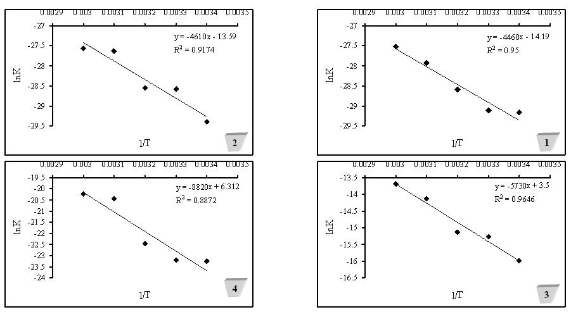
Fig (1) : Relationship between lnKa versus T⁻¹ for geometrical isomer in :-
- syn methyl 2-pyridyl ketoxime 3- syn 3 hydroxy benzaldoxime (lnK₁)
- anti methyl 2-pyridyl ketoxime 4- syn 3 hydroxy benzaldoxime (lnK₂)

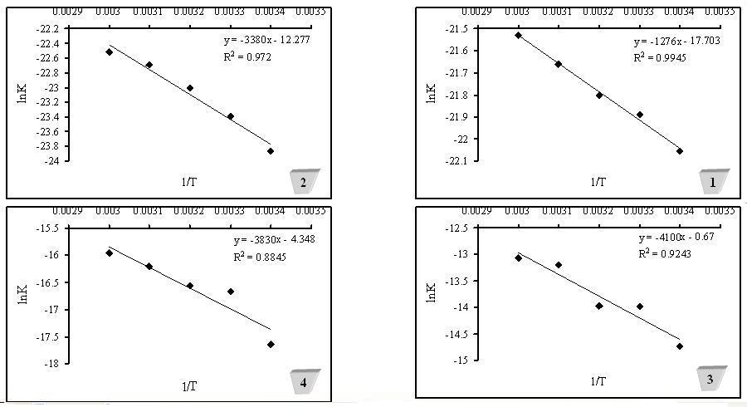

Fig (2) : Relationship between lnKa versus T⁻¹ for geometrical isomer in :-
- Anti 3-hydroxy benzaldoxime (lnK₁) 3- syn 4 hydroxy benzaldoxime (lnK₁)
- Anti 3-hydroxy benzaldoxime (lnK₂) 4- syn 4 hydroxy benzaldoxime (lnK₂)

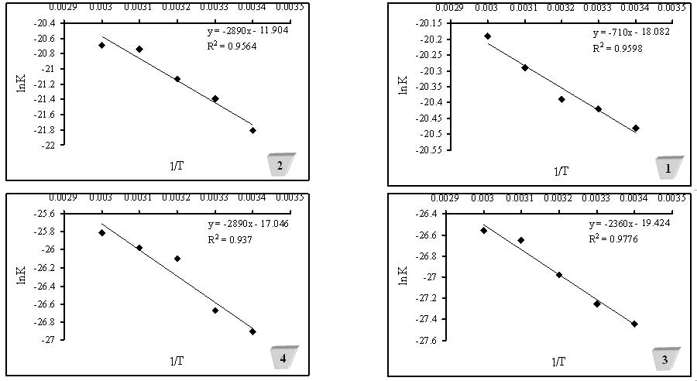

Fig(3) : Relationship between lnKa versus T⁻¹ for geometrical isomer in :-
- Anti 4-hydroxy benzaldoxime (lnK₁) 3- syn 4 methoxy benzaldoxime
- Anti 4-hydroxy benzaldoxime (lnK₂) 4- syn 4 methoxy benzaldoxime

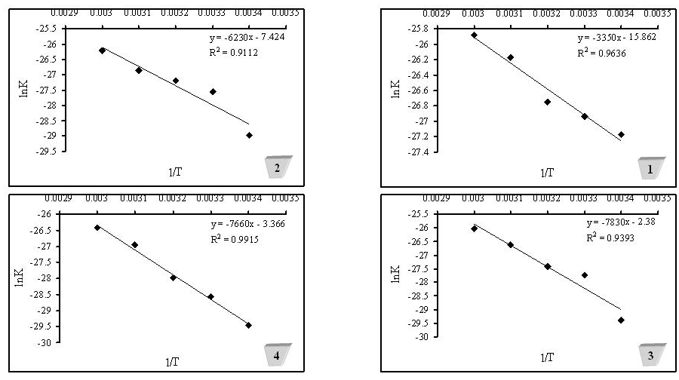

Fig (4) : Relationship between lnKa versus T⁻¹ for phenolic Schiff bases in :-
- Methyl 2-pyridyl ketonylidene o-hydroxy aniline 3- Methyl 2-pyridyl ketonylidene p-hydroxy aniline
- Methyl 2-pyridyl ketonylidene m-hydroxy aniline 4- Methyl 2-pyridyl ketonylidene p-amino napthol

Conclusions
- Fifteen imines in a forms of Schiff bases and syn and anti oximes were prepared by standard methods using aromatic aldehydes and ketones.
- The pK_{a} for these imines and their acids conjugate were estimated by accurate and simple potentiometric method in 10% ethanol solvent at temperature range between (293-333)K.
- The thermodynamic parameters calculated for ionization reactions proved that these reactions were occurred in non spontaneous and endothermic process. Also ionization reactions were accompanied by an increase or decrease in entropy as discussed properly in a scientific way and supported by suitable references ^{14-15,19-20}.

References
1-S.Aureus , E.Coli , C.Styphi , A. Rhizopussp and A.Niger , 2010, Organic Chemistry International , Article ID 648589 , 7 pages.
2-J.Salimon ,N.Salish , E.Yousif , A.Hameed and H.Ibraheem, Australin J. Basic and Applied Sciences , 2010 , 4(7) 2016.
3-S.Rao and A.S.Mitlra ,J. Indian chem. Soc., 1978 , 55,420.
4-A.K.Mittal and O.P.Singhal, J.Indian chem..Soc. ,1986 , 63,739.
5-S.J.Yan and W.H.Burton, P.L.Chlen and C.C.Cheng, J.Hetrocyclic chem. , 1978 , 15 , 297.
6- T.Papenfushs, Ger. Offen .Chem. Abst. , 1976, 84 , 6481.
7-M.N.Ibrahim and S.A.Sharif, E Journal of Chemistry , 2007, 4(4) , 531.
8-A.R.Butler , Problems in Physical Organic Chemistry , 1972 , John Wiley , London.
9-A.S.P.Azzouz, Z. Phys.Chem., 2002 , 216 ,1053
10- A.S.P.Azzouz ,M.M.H.AL- Niemi, Z. Phys.Chem .,2005, 219, 1591.
11- A.S.P.Azzouz, Nat. J.Chem., 2006 , 22 , 214.
12- A.S.P.Azzouz, M.A.Hussin and M.G.AL-Dabbagh, Nat. J.Chem., 2010, 38 ,361.
13-A.S.P.Azzouz, S.A.Ahmed and R.H.AL-Hyali, Nat. J.Chem., 2010, 39 , 499.
14- A.S.P.Azzouz, M.A.Hussin, J.Edu.Sci., 2011 , 24(4),1.
15-A.S.P.Azzouz andH.J.S.AL-Moula,,AL-Anbar J.Pure Sci., 2010, 4(2), 59.
16- A.F.Vogel, Textbook of Practical Organic Chemistry ,1978, 4th ed., Logman, London, 847.
17-J.R.Majer and A.S.P.Azzouz, J.Chem. Soc . Farad. Trans. 1, 1983, 79, 675.
18-A.S.P.Azzouz and D.P.AL-Bakzo, Phy. Chem An Indian J.,2012 ,7(1),2.
19- A.S.P.Azzouz and N.A.AL-Azzawi, J.Edu.Sci.,2002, 1(14) ,20.
20- A.S.P.Azzouz and R.D. Sulayman , Asian J.Chem.,2013,25(10),5303

