Special Care for Hand Burns

Hassan S. Alttai
Karkh General Hospital, Baghdad, Iraq.

Received 2 October 2013 Accepted 27 October 2013
Abstract
Background: Hand burns can be regarded as a small wound area with major potential for disability, and these burns require special efforts that begin from initial care, throughout the subsequent management to be continued with post-operative follow up which include scar modulation measures and rehabilitation.
Objectives: To evaluate the special efforts used for management of hand burns mainly the early surgical excision and skin graft coverage and their effects on the final outcome in regard to; movements, scar formation and contracture points of view.
Patients and Methods: We assigned 46 cases of different ages who sustained to hand burns, they were of deep second and third degree burns; wound healing, skin graft coverage and their effects on the final outcomes and function of hands as well as their scars were evaluated.
Results: Of our 46 cases of hand burns ;38 cases were grafted with excellent results ,from both functional and cosmetic points of view were obtained as well as reduction of hospital stay. Minimal complications and less long term sequels.
Conclusion: Hand burns need to be managed with special efforts that including initial care, splintage and early excision and coverage to preserve their pre-burn movement as much as possible with minimal post healing scar formation.
Keywords: Hand burn, early excision and graft, splinting of burn hand.
العناية الخـــــــاصة بحـــــــــــروق اليد
الخلاصة
الخلفية: تعتبر حروق اليد حروق صغيرة المساحة نسبيا بدرجة عالية من الضرر والعوق وتحتاج هذه الحروق الى جهود استثنائية وخاصة لمعالجتها بدءا من العنايه الاولية مرورا بالخطوات اللاحقه لتنتهي بالمتابعة لما بعد العملية والتي تتضمن تحوير التندبات وصقلها فضلا عن التاهيل الطبي من خلال العلاج الطبيعي.
هدف البحث: يهدف البحث الى تقييم الجهود الخاصة المتبعة في معالجة حروق اليد وخصوصا القشط المبكر مع الترقيع الجلدي وتأثيرها على النتيجة النهائية من حيث الحركة وشكل التندبات او التقلصات التي عادة ماتصاحب الحروق.
الطريقة: تضمن البحث متابعة 46 حالة من الحروق بمختلف الاعمار ممن اصيبوا بحروق من الدرجة الثانية العميقة والثالثة ,وكانت سرعة التآم الحروق وتأثير عمليات الترقيع على النتائج النهائية من حيث الوظيفة وشكل التندبات ونضوجها هي موضع تقييم الدراسة.
النتائج:كان هناك 38 حالة من مجموع الحالات الكلي قد اجريت لها عمليات قشط مبكر مع ترقيع جلدي بنائج جيده جدا وممتازة احيانا من الناحيتين الوظيفية وشكل التندبات ونضوجها وكذلك تقصير فترة الرقود والعلاج.
الاستنتاجات: ان حروق اليد من الحروق التي يجب ان تحظى بأهتمام ورعاية خاصة بدءا من الاستقبال الاولي والخطوات العلاجية المتعاقبة والمتظمنة استخدام المساند الخاصة المتزامن مع العلاج الطبيعي المركز وكذلك عمليات القشط المبكر والترقيع الجلدي لما لها من تأثير مهم في اعادة وظيفة اليد وشكلها وشكل التندبات ونضوجها بنحو مقارب جدا الى شكل ووظيفة اليد قبل الاصابة.
ــــــــــــــــــــــــــــــــــــــــــــــــــــــــــــــــــــــــــــــــــــــــــــــــــــــــــــــــــــــــــــــــــــــــــــــــــــــــــــــــــــــــــــــــــــــــــــــــــــــــــــــــــــــــــــــــــــــــــــــــــــــــــــــــــــــــــــــــــــــــــــــــــــــــــــــــــــــــــــــــــــــــــــــــــــــــــــــــــــــــــــــــــــــــــــــــــــــــــــــــــــــــــــــــــــــــــــــــــــــــــــــــــــــــــــــــــــــــــــــــــــــــــــــــــــــــــــــــــــــــــــــــــــــــــــــــــــــــــــــــــــــــــــــــــــــ

Introduction
T
he palm of the hand comprises only one percent of the body surface area, though a burn of the hand can represent a serious short or long term disability[1,2].
Initial care:-
The management and care of burns of the hand begins on the day of injury and may be carried out simultaneously with resuscitation and other treatment if the burn involves a large body surface area. After evaluation of the patient as a whole in regard to his other burns and any associated injuries, evaluation of radial, ulnar, and palmar arch pulses should be undertaken by palpation (Allen's test) or Doppler ultrasound at the time of initial evaluation and hourly thereafter, changes in or loss of pulses indicate the need for escharotomy if hand or arm burn are circumferential.
Whether or not to break blisters remains controversial, though some claimed that blister fluid contains very high levels of thromboxan B2 and prostaglandin E2, definite studies demonstrating the advantage of one method over another are lacking [3,4]. Our routine job is to debride blisters to facilitate hand movement and to get benefit from wearing elastic gloves used for hand burn for more easy movement, perspiration and comfort ability.
Daily careis carried out through the use of admixture of water and soap with silver sulfadiazine cream 1% or mafenide acetate 11% cream. Although prophylactic systemic antibiotics have no role in thermal injury, topical antimicrobial therapy is efficacious. [8]
Rehabilitation and splintig therapy begins on admission to maximize functional recovery[8].
Surgical management:-
The goal of wound management is to have the skin healed by post-burn day 14.[6] in many cases, this will occur non operatively with good wound care. In other cases surgical excision of the burn with split thickness skin grafting will become necessary. Grafting should be under taken as soon as it becomes obvious that wound healing will not be complete by post-burn day 14.[3]More recently, many clinical studies have confirmed that immediate burn surgery is beneficial considering the (3L)s: lower treatment costs, less peri-operative blood loss and less mortality when compared with surgery starting at the later time point. [4, 6, 7]
Considerable controversy surrounds the needs, timing and method of grafting of burned hands still present. Several prospective studies show that final function outcome of burned hands is not impacted by surgical management versus non operative care, likewise function is not affected by the choice of sheet graft over meshed graft, and some claimed that cosmetic result is similar with meshed and unmeshed grafts[3, 6-9].

Patients and Methods

From January 2009 to September 2011, 46 cases of hand burns were evaluated and managed accordingly either as a sole hand burns or as a part of other body burn injuries, we selected the burns of deep 2nd degree and 3rd degree burns so also we choose adult victims only as the children cannot be cooperative well with the requirements of our study that didn’t mean we were not treat them but otherwise they were excluded for the study, their ages were between (18-52) yrs. Our cases were mostly male victims of whom we choose 40 cases and only 6 cases were female, all of them were house wives. The burns were ranging from deep second degree to third degree burns.
30 cases out of 40 were by flame and the remaining 10 by scald and all the female burns were of flame type, the burns of the hand were bilateral in 29 cases and unilateral in 17 cases.
The 6 cases of female were bilateral, circumferential type of burns were in 26 cases, and only dorsum of hand were in 15 cases and 5 cases only the palmer aspect and slight patches on the dorsum. Escharotomy was needed for 23 cases of circumferential burns cases and all were extended to fingers.
We used to use our routinely preceding burn care of hand through initial examination, assessment of the burn degree, edema, pulses and temperature of the hand and capillary refilling, and decided whether or not the need for escharotomy, which all were done in the bed side by using analgesia (pethidine100mg i.m and tramadol100 mg i.m half an hour prior to the procedures) and sterile equipments and dressing. Homeostasis if were needed we did them through ligature only using 4.0 chromic catgut, no electrocautry were used as we didn’t have bipolar diathermy. These procedures were all done under ECG monitoring and pulse oximeter control, we incised the eshcars down to the fascia till relaxation and softening of the affected area, pinkish color, positive capillary filling, and good oxygen saturation of the hand were obtained, providing these gained results were continued positively throughout the next hours of the follow up. After that we were preceding through daily wound care in a form of washing with soap and water which is of reversed osmosis (RO) type, then we use the available antimicrobial agent mostly of silver sulphadiazin1% cream and mefanide11% and multilayer’s sterile cotton gauze as closed method type of dressing, and finally we put the hand in an elastic nylon sacs to facilitate perspiration and mobility. We continued on the above lines of management until the patients were ready for operation (i.e. excision and skin graft coverage). Not all our cases were needed skin graft coverage, of 46 cases, 38 cases were subjected to excision and skin graft, all of which were of split thickness skin graft (S.T.S.G), the other 8 cases were needed excision only, epithelization and secondary intension healing were obtained. Few cases of those of the 38 cases that needed excision and graft and all the 8 cases of the excision only were subjected to subsequent debridement through the use of Versa jet (water jet), an instrument that recently used in our center, which works through the usage of a water stream as a cutting effect, debriding dead tissues only leaving viable tissue in place with minimal blood loss and pain free procedure. This maneuver can be done as a routine job at bed side that needs minimal experience to be carried out even through the hand of the office resident doctors. Our routine splinting after hand surgery were that of volar slap of plaster of Paris (POP) in a form of functioning hand position (i.e 30⁰ extension of wrist ,90⁰ flexion MPJ and full extension of the IPJ and the thumb MPJ and IPJ were abducted and laterally rotated).The patients investigated thoroughly for surgical preparation in addition to what routinely twice weekly checking up ,and these including hematological ,biochemistry and culture sensitivity tests, then soon the patient became haemodynimically stable we did surgery of excision and /or skin graft as mentioned above .All our procedures were done under general anesthesia and tourniquet effects ,tangential excision ,hemostasis and sheath grafts of medium thickness with number of fenestrations by scalpel (using number 11 scalpel as it can easily cut the grafts in straight cuts), for those cases needed coverage .The skin graft was fixed with surgical clips and tie over dressing using 2/0 silk sutures in multilayer of tulle grass of framyciten umblicated over sterile cotton. The first change of dressing was carried out on 5-7 days postoperatively then subsequently every other day for 3 weeks through which splints were left on.
Of our 46 cases, 38 cases were excised and skin grafted, the grafts were all of thick type partial thickness for more durability to be obtained, no tie over were used but the fixation was done by surgical clips(stapels) on the dorsum and palmar aspects of the hand. 3-0 silk was used on the fingers fitted with paraffin gauze and multilayer cotton gauze with bandaging, the splints were fitted on just after the first change of dressings, which were done mostly on the 3rdto 5th postoperative day, no loss of skin graft were obtained apart from small islands which were re-epithelised on subsequent dressings.
All the cases were wound swabbed prior to surgery and they revealed mild to moderate growth of pseudomonas spp. in 37 cases, klebsiella spp. in 4 cases, E.coli spp. in 3 cases, B.hemolytic streptococci spp. in 2 cases, in these last 2 cases the surgical operations were postponed until the wound swabs revealed no growth as we expect them to destroy the graft on our experience bases, while otherwise we did graft for the other 44 cases.
Infection with the same spp. had been obtained in 3 cases for pseudomonas, yet they had no effect on the graft take and that only pus accumulation of greenish tinges were shown on the first dressing change. Donor site infection were obtained in 3 cases extra, and they were subsided by daily dressing and oral systemic antibiotic (i.e. 3rd generation Cephalosporin). On the 10th postoperative day we changed the topical agents (fusidic acid) to emollient agent only (i.e. Vaseline) and the hypertrophic skin graft edges were soften by antihypertrophic scar agent (ex. Contractubex gel) 6 weeks from the graft take. The grafted hands were continued to be splinted for 6 weeks at the same time physiotherapy was conducted throughout these 6 weeks and on ward.
Results
For the 38 cases that were excised and skin grafted, no loss of skin graft were obtained apart from small islands which were re-epithelised on subsequent dressings, donor site infection were obtained in 3 cases extra, and they were subsided by daily dressing and oral systemic antibiotic (i.e. 3rd generation Cephalosporin). For the 8 cases which were subjected to excision only, that had been done on the 14th post burn day, they were epithelialized 7-10 days later leaving hypertrophic scar with variable degrees of contractures that had been dealt with accordingly. From these results we are sticking to the policy of early excision and graft as a first option modality in the management of deep 2nd and 3rd degree burn.

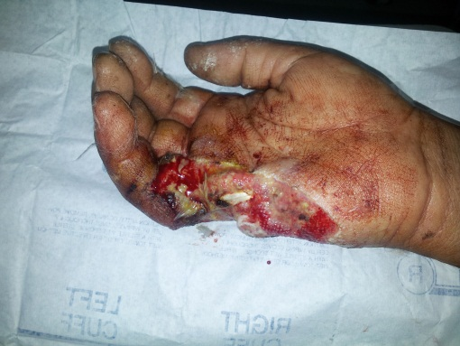
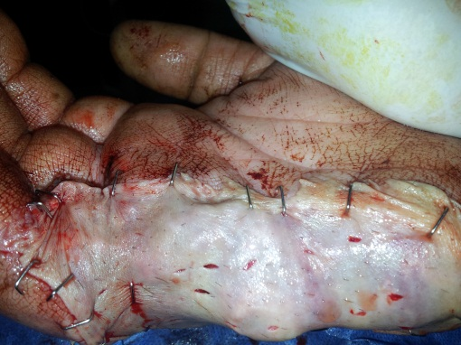

Figure1 pre and post operation pictures for deep full thickness burns of the hand

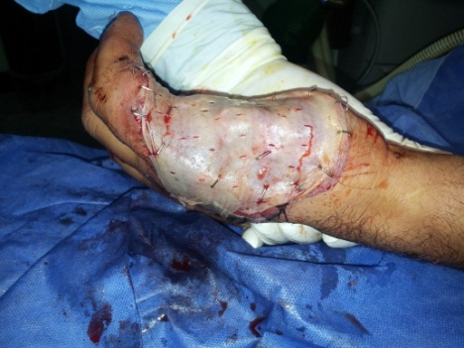
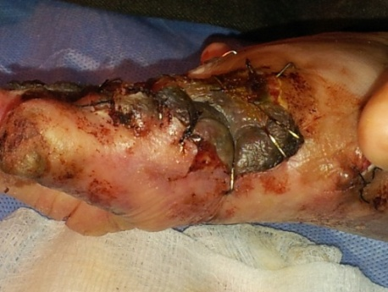
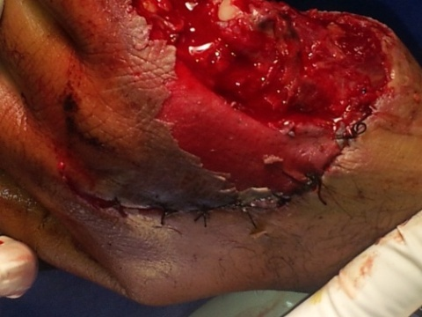
Figure 2 wound excision of deep burns of a hand, and skin graft coverage

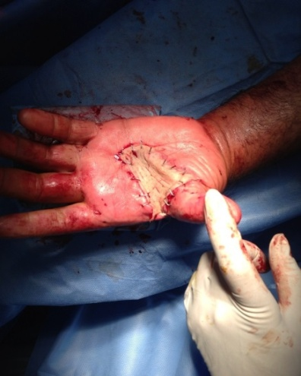
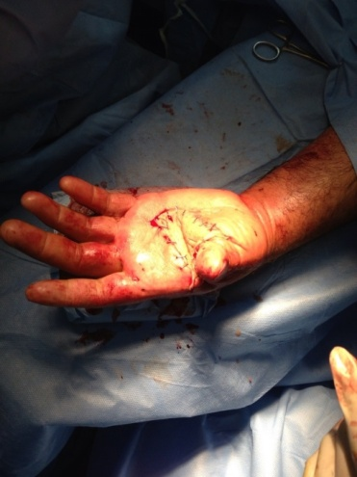

Figure 3 post operative pictures of an excised burns of a hand and skin graft coverage (the preoperative picture was missing)

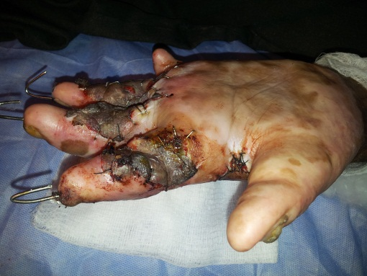
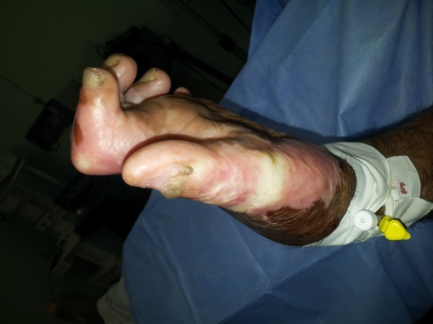

Figure 4 release of an old post burn contractures of a hand with skin graft coverage and k.wires fixation

Discussion
Though the hand burns represent 4% in total in regard to TBSA, but carry major potential disability for the patient as the hands concern directly with the daily activities of the human being ,so any defect in their movements make the patient partially or totally handicapped and dependant person, and that the burn surgeon must pay special attention to their managements,and this concern is beginning from his first look till he regains the patient to his normal daily activities, put in mind the post healing cosmetic appearance of the hands as they are regarded as integral parts of the body beauty images in addition to their important functions, hence the surgeon have to put special concerns to be look after when facing burned hands and not to waste any time and efforts to reach these goals, and the first thing to be put in mind is that how to preserve integral blood flow to their distal parts as much as possible, and this can be achieved by strict elevation of the affected hands, checking their capillary refill both clinically and through pulse oxymeters, and escharotomy has to be done as early as possible in the moment he feel they are compromised (i.e within first 24 hours) post burn periods.
From interpretation of our results ,we can emphasize that leaving the burns of the hands to heal on their own gives an unaccepted sequels from both function and appearance points of view, causing the patient to suffer a lot in regard to his manual jobs, bothersome painful and itching, as well as embarrassing scars ,hence early excision and skin graft coverage may reduce all these complications dramatically ,so also it shorten the time for healing process and early return of the patient to his normal pre-burn life and activities , and these gone well with what Achauer BM saw and done for such cases.(10)and this is more obvious for patients who have got bilateral hand burns. Another point is that the patients whom underwent early surgery having less opportunity for revision surgeries later on in comparison with those whom wounds left to heal by conservative management and excision only.
Infection seemed to be negligible in our lines of management though they were equal for both modalities, escharotomy was having tremendous role in preventing auto-amputations that may have to obtain if there any delay or hesitation to do them specially for cases whom were vulnerable to be deprived from their blood flow. One of the most important complications of excisionand grafting is bleeding, which can be substantial (100 to 200 ml of blood for every 1% of body-surface area that is excised, according to one study).To reduce the severity of bleeding during excision, the fatty tissue under the burned areas can be infiltrated with a solution of dilute epinephrine in saline until the tissue is distended and has a smooth, firm texture (“tumescent technique”).For burn wounds on a limb, a tourniquet can be placed to further limit bleeding during excision. Other hemostatic methods — such as the use of spray or sponge-soaked thrombin, topical epinephrine,vasopressin,fibrin sealant,and intravenous recombinant factor VII29 — can also reduce bleeding.⁽¹³⁾In our study we used only diluted adrenaline (1:200000)saline.

Conclusions
1-Hand burns must be managed with special care in multidisciplinaryteam in a highly expertise burn centre.
2-Early excision and graft represent an integral part in the management of deep hand burns.
3-Thick split thickness skin graft gives better durability and sensibility for the affected hands, leaving least scarring if they have conducted as early as possible.
4-Early and continuous utility of splinting and physiotherapy play major roles in the hand burn care.

References
1.Commitee on Trauma, American College of Surgeons. Advanced Trauma Life Program for Physicians, 1997.
2. American Burn Association. Advanced Burn Life Support Course. Chicago, IL,: American Burn Association, 2001.
3. Robson MC, Smith DJ. Burned hand. In:Jurkiewicz MJ (ed). Plastic surgery: Principles and Practices. St Louis, MO: C.V Mosby Co., 1990 .
4. Still JM, Law EJ, Craft-Coffman B: An evaluation of excision with application of autografts or porcine xenografts within 24 hours of burn injury. Ann Plast Surg 1996;36:176–179
5. Barret JP, Herndon DN: Modulation of inflammatory and catabolic
responses in severely burned children by early burnwound excision in the first 24 hours. Arch Surg 2003;138(2):
127–132
6. Herndon DN, Broemeling L, Barrow RE, Nichols RJ, Ruton RL:Early burn wound excision significantly reduces blood loss.Ann Surg 1990;211:753–762
7. Still JM, Law EJ: Primary excision of the burn wound. Clin Plast Surg 2000;27:23–47
8.Herndon DN (ed):Total burn care. Philadelphia, Elsevier Saunders, 2007.
9.Heggers Jp, ko F, Robson MC, et al. Evaluation of burn blister fluid. Plast recons surgery 1980;65;798-804.
10.Achauer BM. Burn Reconstruction, NewYork, NY; Thieme Medical publisher,1991.
11.Barilla DJ, Harvey KD, Hobbs KL, et al. prospective outcome analysis of a protocol for the surgical and rehabilitation management of burns to the hands. plast reconst surg 1997;100:1442-51.
12.Goodwin CW, McGuire MS, McManus WF, et al. Prospective study of burned wound excision of the hands. J Trauma 1983; 23:510-7.
13. D. Jergovic, P.A. Danielsson, PERSPECTIVE ON CONTEMPORARY BURN SURGERY AND BURN CARE IN SWEDEN Scandinavian Journal of Surgery 92: 281–286, 2003.
14.Edstrom LE, Robson MC, Macchiaverna JR, Scala AD. Prospective randomized treatments for burned hands; nonoperative vs, operative, Scand J plast Reconst Surg 1979;13:131-5
15.Faucher LD, Furukawa K:Practice guidelines for the management of pain. J Burn care rehabil 2006;27:659-668.
16. Latenser BA, Miller SF, Bessey PQ, Browning SM, Caruso DM, Gomez M, et al. National Burn Repository 2006:a ten-year review. J Burn Care Res. Sep-Oct 2007;28(5):635-58.
17. Uppal SK, Ram S, Kwatra B, Garg S, Gupta R, Evaluation of surface swab and quantitative full thickness wound biopsy culture in burn patients. Burns.JUN 2007;33(4):460-3.
18. Ong YS, Samuel M, Song C, Meta-analysis of early excision of burns. Burns.MAR 2006;32(2):145-50.
19. Church D, Elsayed S, Reid O, Winston B, Lindsay R. Burn wound infections.Clin microbial Rev. Apr 2006;19(2):403-34.
20. Esselman PC. Burn rehabilitation:An overview.Arch phys Mid Rhabil. Dec 2007;88(12 Suppl 2):S3-6.

