M J B
Ultrasonography for Detecting Ureteric Calculi with Non Enhanced CT as a Reference Standard (Prospective Study )
Kassim A. Hadi Taj-Aldean
College of Medicine, University of Babylon, Hilla, Iraq.

Abstract
Objective: To prospective study determine the sensitivity and specificity of ultrasonography (US) for detecting ureteric calculi and to establish the accuracy of US for determining the site ,size and number of calculi in ureter .
Patients and Methods: Between June 2008 and December 2009, 100 consecutive patients (age range, 16-65 years; 60 male, 40 female) seen on our emergency department with ureteric colic suspected to have ureteric stone by clinical examination ,underwent US evaluation included a careful search for ureteral calculi. Presence of calculi ,site of calculi and obstruction and incidental diagnoses were recorded .then patients undergo CT on same day or second day for compare the result. All CT studies evaluated the ureter for presence of calculi .US and computed tomography (CT) examinations were compared for the presence of ureteric calculi (site in ureter and size ). The sensitivity of US was determined for presence of calculi in ureter findings were compared with computed tomography . The size of calculi in longest axis were compared on US and CT images .
Results: US depicted 20 calculi identified at CT ,yielding sensitivity 20% and specificity 100 %,there was no substantial difference for detecting calculi in left or right ureter ,the specificity of the ultrasound examination was 100 %, but the sensitivity was 20 % except for the lower ureteric calculi (sensitivity 28%). US find 6 calculi in upper ureter from 26 calculi (sensitivity 23 %) ,while 2 calculi from 30 in middle ureter (sensitivity 6 %) ,and 12 calculi from 42 calculi in lower ureter (sensitivity 28 % ) identified at CT,
Conclusion: US is of limited value for detecting ureteric calculi specially in middle ureter
حساسية ونوعية والقيم التنبوئيه للسونار في تشخيص الحصى داخل الحالب
الخلاصة
الغرض: تقيم حساسية التشخيص والنوعية والقيم التنبوئيه ألموجبه والسالبة لفحص السونار للحصى داخل الحالب .
المرضى وطرائق البحث:أجريت دراسة مقطعيه ل100 مريض يشتبه بإصابتهم بحصوة داخل الحالب بين حزيران 2008 – كانون الثاني 2009 أعمارهم بين 16 - 65 سنة وتم إجراء فحص السونار والمفراس للمرضى المصابين بحصوة داخل الحالب وتم استخلاص نسبة الحساسية والتخصصية لكل منهما لكل مريض .
النتائج:خلاصة فحص السونار 20% لكن التحسسية كان 100% ماعدا الحصى أسفل الحالب 28% لهذا فان فحص السونار اقل دقة من المفراس . بينما حساسية الأشعة المقطعية للمفراس 98% في تشخيص الحصوة داخل الحالب والتشخيصية 100%
استنتاج:نستنتج من هذه الدراسة أن الفحص بالسونار يساعد على تشخيص وجود حصوة داخل الحالب وبحساسة عاليه 100%, في حين انخفضت نوعية هذا الفحص وارتفعت قيمته التنبوئيه السالبة.
ـــــــــــــــــــــــــــــــــــــــــــــــــــــــــــــــــــــــــــــــــــــــــــــــــــــــــــــــــــــــــــــــــــــــــــــــــــــــــــــــــــــــ

Introduction
Non enhanced helical computed tomography (CT) has become the primary imaging modality for evaluating acute flank pain and suspected renal stone disease. The high sensitivity (97%) and specificity (96%) of helical CT for depicting genitourinary calculi has been established [1], and CT is of particular value for detecting ureteral calculi, which often are not visualized with other imaging modalities. [1]Use of imaging for suspected urinary tract calculi has increased markedly since the introduction of unenhanced CT, with little effect on acute care of patients in the emergency department .[2]An unenhanced CT scan is obtained to detect calculi reveal the unenhanced appearance of abnormalities. Unenhanced images are also useful for evaluating masses for fat or calcium...iodine . [3]
Magnetic resonance urography /KUB (kidney ureter bladder )using HASTE sequences can diagnose the presence of acute calculus ureteric obstruction with similar accuracy to spiral CT [4]
The use of non-contrast CT urography is recommended in the initial investigation of patients with ureteric colic. [5]
Noncontrast helical CT is a very sensitive and specific investigation for evaluation of acute flank pain due to urolithiasis, besides helping in the detection of nonrenal causes of pain [6]
Nonetheless, US continues to be performed in the setting of acute flank pain or nephrolithiasis for the detection of calculi in the renal pelvis and parenchyma. US is also performed to identify fragmented renal calculi after extracorporeal shock-wave lithotripsy (ESWL). The sensitivity of US for detecting renal calculi has been reported to be as high as 96% compared with that of abdominal radiography and conventional tomography [7]. However, the true sensitivity of US for renal calculi may be substantially less given evidence that radiography is less sensitive than previously thought [8].
The sensitivity of US for detection of renal calculi compared with that of helical CT is unclear. Establishing the sensitivity of US for renal calculi will allow informed decisions regarding which type of imaging examination to perform for a given clinical situation. Whereas studyies author have evaluated the sensitivity of US for ureteral calculi relative to that of nonenhanced helical CT [9], we are not aware of prior studies in which US and nonenhanced helical CT were compared for sensitivity for calculi within the renal pelvis or renal parenchyma.
Patients and Methods
Between June 2008 to Decenber 2009 , One hundred patients aged between 16-65 years referred from the emergency department in Hilla teaching hospital as ureteric colic ranging in duration from a few hours to a maximum of 36h presenting first time or as second or third episode of ureteric colic were evaluated with USG followed by noncontrast helical CT.
One hundred patients (60 male and 40 female patients; mean age, 40 years; age range, 16–65 years) seen on our emergency department with ureteric colic suspected to have ureteric stone by clinical examination ,underwent US evaluation included a careful search for ureteral calculi. Presence of calculi ,site of calculi and obstruction and incidental diagnoses were recorded ,then patients undergo CT on same or second day for compare the result. All CT studies evaluated the ureter for presence of calculi .US and computed tomography (CT) examinations were compared for the presence of ureteric calculi (site in ureter and size ). The sensitivity of US was determined for presence of calculi in ureter findings were compared with computed tomography . The size of calculi in longest axis were compared on US and CT images
Patients who had previously undergone renal transplantation were excluded from the study. The findings were confirmed on operative retrieval or spontaneous passage. Patients after emergency NCCT were followed up for spontaneous passage, persistence or aggravation of symptoms. All these cases were followed for a few months to 18 months depending upon whether the stone was passed spontaneously or the patient was subjected to surgical intervention.
All US examinations were performed with Siemens versa with a 5-MHz -array transducer. The scanning protocol included both transverse and longitudinal real-time imaging of the ureteric stone , with representative hard-copy images acquired in each plane.
Nonenhanced helical CT was performed by using a Siemens somatom plus 4 and a dedicated protocol with 5.0-mm collimation and 1.0 pitch (120–140 kVp, 120–140 mA). Scanning was performed from the upper abdomen through the pubis, with images reconstructed at 5.0-mm intervals , Unenhanced CT examinations were performed without orally or intravenously administered contrast material with helical scanners ,focal high-attenuating opacities at CT or shadowing echogenic foci at US are termed as calculus or calculi because CT and US cannot enable reliable distinction of calcium deposition from a concretion of different materials with similar attenuation or echogenicity.
For each patient, the US images were reviewed prior to the CT examination. The calculi size (longest axis) and number were recorded for the US and CT examinations, the location of each calculus was recorded as being in either the right or the left ureter ureteric calculi were diagnosed on US images on the basis of focal echogenicity with acoustic shadowing in the ureter . Punctate high-attenuating foci in the renal ureter were used as criteria for the diagnosis of renal calculi on CT scans. Calculi in the kidney or bladder were not included in this study.
The sensitivity of US for calculi in the renal ureter was calculated by using CT as a reference
Results
One hundred patients during period June 2008 and December 2009 ,presented in Hilla teaching hospital of having different presentation table (1 )show clinical presentation of each patient ,then ultrasound examination done for all of them ,by ultrasound examination found the patients to dilatation of PCS with dilatation of ureter search for ureteric calculi ,patient with negative ultrasound finding exclude from this study ,then underwent CT examination in department of radiology in Hilla teaching hospital during same or second day .
Of 100 patients ( 60 male and 40 female )table (4) , age range 16-65 years sonographically find ;20 diagnosis to have ureteric calculi and 78 to have negative ultrasiound Fig. (1).
In comparison with the CT scan examination findings,20 patients were proved to be ureteric calculi Fig .(2) ,while 78 of the sonographically diagnosed as negative proved by CT scan to have ureteric calculi table (2) , two patients with negative ultrasound also have negative CT scan diagnosis by ureteroscopy to have negative calculi .
By US of 100 patients ,20 patients have stone mean size 5.1 mm ± 20.2mm, 14 male patients and 6 female (14 in left ureter and 6 in right ureter ) with a mean age of 40 years (age range, 15-65years) table (5),78 patients have negative ultrasound finding Fig. (3)., By CT examination of 100 patients 98 patients have ureteric stone mean size 3.1 mm ±2 mm only 2 patient with negative CT scan Fig.(4)do ureteroscopy to haves true negative calculi one of them have ureteric stricture and other have ureteric tumor diagnosis by ureteroscopy .
US find 6 calculi in upper ureter from 26 calculi (sensitivity 23 %) ,while 2 calculi from 30 in middle ureter (sensitivity 6 %) ,and 12 calculi from 42 calculi in lower ureter (sensitivity 28 % ) identified at CT,
So as result 78 patients of 100 have stone by CT examination ,negative by US .

Discussion
The high sensitivity of nonenhanced helical CT for genitourinary calculi has been established [8], and this modality is viewed by many to be preferred for depicting renal colic and evaluating renal stone disease [8]. Nonenhanced CT enjoys clear advantages for evaluation of ureteral calculi that are often difficult to visualize with US or radiography because of overlying bowel gas and adjacent bone structures. Yilmaz and colleagues [9] have demonstrated the superiority of CT for the detection of ureteral calculi compared with both US and intravenous urography.
The sensitivity of ultrasound , in our study , 20 % while specificity 100% compare with 98 % for nonenhanced CT , the finding in our study consistent with finding by Yilmaz and colleagues [9] who findening the sensitivity of US for ureteral calculi was found to be 19% compared with 94% for nonenhanced CT.
This finding also consistent with finding by Feroze S. etal [6], whose finding noncontract helical CT was 91% sensitive and 98% specific in detecting urolithiasis compared to a sensitivity of 20% and 30% for KUB and USG and specificity of 94% and 98% respectively.
The poor sensitivity of US demonstrated in the current study is related to multiple factors, the most important being the excellent contrast resolution of CT that allows discrimination of slight differences in attenuation within the ureter. Helical CT enables acquisition of a volume of data that includes the entire kidney, thus allowing complete evaluation, whereas some portions of the kidney may not be visualized at US. Furthermore, CT is less dependent on factors such as patient body habitus and operator skill that are critical to US. Calculi may be missed at US because of a lack of acoustic shadowing that can occur with intervening tissue of different acoustic impedance. Inappropriate selection of transducer power and focal length can also impair acoustic shadowing [10]. Because US has been shown to be sensitive to nonopaque renal calculi, it is unlikely that chemical composition plays a major role in the ability of US to depict calculi [11]
Our data indicate that US is of limited value for the detection of ureteric calculi. Of the 98 ureteric calculi identified on CT scans, only 20 (20%) were depicted on renal US images. No substantial difference in sensitivity was observed between the right and left ureter , consistent with the prior findings of Middleton et al [12]. The sensitivity of US for ureteric calculi in the current study is substantially lower than that in prior studies [12,9] in which US was compared with radiography and conventional tomography. This finding suggests that with both radiography and CT, a substantial number of ureter calculi are missed that are easily detected with CT. Data from a previous study by Sommer et al [10] in which ureteral calculi were evaluated suggest similar difficulties identifying renal calculi at US. In that study, seven renal calculi were identified at CT, whereas a single renal calculus was detected at US in the same group of patients.
The specificity of US was found to be 100%, equal to that found in the study by Middleton et al [12]. In most cases as shown by other investigators [2,10, 13], US sensitivity is dependent on calculi size, and our data indicate that US is poor at depicting calculi of 3.0 mm or less. The mean size of missed calculi was 3.3 mm ± 0.6, whereas the mean size of calculi detected with US was 7.1 mm ± 1.2. King et al [10] have shown that the presence of an acoustic shadow depends on the size of a calculus, and it follows that smaller calculi are more likely to be missed if the diagnostic criteria for calculi include acoustic shadowing.
Because approximately 80% of calculi smaller than 5 mm will pass spontaneously [14], it is reassuring that the bulk of missed calculi are relatively small. However, this finding suggests that US is of limited value for evaluating the progression of renal stone disease, in which the identification of new small calculi would be important. Likewise, small fragments that occur after ESWL could be missed.
Our data indicate that US is a poor modality for demonstrating the full extent of calculi burden. US enabled identification of 20% of the patients with ureteric calculi demonstrated at CT. A study by Vrtiska et al [13] has shown similar difficulties in identifying the full extent of ureteric calculi with US. Calculi burden and the formation of new calculi is important in the clinical evaluation of patients with renal stone disease, and these findings raise questions concerning the efficacy of renal US for follow-up examination of these patients.
In this study the mean time between performance of US and CT was less than 1 week, it clearly would be optimal to perform the examinations concurrently to minimize the likelihood of calculi passage prior to the second examination. However, unlike ureteral calculi that are typically being passed when imaging is performed, we think that a majority of renal calculi would not be passed within the interval between examinations used in this study.
Nonenhanced CT should be considered the standard for determining the size, number, and position of ureteric calculi. At our institution, we have adopted CT as the primary modality for the detection of ureteric calculi. Although the cost of CT remains a barrier to widespread use, authors of one study [16] suggest that modified nonenhanced CT may in fact be less costly than a combination of radiography and US.
In this study found sensitivity of computed tomography are 98 % in detecting ureteric calculi this finding consistent with finding by Ciaschini et al [17],whose found the sensitivity of computed tomography is 98%
Shreyer 2002,[18]similarly Marineck 2002[19]and Tamm et al 2003[20] in their comments describe the high accuracy rate of helical CT scan in detecting urolithiasis even at low doses
Conclusion
USG are less sensitive than NCCT although specificity is almost the same. USG diagnosed 20 cases and missed 78 cases whereas NCCT diagnosed all 98 cases. We recommend NCCT in all cases of clinical findings of urerteric colic where USG are negative.

Table 1 Clinical presentation of patients.
Clinical feature | No.
haematuria | 20
Ureteric colic | 70
Abdominal discomfort | 4
Urinary symptom | 6
total | 100

Table 2 Validity ,positive and negative predictive value for diagnosis ureteric calculi by sonography study.
Total | CT scan negative | CT scan positive
20 | FP 0 | TP 20 | Ultrasound positive
80 | TN 2 | FN 78 | Ultrasound Negative
100 | 2 | 98 | Total
Sensitivity :TP/TP+FN 20/98*100=20%
Specificity :TN/TN+FP 2/2+0*100=100%
Positive predictive value TP/FP+TP 20/0+20 *100=20%
Negative predictive value :TN/TN+FN 2/ 80*100=2.5%
TP:true positive
TN:true negative
FP:false positive
FN:false negative
Table 3 The side involved by ureteric calculi
number | side
60 | Left
40 | Right

Table 4 Distribution of ureteric calvuli in relation to sex
number | Sex
60 | Male
40 | Female

Table 5 Distribution of ureteric calculi in relation to age of patients
Number | Age
16 | 16-25 years
20 | 26-35 years
28 | 36-45 years
20 | 46-55 years
16 | 56-65 years
100 | total

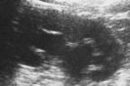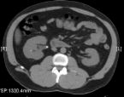
Figure1 US show dilated pcs and upper ureter ,no found stone while CT found stone 8 mm in upper ureter .

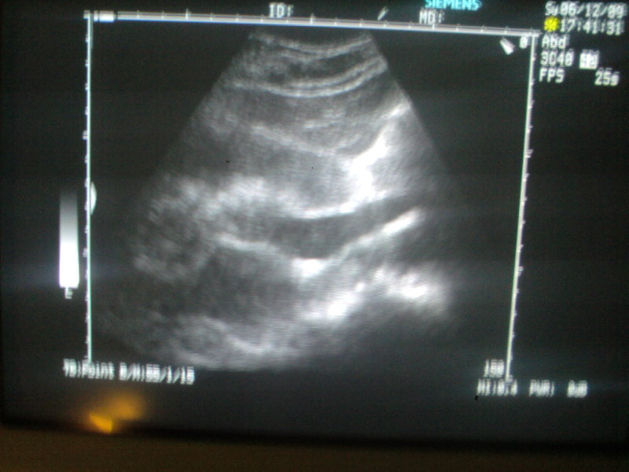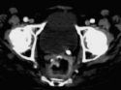
Figure 2 US found dilated pcs and whole ureter stone 9 mm found in left VUJ confirm by CT to have stone at left VUJ
Figure 3 US found dilated pcs with dilated upper ureter no stone found by US ,by CT scan found stone 10 mm in left middle ureter

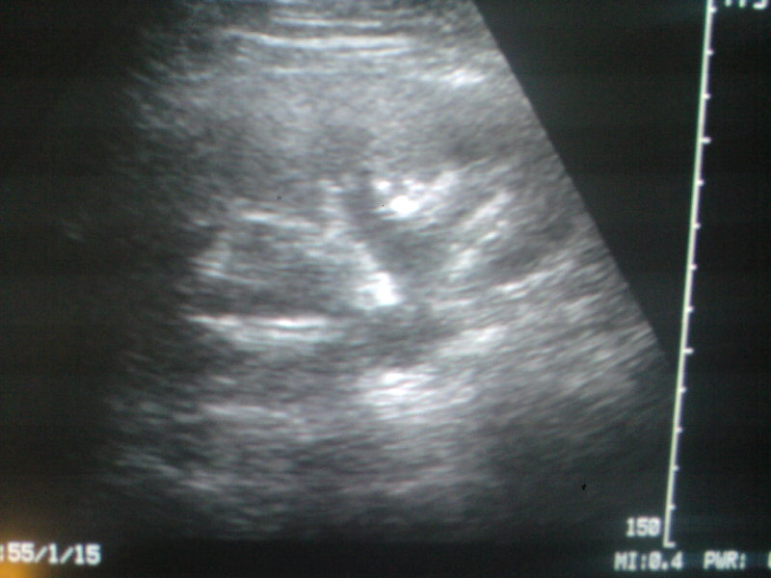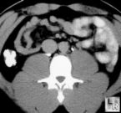
Figure 4 US and CT found dilated pcs with dilatation upper ureter ,negative found by US and CT scan ,confirmed by ureteroscopy to found no stone .

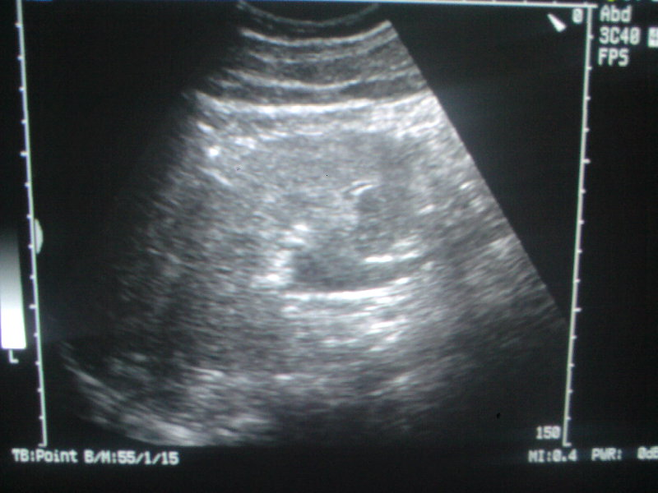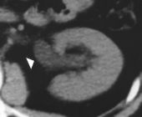

References
1. Smith RC, Verga M, McCarthy S, Rosenfield AT. Diagnosis of acute flank pain: value of unenhanced helical CT. AJR Am J Roentgenol 1996; 166:97-101.
2. Ronald H. Gottlieb, MD, MPH, Thao Christine La, et al. CT in Detecting Urinary Tract Calculi: Influence on Patient Imaging and Clinical Outcomes. Radiology 2002;225:441-449
3. Stuart G. Silverman John R. Leyendecker and E.Stephen Amis .What Is the Current Role of CT Urography and MR Urography in the Evaluation of the Urinary Tract? Radiology February 2009 250:309-323
4. Regan F, Kuszyk B, Bohlman ME, Jackman S .Acute ureteric calculus obstruction: unenhanced spiral CT versus HASTE MR urography and abdominal radiograph. Br J Radiol. 2005 Jun;78(930):506-11
5. Ulahannan D; Blakeley CJ; Jeyadevan N; Hashemi K . Benefits of CT urography in patients presenting to the emergency department with suspected ureteric colic. Emerg Med J. 2008 Sep;25(9):569-71
6. Feroze S, Singh B, Gojwari T, Manjeet S, Athar B, Hamid H. Role of non-contrast spiral computerized tomography in acute ureteric colic. Indian J Urol 2007;23:119-21
7. Middleton WD, Wylie JD, Lawson TL, Foley WD. Renal calculi: sensitivity for detection with US. Radiology 1988; 167:239-244
8. Levine JA, Neitlich J, Verga M, Dalrymple N, Smith RC. Ureteral calculi in patients with flank pain: correlation of plain radiography with unenhanced helical CT. Radiology 1997; 204:27-31.
9. Yilmaz S, Sindel T, Arslan G, et al. Renal colic: comparison of spiral CT, US and IVU in the detection of ureteral calculi. Eur Radiol 1998; 8:212-217.
10. King W, Kimme-Smith C, Winter J. Renal stone shadowing: an investigation of contributing factors. Radiology 1985; 154:191-196.
11. Pollack HM, Arger PH, Goldberg BB, Mulholland SG. Ultrasonic detection of nonopaque renal calculi. Radiology 1978; 127:233-237.
12. Middleton WD, Wylie JD, Lawson TL, Foley WD. Renal calculi: sensitivity for detection with US. Radiology 1988; 167:239-244.
13. Vrtiska TJ, Hattery RR, King BF, et al. Role of ultrasound in medical management of patients with renal stone disease. Urol Radiol 1992; 14:131-138.
14. Motola JA, Smith AD. Therapeutic options for the management of upper tract calculi. Urol Clin North Am 1990; 17:191-206.
15. Chan V, Hanbidge A, Wilson S, Pron G, Moore L. Case for active physician involvement in US practice. Radiology 1996; 199:555-560.
16. Remer EM, Herts BR, Streem SB, et al. Spiral noncontrast CT versus combined plain radiography and renal US after extracorporeal shock wave lithotripsy: cost-identification analysis. Radiology 1997; 204:33-37.
17. M. W. Ciaschini , M. E. Baker , E. M. Remer ,et al .Urinary Calculi: Radiation Dose Reduction of 50% and 75% at CT--Effect on Sensitivity Radiology April 1, 2009 251:105-111.
18. Schreyer HH, Uggowitzer MM, Ruppert-Kohlmayr A. Helical CT or urinary organs. Eur Radiol 2002;12:575-91.
19. Marineck B. Nontraumatic abdominal emergencies: Acute abdominal pain - diagnostic strategies. Eur Radiol 2002;12:2136-50.
20. Tamm EP, Silverman PM, Shuman WP. Evaluation of the patient with flank pain and possible ureteral calculus. Radiology 2003;228:319-29.

