M J B

Antibacterial Efficiency for Alcoholic extracted of (Thymus vulgaris and Negilla sativa)

Taisir Abdulelah kadhim Hussein Ali Khayoon Azal Hamoody Juma’a
Collage of Medicine, Almuthanna University, Alsemaua, Iraq.

Abstract
The aim of this study was to evaluate the Antibacterial activity of various concentrations of mixtures of Thymus vulgaris and Negilla sativa on various pathogenic bacteria (Escherichia coli, Pseudomonas aeroginosa, Staphylococcus aureus, Enterococcus faecalis, Serratia sp. and Bacillus subtilis )
In general, all extracts in concentraction (40 μg/ml) have the same effects on Gram positive bacteria (, Staphylococcus aureus, Streptococcus faecalis, and Bacillus subtilis) , whereas the less effect on Escherichia coli (60 μg /ml), the biggest effect on Serratia sp. (20 μg /ml) and Pseudomonas aeroginosa was (40 μg /ml)
The limits of minimal inhibitory concentration (MIC) of all extracts are between (10-320 μg /ml).
The efficiency of antibacterial activity of T. vulgaris and N. sativa extract were compared with efficiency of standard antibiotics against (Ampicillin, Amikacin, Erythromycin, Kanamicin, Tobramycin, Imipenem, Neomycin, cephalothin, Cephalexin and Augmentin) the same bacterial types.
ــــــــــــــــــــــــــــــــــــــــــــــــــــــــــــــــــــــــــــــــــــــــــــــــــــــــــــــــــــــــــــــــــــــــــــــــــــــــــــــــــــــــــــــــــــــــــــــــــــــ

Introduction
In perspectives of the ancient Chinese thoughts meaning that food and medicine are isogenic, currently there is a revival of interest in the use of plants as source of food and medicine. It is well known that plants are the richest source of bioactive phytochemicals and antioxidant nutrients[1]. Consequently, in recent years there is a much focus on replacing synthetic food additives which might have adverse effects with those of plant-based natural ones[2]. The increasing uses of herbal products demand extra attention with particular focus on their safety, effectiveness and drug interactions. Over the last few decades, a substantial body of scientific evidence is available demonstrating wide range of pharmacological and nutraceutical activities of medicinal herbs [3]. These include antioxidant, anticancer, anti-inflammatory activities. Thymus vulgaris comprising of around 350 species of perennial, aromatic herbs and subshrubs is predominantly found in Mediterranean region, Asia, Southern Europe and North Africa [4]. Thymus species are considered as medicinal plants due to their pharmacological and biological properties. In native medicine, flowering parts and leaves of Thymus species have been extensively used as herbal tea, tonic, carminative, antitussive and antiseptic, as well as for treating colds [5]. Negilla sativa: The seeds have been thoroughly studied scientifically in the last 3-4 decades and have been reported to possess a number of medicinal properties [6]. Their crude extracts [7] have been shown to possess antibacterial activity against several bacteria.

Materials and Methods
Preparation of Extract:
The extraction of Nigella sativa seeds and Thymus vulgaris leaves was prepared according to the method of Hadjzadeh et al. (2007)[8] with special modification. Nigella sativa seeds and Thymus vulgaris leaves were purchased from a local market with a highly degree of quality assurance. The seeds of N.S and leaves of T.V were cleaned, dried and powdered in an electrical grinder and stored at 5 ºC until further use. The combination between the two plant powders at percent 1:1 was extracted with a sufficient volume of 96% ethanol using hot magnetic stirrer apparatus. Ethanol was evaporated at 40°-50°C under reduced pressure and the yield of extract was dissolve in water before use. The extracts were filtered through Millipore 0.22 µg and final prepared two fold concentrations of 10, 20, 40, 80, 160, and 320 µg /ml [9].
The antibacterial activity of plant extracts was compared with (10) standard commercial antibiotics. (Ampicillin, Amikacin, Erythromycin, Kanamicin, Tobramycin, Imipenem, Neomycin , cephalothin, Cephalexinand and Augmentin )
Antibacterial activity:
Various types of pathogenic bacteria isolated from clinical specimens and identified by routine methods were used. These bacteria are: (Escherichia coli, Pseudomonas aeroginosa, Staphylococcus aureus, Streptococcus faecalis, Serratia sp. and Bacillus subtilis )
Blood agar (BA) and Nutrient agar (NA) prepared for isolation of bacteria. The antibacterial activity was carried out by two techniques. [10].
1- Agar diffusion technique: To determine the diameters of inhibition zone by using Mueller Hinton agar (MHA).
2- Tube technique: To determine the minimal inhibitory concentrations (MICs) by using Brain Heart Infusion broth (BHI) .
0.1 ml (103 cell/ml) from each bacterial isolates were inoculated on to MHA and BHI.

Results
In general, the present study showed that the combination of Nigella sativa and Thymus vulgaris are more effect on pathogenic bacteria than commercial antibiotics.
The results summarized in chart (A) and chart (B).

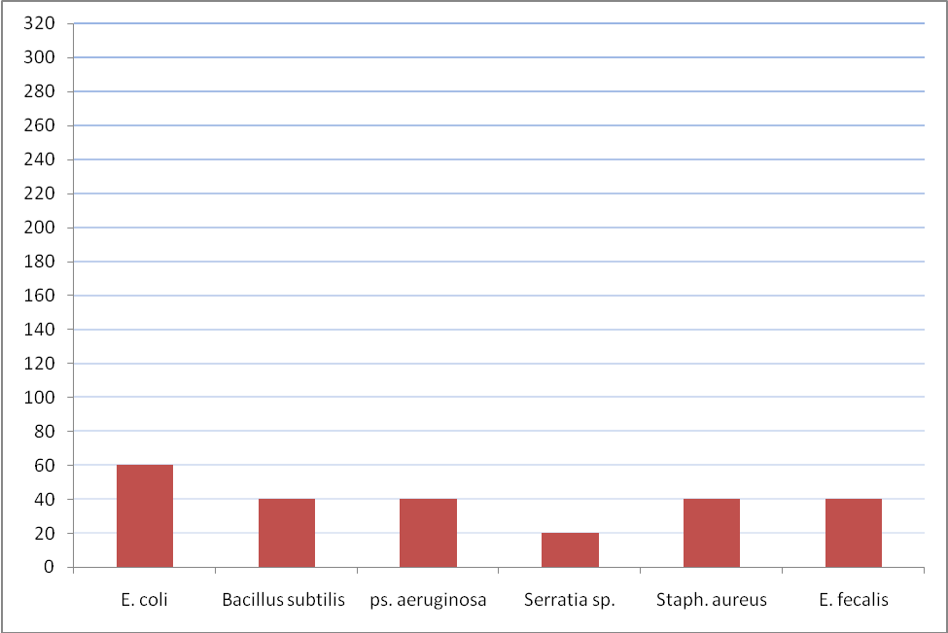
Chart A showed the effects of various concentraction (μg/ml) of minimum inhibitory concentraction for combination of Nigella sativa and Thymus vulgaris on different pathogenic bacteria

Chart (A) illustrates efficacious of various concentration of MIC for combination of N.S and T.V on six bacterial types.
The results from the disc diffusion method followed by MIC indicated that E.coli showed maximum antimicrobial activity (60 μg/ml), and MIC effects for combination (N.S and T.V) extracted showed decrease the MIC values (40μg/ml) on other isolated bacteria (Bacillus subtilis, pseudomonas aeruginosa, staphylococcus aureus and enterococcus fecalis).
The more effect of (N.S and T.V) as antibacterial on Serriatia sp. (20 μg/ml).

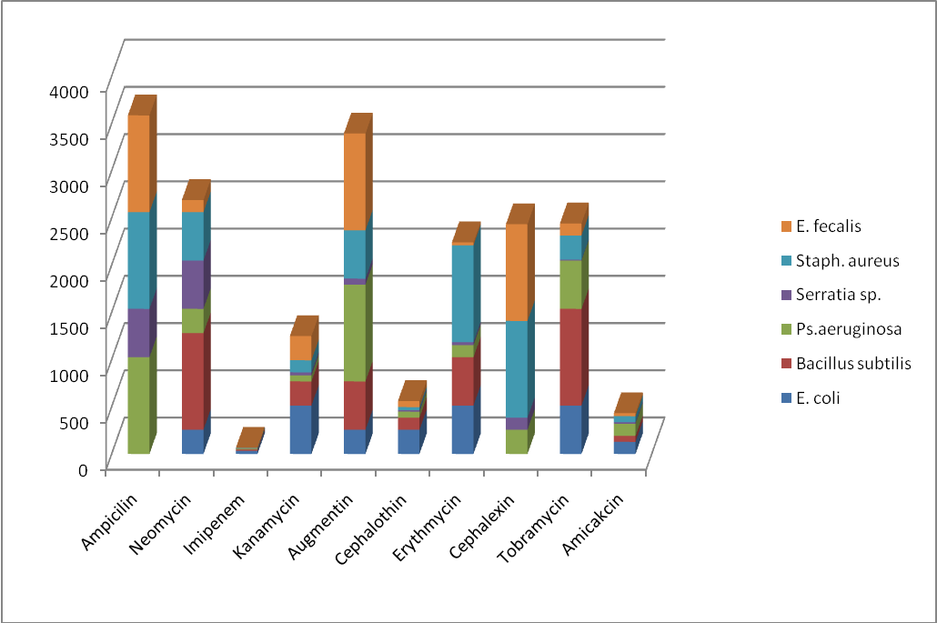
Chart B The effects of minimum inhibitory concentration for different commercial Antibiotics (μg /ml) on different pathogenic bacteria

Chart (B): showed the effects of minimum inhibitory concentration for different commercial Antibiotics (μg /ml) on six pathogenic bacteria.
Imipenem antibiotic showed exhibited excellent antimicrobial activity against all microorganisms tested and showed values between (2- 32) μg /ml, and the moderate effect of MIC for Amikacin antibiotic was between (16-128) μg /ml , and less effect of other antibiotics (Kanamycin, Erythmycin, Tobramycin, Cephalothin, Neomycin, Augmentin, Cephalexin, Ampicilin).

Discussion
The results of present study showed that combination of N.S and T.V. have more effect on negative and positive pathogenic bacteria. Their mode of antimicrobial action may be related to their ability to inactivate microbial adhesions, enzymes, cell envelope transport proteins. The results obtained from previous study showed that the Gram-negative bacteria were more sensitive to the extract of Thymus vulgaris leaves [11-13] isolated Thymohydroquinone from volatile oil of N. sativa seeds and found it to have high antimicrobial effect against gram positive bacteria. In a study by Kahsai (2002)[14], thymoquinone present in volatile oil obtained from the crude extract exhibited remarkable inhibition of the growth of various strains of bacteria. Thymoquinone is present in the methanol soluble portion of N. sativa oil [15] and thus will be extracted in methanolic extract of seeds also. Probable targets in the microbial cell are surface-exposed adhesins, cell wall polypeptides, and membrane-bound enzymes. Quinones may also render substrates unavailable to the microorganism [16]. The seeds also contain tannins, which can be extracted by methanol [17]. A number of studies have reported antimicrobial properties of tannins [18]. In our study, the antimicrobial activity of the oil could be due to borneol, alpha-pinene and beta -pinene. Borneol has been reported to have significant antimicrobial activity [19,20]. Pinene-type monoterpene hydrocarbons (alpha-Pinene & beta -Pinene) are well-known chemicals having antimicrobial potentials [21]. The antimicrobial activity of the essential oil of thyme is apparently related to its terpenes type components such as, myrcene, camphene and pcymene, since there is a relationship between the chemical structures of the most abundant oils and their antimicrobial activities. Although the mechanism of action of terpenes is not fully understood, it is thought to involve membrane disruption by the lipophilic compounds [22]. The essential oils containing terpenes are also reported to possess antimicrobial activity [21], which are consistent with our present studies. The synergistic effects of these active chemicals with other constituents of the essential oils should be taken into consideration for the antimicrobial activity to reach to broad spectrum. This hypothesis is further supported by our study which failed to find any relationship between the sensitivity of tested strains to Nigella sativa and to other commonly used antibiotics. Synergistic effects resulting from the combination of antibiotics with various plant extracts or with another antibiotics had been studied and experimented by a number of scientists and researcher, but in this study determined the synergestic effect by combination with two ptant T.V+N.S for equivalent weight 1:1 and then extraction accrued
Conclusion and Recommendation
We concluded that the combination of Thymus vulgaris and Negilla sativa extract have wide spectrum antibacterial activity in comparison with standard antibiotics.
And we recommended testing of this combination in vivo

References
1- Elless, M. P., M. J. Blaylock, J. W. Huang and C. D. Gussman. 2000. Plants as a natural source of concentrated mineral nutritional supplements. Food Chemistry. 71:
181-188.
2-Paradiso, V. M.., C. Summo, A. Trani, and F. Caponio. 2008. An effort to improve the shelf life of breakfast cereals using natural mixed tocopherols. Journal of Cereal Science. 47: 322-330.
3-Edris, A. E. 2007. Pharmaceutical and therapeutic potential of essential oils and their individual volatile constituents: A review. Phytotherapy Research. 21: 308-323.
4-Maksimovic, Z., D. Stojanovic, I. Sostaric, Z. Dajic and M. Ristic. 2008. Composition and radical-scavenging activity of Thymus glabrescens Willd. (Lamiaceae)essential oil. Journal of the Science of Food and Agriculture. 88: 2036-2041.
5-Rota, M. C., A. Herrera, R. M. Martinez, J. A. Sotomayor and M. J. Jordan. 2008.
Antimicrobial activity and chemical composition of Thymus vulgaris, Thymuszygis and Thymus hyemalis essential oils. Food Control. 19: 681-687.
6-Ali BH and Blunden G, Pharmacological and toxicological properties of Nigella sativa, Phytother Res, 2003, 17(4), 299.
7-Ali NA, Julich WD, Kusnick C and Lindequist U, Screening of Yemeni
medicinal plants for antibacterial and cytotoxic activities., J Ethnopharmacol, 2001, 74(2), 173-179.
8- Hadjzadeh, M.A.R., A. Khoei, Z. Hadjzadeh, and M. Parizady, 2007. Ethanolic extract of Nigella sativa L seeds on ethylene glycol-induced kidney calculi in rats. Urol. J., 4(2): 86-90.
9- Taylor RSL, Edel F, Manandhar NP, Towers GHN (1996). Antimicrobial activity of Southern Nepalese medicinal plants. J. Ethnopharmacol 50: 97-102.
10- Baron, E. J., Peterson, L. R. and Finegold, S. M. (1994). Baily & Scott's Diagnostic Microbiology. 9th ed. Mosby-Year book, Inc., St. Louis.
11-B. Imelouane1, H. Amhamdi, J.P. Wathelet, M. Ankit, K. Khedid And A. El Bachiri., 2009. Chemical Composition and Antimicrobial Activity of Essential Oil of Thyme (Thymus vulgaris) from Eastern Morocco. International Journal of Agriculture & Biology ISSN Print: 1560–8530;
12-Toama Mohamed A., Taha S. El-Alfy, and Hamed M. El-Fatatry; Antimicrobial Activity of the Volatile Oil of Nigella sativa Linneaus Seeds; Antimicrobial. Agents Chemotherapy. 1974 August; 6(2): 225–226.
13-El-Fatatry HM.; Isolation and structure assignment of an antimicrobial principle from the volatile oil of Nigella sativa L. seeds. Pharmazie. 1975 Feb; 30 (2):109-11.
14-Kahsai AW, Isolation and Characterization of Active Ingredients from Nigella sativa for Antibacterial Screening; Master's Thesis, Department of Chemistry,
East Tennessee State University, 2002. http://etd10submit.etsu.edu/etd/theses/available/etd-0715102-001118/; last accessed on 07/12/2007.
15-Abou, Basha. L. I., M. S. Rashed, Aboul, E. H. Y (1995). TLC assay of
thymoquinone in Black Seed oil (Nigella sativa Linn) and identification of dithymoquinone and thymol. Journal of Liquid Chromatography 18(1): 105-115.
16-Mason, T. L., and B. P. Wasserman.; 1987. Inactivation of red beet beta-glucan
synthase by native and oxidized phenolic compounds. Phytochemistry 26:2197-2202.
17-Eloff, 1998
18-Scalbert, A. 1991. Antimicrobial properties of tannins. Phytochemistry 30:3875-3883.
19-Tabanca, N., N. Kirimer, B. Demirci, F. Demirci and K.H.C. Baser, 2001.Composition and antimicrobial activity of the essential oils of Micromeria cristata subsp. phyrgia and the enantiomeric distribution of borneol. J. Agric. Food Chem., 49: 4300–4303.
20-Vardar, U.G., F. Candan, A. Sokmen, D. Daferera, M. Polissiou, M. Sokmen, E. Donmez and B. Tepe, 2003. Antibacterial and antioxidant activity of the essential oil and methanol extracts of Thymus pectinatus Fisch. et Mey var. pectinatus (Lamiaceae). J. Agric. Food Chem., 51: 63–67.
21-Dorman, H.J.D. and S.G. Deans, 2000. Antimicrobial agents from plants: antibacterial activity of plant volatile oils. J. Appl. Microbiol., 88:308–316.
22-Cowan, M.M., 1999. Plant products as antimicrobial agents. Clin. Microbiol. Rev., 12: 564–582.

