Laser principles-lecture -1-
The first stage
Mohammed Hamza
PROPERTIES OF LIGHT

PROPERTIES OF WAVES:
A wave is a disturbance that transmits energy from one point to another. Any periodic disturbance can be represented by waves; for example, musical sounds, human speech, the swine of a pendulum, a cork bobbing up-and-down in the water, and the violent shock from an earthquake. Light, as it travels through space, also can be described as a wave phenomenon.
Figure 1 illustrates a wave traveling to the right at one instant of time. The displacement is the vertical distance from the equilibrium position at any point along the wave. The amplitude is the maximum displacement of the wave. Wavelength is defined as "the distance over which the wave repeats itself" and is represented by the Greek letter lambda (λ).
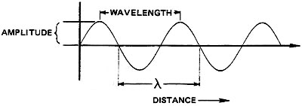
Fig. 1 Displacement-versus-distance along a
Figure 2 illustrates the same wave as a function of time at a single point. The period is the time over which the wave repeats it self-the time required for one complete cycle of the wave. The frequency of the wave is the number of cycles of the wave in one second and is represented by the Greek letter nu (ν).
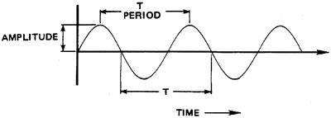
Fig. 2 Displacement-versus-time at one point on the wave
Frequency and period are related by Equations 1 and 2:
Equation 1
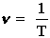
Equation 2
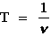
where: | T = Period in seconds (sec).  ν = Frequency in hertz (Hz).
The unit of frequency is cycles/second, or hertz, and may be expressed symbolically as Hz, sec⁻¹, or /sec. Period is measured in seconds and wavelength in meters. Table 1 lists prefixes used with these base units and the common units formed. The unit micrometer (10⁻⁶ m) is a widely-used unit of length and also is called a "micron." The micron is represented by either μm or μ, with μm preferred. A common wavelength unit not included in this table is the angstrom (1 Angstrom = 10⁻¹⁰ m).
Prefix | Symbol | Value | Common Use
 |  |  | Wavelength (m) | Time (sec) | Frequency (Hz)
Tera  Giga  Mega  kilo  milli  micro  nano  pico | T  G  M  k  m  μ  n  p | 10¹²  10⁹  10⁶  10³  10⁻³  10⁻⁶  10⁻⁹  10⁻¹² | mm  μm or μ  nm | ms  μs  ns  ps | THz  GHz  MHz  kHz
Since speed is defined as distance traveled divided by elapsed time, the speed of a wave is the distance traveled in one cycle, or the wavelength divided by the time required for one cycle (the period). Equations 3 and 4 are expressions of wave speed.
Equation 3
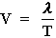
Equation 4
V = λν
where: | T = Period of the wave  λ = wavelength  ν = Frequency of the wave  V = Speed of the wave
The speed of light waves through a vacuum is 3 x 10⁸ m/sec and is expressed by the symbol c, which can be substituted for V in Equation 4 to give Equations 5, 6, and 7.
Equation 5
c = λν
Equation 6
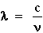
Equation 7
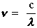

EXAMPLE A: CALCULATION OF FREQUENCY AND PERIOD
Given: | A radio wave has a wavelength of 30 m.
Find: | The frequency and period of the wave.
Solution:

EXAMPLE B: CALCULATION OF WAVELENGTH AND PERIOD
Given: | Ordinary ac current has a frequency of 60 Hz.
Find: | The wavelength and period of the wave.
Solution:

EXAMPLE C: CALCULATION OF FREQUENCY AND WAVELENGTH
Given: | The light produced by a He-Ne laser has a period of 2.11 x 10⁻¹⁵ sec.
Find: | The frequency and wavelength of the wave.
Solution:

ELECTROMAGNETIC WAVES:

THE NATURE OF ELECTROMAGNETIC WAVES:
Light consists of electromagnetic waves moving through space. Figure 3 is a representation of a plane-polarized electromagnetic wave at one instant in time. The concept of polarization is discussed in detail in a later section of this module.
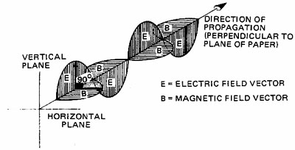
Fig. 3 Three-dimensional model of plane-polarized E-M waves
This wave consists of variations in two types of fields in space. In this case, the electric field (E) always oscillates vertically to form an electric wave; the magnetic field (B) always oscillates horizontally to form a magnetic wave. The two fields are perpendicular to each other, and both are perpendicular to the direction of propagation of the wave. All electromagnetic waves have this same basic composition. They differ only in frequency and wavelength.

THE ELECTROMAGNETIC SPECTRUM:
The span of frequencies and wavelengths covered by electromagnetic radiation is indicated by portion A of Figure 4. Devices that produce or detect electromagnetic waves must be designed to operate at the frequency of the waves they emit or receive. Radio transmitters and receivers operate at frequencies in the 10³- and 10⁷ -Hz range and are designed to emit or respond to these frequencies. X-ray tubes and films are designed for use in the 10¹⁷- to 10^{l9}-Hz frequency range. Lasers produce coherent light in the frequency and wavelength range indicated by portion B of Figure 4. This range includes the spectral regions commonly identified as the infrared, visible, and ultraviolet regions. The human eye responds to the visible spectrum given in portion C of Figure 4
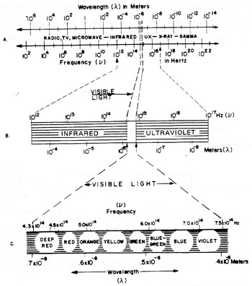
Fig. 4 The electromagnetic spectrum

INDEX OF REFRACTION:
All electromagnetic waves travel through a vacuum at the constant speed of c = 3 * 10⁸ m/sec. When these waves travel through a transmitting material, however, their speed is reduced. The index of refraction of a material is the ratio of the speed of light in a vacuum to its speed in that material and is given by Equation 8.
Equation 8
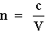
where: | n = Index of refraction.  V = Speed of light inside material.
The frequency of a light wave does not change when it enters a material, but its wavelength is reduced (Figure 5). The index of refraction is also the ratio of wavelength in vacuum to the wavelength in the material (Equation 9).
Equation 9
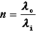
where: | λ₀ = Wavelength in vacuum.  λ_{i} = Wavelength in material.
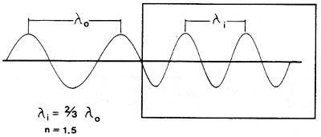
Fig. 5 Wavelength reduction in material
When light leaves a material and enters a vacuum, it returns to speed c and to wavelength λ₀? The index of refraction of air is about 1.0003, but is assumed to be 1.0 in most applications.

EXAMPLE D: INDEX OF REFRACTION OF RUBY
Given: | Light travels through a ruby laser rod at a speed of 1.74 * 10⁸ m/sec.
Find: | Index of refraction of ruby.
Solution:

EXAMPLE E: SPEED AND WAVELENGTH OF LIGHT IN GLASS
Given: | A He-Ne laser beam (λ = 633 nm) travels through a glass window with an index of refraction of 1.65.
Find: | Speed and wavelength inside the glass.
Solution:

PROPERTIES OF LIGHT:

POLARIZATION:
All light consists of wave variations in electric and magnetic fields. Many applications require that the electric and magnetic fields have a particular direction. If the direction of one of these fields is known, the direction of the other must be specified since the two are always perpendicular. The polarization of light describes the orientation of the electric field in space. The following terms commonly are employed in the description of polarized light:
- Unpolarized light has no specific orientation of electric field. The direction of the electric field varies randomly at approximately the frequency of light, as shown schematically in Figure 6c.
- Plane-polarized light is light in which the electric field oscillates in one plane only.
- In vertically-polarized light (Figure 6a), the plane of the electric field is vertical — up and down in the plane of the paper and shown as vertical arrows.
- In horizontally-polarized light (Figure 6b), the plane that contains the electric field is horizontal — perpendicular to the plane of the paper.
- In circularly-polarized light, the direction of the electric field is neither random nor confined to a single plane. The direction of the electric field of circularly-polarized light sweeps out a circle during each period of the wave.
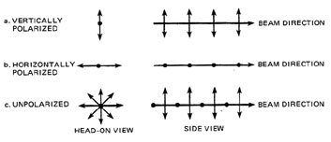
Fig. 6 Representations of polarized light
Figure 7 illustrates the operation of an optical element termed a "linear polarizer." It consists of a elastic sheet that contains needle-shaped crystals of herapathite (an iodine compound). These crystals strongly absorb the horizontal components depicted in Figure 7, but they transmit most of the vertical components.
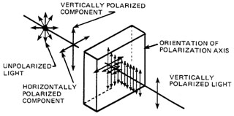
Fig. 7 Polarization by absorption
Polarization by reflection of light from a surface is illustrated in Figure 8. Unpolarized light strikes the surface with an angle of incidence A. A portion of the light is reflected, and the remainder is transmitted. The amount of each polarized component that is reflected from the surface depends on the angle of incidence A. The polarization components are designated as "parallel" (denoted by the symbol ||) or "perpendicular" (denoted by the symbol .) In each case, the direction of polarization is referred to the plane of incidence. Recall that the plane of incidence is that plane that contains the surface normal and the incident ray. (It is not the same as the plane of the paper!) Thus in Figure 8 the dots () refer to the perpendicular polarizations; the short arrows () refer to the parallel polarizations.
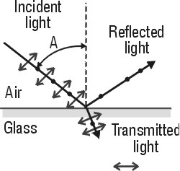
Fig. 8 Polarization by reflection
Figure 9 depicts the reflectance of a glass surface as a function of the angle of incidence for light polarized perpendicular to the plane of incidence () and light polarized parallel to the plane of incidence (||). The reflectance–the fraction of incident power refected– given as a percent in Figure 9, represents the fraction of Unpolarized incident light reflected for each of the two polarizations, perpendicular () and parallel (||) for each angle of incidence between 0 (normal incidence) and 90 (grazing incidence.) For example, according to Figure 9, at 0each component is equally reflected — 4% for each one. Near 90 (grazing incidence,) each component is equally reflected — close to 100% for each in the region between 20and 90, the perpendicular component, , is reflected more strongly.

Brewster's Angle:
Note that at one particular angle, labeled A in Figure 8 and B in Figure 9, the perpendicular component, , is 15% reflected, while the parallel component, ||, is 0% reflected. This angle is called the Brewster Angle. Its value depends on the index of refraction of the reflecting material. Thus, if light is incident on glass (n=1.5) at the Brewster angle (about 56.3�,) then the 15% of the light reflected is totally polarized in a perpendicular direction. None of the parallel polarized light is reflected. Of course, in all cases, what is not reflected, is always transmitted beyond the interface.
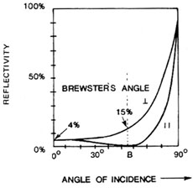
Fig. 9 Reflectance of a glass surface as a function of angle of
incidence for perpendicular () and
parallel (||) polarization
Brewster's angle is related to the index of refraction by Equation 10.
n = tan B | Equation 10
This equation states that Brewster's angle for a material in air is the angle whose tangent is equal to the index of refraction of the material. Example F illustrates the use of Equation 10.
EXAMPLE F: BREWSTER'S ANGLE
Given: | The index of refraction of the fused quartz window of a He-Ne laser tube is 1.45. The fused quartz window is adjacent to air.
Find: | Brewster's angle.
Solution: | n = tan B  B = arc tan N  = arc tan (1.45)  B = 55.4
Figure 10 is concerned with the operation of Brewster windows in a gas laser to produce a polarized laser beam. Figure 10a shows the overall cavity geometry, including the two cavity mirrors, the two Brewster windows and the gas laser tube. Figure 10b shows the initial action of a Brewster window on an Unpolarized laser beam incident on the window at Brewster's angle (56 for an air-to-glass interface).
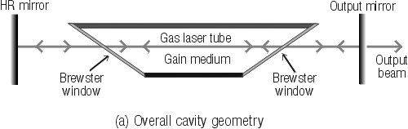
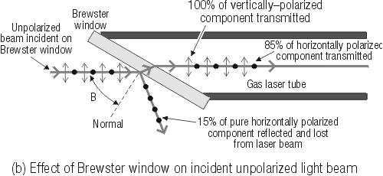
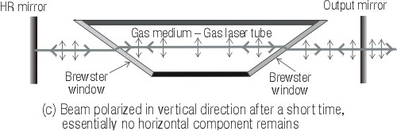
Fig. 10 Action of Brewster windows on an initially
Unpolarized beam reflecting back and forth
in the cavity laser cavity.
The incident Unpolarized beam contains equal amounts of vertically polarized light (shown as vertical arrows in the plane of the drawing) and horizontally polarized light (shown as black dots to represent arrows perpendicular to the plane of the drawing). Since the beam is incident at the Brewster angle, the reflected portion is totally horizontally polarized and represents about 15% of the incident beam power. This reflected part is rejected out of the cavity and plays no further role in the laser operation. As a result, the transmitted beam retains 85% of the incident beam power, made up of all the vertical polarization (50% of the initial beam power) and the remaining 35% of the horizontal polarization. When the transmitted beam strikes the next Brewster window, the process is repeated. Since the laser beam reflects back and forth between the cavity mirrors (about a billion round trips per second) the loss of the 15% per reflection at the Brewster window quickly wipes out the horizontal component, leaving only the vertical component–50% of the initial beam power. Almost instantaneously, then, the cavity—and the output beam as well–becomes nearly 100% polarized in the vertical direction. This situation is shown in Figure 10c.
The polarization of a CW laser beam can be tested by rotating a linear polarizer in the laser beam and examining the beam passing through the polarizer. If the beam is polarized, the transmitted intensity will vary from a maximum value to near zero as the polarizer is rotated through 90.When the transmission axis of the linear polarizer has the same direction as the electric field of the polarized beam, maximum transmission occurs. When the two are perpendicular, no light is transmitted. A measure of how well a laser beam is linearly polarized is known as the "extinction ratio" (ER). This is the ratio of the power transmitted through the polarizer when its transmission exit is aligned with the polarization plane (maximum power) to the power transmitted when the polarizer is rotated 90 (minimum power), assuming a perfect polarizer.

