Oxidative Stress in Post-traumatic Stress Disorders for Terror Attack Victims in Iraq†
Abdulsamie H. Alta'ee Dr. Tarik Hufdy Al-Khayat
Dr. Waleed Azeez Al-Ameedy
College of Medicine, University of Babylon, Hilla, Babylon, Iraq.
Dr. Lamia Abdul Majeed
College of Science, University of Babylon, Hilla, Babylon, Iraq.
Abstract
Background: There is accumulating evidence for a link between posttraumatic stress disorder (PTSD) and reduced health status for terror attack victims.
Objective: To assess the oxidants/ antioxidant status in patients with PTSD.
Patients and Methods: 70 Iraqi subjects (59 males, 11 females) witnessed on Alnasej Factory explosion occurred at 10th June 2010 in Hilla city of Iraq, as well as 35 apparently healthy persons served as a controls group (21 males, 14 females) were subjected to present study. Participants were grouped to four groups according to PTSD Checklist (PCL) scores. Antioxidant enzymes superoxide dismutase (SOD) catalase (CAT), glutathione peroxidase (GPx), reduced glutathione (GSH), and lipid peroxidation were determined using spectrophotometric methods
Results: The antioxidant enzymes activities, SOD, GPx, and peroxidation product MDA, found to be insignificantly increased in the present study, whereas, the antioxidant enzyme activity CAT and non-enzymatic antioxidant GSH showed an insignificant decreased in all groups of PTSD patients, when compared to control group. Also there are positive correlations between SOD, GPx and MDA, with severity of PTSD. Whereas; there is negative correlation between CAT and GSH with severity of PTSD.
Conclusion: Results may indicate an involvement of mild oxidative stress in the pathogenesis of PTSD due to active hypothalamic-pituitary-adrenal (HPA) axis and hypothalamic-pituitary-thyroid (HPT) axis.
† This paper is a part of a doctoral thesis and the work is still underway to complete the study.
Introduction:
The incidence of explosive injuries and suicide bombing has become frequent in Iraq after 2003 due to terrorist attacks which occurred throughout the country. The victims of terrorist attacks suffer from long term post traumatic symptoms and emotional distress in addition to their difficulties to re-adjust with normal living style and to cope with different types of social activities.
Posttraumatic stress disorder (PTSD)is an anxiety disorder involving both somatic and psychological symptoms that occur as a consequence to severe trauma. [1]
PTSD was defined in Diagnostic and Statistical Manual of Mental Disorders, fourth edition (DSM-IV) as an event that involves life endangerment, death, or serious injury or threat and is accompanied by feelings of intense fear, horror, or helplessness.[2]
The most common types of trauma reported that may lead to PTSD are witnessing someone being injured or killed, being involved in a natural disaster, and being involved in a life-threatening accident.[3]
The symptoms of PTSD described by DSM-IV involve: re-experience of the trauma, avoidance of thoughts and/or places associated with the traumatic event, enhanced vigilance and hyperarousal, sleep disturbances, and emotional numbling. This symptoms should be continued for more than 1 month.[4]. Symptoms that have been present for 1 to 3 months are termed acute, whereas those that persist beyond 3 months are considered chronic. The development of symptoms 6 months or more after the trauma is termed delayed onset.[2].
There are accumulative evidences that oxidative stress, which is defined as the imbalance between oxidants and antioxidants preferring the former, implicates in the pathogenesis of many disease, like atherosclerosis and cardiovascular diseases, diabetes mellitus, mutagenesis and cancer [5-7].
Reactive oxygen species or free radicals which produce oxidative stress result from metabolic and physiological processes, and harmful oxidative reactions that may occur in organisms and are removed via enzymatic and non-enzymatic antioxidative mechanisms. The increases in oxidants and decreases in antioxidants cannot be avoided, and the oxidative/antioxidative balance shifts towards the oxidative stress in more than 100 types of diseases [8-9].
Clinical and experimental studies have shown that oxidative stress participate in many psychiatric disorder which may lead to neuronal loss in cerebral ischemia and haemorrhage, also it may be involved in degeneration of neurons in normal aging [10], epilepsy [11], Parkinson's disease [12], Alzheimer's disease [13], and possibly in schizophrenia which is considered as a major psychiatric disorder.[14-16].
This study was designed to assess the oxidative stress associated with the pathogenesis of PTSD. To our knowledge, no previous study has been done in Iraqi population.
Superoxide dismutase, catalase, glutathione peroxidase, reduce glutathione, and lipid peroxidation were measured in the present study as an indicators of oxidative stress in patients with PTSD, as well as control group.
Material and Methods
Patients
Seventy Iraqi subjects (59 males, 11 females) witnessed on so called Alnasej Factory explosion occurred at 10th June 2010 in Hilla city of Iraq. All these subjects were employees in the State Company for Textile Industries (Alnasej Factory), as well as thirty five subjects (21 males, 14 females) apparently healthy controls after asked them about their health as a control groups.
Diagnosis of patients was made according to trained psychologist raters according to the DSM-IV criteria using the Structured Clinical Interview for DSM-IV and the Clinician Administered PTSD Scale (CAPS), and by use PTSD Checklist (PCL) scores self-reported. The PCL is a self-report questionnaire consisting of 17 DSM-IV PTSD symptoms. They are rated on a five-point scale ranging from “not at all” to “extremely.” Items are added to obtain a total score. The higher the score, the more symptoms are present. A cutoff score of 50 was used for this analysis to indicate PTSD status [17].
Participants were categorized to four groups according to PCL scores: >50 (A), 26-49 (B), 1-25 (C), and control group (D).
Blood Collection
Five milliliters of overnight fasting blood were drawn at 8:00-8:30 am and allowed to clot for 15 minutes. Serum was obtained by centrifuging for 10 minutes at a relative centrifugal force (RCF) 2000 x g.
Superoxide dismutase (SOD)
Superoxide dismutase was determined by use a simple and rapid method [18], based on the ability of the enzyme to inhibit the autoxidation of pyrogallol. The autoxidation of pyrogallol in the presence of EDTA in the pH 8.2 is 50%
SOD activities were expressed as units/ml. one unit of SOD activity being defined as amount of enzyme required to cause 50% inhibition of pyrogallol autoxidation [18].
Catalase (CAT)
The catalase assay performed using spectrophotometric determination of hydrogen peroxide which form stable complex with ammonium molybdate that absorbs at 405 nm[19]. One unit CAT decomposes 1 µmole of hydrogen peroxide/ l minute under assay conditions. CAT activities were expressed as kilo unit per liter (kU/l)
Glutathione peroxidase (GPx)
Total glutathione peroxidase was measured by the reaction of cumin hydroperoxide with glutathione (GSH) as the reducing substrate to form yellow color that is absorbed at 412 nm. [20]
Reduced Glutathione (GSH)
Serum GSH was determined by using a modified procedure utilizing Ellman’s reagent. 5,5´-Dithiobis (2-nitrobenzoic acid) (DTNB) is a disulfide chromogen that is readily reduced by sulfhydryl group of GSH to an intensely yellow compound. The absorbance of the reduced chromogen is measured at 412nm and is directly proportional to the GSH concentration. [21]
Lipid Peroxidation
Serum lipid peroxidation in the form of lipid peroxidation product malondialdehyde (MDA) was determined by the colorimetric thiobarbituric acid (TBA) method. Lipid peroxides break down to form MDA under acidic and heating conditions. The latter compound reacts with TBA to form pink complexes absorb maximally at 532 nm [22].
Statistical analysis
All values were expressed as mean ± standard deviation (SD). Student’s t-test was used to estimate differences between the groups and differences were considered significant at probability (p < 0.05).
Coefficient of variation percentage (CV) is used to express precision [23].
Results and Discussion
Results of present study were categorized to four groups according to PCL scores: > 50 (A), 26-49 (B), 1-25 (C), and control group (D) to show the effect of severity of PTSD symptoms. as shown in Table 1

Table 1 antioxidant and oxidative stress parameters in different groups of PTSD patients compared to control group.
MDA  (µM) | GSH  (µM) | GPx  (U/L) | Catalase  (kiloU/L) | SOD  (U/ml) | Age  (years)
6.81 | 23.84 | 244.36 | 25.87 | 2.80 | 47.40 | Mean no.20  G A, PCL (> 50)
1.75 | 8.96 | 54.89 | 7.32 | 0.41 | 6.19 | SD
0.05 | 0.09 | 0.09 | 0.33 | 0.98 | 0.01 | P
25.74 | 37.58 | 22.46 | 28.30 | 14.54 | 13.06 | CV%
6.66 | 23.96 | 235.62 | 27.73 | 2.78 | 44.96 | Mean no.26  G B, PCL (26-49)
3.29 | 12.64 | 52.47 | 8.83 | 0.36 | 5.88 | SD
0.16 | 0.10 | 0.30 | 0.89 | 0.82 | 0.13 | P
49.40 | 52.75 | 22.27 | 31.85 | 13.05 | 13.07 | CV%
5.73 | 28.06 | 232.40 | 27.93 | 2.74 | 43.91 | Mean no. 24  G C, PCL (1-25)
3.26 | 12.43 | 91.69 | 8.33 | 0.47 | 4.99 | SD
0.70 | 0.73 | 0.15 | 0.44 | 0.58 | 0.33 | P
56.91 | 44.31 | 39.45 | 29.80 | 17.21 | 11.36 | CV%
5.39 | 29.25 | 213.16 | 28.03 | 2.61 | 42.40 | Mean no.35  G D, (control)
3.11 | 12.20 | 67.34 | 7.25 | 0.41 | 2.96 | SD
57.75 | 41.71 | 31.59 | 25.85 | 15.81 | 6.99 | CV%
G= group, SD= standard deviation, P= probability, CV%= coefficient of variation percentage, no. =number of subjects, PCL= PTSD Checklist

The antioxidant enzymes activities, SOD, GPx, and lipid peroxidation product MDA, found to be increased in the present study, whereas, the antioxidant enzyme activity CAT and non-enzymatic antioxidant GSH were decreased in all groups of PTSD patients, when compared to control group, but this decreases or increases are insignificant. These findings are similar to those of Tezcan E. et al. 2003 [24]. In this study, we try to explain the correlation between oxidative stress and the pathogenesis of PTSD.
The neurobiology of PTSD exhibits amazing resemblances to that of major depression; however, PTSD defer as a stress-induced syndrome distinct from depression. In general, the studies of depression and PTSD have concentrated upon the two biological systems in stress-related research: the hypothalamic-pituitary-adrenal (HPA) axis and the catecholamine/sympathetic nervous system. Depression and PTSD are associated with hyperactivity of the two systems; but, PTSD shows the important dissimilarity of being associated with normal to low cortisol levels (hypocortisolaemia) in spite of hyper-secretion of corticotropin-releasing factor (CRF) [25, 26].
High levels of cortisol that are secreted from the adrenal glands in response to a stressful situation have been related to neuronal damage which has been linked to the increased generation of reactive oxygen species (ROS) [27]. Increased ROS levels in the central nervous system (CNS) have been associated with the development of a number of neuropsychiatric diseases including depression [28].
PTSD pathophysiology may also involve dysfunction of the innate immune inflammatory system. PTSD patients have been found to exhibit increased concentrations of circulating inflammatory markers such as C-reactive protein and interleukin-6 (IL-6), suggesting dysfunction of the innate immune inflammatory system. Women with PTSD also shown increased necrosis factor-κB (NF-κB) pathway activity compared to controls and was positively correlated with PTSD severity. These findings suggest that enhanced inflammatory system activity in participants with PTSD is observable at the level of NF-κB, and that in general decreased immune cell glucocorticoid sensitivity may contribute to increased NF-κB pathway activity [29].
Researches on NF-κB from animal models suggest involvement of NF-κB in cerebral ischemia-reperfusion injury, response to neurotrauma, involved in the pathogenesis of human cerebral infarction, and Alzheimer dementia, the atherosclerotic inflammatory disorders associated with the human brain, and in generation of ROS [30].
On the other hand, there are accumulated evidences of an association between traumatic stress and the onset of clinical hyperthyroidism, a few of researches has been focused on hypothalamic-pituitary-thyroid (HPT) axis in PTSD. These studies have shown an increase in HPT axis activity in PTSD. Especially, the peripheral measurement of both the total and the free of triiodothyronine (T3) and thyroxine (T4) have revealed that these are elevated in PTSD patients. In addition, the elevations in T3 are disproportionately higher than those of T4, suggesting enhanced peripheral deiodination of T4 to the more biologically active T3 form of the hormone [31, 32].
Previous studies shown that thyroid hormone T3 calorigenesis in the rat involves higher rates of O₂ consumption in the liver, with generation of ROS in hepatocytes and Kupffer cells and antioxidant depletion [33]. This enhancement of status of the oxidative stress of the liver, which is counted a mild redox alteration due to the deficiency of morphologic changes occurrence in parenchymal cell of liver, except Kupffer cells which undergo hyperplasia and hypertrophy [34] , was found to trigger the redox regulation of gene expression [33,35].
Since increased oxidative stress displays a strong correlation with activation of the immune system as well as a number of neuropsychiatric disorders, the antioxidant effects seem to be mediated through direct quenching of ROS by increase the gene expression of major antioxidant enzymes [36].
The insignificant increase in the antioxidant enzymes activities, SOD and GPx, and oxidation product MDA, and the insignificant decrease in the antioxidant enzyme activity CAT and the non-enzymatic antioxidant GSH, in the present study, may be attributed to the active HPA axis and HPT axis in PTSD patients [26, 31].
This pattern of alteration in levels of oxidant /antioxidant parameters (but with significant differences) has been shown in patients with thalassemia [37,38], diabetes mellitus [39] and urolithiasis [40]; a diseases characterized by increased oxidative stress.
Also there are positive correlations between antioxidant enzymes activities SOD, GPx and MDA, with severity of PTSD. Whereas, there is negative correlation between antioxidant enzyme CAT, non-enzymatic antioxidant GSH with severity of PTSD. This correlation may support our finding postulation of involvement of mild oxidative stress in the pathogenesis of PTSD. Figure 1-5.
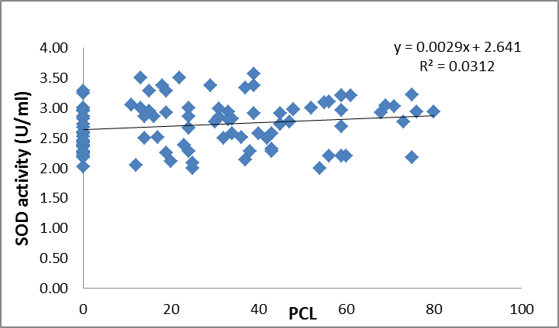
Figure 1 the correlation between SOD activities and PCL ( r = 0.18)
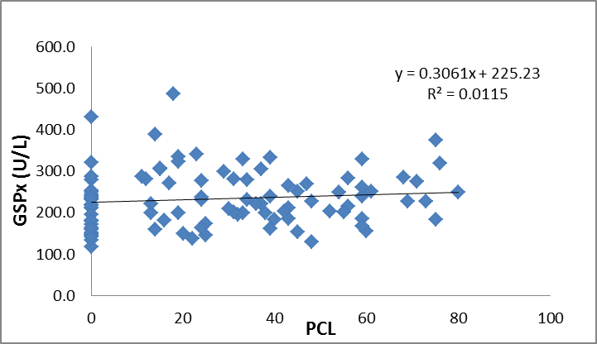
Figure 2 the correlation between GPx activities and PCL (r=0.1166)
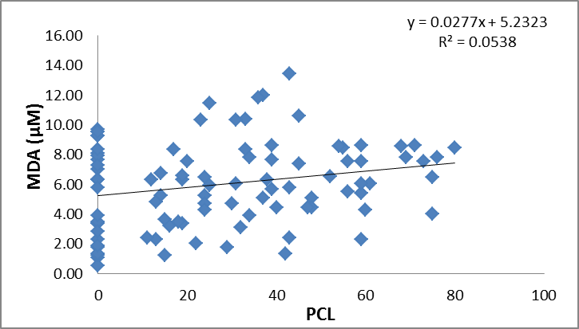
Figure 3 the correlation between MDA and PCL (r= 0.2319)
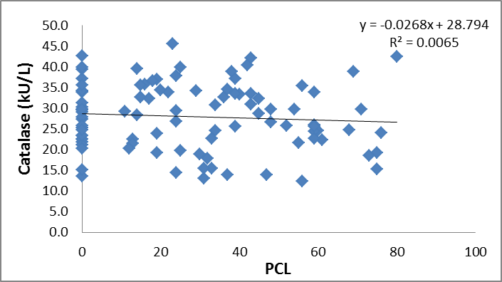
Figure 4 the correlation between CAT activities and PCL (r= 0.0806)
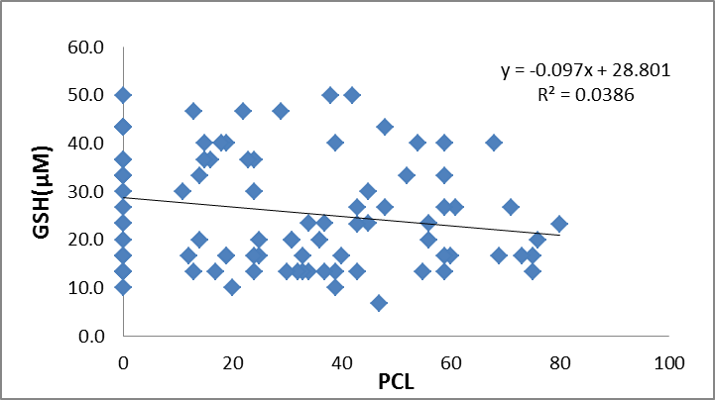
Figure 5 the correlation between GSH and PCL (r=0.1964). Note: points on zero x axes seem to be less than the real number due to equated values.

References
1.Brian M. Freidenberg, Rebecca Gusmano, Edward J. Hickling, Edward B. Blanchard, J. Douglas Bremner, Cheryl Frye, Women with PTSD have lower basal salivary cortisol levels later in the day than do men with PTSD: A preliminary study, Physiology & Behavior, (2010) 99: 234-236.
2. Kathryn M. Connor, Marian I. Butterfield, Posttraumatic Stress Disorder, FOCUS, (2003) 1,3:247-262.
3. Kessler RC, Sonnega A, Bromet E, Hughes M, Nelson CB: Posttraumatic stress disorder in the National Comorbidity Survey. Arch Gen Psychiatry, (1995) 52:1048–1060.
4. Yuqing Song, Dongfeng Zhou, Xiangdong Wang, Increased serum cortisol and growth hormone levels in earthquake survivors with PTSD or subclinical PTSD, Psychoneuroendocrinology, (2008) 33, 1155-1159.

5. Frei B., Molecular and biological mechanisms of antioxidant action FASEB J., (1999) 13, 963.

6. Schulz J.B., Lindenau J., Seyfried J., and Dichgans J., Glutathione, oxidative stress and neurodegeneration, Eur. J. Biochem, (2000) 267, 4904.
7. Abdulsamie H.Alta'ee , O.M.Alzamely and M.J.Ewadh, Oxidative Stress Measurements Via Trace Elements Levels in Sera of Patients with Cancer. National Journal of Chemistry, (2003) 12: 562-570.
8.Durmuş Yıldıray Şahin, Zafer Elbasan, Mustafa Gür, Caner Türkoğlu, Betül Özaltun, Zehra Sümbül, Murat Çaylı,Relationship between oxidative stress markers and cardiac syndrome X, J Clin Exp Invest, (2012), 3,2: 174-180
9. Halliwell B, Gutteridge JMC. Free radicals in biology and medicine. Third ed. Oxford: Oxford Science Publications; (2000) 617-24.
10. Berlett SB, Stadtman ER. Protein oxidation in aging, disease and oxidative stress. J Clin Chem (1997),272,33:20313-20316.
11. Nikushkin EV, Kryzhanovski GN, Tupeev IR, Bordyukov MM, Yuzefova SM. Blood anitoxidant enzymes during epileptic ac-tivity. Biull Eksp Biol Med (1987),3:297-299.
12. Ceballos I, Lafon M, Javoy-Agid F, Hirsch E, Nicole A, Sinet PM, Agid Y. Superoxide dismutase in Parkinson's disease. Lancet (1990),335:1035-1036.
13. Smith CD, Carney JM, Starke-Reed PE, Oliver CN, Stadtman ER, Floyd RA, Markesbery WR. Excess brain protein oxidation and enzyme dysfunction in normal aging and in Alzheimer dis-ease. Proc Natl Acad Sci USA (1991),88:10540-10543.
14. Abdalla DSP, Monteiro HP, Oliveira JAC, Bechara EJH. Ac-tivities of superoxide dismutase and glutathione peroxidase in schizophrenic and manic-depressive patients. Clin Chem (1986) 32,5:805-807.
15. Dušica Pavlović, Vesna Tamburi ć, Ivana Stojanović, Gordana Koci ć, Tatjana Jevtovi ć, Vidosava Dordević, Oxidative stress as marker of positive symptoms in schizophrenia, Med. & Biology, (2002) 9, 2: 157- 161.
16. Mirjana Tosic, Jurg Ott, Sandra Barral, Pierre Bovet, Patricia Deppen, Fulvia Gheorghita,et al., Schizophrenia and Oxidative Stress: Glutamate Cysteine Ligase Modifier as a Susceptibility Gene, Am J. Hum Gen. , (2006) 79, sep: 586-592
17. Amy A. Gravely, Andrea Cutting, Sean Nugent, Joseph Grill, Kathleen Carlson, Michele Spoont, Validity of PTSD diagnoses in VA administrative data: Comparison of VA administrative PTSD diagnoses to self-reported PTSD Checklist scores, JRRD, (2011) 48,1:21-30
18. Marklund, S. and Marklund, G. Involvement of the superoxide anion radical in the autooxidation of pyrogallol and a convenient assay for superoxide dismutase. Eur. J. Biochem. (1974) 47: 469-474.
19. L. Goth, A simple method for determination of serum catalase activity and revision of reference range. Clinica Chimica Acta, (1991) 196: 143-152
20. Rotruck JT, Pope AL, Ganther FIE and et a/. Selenium: Biochemical Role as a Component of Glutathione Peroxidase. J Science. (1973) 179, 588-5.
21. Burtis C.A. and Ashwood E.R., Tietz Textbook of Clinical Chemistry, 3rd ed., Philadelphia, W.B.Saunders Co. (1999).
22- Lunec J., Free radicals: their involvement in disease processes, Ann.Clinic Biochem. (1990),27:173-182.
23. Martin A. Crook, Clinical chemistry and metabolism medicine, 7th edition, Edward Arnold Led, UK, 2006.
24. Tezcan E., Atmaca M., Kuloglu M., Ustundag B. Free radical in patient with PTSD, Eur Arch Psychiatry Clin Neurosci (2003) 253:89-91.
25. D. Jeffrey Newport, Charles B. Nemeroff, Neurobiology of Posttraumatic Stress Disorder, FOCUS, I (2003) 3: 313-321.
26. Rachel Yehuda, Linda M. Bierer, James Schmeidler, Daniel H. Aferiat, Ilana Breslau, Susan Dolan, Low Cortisol and Risk for PTSD in Adult Offspring of Holocaust Survivors, Am J Psychiatry (2000), 157:1252–1259.
27. McIntosh, L.J., Sapolsky, R.M.,. Glucocorticoids increase the accumulation of reactive oxygen species and enhance adriamycin-induced toxicity in neuronal culture. Exp. Neurol. (1996) 141:201-206.
28. Halliwell, B., Cross, C.E. Oxygen-derived species: their relation to human disease and environmental stress. Environ. Health Perspect. (1994) 102 , 10, 5 -12.

29. Thaddeus W.W. Pace Katja Wingenfeld Iris Schmidt, Gunther Meinlschmidt, Dirk H. Hellhammer, Christine M. Heim, Increased peripheral NF-κB pathway activity in women with childhood abuse-related posttraumatic stress disorder, Brain, Behavior, and Immunity (2012), 26,1:13-17
30. John W. Christman, Timothy S. Blackwell, Bernhard H.J. Juurlink, Redox Regulation of Nuclear Factor Kappa B: Therapeutic Potential for Attenuating Inflammatory Responses , Brain Pathology(2000) 10: 153-162
31. Prange AJ Jr: Thyroid axis sustaining hypothesis of posttraumatic stress disorder. Psychosom Med (1999) 61:139–140.
32. Bremner J, Southwick S, Charney D: The neurobiology of posttraumatic stress disorder: an integration of animal and human research. In Posttraumatic Stress Disorder: A Comprehensive Text. Edited by Saigh P, Bremner J. Needham Heights, MA, Allyn & Bacon, (1999) 103–143.
33. Videla, L. A.; Fernández, V.; Tapia, G.; Varela, P. Thyroid hormone calorigenesis and mitochondrial redox signaling: upregulation of gene expression. Front. Biosci., (2007) 12:1220–1228.
34. Tapia, G.; Pepper, I.; Smok, G.; Videla, L. A. Kupffer cell function in thyroid hormone-induced liver oxidative stress. Free Radic. Res., (1997) 26:267–279.
35. Virginia Fernández, Gladys Tapia, Patricia Varela, Leonardo Gaete, Gemma Vera, Catalina Mora, María T. Vial, Luis A. Videla, Causal role of oxidative stress in liver preconditioning by thyroid hormone in rats, Free Radical Biology & Medicine, (2008) 44: 1724-1731
36. O. Grundmann,Y.Lv, O. Kelber, V. Butterweck, Mechan ism of St. John' s wort extract (ST W3-VI) during chronic restraint stress is mediated by the interrelationship of the immune, oxidative defense, and neuroendocrine system, Neuropharmacology, (2010) 58: 767-773
37. Lamia A. M. J., New evidence for the oxidative hypothesis in patients with beta - thalassemia major, PhD thesis, Basrah University, (2005).
38. Mudher K. M.Biochemical changes in beta-thalassemia major patients, MSc. Thesis, University of Babylon, (2011)
39. Ferdous A. J., Evaluation the oxidative stress of Patients with Diabetes Mellitus by using Some Enzymatic Indicators, PhD thesis, University of Babylon, (2005).
40. Roua H. M., Assessment of the clinical significance of lipid peroxidation, antioxidant enzymes and N-acetyl. β.D-glucosaminidase in sera of patients with urolithiasis, MSc. Thesis, University of Babylon, (2009).

